课程名称 数据结构 实验名称 线性表的存储和其它操作 实验日期 2019.3.5
班 级 计科1805 姓 名 吕思颖 学号 1033180511 仪器编号＿＿＿＿＿＿
实验报告要求 1.实验目的 2.实验要求 3.实验步骤 4.程序清单 5.运行情况 6.流程图 7.实验体会
实验目的：
掌握线性表的顺序存储结构和链式存储结构设计与其它操作的实现
实验内容：
1、采用线性表动态分配顺序存储结构，编程实现顺序表中数据元素的逆置操作。
2、有一个带头结点的线性链表L，编程实现链表中数据元素的逆置操作。要求不另设新结点。
3、采用线性表动态分配顺序存储结构，编程实现顺序表中数据元素按值非递减排列。
4、有一个带头结点的线性链表L，编程实现链表中数据元素按值非递减排列。要求不另设新结点。
程序清单：
1.
#include<stdio.h>
#include<stdlib.h>
#include<math.h>
#include<time.h>
#define TURE 1
#define FALSE 0
#define OK 1
#define ERROR 0
#define INFEASIBLE -1
#define OVERFLOW -2
#define LIST_INIT_SIZE 100
#define LISTINCREMENT 10
typedef int ElemType;
typedef int Status;
typedef struct{
ElemType *elem;
int length;
int listsize;
}SqList;

//构造一个空的线性表L
Status InitList_Sq(SqList &L){
L.elem=(ElemType*)malloc(LIST_INIT_SIZE*sizeof(ElemType));
if(!L.elem)return OVERFLOW;
L.length=0;
L.listsize=LIST_INIT_SIZE;
return OK;
}

//Create the sequential list if n elements
Status ListCreate_Sq(SqList &L,int n){
int i;
srand(time(0));
for(i=0;i<n;i++){
L.elem[i]=rand()%90+10;
++L.length;
}
printf("\n");
if(L.length==0)return ERROR;
return OK;
}

//Output the list
Status ListOutput_Sq(SqList L){
int i;
if(L.length==0)return ERROR;
for(i=0;i<L.length;i++)
printf("%-4d",L.elem[i]);
printf("\n");
return OK;
}

//Data elements of the sequential list are converse
Status ListConverse_Sq(SqList &L){
ElemType temp;
int i;
if(L.length==0)return ERROR;
for(i=0;i<(int)L.length/2;i++){
temp=L.elem[i];
L.elem[i]=L.elem[L.length-i-1];
L.elem[L.length-i-1]=temp;
}
return OK;
}

int main(){
SqList L;
printf("Initialize the sequential list!");
InitList_Sq(L);
if(L.length==0)
printf("The sequential list is empty!\n");
printf("Create the sequential list,");
ListCreate_Sq(L,5);
printf("Output all elements of the sequential list!\n");
ListOutput_Sq(L);
ListConverse_Sq(L);
printf("Output all converse elements of the sequential list\n");
ListOutput_Sq(L);
return OK;
}
2.
#include<stdio.h>
#include<stdlib.h>
#include<time.h>
#define TURE 1
#define FALSE 0
#define OK 1
#define ERROR 0
#define OVERFLOW -2
typedef int Status;
typedef int ElemType;
typedef struct LNode{
ElemType data;
struct LNode *next;
}LNode,*LinkList;

//Create the linked list L with n elements from head to rear
void CreateList_L(LinkList &L,int n){
LinkList p,q;
int i;
L=(LinkList)malloc(sizeof(LNode));
q=L;
srand(time(0));
for(i=1;i<=n;i++){
p=(LinkList)malloc(sizeof(LNode));
p->data=rand()%90+10;
q->next=p;
q=p;
}
p->next=NULL;
}

//Output the linked list
Status OutputList_L(LinkList L){
LinkList p=L->next;
if(p==NULL)return ERROR;
while(p!=NULL){
printf("%4d",p->data);
p=p->next;
}
printf("\n");
return OK;
}

//Data elements of the linked list are converse
Status ListConverse_L(LinkList &L){
LinkList p,q;
p=L->next;
L->next=NULL;
while(p){
q=p;
p=p->next;
q->next=L->next;
L->next=q;
}
return OK;
}

int main(){
LinkList L;
printf("Create the linked list,");
CreateList_L(L,5);
printf("Output all elements of the linked list!\n");
OutputList_L(L);
ListConverse_L(L);
printf("Output all converse elements of the linked list!\n");
OutputList_L(L);
}
3.
#include<stdio.h>
#include<stdlib.h>
#include<time.h>
#define OK 1
#define TRUE 1
#define FLASE 0
#define ERROR 0
#define OVERFLOW -2
#define LIST_INIT_SIZE 100
#define LISTINCREMENT 10
typedef int Status;
typedef int ElemType;
typedef struct{
ElemType *elem;
int length;
int listsize;
}SqList;

//Initialize the sequential list
Status Initlist_Sq(SqList &L){
L.elem=(ElemType*)malloc(LIST_INIT_SIZE*sizeof(ElemType));
if(!L.elem)return OVERFLOW;
L.length=0;
L.listsize=LIST_INIT_SIZE;
return OK;
}

//Create the sequential list of n elements
Status Createlist_Sq(SqList &L,int n){
int i;
srand(time(0));
for(i=0;i<n;i++){
L.elem[i]=rand()%90+10;
++L.length;
}
if(L.length==0)return ERROR;
return OK;
}

//Output the sequential list of n elements
Status Outputlist_Sq(SqList &L){
int i;
if(L.length==0)return ERROR;
for(i=0;i<L.length;i++){
printf("%4d",L.elem[i]);
}
printf("\n");
return OK;
}

//按值非递减排列
Status Listsort_Sq(SqList &L){
int i,j,k,temp;
if(L.length==0)return ERROR;
for(i=0;i<L.length-1;i++){
for(j=i+1;j<L.length-1;++j){
k=i;
if(L.elem[k]>L.elem[j]){
k=j;
}
if(k!=i){
temp=L.elem[k];
L.elem[k]=L.elem[i];
L.elem[i]=temp;
}
}
}
}

int main(){
SqList L;
printf("创建一个线性表：");
Initlist_Sq(L);
Createlist_Sq(L,5);
printf("\n");
printf("输出线性表：");
Outputlist_Sq(L);
printf("\n");
printf("按非递减顺序排列并输出：");
Listsort_Sq(L);
Outputlist_Sq(L);
}
4.
#include<stdio.h>
#include<stdlib.h>
#include<time.h>
#define OK 1
#define ERROR 0
#define TRUE 1
#define FLASE 0
#define OVERFLOW -2
typedef int Status;
typedef int ElemType;
typedef struct LNode{
ElemType data;
struct LNode *next;
}LNode,*LinkList;

//Create the link list L with n elements from head to rear
void Createlist_L(LinkList &L,int n){
LinkList q,p;
int i;
L=(LinkList)malloc(sizeof(LNode));
q=L;
srand(time(0));
for(i=0;i<=n;i++){
p=(LinkList)malloc(sizeof(LNode));
p->data=rand()%90+10;
q->next=p;
q=p;
}
p->next=NULL;
}

//Output the linked list
Status Outputlist_L(LinkList L){
LinkList p=L->next;
if(p==NULL)return ERROR;
while(p!=NULL){
printf("%4d",p->data);
p=p->next;
}
printf("\n");
return OK;
}

//Sort the linked list
Status Sortlist_L(LinkList L){
LinkList p,q;
int temp;
p=L->next;
while(p->next){
q=L->next;
while(q->next){
if(q->data<q->next->data){
temp=q->data;
q->data=q->next->data;
q->next->data=temp;
}
q=q->next;
}
p=p->next;
}
return OK;
}

int main(){
LinkList L;
printf("Create a list:");
Createlist_L(L,3);
printf("\n");
printf("Output a list:");
Outputlist_L(L);
printf("\n");
printf("按非递减输出：");
Sortlist_L(L);
Outputlist_L(L);
}

运行情况：
1.
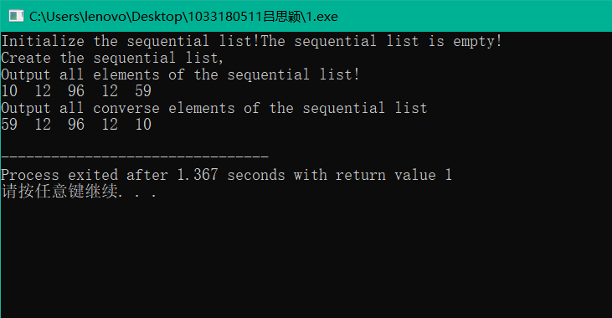
2.
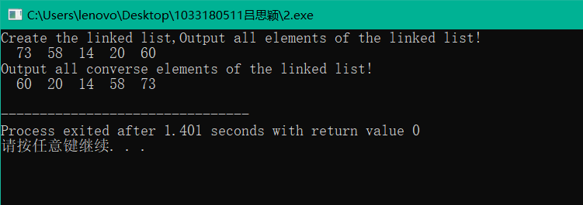

3.
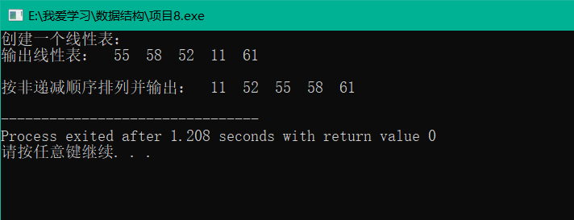
4.
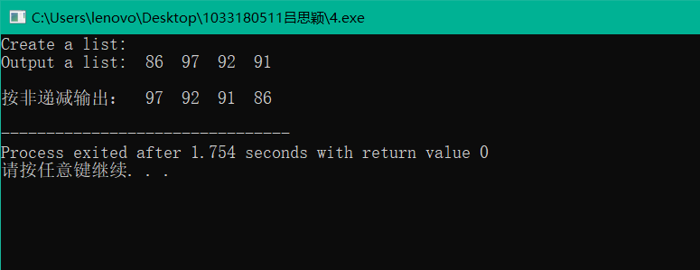

实验体会：
要先理解代码，再自己想着编写才能更好的提高自己的能力
教师评价 | 优 |  | 良 |  | 中 |  | 及格 |  | 不及  格 |  | 教师签名 |  | 日期
江南大学物联网工程学院实验报告

