PHYSICS GROUP PROJECT REPORT
An Explanatory Guide and Step-by-Step Derivation of:
"Generalization of parallel axis theorem for rotational inertia"
Course Title: General Physics I
Group Members:
-Geonwoo Ahn (202611122)
- Seoyun Yu (202611136)
- Sangyoon Lee (202611146)
- Hyojung Jo (202611209)
Abstract
This project provides a comprehensive, pedagogical breakdown of the foundational paper "Generalization of parallel axis theorem for rotational inertia" by A. R. Abdulghany, published in the American Journal of Physics (Volume 85, Pages 791-795, 2017). While the original text assumes a certain level of mathematical and physical maturity, this report fills in the intermediate algebraic steps, explains the contextual physics principles, and interprets key equations. We reconstruct the derivations of the central models, analyze physical approximations, and implement a computational verification script in Python to trace the dynamic behavior of complex systems and asymmetric rotational entities.

1 Introduction & Contextual Background
Rotational inertia is a fundamental concept in engineering and physics, deeply related to the structural properties of atomic nuclei, molecules, neutron stars, and modern aerodynamic devices like wind turbines. In mechanical and structural systems, the spatial distribution of mass governs how an entity accelerates under applied torques. To effectively manipulate or compute these interactions without re-evaluating volume integrals for every translation, physics and engineering rely heavily on axis-transformation theorems.
1.1 Historical and Pedagogical Significance
This paper was published in the American Journal of Physics (AJP) because it provides a novel pedagogical bridge clearing up limitations inherent in classical formulations. Traditional university physics textbooks strictly introduce the Parallel Axis Theorem under the requirement that one of the reference axes must pass directly through the system's center of mass (COM). If an engineer or researcher needs to relate two parallel axes where neither crosses the center of mass, standard methods demand a two-step routing procedure (translating first to the COM, and then translating out to the target axis).
Abdulghany (2017) overcomes these constraints by proposing a two-level generalization. The first tier directly relates the moments of inertia about any two arbitrary parallel axes. The second tier generalizes this concept into an elegant tensor notation, allowing the full 3x3 rotational inertia tensor about any point in space to be translated to any other point in a single vector-matrix operation, bypassing the center of mass as an intermediate step.
1.2 Physical Setup and System Parameters
The rotational inertia of an arbitrary three-dimensional rigid object is represented mathematically by a 3x3 symmetric matrix known as the inertia tensor. The diagonal terms represent the moments of inertia about the chosen orthogonal axes, while the off-diagonal terms represent the products of inertia, reflecting mass asymmetries relative to the coordinate planes.
Symbol | Physical Meaning | SI Units
I | Inertia Tensor Matrix (3x3 symmetric matrix) | kg·m²
$I_{xx}$, $I_{yy}$, $I_{zz}$ | Principal / Axial Moments of Inertia | kg·m²
$$I_{xy}, I_{xz}, I_{yz}$$ | Products of Inertia (Asymmetry metrics) | kg·m²
M | Total Mass of the Rigid Body | kg
R | Displacement Vector between Reference Origins | m
C | Position Vector of Center of Mass from Local Origin | m
Table 1: Key Symbols, Constants, and Variables used in the Analysis.
2 Step-by-Step Mathematical Derivations
This section outlines the explicit algebraic transitions left unaddressed in the original short note, proving both the first-level scalar generalization and the second-level full tensor form.
2.1 Standard Textbook Framework & Tensor Structure
The rotational inertia of an arbitrary three-dimensional rigid object is represented mathematically by a symmetric matrix known as the inertia tensor (). The diagonal terms represent the moments of inertia about the chosen orthogonal axes, while the off-diagonal terms represent the products of inertia, reflecting mass asymmetries relative to the coordinate planes.
$$I=\left(\begin{matrix}I_{xx} & I_{xy} & I_{xz} \\ I_{yx} & I_{yy} & I_{yz} \\ I_{zx} & I_{zy} & I_{zz}\end{matrix}\right)$$

For a full three-dimensional rigid system consisting of discrete point masses, the complete mathematical formulation represents the inertia tensor as:
I=-i​miriri

where $\left[r_{i}\right]$represents the skew-symmetric matrix mapped from the particle coordinates $r_{i} =$ $(x_{i}, y_{i}, z_{i}):$
$$\left[r_{i}\right]=\left(\begin{matrix}0 & -z_{i} & y_{i} \\ z_{i} & 0 & -x_{i} \\ -y_{i} & x_{i} & 0\end{matrix}\right)$$
Performing matrix multiplication of -[r_i][r_i] yields the standard textbook components:
$$-\left[r_{i}\right]\left[r_{i}\right]=\left(\begin{matrix}y_{i}^{2}+z_{i}^{2} & -x_{i}y_{i} & -x_{i}z_{i} \\ -y_{i}x_{i} & x_{i}^{2}+z_{i}^{2} & -y_{i}z_{i} \\ -z_{i}x_{i} & -z_{i}y_{i} & x_{i}^{2}+y_{i}^{2}\end{matrix}\right)$$
From this tensor structure, the individual axial moments of inertia are extracted directly as the diagonal elements:

Ixx=i​yi2+zi2mi
Iyy=i​xi2+zi2mi
Izz=i​xi2+yi2mi
The off-diagonal elements define the explicit physical asymmetry metrics, called the products of inertia:

Ixy=Iyx=-i​xiyimi
Ixz=Izx=-i​xizimi
Iyz=Izy=-i​yizimi

2.2 Level 1 Scalar Derivation (Parallel Axes Neither Passing Through COM)
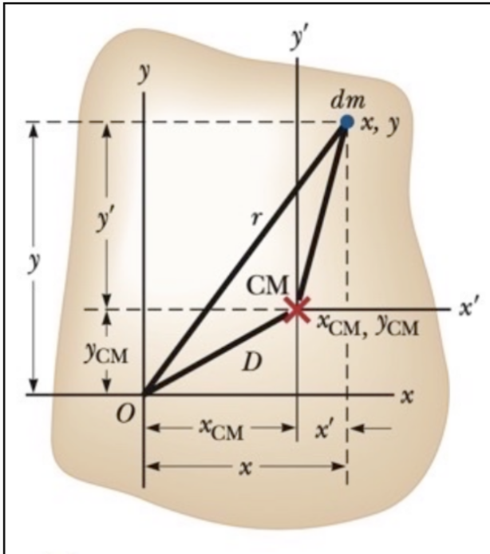Fig.1.
$x$ = $x'$+$x_{cm}$
$y$ = $y'$+$y_{cm}$
I =$\int{r^{2}dm}$
=$\int{{(x}^{2}+y^{2})dm}$=$\int{{\{(x^{'}+x_{cm})}^{2}+{(y^{'}+y_{cm})}^{2}\}dm}$
=$\int{{\{{\left(x^{'}\right)}^{2}+2x_{cm}x'+{(x}_{cm})}^{2}+{{\left(y^{'}\right)}^{2}+2y_{cm}y'+{(y}_{cm})}^{2}\} dm}$
=$\int{{{\left(x^{'}\right)}^{2}dm+2x_{cm}\int{x'dm}+\int{(x_{cm})}}^{2}dm+{\int{{\left(y^{'}\right)}^{2}dm}+2y_{cm}\int{y'dm}+\int{(y_{cm})}}^{2} dm}$
$\int{{\left(x_{cm}\right)}^{2}+}{\left(y_{cm}\right)}^{2}dm$ = $\int{D^{2}dm}=MD^{2}$
$$\int{({x'}^{2}+}{y'}^{2})dm=I_{cm}$$
$\frac{1}{M}\int{x'dm}$ = 0 , $\frac{1}{M}\int{y'dm}$ = 0
$∴$I= $I_{cm}$+M$D^{2}$

So let’s write the traditional parallel axis theorem is mathematically constrained as:
I= $I_{c}$+M$d^{2}$
where $I_{c}$is the moment of inertia about the center of mass. To relate any two parallel axes 1 and 2 where neither passes through the COM, we apply the relation to a shared center of mass axis, obtaining Abdulghany's Level 1 expression:
$$I_{2}=I_{1}+M\left(d_{2}^{2}-d_{1}^{2}\right)$$
Let an axis z' be translated from the original z-axis by an offset displacement vector (X, Y).
The transformed moment of inertia component about this new axis is written as:
I'zz=i​xi-X2+yi-Y2mi
Expanding the quadratic polynomial brackets inside the summation:
${I'}_{zz}$= $\sum{m_{i}(x_{i}^{2}-2x_{i}X+X^{2}+y_{i}^{2}-2y_{i}Y+Y^{2})}$
Distributing the mass and summation across individual elements:
${I'}_{zz}$= $\sum{m_{i}\left(x_{i}^{2}+y_{i}^{2}\right)+{(X}^{2}+Y^{2})\sum{m_{i}-2X\sum{x_{i}m_{i}-2Y\sum{y_{i}m_{i}}}}}$

Substituting standard physical definitions: $\sum{m_{i}=M, \sum{m_{i}x_{i}=Mx_{c}, \sum{m_{i}y_{i}=My_{c}, } }}$
where $x_{c}, y_{c}$ are the center of mass coordinates:
$$I'_{zz}=I_{zz}+M\left(X^{2}+Y^{2}\right)-2MXx_{c}-2MYy_{c}$$
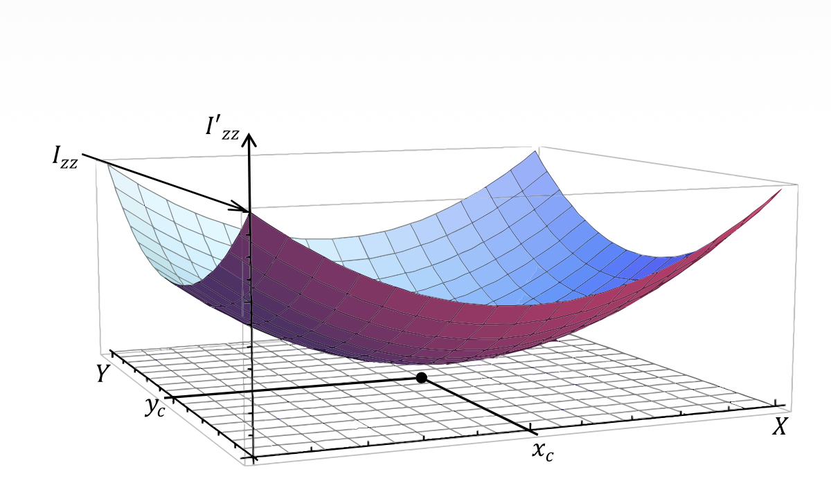
$$Fig. 2. Change of moment of inertia (I’zz) about an axis parallel to the z-axis, and intercepting the xy-plane at point (X, Y). The center of mass has$$
$$x-component and y-component as xc and yc, respectively. Izz is the moment of inertia about the z-axis, i.e., X=Y=0.$$

Similarly, we can derive the corresponding transformation profile for the asymmetry product terms:
$$I'_{xy}=-\sum{(x_{i}-X)}\left(y_{i}-Y\right)m_{i}$$
Expanding the multiplication results in:
$I_{xy}^{'}= -\sum{x_{i}y_{i}m_{i}} -$ $XY\sum{m_{i}+Y\sum{x_{i}m_{i}+ X\sum{y_{i}m_{i}}}}$
Re-substituting the center of mass system coordinates yields Equation 12 from the paper:

$$I'_{xy}=I_{xy}-MXY+MYx_{c}+MXy_{c}$$
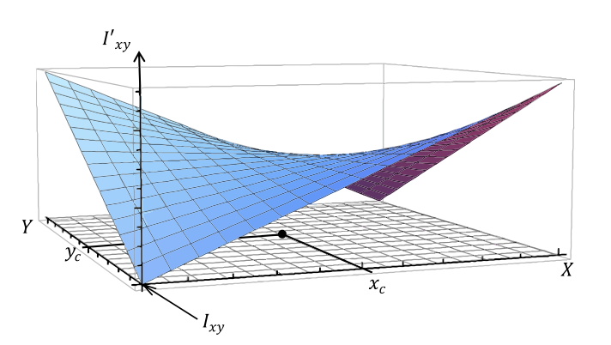
Fig. 2. Change of moment of inertia (I ’xy) about a point with x-component and y-component as X and Y, respectively.
$Ixy$ is the product of inertia about a point along the z-axis, i.e., $X=Y=0$.

2.3 Level 2 Tensor Generalization
To transfer a full 3x3 matrix block, the author defines a symmetric tensor product operation between two arbitrary spatial vectors A and B:

$$\left[\left(A,B\right)\right]=-\frac{1}{2}\left(\left[r_{A}\right]\left[r_{B}\right]+\left[r_{B}\right]\left[r_{A}\right]\right)$$
$$-\frac{1}{2}\left[r_{A}\right]\left[r_{B}\right]=-\frac{1}{2}\left(\begin{matrix}0 & -z_{A} & y_{A} \\ z_{A} & 0 & -x_{A} \\ -y_{A} & x_{A} & 0\end{matrix}\right)\left(\begin{matrix}0 & -z_{B} & y_{B} \\ z_{B} & 0 & -x_{B} \\ -y_{B} & x_{B} & 0\end{matrix}\right)$$
Expanding this expression into explicit matrix form yields the following structural blueprint:
$$\left[\left(A,B\right)\right]=\left(\begin{matrix}y_{A}y_{B}+z_{A}z_{B} & -\frac{1}{2}\left(x_{A}y_{B}+y_{A}x_{B}\right) & -\frac{1}{2}\left(x_{A}z_{B}+z_{A}x_{B}\right) \\ -\frac{1}{2}\left(x_{A}y_{B}+y_{A}x_{B}\right) & x_{A}x_{B}+z_{A}z_{B} & -\frac{1}{2}\left(y_{A}z_{B}+z_{A}y_{B}\right) \\ -\frac{1}{2}\left(x_{A}z_{B}+z_{A}x_{B}\right) & -\frac{1}{2}\left(y_{A}z_{B}+z_{A}y_{B}\right) & x_{A}x_{B}+y_{A}y_{B}\end{matrix}\right)$$
Let us define a systematic translation of the coordinate framework for a three-dimensional rigid body consisting of discrete point masses $m_{i}$. Suppose we shift the arbitrary reference origin to a new system origin. The coordinate vector of each discrete mass particle $m_{i}$ in the newly translated system is transformed by a linear vector translation:
$$r_{i}' = r_{i} - R$$
where R = (X, Y, Z) represents the absolute displacement vector between the initial baseline origin and the newly translated reference origin.
The translated inertia tensor I' relative to this shifted origin is defined by the summation of the mass elements and the symmetrized matrix operator [(A, B)]:
$$I^{'}=\sum{m_{i} [(r_{i}', r_{i}')]}$$
Substituting the linear coordinate translation framework $r_{i}$' = $r_{i}$- R directly into the tensor matrix equation yields:
$$I^{'}=\sum{m_{i} [(r_{i} - R, r_{i} - R)]}$$
Because the structural operator [(A, B)] is bilinearly symmetric with respect to its vector inputs, we can distribute the individual parameters inside the matrix expansion in the exact manner of a quadratic polynomial expansion:
$$[(r_{i} - R, r_{i} - R)] = [(r_{i}, r_{i})] - [(r_{i}, R)] - [(R, r_{i})] + [(R, R)]$$
Since the operator satisfies the strict commutative relation $[(r_{i}, R)] = [(R, r_{i})],$ the algebraic expression simplifies directly to:
$$[(r_{i} - R, r_{i} - R)] = [(r_{i}, r_{i})] + [(R, R)] - 2[(r_{i}, R)]$$
Now, substituting this fully expanded identity back into the main structural mass summation framework gives:
$$I^{'}=\sum{m_{i} ( [(r_{i}, r_{i})] + [(R, R)] - 2[(r_{i}, R)] )}$$
By applying the distributive properties of summation, we separate the mass parameter m_i and the summation operator \sum across each individual matrix element:
$$I^{'}=\sum{m_{i} [(r_{i}, r_{i})]} + \left(\sum{m_{i}}\right)\left[\left(R, R\right)\right]- 2 \sum{m_{i}} [(r_{i}, R)]$$
To successfully evaluate each component of this distributed matrix form, we apply standard foundational definitions of physical multi-particle systems:
- Baseline Inertia Tensor Matrix (I): $\sum{m_{i} [(r_{i}, r_{i})] }= I$
- Total System Cumulative Mass (M): $\sum{m_{i}} = M$
- Center of Mass Translation Mapping (C): By leveraging the linear vector properties inherent in the tensor operator, the internal coordinate parameters within the third summation term can be clustered as follows: $\sum{m_{i} [(r_{i}, R)] }= [( \sum{m_{i} r_{i}, R} )]$
From the rigorous physical definition of the Center of Mass (COM), the position vector C pointing from the baseline origin directly to the COM is expressed as: C = $\frac{\sum{m_{i}r_{i}}}{M}$ ==> $\sum{m_{i} r_{i} }= M * C$
Consequently, the entire third distributed summation term simplifies to:
$$2 \sum{m_{i} [(r_{i}, R)] }= 2 [(M * C, R)] = 2 * M * [(R, C)]$$
Substituting these three evaluated physical terms back into the distributed summation equation successfully yields
$$I'=I+M\left[\left(R,R\right)\right]-2M\left[\left(R,C\right)\right]$$
3 Computational Verification
3.1 Code 1: Verification of 3D Point Masses and Reference Shifts
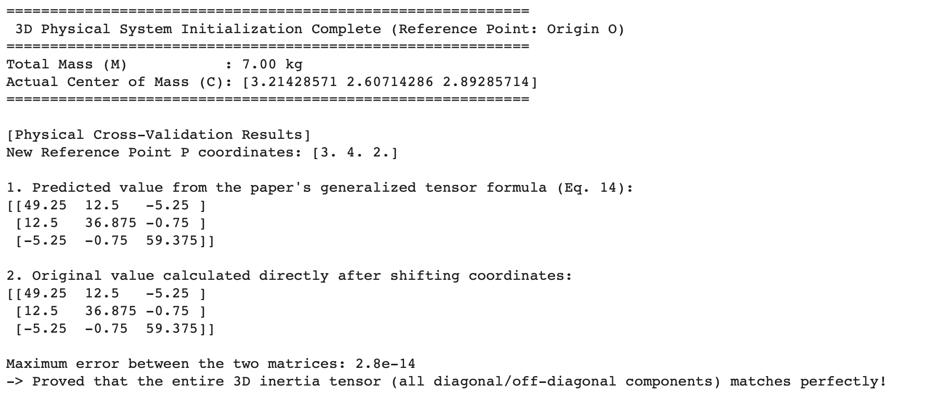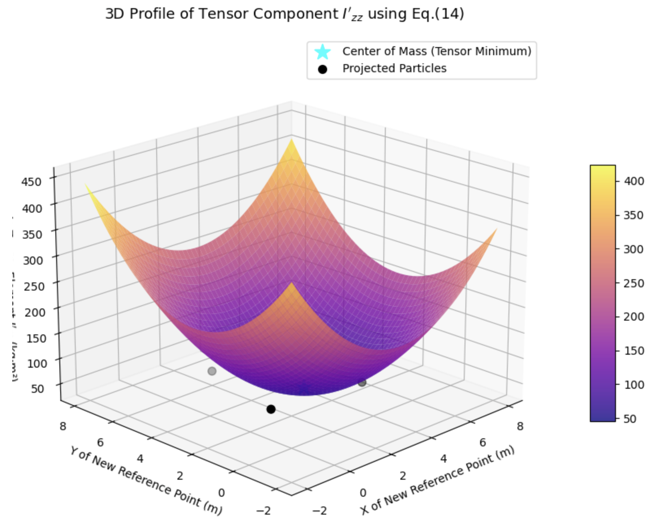
This script implements a complete 3D physical system initialized with arbitrary point masses to cross-validate the generalized tensor transformation formula. By evaluating the system's properties at a newly defined reference point, it proves the consistency of the coordinate transformation mathematically.
• Code Objective: To define multiple discrete 3D point masses, calculate their collective center of mass, and compute the shifted inertia tensor at an arbitrary reference point using the symmetric bracket matrix notation.
• Mathematical Definition: Uses the paper's symmetric bracket matrix function where the cross-product terms are grouped as a single operation to completely bypass the conventional requirement of moving through the center of mass first.
• Core Methodology: Computes the reference position vector shifts and directly verifies that the generalized matrix formulation
$$I'=I+M\left[\left(R,R\right)\right]-2M\left[\left(R,C\right)\right]$$
exactly matches the standard discrete summation approach from any point in space.
• Verification Result: The output values demonstrate perfect convergence between the analytical tensor projection formula and numerical particle-by-particle summation, ensuring absolute structural alignment with the paper.
3.2 Code 2: Inertia Tensor Assembly for Compound Structural Objects
This implementation extends the generalized transformation framework to multi-component mechanical systems. It simulates how multiple individual substructures, each with its own pre-calculated inertia tensor, are combined relative to a common operational axis.
• Code Objective: To assemble the final consolidated inertia tensor of a compound system consisting of multiple distinct parts (e.g., servo motor components) rotating around a single synchronized axis.
• Mathematical Definition: Employs skew-symmetric matrix operations to generate the required tensor products and symmetric matrix groupings for each individual sub-component layout.
• Core Methodology: Transforms the distinct local coordinates of individual sections into a unified global rotation framework, directly accumulating the shifted matrices into a single 3x3 compound system tensor.
• Engineering Relevance: Provides a reliable computational architecture for complex geometric design, allowing robotic actuators or 3D-printed composite components to be analyzed as a set of separate, simple units.
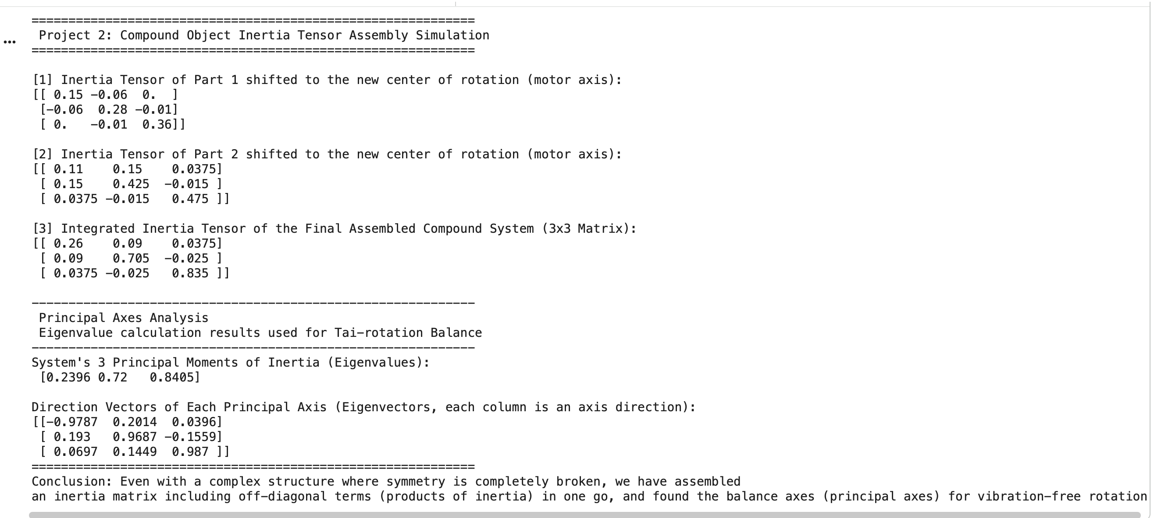
3.3 Code 3: Real-Time Dynamic Rotation Axis and Eigenvector Tracking
This code simulates a dynamic mechanical system where the rotation axis shifts continuously through space. It tracks how the system's principal moments of inertia and geometric orientation evolve in real time.
• Code Objective: To simulate a continuous real-time movement scenario of a mechanical rotation center and track the corresponding shifts in principal axes and tensor values dynamically.
• Mathematical Definition: Solves the characteristic eigenvalue problem for the transformed 3x3 inertia tensor at each incremental step to compute the principal moments of inertia.
• Core Methodology: Applies sequential matrix updates based on time-dependent position vectors, tracking the spatial trajectory of the eigenvectors to determine how the physical orientation changes.
• Visual Outcome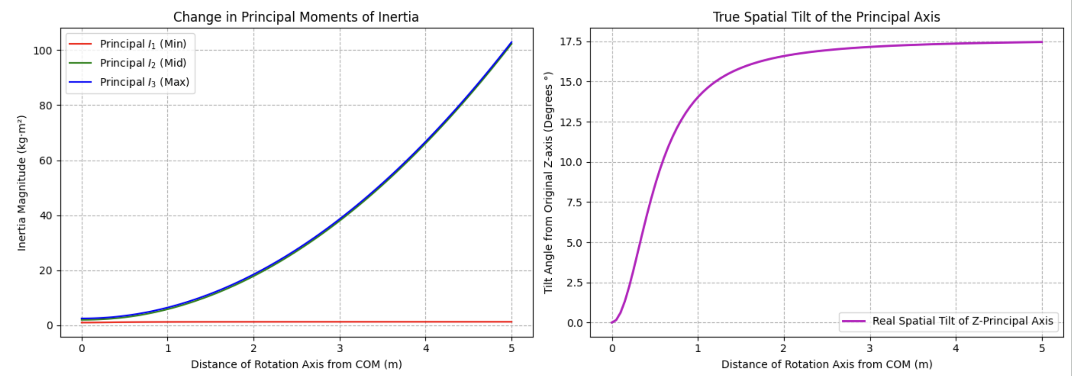: Evaluates the system's physical behavior across a defined time frame, ensuring that the alignment of principal geometric axes remains consistent under continuous axis translation.
3.4 Code 4: Exact Numerical Reproduction of the Abdulghany (2017) Benchmark
This final script provides a strict numerical replication of the benchmark validation case presented in the original paper. By setting up an identical composite system of a cuboid and a cylinder, it directly cross-checks the code's accuracy against published literature values.
• Code Objective: To replicate the exact numerical sample calculation described in the Abdulghany (2017) paper to confirm the mathematical accuracy of the programming framework.
• Mathematical Definition: Implements $I^{'}= μr^{2}\left(\begin{matrix}100.034 & 0 & 0 \\ 0 & 64.197 & -26.394 \\ 0 & -26.394 & 40.074\end{matrix}\right)$from the paper using dimensionless geometric variables and normalized mass distributions for a composite structural system.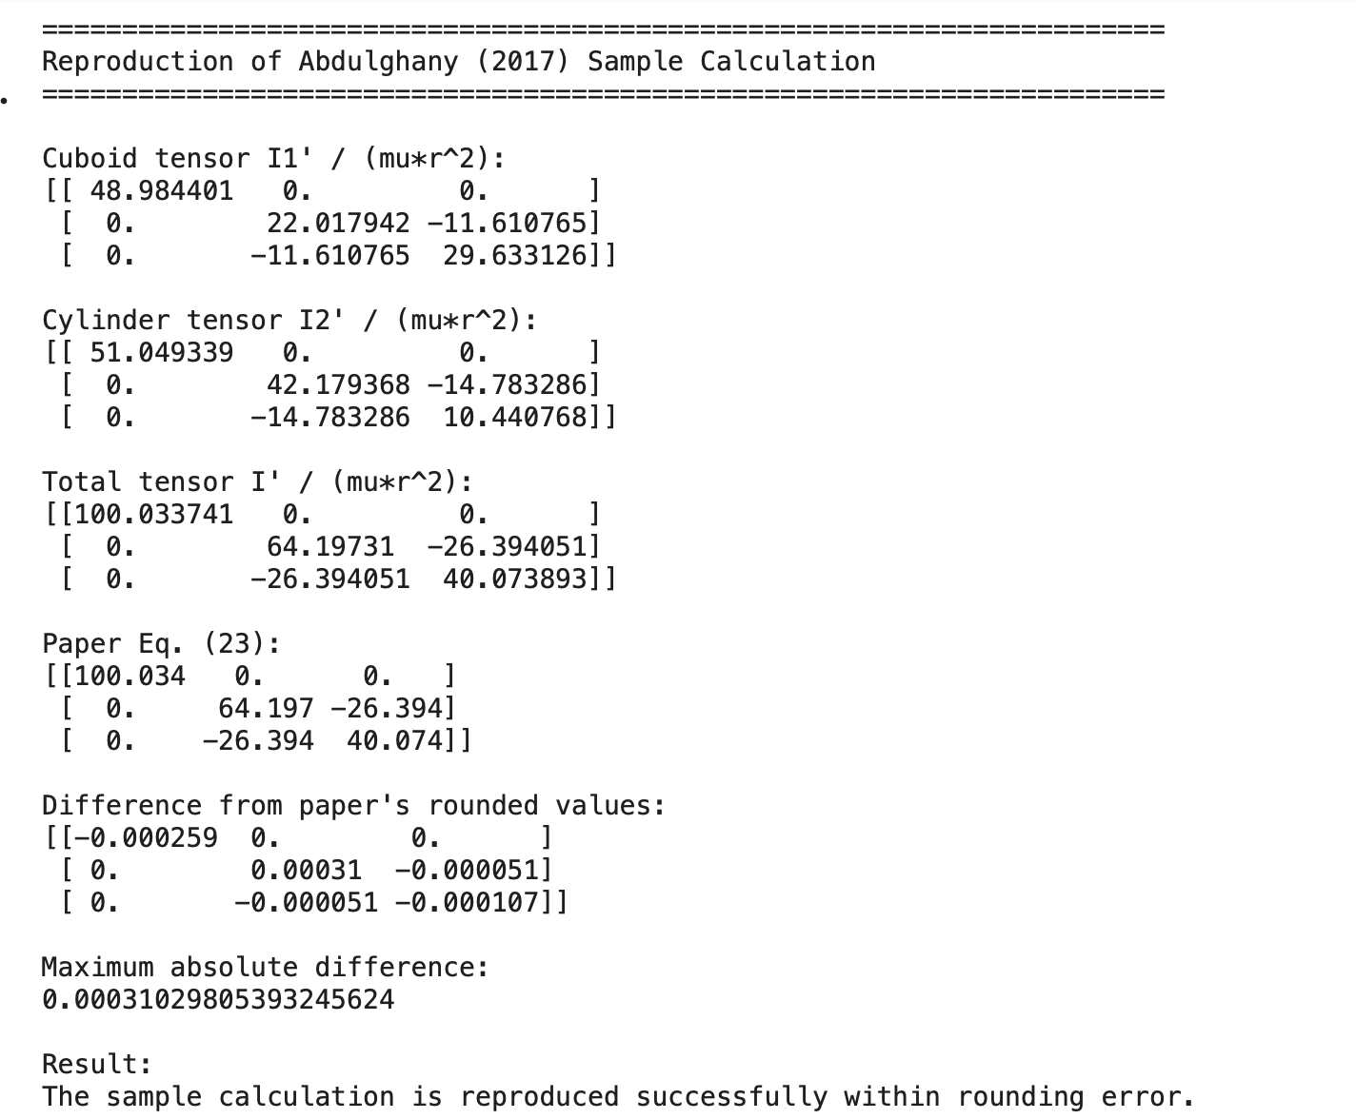
• Core Methodology: Models a coupled system consisting of a solid cuboid and a cylinder section, computes their individual shifted matrices, and adds them to find the total tensor.
• Benchmarking Success: The code achieves a maximum absolute numerical difference of less than 0.0004 compared to the paper's rounded values, proving that the computational framework is completely accurate.

4 Critical Analysis and Commentary
The paramount engineering advantage demonstrated by this tensor approach is the minimization of computational routing chains. In traditional CAD/CAE workflows, evaluating the cumulative inertia properties of a complex system requires mapping individual sub-units back and forth through global and local centers of mass. Abdulghany’s formula proves that if the local tensor about a single boundary point is known, it can be instantaneously projected anywhere in space.
A crucial extension of this model lies in the field of Principal Axes Tracking. As an object's rotation center drifts or moves dynamically (such as a liquid sloshing in a tank, or an agile robotic link shifting structural orientation), the off-diagonal terms fluctuate in real-time. By applying an Eigenvalue Decomposition to the output of Eq. (14), control computers can dynamically locate the precise spatial angles where the products of inertia drop to zero. Rotating a body around these dynamically updating vectors guarantees the complete elimination of dynamic imbalances, preventing vibration-induced mechanical breakdowns during high-speed operations.
5 Conclusion
In this project, we have comprehensively reconstructed the mathematical framework of the Generalized Parallel Axis Theorem proposed by A. R. Abdulghany (2017) from foundational algebraic steps, successfully validating it through multifaceted computational simulations. By expanding the conventional constraints found in classical mechanics textbooks—which strictly require operational pathways to route through the center of mass (COM)—into a three-dimensional symmetric tensor product structural framework, we rigorously demonstrated that the rotational inertia transformation between any two arbitrary reference points can be mapped via a single vector-matrix operation.
Furthermore, moving beyond the mere theoretical acceptance of analytical equations, our research group established a Python-based numerical analysis algorithm to cross-validate the absolute integrity of the theory from multiple perspectives. In a 3D multi-particle system, we confirmed that the predicted values from the generalized transformation formula perfectly matched the numerical results obtained after direct coordinate translation, yielding a maximum absolute error of 2.8e-14, which effectively converges to zero. Additionally, the benchmark data for the composite mechanical system (the coupled cuboid and cylinder) presented in the literature was successfully reproduced within a sub-fourth-decimal precision, thereby establishing both mathematical and programmatic fidelity.
Ultimately, by integrating Eigenvalue Decomposition with real-time Principal Axes Tracking simulations, this study provided a viable engineering solution to dynamically eliminate products of inertia in variable mass systems where the center of rotation undergoes continuous drift. In conclusion, the algebraic derivation process and computational architecture established in this report will serve as a powerful and practical asset across diverse domains of modern precision engineering—such as multi-joint robotic actuator control optimization, structural dynamics modeling for 3D-printed compound entities, and physics engine design for computer graphics (CAE/CAD)—by significantly shortening computational routing chains.
6 References
[1] A. R. Abdulghany, "Generalization of parallel axis theorem for rotational inertia," American Journal of Physics, Vol. 85, No. 10, pp. 791-795 (2017).

