Feedback-Driven Tool Use for CSV Analysis Agents
Does dataset-aware validation help an LLM recover from wrong tool calls?
COMP5511 Artificial Intelligence Concepts — Final Project Report
Student name: [Your official English name]
Student ID: [Your student ID]
November 2026

1. Motivation
Large language models (LLMs) become agents when they can call tools: they turn a user goal into actions, observe the results and decide what to do next [1, 2, 3]. For data analysis this is attractive. A student or analyst with little programming experience can upload a CSV file and ask a question in plain English, while trusted code performs every calculation. The weak point is the interface between the model and the tools. The model must name columns, choose operations and fill structured arguments, and it often chooses something that sounds right but does not exist in the data: a user who asks about “gender” may get a call that groups by gender when the column is named Sex. Such a call either fails, ending the task, or, worse, runs and returns a wrong answer that still reads convincingly.
This project builds a tool-using CSV analysis agent and studies one capability in it: recovery from wrong tool arguments. The research question is whether dataset-aware validation with structured error feedback helps the model repair a failed call, compared with stopping at the first error or returning only the raw error message, and what this costs in time and model usage. The intended users are students and other non-programmers doing exploratory analysis, who cannot easily spot a wrong column or an unsuitable statistic.

2. Description

2.1 Agent workflow and tools
The agent answers one question about one uploaded CSV. The user’s question and a compact data summary (column names, types, missing counts, category samples and three preview rows) form the first message. The model, DeepSeek through its OpenAI-compatible tool-calling interface [5], then chooses among three predefined tools, and local Python code executes them:
- inspect_dataset returns the data summary again.
- aggregate_data applies AND-combined filters (eq, ne, gt, ge, lt, le, in), optional grouping, and the metrics row_count, count, sum and mean, with optional sorting. It returns a result_id, the filtered row count and the result rows.
- plot_result draws a bar or line chart from an existing result_id, so chart values can only come from computed results.
The model never executes code and never supplies numbers; all statistics come from Python. This follows the ReAct pattern of interleaving reasoning and actions [2], restricted to a whitelist for safety. The final answer is short English text that cites the result_ids it used, displayed with the table, the chart and an action log of every observable call.

2.2 Three ways to handle a failed call
All three modes share the model, system prompt, tool descriptions, column notes and budgets. They differ only after a tool call fails:
- baseline: the first failed call ends the task with status tool_error.
- raw_retry (ablation): the error code and the tool’s raw message are returned to the model, which may revise its call in up to two repair rounds.
- proposed: before execution, a validator checks the call against the current dataset: do the columns exist, are sum and mean applied to numeric columns, do filter values have the column’s type, do category values occur in the data, does the result_id belong to the current run, and are the plot fields in that result. A failed check returns structured feedback with the failing field, the requested value, a message, and context such as the available columns, up to five close matches, valid category values or the numeric columns. The program never rewrites the call; the model decides how to revise it, within the same two repair rounds.
The raw_retry mode was added beyond the proposal’s baseline to separate two effects that a stop-on-error baseline would mix: the benefit of being allowed to retry at all, and the benefit of dataset-aware feedback. Iterative self-correction from feedback is known to help LLM agents [4, 6]; the question here is how much the content of the feedback matters.

2.3 Controller algorithm and budgets
Algorithm 1 shows the controller. T counts attempted tool calls (failures count), at most 8 per task. R counts repair rounds: the first model response after a failure is one round, whatever it does, at most 2. Further limits are 12 model requests, a 60-second HTTP timeout with two network retries (not counted as repairs), and 180 seconds per task. When T reaches 8, one final request without tools lets the model write its answer.
Algorithm 1. Agent controller (mode m ∈ {baseline, raw_retry, proposed})
messages ← [system prompt, question + summary(D)]
T ← 0; R ← 0; pending ← false
loop
if pending then R ← R + 1 # a repair round
response ← LLM(messages, tools if T < 8 else none)
if response has no tool call then
return answer (status unresolved if pending, else completed)
for each call c in response, in order do
if an earlier call of this response failed or T = 8 then
reply "skipped" to c; continue
T ← T + 1
if m = proposed and Validate(c, D) finds an issue then
result ← structured feedback(issue)
else result ← Run(c) # shared basic checks
append result to messages
if a call failed then
if m = baseline then return tool_error
if R = 2 then return repair_exhausted
pending ← true
if T = 8 then make one request without tools and return

3. Implementation
The application is written in Python 3.12 with Streamlit for the interface, Pandas for reading the reference data [7], Matplotlib for charts, Pydantic for argument models and httpx for the API. No agent framework is used, so that every counter and message in the loop is explicit. Table 1 lists the modules and their key functions.
Module | Key functions and variables
datasets.py | load_csv: strict UTF-8 parsing, only empty fields are missing, logical types numeric / text / unknown; inspect_dataset
analysis.py | aggregate_data: filters, groups (missing keys kept), row_count / count / sum / mean, sorting; explicit Python for fixed missing-value rules
plotting.py, state.py | plot_result; AnalysisSession binds every result_id and chart_id to the session, dataset and run
contracts.py, tools.py | Pydantic models AggregateRequest and PlotRequest; TOOL_SPECS (JSON schemas); dispatch(name, raw_json, session) with the envelope {success, data, error, warnings}
validation.py | validate(name, raw_json, session) → issue or None; close_matches; feedback_envelope
llm.py | DeepSeekClient.chat (thinking disabled, bounded network retries, usage); FakeLLM for offline tests
controller.py | run_agent(question, session, llm, AgentConfig(mode)); RunResult with status, T, R, model_requests, tokens, latency, steps
evaluation/ | tasks.json, references.py, scoring.py, faults.py, runner.py, metrics.py, figures.py
Table 1. Modules and key functions.
Every run is written as one JSON line containing the observable steps (tool, arguments, success or error code, T, R), the result tables and chart metadata, token usage and latency, so all reported numbers can be recomputed. The API key is read from a local .env file and never logged. Offline tests with a scripted FakeLLM cover the counting rules (first-error stop, skipped calls, the 8-call budget, bounded repairs, inspect-only repair rounds) and an oracle cross-check described below.

4. Data
Two public datasets were chosen because they combine the difficulties the validator targets. The Titanic training set [8] has 891 rows and 12 columns with mixed types and missing values (Age 177, Cabin 687, Embarked 2), and its column names differ from everyday words (Sex, Pclass, SibSp, Parch). The UCI Bike Sharing daily set [9] has 731 rows and 16 columns without missing values, many coded columns (season 1–4, yr 0/1, weathersit 1–4, weekday 0–6), normalised measurements (temp, hum) and a date column stored as text. A short column note from each dataset’s documentation, for example “yr: 0 = 2011, 1 = 2012”, is given to every mode.
For each dataset I wrote 20 formal tasks: 4 filter-and-statistic questions, 6 grouped statistics, 4 comparisons, 3 bar charts and 3 line charts (40 in total). Many are phrased in everyday words rather than column names (“total rentals”, “humidity”, “gender”). Comparison questions ask the model to start its answer with the winning group. Ten further development tasks were used only to tune the prompt and scoring and for a smoke test; they are excluded from the results. Reference answers are computed by an independent Pandas script that imports none of the agent’s code, with the same documented missing-value rules. As a check of both implementations, an oracle that issues the ideal calls for all 50 tasks reproduced every reference answer.
Ten fault cases test recovery directly (Table 2). Each is bound to one formal task; the injector replaces one field in the model’s first call of the target tool, identically in every mode, before validation and execution, and records the values before and after. Injection adds no model request.
Fault | Task | Injected field | Error
F01 | T11 | group_by | unknown column gender
F02 | T05 | metric column | wrong case: survived
F03 | T06 | metric column | mean of the text column Name
F04 | T02 | filter value | category not present: Female (legal, returns 0 rows)
F05 | T13 | filter column | unknown column Class
F06 | B07 | group_by | unknown column month
F07 | B05 | metric column | unknown column rentals
F08 | B03 | metric column | sum of the text date column dteday
F09 | B04 | filter value | type mismatch: weathersit = "rain"
F10 | B15 | plot y field | field total not in the result
Table 2. Injected fault cases.

5. Experiment Setting, Baselines, and Performance

5.1 Setting
The model was deepseek-flash (DeepSeek-V4.1-Flash) with thinking mode disabled and temperature 0, the identifier and settings having been checked against the official documentation on 20 October 2026. Each of the 40 formal tasks was run three times in each mode (360 runs) and each fault three times in each mode (90 runs). The three modes were interleaved per task and repeat, with a fresh session for every run. A run succeeds only if its status is completed, a result table it produced (those cited in the answer, if any) has the requested grouping and values within an absolute tolerance of 1e-6, the requested chart is drawn from a matching result with the right type, axes and non-empty labels, and, for comparisons, the winning group is named before any losing group. Successful tool execution alone is never counted as success. Recovery rate is the success rate on fault runs. Paired differences use the exact McNemar test [10] over (task or fault, repeat) pairs.

5.2 Results
Measure | baseline | raw_retry | proposed
Natural task success (120 runs) | 100.0% | 100.0% | 100.0%
Fault recovery (30 runs) | 10.0% | 93.3% | 100.0%
Faults: mean tool calls | 1.20 | 2.87 | 2.10
Faults: mean model requests | 1.30 | 3.87 | 3.10
Faults: mean tokens per run | 3,817 | 13,174 | 9,814
Faults: median latency (s) | 2.75 | 10.82 | 8.14
Natural: mean tokens per run | 7,136 | 7,169 | 7,132
Natural: median latency (s) | 5.50 | 5.52 | 5.56
Table 3. Main results.
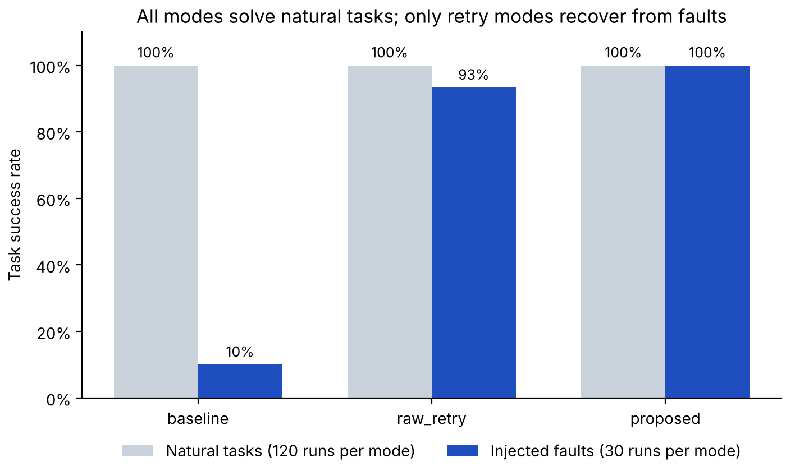
Figure 1. Natural task success and recovery on injected faults per mode.
On natural tasks all three modes reached 100%. In 360 runs the model made only one argument error (task B19 in raw_retry: a percent chart without unit = "fraction", repaired in one round). On injected faults the modes separate clearly. Baseline recovered only 3 of 30 runs, all from F04. Returning the raw error raised recovery to 28 of 30, and proposed recovered all 30. Both retry modes differ significantly from baseline (25 and 27 discordant pairs, p = 6.0e-8 and 1.5e-8); proposed versus raw_retry differs in only two runs (p = 0.5).
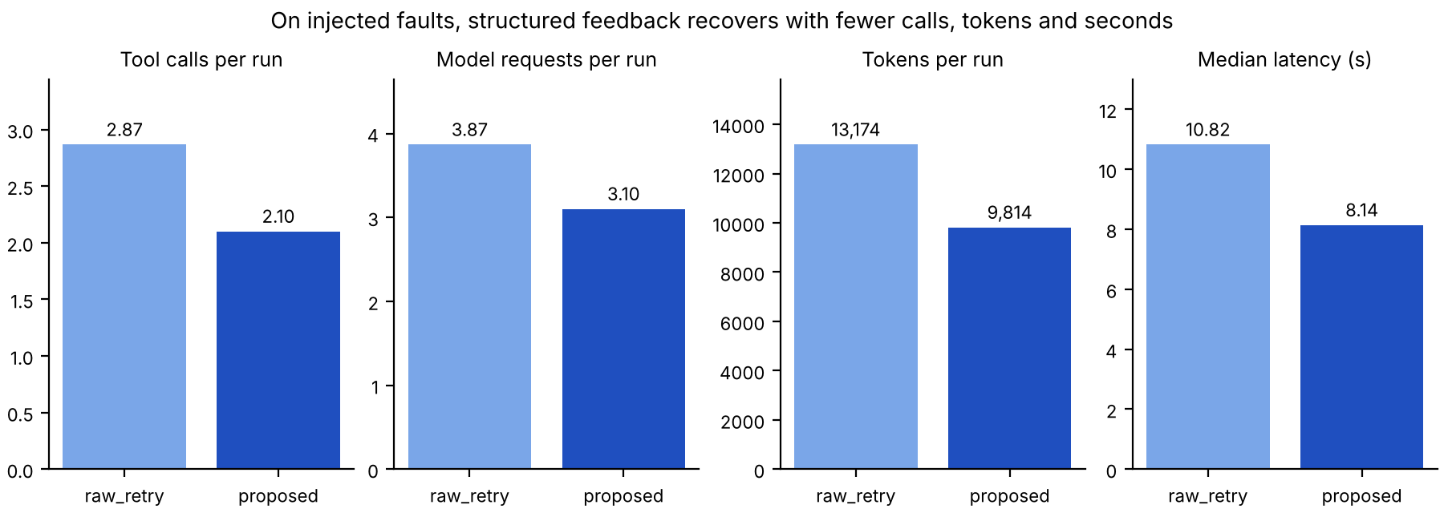
Figure 2. Cost of recovery on injected faults (raw_retry versus proposed).
The clearer advantage of structured feedback is efficiency (Figure 2). Every proposed fault run recovered in exactly one repair round, with 27% fewer tool calls, 20% fewer model requests, 26% fewer tokens and 25% lower median latency than raw_retry. When nothing goes wrong, validation adds no measurable cost: tokens and latency on natural tasks are equal across modes. All 450 runs together used 3.24 million prompt and 0.13 million completion tokens, about USD 0.6–1.1 at the list price on the run date.
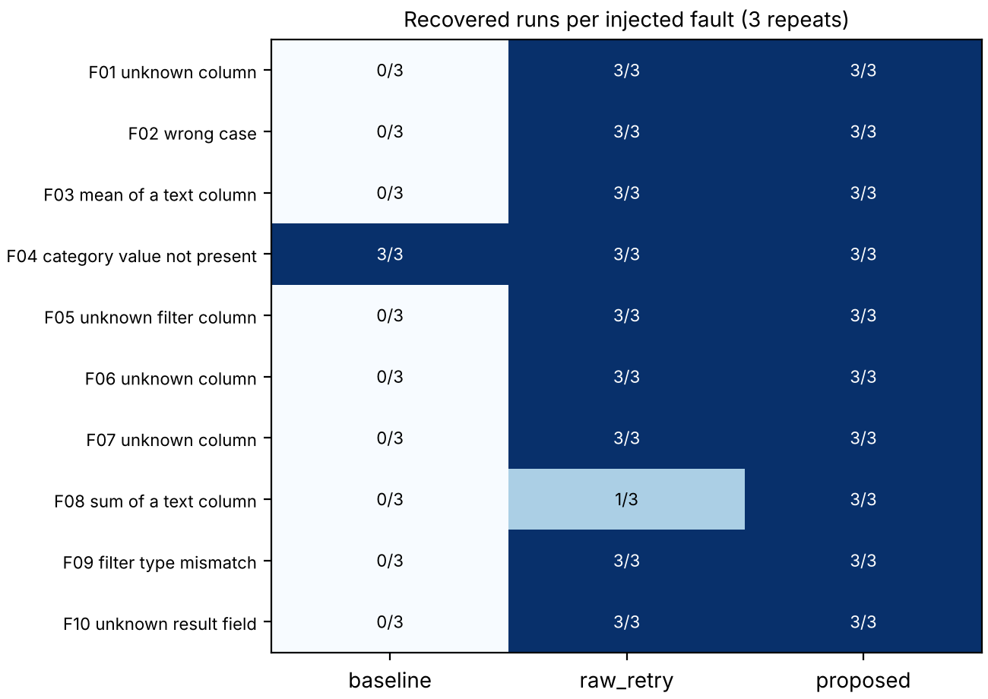
Figure 3. Recovered runs per fault and mode (out of 3).

5.3 Examples
F08, sum of a text column. raw_retry received “sum and mean require a known numeric column”, which does not say which columns are numeric. In two of three runs the model then tried to filter the text date column with dteday < "2012-01-01", failed again, used its second repair, and finally answered from a table grouped by year. The number it reported (1,243,103) was correct, but the cited table did not match the requested filtered total, so the frozen scoring rule counts these runs as failures. With proposed, the feedback “'sum' needs a numeric column, but 'dteday' is text” and the list of numeric columns led every run directly to sum of cnt with the filter yr = 0.
F04, a silent fault. Sex = "Female" is a legal filter that matches no rows, so the shared tool returns an empty result with a warning instead of an error, and even baseline continues. In all three baseline runs the model noticed the empty result and re-queried with "female". Proposed rejects the value before execution and lists the valid values female and male. Without the model’s own attentiveness, this kind of fault would yield a confident wrong answer.

6. Discussions
The results support a nuanced answer to the research question. First, allowing the agent to repair is the largest single improvement: baseline wastes tasks that are easy to recover. Second, dataset-aware feedback makes recovery reliable and noticeably cheaper, because it states exactly which field is wrong and what valid alternatives exist, so the model fixes the call in one round instead of exploring. For simple faults such as a misspelt column, a capable model can often guess the right name from a raw error, which explains the small success gap between raw_retry and proposed. The feedback matters most when the raw message lacks the information needed for the fix, as in F08, or when a fault produces no error at all, as in F04.
The natural tasks did not separate the modes. With exact column names, a data summary and column notes in the prompt, the model almost never produced invalid arguments. This is good news for the agent but means the natural benchmark was too easy for this purpose; the comparison therefore rests on the injected faults, which are artificial and placed only in the first call of one tool. Other limitations are the use of one model, two datasets and ten hand-designed faults, and a strict scoring rule: under a lenient rule that accepts any table containing the correct value, raw_retry would also recover 30 of 30. A validator cannot detect a call that is valid but answers the wrong question, such as averaging the wrong column; that is semantic correctness, which only independent reference answers caught here.
Possible improvements are harder natural tasks without column notes or with ambiguous wording, evaluation across several models including weaker ones where argument errors are more frequent, faults injected at later steps, and semantic checks such as confirming with the user when a filter returns zero rows. The main insight is practical: an agent should be allowed to repair its own tool calls, and the error messages it receives should be written for it, with the data context needed to fix the call, because this costs nothing when the call is right and saves time and tokens when it is wrong.

Contribution and Acknowledgements
[Describe your own contribution here, for example: the research question and experiment design, the validator and feedback protocol, the 40 tasks and 10 fault cases, review of all generated code, running the experiments and the analysis.] The code was developed with AI assistance (OpenAI Codex and Anthropic Claude), and this report was drafted with AI assistance and then revised by the author; all experimental numbers come from the logged runs. External resources: the DeepSeek API, Python, Streamlit, Pandas, Matplotlib, Pydantic and httpx, and the Kaggle Titanic and UCI Bike Sharing datasets.

References
[1] L. Ning et al., “A Survey of WebAgents: Towards Next-Generation AI Agents for Web Automation with Large Foundation Models,” arXiv:2503.23350, 2025.
[2] S. Yao et al., “ReAct: Synergizing Reasoning and Acting in Language Models,” in Proc. ICLR, 2023.
[3] T. Schick et al., “Toolformer: Language Models Can Teach Themselves to Use Tools,” in Proc. NeurIPS, 2023.
[4] N. Shinn et al., “Reflexion: Language Agents with Verbal Reinforcement Learning,” in Proc. NeurIPS, 2023.
[5] DeepSeek, “DeepSeek API Documentation: Tool Calls; Thinking Mode; Models & Pricing,” https://api-docs.deepseek.com/, accessed 20 Oct. 2026.
[6] A. Madaan et al., “Self-Refine: Iterative Refinement with Self-Feedback,” in Proc. NeurIPS, 2023.
[7] W. McKinney, “Data Structures for Statistical Computing in Python,” in Proc. 9th Python in Science Conf., 2010, pp. 56–61.
[8] Kaggle, “Titanic — Machine Learning from Disaster,” https://www.kaggle.com/competitions/titanic/data.
[9] H. Fanaee-T, “Bike Sharing,” UCI Machine Learning Repository, 2013, doi:10.24432/C5W894.
[10] Q. McNemar, “Note on the Sampling Error of the Difference Between Correlated Proportions or Percentages,” Psychometrika, vol. 12, no. 2, pp. 153–157, 1947.

