**Simple tic-tac-toe Game**

SHAOZHUO_LI

[40413818@live.napier.ac.uk](mailto:40413818@live.napier.ac.uk)

Edinburgh Napier University – Algorithms and Data Structures (SET08122)

**Abstract**

Algorithms and Data Structures is the course that taught me the structures of data and so many data structures and how to achieve these structures with C language. This report aims to introduce the coursework that writing one tic-tac-toe game for two players and some advantages and enhancements of my work. To be more specific, this report will show my work on data structures, function I achieved, the idea of my game and some codes of it.

1. **Introduction**

Tic-tac-toe or noughts and crosses or Xs and Os, is a game for two players playing on the paper with pencils, X and O, who take turns making spaces in a 3 x 3 grid. The player who places three marks of X or O in a horizontal, vertical or a diagonal row wins it successfully (Reference 1 ). That is the rule and the playing way of it. The design structure of my game is same as the traditional way, so this part will focus on the function and data structure of my work. I have designed five functions, compute, initialboardbuild, printboard, build and main to achieve this game. The functions I achieved are that two-players-game, show each step of every player and record the information of win and lose of each game. The structures I used is cycle structure to make the game working and the data structure is two-dimensional array, which is used to contain the data.

1. **Design**

In this part, I will introduce my game detailly. First of all, the design idea is important. When playing the tic-tac-toe game, the rules is necessary, for example, how to identify the winner, so the select statement is the first thing I recommended. The reason why I choose the switch structure is that there are so many conditions one player wins, use if structure is so complex and there are so many codes, while the switch statement is simple. Then is thinking about all the conditions identify winner, like I mentioned in the introduction part. Next, is making decisions about how to structure the board and contain the data. Array is absolutely fits this role, we can use two-dimensional array to structure the board and use the number to set the position of each place of the board. When playing the game, players typed number 1 to 9 to take place. Before playing the game, I need to ‘clean ’ the board in order to empty the place. And print board after players take place so that I can record the details of every game. The last but not last, I need to build one main function to make the game working. The first function I set is compute, which is the conditions of players win this game, I used switch statement to list all the conditions, whenever these conditions achieved, this game will be end. Next is initialboardbuild, it is used to ‘clear’ the board at the beginning of this game. Then is the printboard, after player do the move, the board will be printed. After then is build, it is used to record the move of each player and print the board as a record. The last is main function, it is the total function to make all functions work together as one part. And the process of run the game will be showed in the references part. And the text data is that player 1 moves 1, 5, 9, player 2 moves 3, 6.

1. **Enhancements**

At this work, I just achieved the basic function of tic-tac-toe, which means it can work or can be played. However, there are more good functions I did not achieved, for example, replay, undo and redo. The main reason is that I am not good at using lists and structs and this is my first time to write one game program, although I have the idea of how to make it, the skills I masked cannot implement all my goals and I need to learn about the data structures. What make happy is that I used all I learned and did my best to implement this game. Although my game runs correctly, there are still many mistakes need to correct in my program.

1. **Critical Evaluation**

During the process of writing code, I also learned from the online materials that the process of how to make tic-tac-toe game, and this website will show in the references(Reference 2). In this process, I tried to deal problems by myself, it is good solution and learn by myself makes me have a higher understand of how to write a good script. I also did some good works, for instance, I replaced ‘X’ and ‘O’ with ‘number 1’ and ‘number 2’. However, I also find some problems of myself, for example, the thinking models of dealing problems is simple, cannot think from different ways. The thing I did not good is that cannot implement the replay function, which is the only problem I had no idea. And another problem is that the code is a little bit long, I know use the data structure can make code less, but I am not able to do that.

1. **Personal Evaluation**

In this task, I reviewed how to check the size of data type and learned how to do some operations with these data structures, such as structs, lists and so on and learned many kinds of searching function with C program language. Writing codes is actually a good way to get the most critic evaluation of studying performance. I also realized knowledge that I did not have a good mast, I need to learn more about it and do more exercises. When I faced challenges, I tried to solve by myself, if I still cannot overcome it, I searched it online after that I asked my friends for help, fortunately, I solved it at the end. In conclusion, I feel I performed not bad.

1. **References**

Then diagram of the process of game running.

Step 1

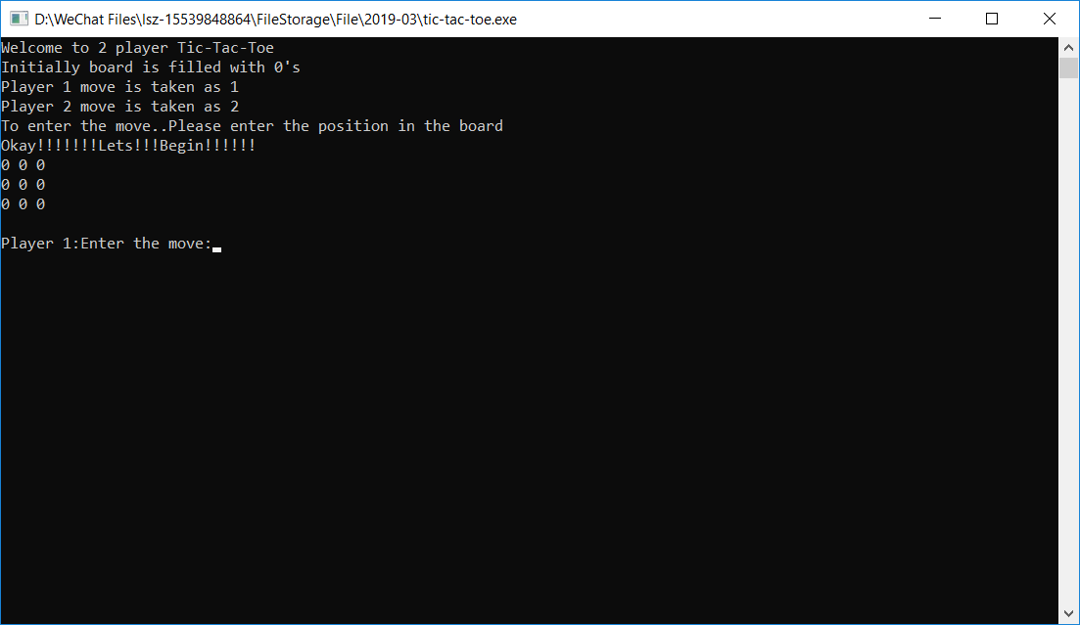 (The start page)

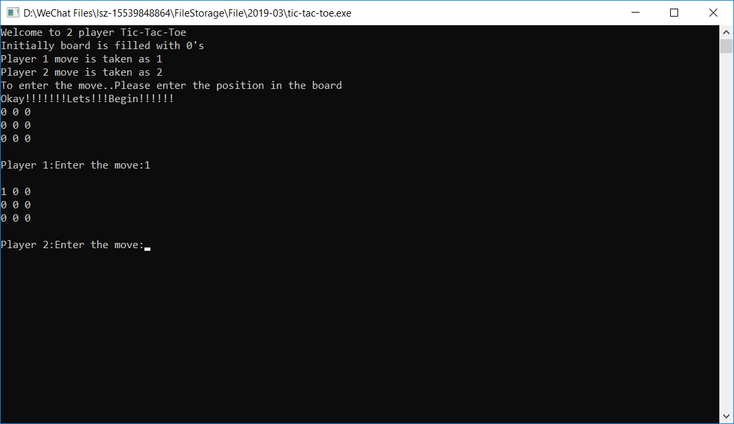(Player 1 moves 1)

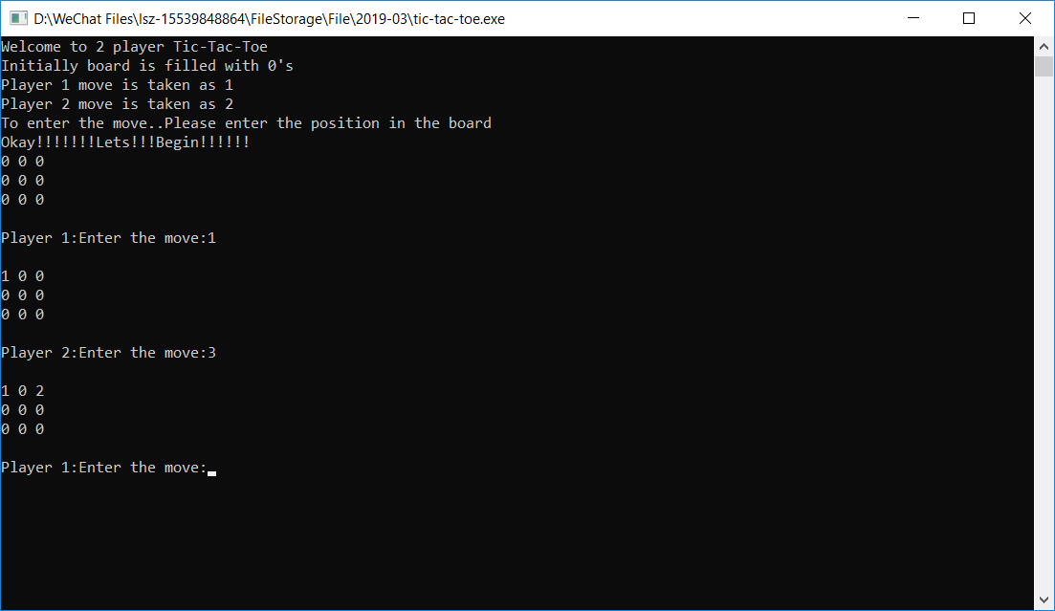(Player 2 moves 3)

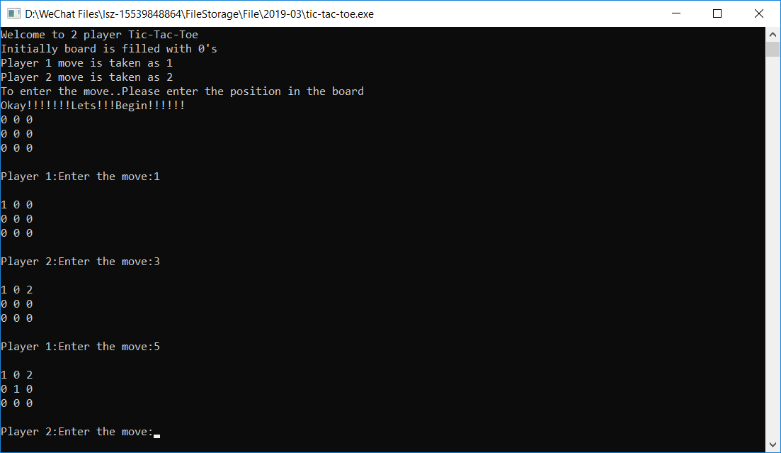(Player 1 moves 5)

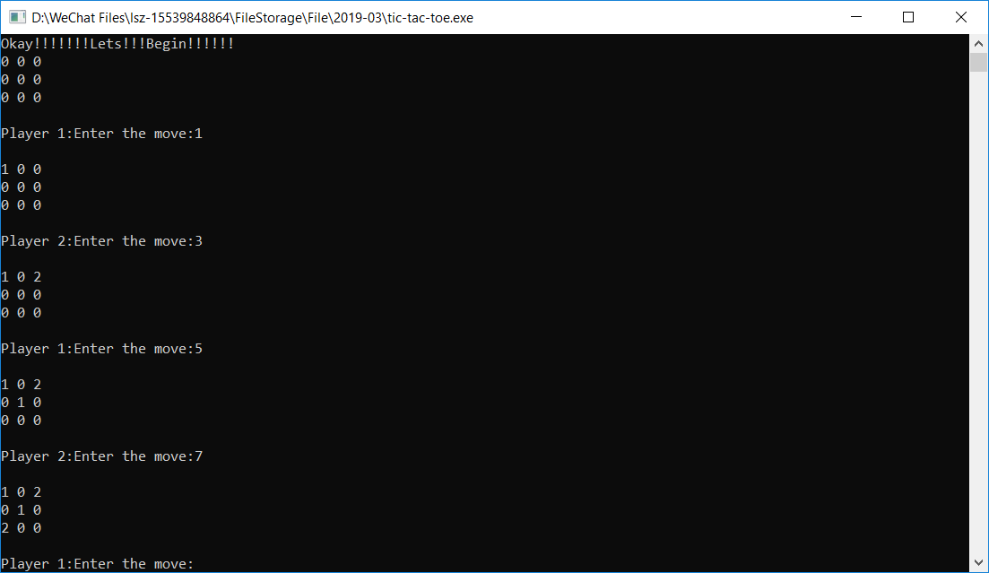(Player 2 moves 7)

After player 1 moves 9, this game finished and broke.

1. “Tic-tac-toe” Wikipedia, 20 March 2019 <https://en.wikipedia.org/wiki/Tic-tac-toe>
2. “用C语言完成：三子棋（Finishing tic-tac-toe with c programme ）” 22 October 2017 https://www.cnblogs.com/xiefei777/p/7710856.html