Project Address: https://github.com/kalyan02/NanoCMS
After downloading the compressed file, extracting it will yield the following files.
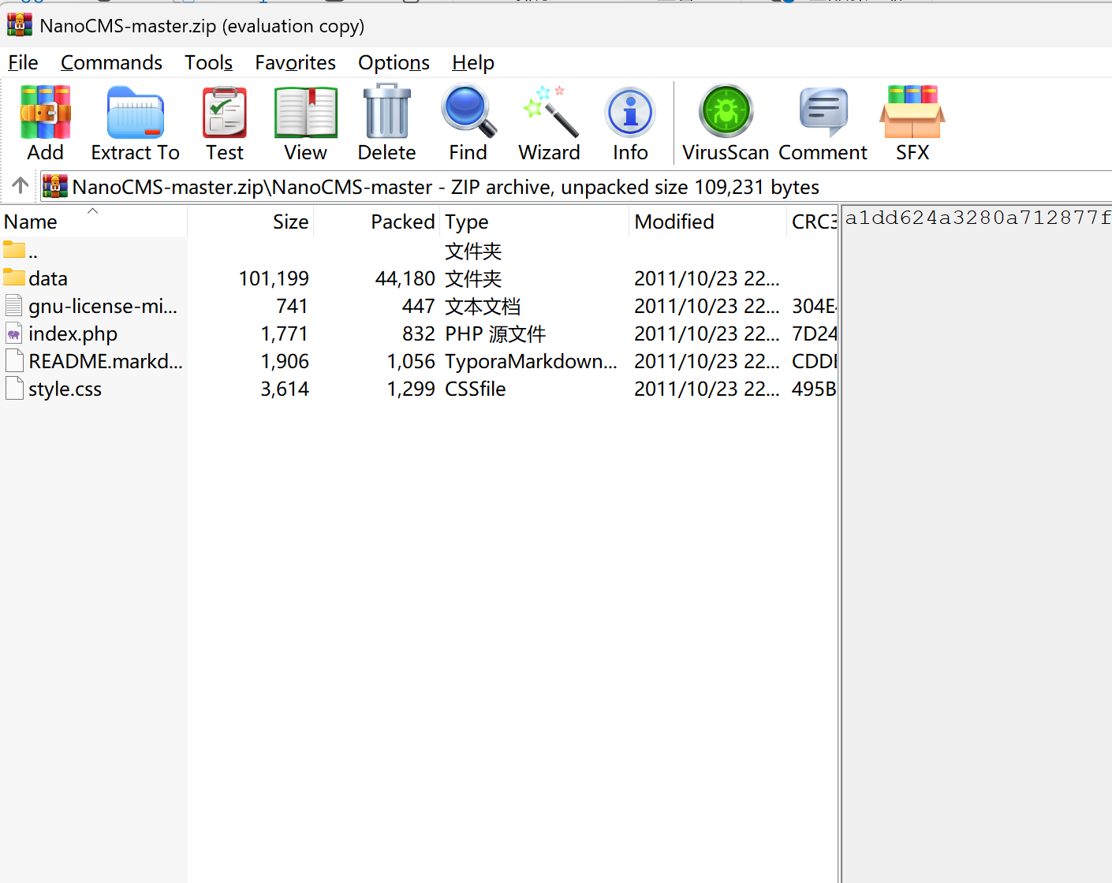
The data folder contains the following files.
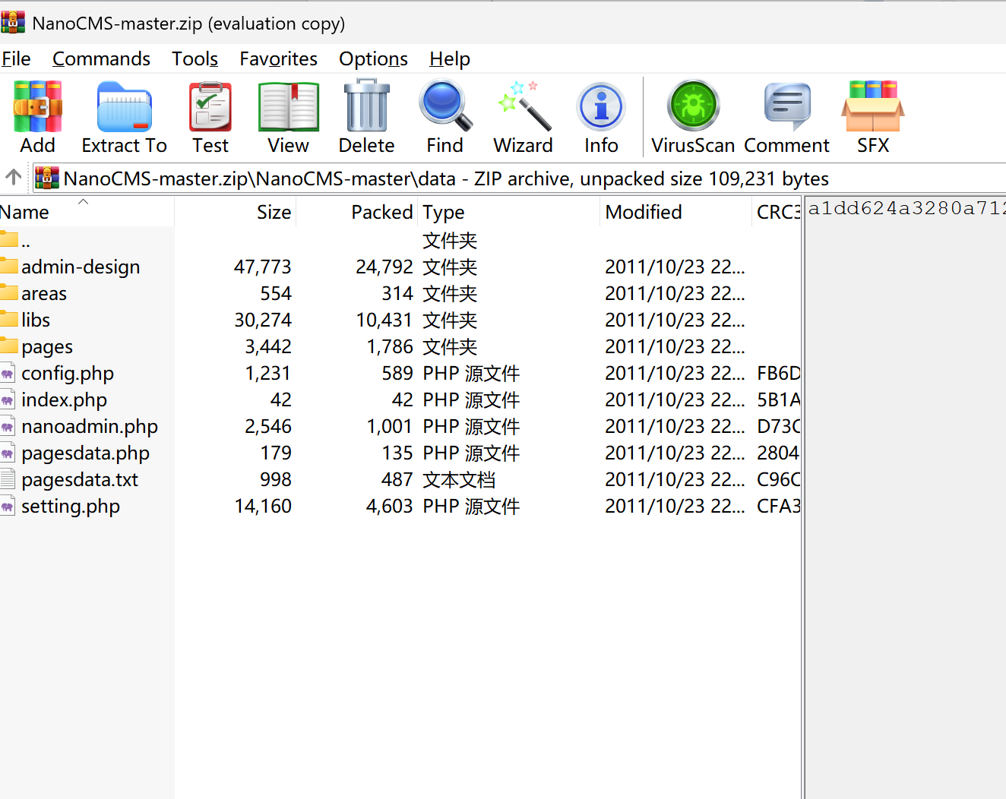
Place the extracted folder named NanoCMS into the www folder in the root directory of phpstudy_pro.
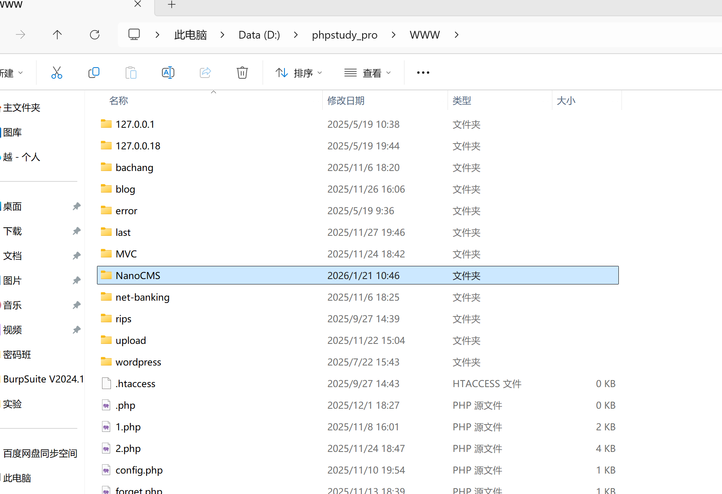
Nano CMS is the tiniest CMS you can find around. It is fully file-based and does not use a database, has extremely easy, simple, and friendly user interface.

Once the above environment is configured, you can successfully access the project.
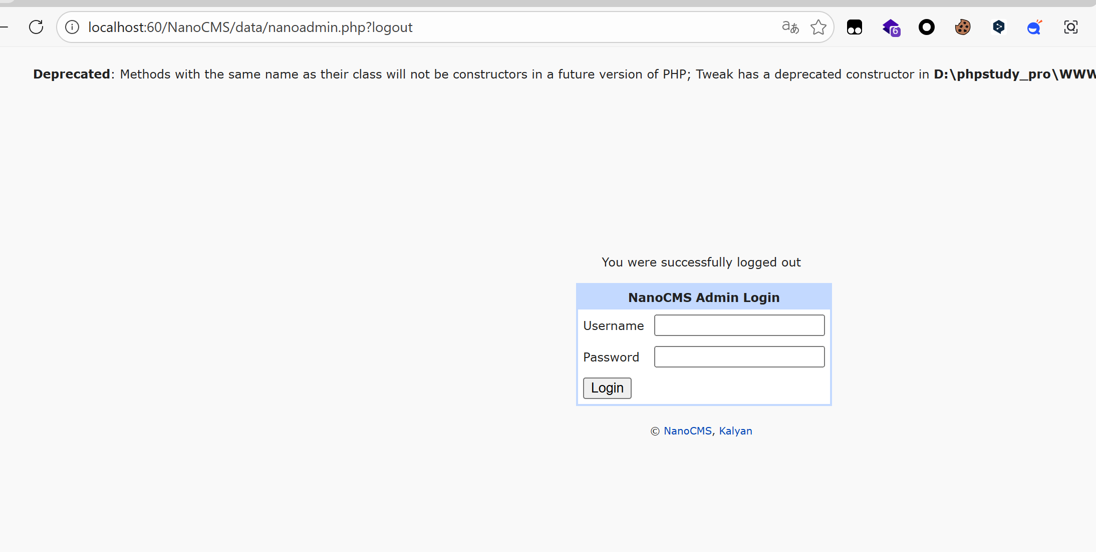
Based on the existing user data
- Username: admin
- Password: demo
You can log in successfully.
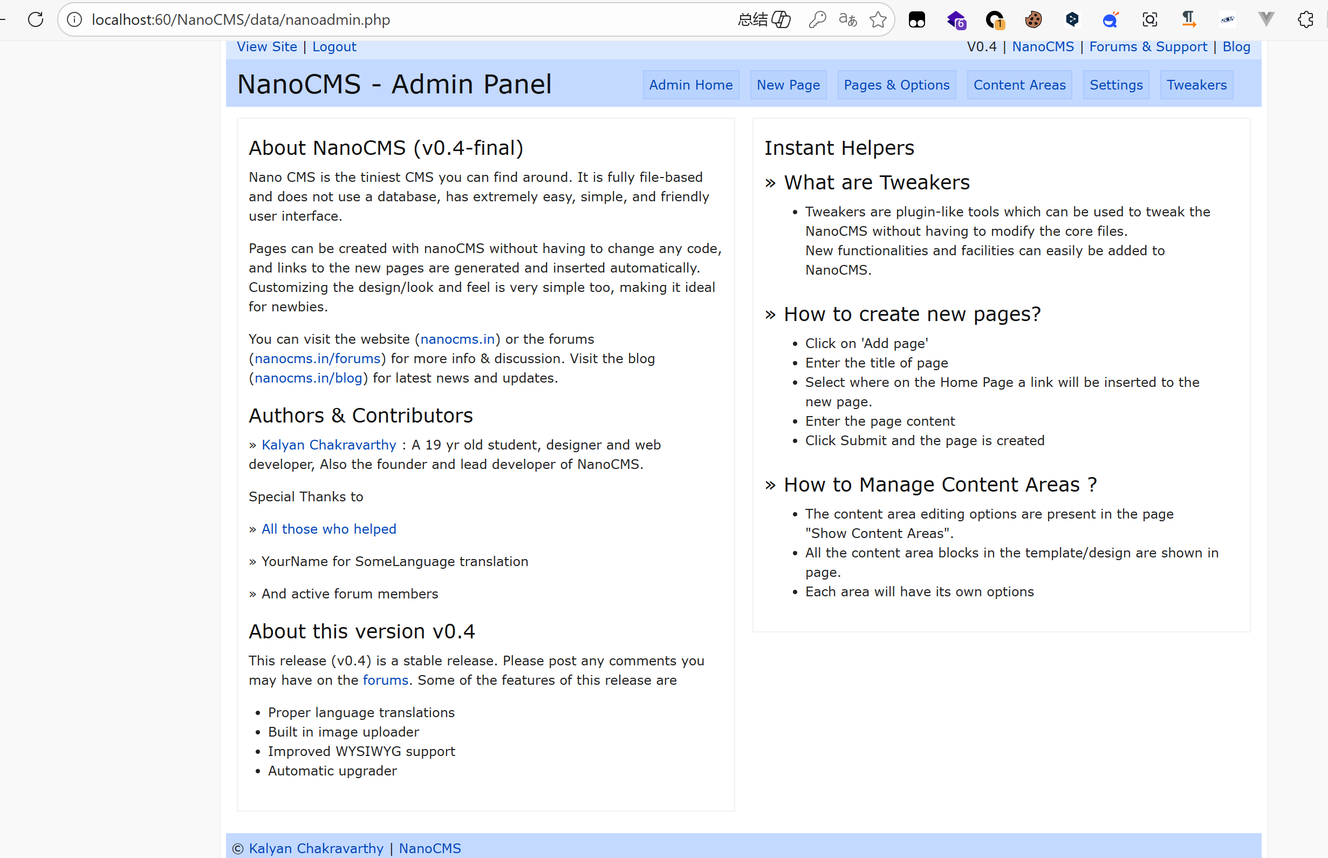
Then click the “New Page” to the write shell into this page
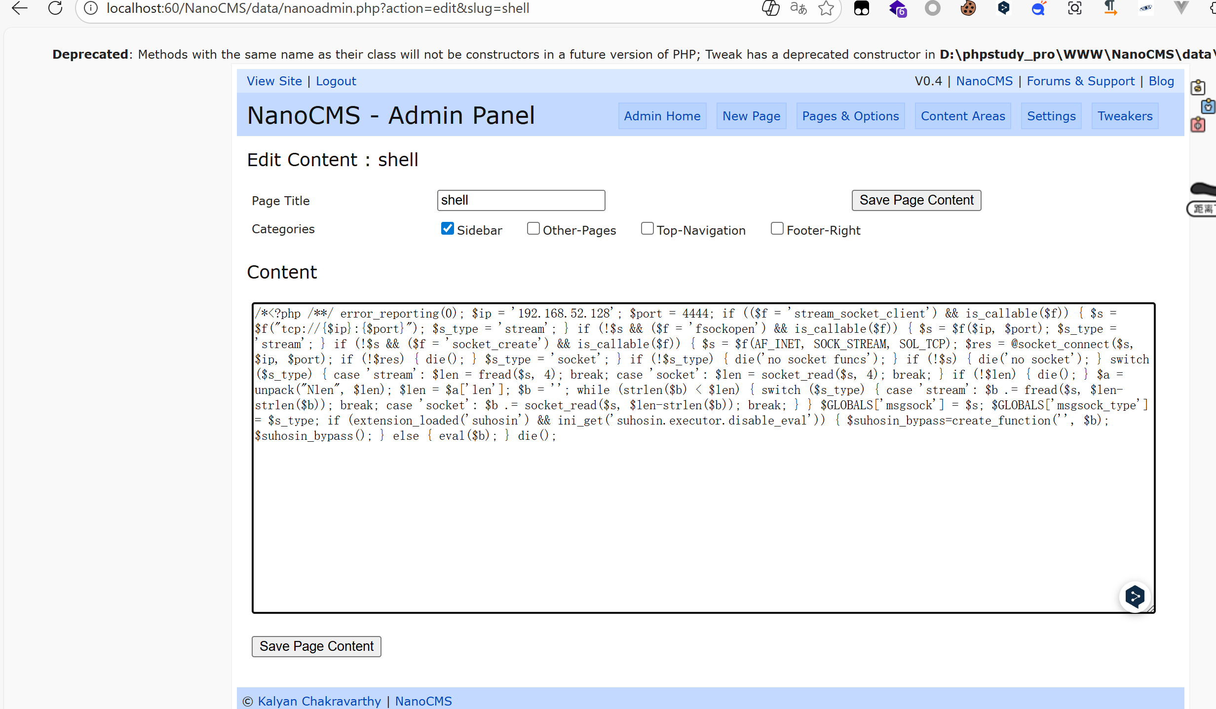
Then use kali’msfconsole to connect the shell.When click this url,connect successfully.
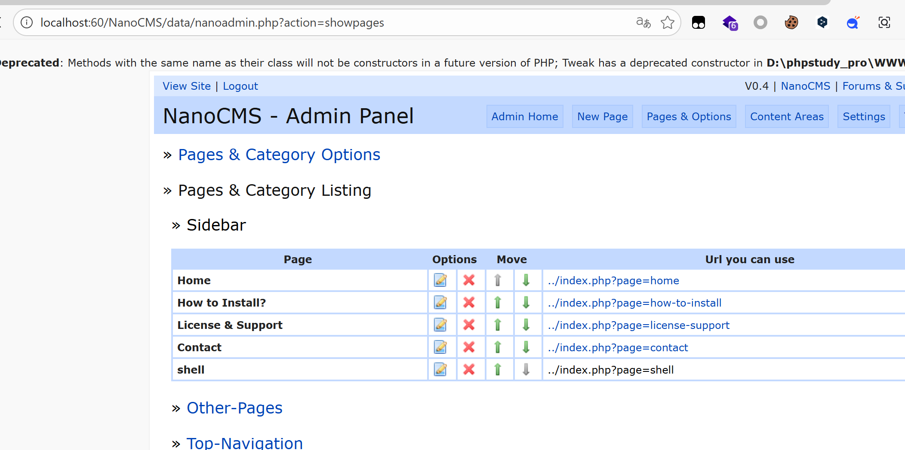
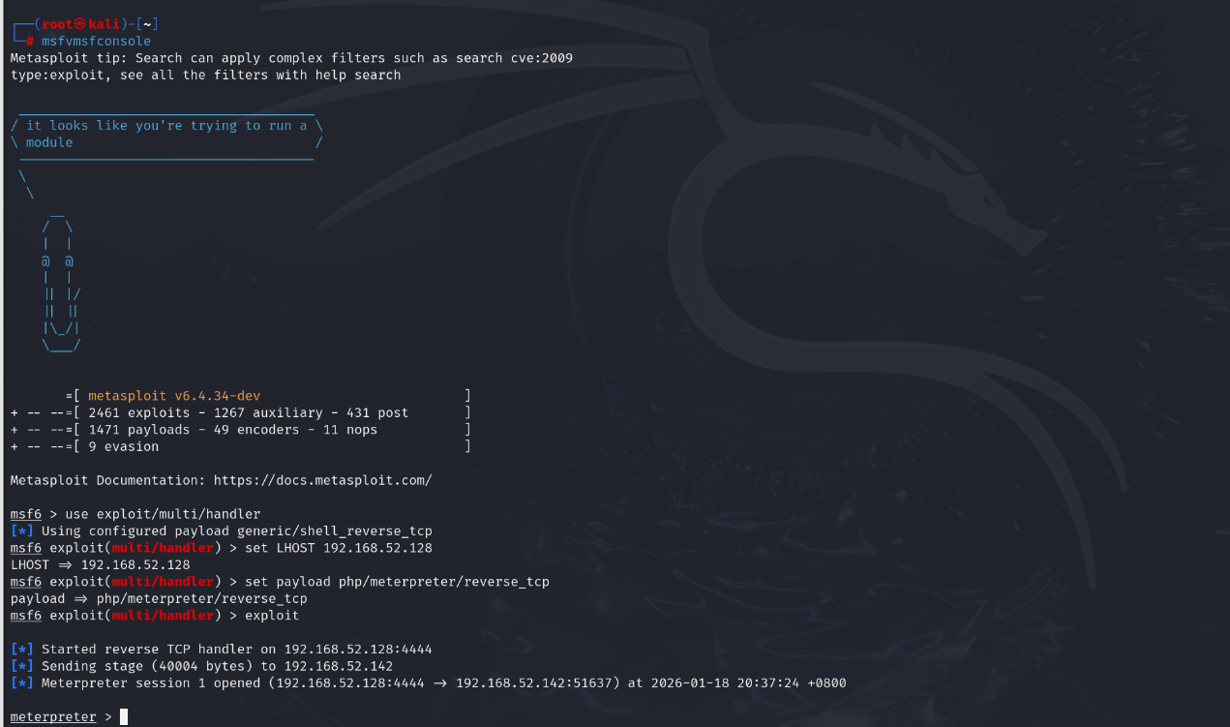

Then We can use historical records to locate administrator users for authorization
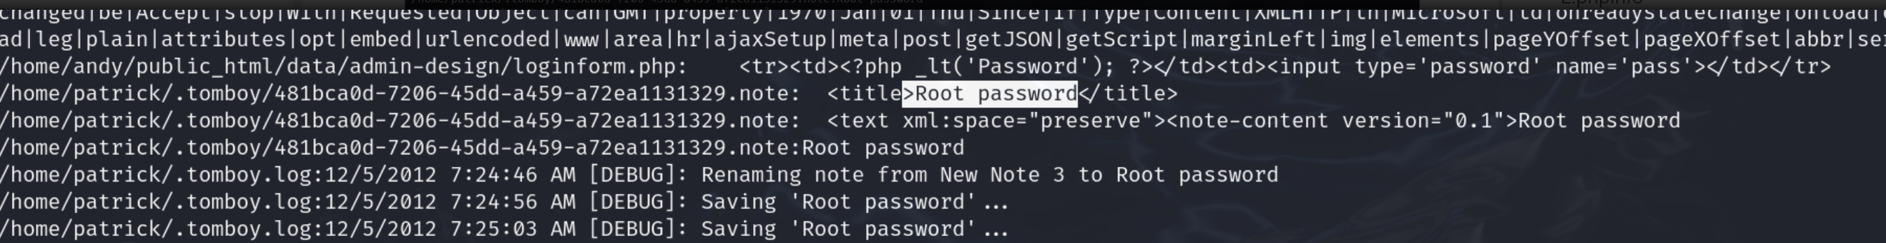
Access this file to obtain the account password
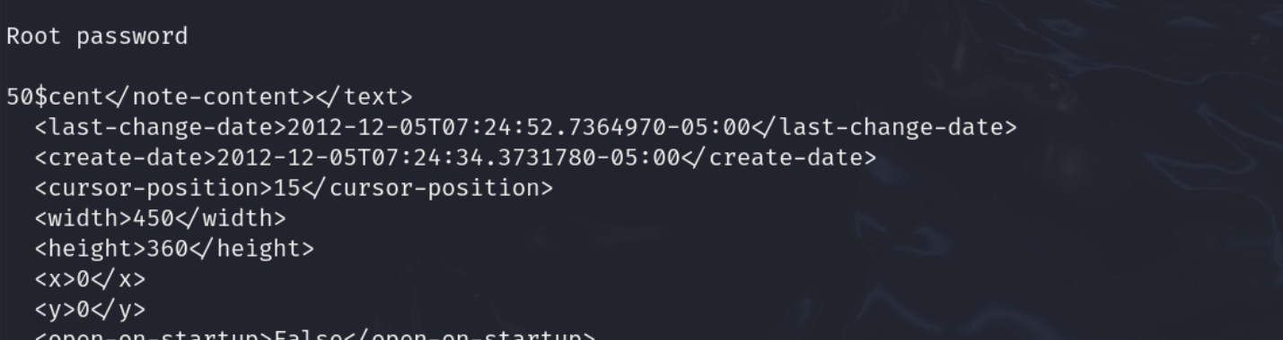

Then we can obtain administrator privileges
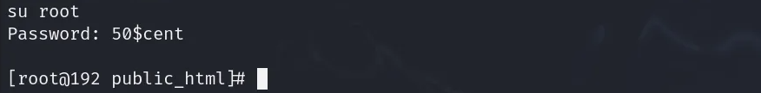

This website has a Remote code execution vulnerability

