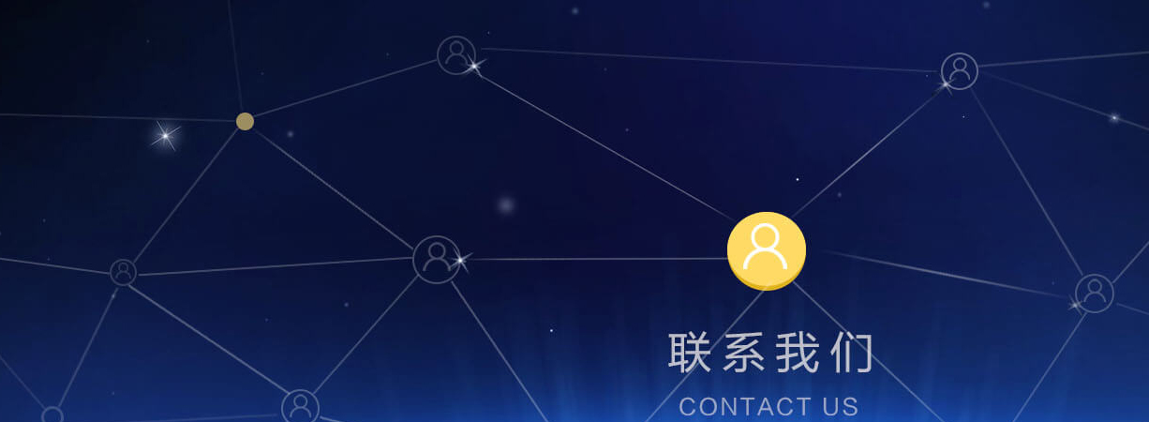
联系我们
南京总部
地址：江苏省南京市秦淮区中山南路315号瑞华大厦18楼
邮政编码：210001
电话： 025-83356968
传真： 025-83356968
邮箱： sales@skymems.com
Contact Us
Nanjing Headquarter
Address: Floor 18, No.315, Zhongshan South Road, Qinhuai District, Nanjing City, Jiangsu Province, China 210001
Mobile number: 86-133 7203 8516
Phone: +86-25-8335 6968
Email: sales@ztecom.com
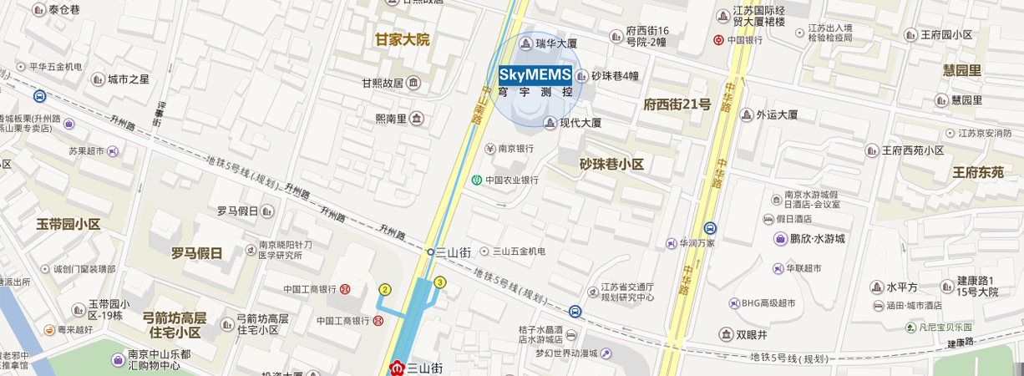
公共交通
地铁：1号线三山街站，3号出口沿中山南路向北150米
公交：16路;33路;35路;100路;100路高峰巴士直达中山南路-升州路站下即到

Public Transport
Metro: line 1 Sanshanjie station, port 3, 150 meters in the north along the zhongshan south road
Bus: Zhongshan south road, shengzhou road station by line 16, 33, 35 and 100

