表3.1 数据库表设计

|  |  |  |  |  |  |
| --- | --- | --- | --- | --- | --- |
| **数据集** | **模型** | **2层** | **4层** | **8层** | **16层** |
| Cora | GCN | 87.15 | 85.94 | 86.35 | 26.51 |
| GCN(WD) | 85.94 | 87.55 | 85.94 | 42.17 |
| Citeseer | GCN | 76.42 | 75.94 | 72.64 | 63.21 |
| GCN(WD) | 76.42 | 75 | 75 | 72.64 |
| Pubmed | GCN | 86.87 | 85.6 | 84.43 | 59.99 |
| GCN(WD) | 85.55 | 86.11 | 84.69 | 70.59 |

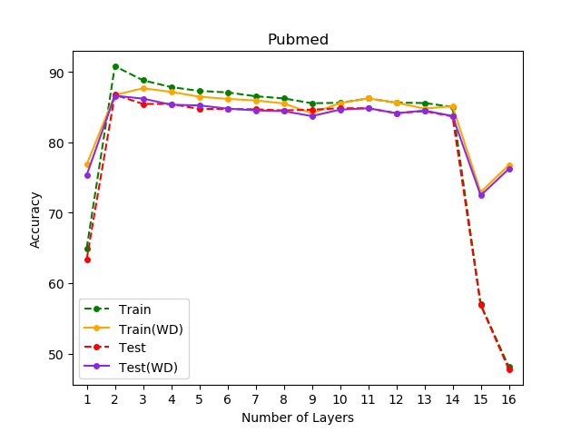

表3.1 数据库表设计

|  |  |  |  |  |  |
| --- | --- | --- | --- | --- | --- |
| **数据集** | **模型** | **2层** | **4层** | **8层** | **16层** |
| Cora | GCN | 85.14 | 83.94 | 85.14 | 26.51 |
| GCN(ES) | 87.15 | 85.94 | 86.35 | 26.51 |
| Citeseer | GCN | 69.81 | 67.92 | 68.4 | 69.81 |
| GCN(ES) | 76.42 | 75.94 | 72.64 | 63.21 |
| Pubmed | GCN | 86.46 | 84.94 | 84.08 | 40.37 |
| GCN(ES) | 86.87 | 85.6 | 84.43 | 59.99 |

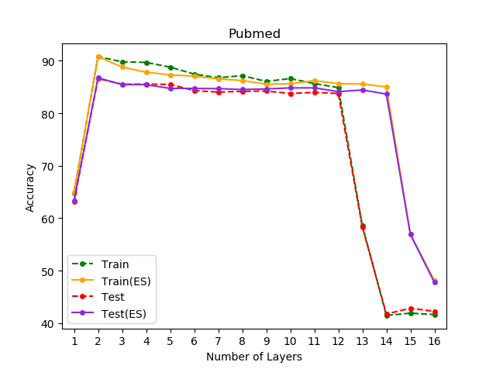

表3.1 数据库表设计

|  |  |  |  |  |  |
| --- | --- | --- | --- | --- | --- |
| **数据集** | **模型** | **2层** | **4层** | **8层** | **16层** |
| Cora | GCN | 87.15 | 85.94 | 86.35 | 26.51 |
| GCN(DO) | 88.76 | 87.15 | 87.95 | 33.33 |
| Citeseer | GCN | 76.42 | 75.94 | 72.64 | 63.21 |
| GCN(DO) | 75.94 | 75.94 | 74.53 | 76.42 |
| Pubmed | GCN | 86.87 | 85.6 | 84.43 | 59.99 |
| GCN(DO) | 88.44 | 85.85 | 84.94 | 82.25 |

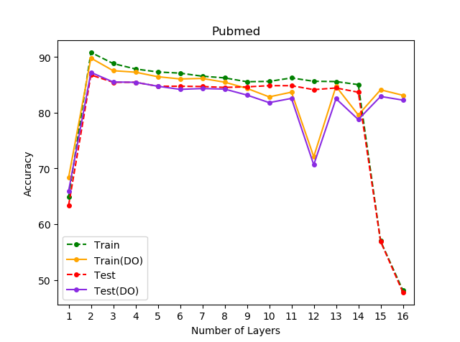

|  |  |  |  |  |  |
| --- | --- | --- | --- | --- | --- |
| **数据集** | **模型** | **2层** | **4层** | **8层** | **16层** |
| Cora | GCN | 86.35 | 83.13 | 86.35 | 30.92 |
| GCN(Xa) | 87.15 | 89.16 | 85.14 | 30.92 |
| Citeseer | GCN | 76.89 | 74.06 | 71.7 | 65.28 |
| GCN(Xa) | 79.25 | 76.89 | 75.94 | 64.32 |
| Pubmed | GCN | 86.56 | 85.5 | 84.03 | 44.02 |
| GCN(Xa) | 86.41 | 85.8 | 83.37 | 54.87 |

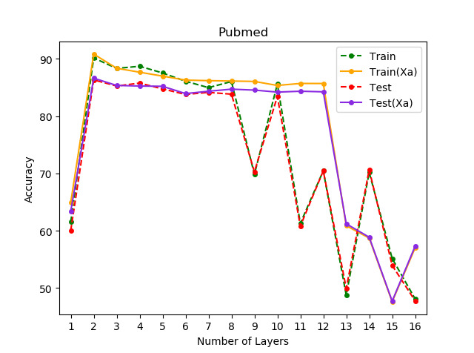

|  |  |  |  |  |  |
| --- | --- | --- | --- | --- | --- |
| **数据集** | **模型** | **2层** | **4层** | **8层** | **16层** |
| Cora | GCN | 87.15 | 89.16 | 85.14 | 30.92 |
| GCN(GC) | 87.15 | 85.94 | 85.54 | 69.08 |
| Citeseer | GCN | 79.25 | 76.89 | 75.94 | 64.32 |
| GCN(GC) | 76.42 | 75.94 | 72.64 | 71.23 |
| Pubmed | GCN | 86.41 | 85.8 | 83.37 | 54.87 |
| GCN(GC) | 86.87 | 85.6 | 84.43 | 60.9 |

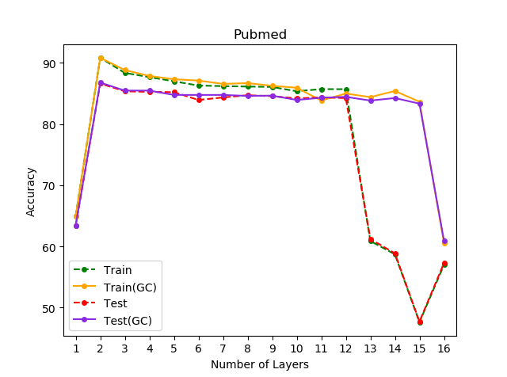

|  |  |  |  |  |  |
| --- | --- | --- | --- | --- | --- |
| **数据集** | **模型** | **2层** | **4层** | **8层** | **16层** |
| Cora | GCN | 87.15 | 89.16 | 85.14 | 30.92 |
| GCN(BN) | 77.51 | 77.51 | 81.93 | 85.54 |
| Citeseer | GCN | 79.25 | 76.89 | 75.94 | 64.32 |
| GCN(BN) | 67.92 | 61.79 | 70.28 | 73.58 |
| Pubmed | GCN | 86.41 | 85.8 | 83.37 | 54.87 |
| GCN(BN) | 87.73 | 85.45 | 83.92 | 83.57 |

