表3.1 数据库表设计

|  |  |  |  |  |  |
| --- | --- | --- | --- | --- | --- |
| **数据集** | **模型** | **2层** | **4层** | **8层** | **16层** |
| Cora | GCN | 87.15 | 85.94 | 86.35 | 26.51 |
| GCN(WD) | 85.94 | 87.55 | 85.94 | 42.17 |
| Citeseer | GCN | 76.42 | 75.94 | 72.64 | 63.21 |
| GCN(WD) | 76.42 | 75 | 75 | 72.64 |
| Pubmed | GCN | 86.87 | 85.6 | 84.43 | 59.99 |
| GCN(WD) | 85.55 | 86.11 | 84.69 | 70.59 |

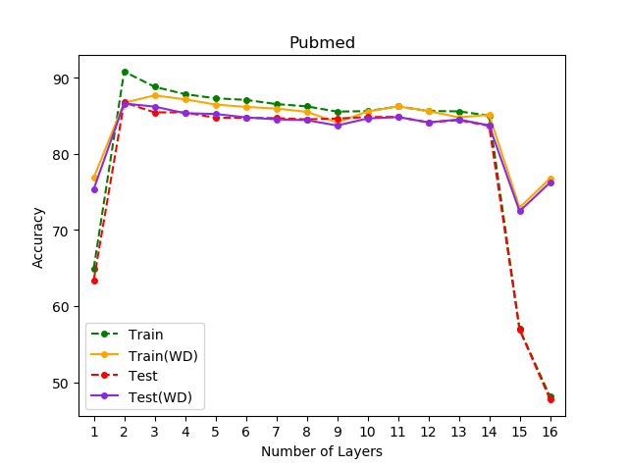

表3.1 数据库表设计

|  |  |  |  |  |  |
| --- | --- | --- | --- | --- | --- |
| **数据集** | **模型** | **2层** | **4层** | **8层** | **16层** |
| Cora | GCN | 85.14 | 83.94 | 85.14 | 26.51 |
| GCN(ES) | 87.15 | 85.94 | 86.35 | 26.51 |
| Citeseer | GCN | 69.81 | 67.92 | 68.4 | 69.81 |
| GCN(ES) | 76.42 | 75.94 | 72.64 | 63.21 |
| Pubmed | GCN | 86.46 | 84.94 | 84.08 | 40.37 |
| GCN(ES) | 86.87 | 85.6 | 84.43 | 59.99 |

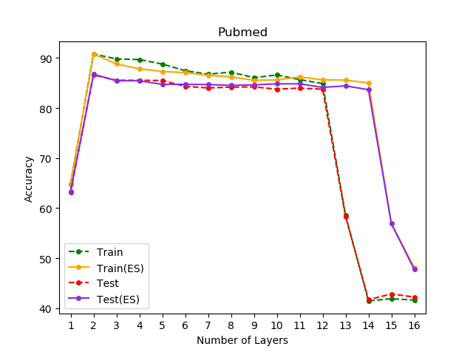

表3.1 数据库表设计

|  |  |  |  |  |  |
| --- | --- | --- | --- | --- | --- |
| **数据集** | **模型** | **2层** | **4层** | **8层** | **16层** |
| Cora | GCN | 87.15 | 85.94 | 86.35 | 26.51 |
| GCN(DO) | 88.76 | 87.15 | 87.95 | 33.33 |
| Citeseer | GCN | 76.42 | 75.94 | 72.64 | 63.21 |
| GCN(DO) | 75.94 | 75.94 | 74.53 | 76.42 |
| Pubmed | GCN | 86.87 | 85.6 | 84.43 | 59.99 |
| GCN(DO) | 88.44 | 85.85 | 84.94 | 82.25 |

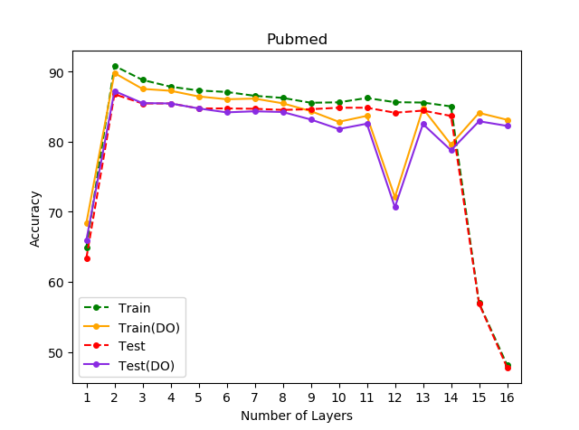

|  |  |  |  |  |  |
| --- | --- | --- | --- | --- | --- |
| **数据集** | **模型** | **2层** | **4层** | **8层** | **16层** |
| Cora | GCN | 86.35 | 83.13 | 86.35 | 30.92 |
| GCN(Xa) | 87.15 | 89.16 | 85.14 | 30.92 |
| Citeseer | GCN | 76.89 | 74.06 | 71.7 | 65.28 |
| GCN(Xa) | 79.25 | 76.89 | 75.94 | 64.32 |
| Pubmed | GCN | 86.56 | 85.5 | 84.03 | 44.02 |
| GCN(Xa) | 86.41 | 85.8 | 83.37 | 54.87 |

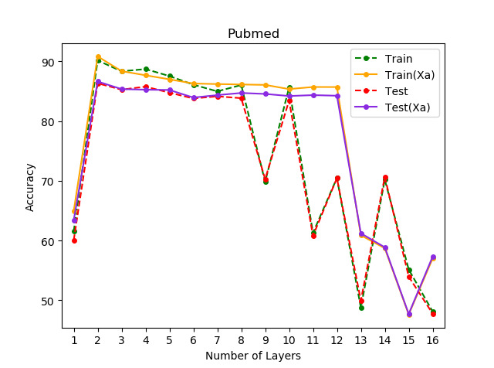

|  |  |  |  |  |  |
| --- | --- | --- | --- | --- | --- |
| **数据集** | **模型** | **2层** | **4层** | **8层** | **16层** |
| Cora | GCN | 87.15 | 89.16 | 85.14 | 30.92 |
| GCN(GC) | 87.15 | 85.94 | 85.54 | 69.08 |
| Citeseer | GCN | 79.25 | 76.89 | 75.94 | 64.32 |
| GCN(GC) | 76.42 | 75.94 | 72.64 | 71.23 |
| Pubmed | GCN | 86.41 | 85.8 | 83.37 | 54.87 |
| GCN(GC) | 86.87 | 85.6 | 84.43 | 60.9 |

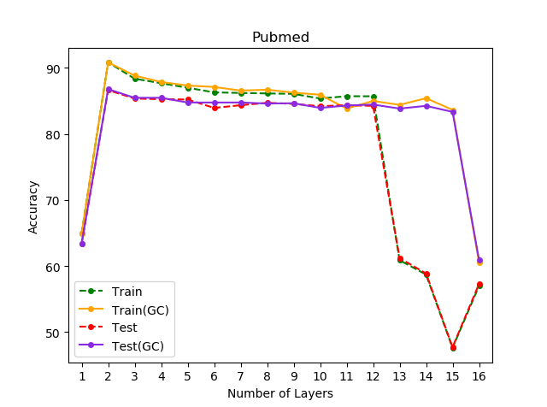

|  |  |  |  |  |  |
| --- | --- | --- | --- | --- | --- |
| **数据集** | **模型** | **2层** | **4层** | **8层** | **16层** |
| Cora | GCN | 87.15 | 89.16 | 85.14 | 30.92 |
| GCN(BN) | 77.51 | 77.51 | 81.93 | 85.54 |
| Citeseer | GCN | 79.25 | 76.89 | 75.94 | 64.32 |
| GCN(BN) | 67.92 | 61.79 | 70.28 | 73.58 |
| Pubmed | GCN | 86.41 | 85.8 | 83.37 | 54.87 |
| GCN(BN) | 87.73 | 85.45 | 83.92 | 83.57 |

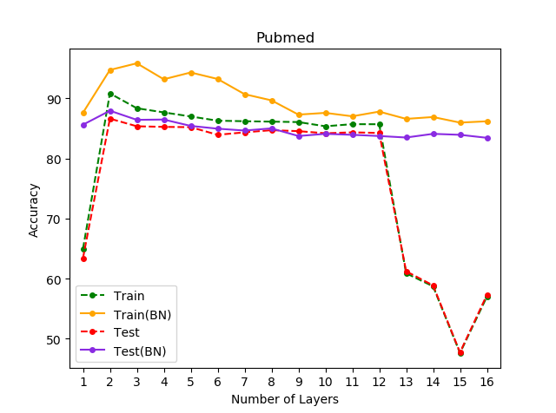

|  |  |  |  |  |  |  |
| --- | --- | --- | --- | --- | --- | --- |
| **模型** | **SGC** | **SGC(DR0)** | **SGC(DR1)** | **GCN** | **GCN(DR0)** | **GCN(DR1)** |
| Cora | 84.34(3) | 85.54(2) | 84.34(3) | 87.95(3) | 86.75(6) | 87.35(4) |
| Cite. | 76.89(2) | 75.24(1) | 77.36(2) | 76.18(2) | 76.65(2) | 76.65(2) |
| Pubm. | 82.25(1) | 82.18(2) | 82.3(2) | 86.92(2) | 87.04(2) | 87.2(2) |
| Cham. | 42.98(2) | 41.01(2) | 45.83(2) | 43.2(2) | 44.3(2) | 46.27(1) |
| Squi. | 28.28(5) | 28.31(2) | 29.17(2) | 27.83(6) | 27.64(2) | 29.08(2) |
| Actor | 28.51(1) | 28.09(1) | 34.93(1) | 27.63(2) | 27.76(2) | 33.55(3) |
| Corn. | 26.32(1) | 34.21(2) | 34.21(4) | 26.32(2) | 26.32(1) | 63.16(3) |
| Texa. | 64.91(2) | 65.79(1) | 73.68(2) | 68.42(2) | 63.16(2) | 71.05(3) |
| Wisc. | 60.26(2) | 59.62(4) | 80.77(4) | 57.69(2) | 57.69(2) | 82.69(5) |

|  |  |  |  |  |
| --- | --- | --- | --- | --- |
| **模型** | SGC | SGC(WE) | GCN | GCN(WE) |
| Cora | 84.34(3) | 85.34(3) | 87.95(3) | 87.55(2) |
| Cite. | 76.89(2) | 74.76(1) | 76.18(2) | 76.42(2) |
| Pubm. | 82.25(1) | 82.96(2) | 86.92(2) | 87.22(3) |
| Cham. | 42.98(2) | 45.83(4) | 43.2(2) | 46.49(3) |
| Squi. | 28.28(5) | 28.98(4) | 27.83(6) | 29.17(1) |
| Actor | 28.51(1) | 33.22(1) | 27.63(2) | 33.03(1) |
| Corn. | 26.32(1) | 26.32(1) | 26.32(2) | 26.32(1) |
| Texa. | 64.91(2) | 68.42(1) | 68.42(2) | 68.42(2) |
| Wisc. | 60.26(2) | 63.46(1) | 57.69(2) | 59.85(3) |

|  |  |  |  |  |
| --- | --- | --- | --- | --- |
| **模型** | **GCN** | **GCN(RES0)** | **GCN(RES1)** | **GCN(DEN)** |
| Cora | 87.95(3) | 87.15(6) | 87.55(3) | 85.74(2) |
| Cite. | 76.18(2) | 76.89(2) | 78.07(2) | 76.65(2) |
| Pubm. | 86.92(2) | 88.18(5) | 88.59(5) | 86.82(6) |
| Cham. | 43.2(2) | 46.49(1) | 49.12(1) | 43.64(4) |
| Squi. | 27.83(6) | 30.81(8) | 30.71(8) | 27.83(7) |
| Actor | 27.63(2) | 33.88(1) | 34.54(1) | 26.71(2) |
| Corn. | 26.32(2) | 34.21(2) | 60.53(2) | 26.32(2) |
| Texa. | 68.42(2) | 71.05(1) | 78.95(4) | 68.42(8) |
| Wisc. | 57.69(2) | 65.38(1) | 75.0(2) | 59.62(2) |

|  |  |  |  |  |
| --- | --- | --- | --- | --- |
| **模型** | **SGC** | **SGC(SE)** | **GCN** | **GCN(SE)** |
| Cora | 84.34(3) | 84.34(6) | 87.95(3) | 87.75(3) |
| Cite. | 76.89(2) | 78.3(1) | 76.18(2) | 77.12(2) |
| Pubm. | 82.25(1) | 83.22(2) | 86.92(2) | 86.71(2) |
| Cham. | 42.98(2) | 48.25(5) | 43.2(2) | 43.86(3) |
| Squi. | 28.28(5) | 30.9(4) | 27.83(6) | 30.04(2) |
| Actor | 28.51(1) | 37.11(1) | 27.63(2) | 32.43(2) |
| Corn. | 26.32(1) | 26.32(1) | 26.32(2) | 50.0(1) |
| Texa. | 64.91(2) | 68.42(2) | 68.42(2) | 71.05(3) |
| Wisc. | 60.26(2) | 65.38(1) | 57.69(2) | 65.38(1) |