

User Manual
GT Stock Manager
Version 2.1.1 | English
Gestão de Terminais, SA
by Layton Taimo

Contents
This manual explains the operational and administrative use of GT Stock Manager. Available screens and actions depend on the profile assigned to each user.
1. Access and language
2. Dashboard
3. Products and store
4. Stock movements
5. SR requisitions and approvals
6. Procurement / Non-stock
7. Stock replenishment
8. Reports
9. Users
10. Profiles and permissions
11. Settings
12. Notifications, documents and imports
13. Audit and security
14. Mobile use
15. Profile responsibilities

1. Access and language
1. Open the system address, enter your username and password, and select Sign in.
2. Use the PT/EN selector in the header. The preference is stored on the account and remains after signing out and signing in again.
3. On first access, change the password when prompted. Never share credentials.
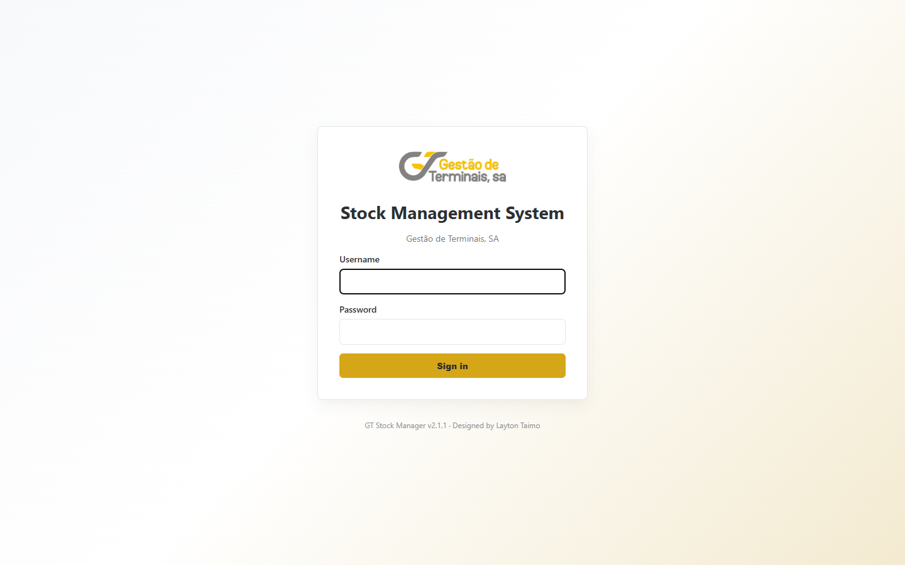
1. Access and language

2. Dashboard
1. The Dashboard summarises products, stock-outs, warnings, movements, requisitions and Procurement processes.
2. Cards and charts update from recorded movements and workflow statuses.
3. Use the shortcuts and tables to open the related report or process.
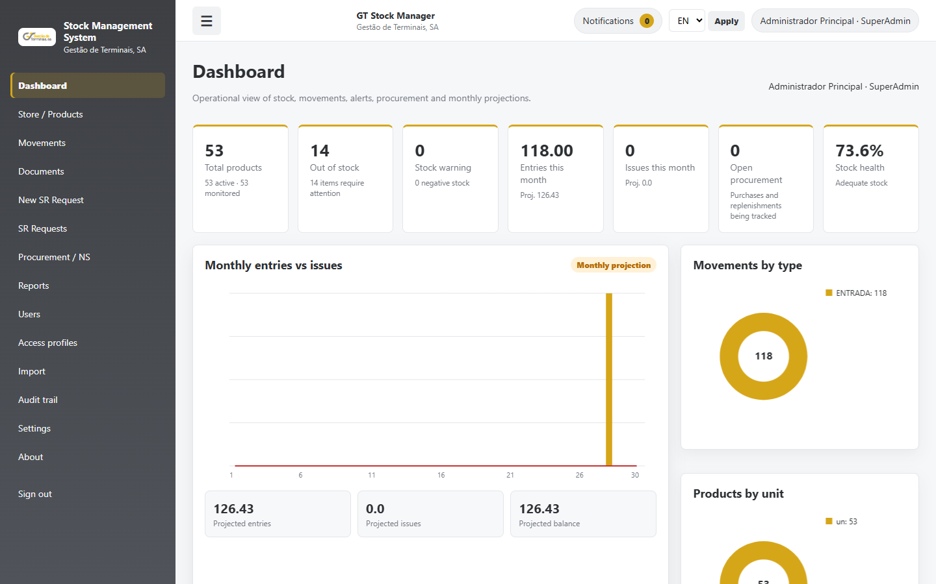
2. Dashboard

3. Products and store
1. View, filter and edit products. The system generates the code; the original name is never translated automatically.
2. An optional English display name can be entered without replacing the original business data.
3. Define unit, unit price, minimum stock and monitoring. Inactive or unmonitored items do not create replenishment warnings.
4. Existing quantity adjustments require permission, a mandatory reason and an audit movement.
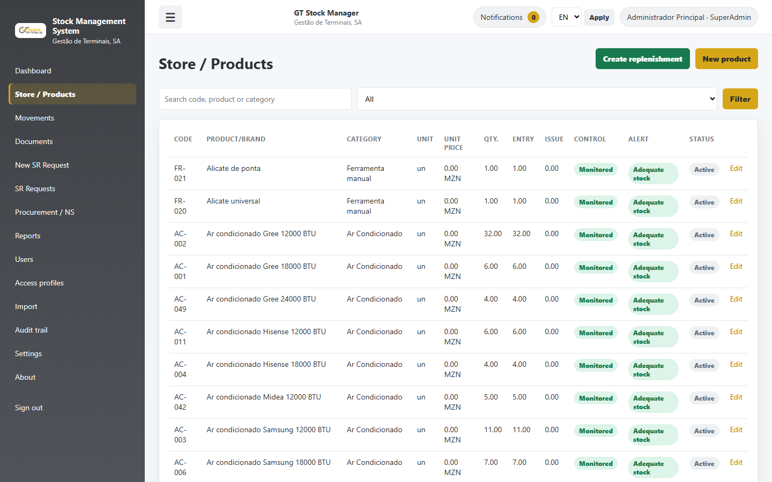
3. Products and store

4. Stock movements
1. Select Entry, Issue, Return or Adjustment. Relevant fields change with the action.
2. Entries require an origin or supplier; issues require a destination department and responsible person.
3. The system blocks invalid quantities and any operation that would create negative stock.
4. Manual adjustments require a reason and remain in the audit trail.
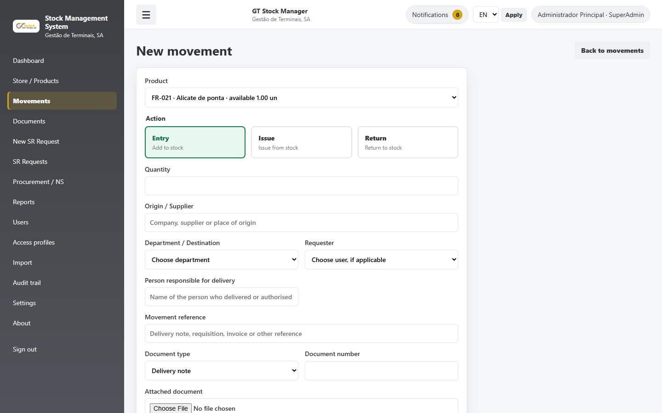
4. Stock movements

5. SR requisitions and approvals
1. Select the department, Operational Manager on duty and products with available stock.
2. The total value is calculated from unit prices and determines the approver profile through the matrix.
3. The reviewer may approve all, reject all or partially approve. Every rejected quantity requires an observation.
4. Approval does not reduce stock. The Stock Manager records the issue/delivery once.
5. Use Cancel or Back to leave the workflow without creating movements.
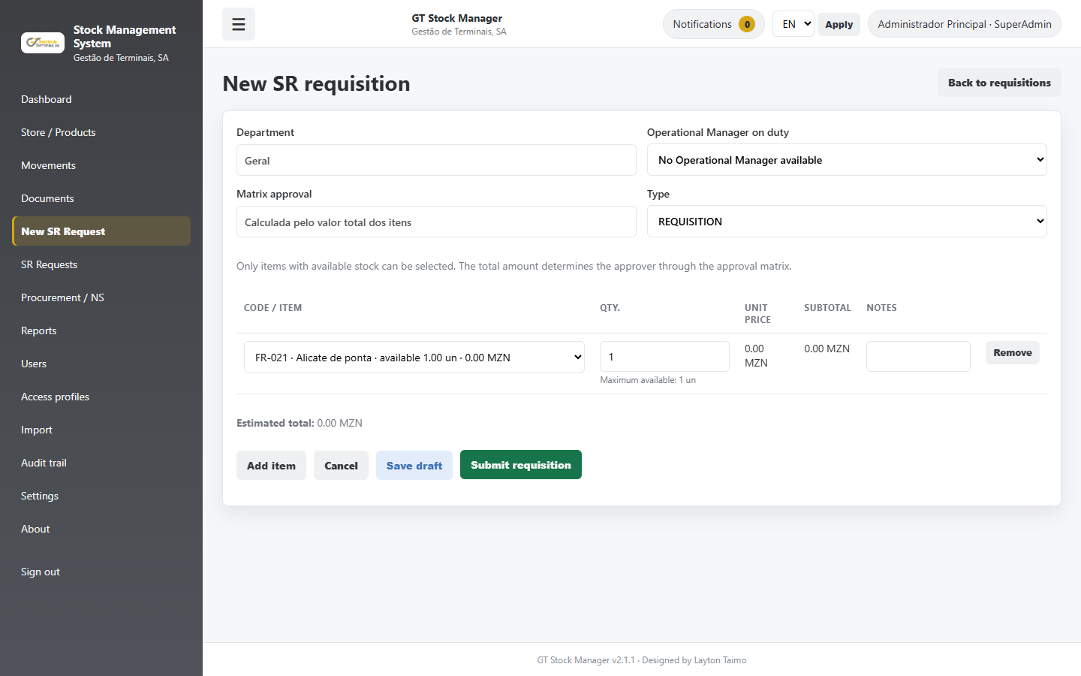
5. SR requisitions and approvals

6. Procurement / Non-stock
1. Create a request with need type, priority, estimated budget, description, technical requirements and HSE requirements.
2. The workflow is: need, ToR, HOD and Terminal Manager approvals, budget, classification, tender, technical and financial evaluations, award, PO, receipt and archive.
3. The final approval route is calculated from the matrix using the current process value.
4. The ToR and request form can be previewed, downloaded as PDF and sent by email.
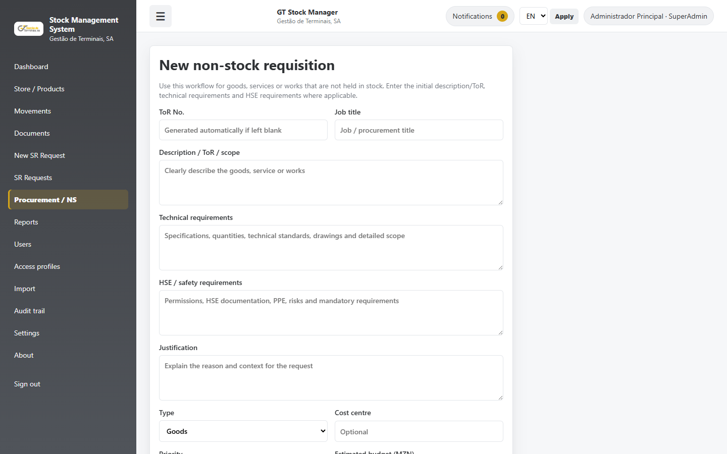
6. Procurement / Non-stock

7. Stock replenishment
1. The Stock Manager selects monitored products, enters quantities and estimated prices, and creates the purchase request.
2. The selection may include minimum-stock suggestions and other active products.
3. After approval and PO, record only physically received quantities. Each receipt creates a stock entry linked to the process.
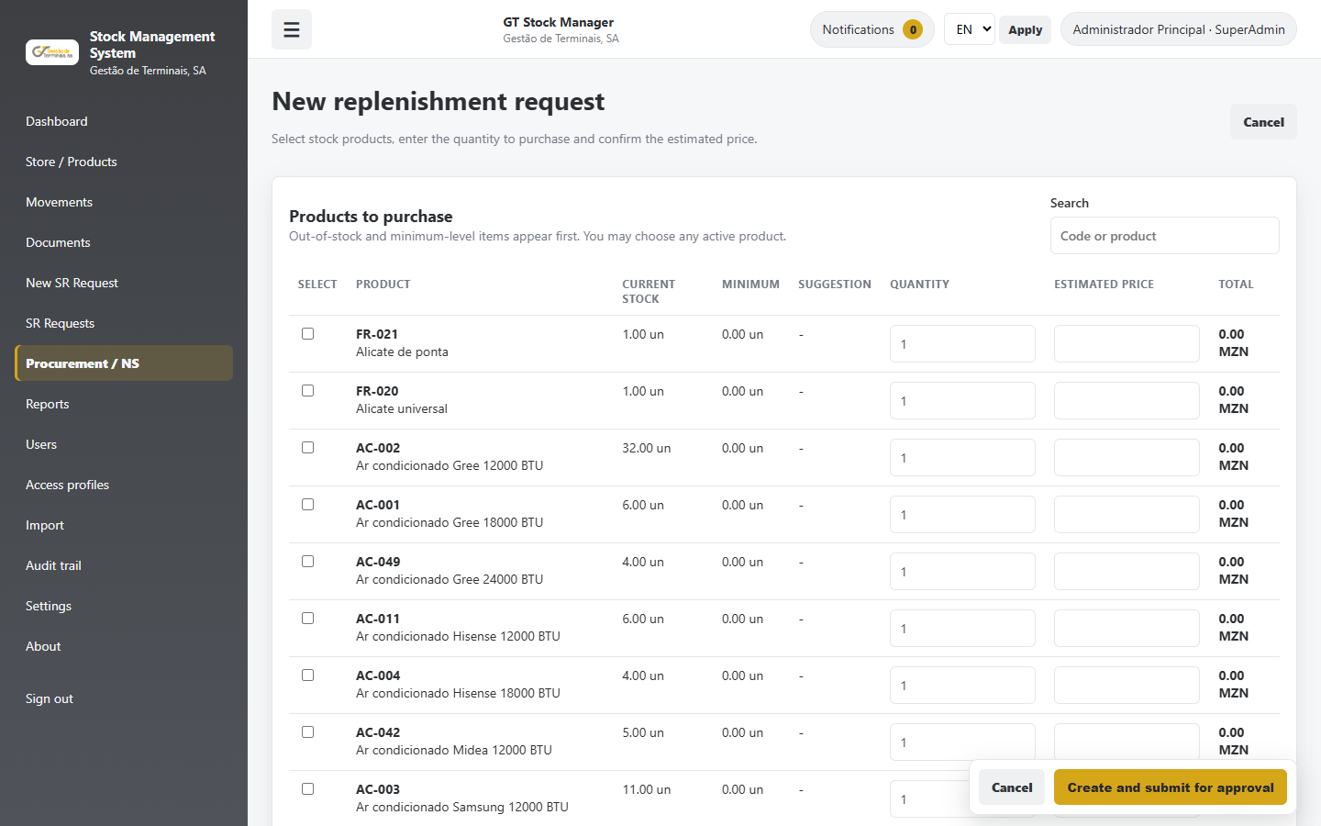
7. Stock replenishment

8. Reports
1. Reports cover stock, movements, requisitions, Procurement/replenishments and items requiring attention.
2. Apply filters before exporting. CSV, Excel and PDF follow the selected language and preserve user-entered data.
3. Inactive or unmonitored products are excluded from the attention report.
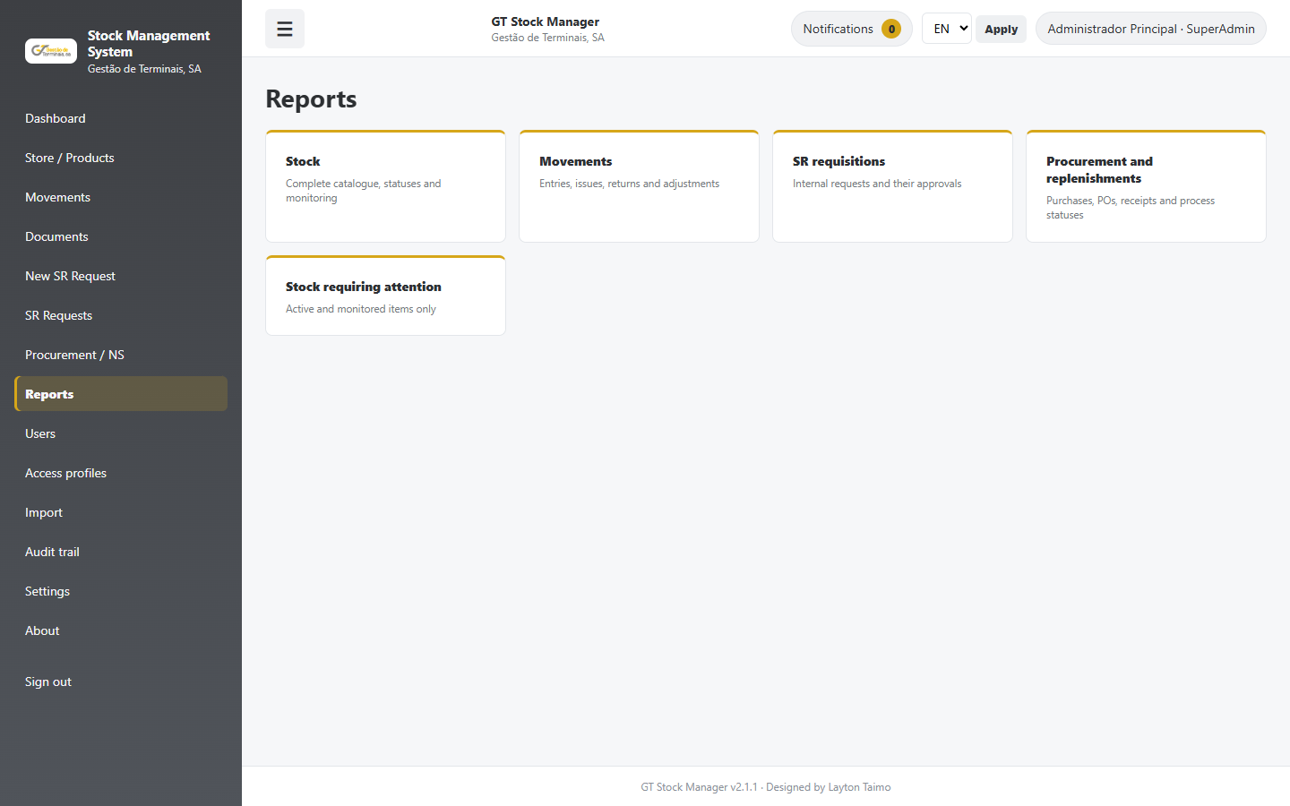
8. Reports

9. Users
1. Administrators can create and edit accounts and assign profile, department, language and notification channels.
2. Department is optional; invalid fields show a clear message instead of a technical error.
3. Removing access deactivates the account and preserves history. SuperAdmin and self-removal have additional protection.
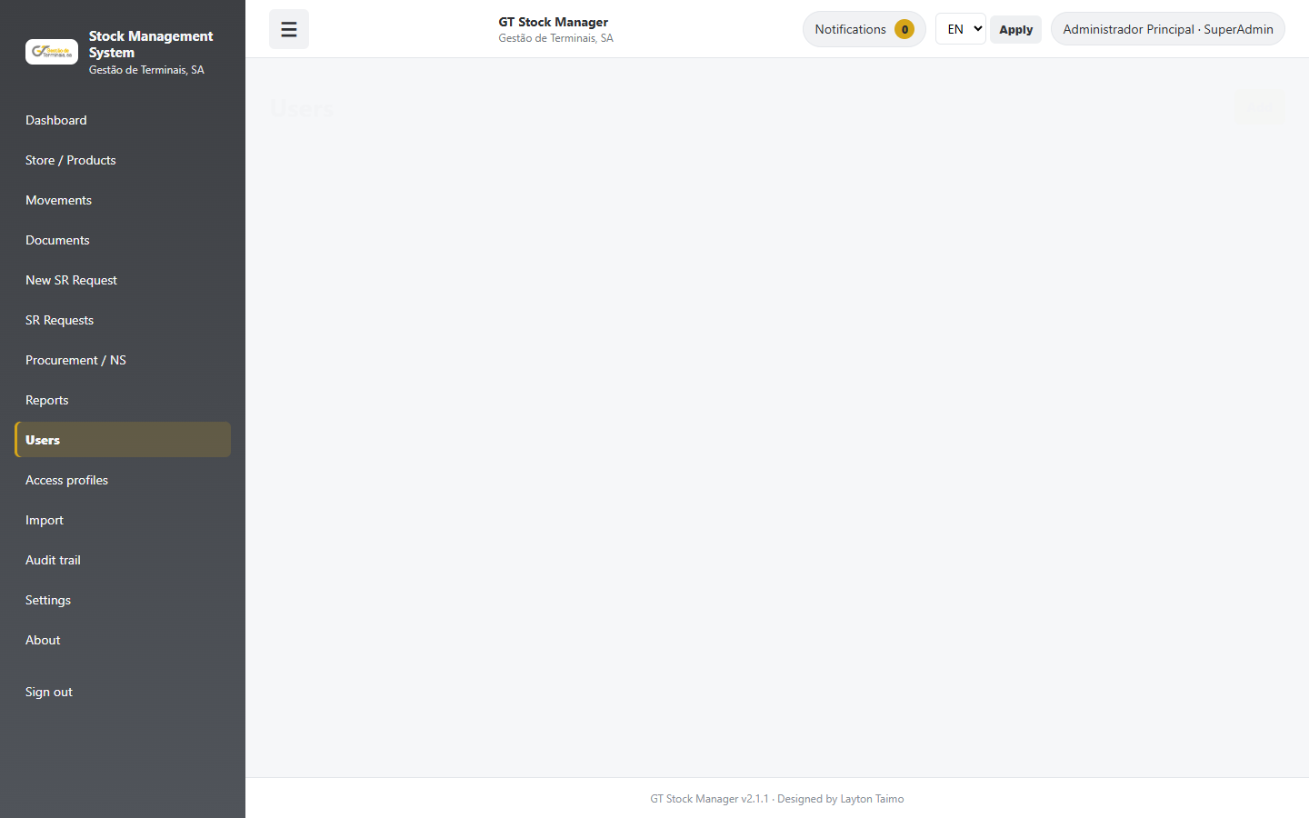
9. Users

10. Profiles and permissions
1. Profiles represent functions and control available modules and actions. They can be created, edited and removed when unused.
2. The approval matrix references profiles, not product categories.
3. Apply least privilege: assign only the access required for the user's responsibilities.
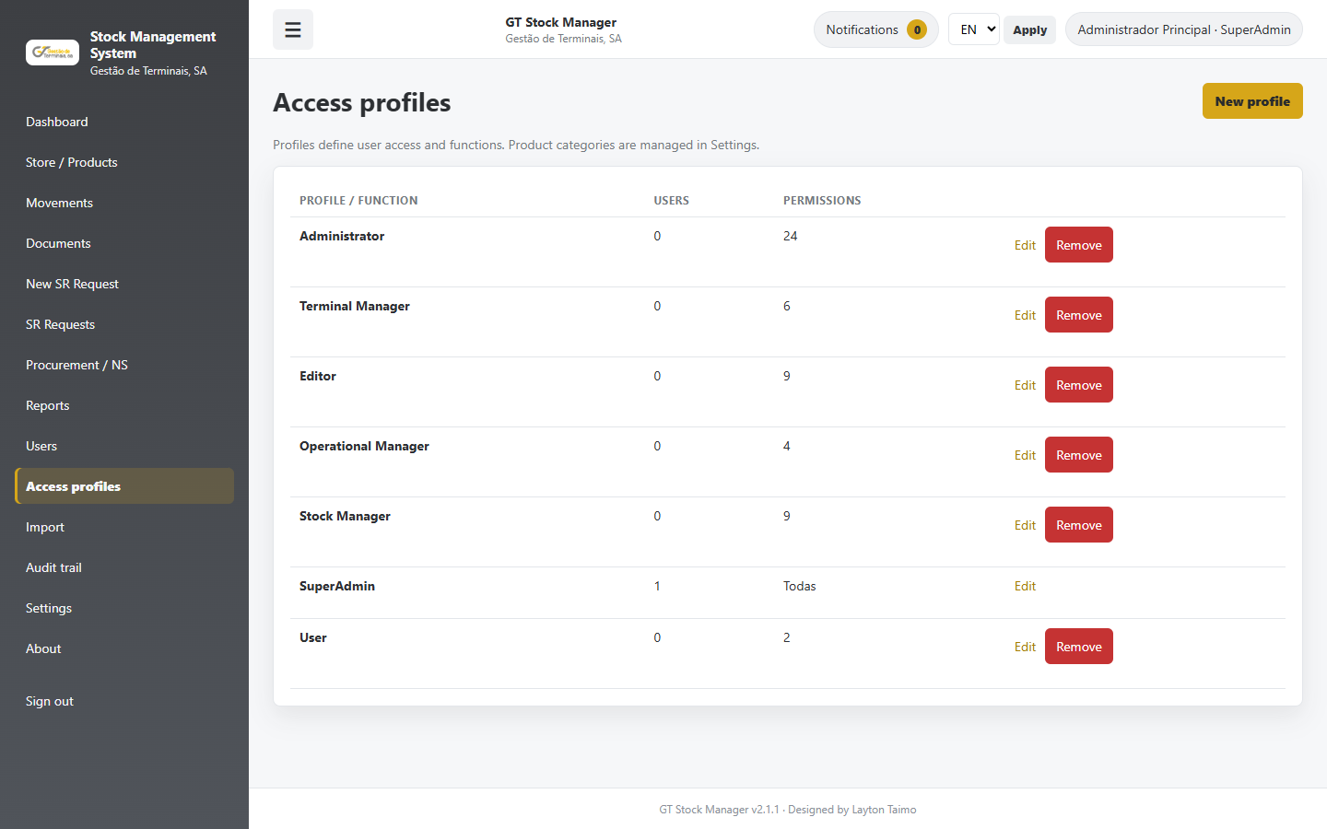
10. Profiles and permissions

11. Settings
1. Manage categories, departments and the approval matrix. Removal preserves historical records through deactivation where required.
2. The matrix defines value ranges, procurement method and approver profile. Avoid incomplete or overlapping ranges.
3. Full stock reset requires permission, typed confirmation and a security code; it creates adjustment movements and keeps history.
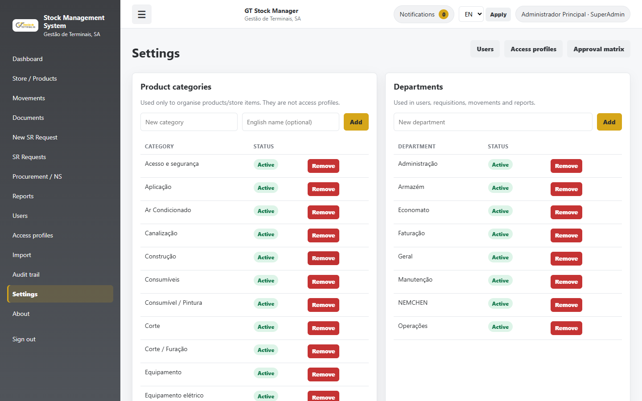
11. Settings

12. Notifications, documents and imports
1. Notifications open the related requisition or process directly and are created in the recipient's language.
2. Email and WhatsApp follow the user's preference and configuration. Stock documents remain linked to the related movement or product.
3. For imports, review the preview and error report before confirmation. Saving is transactional and auditable.
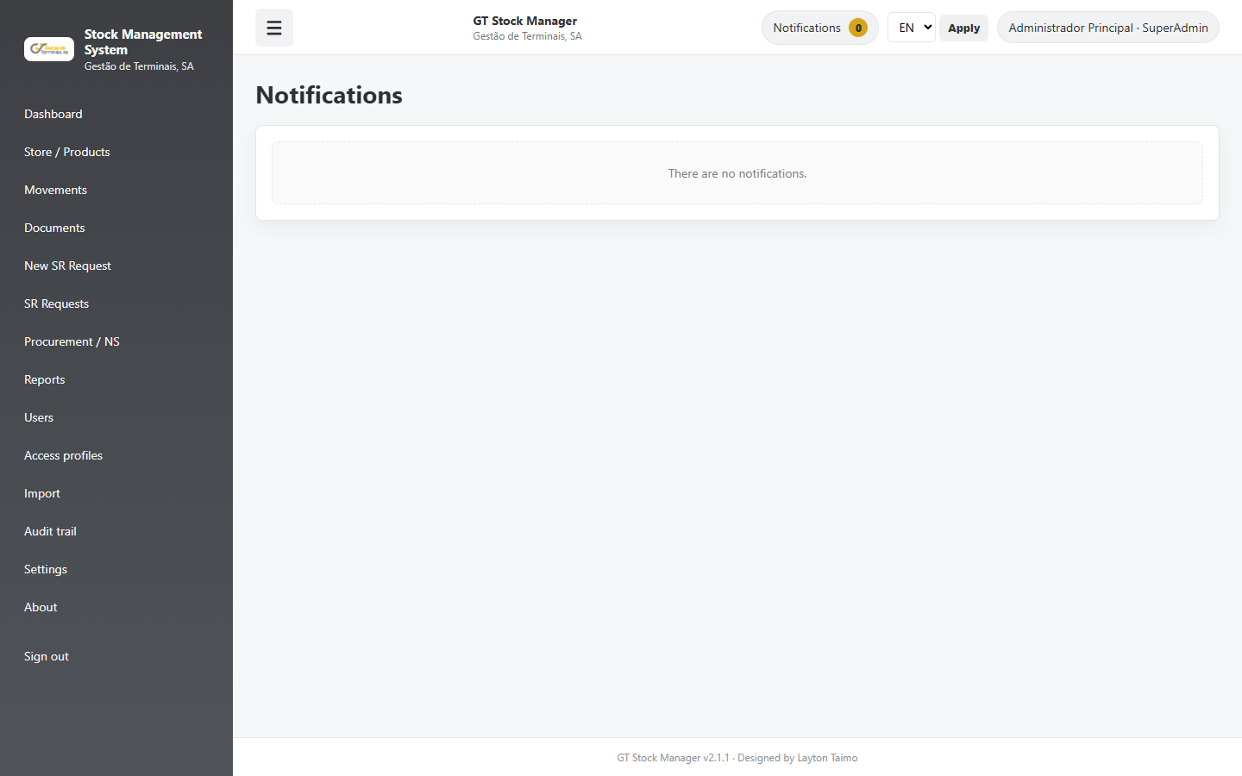
12. Notifications, documents and imports - notifications
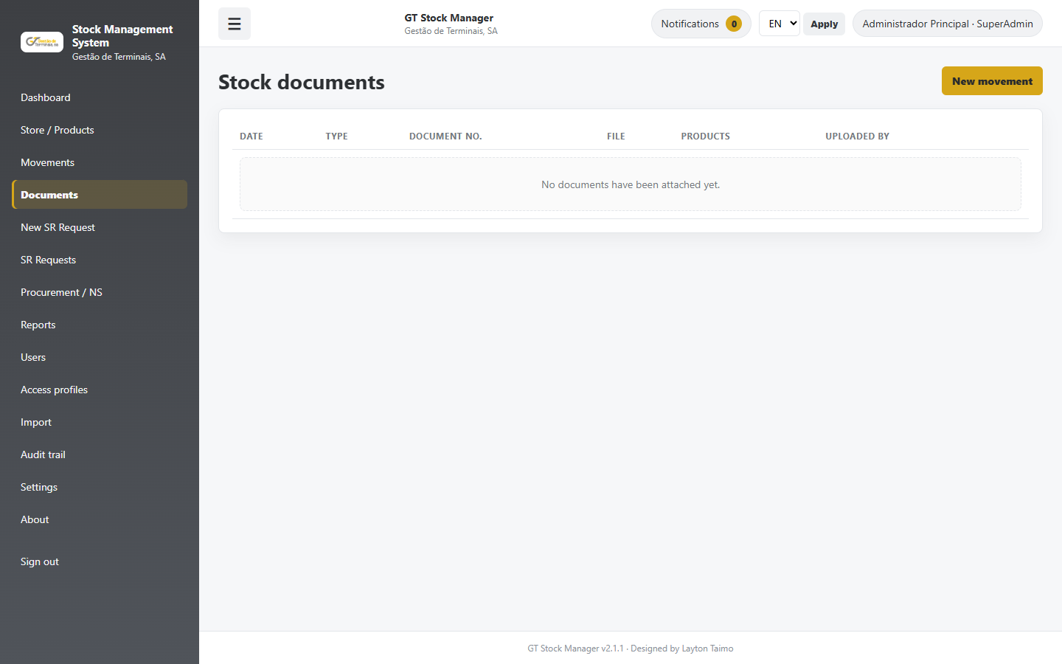
12. Notifications, documents and imports - documents
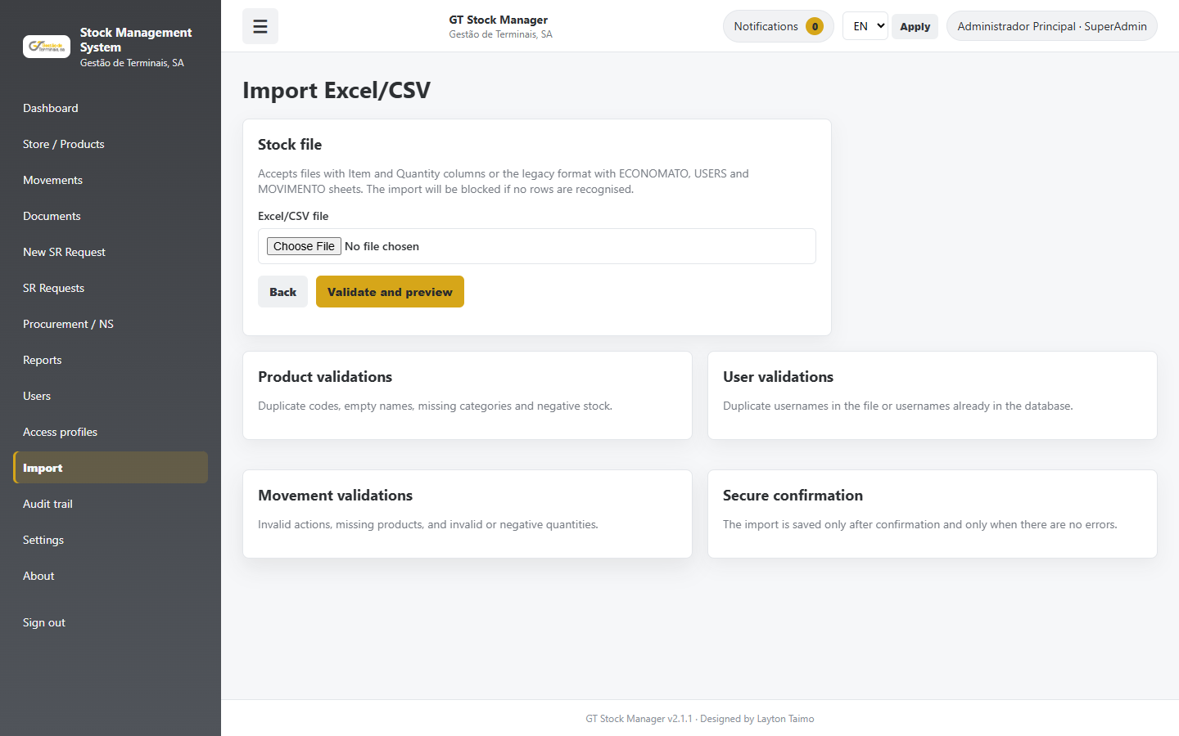
12. Notifications, documents and imports - imports

13. Audit and security
1. The audit trail shows user, action, module, record, previous/new values and IP/device in the selected language.
2. Internal values remain canonical in the database and are translated only for display.
3. Regularly review active accounts, profiles, matrix rules, negative stock, import failures and pending processes.
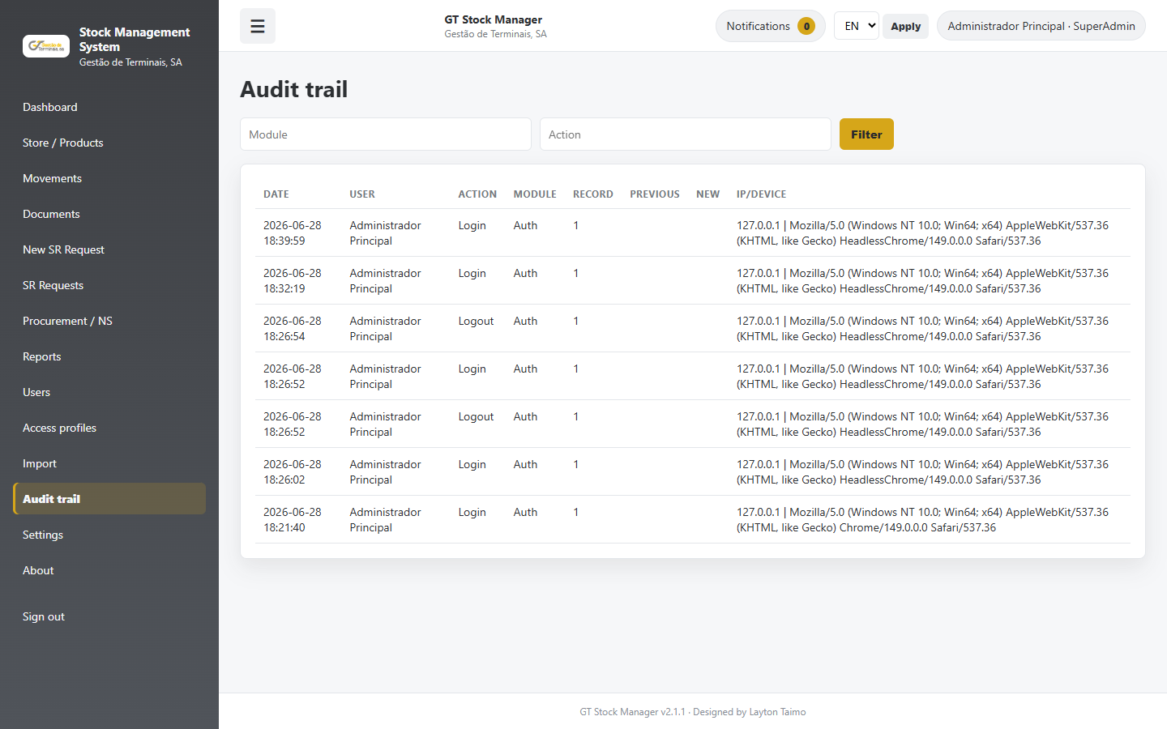
13. Audit and security

14. Mobile use
1. On phones, the menu is collapsed into the top button and forms/tables adapt to screen width.
2. Approvals, notifications and enquiries can be completed without horizontal scrolling.
3. A larger screen is recommended for extensive settings or import tasks.
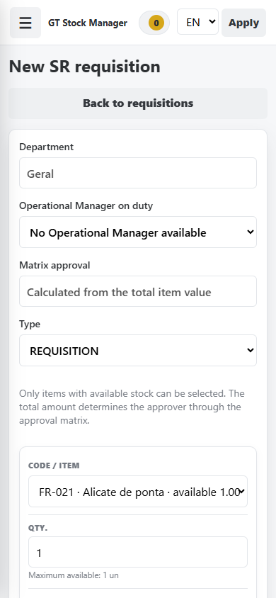
14. Mobile use

Profile responsibilities
Profile | Responsibility
SuperAdmin | Full configuration, users, profiles, matrix, audit and protected actions.
Administrator | Broad administrative operation without SuperAdmin-only protections.
Stock Manager | Movements, issue/delivery, replenishment, receipt and authorised adjustments.
Terminal Manager | Requisition and ToR approval according to profile and matrix.
Operational Manager | Request creation and HOD approval where configured.
Procurement / Committees | Classification, tender, evaluations, PO, receipt and archive according to permissions.
User | Creation and tracking of permitted own requests.

Support and good practice
When reporting an error, record the process number, page, time and displayed message. Do not change data to bypass validations.
Controlled document | GT Stock Manager 2.1.1 | by Layton Taimo

