Name: Linh Tang

CS 32

Date: 02/02/2021

Homework 2

2. Given the algorithm, main function, and maze shown at the end of problem 1, the first 12 (r,c) coordinates popped off the stack by the algorithm are:

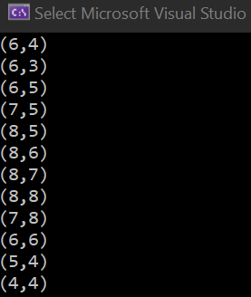

4. Given the same main function and maze as are shown at the end of problem 1, the first 12 (r,c) coordinates popped from the queue in your queue-based algorithm are:

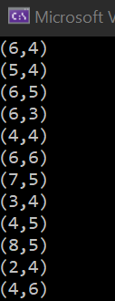

The algorithm of the queue is based on first in first out principle. Therefore, all the coordinates are collected and evaluated based on the order they are added to the queue.

Besides, the stack operates differently; it works based on last in first out principle. It does the Depth first search rather than searching level by level. It follows until the end of a branch and then searches backward.