NATIONAL ECONOMICS UNIVERSITY
FACULTY OF MATHEMATICAL ECONOMICS

MAJOR ASSIGNMENT
Course: Deep Learning

COMPARATIVE PET SEMANTIC SEGMENTATION:
FROM A SIMPLE ENCODER–DECODER TO TRANSFER LEARNING

Project information | Details
Instructor | ________________________________________
Students | 1. ____________________ ID: __________  2. ____________________ ID: __________  3. ____________________ ID: __________  4. ____________________ ID: __________
Task | Binary semantic segmentation
Dataset | Oxford-IIIT Pet
Experimental seed | 42

Hanoi, October 2026

Declaration and reproducibility note
This report documents an independently implemented comparison rather than reproducing a published experimental table. All three models were trained with the same saved sample indices and evaluated on the same 100-image official-test subset. The reported values were regenerated from the project checkpoints on 6 October 2026. Source ideas and external implementations are acknowledged in the References section.
The cover provides blank fields for the instructor and four group members; these identity fields do not affect the documented experiment.

Executive summary
The project studies foreground–background segmentation of cats and dogs under a deliberately small-data setting. Three approaches were compared: a 106,770-parameter encoder–decoder designed from scratch, a 118,290-parameter Mini U-Net with skip connections, and a pretrained DeepLabV3 model with a MobileNetV3-Large backbone. The experiment used 600 training images, 100 validation images and 100 held-out test images, all resized to 128×128 pixels.
DeepLabV3–MobileNetV3 obtained the strongest test result (IoU 0.8271 and F1/Dice 0.9054). The small Mini U-Net did not automatically outperform the simpler baseline: its IoU was 0.5989 versus 0.6052. This negative result is informative. Skip connections improved recall (0.7113 versus 0.6853) but also produced more false-positive foreground pixels, lowering precision. It illustrates that architectural complexity alone is not a guarantee of higher generalization when training data and tuning time are limited.

Table of contents
Part 1. Theoretical Background of CNNs ........................ 3
Part 2. Practical Application ................................. 5
3. Experimental Results ....................................... 9
4. Conclusion ................................................. 12
5. Requirement Compliance Audit ............................... 12
6. References ................................................. 13
Appendix A. Reproduction Commands ............................. 13

Part 1. Theoretical Background of CNNs

1.1 From image classification to semantic segmentation
A digital colour image can be represented as a tensor X ∈ R^(C×H×W), where C is the number of channels and H and W are spatial dimensions. Image classification produces one label for the complete tensor. Semantic segmentation instead predicts a class at every spatial position. For this project the network output has shape B×2×128×128: channel 0 scores background and channel 1 scores pet. Applying argmax along the class dimension yields a binary mask for each image.

1.2 Convolutional layers
A convolutional layer applies a shared kernel over local neighbourhoods. For output channel k at location (i,j), the pre-activation can be written as z[k,i,j] = b[k] + Σc Σu Σv W[k,c,u,v] X[c,i+u,j+v]. Weight sharing gives convolution substantially fewer parameters than a dense layer over all pixels and creates translation-equivariant feature extraction. Early filters commonly respond to edges and colour contrasts; deeper filters combine these signals into object parts and semantic patterns.

1.3 Activation, pooling and receptive field
The rectified linear unit ReLU(z)=max(0,z) introduces non-linearity and supports efficient gradient propagation. Max-pooling reduces spatial resolution by retaining the strongest response in each local window. Downsampling increases the effective receptive field, helping the network understand global object context, but it can discard boundary location. A segmentation decoder must therefore reconstruct a dense prediction from compressed features.

1.4 Encoder–decoder learning
An encoder successively extracts features and reduces their spatial size. A decoder upsamples them back to the input resolution. Bilinear interpolation used here has no trainable weights; following convolution blocks learn how to refine the enlarged maps. A final 1×1 convolution changes the number of channels to the number of classes without changing height or width. Although the assignment wording mentions fully connected layers, a dense layer is inappropriate for pixelwise output: the 1×1 convolution is the fully convolutional analogue of a per-pixel classifier and preserves spatial correspondence.

1.5 Skip connections and U-Net
Pooling creates an information bottleneck. U-Net addresses it by concatenating high-resolution encoder features with decoder features at matching scales. The decoder then has access to both semantic context and local boundary cues. In this implementation, the 64-channel bottleneck is concatenated with 32 encoder channels, and the next decoder output is concatenated with 16 encoder channels. The design is intentionally compact so that its contribution can be compared fairly with the simple baseline.

1.6 Transfer learning and fine-tuning
Transfer learning starts from representations learned on a large source dataset instead of random initialization. The selected Torchvision weights combine MobileNetV3-Large features with DeepLabV3 segmentation components. Training proceeds in two phases. During epochs 1–2 the backbone is frozen and only the task-specific classifier is optimized at learning rate 10⁻³. During epochs 3–10 the backbone is unfrozen and the complete network is fine-tuned at 10⁻⁴. The lower rate reduces the risk of destroying useful pretrained features.

1.7 Objective function and optimization
For each pixel with target class y, cross-entropy loss is L = −log(exp(z_y)/Σc exp(z_c)). PyTorch CrossEntropyLoss accepts raw logits, so applying softmax beforehand would be redundant and numerically less stable. Adam updates parameters using adaptive first- and second-moment estimates of the gradients. Each mini-batch follows zero_grad(), forward inference, loss.backward(), and optimizer.step().

1.8 Evaluation metrics
Pet is treated as the positive class. From aggregate test-pixel counts TP, FP, FN and TN, the metrics are: Accuracy=(TP+TN)/(TP+TN+FP+FN); Precision=TP/(TP+FP); Recall=TP/(TP+FN); IoU=TP/(TP+FP+FN); Dice=2TP/(2TP+FP+FN); and F1=2·Precision·Recall/(Precision+Recall). With one positive class, Dice and F1 are algebraically identical. IoU and Dice are emphasized because pixel accuracy can look high when background pixels dominate.

Part 2. Practical Application

2.1 Problem description
Item | Project definition
Title | Comparative pet semantic segmentation using three CNN strategies
Research question | How do model complexity and transfer learning affect pet segmentation under the same small-data split?
Input | A normalized RGB tensor of shape 3×128×128
Output | A 128×128 binary label map: 0=background, 1=pet (including trimap border)
Main tasks | Data verification, synchronized augmentation, three-model training, validation checkpoint selection, common-test evaluation and qualitative comparison

The practical goal is not merely to rank models. It is to isolate three learning strategies while controlling the dataset split, input resolution, label rule, loss and evaluation code. This design makes performance differences easier to attribute to architecture and pretraining.

2.2 Dataset description
Oxford-IIIT Pet contains 7,349 images covering 37 cat and dog breeds, with roughly 200 images per breed. Images have variable native dimensions and are accompanied by breed labels, head bounding boxes and pixel-level trimaps. The official trainval and test lists each contain 3,680 and 3,669 images respectively. This project intentionally samples only 800 images to keep the midterm experiment computationally manageable.
Official download page: https://www.robots.ox.ac.uk/~vgg/data/pets/
A trimap uses value 1 for pet, 2 for background and 3 for a narrow border/uncertain region. The implementation maps every value other than 2 to foreground. Consequently, pet and border become class 1 while background becomes class 0. This rule is applied after nearest-neighbour mask resizing, which avoids inventing non-integer labels.
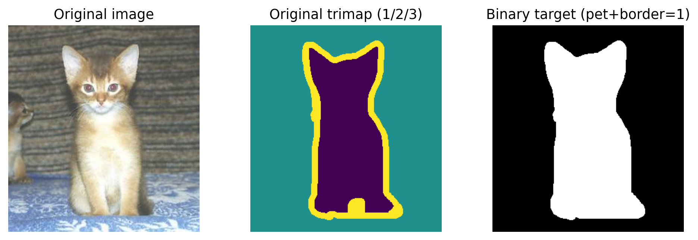
Figure 1. Preprocessing example from the saved test subset (Abyssinian_232).

2.3 Cleaning, normalization and augmentation
- Integrity: the official image and annotation archives were verified by MD5 (5c4f…e54c and 95a8…f68f) before the final run; zero-byte files from an interrupted download were replaced.
- Resize: RGB images use bilinear interpolation; masks use nearest-neighbour interpolation.
- Scale and normalize: PIL images are converted to [0,1] tensors and standardized using ImageNet mean [0.485, 0.456, 0.406] and standard deviation [0.229, 0.224, 0.225].
- Augmentation: a random horizontal flip with probability 0.5 is applied jointly to the image and mask, and only to training samples.
- Label validation: returned masks are int64 tensors containing only 0 and 1, compatible with CrossEntropyLoss.
The augmentation is intentionally conservative. A horizontal flip is plausible for pet photographs, whereas arbitrary vertical flips would create unnatural images. Applying the same random geometric operation to both image and target is essential; otherwise training pairs would be misaligned.

2.4 Dataset split and leakage control
Subset | Source partition | Samples | Purpose
Training | Official trainval | 600 | Gradient-based parameter learning
Validation | Official trainval, disjoint from train | 100 | Checkpoint selection by best IoU
Test | Official test | 100 | Final comparison only

A NumPy generator with seed 42 produces the indices once, and outputs/splits.npz stores them. The same file is loaded for all models. Training and validation indices are unique and non-overlapping; test indices refer to the separate official test partition. Test labels do not influence optimization or checkpoint selection.

2.5 CNN model design
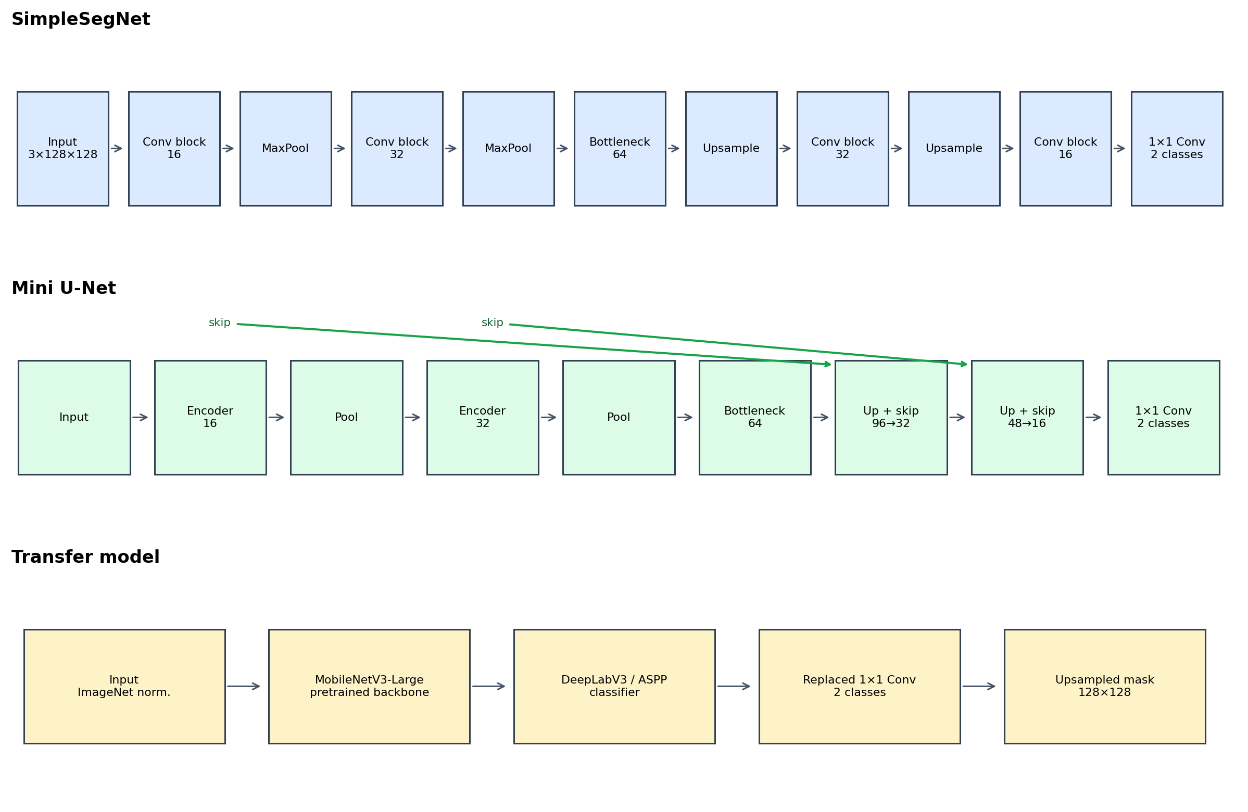
Figure 2. Architectures used in the controlled comparison. Each Conv block contains two 3×3 Conv–ReLU pairs.

2.5.1 SimpleSegNet: custom simple CNN
SimpleSegNet is a fully convolutional encoder–decoder without skip connections. Two Conv blocks (3→16 and 16→32 channels) are followed by 2×2 max-pooling. A 64-channel bottleneck represents the most compressed feature map. The decoder alternates bilinear upsampling and Conv blocks (64→32 and 32→16), ending in a 1×1 convolution with two outputs. It has 106,770 trainable parameters. Its simplicity provides a meaningful from-scratch baseline.

2.5.2 Mini U-Net: custom complex CNN
Mini U-Net uses the same encoder depth but introduces two skip concatenations. At 64×64 resolution, the upsampled 64-channel bottleneck is concatenated with the 32-channel encoder map; at 128×128, 32 decoder channels are concatenated with 16 encoder channels. The resulting decoder blocks receive 96 and 48 channels respectively. It has 118,290 parameters—10.8% more than SimpleSegNet—so the experiment tests whether spatial feature reuse helps without merely scaling parameter count dramatically.

2.5.3 DeepLabV3–MobileNetV3: transfer learning
The third model is torchvision.models.segmentation.deeplabv3_mobilenet_v3_large with default pretrained segmentation weights. MobileNetV3 is an efficient feature extractor; DeepLabV3 uses atrous convolutions and multi-scale context aggregation. The original classifier output is replaced by a 1×1 convolution for two classes and the auxiliary head is disabled. The model has 11,020,594 parameters. During the frozen phase 8,048,642 classifier-side parameters are trainable according to the implemented parameter grouping; the full backbone becomes trainable after epoch 2.

2.6 Training configuration
Setting | SimpleSegNet | Mini U-Net | Transfer model
Initialization | Random | Random | Pretrained weights
Epochs | 15 | 15 | 10 (2 frozen + 8 fine-tune)
Optimizer | Adam | Adam | Adam
Learning rate | 1×10⁻³ | 1×10⁻³ | 1×10⁻³ head; 1×10⁻⁴ full
Loss | Cross-entropy | Cross-entropy | Cross-entropy
Batch size | 8 | 8 | 8
Checkpoint rule | Best validation IoU | Best validation IoU | Best validation IoU

Deterministic seeds are set for Python, NumPy, PyTorch and DataLoader workers. cuDNN benchmarking is disabled and deterministic behavior enabled. This improves repeatability, although exact floating-point timing and the final least significant digits can still vary across CUDA and library versions.

3. Experimental Results

3.1 Quantitative comparison on the held-out test set
Model | Accuracy | Precision | Recall | F1 | IoU | Dice | Params | ms/image
SimpleSegNet | 0.8126 | 0.8381 | 0.6853 | 0.7540 | 0.6052 | 0.7540 | 106,770 | 0.16
Mini U-Net | 0.8003 | 0.7912 | 0.7113 | 0.7491 | 0.5989 | 0.7491 | 118,290 | 0.16
DeepLabV3–MobileNetV3 | 0.9205 | 0.9030 | 0.9077 | 0.9054 | 0.8271 | 0.9054 | 11,020,594 | 0.46

Table 4 reports micro-aggregated pixel counts over all 100 test images. Timing was measured on the available CUDA device after warm-up and excludes data loading; it should be interpreted as a within-run engineering comparison, not a hardware-independent benchmark.
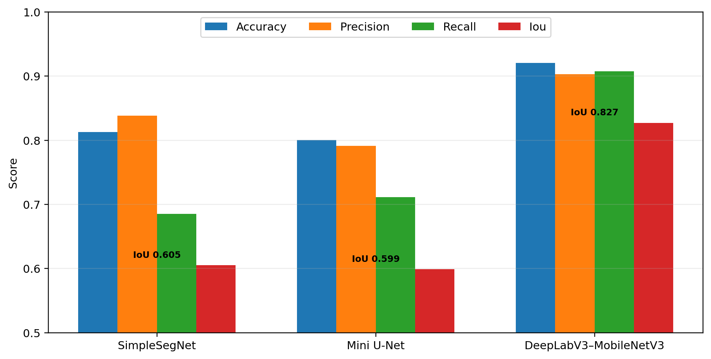
Figure 3. Test-set performance. IoU is annotated because it is the checkpoint-selection and primary overlap metric.

3.2 Qualitative comparison
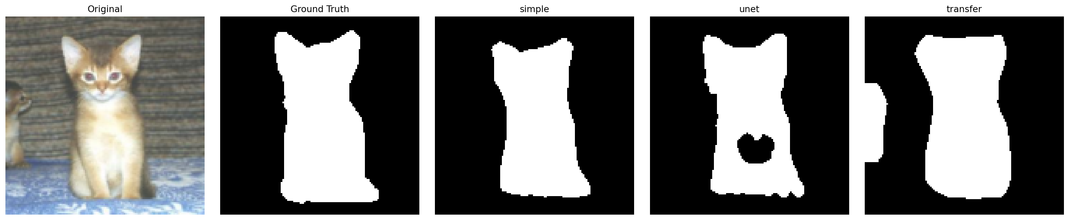
Figure 4. Original image, binary ground truth and predictions from the three trained models on the first deterministic test batch.
The qualitative panel should be read together with the aggregate metrics. One image can illustrate boundary shape and false regions but cannot establish general performance. The numerical table summarizes more than 1.6 million evaluated pixels, whereas the panel provides an interpretable example of what the class scores mean spatially.

3.3 Interpretation
DeepLabV3–MobileNetV3 is the clear winner: its IoU exceeds SimpleSegNet by 0.2219 (36.7% relative) and its recall is 0.9077 without sacrificing precision (0.9030). This balance suggests that pretrained and multi-scale features help distinguish pet contours from varied backgrounds despite only 600 training examples.
The comparison between the two custom networks is less obvious and therefore more valuable. Mini U-Net achieves higher recall than SimpleSegNet (0.7113 versus 0.6853), consistent with recovering more foreground pixels through skip features. However, its precision is lower (0.7912 versus 0.8381), indicating additional false-positive foreground regions. The net effect is slightly lower IoU (0.5989 versus 0.6052). The result does not invalidate skip connections; it shows that this compact implementation and short training schedule did not convert the added detail into better overall overlap.
SimpleSegNet and Mini U-Net have the same measured latency after rounding (0.16 ms/image), while transfer learning is about 2.9 times slower in this run and has roughly 93 times as many parameters as Mini U-Net. The accuracy gain may justify the cost for offline photo processing, but the custom models are easier to deploy in constrained environments.

3.4 Error analysis
- Fine boundaries such as ears, legs, whiskers and fur are vulnerable to the 128×128 resize and pooling.
- Foreground/background confusion is likely when pet fur resembles the surrounding colour or texture.
- The binary conversion labels the original trimap border as foreground, making the desired mask slightly wider than the object interior.
- Only horizontal flips diversify training geometry; lighting, crop and scale diversity remain limited.
- Global pixel aggregation gives larger objects more influence than small pets. A per-image IoU distribution would reveal variance hidden by one aggregate score.

3.5 Validity and limitations
The experiment controls split, preprocessing and metric implementation, but model-specific training schedules differ. This is intentional for transfer learning, whose backbone benefits from a smaller fine-tuning rate. Nevertheless, the comparison is not a search for each architecture’s absolute optimum. Only one random seed, one small subset and minimal hyperparameter tuning were used. Generalization claims should therefore be limited to this experimental setting.

4. Conclusion
This project implemented all requested stages for a semantic segmentation problem: data cleaning and validation, normalization, synchronized augmentation, train/validation/test splitting, two custom CNN designs, transfer learning with a frozen-to-unfrozen schedule, and common-test evaluation using accuracy, precision, recall, F1, IoU and Dice.
The strongest model was DeepLabV3–MobileNetV3, achieving IoU 0.8271 and Dice/F1 0.9054. Its pretrained representation and multi-scale segmentation head provided a large benefit in the limited-data setting. Model complexity alone was not sufficient: the compact Mini U-Net slightly underperformed the simpler encoder–decoder in IoU, although it increased recall. Thus, the main conclusion is not simply that “larger is better,” but that transferred features were more consequential than a modest structural change under the available data and training budget.
Future work should repeat experiments over several seeds, report per-image IoU distributions, add stronger paired augmentations, test class-weighted or Dice-based losses, and evaluate higher input resolutions. These extensions would determine whether the Mini U-Net’s additional spatial information can be converted into more precise boundaries.

5. Requirement Compliance Audit
Requirement from supplied documents | Evidence in implementation/report | Status
CNN theoretical background | Part 1 explains convolution, pooling, activation, encoder–decoder, loss, optimization and metrics. | Met
Clean, normalize and augment | Integrity repair; resize; ImageNet normalization; synchronized random horizontal flip. | Met
Three subsets with sample counts | 600 train / 100 validation / 100 official-test; saved seed-42 indices. | Met
Own simple CNN | SimpleSegNet: convolution, pooling, bottleneck, decoder and per-pixel 1×1 classifier. | Met
Own complex CNN | Mini U-Net: reusable Conv blocks and two skip concatenations. | Met
Transfer learning/fine-tuning | Pretrained DeepLabV3–MobileNetV3; 2 frozen epochs then 8 full fine-tuning epochs. | Met
Illustrate architectures | Figure 2 plus layer/channel descriptions. | Met
Evaluate on test set | Table 4; accuracy, precision, recall, F1, IoU, Dice, parameters and latency. | Met
Conclusion and references | Sections 4 and 6. | Met
Group identity | Editable placeholders because names were not provided. | Action before submission

6. References
[1] O. M. Parkhi, A. Vedaldi, A. Zisserman, and C. V. Jawahar, “Cats and Dogs,” IEEE CVPR, 2012. Dataset: https://www.robots.ox.ac.uk/~vgg/data/pets/
[2] O. Ronneberger, P. Fischer, and T. Brox, “U-Net: Convolutional Networks for Biomedical Image Segmentation,” MICCAI, 2015. https://arxiv.org/abs/1505.04597
[3] L.-C. Chen, G. Papandreou, F. Schroff, and H. Adam, “Rethinking Atrous Convolution for Semantic Image Segmentation,” 2017. https://arxiv.org/abs/1706.05587
[4] A. Howard et al., “Searching for MobileNetV3,” IEEE ICCV, 2019. https://arxiv.org/abs/1905.02244
[5] PyTorch, “CrossEntropyLoss,” https://pytorch.org/docs/stable/generated/torch.nn.CrossEntropyLoss.html (accessed 6 October 2026).
[6] Torchvision, “OxfordIIITPet,” https://docs.pytorch.org/vision/stable/generated/torchvision.datasets.OxfordIIITPet.html (accessed 6 October 2026).
[7] Torchvision, “DeepLabV3 MobileNetV3 Large,” https://docs.pytorch.org/vision/stable/models/generated/torchvision.models.segmentation.deeplabv3_mobilenet_v3_large.html (accessed 6 October 2026).
[8] D. P. Kingma and J. Ba, “Adam: A Method for Stochastic Optimization,” ICLR, 2015. https://arxiv.org/abs/1412.6980

Appendix A. Reproduction commands
python train.py --model simple
python train.py --model unet
python train.py --model transfer
python evaluate.py
python demo.py
python -m unittest discover -s tests -v
Expected generated artifacts: outputs/checkpoints/{simple,unet,transfer}_best.pt, outputs/results/metrics.csv, and outputs/results/demo_comparison.png.

