**Simple coordination in an avian incubation system**

Liam U. Taylor

**ABSTRACT**

Leach’s Storm-petrels (Aves: Procellariiformes, *Oceanodroma leucorhoa*) are biparental breeders, with parents of both sexes working to incubate a single egg in a burrow located hundreds of kilometers away from their foraging grounds. Here, I develop a set of empirically-parameterized models to investigate the mechanisms by which two Leach’s Storm-petrel adults can coordinate their own energetic demands in addition to the developmental demands of their egg. I find that a simple “no overlap” condition (with either orderly or random swapping) increases hatching success from 11.1% to a near-perfect 99.8%. This simple rule also improves the developmental condition of the egg and the energetic outcomes of adults throughout the season. Further, I find that the energetic cost of the egg to females has minimal impact on incubation outcomes, suggesting other constraints on the clutch size of this species. Finally, the model is revealed to be critically sensitive to the mean (but not the variance) in normally-distributed foraging outcomes. Although a more complicated coordination strategy is not necessary given only the incubation dynamics presented here, incorporating multiple breeding seasons and the additional constraints of chick rearing/brooding may reveal the ways in which long-lived Leach’s Storm-petrels adaptively reduce their hatching success rate through dynamic scheduling behaviors that ultimately maximize lifetime reproductive success.

**INTRODUCTION**

Seabirds of the order Procellariiformes are noteworthy for a suite of life-history traits and behaviors which flourish in a pelagic environment with high energetic costs and high energetic stochasticity. Many members of this order, including the Leach’s Storm-petrel (*Oceanodroma leucorhoa*) exhibit a strict breeding strategy: large breeding colonies, single-egg clutches, long incubation and fledging periods, social monogamy, and obligate biparental care [(Huntington et al. 1996)](https://www.zotero.org/google-docs/?RGqhN3). In Leach’s Storm-petrels, both parents invest in the raising of their single-egg clutch throughout the incubation, chick brooding, and chick rearing periods [(Ricklefs et al. 1986)](https://www.zotero.org/google-docs/?xH5v2b)

A variety of energetic and behavioral constraints to Leach’s Storm-petrel biparental reproduction have been carefully examined. These storm-petrels fly in and out of their nesting burrows at night [(Huntington et al. 1996)](https://www.zotero.org/google-docs/?qOJLVF). During the day, adults at the breeding site will remain in their nesting burrow, incubating the egg for bouts of several consecutive days. During the incubation and chick-rearing seasons, which can last for over 40 days each, adult must fly hundreds (or thousands) of kilometers away from the breeding colony to access the foraging grounds [(Pollet et al. 2014, Hedd et al. 2018)](https://www.zotero.org/google-docs/?UjKuRI). Given the high energetic demands of reproduction, in conjunction with the strict tradeoff between incubation and foraging, it is unclear how two parents coordinate timing and energetics while raising their young. In this paper, I focus on the incubation period of this reproductive system (which lacks some of the additional complexity of a growing chick; [Ricklefs et al. 1980)](https://www.zotero.org/google-docs/?Enx1cf).

Three broad levels of coordination can be proposed. First, there may be no active coordination or scheduling mechanism, and the presence or absence of adults at the nest may emerge from the straightforward energetic demands of metabolic intake and output [(Ricklefs 1983, Montevecchi et al. 1992)](https://www.zotero.org/google-docs/?zo1Pp9). The adaptive flaws in this energetically-driven “null” coordination system could be filled by storm-petrel eggs’ ability to withstand long periods of incubation neglect (as in the Fork-tailed Storm-petrel, *Oceanodroma furcata*; [Boersma and Wheelwright 1979)](https://www.zotero.org/google-docs/?8Nn4Wy)*.*

Second, consistent with the observation that only one adult incubates at a time (*pers. obs.*), there may be a simple “no overlap” rule which, in conjunction with the energetics of the system, results in a minimization of redundant effort and results in coordination suitable enough for successful incubation.

Third, there may be more dynamic, active forms of coordination. This coordination could presumably operate across large spatiotemporal scales as a function of these birds’ strong olfactory senses [(Grubb 1974)](https://www.zotero.org/google-docs/?IjYR3R) and the possible transfer of information at site-specific foraging grounds [(Hedd et al. 2018)](https://www.zotero.org/google-docs/?Q5a4GB).

Inspired by the work of [Ricklefs (1983)](https://www.zotero.org/google-docs/?Ki8euc) and [Ricklefs and Schew (1994)](https://www.zotero.org/google-docs/?4PRDc0), I develop a set of models that gradually increase the number of conditions and rules in this incubation system (Table 1). These models test the ways in which coordinated biparental care can emerge from either the energetics of the Leach’s Storm-petrel incubation system alone, or from a simple “no overlap” coordination condition. Further, I simulate the effects of both sex-specific costs (the cost of the egg), and environmental changes. I parameterize my models, and discuss their results, using data and literature from Kent Island, New Brunswick, Canada (44.582°N, 66.756°W). The breeding colony of Leach’s Storm-petrels on Kent Island has been studied continuously since 1953 [(Wheelwright and Mauck 2017)](https://www.zotero.org/google-docs/?LA4Cdl).

**METHODS**

**Model Descriptions**

*Basic Behavior: NULL model*

The NULL model describes the basic energetic behavior of a breeding pair of adult Leach’s Storm-petrels and their single egg over an incubation season. See Table 2 for all parameter values and sources.

Each parent begins the season with an identical, deterministic initial energy value. For each discrete time-step (representing a 24-hour period), adult parents can be in one of two states: *incubating* or *foraging*. The only sex-specific difference in this model is that the female begins the season in the *incubating* state, whereas the male begins the season in the *foraging* state.

In the *incubating* state, the parent loses a deterministic amount of energy to incubation metabolism. After suffering this metabolic cost, the parent will deterministically switch to the *foraging* state if its energy level has fallen below a threshold.

In the *foraging* state, the parent loses a deterministic amount of energy to foraging metabolism, but also stochastically gains energy. This stochastic foraging energy intake is randomly drawn from a normal distribution with an empirically-derived mean and standard deviation (Table 2). After both metabolism and energy intake, the parent will deterministically switch to the *incubation* state if its energy level has passed above a threshold.

Before any parent behavior occurs for the time-step, the egg is either incubated (if one or both parents are in the *incubating* state) or neglected (if neither parent is in the *incubating* state). For each day of incubation, the egg moves one time-step closer to its hatch date. On the other hand, for each day of neglect, the egg not only *does not* move closer to the hatch date, but also pushes the hatch date further due to the developmental cost of being left cold [(Boersma and Wheelwright 1979)](https://www.zotero.org/google-docs/?jiHFI9). Thus, there are two ways for each breeding season to end: the egg successfully hatches after being sufficiently incubated over the course of the season, or the season hits a maximum time-step limit wherein the hatch date has been continually pushed later due to repeated neglect. In the latter case, the egg never hatches, and the season is recorded as a failure.

*Simple coordination: OVERLAP models*

The OVERLAP_SWAP model inherits the entirety of the NULL model, with a single additional rule that represents a simple coordination behavior. After parent behavior each day (including switching states following the NULL energetic threshold rules), this model then determines if both parents are in the *incubating* state. If both parents are *incubating*, the parent that was *incubating* the previous time-step is automatically switched to the *foraging* state before the beginning of the next time-step. Thus, in this model, only one parent incubates at a time, and the arrival of a parent to the nest after foraging will automatically trigger the departure of an already-incubating mate, even if that mate’s energy level has not yet fallen below the standard energetic threshold.

The OVERLAP_RAND model tests a slight alteration of the OVERLAP_SWAP model. In this model, if both parents are *incubating* at the end of the time-step, then a single random parent is switched to the *foraging* state before the beginning of the next time-step. This switch occurs with *equal, random chance*, independent of either the standard energetic thresholds or which parent was previously incubating.

*Sex-specific costs: SEXDIFF model*

The SEXDIFF model inherits the entirety of the OVERLAP_SWAP model, with a single additional rule that represents the energetic cost of egg production to the female. Before the first time-step of the breeding season, the female parent’s initial energy value is decreased by the energetic cost of the egg [(Montevecchi et al. 1983)](https://www.zotero.org/google-docs/?dg4Far). Additionally, altering the parameter in this model tests the effects of incurring that energetic egg cost multiplied by 1--5 times. This parameter alteration simulates one consequence of an increase in clutch size, an avian parameter that has deeply-considered fitness implications [(Lack 1947, Charnov and Krebs 1974)](https://www.zotero.org/google-docs/?qBFNzT).

*Environmental shifts: FORAGING models*

Two foraging models simulate the consequences of environmental changes, which can affect the metabolic intake of adults. The FORAGING_VAR model simulates breeding seasons in which the standard deviation of the normal distribution governing foraging outcomes is altered by a multiplicative coefficient of 0.5-9.5, in increments of 1.0.

The FORAGING_MEAN model simulates breeding seasons in which the mean of the normal distribution governing foraging outcomes is decreased by a multiplicative coefficient of 0.8-1.0, in increments of 0.02. Both the FORAGING_VAR and FORAGING_MEAN models affect the foraging distributions of both males and females across the entire breeding season.

**Implementation and Analysis**

All of the models were implemented using an object-oriented approach in C++. The model code was compiled and run directly through R using *Rcpp* (Eddelbuettel et al. 2011). Each model (or set of parameters for a given model) was run for 100,000 independent iterations that shared a single, uniquely seeded pseudorandom number generator. All iterations were monitored for a suite of output variables including hatching success, overall incubation length, the final, mean, and variance energy values of each parent across the incubation season, as well as the length and number of their *foraging* and *incubating* bouts. Output analysis and visualization was conducted in R using *tidyverse* packages (Wickham 2017). A repository containing all model, analysis, and visualization code is available at<https://github.com/ltaylor2/LHSP>.

Hatching success rates between models were compared using (Bonferroni-corrected) pairwise Chi-squared tests. Energy values between models were compared with ANOVA and Tukey’s Honest Significant Difference testing, and energy values between sexes were compared using paired T-Tests. All results are indicated with mean ± standard deviation.

**RESULTS**

*Basic behavior*

Over 100,000 iterations, the NULL model resulted in only 11,119 successful breeding seasons (hatching success rate = .111). Successful seasons were characterized by incubation times almost equal to the hatching failure limit (mean ± s.d. = 56.6 ± 4.27 days), with correspondingly long overall neglect times (12.7 ± 3.02 days) and long consecutive periods of neglect (9.98 ± 2.41 days). Incubation and foraging bout lengths both greatly exceeded empirical data, with a low number of bouts per season (incubating: 17.3 ± 4.88 days, 1.98 ± 0.14 incubation bouts per parent per season; foraging: 13.5 ± 0.683, 1.39 ± 0.49 foraging bouts per parent per season; Fig. 1). Male final energy values at the end of the season were significantly lower than those of females (*p* < 0.001; Fig. 1), but this difference is a somewhat predictable result of the interaction between the length of the breeding cycle and the fact that males begin every season in the *foraging* state, whereas females begin in the *incubating* state.

*Simple coordination*

Hatching success in the OVERLAP_SWAP model was 88.8% greater than in the NULL model (hatching success rate = 0.998; *p* < 0.001 after Bonferroni correction). Successful breeding seasons in this model had significantly lower hatch times, approaching the minimum hatch time (39.1 ± 3.22 days to hatch, *p* < 0.001 *vs*. NULL), corresponding to low rates of overall and consecutive neglect (overall neglect: 0.73 ± 2.14 days; maximum consecutive neglect: 0.70 ± 2.03 days; *p* < 0.001 all comparisons *vs.* NULL). Incubation and foraging bout lengths were similar to one another, and were greatly reduced to levels more similar to real-world data (Fig. 1). However, these bouts demonstrated elevated levels of single-day bout shifts, with an near-exponential decline towards longer bouts (incubating: 3.36 ± 3.54 days, 5.47 ± 3.54 bouts per parent per season; foraging: 3.10 ± 3.07 days, 4.96 ± 3.55 bouts per parent per season).

Successful adults in this model also ended the season with significantly higher energy levels (552 ± 184 kJ for OVERLAP_SWAP adults, *vs*. 435 ± 206 kJ for NULL adults; p < 0.001; Fig. 2). Further, these adults had significantly higher mean energy across the season, and had significantly lower energy variance across the season (OVERLAP_SWAP: mean = 648 ± 91.6 kJ, variance = 18,544 ± 13,936 kJ; RAND: mean = 445 ± 32.4 kJ, variance = 44,530 ± 5,433 kJ; *p* < 0.001 all comparisons).

The OVERLAP_RAND model revealed no significant differences in hatching success rate, neglect outcomes, or final or overall energy of adults. However, OVERLAP_RAND adults had significantly higher energy variance across the season (25,667 ± 13,939 kJ) than OVERLAP_SWAP adults (*p* < 0.001).

*Sex-specific costs*

Females incurring the cost of a single egg in the basic SEXDIFF model resulted in an extremely minor, albeit statistically significant, decline in hatching success rate (0.997; 0.01 less than OVERLAP_SWAP, *p* < 0.001). Given a single egg, females showed what were again miniscule but technically significant declines in final energy values (-2.70 kJ *vs.* males; *p* = 0.004; Fig. 2), mean energy values (-3.49 kJ *vs*. males; *p* < 0.001), and energy variance (-1,493.4 *vs*. males; *p* < 0.001). The energetic cost of the single egg resulted in an increase of only 0.54 days required to hatch over the OVERLAP_SWAP model, with a complementary minor increase in neglect (*p* < 0.001 all neglect comparisons SEXDIFF[1 egg] *vs.* OVERLAP_SWAP).

Hatching success rates declined significantly from 0.997 at a single-egg cost to 0.984 at a five-egg cost, meaning only a small maximum decline of 1.3% (*p* = 0.003, linear regression; Fig. 3).

*Environmental shifts*

Increasing the standard deviation of the distribution governing foraging outcomes decreased overall hatching success (with a low of -11.5% to hatching success rate *vs.* SEXDIFF[1 egg] given a 550% standard deviation increase; Fig. 4). However, further increasing foraging variance led to hatching success rates that began to increase past 550% standard deviation (e.g., hatching success rate at 650% s.d. was equal to that of 450% s.d.; *p* ≅1).

Decreasing the mean of the foraging distribution had a more severe effect on hatching success, showing a near-idealized logistic decline in hatching success and the mean was decreased (Fig. 5). A decrease in the mean by 20% was met with an overall hatching success of < 2%.

Small declines in the mean foraging outcome mirrored the effects of more drastic changes to other parameters. For example, the success rate of breeders given just a 2% decrease in mean foraging intake was identical to the hatching success rate of breeders whose females incur the cost of *four eggs* (*p* ≅ 1). Decreasing the mean by just 6% caused a decline in hatching success equivalent to the decline caused by increasing the foraging standard deviation to 850% (*p* = 0.119).

At a 12% decrease in foraging mean (approximately the inflection point of the near-logistic curve; Fig. 5), *successfully* breeding adults across sexes suffered a -152.2 kJ decline in final energy, a -105.1 kJ decline in mean energy, and an 84% increase in energy variance (*vs.* SEXDIFF[1 egg], *p* < 0.001 all comparisons). Further, successful adults took 9.48 additional days of incubation to hatch their eggs, with the eggs suffering maximum neglect streaks lasting an average of 5.59 days longer (*vs.* SEXDIFF[1 egg], *p* < 0.001 all comparisons).

**DISCUSSION**

The addition of only the simplest (“no overlap”) coordination mechanism eliminate redundant incubation effort and can alone boost the hatching success of Leach’s Storm-petrels in these models from 11.1% to a near-perfect 99.8%. The models with overlap conditions are also far more realistic than the NULL model in terms of the length of incubation and foraging bouts. The “no overlap” mechanism also results in overall hatching times being reduced from ~56 days (perhaps outside the bounds of reasonable incubation times) to a more realistic period of ~39 days [(Huntington et al. 1996)](https://www.zotero.org/google-docs/?ZmIKgx). From this perspective, no additionally complicated biparental coordination mechanisms appears necessary.

For this long-lived species, the ability to maintain individual energetic condition (i.e., mean energy) is more important than the reproductive success in any single season [(Mauck and Grubb 1995, Mauck et al. 1999, Zangmeister et al. 2009)](https://www.zotero.org/google-docs/?iaE5Dn). Looking within a breeding season, the incubation period is followed by two equally critical reproductive stages: chick brooding and chick feeding. During both periods, the parents incur the added cost of feeding the chick, while, during brooding, adults are also prevented from foraging for themselves [(Ricklefs et al. 1980, 1986, Ricklefs 1983)](https://www.zotero.org/google-docs/?ldOy3C). Therefore, adults may face intense selection pressure to maximize their energy for the end of the incubation period. Adults who avoided incubation overlap ended incubation with significantly more energy, and maintained higher energy levels throughout the season.

It is interesting to note that there was no difference in hatching success rate whether the breeding pair avoided overlaps with maximum efficiency (switching-off at every overlap) or avoided overlaps with a random mate leaving. Indeed, the former behavior is almost always observed in this species, and disorderly switches (where an adult arrives at an incubated burrow and then leaves again) has only been observed in pairs that eventually abandon the nest (*pers. obs.*). Empirically-observed orderly swapping behaviors are supported by the model given that adults that switched randomly had far greater *variance* in energy across the breeding season than those that swapped in an orderly fashion. As with mean condition, variance in energy throughout the season may be a key factor for the long-term reproductive success of an adult.

Altering the variance of foraging outcomes itself, however, had relatively little effect. More than doubling the standard deviation of foraging outcomes resulted in a decrease of only 5.1% to hatching success. On the other hand, changes to the mean of foraging outcomes was a major driver for the condition of both eggs and their parents. A decrease of 20% in the mean foraging parameter resulted in near-complete breeding failure. This environmental sensitivity could have dire consequences for procellariiforms, as well as seabirds as a whole, which are among the most threatened of all avian groups [(Cooper et al. 2006, Croxall et al. 2012)](https://www.zotero.org/google-docs/?u2oV2T). Further, Leach’s Storm-petrels breeding at Kent Island forage almost exclusively along the edge of the Gulf of Maine (Hedd et al. 2018), a body of water warming faster than 99% of the world’s oceans [(Pershing et al. 2015)](https://www.zotero.org/google-docs/?NxYB4q). Although both the large foraging ranges of this species [(Pollet et al. 2014, Hedd et al. 2018)](https://www.zotero.org/google-docs/?4MoKcu) and the energetics of the system itself may be resilient to climate-induced changes in foraging *variance*, the system appears to be intensely sensitive to change in *overall* energy availability.

Modeling the cost of an egg for female parents resulted in a significant decrease in overall hatching success rate, as well as a decrease in female energy values, but the sizes of these differences were miniscule. Hatching success given a single-egg cost was negligibly suppressed, while hatching success given a five-egg cost declined by only an addition 1.3%. Incredibly, these results suggest that a storm-petrel female that lays five eggs will have nearly four-fold greater fitness than a female that lays the standard single egg. Under these conditions, one would expect clutch size to rapidly increase towards the fitness optimum [(Lack 1947, Charnov and Krebs 1974)](https://www.zotero.org/google-docs/?06ICJI).

It therefore seems clear that the energetic cost of the egg alone does not account for the true cost of the egg to the female. While the energetic cost is equal to only a small fraction of overall female metabolism, these eggs reach more than 20% of adult female mass [(Montevecchi et al. 1983)](https://www.zotero.org/google-docs/?V3PBJZ). Further, the ability of the adult to heat the egg during incubation is a key incubation mechanism, and the heat-per-egg ratio given five eggs would likely decrease below developmentally-stable levels [(Ricklefs et al. 1986](https://www.zotero.org/google-docs/?zHHTAy)). Neither of these biomechanical constraints are represented in the sex-difference testing of these models. Even if a breeding pair could hatch multiple chicks, the energetic demands of fostering those chicks would be overwhelming [(Montevecchi et al. 1983)](https://www.zotero.org/google-docs/?i9L4G1), and the species would revert to a single-egg optimum.

The near-perfect hatching success rate given only a simple non-overlap condition--even when additional complexity such as the cost of the egg is included--suggests that no complex social coordination scheme is necessary to overcome the energetic constraints of biparental incubation in this species. However, empirical observations suggest that this modeling outstrips the true success of storm-petrels breeding on Kent Island in terms of not only hatching success rate but also the amount of neglect experienced by eggs. Across 40 years of Kent Island observations, the maximum observed hatching success rate was 0.86, and nest-checks found up to 22% of eggs neglected at once [(Huntington et al. 1996)](https://www.zotero.org/google-docs/?0WR3Ae). Further, the lack of sex-specific differences as a result of the simple energetic cost of the egg eliminates the possibility for the empirically-observed compensatory reproductive effort of males in this species [(Mauck et al. 2011, Mauck et al. *In Review*)](https://www.zotero.org/google-docs/?SIGkIr).

There are three major explanations for these discrepancies. First, the model may be failing to capture a key source of energetic stochasticity during the breeding season. This explanation is unlikely, as the observations of both the breeding behavior of these birds, as well as the energetic gains/losses, appear to be robust across multiple populations [(Ricklefs et al. 1986, Montevecchi et al. 1992, Huntington et al. 1996)](https://www.zotero.org/google-docs/?EGYS2s). Two critical energetic assumption that must be more closely examined, however, are the minimum and maximum energy thresholds for incubation and foraging, respectively. Although the thresholds in this model have been designed in a conservative sense (the adult stops incubating only when foraging metabolism would otherwise kill it, and stops foraging as soon as it has energy to match the mean empirical energy of freshly-incubating adults), their true value remains unknown.

The second possible explanation for the high reproductive success in models with overlap conditions is that they represent reproductive behavior only through the lens of incubation. As discussed above, the necessary periods of chick brooding and feeding may further dictate or constrain the development of coordination rules that then incidentally govern incubation behavior earlier in the season. One piece of supporting evidence for this explanation is that adults cycle more frequently between foraging and incubation as the breeding season progresses towards egg hatching (Kent Island data not shown). This pattern is in line with the critical need for a brooding adult to be present for a brief period when the chick is newly hatched, during which time the chick is unable to effectively thermoregulate [(Ricklefs et al. 1980)](https://www.zotero.org/google-docs/?jFYJOW). Such an adaptive scheduling response does emerge from the energetics of incubation alone.

To follow the above logic further, we may also imagine a third hypothesis: Leach’s Storm-petrels have coordination behaviors that *adaptively* result in a *decrease in hatching success rate* during the incubation period. As mentioned above, a long-lived species may be biased towards future reproductive payoffs over the success of a single egg in the current season [(Mauck and Grubb 1995)](https://www.zotero.org/google-docs/?3EerXe). Given that the energy expended incubating is in a direct trade-off with an adult’s own physiological condition, breeding adults may prefer sub-optimal incubation scheduling over personal physiological sacrifices. These behaviors, which could maximize the lifetime fitness of adults at the expense of individual breeding seasons, could in turn drive the egg towards periods of (and adaptations against) neglect. Further, the trade-off between incubation efficiency and adult condition could play out *within* a breeding season, with adults forcing the egg into periods of neglect in order to better buffer against the greater constraints of chick brooding/feeding. This line of reasoning is consistent with both a traditional understanding of life-history tradeoffs as well as more recent research into the ways complex social behaviors emerge as a form of “bet-hedging” against environmental uncertainty (e.g., sociality in *Lamprotornis superbus*; [Rubenstein 2011)](https://www.zotero.org/google-docs/?WXanEB). Bet-hedging does occur in the chick-rearing stage of this species, as adults overfeed their chicks as a potential buffer against foraging stochasticity [(Ricklefs 1992, Ricklefs and Schew 1994)](https://www.zotero.org/google-docs/?tlZlDo).

Any bet-hedging on the part of one adult could result in a set of compensatory coordination mechanisms on the part of the other adult, as both parents strive to maximize both present and future reproductive success. In other words, bet-hedging adaptations *within* and *across* seasons can result in conflict (and therefore, strategies) between both mate/mate and parent/offspring pairs. For example, Leach’s Storm-petrels may preferentially abandon nests [(Zangmeister et al. 2009)](https://www.zotero.org/google-docs/?gujGpI) and switch mates at much higher rates after failed breeding seasons [(Huntington et al. 1996)](https://www.zotero.org/google-docs/?aLwLrO), but the mechanisms of these behaviors remain relatively unexplored. One possibility is that divorce is an emergent mechanism for adults (in a population with a set of diverse breeding strategies) to match with a mate with a complementary (or even “subservient”) strategy.

Although the present models have revealed how an exceedingly simple rule (“no overlap”) can create a drastically more efficient and realistic outcome in this biparental incubation system, the above discussion highlights next steps that are clearly necessary. Further work on this model will focus on (1) integrating chick brooding and chick feeding periods as a continuous part of the breeding season and (2) iterating individuals over multiple breeding seasons. These additions to the model will help pinpoint key tradeoffs that may be driving more complex behaviors, both within and across breeding seasons, as well as expose sex-specific costs and the sex-specific compensation that results.

**ACKNOWLEDGMENTS**

I’d like to thank Dr. Robert Mauck for his ongoing support in my stochastic Leach’s Storm-petrel quest, and for encouraging me to begin thinking about biparental coordination during my summers on Kent Island. My thanks also to Jason Teplitz, whose brief effort helped me fix a ridiculous pointer error in C++, further demonstrating why I should probably just stop using C++.

**LITERATURE CITED**

[Boersma, P. D., and N. T. Wheelwright. 1979. Egg neglect in the Procellariiformes: reproductive adaptations in the Fork-tailed Storm-Petrel. Condor 81:157–165.](https://www.zotero.org/google-docs/?ECpPO5)

[Charnov, E. L., and J. R. Krebs. 1974. On clutch-size and fitness. Ibis 116:217–219.](https://www.zotero.org/google-docs/?ECpPO5)

[Cooper, J., G. B. Baker, M. C. Double, R. Gales, W. Papworth, M. L. Tasker, and S. M. Waugh. 2006. The Agreement on the Conservation of Albatrosses and Petrels: rationale, history, progress and the way forward. Marine Ornithology 34:1–5.](https://www.zotero.org/google-docs/?ECpPO5)

[Croxall, J. P., S. H. M. Butchart, B. Lascelles, A. J. Stattersfield, B. Sullivan, A. Symes, and P. Taylor. 2012. Seabird conservation status, threats and priority actions: a global assessment. Bird Conservation International 22:1–34.](https://www.zotero.org/google-docs/?ECpPO5)

[Grubb, T. C. 1974. Olfactory navigation to the nesting burrow in Leach’s petrel (*Oceanodroma leucorrhoa*). Animal Behaviour 22:192–202.](https://www.zotero.org/google-docs/?ECpPO5)

[Hedd, A., I. L. Pollet, R. A. Mauck, C. M. Burke, M. L. Mallory, L. A. M. Tranquilla, W. A. Montevecchi, G. J. Robertson, R. A. Ronconi, D. Shutler, S. I. Wilhelm, and N. M. Burgess. 2018. Foraging areas, offshore habitat use, and colony overlap by incubating Leach’s storm-petrels *Oceanodroma leucorhoa* in the Northwest Atlantic. PLOS ONE 13:e0194389.](https://www.zotero.org/google-docs/?ECpPO5)

[Huntington, C. E., R. G. Butler, and R. A. Mauck. 1996. Leach’s Storm-Petrel (*Oceanodroma leucorhoa*). The Birds of North America Online.](https://www.zotero.org/google-docs/?ECpPO5)

[Lack, D. 1947. The significance of clutch-size. Ibis 89:302–352.](https://www.zotero.org/google-docs/?ECpPO5)

[Mauck, R. A., and T. C. Grubb. 1995. Petrel parents shunt all experimentally increased reproductive costs to their offspring. Animal Behaviour 49:999–1008.](https://www.zotero.org/google-docs/?ECpPO5)

[Mauck, R. A., E. A. Marschall, and P. G. Parker. 1999. Adult survival and imperfect assessment of parentage: effects on male parenting decisions. American Naturalist 154:99–109.](https://www.zotero.org/google-docs/?ECpPO5)

[Mauck, R. A., J. L. Zangmeister, J. C. Cerchiara, C. E. Huntington, and M. F. Haussmann. 2011. Male-biased reproductive effort in a long-lived seabird. Evolutionary Ecology Research 13:19–33.](https://www.zotero.org/google-docs/?ECpPO5)

[Mauck, R., S. Adrianowycz, A. Hedd, I. Pollet, T. McFarlane, W. A. Montevecchi, C. McMahon, H. Acker, L. Taylor, J. McMahon, and D. C. Dearborn. *In Review*. Female and male Leach’s Storm-Petrels pursue different foraging strategies during the incubation period. Ibis](https://www.zotero.org/google-docs/?ECpPO5).

[Montevecchi, W. A., V. L. Birt-Friesen, and D. K. Cairns. 1992. Reproductive energetics and prey harvest of Leach’s storm-petrels in the northwest Atlantic. Ecology 73:823–832.](https://www.zotero.org/google-docs/?ECpPO5)

[Montevecchi, W. A., I. R. Kirkham, D. D. Roby, and K. L. Brink. 1983. Size, organic composition, and energy content of Leach’s storm-petrel (*Oceanodroma leucorhoa*) eggs with reference to position in the precocial–altricial spectrum and breeding ecology. Canadian Journal of Zoology 61:1457–1463.](https://www.zotero.org/google-docs/?ECpPO5)

[Pershing, A. J., M. A. Alexander, C. M. Hernandez, L. A. Kerr, A. L. Bris, K. E. Mills, J. A. Nye, N. R. Record, H. A. Scannell, J. D. Scott, G. D. Sherwood, and A. C. Thomas. 2015. Slow adaptation in the face of rapid warming leads to collapse of the Gulf of Maine cod fishery. Science 350:809–812.](https://www.zotero.org/google-docs/?ECpPO5)

[Pollet, I. L., R. A. Ronconi, I. D. Jonsen, M. L. Leonard, P. D. Taylor, and D. Shutler. 2014. Foraging movements of Leach’s storm-petrels *Oceanodroma leucorhoa* during incubation. Journal of Avian Biology 45:305–314.](https://www.zotero.org/google-docs/?ECpPO5)

[Ricklefs, R. E. 1983. Some considerations on the reproductive energetics of pelagic seabirds. Studies in Avian Biology 8:84–94.](https://www.zotero.org/google-docs/?ECpPO5)

[Ricklefs, R. E. 1992. The roles of parent and chick in determining feeding rates in Leach’s storm-petrel. Animal Behaviour 43:895–906.](https://www.zotero.org/google-docs/?ECpPO5)

[Ricklefs, R. E., D. D. Roby, and J. B. Williams. 1986. Daily Energy expenditure by Adult Leach’s Storm-Petrels during the Nesting Cycle. Physiological Zoology 59:649–660.](https://www.zotero.org/google-docs/?ECpPO5)

[Ricklefs, R. E., and W. A. Schew. 1994. Foraging stochasticity and lipid accumulation by nestling petrels. Functional Ecology:159–170.](https://www.zotero.org/google-docs/?ECpPO5)

[Ricklefs, R. E., S. C. White, and J. Cullen. 1980. Energetics of postnatal growth in Leach’s Storm-Petrel. Auk 97:566–575.](https://www.zotero.org/google-docs/?ECpPO5)

[Rubenstein, D. R. 2011. Spatiotemporal environmental variation, risk aversion, and the evolution of cooperative breeding as a bet-hedging strategy. Proceedings of the National Academy of Sciences 108:10816–10822.](https://www.zotero.org/google-docs/?ECpPO5)

[Wheelwright, N. T., and R. A. Mauck. 2017. Charles Ellsworth Huntington, 1919–2017. Auk 135:158–159.](https://www.zotero.org/google-docs/?ECpPO5)

Wickham, H. 2017. Tidyverse: Easily install and load ’tidyverse’ packages. R package version 1.

[Zangmeister, J. L., M. F. Haussmann, J. Cerchiara, and R. A. Mauck. 2009. Incubation failure and nest abandonment by Leach’s Storm-Petrels detected using PIT tags and temperature loggers. Journal of Field Ornithology 80:373–379.](https://www.zotero.org/google-docs/?ECpPO5)

**TABLES AND FIGURES**

**Table 1.** Concise descriptions for models of Leach’s Storm-petrel incubation behavior. All models include two adult storm-petrel parents (one of each sex) and a single egg for a single season per iteration.

|  |  |  |  |
| --- | --- | --- | --- |
| **Model** | **Description** | **Inherits** | **Parameters tested** |
| NULL | Basic energetic behavior |  |  |
| OVERLAP_SWAP | One parent incubates at a time, with the newly arrived parent remaining to incubate | NULL |  |
| OVERLAP_RAND | One parent incubates at a time, with a random parent remaining to incubate | NULL |  |
| SEXDIFF | Female incurs the cost of the egg once each season | OVERLAP_SWAP | Egg Cost:  {1x-5x, by=1} |
| FORAGING_VAR | Altering the standard deviation of the foraging distribution | SEXDIFF | Foraging s.d.:  {0.5x-9.5x, by=1} |
| FORAGING_MEAN | Altering the mean of the foraging distribution | SEXDIFF | Foraging Mean:  {0.8x-1.0x, by=0.02} |

**Table 2.** Energetic and behavioral parameters of Leach’s Storm-petrel adults and eggs for all models. As described in the main text, some models include coefficients to adjust these parameters.

|  |  |  |  |
| --- | --- | --- | --- |
| **Parameter** | **Value** | **Source** | **Note** |
| Starting time to hatch egg | 37.0 days | [Huntington et al. (1996)](https://www.zotero.org/google-docs/?0nuw2u) |  |
| Maximum time to hatch egg | 60 days | *pers. obs.* | Highly conservative estimate |
| Neglect penalty | 1.43 incubation days per neglect day | [Boersma and Wheelwright (1979)](https://www.zotero.org/google-docs/?LJk7td) | From *Oceanodroma furcata* |
| Energetic cost of egg | 69.7 kJ | [Montevecchi et al. (1983](https://www.zotero.org/google-docs/?g9i82Y)) |  |
| Starting adult energy | 766 kJ | [Ricklefs et al. (1986)](https://www.zotero.org/google-docs/?SEOG7M) | From mean energy at the beginning of observed incubation bouts |
| Incubation metabolism | -52 kJ/day | [Ricklefs et al. (1986), Montevecchi et al. (1992)](https://www.zotero.org/google-docs/?Af3Yog) |  |
| Foraging metabolism | -123 kJ/day | [Ricklefs et al. (1986), Montevecchi et al. (1992)](https://www.zotero.org/google-docs/?0xTBzV) | Includes distributed cost of flying to and from foraging ground |
| Foraging metabolic intake (mean ± s.d.) | 162 ± 47 kJ/day | Montevecchi et al. (1992) | From Newfoundland population |
| Minimum energy threshold (to stop incubating) | 123 kJ | Same as foraging metabolism for one day |  |
| Maximum energy threshold (to stop foraging) | 766 kJ | Same as starting adult energy |  |

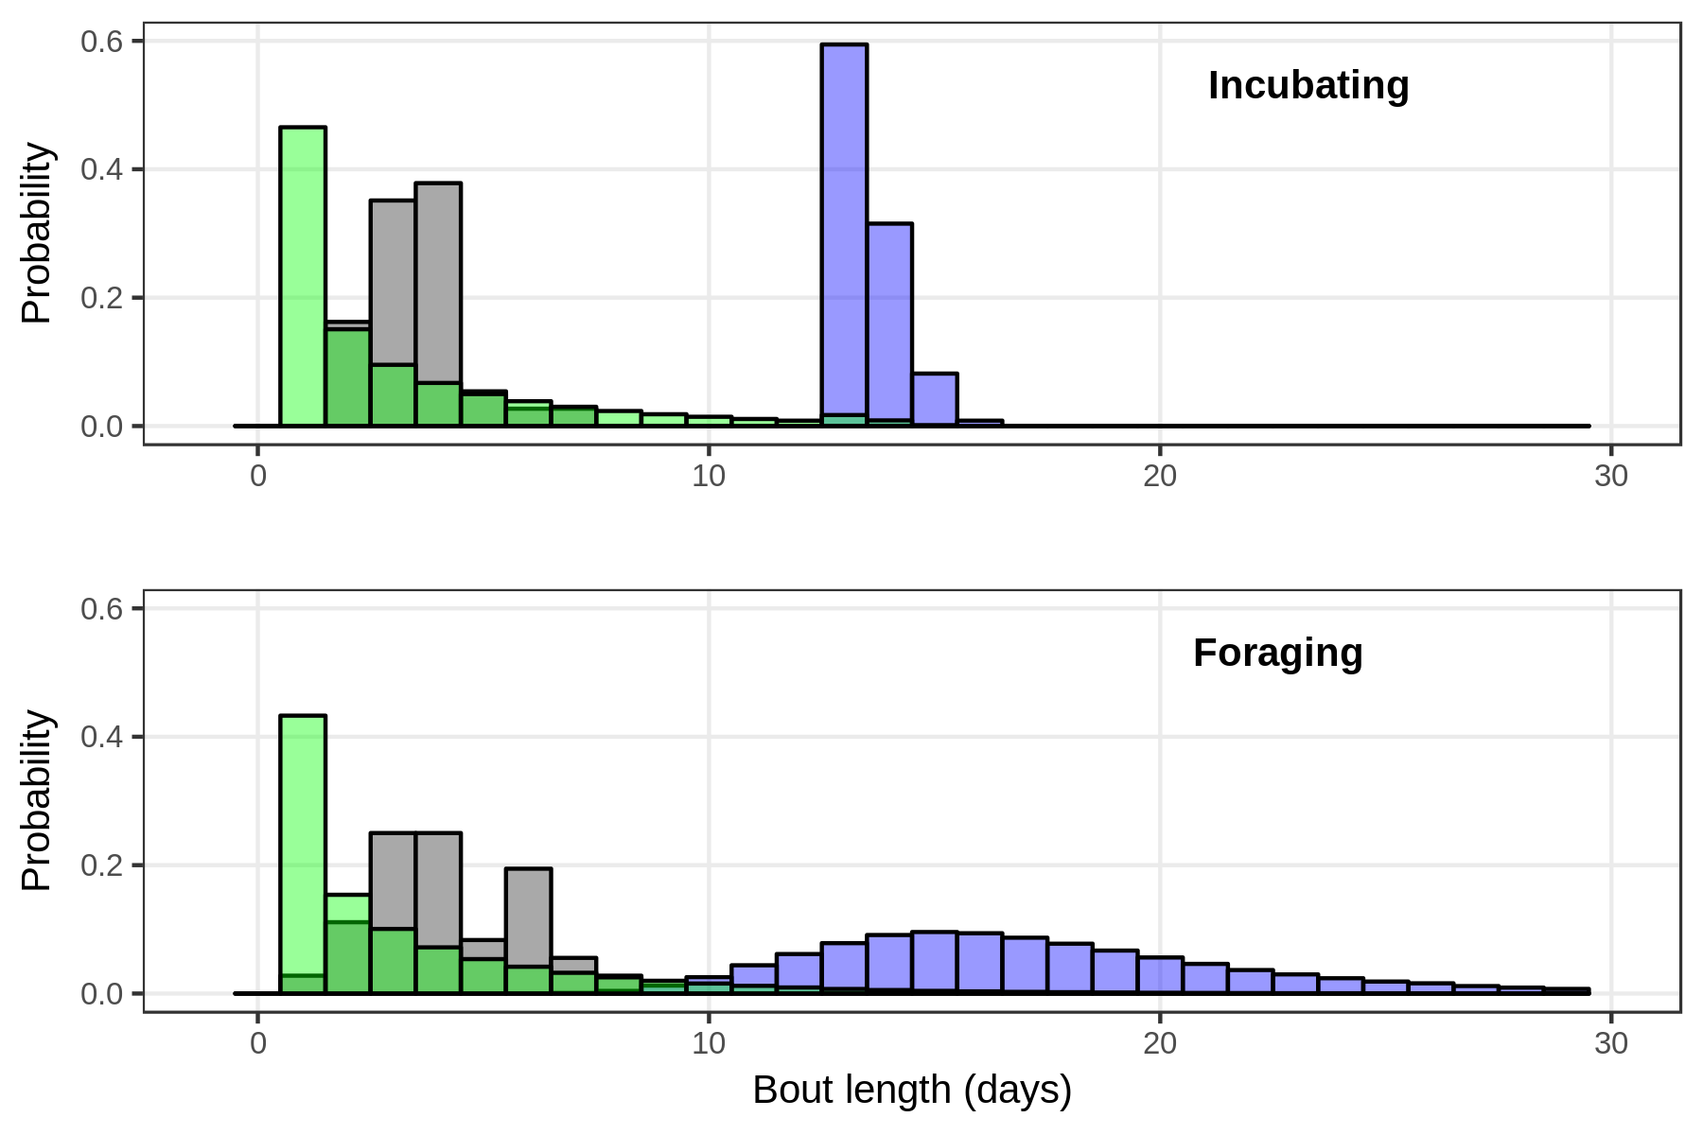

**Figure 1.** Length of consecutive incubating and foraging bouts by empirical (gray), NULL model (blue), or OVERLAP_SWAP model (green) adults of both sexes across the entire incubation season. Each model was run for 100,000 iterations. Empirical data were gathered from continuous real-time detection of actively breeding adults (N=8) on Kent Island using Passive Integrated Transponder tags (see [Zangmeister et al. 2009](https://www.zotero.org/google-docs/?dqDC13)for similar methods). Values > 30 days not shown.

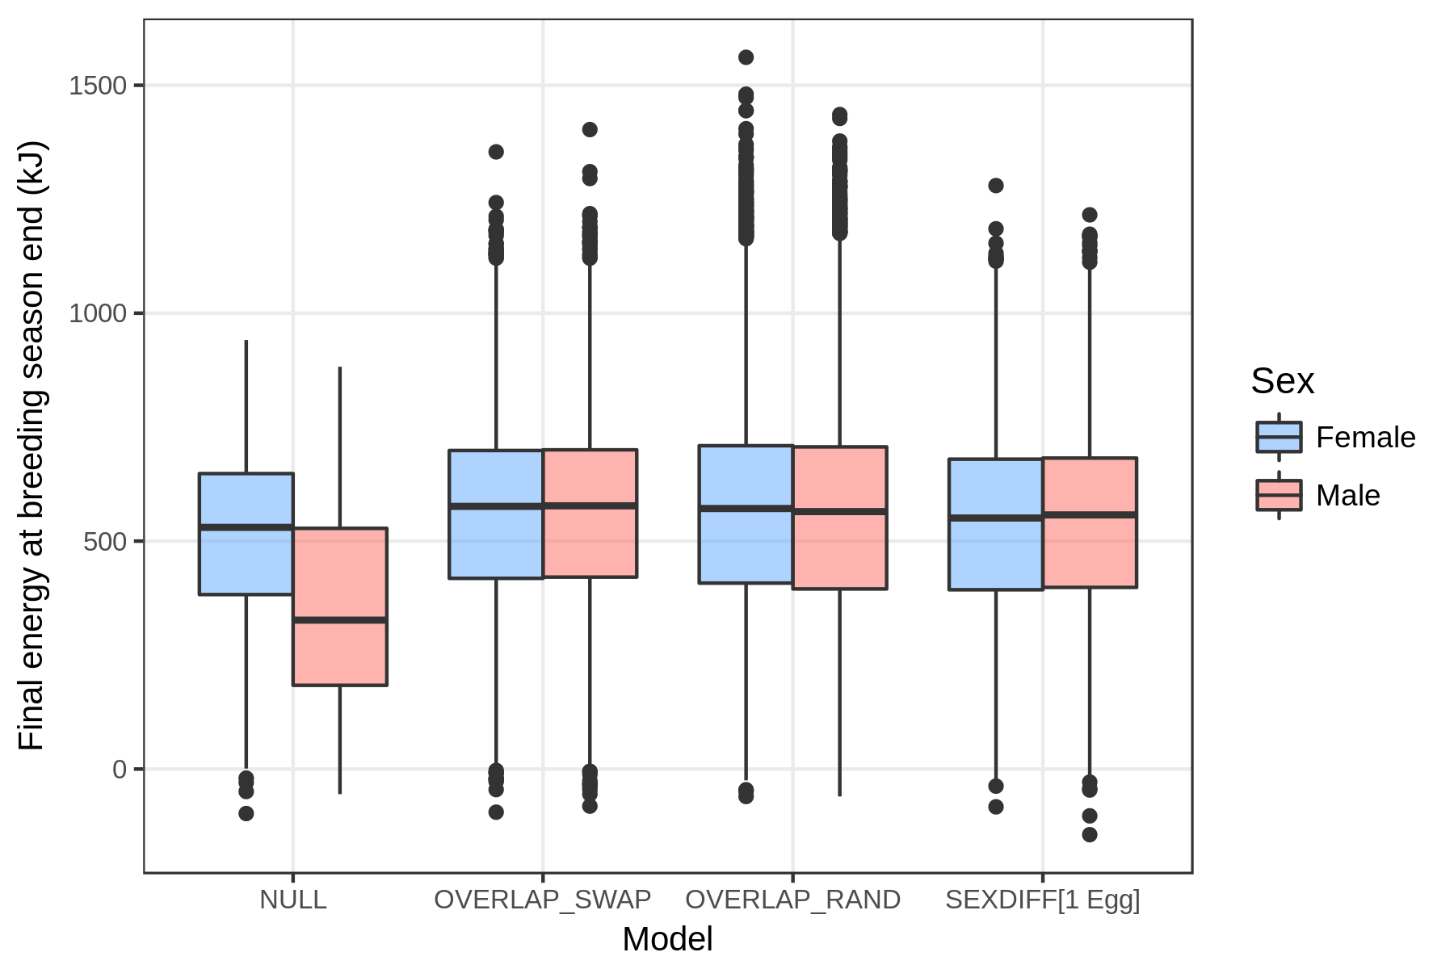

**Figure 2.** Final energy values from successful male and female breeders at the end of an incubation period. Successful breeders were taken from 100,000 iterations of each model. Significant differences are discussed in the text.

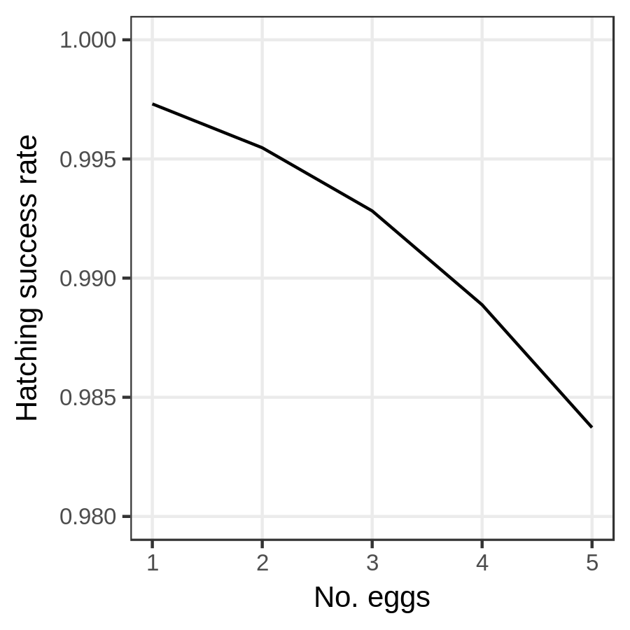

**Figure 3.** Hatching success rates from SEXDIFF models with different initial egg costs (100,000 iterations per parameter).

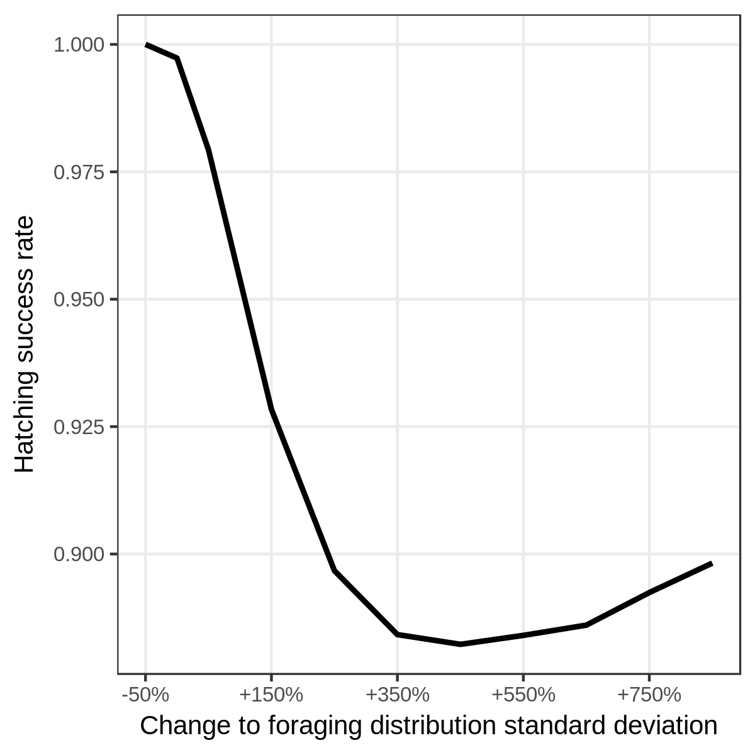

**Figure 4.** Hatching success rates from FORAGING_VAR models with different changes to the standard deviation of the foraging outcome distribution (100,000 iterations per parameter).

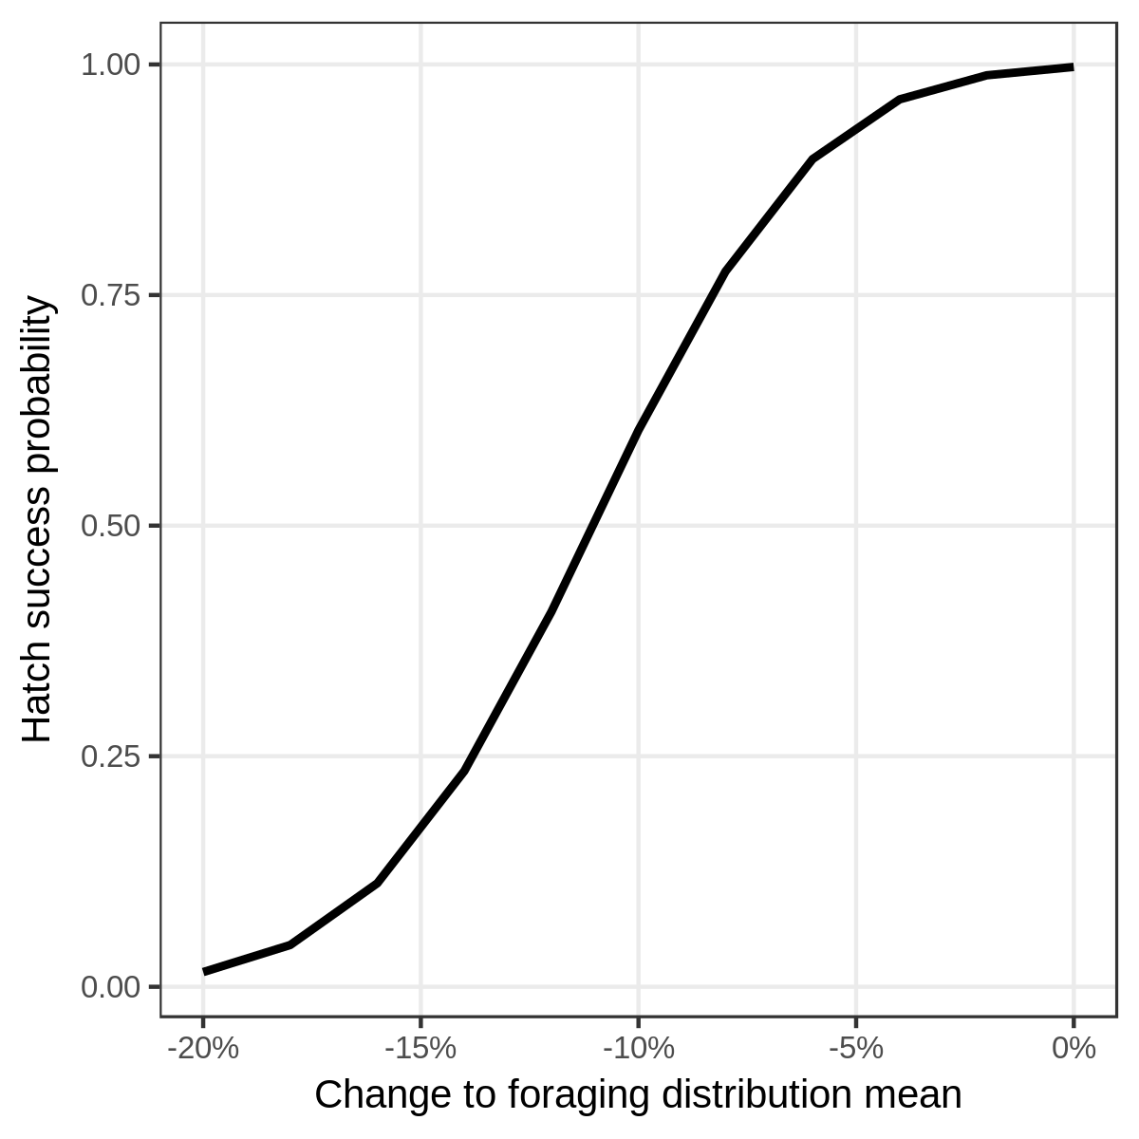

**Figure 5.** Hatching success rates from FORAGING_MEAN models with different changes to the mean of the foraging outcome distribution (100,000 iterations per parameter).