**Table 1.** The presence of core behavioral elements in male *Masius* courtship displays varies with audience context. By definition, all displays featured an Audible log-approach dive or a Side-to-side bow. SOLO (n = 308) displays lacked a female audience, AUDI (n = 102) displays featured a female audience but were unsuccessful, and COP (n = 13 across 3 males) displays ended in successful copulation. Single-letter codes used in display strings are given on the left. Voucher videos of behaviors are archived at the Macaulay Library of Natural Sounds at Cornell University.

|  |  |  |  |  |  |
| --- | --- | --- | --- | --- | --- |
|  |  | **% displays present** | | |  |
|  | **Behavior** | **SOLO** | **AUDI** | **COP** | **Description** |
| A. | Zero | 98 | 25 | 0 | Inactive (>5 s) while on display log |
| B. | Audible log-approach dive | 97 | 87 | 100 | Swoop with vocalization from near the canopy to log, with a dramatic snap and gymnastic vault upon landing |
| C. | Silent log-  approach dive | 71 | 1 | 0 | Same swoop as above, though lacking vocalization and often without vault |
| D. | Side-to-side bow | 85 | 100 | 100 | Movement from one edge of log to the other, then bowing head almost to log surface |
| E. | Half bow | 38 | 18 | 15 |  |
| F. | Head-down bow | 94 | 87 | 0 | Stationary, chin-down posture with head held close to the surface of log |
| G. | Metronome | 0 | 1 | 0 | Rhythmic swaying while perched near log |
| H. | Position switch | 7 | 45 | 8 | Rapid body rotation (generally ~45°) |
| I. | Neck twist | 9 | 95 | 69 | With feet planted, lowering the side of the head towards the surface of the log |
| J. | To-and-fro flight | 28 | 82 | 15 | Flights of variable duration and distance from the log and back. |
| K. | Mixed | 13 | 4 | 0 | Mixture of two defined elements |
| L. | Other | 24 | 7 | 8 | Uncharacterized or miscellaneous behaviors (e.g., wing flashing) |

**Table 2.** Male *Masius* courtship display behaviors change with female behavior. Females were either on or off the display log during each male behavior. When on the log, females could stand either upslope or downslope of the male. Males almost always performed Side-to-side bows when females were downslope on the log, but this situation was more common in successful (COP) displays. Total elements used to calculate percentages are given at the bottom. Some elements in the dataset lacked female location information, including some Audible log-approach dives that immediately preceded copulations.

|  |  |  |  |  |  |  |  |  |  |  |  |
| --- | --- | --- | --- | --- | --- | --- | --- | --- | --- | --- | --- |
|  |  | **% elements performed by males** | | | | | | | | | |
|  |  | **Female off log** | | | | **Female on log** | | **Female upslope** | | **Female downslope** | |
|  | **Behavior** | **SOLO** | | **AUDI** | **COP** | **AUDI** | **COP** | **AUDI** | **COP** | **AUDI** | **COP** |
| A. | Zero | 27 | 1 | | 0 | <1 | 0 | 0 | 0 | <1 | 0 |
| B. | Audible log-approach dive | 11 | 1 | | 0 | 3 | 2 | 0 | 0 | <1 | 0 |
| C. | Silent log-  approach dive | 8 | <1 | | 0 | 0 | 0 | 0 | 0 | 0 | 0 |
| D. | Side-to-side bow | 23 | 7 | | 3 | 67 | 96 | 2 | 0 | 97 | 99 |
| E. | Half bow | 3 | <1 | | 1 | <1 | <1 | 0 | 0 | <1 | <1 |
| F. | Head-down bow | 12 | 3 | | 0 | 20 | 0 | 68 | 0 | <1 | 0 |
| G. | Metronome | 0 | <1 | | 0 | 0 | 0 | 0 | 0 | 0 | 0 |
| H. | Position switch | 3 | 16 | | 9 | 0 | 0 | 0 | 0 | 0 | 0 |
| I. | Neck twist | 2 | 57 | | 80 | 10 | 2 | 30 | 100 | 2 | <1 |
| J. | To-and-fro flight | 5 | 15 | | 7 | <1 | 0 | 0 | 0 | <1 | 0 |
| K. | Mixed | 4 | <1 | | 0 | <1 | 0 | <1 | 0 | 0 | 0 |
| L. | Other | 2 | <1 | | 0 | <1 | <1 | 0 | 0 | <1 | <1 |
|  | **Total elements** | 7003 | 4555 | | 69 | 5062 | 736 | 1397 | 14 | 3419 | 709 |

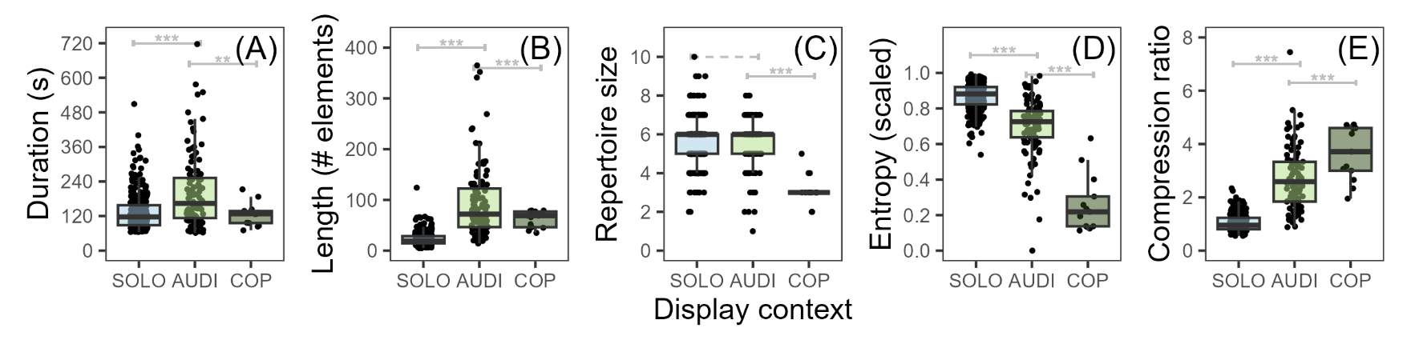**Figure 1.** Female audience context determinesthe constituent elements and syntactic arrangement of courtship displays by male *Masius*. Displays for a female audience (AUDI) had the same repertoire size as displays performed without an audience (SOLO), but were longer, arranged more predictably (i.e., lower entropy), and had a simpler and more repetitive syntax (i.e., higher compression ratio). In turn, successful displays ending in copulation (COP) were shorter than AUDI displays, had small repertoires, and were the simplest and most repetitive. A) Display duration in seconds. B) Display length in number of male behavioral elements. C) Repertoire size in number of distinct elements. D) Scaled first-order entropy. E) Compression ratio, calculated by translating displays into strings of individual behavior characters and compressing the strings via LZ77 and Huffman Coding. Gray brackets indicate significance from linear models, with AUDI as the intercept category and fixed effects for observation month and male ID (\*\**P* ≤ 0.01; \*\*\**P* ≤ 0.001; dashed = not significant).

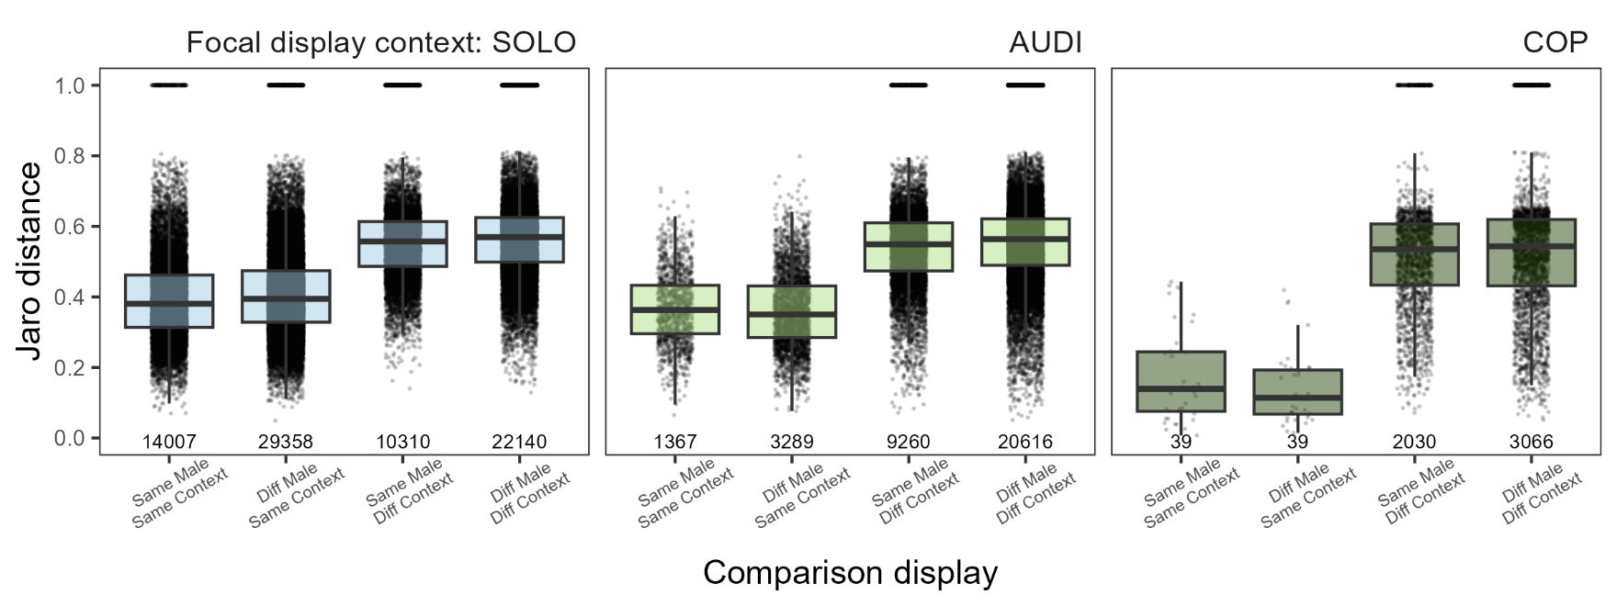**Figure 2.** The composition of *Masius* courtship displays is determined by female audience context (SOLO, AUDI, COP) more than male identity. Displays in every context are, on average, more similar to displays performed in the same context than to displays performed by the same male in different contexts. Jaro distance measures the syntax similarity of two displays coded as strings of male behavioral elements (0 = complete match, 1 = complete mismatch). Each point indicates Jaro distance between a display in the focal context and a second display. Values along the x-axis indicate the total number of pairwise comparisons.