**SUPPLEMENTARY MATERIAL**

Female audiences shape male courtship displays in a lek-mating bird

***Table of contents***

|  |  |  |  |
| --- | --- | --- | --- |
| p. | 2 | Table S1 | *Raw behavioral frequencies* |
| p. | 3 | Table S2 | *Male display activity* |
| p. | 4 | Table S3 | *Female audience activity* |
| p. | 5 | Table S4 | *Copulation display strings* |
| p. | 6 | Table S5 | *Final dataset of behavioral frequencies* |
| p. | 7 | Figure S1 | *Display observation dates* |
| p. | 8 | Figure S2 | *COP display characteristics* vs. *randomized subset* |
| p. | 9 | Figure S3 | *Entropy* vs. *compression* |
| p. | 10 | Figure S4 | *Display length (number of elements)* vs. *compression* |
| p. | 11 | Figure S5 | *Display length and repertoire size* vs. *Jaro distance* |
| p. | 12 | Figure S6 | *COP Jaro distances* vs. *randomized subsets* |
| pp. | 13-18 | Comparison of pre- and post-copulation displays | *Including Tables S6-8, Figs. S7-8* |
| pp. | 19-23 | Display characteristic linear modeling results |  |
|  |  |  |  |

**Table S1.** Original behavioral elements used in BORIS logging. *N* gives number of occurrences in raw dataset.

|  |  |  |  |
| --- | --- | --- | --- |
| **Element** | ***N*** | **Classification** | |
| Attempted Copulation | 11 | Excluded | Non-display |
| Bird2 ALAD | 55 | Excluded | Multiple male performers |
| Bird2 BowLeft | 695 | Excluded | Multiple male performers |
| Bird2 BowRight | 677 | Excluded | Multiple male performers |
| Bird2 Half-bow Left | 26 | Excluded | Multiple male performers |
| Bird2 Half-bow Right | 21 | Excluded | Multiple male performers |
| Bird2 HeadDownBowing | 56 | Excluded | Multiple male performers |
| Bird2 Mixed Element | 13 | Excluded | Multiple male performers |
| Bird2 NeckTwist | 1693 | Excluded | Multiple male performers |
| Bird2 On-log NO display | 79 | Excluded | Multiple male performers |
| Bird2 SLAD | 1 | Excluded | Multiple male performers |
| Bird2 TafLF_Off | 28 | Excluded | Multiple male performers |
| Bird2 TafLF_On | 26 | Excluded | Multiple male performers |
| Copulation | 24 | Excluded | Non-display |
| End | 485 | Excluded | Tracking |
| Female Looking Away | 1736 | Excluded | Female response |
| Female Movement | 978 | Excluded | Movement |
| Female Off Log | 320 | Excluded | Movement |
| Female On Log | 320 | Excluded | Movement |
| Female ResponseToALAD | 188 | Excluded | Female response |
| Female Tracking Male | 1924 | Excluded | Female response |
| FemaleSwitch | 406 | Excluded | Movement |
| Male1 ALAD | 1101 | Retained |  |
| Male1 BowLeft | 8083 | Partial | subsumed under Male1 Bow |
| Male1 BowRight | 7943 | Retained | As Male1 Bow |
| Male1 Half-bow Left | 296 | Partial | subsumed under Male1 Half-bow |
| Male1 Half-bow Right | 258 | Retained | As Male1 Half-bow |
| Male1 HeadDownBowing | 2357 | Retained |  |
| Male1 Metronome_Left | 11 | Partial | subsumed under Male1 Metronome |
| Male1 Metronome_Right | 25 | Retained | As Male1 Metronome |
| Male1 Mixed Element | 361 | Retained |  |
| Male1 NeckTwist | 5618 | Retained |  |
| Male1 Off Log | 41 | Excluded | Movement |
| Male1 On Log | 39 | Excluded | Movement |
| Male1 On Log No Display | 2220 | Retained | Movement |
| Male1 Other Behavior | 2139 | Partially retained | Excluded if specified as  “Vocalization” or “Gardening” |
| Male1 SLAD | 655 | Retained |  |
| Male1 Switch | 1145 | Retained |  |
| Male1 TafLF_Off | 1191 | Partial | subsumed under Male1 Taf |
| Male1 TafLF_On | 1220 | Retained | As Male1 Taf |
| Start | 485 | Excluded | Tracking |

**Table S2**. Individual male display activity in the final dataset. Band IDs correspond to the unique suffix on an individual aluminum leg band.

|  |  |  |  |  |  |  |  |
| --- | --- | --- | --- | --- | --- | --- | --- |
| **Band ID** | **Date banded** | **Plumage at banding** | **SOLO** | **AUDI** | **COP** | **First display** | **Last display** |
| 112 | 2017-09-23 | Definitive | 13 | 11 | 0 | 2017-10-03 | 2017-12-20 |
| 113 | 2017-09-17 | Definitive | 5 | 1 | 0 | 2017-11-11 | 2017-11-26 |
| 296 | 2015-07-10 | Definitive | 143 | 47 | 9 | 2016-06-24 | 2017-12-20 |
| 299 | 2017-10-25 | Definitive | 19 | 3 | 0 | 2017-11-10 | 2017-11-27 |
| 940 | 2013-05-26 | Definitive | 7 | 4 | 1 | 2015-01-01 | 2015-01-14 |
| 948 | 2013-06-10 | Predefinitive | 1 | 1 | 0 | 2016-08-15 | 2016-08-15 |
| 965 | 2014-07-03 | Definitive | 23 | 4 | 0 | 2015-08-06 | 2017-10-02 |
| 975 | 2014-07-22 | Definitive | 1 | 0 | 0 | 2016-07-22 | 2016-07-22 |
| 976 | 2014-07-22 | Predefinitive | 1 | 1 | 0 | 2016-07-30 | 2016-07-30 |
| 978 | 2014-07-23 | Definitive | 0 | 4 | 0 | 2015-08-12 | 2015-08-19 |
| 980 | 2014-07-24 | Definitive | 82 | 21 | 3 | 2015-08-03 | 2017-12-20 |
| *Unk* |  |  | 12 | 5 | 0 | 2015-08-23 | 2017-10-25 |

**Table S3.** Individual female audience activity. Band IDs correspond to the unique suffix on an individual aluminum leg band. Unknown birds were either suspected female, suspected predefinitive male, or completely unknown given plumage and behavior.

|  |  |  |  |  |  |  |  |
| --- | --- | --- | --- | --- | --- | --- | --- |
| **Band ID** | **Date banded** | **AUDI** | **COP** | **First audience** | **Last audience** | **Males viewed** | **Males copulated** |
| 118 | 2017-09-29 | 2 | 0 | 2017-11-19 | 2017-12-07 | 112, 296 |  |
| 289 | 2015-07-28 | 7 | 0 | 2017-10-09 | 2017-12-20 | 112, 980 |  |
| 292 | 2015-07-26 | 1 | 0 | 2015-08-23 | 2015-08-23 | *Unk* |  |
| 294 | 2015-07-19 | 6 | 0 | 2015-08-23 | 2017-11-21 | 296, *Unk* |  |
| 295 | 2015-07-14 | 3 | 1 | 2015-08-23 | 2017-12-08 | 296, 299, *Unk* | 296 |
| 299 | 2017-10-25 | 1 | 0 | 2017-11-15 | 2017-11-15 | 113 |  |
| 935 | 2013-05-28 | 3 | 0 | 2016-07-30 | 2017-12-02 | 112, 296, 976 |  |
| 936 | 2013-05-26 | 0 | 2 | 2017-11-15 | 2017-12-10 | 296 | 296 |
| 959 | 2015-01-06 | 0 | 1 | 2017-12-06 | 2017-12-06 | 296 | 296 |
| 972 | 2014-07-15 | 1 | 0 | 2017-10-26 | 2017-10-26 | 980 |  |
| 981 | 2016-07-06 | 8 | 0 | 2016-08-15 | 2017-12-15 | 112, 296, 299, 948, 965 |  |
| 984 | 2014-07-28 | 1 | 0 | 2017-11-26 | 2017-11-26 | 296 |  |
| 988 | 2014-08-03 | 1 | 0 | 2015-01-10 | 2015-01-10 | 940 |  |
| *Female?* |  | 27 | 8 | 2015-01-01 | 2017-12-20 | 112, 296, 940, 965, 980, *Unk* | 296, 980 |
| *Male?* |  | 26 | 1 | 2015-01-01 | 2017-12-20 | 112, 296, 299, 940, 978, 980 | 940 |
| *Unk* |  | 22 | 0 | 2017-10-25 | 2017-12-20 | 112, 113, 296, 299, 980 |  |

**Table S4.** Coded display strings for *Masius* displays that resulted in successful copulation (COP). Copulation occurred following the final behavioral element. Total duration (seconds), length (number of elements), entropy (scaled), and compression (ratio of uncompressed to compressed string lengths) are given for each display. See Table S5 for behavioral codes.

|  |  |  |  |  |  |  |  |
| --- | --- | --- | --- | --- | --- | --- | --- |
| **Display ID** | **Male** | **Date** | **Duration** | **Length** | **Entropy** | **Compression** | **Coded display string** |
| 1455 | 296 | 2017-11-15 | 187 | 79 | 0.22 | 4.4 | IIDDDDDDDEDDDDDDDDDDDDDDDDDDDDDDDDDDDDDD DDDDDDDDDDDDDDDDDDDDDDDDDDDDDDDDDDDDDEB |
| 1533 | 296 | 2017-11-19 | 128 | 66 | 0.11 | 4.7 | DDDDDDDDDDDDDDDDDDDDDDDDDDDDDDDDDDDDDDDD DDDDDDDDDDDDDDDDDDDDDDDDDB |
| 1558 | 296 | 2017-11-20 | 143 | 78 | 0.12 | 4.6 | EDDDDDDDDDDDDDDDDDDDDDDDDDDDDDDDDDDDDDDD DDDDDDDDDDDDDDDDDDDDDDDDDDDDDDDDDDDDDB |
| 1817 | 296 | 2017-12-05 | 84 | 46 | 0.26 | 3.1 | IIDDDDDDDDDDDDDDDDDDDDDDDDDDDDDDDDDDDDDD DDDDDB |
| 1824 | 296 | 2017-12-06 | 97 | 77 | 0.63 | 2.7 | IIIIIIIIIIIDDDIIIIIIIIDDDIIIIIIIIDDDDDDD DDDDDDIIIIIIIIIIIIIDDDDDIIIIIIIIIIIDB |
| 1878 | 296 | 2017-12-08 | 134 | 79 | 0.40 | 3.2 | JJHHHHHHIIIIDDDDDDDDDDDDDDDDDDDDDDDDDDDD DDDDDDDDDDDDDDDDDDDDDDDDDDDDDDDDDDDDDDB |
| 1920 | 296 | 2017-12-10 | 86 | 45 | 0.19 | 3 | IDDDDDDDDDDDDDDDDDDDDDDDDDDDDDDDDDDDDDDD DDDDB |
| 1987 | 296 | 2017-12-13 | 96 | 39 | 0.51 | 2 | IIDDDDDDDDDDDDDDDDDDDDDDDDDDDDJJJIIDDDB |
| 2020 | 296 | 2017-12-15 | 213 | 71 | 0.13 | 4.7 | DDDDDDDDDDDDDDDDDDDDDDDDDDDDDDDDDDDDDDDD DDDDDDDDDDDDDDDDDDDDDDDDDLDDDDB |
| 5005 | 940 | 2015-01-14 | 70 | 35 | 0.24 | 2.3 | IDDDDDDDDDDDDDDDDDDDDDDDDDDDDDDDDDB |
| 989 | 980 | 2017-10-26 | 138 | 52 | 0.14 | 3.7 | DDDDDDDDDDDDDDDDDDDDDDDDDDDDDDDDDDDDDDDD DDDDDDDDDDDB |
| 991 | 980 | 2017-10-26 | 127 | 69 | 0.3 | 4.6 | IIIIIDDDDDDDDDDDDDDDDDDDDDDDDDDDDDDDDDDD DDDDDDDDDDDDDDDDDDDDDDDDDDDDB |
| 992 | 980 | 2017-10-26 | 132 | 69 | 0.14 | 4.6 | IDDDDDDDDDDDDDDDDDDDDDDDDDDDDDDDDDDDDDDD DDDDDDDDDDDDDDDDDDDDDDDDDDDDB |

**Table S5.** Behavioral element frequencies in the final dataset.

|  |  |  |  |  |
| --- | --- | --- | --- | --- |
|  | **Behavior** | **SOLO** | **AUDI** | **COP** |
| A. | Zero | 1924 | 46 | 0 |
| B. | Audible log-approach dive | 785 | 162 | 13 |
| C. | Silent log-approach dive | 582 | 1 | 0 |
| D. | Side-to-side bow | 1627 | 3729 | 706 |
| E. | Half bow | 186 | 19 | 3 |
| F. | Head-down bow | 836 | 1112 | 0 |
| G. | Metronome | 0 | 3 | 0 |
| H. | Position switch | 205 | 722 | 6 |
| I. | Neck twist | 108 | 3118 | 71 |
| J. | To-and-fro flight | 335 | 689 | 5 |
| K. | Mixed | 271 | 5 | 0 |
| L. | Other | 144 | 11 | 1 |

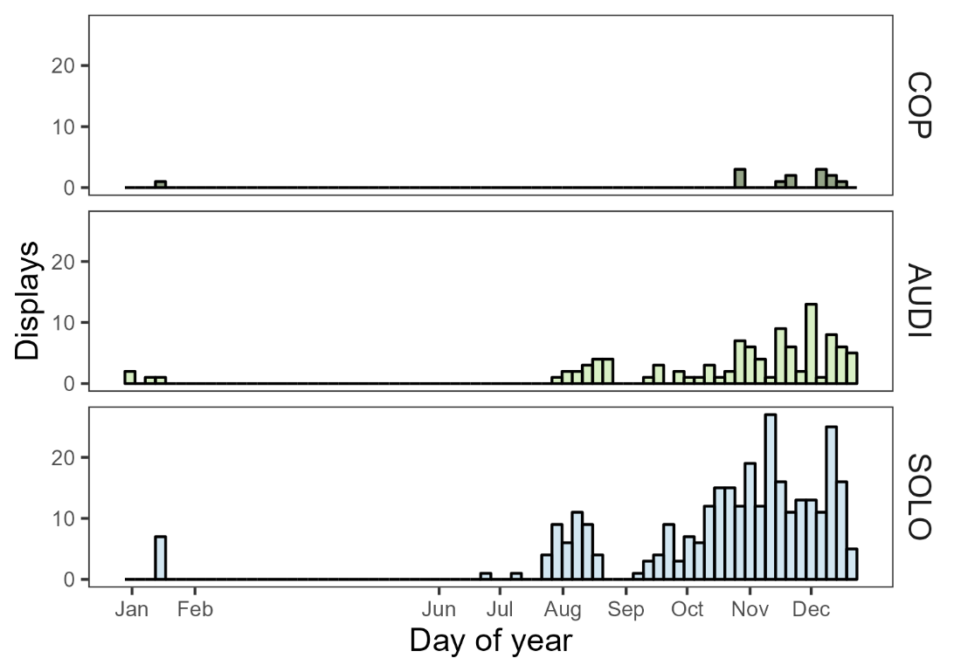

**Figure S1.** Observation dates of male *Masius* displays in the final dataset (2015-2017). Observation effort varied across the date range.

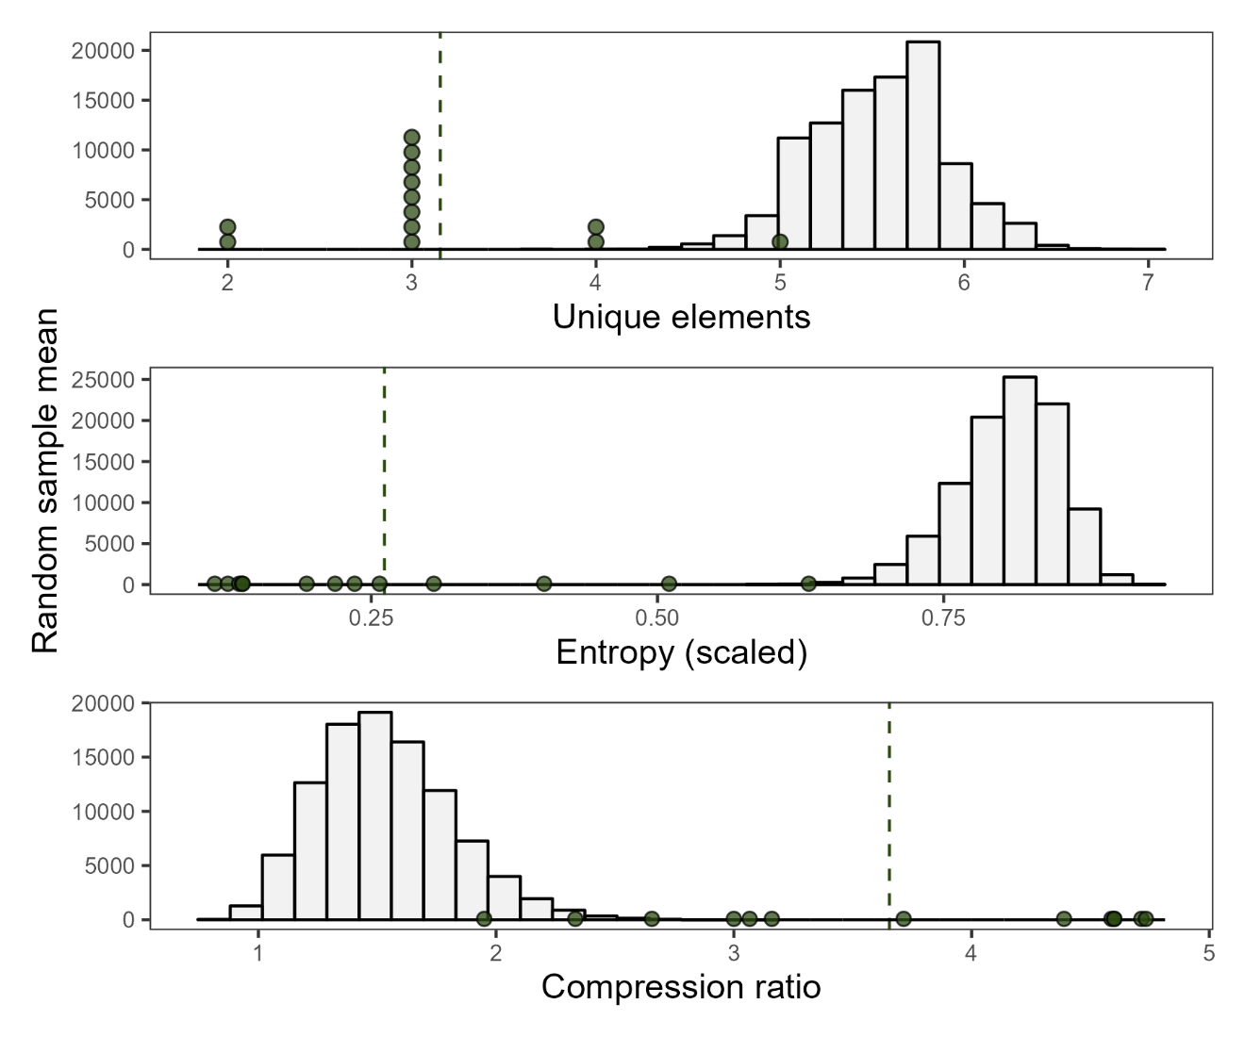

**Figure S2.** Comparison between empirical means from the small sample of COP displays (n = 13 across 3 males) and randomized mean values from total display dataset. Distributions show 100,000 mean values, with each mean value calculated from 13 displays drawn randomly, without replacement, from the full dataset. Green points indicate empirical values from COP displays, with dashed green line indicating the mean of the empirical COP values.

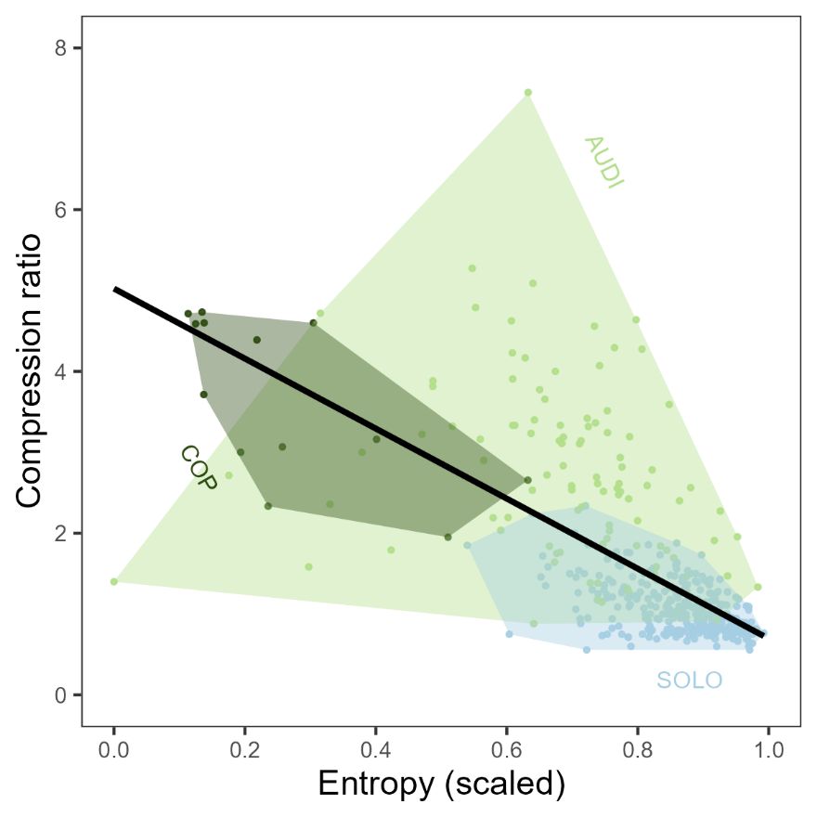

**Figure S3.** Correlation between entropy and compression ratio, two measures of syntactic complexity, in *Masius* courtship displays. Wide variation in their combinations characterized the differences between these metrics. For example, the most compressible display string (AUDI ID-1487, compression ratio = 7.45) had intermediate entropy (0.63) but was long, with 365 total elements; it consisted primarily of long stretches of Side-to-side bows and Neck twists. A display with similar entropy but much lower compression ratio (AUDI ID-453, scaled entropy = 0.64, compression ratio = 2.53) was shorter, with 81 elements, and featured a tail of distinct behaviors (coded “IEDBA”) that made it less compressible. Linear regression *P* < 0.001, adjusted *R2*= 0.46.

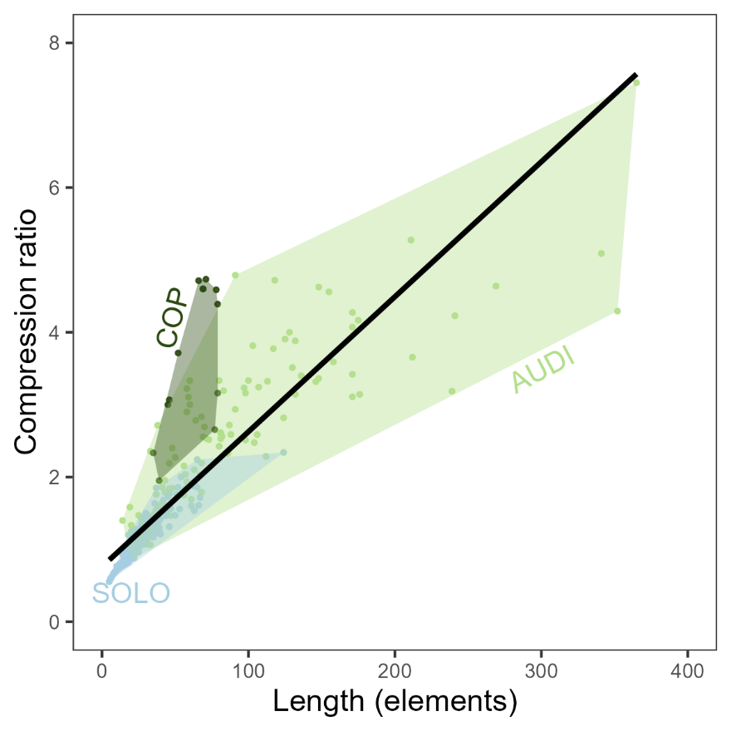

**Figure S4.** Correlation between display length (total number of elements) and compression ratio (the ratio of uncompressed display string length to compressed string length). Note that COP displays did not fall along the regression line; they were significantly shorter than AUDI displays, but, contrary to the expected correlation between the metrics, were also significantly more compressible. Linear regression *P* < 0.001, adjusted *R2*= 0.74. The high compressibility of COP displays was due largely to the presence of long strings of Side-to-side Bow elements (coded as D in Table S4).

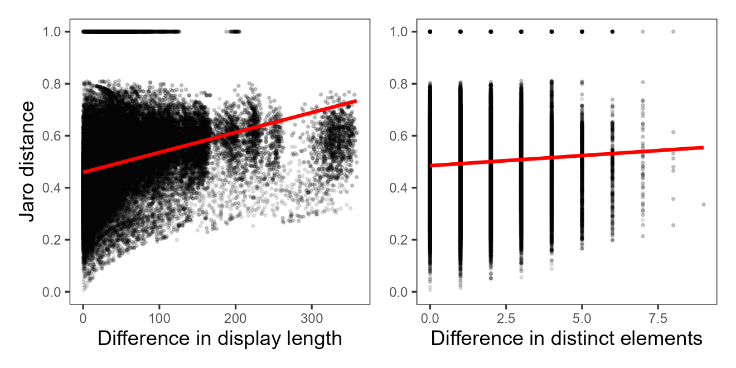

**Figure S5.** Correlations between Jaro distance and (*Left*) absolute difference in display lengths or *(Right)* absolute difference in number of distinct elements between two displays. Red lines show significant but poorly-fitting linear regressions. Jaro distance ~ Difference in display length: *P* < 0.001, adjusted *R2* = 0.09; Jaro distance ~ Difference in unique elements: *P* < 0.001, *R2 <* 0.01.

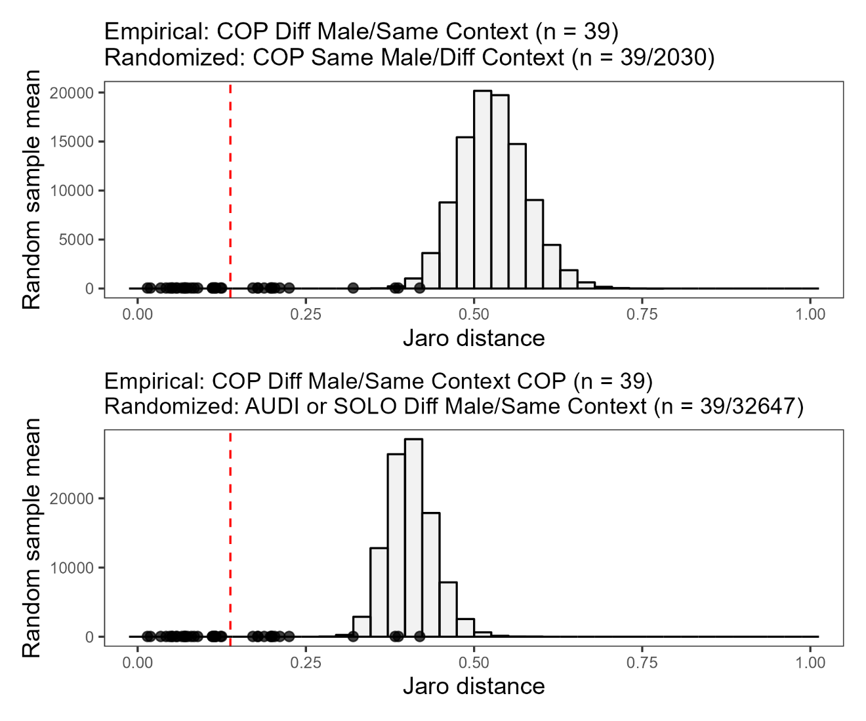

**Figure S6.** Jaro distances involving the small sample of COP displays (n = 13 across 3 males) and randomized mean Jaro distance values from total dataset. Black points in both panels show empirical Jaro distances between a particular male's COP display and a COP display by a different male. Red dashed lines indicate empirical mean Jaro distance across all 39 of those COP-COP comparisons (n = 39 comparisons total). *(Top)* Distribution shows 100,000 mean values of 39 Jaro distances each, where each Jaro distance is drawn from comparisons between a COP display and an AUDI or SOLO display by the same male. (*Bottom*) Distributions show 100,000 mean values of 39 Jaro distances each, where each Jaro distance is drawn from comparisons between a particular male's AUDI or SOLO display and a display by a different male in the same context.

**COMPARSION OF PRE- AND POST-COPULATION DISPLAYS**

In our main analyses, we end successful displays (COP) at the first copulation. However, the males in all 13 COP displays continued performing after this point. Post-copulation displays ranged from 12 to 139 elements in length, featuring both qualitatively and quantitatively different arrays of behaviors compared to pre-copulation displays (Table S6). Side-to-side bows were less frequent post-copulation, whereas long stretches of Neck twists were far more frequent (Tables S6-7). Notably, three elements missing from pre-copulation displays appeared in some post-copulation displays: pauses (“Zero”), Head-down bows, and the rare Metronome behavior. Although males performed Half bows, Position switches, and To-and-fro flights in one or two pre-copulation displays, these elements were absent following copulation (Table S6).

Seven of 13 after-copulation displays featured additional copulations (1-3 copulations each; Table S7), while one featured an attempted copulation (ID#1987; Table S7). As in before-copulation displays, every copulation in after-copulation displays followed an Audible log-approach dive. All but one of these additional copulations—including the attempted copulation—followed a Side-to-side Bow into Audible log-approach dive combination. One after-copulation display (ID#992) featured three successful copulations, each following a Side-to-side Bow into Audible log-approach dive sequence (Table S7). The lone exception (ID#1920) featured a second copulation following a Neck twist into Audible log-approach dive.

Repertoire size, in terms of number of unique display elements, was similar before and after copulation (mean ± SD unique elements before: 3.15 ± 0.80, after: 3.31 ± 0.95; paired two-sided T-test *t* = -0.46, *P* = 0.66; Fig. S7). However, post-copulation displays had a more complicated arrangement. Post-copulation displays had significantly higher entropy (mean ± SD scaled entropy pre: 0.26 ± 0.16, post: 0.52 ± 0.19; *t* = -3.91, *P* < 0.01; Fig. S7), and were significantly less compressible than pre-copulation displays (compression ratio pre: 3.65 ± 1.01, post: 2.62 ± 1.48; *t* = 3.07, *P* < 0.01; Fig. S6).

Using Jaro distances, we found that nearly every pre-copulation display (12/13) was on average more similar to other pre-copulation displays than to post-copulation displays, including the post-copulation section of the same display (Fig. S8). The lone exception was the unusual pre-copulation display that, like several post-copulation displays, featured sections of Neck twists (ID#1824, Table S7; Fig. S8).

In parallel with our main results, an analysis of female behaviors during pre- and post-copulation displays demonstrates a close tie between female attendance and male display behaviors. Both pre- and post-copulation, males performed mainly Neck twists when females were off the log, or upslope on the log (Table S8). Alternatively, males performed mainly Side-to-side bows when females were downslope on the log (Table S8). Females attended the display log for a significantly greater proportion of pre-copulation displays (92.0 ± 13.3% male elements with female on log) compared to post-copulation displays (33.7 ± 33.4%; *t* = 5.83, *P* < 0.001). However, there was no significant difference in the proportion of displays females spent downslope on the log (pre-copulation: 97.2 ± 10.0% male elements with female downslope; post-copulation: 81.5 ± 34.7%; *t* = 1.51, *P* = 0.16). As in our comparison of AUDI and COP displays (main text Table 2), we can thus understand the greater proportion of Neck twists in post-copulation displays as a function of Neck twists being more likely when females were off the log, and females being off the log more frequently in post-copulation displays.

**Table S6.** Behavioral element frequencies across before-copulation (COP) and after-copulation displays (n = 13 from 3 males). Elements *M* (Attempted copulation) and *N* (Copulation) are shown here but excluded from other analyses.

|  |  |  |  |
| --- | --- | --- | --- |
|  | **Element *N*** | **Before** | **After** |
| A. | Zero | 0 | 4 |
| B. | Audible log-approach dive | 13 | 12 |
| C. | Silent log-approach dive | 0 | 0 |
| D. | Side-to-side bow | 706 | 166 |
| E. | Half bow | 3 | 0 |
| F. | Head-down bow | 0 | 9 |
| G. | Metronome | 0 | 8 |
| H. | Position switch | 6 | 0 |
| I. | Neck twist | 71 | 387 |
| J. | To-and-fro flight | 5 | 0 |
| K. | Mixed | 0 | 0 |
| L. | Other | 1 | 2 |
| M. | Attempted copulation | 0 | 1 |
| N. | Copulation | 13 | 9 |

**Table S7.** Coded display strings for pre-copulation (COP) and corresponding post-copulation displays. See Table S6 for single-character behavior codes. Elements *M* (Attempted copulation) and *N* (Copulation) are shown here but excluded from quantitative analyses. Lines break every 40 characters.

|  |  |  |  |
| --- | --- | --- | --- |
| **Display** | **Male** | **Before first copulation (COP)** | **After copulation** |
| 1455 | 296 | IIDDDDDDDEDDDDDDDDDDDDDDDDDDDDDDDDDDDDDD DDDDDDDDDDDDDDDDDDDDDDDDDDDDDDDDDDDDDEBN | DIIIIIIIIIIIIIIIIIIIIIIIIIIIIIIIIIIIIII |
| 1533 | 296 | DDDDDDDDDDDDDDDDDDDDDDDDDDDDDDDDDDDDDDDD DDDDDDDDDDDDDDDDDDDDDDDDDBN | IDDDIIIIIIIIIIIIIIIIIIIIIIIIIIIIIIIIIIII IIIIIIIIIDDDDDDDDDDIIIIIIIIDIIDII |
| 1558 | 296 | EDDDDDDDDDDDDDDDDDDDDDDDDDDDDDDDDDDDDDDD DDDDDDDDDDDDDDDDDDDDDDDDDDDDDDDDDDDDDBN | IIIIIBFDIIIIIIIIIIIIIGGGGGGGGIIIIIIIIIII IIIIIIIIIIIIIIIIIIIIIII |
| 1817 | 296 | IIDDDDDDDDDDDDDDDDDDDDDDDDDDDDDDDDDDDDDD DDDDDBN | IDBNDDDIIIIIIIIIIIIIIAIAIIAIIIIIIIIIIIII IIIII |
| 1824 | 296 | IIIIIIIIIIIDDDIIIIIIIIDDDIIIIIIIIDDDDDDD DDDDDDIIIIIIIIIIIIIDDDDDIIIIIIIIIIIDBN | DBNDDIIIIIIIIIIIIIIIIIIIIIIIIIIIIIIIIIII IIIIIIIII |
| 1878 | 296 | JJHHHHHHIIIIDDDDDDDDDDDDDDDDDDDDDDDDDDDD DDDDDDDDDDDDDDDDDDDDDDDDDDDDDDDDDDDDDDBN | DBNDDDDDDDDDDDIII |
| 1920 | 296 | IDDDDDDDDDDDDDDDDDDDDDDDDDDDDDDDDDDDDDDD DDDDBN | IIIIIIIIBNIIIIIDDDDDDDDDIIIIIIIIIIIIIILL |
| 1987 | 296 | IIDDDDDDDDDDDDDDDDDDDDDDDDDDDDJJJIIDDDBN | DBMDDIIIIIIIA |
| 2020 | 296 | DDDDDDDDDDDDDDDDDDDDDDDDDDDDDDDDDDDDDDDD DDDDDDDDDDDDDDDDDDDDDDDDDLDDDDBN | DBFFFFFFFFIIIIIIIIIIIIIIIIIIIIIIIIIII |
| 5005 | 940 | IDDDDDDDDDDDDDDDDDDDDDDDDDDDDDDDDDBN | IIDDDDDDDDDDD |
| 989 | 980 | DDDDDDDDDDDDDDDDDDDDDDDDDDDDDDDDDDDDDDDD DDDDDDDDDDDBN | DDBNIIIIIIIIIIIIIIIIIIIIIIIIIIIIIIIIIIII  I |
| 991 | 980 | IIIIIDDDDDDDDDDDDDDDDDDDDDDDDDDDDDDDDDDD DDDDDDDDDDDDDDDDDDDDDDDDDDDDBN | DBNIIIIIDDDDDDDDDDDDDDDDDDII |
| 992 | 980 | IDDDDDDDDDDDDDDDDDDDDDDDDDDDDDDDDDDDDDDD DDDDDDDDDDDDDDDDDDDDDDDDDDDDBN | DDDBNIIIIIIIIIIIIIIIIIIDDDDDDDDDDDDDDDDD DDDDDDDDDDDDDDDDDDDDDDDDDDDDDDDDDDDDDDDD DDDDDDDDDDDDDDDDDDDDDDBNDDDBNIIIIIIIIIII IIIIIIIIIIIIIIIIIIII |

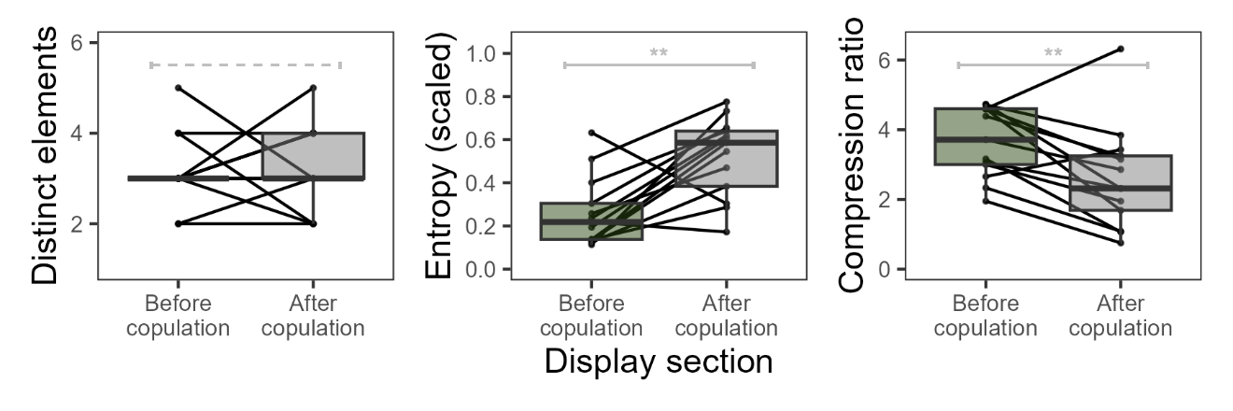

**Figure S7.** Characteristics of male *Masius* displays preceding copulation (COP) and immediately afterwards.Black lines connect pre- and post-copulation sections of the same display, separated by first copulation. Gray brackets indicate paired, two-sided T-tests (\*\**P <* 0.01; dashed = not significant).

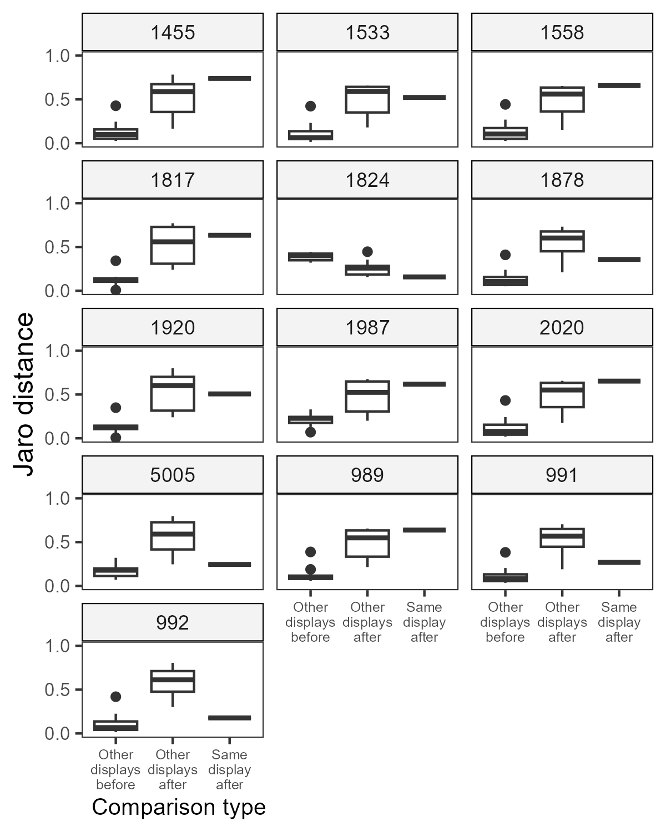

**Figure S9.** Jaro distances between each pre-copulation (COP) display and three sets of comparison displays: (A) other pre-copulation displays (n = 12), (B) other post-copulation displays (n = 12), and (C) the post-copulation section from the same display sequence (n = 1). Lower Jaro distances indicate higher similarity in the syntax of male behavioral elements. Display ID is given above each set of comparisons.

**Table S8.** Frequency of male behaviors during pre-copulation (before) and post-copulation (after) displays. Females were either on or off the display log during each male behavior. When on the log, females could stand either upslope or downslope of the male. Total elements used to calculate percentages are given at the bottom.

|  |  |  |  |  |  |  |  |  |  |
| --- | --- | --- | --- | --- | --- | --- | --- | --- | --- |
|  |  | **% elements performed by males** | | | | | | | |
|  |  | **Female off log** | | **Female on log** | | **Female upslope** | | **Female downslope** | | |
|  | **Behavior** | **Before** | **After** | **Before** | **After** | **Before** | **After** | **Before** | **After** | |
| A. | Zero | 0 | 1 | 0 | 0 | 0 | 0 | 0 | 0 | |
| B. | Audible log-approach dive | 0 | <1 | 2 | 5 | 0 | 0 | 0 | 0 | |
| D. | Side-to-side bow | 3 | 5 | 96 | 65 | 0 | 0 | 99 | 98 | |
| E. | Half bow | 1 | 0 | <1 | 0 | 0 | 0 | <1 | 0 | |
| F. | Head-down bow | 0 | <1 | 0 | 4 | 0 | 12 | 0 | 0 | |
| G. | Metronome | 0 | 2 | 0 | 0 | 0 | 0 | 0 | 0 | |
| H. | Position switch | 9 | 0 | 0 | 0 | 0 | 0 | 0 | 0 | |
| I. | Neck twist | 80 | 91 | 2 | 26 | 100 | 88 | <1 | 2 | |
| J. | To-and-fro flight | 7 | 0 | 0 | 0 | 0 | 0 | 0 | 0 | |
| L. | Other | 0 | 1 | <1 | 0 | 0 | 0 | <1 | 0 | |
|  | **Total elements** | 69 | 360 | 736 | 228 | 14 | 66 | 709 | 151 | |

**DISPLAY CHARACTERISTIC LINEAR MODELING RESULTS**

**Duration (s)**

Call:

lm(formula = Duration ~ Category + as.character(ObsMonth) + UniqueMale1ID,

data = data_analyzed)

Residuals:

Min 1Q Median 3Q Max

-177.45 -43.19 -13.72 25.79 490.50

Coefficients: (1 not defined because of singularities)

Estimate Std. Error t value Pr(>|t|)

(Intercept) 172.317 23.974 7.188 3.43e-12 ***

CategoryCOP -79.402 23.972 -3.312 0.00101 **

CategorySOLO -81.943 9.712 -8.438 6.59e-16 ***

as.character(ObsMonth)10 30.307 31.056 0.976 0.32973

as.character(ObsMonth)11 22.813 30.729 0.742 0.45829

as.character(ObsMonth)12 26.834 28.342 0.947 0.34435

as.character(ObsMonth)6 154.537 85.264 1.812 0.07069 .

as.character(ObsMonth)7 68.640 40.173 1.709 0.08833 .

as.character(ObsMonth)8 64.356 34.074 1.889 0.05968 .

as.character(ObsMonth)9 49.948 37.217 1.342 0.18036

UniqueMale1ID113 -1.031 38.427 -0.027 0.97861

UniqueMale1ID296 3.743 18.705 0.200 0.84149

UniqueMale1ID299 11.084 26.556 0.417 0.67662

UniqueMale1ID8000-110 -21.813 85.139 -0.256 0.79793

UniqueMale1ID8000-150 -90.778 86.350 -1.051 0.29378

UniqueMale1ID8000-157 -4.062 85.139 -0.048 0.96197

UniqueMale1ID8000-213 349.986 86.350 4.053 6.11e-05 ***

UniqueMale1ID8000-220 -53.573 85.139 -0.629 0.52956

UniqueMale1ID8000-234 -82.731 86.350 -0.958 0.33861

UniqueMale1ID8000-235 43.560 86.350 0.504 0.61423

UniqueMale1ID8000-259 -85.792 86.350 -0.994 0.32107

UniqueMale1ID8000-260 -72.044 86.350 -0.834 0.40461

UniqueMale1ID8000-263 -79.097 86.350 -0.916 0.36023

UniqueMale1ID8000-32 -138.620 85.097 -1.629 0.10414

UniqueMale1ID8000-343 63.361 83.781 0.756 0.44995

UniqueMale1ID8000-5010 8.599 83.824 0.103 0.91834

UniqueMale1ID8000-5011 -167.890 83.824 -2.003 0.04589 *

UniqueMale1ID8000-5012 78.811 83.824 0.940 0.34770

UniqueMale1ID8000-5013 -117.862 83.824 -1.406 0.16051

UniqueMale1ID8000-975 75.910 82.603 0.919 0.35868

UniqueMale1ID940 NA NA NA NA

UniqueMale1ID948 58.546 61.716 0.949 0.34340

UniqueMale1ID965 6.939 28.389 0.244 0.80704

UniqueMale1ID975 -51.445 86.350 -0.596 0.55167

UniqueMale1ID976 -35.087 65.329 -0.537 0.59152

UniqueMale1ID978 -117.980 47.337 -2.492 0.01311 *

UniqueMale1ID980 23.872 20.962 1.139 0.25548

---

Signif. codes: 0 '***' 0.001 '**' 0.01 '*' 0.05 '.' 0.1 ' ' 1

Residual standard error: 79.88 on 386 degrees of freedom

Multiple R-squared: 0.2503, Adjusted R-squared: 0.1823

F-statistic: 3.681 on 35 and 386 DF, p-value: 1.412e-10

**Display length (number of elements)**

Call:

lm(formula = DisplayLength ~ Category + as.character(ObsMonth) +

UniqueMale1ID, data = data_analyzed)

Residuals:

Min 1Q Median 3Q Max

-90.517 -11.480 -3.147 8.100 264.290

Coefficients: (1 not defined because of singularities)

Estimate Std. Error t value Pr(>|t|)

(Intercept) 83.312 10.902 7.642 1.71e-13 ***

CategoryCOP -37.133 10.901 -3.406 0.000728 ***

CategorySOLO -76.230 4.416 -17.261 < 2e-16 ***

as.character(ObsMonth)10 4.569 14.122 0.324 0.746444

as.character(ObsMonth)11 6.149 13.974 0.440 0.660144

as.character(ObsMonth)12 3.562 12.888 0.276 0.782405

as.character(ObsMonth)6 18.669 38.773 0.482 0.630432

as.character(ObsMonth)7 4.454 18.268 0.244 0.807508

as.character(ObsMonth)8 1.136 15.495 0.073 0.941608

as.character(ObsMonth)9 7.006 16.924 0.414 0.679122

UniqueMale1ID113 -4.103 17.474 -0.235 0.814498

UniqueMale1ID296 11.249 8.506 1.322 0.186792

UniqueMale1ID299 6.783 12.076 0.562 0.574654

UniqueMale1ID8000-110 15.912 38.716 0.411 0.681311

UniqueMale1ID8000-150 -0.536 39.267 -0.014 0.989115

UniqueMale1ID8000-157 9.912 38.716 0.256 0.798078

UniqueMale1ID8000-213 50.464 39.267 1.285 0.199507

UniqueMale1ID8000-220 2.912 38.716 0.075 0.940087

UniqueMale1ID8000-234 2.464 39.267 0.063 0.949999

UniqueMale1ID8000-235 14.464 39.267 0.368 0.712813

UniqueMale1ID8000-259 -2.536 39.267 -0.065 0.948538

UniqueMale1ID8000-260 0.464 39.267 0.012 0.990579

UniqueMale1ID8000-263 -6.536 39.267 -0.166 0.867888

UniqueMale1ID8000-32 -68.318 38.697 -1.765 0.078278 .

UniqueMale1ID8000-343 -3.218 38.099 -0.084 0.932735

UniqueMale1ID8000-5010 47.553 38.118 1.248 0.212969

UniqueMale1ID8000-5011 -57.447 38.118 -1.507 0.132606

UniqueMale1ID8000-5012 61.553 38.118 1.615 0.107175

UniqueMale1ID8000-5013 -55.447 38.118 -1.455 0.146587

UniqueMale1ID8000-975 22.349 37.563 0.595 0.552218

UniqueMale1ID940 NA NA NA NA

UniqueMale1ID948 -10.833 28.065 -0.386 0.699719

UniqueMale1ID965 9.052 12.910 0.701 0.483599

UniqueMale1ID975 0.464 39.267 0.012 0.990579

UniqueMale1ID976 14.849 29.708 0.500 0.617473

UniqueMale1ID978 -44.197 21.526 -2.053 0.040724 *

UniqueMale1ID980 16.636 9.532 1.745 0.081738 .

---

Signif. codes: 0 '***' 0.001 '**' 0.01 '*' 0.05 '.' 0.1 ' ' 1

Residual standard error: 36.33 on 386 degrees of freedom

Multiple R-squared: 0.4655, Adjusted R-squared: 0.4171

F-statistic: 9.606 on 35 and 386 DF, p-value: < 2.2e-16

**Repertoire size (number of distinct elements)**

Call:

lm(formula = UniqueDisplayElements ~ Category + as.character(ObsMonth)

+

UniqueMale1ID, data = data_analyzed)

Residuals:

Min 1Q Median 3Q Max

-4.4787 -0.7504 0.0750 0.6341 4.3761

Coefficients: (1 not defined because of singularities)

Estimate Std. Error t value Pr(>|t|)

(Intercept) 4.777390 0.361642 13.210 < 2e-16 ***

CategoryCOP -2.345106 0.361616 -6.485 2.72e-10 ***

CategorySOLO 0.145203 0.146501 0.991 0.32224

as.character(ObsMonth)10 0.692976 0.468475 1.479 0.13990

as.character(ObsMonth)11 1.094965 0.463543 2.362 0.01866 *

as.character(ObsMonth)12 1.048593 0.427544 2.453 0.01462 *

as.character(ObsMonth)6 1.332984 1.286199 1.036 0.30068

as.character(ObsMonth)7 1.297455 0.606012 2.141 0.03290 *

as.character(ObsMonth)8 0.833891 0.514012 1.622 0.10555

as.character(ObsMonth)9 0.727217 0.561415 1.295 0.19598

UniqueMale1ID113 -0.660024 0.579678 -1.139 0.25557

UniqueMale1ID296 -0.255578 0.282160 -0.906 0.36561

UniqueMale1ID299 -0.634121 0.400592 -1.583 0.11425

UniqueMale1ID8000-110 -0.649811 1.284323 -0.506 0.61318

UniqueMale1ID8000-150 -3.220048 1.302583 -2.472 0.01386 *

UniqueMale1ID8000-157 -0.649811 1.284323 -0.506 0.61318

UniqueMale1ID8000-213 0.779952 1.302583 0.599 0.54968

UniqueMale1ID8000-220 -0.649811 1.284323 -0.506 0.61318

UniqueMale1ID8000-234 -0.220048 1.302583 -0.169 0.86594

UniqueMale1ID8000-235 -0.220048 1.302583 -0.169 0.86594

UniqueMale1ID8000-259 -2.220048 1.302583 -1.704 0.08912 .

UniqueMale1ID8000-260 -2.220048 1.302583 -1.704 0.08912 .

UniqueMale1ID8000-263 -4.220048 1.302583 -3.240 0.00130 **

UniqueMale1ID8000-32 -0.504607 1.283685 -0.393 0.69447

UniqueMale1ID8000-343 -3.756485 1.263841 -2.972 0.00314 **

UniqueMale1ID8000-5010 1.388719 1.264483 1.098 0.27278

UniqueMale1ID8000-5011 0.388719 1.264483 0.307 0.75869

UniqueMale1ID8000-5012 1.388719 1.264483 1.098 0.27278

UniqueMale1ID8000-5013 0.388719 1.264483 0.307 0.75869

UniqueMale1ID8000-975 1.384430 1.246064 1.111 0.26724

UniqueMale1ID940 NA NA NA NA

UniqueMale1ID948 0.316117 0.930982 0.340 0.73438

UniqueMale1ID965 0.197018 0.428246 0.460 0.64573

UniqueMale1ID975 -2.220048 1.302583 -1.704 0.08912 .

UniqueMale1ID976 -0.147447 0.985487 -0.150 0.88114

UniqueMale1ID978 -1.611281 0.714072 -2.256 0.02460 *

UniqueMale1ID980 0.008375 0.316211 0.026 0.97888

---

Signif. codes: 0 '***' 0.001 '**' 0.01 '*' 0.05 '.' 0.1 ' ' 1

Residual standard error: 1.205 on 386 degrees of freedom

Multiple R-squared: 0.2227, Adjusted R-squared: 0.1522

F-statistic: 3.159 on 35 and 386 DF, p-value: 2.324e-08

**Entropy (first-order, scaled)**

Call:

lm(formula = Entropy_Scaled ~ Category + as.character(ObsMonth) +

UniqueMale1ID, data = data_analyzed)

Residuals:

Min 1Q Median 3Q Max

-0.67689 -0.04644 0.00909 0.05817 0.35066

Coefficients: (1 not defined because of singularities)

Estimate Std. Error t value Pr(>|t|)

(Intercept) 0.690190 0.031119 22.179 < 2e-16 ***

CategoryCOP -0.443666 0.031116 -14.258 < 2e-16 ***

CategorySOLO 0.174085 0.012606 13.810 < 2e-16 ***

as.character(ObsMonth)10 -0.040967 0.040311 -1.016 0.31014

as.character(ObsMonth)11 -0.019403 0.039887 -0.486 0.62692

as.character(ObsMonth)12 0.007241 0.036789 0.197 0.84406

as.character(ObsMonth)6 -0.352387 0.110675 -3.184 0.00157 **

as.character(ObsMonth)7 0.020011 0.052146 0.384 0.70138

as.character(ObsMonth)8 -0.024054 0.044230 -0.544 0.58686

as.character(ObsMonth)9 -0.039060 0.048309 -0.809 0.41927

UniqueMale1ID113 -0.088633 0.049880 -1.777 0.07637 .

UniqueMale1ID296 0.027749 0.024279 1.143 0.25379

UniqueMale1ID299 0.020141 0.034470 0.584 0.55935

UniqueMale1ID8000-110 -0.129011 0.110514 -1.167 0.24378

UniqueMale1ID8000-150 0.021332 0.112085 0.190 0.84916

UniqueMale1ID8000-157 -0.049525 0.110514 -0.448 0.65431

UniqueMale1ID8000-213 -0.024800 0.112085 -0.221 0.82501

UniqueMale1ID8000-220 0.023138 0.110514 0.209 0.83427

UniqueMale1ID8000-234 0.035952 0.112085 0.321 0.74857

UniqueMale1ID8000-235 -0.024385 0.112085 -0.218 0.82789

UniqueMale1ID8000-259 0.034009 0.112085 0.303 0.76173

UniqueMale1ID8000-260 -0.280527 0.112085 -2.503 0.01273 *

UniqueMale1ID8000-263 -0.162359 0.112085 -1.449 0.14828

UniqueMale1ID8000-32 0.092801 0.110459 0.840 0.40135

UniqueMale1ID8000-343 0.130729 0.108751 1.202 0.23007

UniqueMale1ID8000-5010 -0.179038 0.108807 -1.645 0.10069

UniqueMale1ID8000-5011 0.072056 0.108807 0.662 0.50822

UniqueMale1ID8000-5012 0.058402 0.108807 0.537 0.59175

UniqueMale1ID8000-5013 0.117917 0.108807 1.084 0.27916

UniqueMale1ID8000-975 0.033146 0.107222 0.309 0.75739

UniqueMale1ID940 NA NA NA NA

UniqueMale1ID948 0.053776 0.080109 0.671 0.50245

UniqueMale1ID965 0.046201 0.036850 1.254 0.21069

UniqueMale1ID975 -0.019500 0.112085 -0.174 0.86198

UniqueMale1ID976 -0.128854 0.084799 -1.520 0.12945

UniqueMale1ID978 0.033696 0.061445 0.548 0.58374

UniqueMale1ID980 0.027669 0.027209 1.017 0.30984

---

Signif. codes: 0 '***' 0.001 '**' 0.01 '*' 0.05 '.' 0.1 ' ' 1

Residual standard error: 0.1037 on 386 degrees of freedom

Multiple R-squared: 0.6205, Adjusted R-squared: 0.5861

F-statistic: 18.03 on 35 and 386 DF, p-value: < 2.2e-16

**Compression ratio**

Call:

lm(formula = Compression_Ratio ~ Category + as.character(ObsMonth) +

UniqueMale1ID, data = data_analyzed)

Residuals:

Min 1Q Median 3Q Max

-1.9941 -0.2991 -0.0259 0.2698 4.5749

Coefficients: (1 not defined because of singularities)

Estimate Std. Error t value Pr(>|t|)

(Intercept) 2.44789 0.18730 13.069 < 2e-16 ***

CategoryCOP 0.86621 0.18729 4.625 5.12e-06 ***

CategorySOLO -1.77501 0.07588 -23.394 < 2e-16 ***

as.character(ObsMonth)10 0.32578 0.24263 1.343 0.1802

as.character(ObsMonth)11 0.26996 0.24008 1.124 0.2615

as.character(ObsMonth)12 0.11548 0.22143 0.521 0.6023

as.character(ObsMonth)6 1.02086 0.66615 1.532 0.1262

as.character(ObsMonth)7 0.16180 0.31387 0.516 0.6065

as.character(ObsMonth)8 0.22633 0.26622 0.850 0.3958

as.character(ObsMonth)9 0.17774 0.29077 0.611 0.5414

UniqueMale1ID113 -0.01432 0.30023 -0.048 0.9620

UniqueMale1ID296 0.15626 0.14614 1.069 0.2856

UniqueMale1ID299 0.03756 0.20747 0.181 0.8564

UniqueMale1ID8000-110 0.64939 0.66518 0.976 0.3295

UniqueMale1ID8000-150 -0.10135 0.67463 -0.150 0.8807

UniqueMale1ID8000-157 0.41254 0.66518 0.620 0.5355

UniqueMale1ID8000-213 1.04411 0.67463 1.548 0.1225

UniqueMale1ID8000-220 0.14939 0.66518 0.225 0.8224

UniqueMale1ID8000-234 -0.05690 0.67463 -0.084 0.9328

UniqueMale1ID8000-235 0.40342 0.67463 0.598 0.5502

UniqueMale1ID8000-259 -0.14237 0.67463 -0.211 0.8330

UniqueMale1ID8000-260 -0.08468 0.67463 -0.126 0.9002

UniqueMale1ID8000-263 -0.27912 0.67463 -0.414 0.6793

UniqueMale1ID8000-32 -1.46773 0.66485 -2.208 0.0279 *

UniqueMale1ID8000-343 -0.34365 0.65457 -0.525 0.5999

UniqueMale1ID8000-5010 1.20813 0.65490 1.845 0.0658 .

UniqueMale1ID8000-5011 -1.50031 0.65490 -2.291 0.0225 *

UniqueMale1ID8000-5012 0.64396 0.65490 0.983 0.3261

UniqueMale1ID8000-5013 -1.35604 0.65490 -2.071 0.0391 *

UniqueMale1ID8000-975 0.30904 0.64536 0.479 0.6323

UniqueMale1ID940 NA NA NA NA

UniqueMale1ID948 -0.57588 0.48217 -1.194 0.2331

UniqueMale1ID965 0.14063 0.22180 0.634 0.5264

UniqueMale1ID975 -0.08468 0.67463 -0.126 0.9002

UniqueMale1ID976 0.77613 0.51040 1.521 0.1292

UniqueMale1ID978 -0.82592 0.36983 -2.233 0.0261 *

UniqueMale1ID980 0.17818 0.16377 1.088 0.2773

---

Signif. codes: 0 '***' 0.001 '**' 0.01 '*' 0.05 '.' 0.1 ' ' 1

Residual standard error: 0.6241 on 386 degrees of freedom

Multiple R-squared: 0.6653, Adjusted R-squared: 0.635

F-statistic: 21.93 on 35 and 386 DF, p-value: < 2.2e-16