**SUPPLEMENTARY MATERIAL**

Female audiences compose male courtship displays in a lek-mating bird

***Table of contents***

|  |  |  |  |
| --- | --- | --- | --- |
| p. | 2 | Table S1 | *Raw behavioral frequencies* |
| p. | 3 | Table S2 | *Male display activity* |
| p. | 4 | Table S3 | *Female audience activity* |
| p. | 5 | Table S4 | *Copulation display strings* |
| p. | 6 | Table S5 | *Final dataset behavioral frequencies* |
| p. | 7 | Figure S1 | *Display observation dates* |
| p. | 8 | Figure S2 | *COP display characteristics* vs. *randomized subset* |
| p. | 9 | Figure S3 | *Entropy* vs. *compression* |
| p. | 10 | Figure S4 | *Display length* vs. *compression* |
| p. | 11 | Figure S5 | *Display length and repertoire* vs. *Jaro distance* |
| p. | 12 | Figure S6 | *COP Jaro distances* vs. *randomized subset* |
| pp. | 13-16 | Comparison of before- and after-copulation displays | *Including Tables S6-7, Figs. S7-8* |
| pp. | 18-22 | Display characteristic linear modeling results |  |
|  |  |  |  |

**Table S1.** Original behavioral elements used in BORIS logging. *N* gives number of occurrences in raw dataset.

|  |  |  |  |
| --- | --- | --- | --- |
| **Element** | ***N*** | **Classification** | |
| Attempted Copulation | 11 | Excluded | Non-display |
| Bird2 ALAD | 55 | Excluded | Multiple male performers |
| Bird2 BowLeft | 695 | Excluded | Multiple male performers |
| Bird2 BowRight | 677 | Excluded | Multiple male performers |
| Bird2 Half-bow Left | 26 | Excluded | Multiple male performers |
| Bird2 Half-bow Right | 21 | Excluded | Multiple male performers |
| Bird2 HeadDownBowing | 56 | Excluded | Multiple male performers |
| Bird2 Mixed Element | 13 | Excluded | Multiple male performers |
| Bird2 NeckTwist | 1693 | Excluded | Multiple male performers |
| Bird2 On-log NO display | 79 | Excluded | Multiple male performers |
| Bird2 SLAD | 1 | Excluded | Multiple male performers |
| Bird2 TafLF_Off | 28 | Excluded | Multiple male performers |
| Bird2 TafLF_On | 26 | Excluded | Multiple male performers |
| Copulation | 24 | Excluded | Non-display |
| End | 486 | Excluded | Tracking |
| Female Looking Away | 1736 | Excluded | Female response |
| Female Movement | 978 | Excluded | Movement |
| Female Off Log | 320 | Excluded | Movement |
| Female On Log | 320 | Excluded | Movement |
| Female ResponseToALAD | 188 | Excluded | Female response |
| Female Tracking Male | 1924 | Excluded | Female response |
| FemaleSwitch | 406 | Excluded | Movement |
| Male1 ALAD | 1104 | Retained |  |
| Male1 BowLeft | 8088 | Partial | only retained Male1 Bow Right |
| Male1 BowRight | 7950 | Retained |  |
| Male1 Half-bow Left | 296 | Partial | only retained Male1 Half-bow Right |
| Male1 Half-bow Right | 258 | Retained |  |
| Male1 HeadDownBowing | 2360 | Retained |  |
| Male1 Metronome_Left | 11 | Partial | only retained Male1 Metronome Right |
| Male1 Metronome_Right | 25 | Retained |  |
| Male1 Mixed Element | 361 | Retained |  |
| Male1 NeckTwist | 5618 | Retained |  |
| Male1 Off Log | 41 | Excluded | Movement |
| Male1 On Log | 39 | Excluded | Movement |
| Male1 On Log No Display | 2225 | Retained | Movement |
| Male1 Other Behavior | 2142 | Partially retained | Excluded if specified as  “Vocalization” or “Gardening” |
| Male1 SLAD | 655 | Retained |  |
| Male1 Switch | 1145 | Retained |  |
| Male1 TafLF_Off | 1193 | Partial | only retained Male1 TafLF_On |
| Male1 TafLF_On | 1223 | Retained |  |
| Start | 486 | Excluded | Tracking |

**Table S2**. Individual male display activity in the final dataset. Band IDs correspond to the unique suffix on an individual aluminum leg band.

|  |  |  |  |  |  |  |  |
| --- | --- | --- | --- | --- | --- | --- | --- |
| **Band ID** | **Date banded** | **Plumage at banding** | **SOLO** | **AUDI** | **COP** | **First display** | **Last display** |
| 112 | 2017-09-23 | Definitive | 13 | 11 | 0 | 2017-10-03 | 2017-12-20 |
| 113 | 2017-09-17 | Definitive | 6 | 1 | 0 | 2017-11-10 | 2017-11-26 |
| 296 | 2015-07-10 | Definitive | 143 | 47 | 9 | 2016-06-24 | 2017-12-20 |
| 299 | 2017-10-25 | Definitive | 19 | 3 | 0 | 2017-11-10 | 2017-11-27 |
| 940 | 2013-05-26 | Definitive | 7 | 4 | 1 | 2015-01-01 | 2015-01-14 |
| 948 | 2013-06-10 | Predefinitive | 1 | 1 | 0 | 2016-08-15 | 2016-08-15 |
| 965 | 2014-07-03 | Definitive | 23 | 4 | 0 | 2015-08-06 | 2017-10-02 |
| 976 | 2014-07-22 | Predefinitive | 1 | 0 | 0 | 2016-07-22 | 2016-07-22 |
| 978 | 2014-07-23 | Definitive | 1 | 1 | 0 | 2016-07-30 | 2016-07-30 |
| 980 | 2014-07-24 | Definitive | 0 | 4 | 0 | 2015-08-12 | 2015-08-19 |
| *Unk* |  |  | 82 | 21 | 3 | 2015-08-03 | 2017-12-20 |

**Table S3.** Individual female audience activity. Band IDs correspond to the unique suffix on an individual aluminum leg band. Unknown birds were either suspected female, suspected predefinitive male, or completely unknown given plumage and behavior.

|  |  |  |  |  |  |  |  |
| --- | --- | --- | --- | --- | --- | --- | --- |
| **Band ID** | **Date banded** | **AUDI** | **COP** | **First audience** | **Last audience** | **Males viewed** | **Males copulated** |
| 118 | 2017-09-29 | 2 | 0 | 2017-11-19 | 2017-12-07 | 112, 296 |  |
| 289 | 2015-07-28 | 7 | 0 | 2017-10-09 | 2017-12-20 | 112, 980 |  |
| 292 | 2015-07-26 | 1 | 0 | 2015-08-23 | 2015-08-23 | *Unk* |  |
| 294 | 2015-07-19 | 6 | 0 | 2015-08-23 | 2017-11-21 | 296, *Unk* |  |
| 295 | 2015-07-14 | 3 | 1 | 2015-08-23 | 2017-12-08 | 296, 299, *Unk* | 296 |
| 299 | 2017-10-25 | 1 | 0 | 2017-11-15 | 2017-11-15 | 113 |  |
| 935 | 2013-05-28 | 3 | 0 | 2016-07-30 | 2017-12-02 | 112, 296, 976 |  |
| 936 | 2013-05-26 | 0 | 2 | 2017-11-15 | 2017-12-10 | 296 | 296 |
| 959 | 2015-01-06 | 0 | 1 | 2017-12-06 | 2017-12-06 | 296 | 296 |
| 972 | 2014-07-15 | 1 | 0 | 2017-10-26 | 2017-10-26 | 980 |  |
| 981 | 2016-07-06 | 8 | 0 | 2016-08-15 | 2017-12-15 | 112, 296, 299, 948, 965 |  |
| 984 | 2014-07-28 | 1 | 0 | 2017-11-26 | 2017-11-26 | 296 |  |
| 988 | 2014-08-03 | 1 | 0 | 2015-01-10 | 2015-01-10 | 940 |  |
| *Female?* |  | 27 | 8 | 2015-01-01 | 2017-12-20 | 112, 296, 940, 965, 980, *Unk* | 296, 980 |
| *Male?* |  | 26 | 1 | 2015-01-01 | 2017-12-20 | 112, 296, 299, 940, 978, 980 | 940 |
| *Unk* |  | 22 | 0 | 2017-10-25 | 2017-12-20 | 112, 113, 296, 299, 980 |  |

**Table S4.** Coded display strings for *Masius* displays that resulted in successful copulation (COP). Copulation occurred following the final behavioral element. Total duration (seconds), length (number of elements), entropy (scaled), and compression (ratio of uncompressed to compressed string lengths) are given for each display. See Table S5 for behavioral codes.

|  |  |  |  |  |  |  |  |
| --- | --- | --- | --- | --- | --- | --- | --- |
| **Display ID** | **Male** | **Date** | **Duration** | **Length** | **Entropy** | **Compression** | **Coded display string** |
| 1455 | 296 | 2017-11-15 | 187 | 79 | 0.22 | 4.4 | IIDDDDDDDEDDDDDDDDDDDDDDDDDDDDDDDDDDDDDD DDDDDDDDDDDDDDDDDDDDDDDDDDDDDDDDDDDDDEB |
| 1533 | 296 | 2017-11-19 | 128 | 66 | 0.11 | 4.7 | DDDDDDDDDDDDDDDDDDDDDDDDDDDDDDDDDDDDDDDD DDDDDDDDDDDDDDDDDDDDDDDDDB |
| 1558 | 296 | 2017-11-20 | 143 | 78 | 0.12 | 4.6 | EDDDDDDDDDDDDDDDDDDDDDDDDDDDDDDDDDDDDDDD DDDDDDDDDDDDDDDDDDDDDDDDDDDDDDDDDDDDDB |
| 1817 | 296 | 2017-12-05 | 84 | 46 | 0.26 | 3.1 | IIDDDDDDDDDDDDDDDDDDDDDDDDDDDDDDDDDDDDDD DDDDDB |
| 1824 | 296 | 2017-12-06 | 97 | 77 | 0.63 | 2.7 | IIIIIIIIIIIDDDIIIIIIIIDDDIIIIIIIIDDDDDDD DDDDDDIIIIIIIIIIIIIDDDDDIIIIIIIIIIIDB |
| 1878 | 296 | 2017-12-08 | 134 | 79 | 0.40 | 3.2 | JJHHHHHHIIIIDDDDDDDDDDDDDDDDDDDDDDDDDDDD DDDDDDDDDDDDDDDDDDDDDDDDDDDDDDDDDDDDDDB |
| 1920 | 296 | 2017-12-10 | 86 | 45 | 0.19 | 3 | IDDDDDDDDDDDDDDDDDDDDDDDDDDDDDDDDDDDDDDD DDDDB |
| 1987 | 296 | 2017-12-13 | 96 | 39 | 0.51 | 2 | IIDDDDDDDDDDDDDDDDDDDDDDDDDDDDJJJIIDDDB |
| 2020 | 296 | 2017-12-15 | 213 | 71 | 0.13 | 4.7 | DDDDDDDDDDDDDDDDDDDDDDDDDDDDDDDDDDDDDDDD DDDDDDDDDDDDDDDDDDDDDDDDDLDDDDB |
| 5005 | 940 | 2015-01-14 | 70 | 35 | 0.24 | 2.3 | IDDDDDDDDDDDDDDDDDDDDDDDDDDDDDDDDDB |
| 989 | 980 | 2017-10-26 | 138 | 52 | 0.14 | 3.7 | DDDDDDDDDDDDDDDDDDDDDDDDDDDDDDDDDDDDDDDD DDDDDDDDDDDB |
| 991 | 980 | 2017-10-26 | 127 | 69 | 0.3 | 4.6 | IIIIIDDDDDDDDDDDDDDDDDDDDDDDDDDDDDDDDDDD DDDDDDDDDDDDDDDDDDDDDDDDDDDDB |
| 992 | 980 | 2017-10-26 | 132 | 69 | 0.14 | 4.6 | IDDDDDDDDDDDDDDDDDDDDDDDDDDDDDDDDDDDDDDD DDDDDDDDDDDDDDDDDDDDDDDDDDDDB |

**Table S5.** Behavioral element frequencies in the final dataset.

|  |  |  |  |  |
| --- | --- | --- | --- | --- |
|  | **Behavior** | **SOLO** | **AUDI** | **COP** |
| A. | Zero | 1929 | 46 | 0 |
| B. | Audible log-approach dive | 788 | 162 | 13 |
| C. | Silent log-approach dive | 582 | 1 | 0 |
| D. | Side-to-side bow | 1634 | 3729 | 706 |
| E. | Half bow | 186 | 19 | 3 |
| F. | Head-down bow | 839 | 1112 | 0 |
| G. | Metronome | 0 | 3 | 0 |
| H. | Position switch | 205 | 722 | 6 |
| I. | Neck twist | 108 | 3118 | 71 |
| J. | To-and-fro flight | 338 | 689 | 5 |
| K. | Mixed | 271 | 5 | 0 |
| L. | Other | 145 | 11 | 1 |

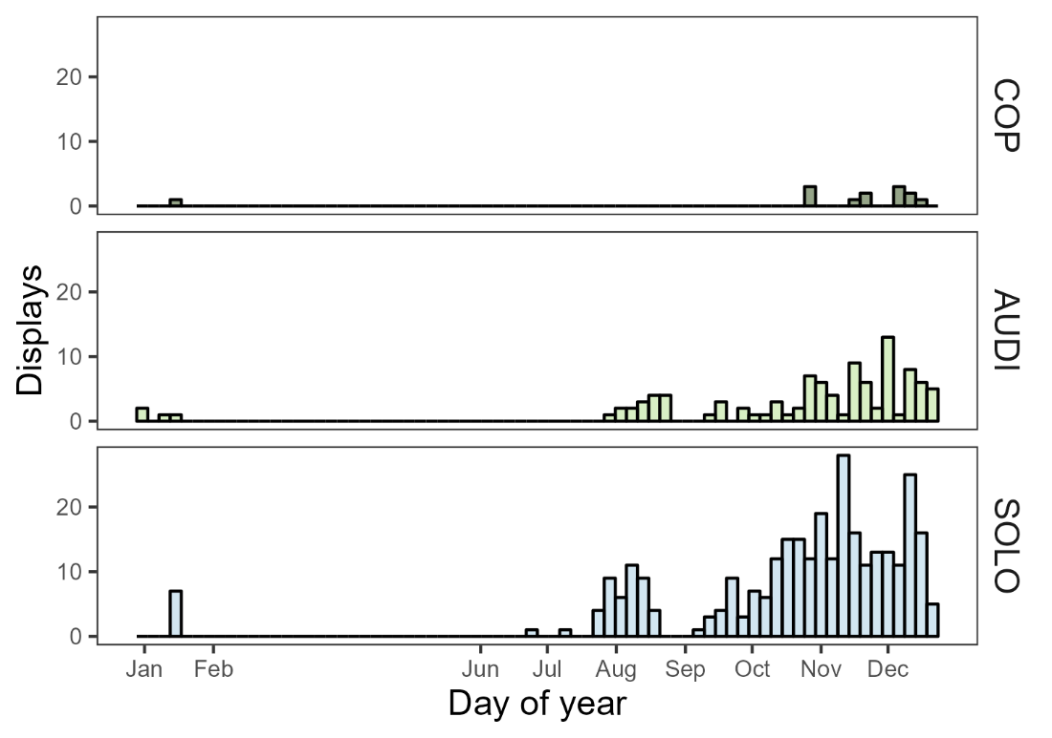

**Figure S1.** Observation dates of male *Masius* displays in the final dataset (2015-2017). Observation effort varied across the date range.

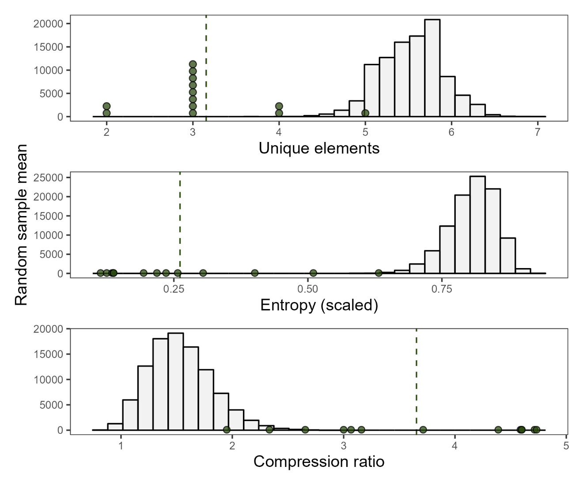

**Figure S2.** Comparison between empirical means from the small sample of COP displays (n = 13 across 3 males) and randomized mean values from total display dataset. Distributions show 100,000 mean values, with each mean value calculated from 13 displays drawn randomly, without replacement, from the full dataset. Green points indicate empirical values from COP displays, with dashed green line indicated empirical mean.

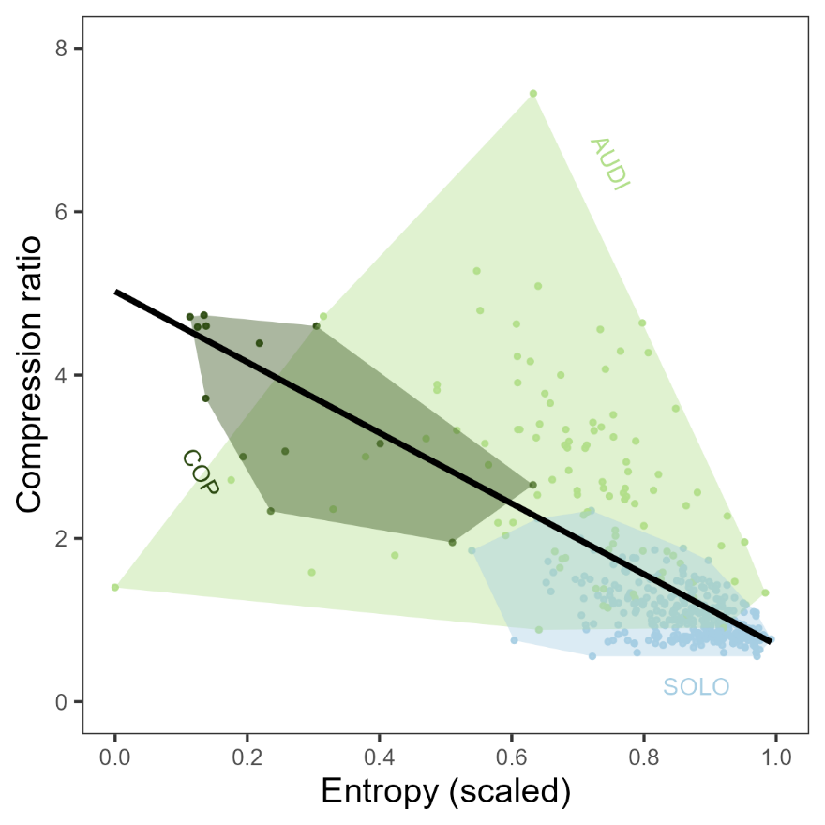

**Figure S3.** Correlation between entropy and compression ratio, two measures of syntax complexity, in *Masius* courtship displays. Wide variation highlighted the differences between these metrics. For example, the most compressible display string (AUDI ID-1487, compression ratio = 7.45) had intermediate entropy (0.63) but was long, with 365 total elements, and primarily made up of long stretches of Side-to-side bows and Neck twists. A display with similar entropy but much lower compression ratio (AUDI ID-453, scaled entropy = 0.64, compression ratio = 2.53) was shorter, with 81 elements, and featured a tail of individual behaviors (coded “IEDBA”) that made it difficult to compress. Linear regression *P* < 0.001, adjusted *R2*= 0. 0.46.

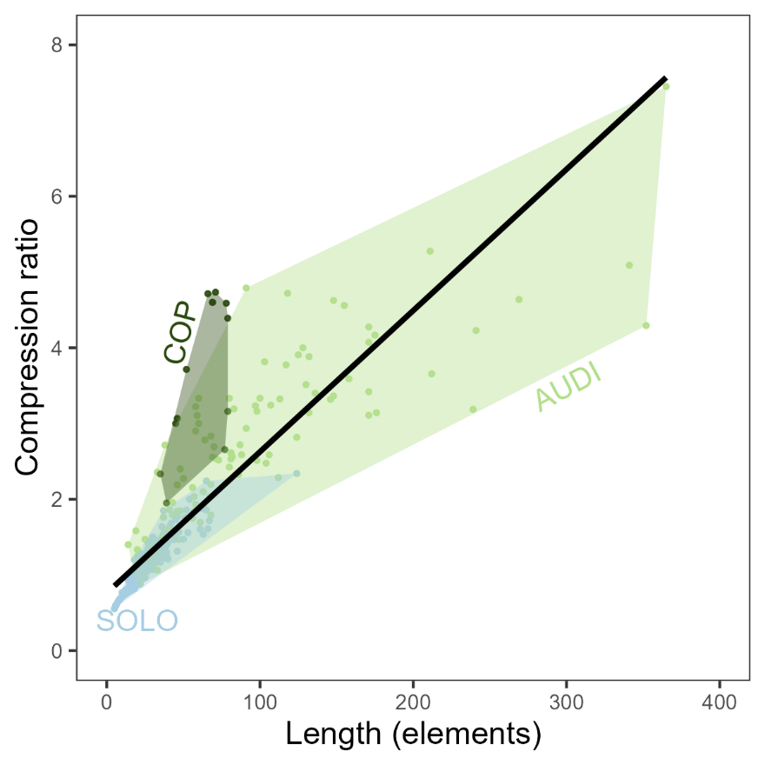

**Figure S4.** Correlation between display length (total number of elements) and compression ratio (the ratio of uncompressed display string length to compressed string length). Note COP displays were significantly shorter than AUDI displays, but significantly more compressible. Linear regression *P* < 0.001, adjusted *R2*= 0.73.

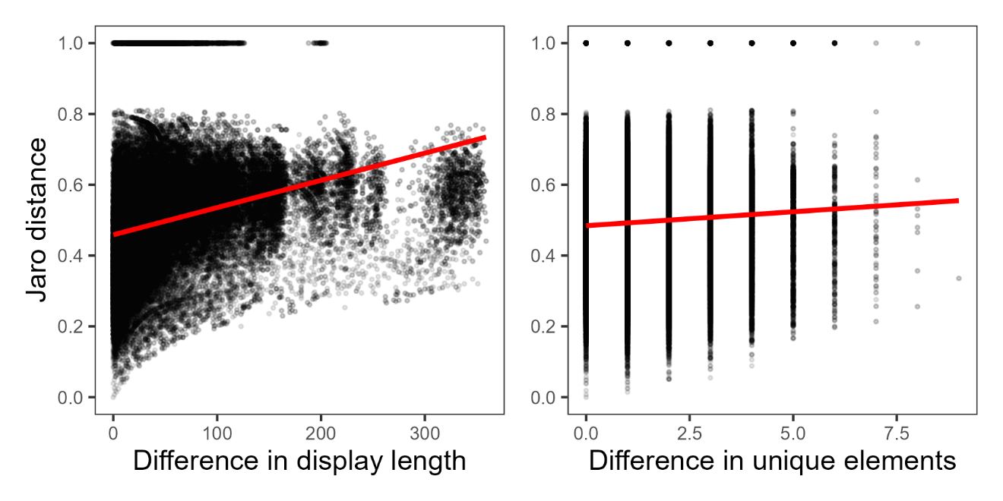

**Figure S5.** Correlations between Jaro distance and (*Left*) absolute difference in display lengths or *(Right)* absolute difference in number of unique elements between two displays. Red lines show significant but poorly-fitting linear regressions. Jaro distance ~ Difference in display length: *P* < 0.001, adjusted *R2* = 0.09; Jaro distance ~ Difference in unique elements: *P* < 0.001, *R2 <* 0.01.

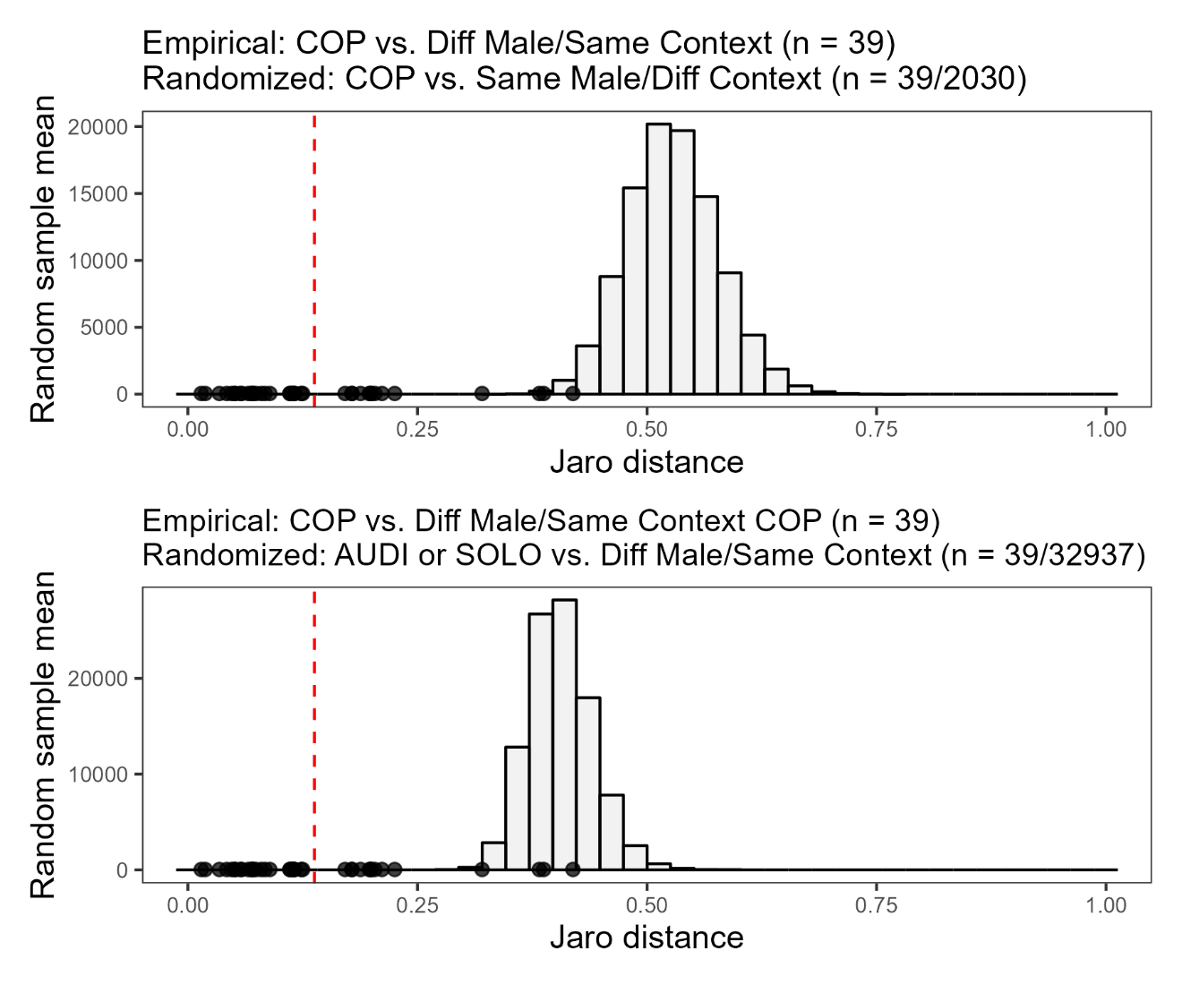

**Figure S6.** Comparison between Jaro distances involving the small sample of COP displays (n = 13 across 3 males) and randomized mean Jaro distance values from total display dataset. Black points in both panels show empirical Jaro distances between a COP display and a second display performed by a different male in the same context (i.e., a second COP display). Red dashed lines indicate empirical mean Jaro distance across all 39 of those COP-COP comparisons (n = 39 comparisons total). *(Top)* Distribution shows 100,000 mean values of 39 Jaro distance each, where each Jaro distance is drawn from comparisons between a COP display and a display performed by the same male in a different context (i.e., an AUDI or SOLO display by the male who performed the COP display). (*Bottom*) Distributions show 100,000 mean values of 39 Jaro distances each, where each Jaro distance is drawn from comparisons between an AUDI or SOLO display and a display by a different male in the same context (i.e., a second AUDI or SOLO display).

**COMPARSION OF BEFORE- AND AFTER-COPULATION DISPLAYS**

In our main analyses, we end successful displays (COP) at the first copulation. However, the males in all 13 COP displays continued performing after this point. After-copulation displays ranged from 12 to 139 elements in length, featuring a both qualitatively and quantitatively different array of behaviors as before-copulation displays (Table S6). Side-to-side bows were less frequent, whereas long stretches of Neck twists were far more frequent (Tables S6-7). Notably, three elements missing from before-copulation appeared in some after-copulation displays: pauses (“Zero”), Head-down bows, and the rare Metronome behavior. Although males performed Half bows, Position switches, and To-and-fro flights in 1-2 displays before copulation displays, these elements were absent following copulation (Table S6).

Seven of 13 after-copulation displays featured additional copulations (1-3 copulations each; Table S7), while one featured an attempted copulation (ID#1987; Table S7). As in before-copulation displays, every copulation in after-copulation displays followed an Audible log-approach dive. All but one of these additional copulations—including the attempted copulation—followed a Side-to-side Bow into Audible log-approach dive combination. One after-copulation display (ID#992) featured three successful copulations, each following a Side-to-side Bow into Audible log-approach dive sequence (Table S7). The lone exception (ID#1920) featured a second copulation following a Neck twist into Audible log-approach dive.

Repertoire size, in terms of number of unique display elements, was similar before and after copulation (mean ± SD unique elements before: 3.15 ± 0.80, after: 3.31 ± 0.95; paired two-sided T-test *t* = -0.46, *P* = 0.66; Fig. S7). However, after-copulation displays had a more complicated arrangement. After-copulation displays had significantly higher entropy (mean ± SD scaled entropy before: 0.26 ± 0.16, after: 0.52 ± 0.19; *t* = -3.91, *P* < 0.01; Fig. S7), and were significantly less compressible than before-copulation displays (compression ratio before: 3.65 ± 1.01, after: 2.62 ± 1.48; *t* = 3.07, *P* < 0.01; Fig. S6).

Using Jaro distances, we found that nearly every before-copulation display (12/13) was on average more similar to other before-copulation displays than after-copulation displays, including the after-copulation section of the same display (Fig. S8). The lone exception was the before-copulation display that, like several after-copulation displays, featured sections of Neck twists (ID#1824, Table S7; Fig. S8).

**Table S6.** Behavioral element frequencies across before-copulation (COP) and after-copulation displays (n = 13 from 3 males). Elements *M* (Attempted copulation) and *N* (Copulation) are shown here but excluded from other analyses.

|  |  |  |  |
| --- | --- | --- | --- |
|  | **Element *N*** | **Before** | **After** |
| A. | Zero | 0 | 4 |
| B. | Audible log-approach dive | 13 | 12 |
| C. | Silent log-approach dive | 0 | 0 |
| D. | Side-to-side bow | 706 | 166 |
| E. | Half bow | 3 | 0 |
| F. | Head-down bow | 0 | 9 |
| G. | Metronome | 0 | 8 |
| H. | Position switch | 6 | 0 |
| I. | Neck twist | 71 | 387 |
| J. | To-and-fro flight | 5 | 0 |
| K. | Mixed | 0 | 0 |
| L. | Other | 1 | 2 |
| M. | Attempted copulation | 0 | 1 |
| N. | Copulation | 13 | 9 |

**Table S7.** Coded display strings for before-copulation (COP) and corresponding after-copulation displays. See Table S6 for single-character behavior codes. Elements *M* (Attempted copulation) and *N* (Copulation) are shown here but excluded from quantitative analyses. Lines break every 40 characters.

|  |  |  |  |
| --- | --- | --- | --- |
| **Display** | **Male** | **Before first copulation (COP)** | **After copulation** |
| 1455 | 296 | IIDDDDDDDEDDDDDDDDDDDDDDDDDDDDDDDDDDDDDD DDDDDDDDDDDDDDDDDDDDDDDDDDDDDDDDDDDDDEBN | DIIIIIIIIIIIIIIIIIIIIIIIIIIIIIIIIIIIIII |
| 1533 | 296 | DDDDDDDDDDDDDDDDDDDDDDDDDDDDDDDDDDDDDDDD DDDDDDDDDDDDDDDDDDDDDDDDDBN | IDDDIIIIIIIIIIIIIIIIIIIIIIIIIIIIIIIIIIII IIIIIIIIIDDDDDDDDDDIIIIIIIIDIIDII |
| 1558 | 296 | EDDDDDDDDDDDDDDDDDDDDDDDDDDDDDDDDDDDDDDD DDDDDDDDDDDDDDDDDDDDDDDDDDDDDDDDDDDDDBN | IIIIIBFDIIIIIIIIIIIIIGGGGGGGGIIIIIIIIIII IIIIIIIIIIIIIIIIIIIIIII |
| 1817 | 296 | IIDDDDDDDDDDDDDDDDDDDDDDDDDDDDDDDDDDDDDD DDDDDBN | IDBNDDDIIIIIIIIIIIIIIAIAIIAIIIIIIIIIIIII IIIII |
| 1824 | 296 | IIIIIIIIIIIDDDIIIIIIIIDDDIIIIIIIIDDDDDDD DDDDDDIIIIIIIIIIIIIDDDDDIIIIIIIIIIIDBN | DBNDDIIIIIIIIIIIIIIIIIIIIIIIIIIIIIIIIIII IIIIIIIII |
| 1878 | 296 | JJHHHHHHIIIIDDDDDDDDDDDDDDDDDDDDDDDDDDDD DDDDDDDDDDDDDDDDDDDDDDDDDDDDDDDDDDDDDDBN | DBNDDDDDDDDDDDIII |
| 1920 | 296 | IDDDDDDDDDDDDDDDDDDDDDDDDDDDDDDDDDDDDDDD DDDDBN | IIIIIIIIBNIIIIIDDDDDDDDDIIIIIIIIIIIIIILL |
| 1987 | 296 | IIDDDDDDDDDDDDDDDDDDDDDDDDDDDDJJJIIDDDBN | DBMDDIIIIIIIA |
| 2020 | 296 | DDDDDDDDDDDDDDDDDDDDDDDDDDDDDDDDDDDDDDDD DDDDDDDDDDDDDDDDDDDDDDDDDLDDDDBN | DBFFFFFFFFIIIIIIIIIIIIIIIIIIIIIIIIIII |
| 5005 | 940 | IDDDDDDDDDDDDDDDDDDDDDDDDDDDDDDDDDBN | IIDDDDDDDDDDD |
| 989 | 980 | DDDDDDDDDDDDDDDDDDDDDDDDDDDDDDDDDDDDDDDD DDDDDDDDDDDBN | DDBNIIIIIIIIIIIIIIIIIIIIIIIIIIIIIIIIIIII  I |
| 991 | 980 | IIIIIDDDDDDDDDDDDDDDDDDDDDDDDDDDDDDDDDDD DDDDDDDDDDDDDDDDDDDDDDDDDDDDBN | DBNIIIIIDDDDDDDDDDDDDDDDDDII |
| 992 | 980 | IDDDDDDDDDDDDDDDDDDDDDDDDDDDDDDDDDDDDDDD DDDDDDDDDDDDDDDDDDDDDDDDDDDDBN | DDDBNIIIIIIIIIIIIIIIIIIDDDDDDDDDDDDDDDDD DDDDDDDDDDDDDDDDDDDDDDDDDDDDDDDDDDDDDDDD DDDDDDDDDDDDDDDDDDDDDDBNDDDBNIIIIIIIIIII IIIIIIIIIIIIIIIIIIII |

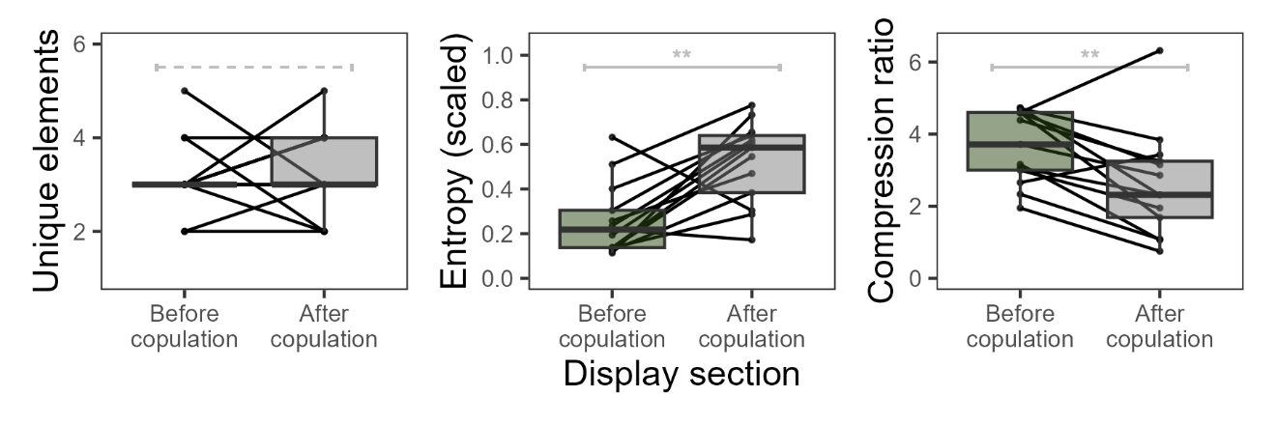

**Figure S7.** Characteristics of male *Maisus* displays preceding copulation (COP) and immediately.Black lines connect before- and after-copulation display sections from the same overall display, separated by first copulation. Gray brackets indicate paired, two-sided T-tests (\*\**P <* 0.01; dashed line = not significant).

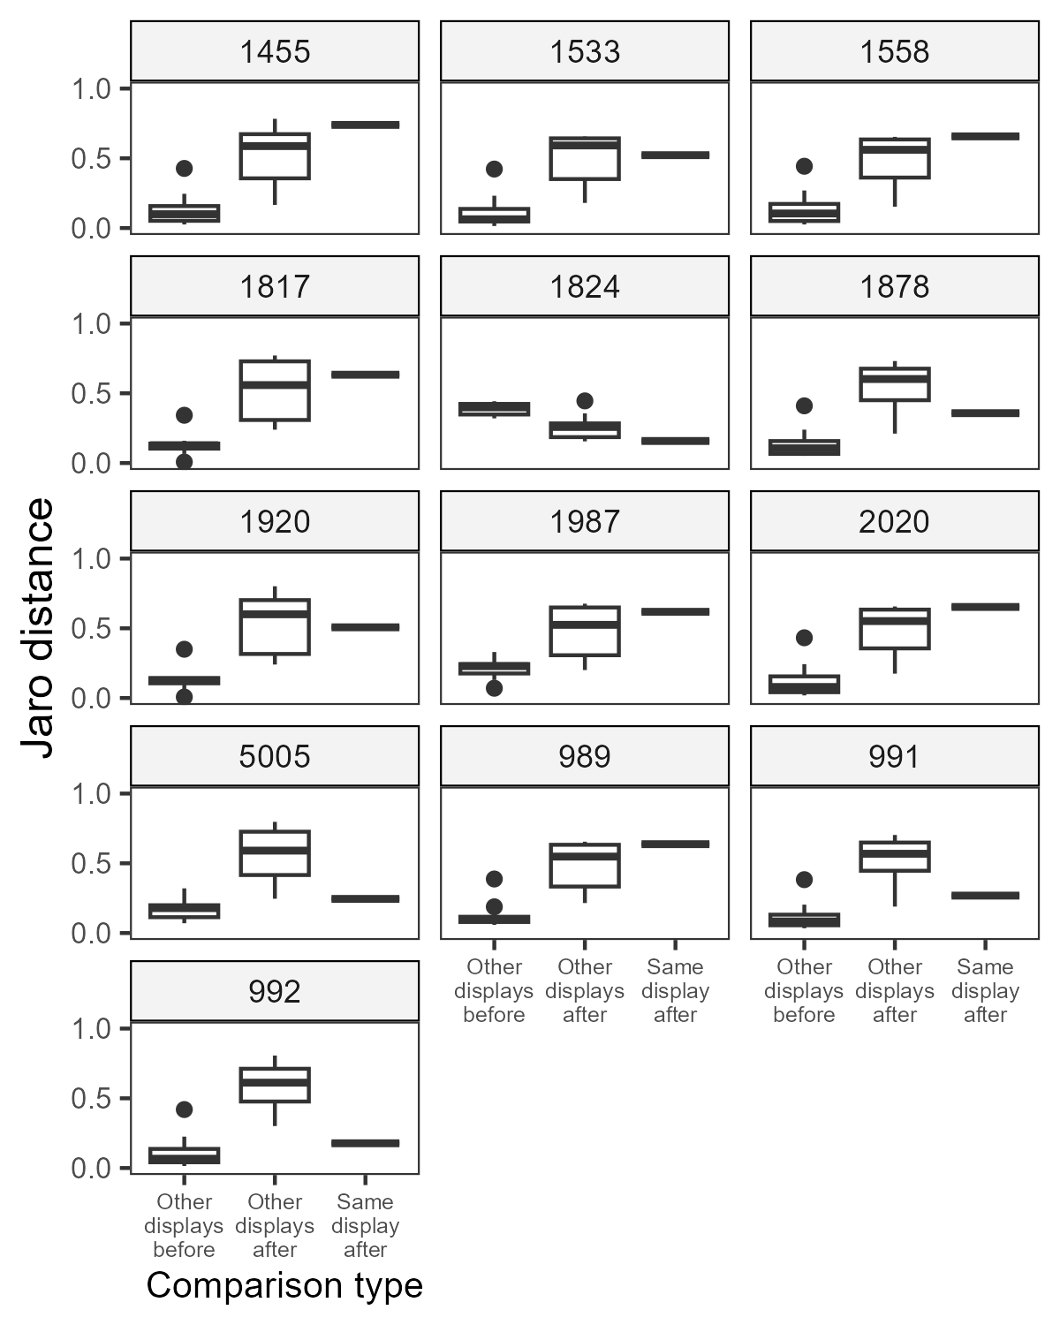

**Figure S9.** Jaro distances between each before-copulation (COP) display and three sets of comparison displays: (A) other before-copulation displays (n = 12), (B) other after-copulation displays (n = 12), and (C) the after-copulation section from the same display sequence (n = 1). Lower Jaro distance indicates higher similarity in the arrangement (i.e., syntax) of male behavioral elements. Display ID is given above each set of comparisons.

**DISPLAY CHARACTERISTIC LINEAR MODELING RESULTS**

**Duration (s)**

Call:

lm(formula = Duration ~ Category + as.character(ObsMonth) + UniqueMale1ID,

data = data_analyzed)

Residuals:

Min 1Q Median 3Q Max

-177.43 -43.13 -13.23 25.73 490.52

Coefficients: (1 not defined because of singularities)

Estimate Std. Error t value Pr(>|t|)

(Intercept) 172.3003 23.9430 7.196 3.24e-12 ***

CategoryCOP -79.3820 23.9412 -3.316 0.0010 **

CategorySOLO -81.9170 9.6977 -8.447 6.11e-16 ***

as.character(ObsMonth)10 30.3089 31.0164 0.977 0.3291

as.character(ObsMonth)11 22.8169 30.6899 0.743 0.4576

as.character(ObsMonth)12 26.8364 28.3064 0.948 0.3437

as.character(ObsMonth)6 154.5331 85.1556 1.815 0.0703 .

as.character(ObsMonth)7 68.6370 40.1223 1.711 0.0879 .

as.character(ObsMonth)8 64.3592 34.0313 1.891 0.0593 .

as.character(ObsMonth)9 49.9532 37.1697 1.344 0.1798

UniqueMale1ID113 0.7259 36.3720 0.020 0.9841

UniqueMale1ID296 3.7376 18.6810 0.200 0.8415

UniqueMale1ID299 11.0747 26.5220 0.418 0.6765

UniqueMale1ID8000-110 -21.8275 85.0313 -0.257 0.7975

UniqueMale1ID8000-150 -90.7843 86.2403 -1.053 0.2931

UniqueMale1ID8000-157 -4.0765 85.0313 -0.048 0.9618

UniqueMale1ID8000-213 349.9797 86.2403 4.058 5.99e-05 ***

UniqueMale1ID8000-220 -53.5875 85.0313 -0.630 0.5289

UniqueMale1ID8000-234 -82.7373 86.2403 -0.959 0.3380

UniqueMale1ID8000-235 43.5537 86.2403 0.505 0.6138

UniqueMale1ID8000-259 -85.7983 86.2403 -0.995 0.3204

UniqueMale1ID8000-260 -72.0503 86.2403 -0.835 0.4040

UniqueMale1ID8000-263 -79.1033 86.2403 -0.917 0.3596

UniqueMale1ID8000-32 -138.6075 84.9891 -1.631 0.1037

UniqueMale1ID8000-343 63.3484 83.6753 0.757 0.4495

UniqueMale1ID8000-5010 8.6135 83.7178 0.103 0.9181

UniqueMale1ID8000-5011 -167.8755 83.7178 -2.005 0.0456 *

UniqueMale1ID8000-5012 78.8255 83.7178 0.942 0.3470

UniqueMale1ID8000-5013 -117.8475 83.7178 -1.408 0.1600

UniqueMale1ID8000-975 75.8988 82.4983 0.920 0.3581

UniqueMale1ID940 NA NA NA NA

UniqueMale1ID948 58.5470 61.6377 0.950 0.3428

UniqueMale1ID965 6.9294 28.3529 0.244 0.8071

UniqueMale1ID975 -51.4513 86.2403 -0.597 0.5511

UniqueMale1ID976 -35.0803 65.2463 -0.538 0.5911

UniqueMale1ID978 -117.9658 47.2766 -2.495 0.0130 *

UniqueMale1ID980 23.8661 20.9354 1.140 0.2550

---

Signif. codes: 0 '***' 0.001 '**' 0.01 '*' 0.05 '.' 0.1 ' ' 1

Residual standard error: 79.78 on 387 degrees of freedom

Multiple R-squared: 0.2504, Adjusted R-squared: 0.1826

F-statistic: 3.693 on 35 and 387 DF, p-value: 1.246e-10

**Display length (number of elements)**

Call:

lm(formula = DisplayLength ~ Category + as.character(ObsMonth) +

UniqueMale1ID, data = data_analyzed)

Residuals:

Min 1Q Median 3Q Max

-90.496 -11.487 -3.018 8.097 264.310

Coefficients: (1 not defined because of singularities)

Estimate Std. Error t value Pr(>|t|)

(Intercept) 83.2941 10.8891 7.649 1.62e-13 ***

CategoryCOP -37.1124 10.8883 -3.408 0.000722 ***

CategorySOLO -76.2025 4.4104 -17.278 < 2e-16 ***

as.character(ObsMonth)10 4.5716 14.1060 0.324 0.746049

as.character(ObsMonth)11 6.1531 13.9575 0.441 0.659573

as.character(ObsMonth)12 3.5650 12.8735 0.277 0.781987

as.character(ObsMonth)6 18.6656 38.7281 0.482 0.630102

as.character(ObsMonth)7 4.4506 18.2473 0.244 0.807435

as.character(ObsMonth)8 1.1387 15.4772 0.074 0.941389

as.character(ObsMonth)9 7.0111 16.9045 0.415 0.678555

UniqueMale1ID113 -2.2737 16.5417 -0.137 0.890746

UniqueMale1ID296 11.2427 8.4960 1.323 0.186517

UniqueMale1ID299 6.7731 12.0620 0.562 0.574765

UniqueMale1ID8000-110 15.8972 38.6716 0.411 0.681239

UniqueMale1ID8000-150 -0.5422 39.2214 -0.014 0.988977

UniqueMale1ID8000-157 9.8972 38.6716 0.256 0.798141

UniqueMale1ID8000-213 50.4578 39.2214 1.286 0.199043

UniqueMale1ID8000-220 2.8972 38.6716 0.075 0.940318

UniqueMale1ID8000-234 2.4578 39.2214 0.063 0.950067

UniqueMale1ID8000-235 14.4578 39.2214 0.369 0.712613

UniqueMale1ID8000-259 -2.5422 39.2214 -0.065 0.948353

UniqueMale1ID8000-260 0.4578 39.2214 0.012 0.990694

UniqueMale1ID8000-263 -6.5422 39.2214 -0.167 0.867612

UniqueMale1ID8000-32 -68.3053 38.6524 -1.767 0.077988 .

UniqueMale1ID8000-343 -3.2304 38.0549 -0.085 0.932395

UniqueMale1ID8000-5010 47.5672 38.0742 1.249 0.212300

UniqueMale1ID8000-5011 -57.4328 38.0742 -1.508 0.132256

UniqueMale1ID8000-5012 61.5672 38.0742 1.617 0.106686

UniqueMale1ID8000-5013 -55.4328 38.0742 -1.456 0.146226

UniqueMale1ID8000-975 22.3368 37.5196 0.595 0.551967

UniqueMale1ID940 NA NA NA NA

UniqueMale1ID948 -10.8316 28.0323 -0.386 0.699416

UniqueMale1ID965 9.0427 12.8947 0.701 0.483554

UniqueMale1ID975 0.4578 39.2214 0.012 0.990694

UniqueMale1ID976 14.8565 29.6735 0.501 0.616890

UniqueMale1ID978 -44.1828 21.5010 -2.055 0.040558 *

UniqueMale1ID980 16.6298 9.5213 1.747 0.081500 .

---

Signif. codes: 0 '***' 0.001 '**' 0.01 '*' 0.05 '.' 0.1 ' ' 1

Residual standard error: 36.28 on 387 degrees of freedom

Multiple R-squared: 0.4656, Adjusted R-squared: 0.4173

F-statistic: 9.633 on 35 and 387 DF, p-value: < 2.2e-16

**Repertoire size (number of unique elements)**

Call:

lm(formula = UniqueDisplayElements ~ Category + as.character(ObsMonth) +

UniqueMale1ID, data = data_analyzed)

Residuals:

Min 1Q Median 3Q Max

-4.4777 -0.7391 0.0769 0.6164 4.3758

Coefficients: (1 not defined because of singularities)

Estimate Std. Error t value Pr(>|t|)

(Intercept) 4.77651 0.36128 13.221 < 2e-16 ***

CategoryCOP -2.34409 0.36126 -6.489 2.65e-10 ***

CategorySOLO 0.14656 0.14633 1.002 0.31718

as.character(ObsMonth)10 0.69308 0.46802 1.481 0.13945

as.character(ObsMonth)11 1.09516 0.46309 2.365 0.01853 *

as.character(ObsMonth)12 1.04874 0.42712 2.455 0.01451 *

as.character(ObsMonth)6 1.33281 1.28494 1.037 0.30027

as.character(ObsMonth)7 1.29728 0.60542 2.143 0.03275 *

as.character(ObsMonth)8 0.83404 0.51351 1.624 0.10515

as.character(ObsMonth)9 0.72747 0.56087 1.297 0.19539

UniqueMale1ID113 -0.56873 0.54883 -1.036 0.30073

UniqueMale1ID296 -0.25588 0.28188 -0.908 0.36458

UniqueMale1ID299 -0.63461 0.40020 -1.586 0.11362

UniqueMale1ID8000-110 -0.65054 1.28307 -0.507 0.61243

UniqueMale1ID8000-150 -3.22036 1.30131 -2.475 0.01376 *

UniqueMale1ID8000-157 -0.65054 1.28307 -0.507 0.61243

UniqueMale1ID8000-213 0.77964 1.30131 0.599 0.54944

UniqueMale1ID8000-220 -0.65054 1.28307 -0.507 0.61243

UniqueMale1ID8000-234 -0.22036 1.30131 -0.169 0.86562

UniqueMale1ID8000-235 -0.22036 1.30131 -0.169 0.86562

UniqueMale1ID8000-259 -2.22036 1.30131 -1.706 0.08876 .

UniqueMale1ID8000-260 -2.22036 1.30131 -1.706 0.08876 .

UniqueMale1ID8000-263 -4.22036 1.30131 -3.243 0.00128 **

UniqueMale1ID8000-32 -0.50398 1.28243 -0.393 0.69454

UniqueMale1ID8000-343 -3.75711 1.26260 -2.976 0.00311 **

UniqueMale1ID8000-5010 1.38945 1.26325 1.100 0.27206

UniqueMale1ID8000-5011 0.38945 1.26325 0.308 0.75803

UniqueMale1ID8000-5012 1.38945 1.26325 1.100 0.27206

UniqueMale1ID8000-5013 0.38945 1.26325 0.308 0.75803

UniqueMale1ID8000-975 1.38385 1.24485 1.112 0.26697

UniqueMale1ID940 NA NA NA NA

UniqueMale1ID948 0.31617 0.93007 0.340 0.73409

UniqueMale1ID965 0.19654 0.42783 0.459 0.64621

UniqueMale1ID975 -2.22036 1.30131 -1.706 0.08876 .

UniqueMale1ID976 -0.14708 0.98452 -0.149 0.88132

UniqueMale1ID978 -1.61055 0.71337 -2.258 0.02452 *

UniqueMale1ID980 0.00806 0.31590 0.026 0.97966

---

Signif. codes: 0 '***' 0.001 '**' 0.01 '*' 0.05 '.' 0.1 ' ' 1

Residual standard error: 1.204 on 387 degrees of freedom

Multiple R-squared: 0.2224, Adjusted R-squared: 0.1521

F-statistic: 3.163 on 35 and 387 DF, p-value: 2.231e-08

**Entropy (first-order, scaled)**

Call:

lm(formula = Entropy_Scaled ~ Category + as.character(ObsMonth) +

UniqueMale1ID, data = data_analyzed)

Residuals:

Min 1Q Median 3Q Max

-0.67661 -0.04607 0.00950 0.05871 0.35067

Coefficients: (1 not defined because of singularities)

Estimate Std. Error t value Pr(>|t|)

(Intercept) 0.689961 0.031169 22.136 <2e-16 ***

CategoryCOP -0.443398 0.031167 -14.227 <2e-16 ***

CategorySOLO 0.174441 0.012624 13.818 <2e-16 ***

as.character(ObsMonth)10 -0.040940 0.040377 -1.014 0.3112

as.character(ObsMonth)11 -0.019352 0.039952 -0.484 0.6284

as.character(ObsMonth)12 0.007279 0.036849 0.198 0.8435

as.character(ObsMonth)6 -0.352433 0.110855 -3.179 0.0016 **

as.character(ObsMonth)7 0.019966 0.052231 0.382 0.7025

as.character(ObsMonth)8 -0.024016 0.044302 -0.542 0.5881

as.character(ObsMonth)9 -0.038995 0.048387 -0.806 0.4208

UniqueMale1ID113 -0.064707 0.047349 -1.367 0.1725

UniqueMale1ID296 0.027670 0.024319 1.138 0.2559

UniqueMale1ID299 0.020013 0.034526 0.580 0.5625

UniqueMale1ID8000-110 -0.129202 0.110693 -1.167 0.2438

UniqueMale1ID8000-150 0.021251 0.112267 0.189 0.8500

UniqueMale1ID8000-157 -0.049716 0.110693 -0.449 0.6536

UniqueMale1ID8000-213 -0.024881 0.112267 -0.222 0.8247

UniqueMale1ID8000-220 0.022947 0.110693 0.207 0.8359

UniqueMale1ID8000-234 0.035871 0.112267 0.320 0.7495

UniqueMale1ID8000-235 -0.024466 0.112267 -0.218 0.8276

UniqueMale1ID8000-259 0.033928 0.112267 0.302 0.7627

UniqueMale1ID8000-260 -0.280608 0.112267 -2.499 0.0129 *

UniqueMale1ID8000-263 -0.162440 0.112267 -1.447 0.1487

UniqueMale1ID8000-32 0.092965 0.110638 0.840 0.4013

UniqueMale1ID8000-343 0.130565 0.108928 1.199 0.2314

UniqueMale1ID8000-5010 -0.178847 0.108983 -1.641 0.1016

UniqueMale1ID8000-5011 0.072247 0.108983 0.663 0.5078

UniqueMale1ID8000-5012 0.058593 0.108983 0.538 0.5911

UniqueMale1ID8000-5013 0.118108 0.108983 1.084 0.2792

UniqueMale1ID8000-975 0.032992 0.107396 0.307 0.7589

UniqueMale1ID940 NA NA NA NA

UniqueMale1ID948 0.053789 0.080240 0.670 0.5030

UniqueMale1ID965 0.046076 0.036910 1.248 0.2127

UniqueMale1ID975 -0.019581 0.112267 -0.174 0.8616

UniqueMale1ID976 -0.128757 0.084937 -1.516 0.1304

UniqueMale1ID978 0.033887 0.061544 0.551 0.5822

UniqueMale1ID980 0.027586 0.027254 1.012 0.3121

---

Signif. codes: 0 '***' 0.001 '**' 0.01 '*' 0.05 '.' 0.1 ' ' 1

Residual standard error: 0.1039 on 387 degrees of freedom

Multiple R-squared: 0.6188, Adjusted R-squared: 0.5843

F-statistic: 17.95 on 35 and 387 DF, p-value: < 2.2e-16

**Compression ratio**

Call:

lm(formula = Compression_Ratio ~ Category + as.character(ObsMonth) +

UniqueMale1ID, data = data_analyzed)

Residuals:

Min 1Q Median 3Q Max

-1.9941 -0.2991 -0.0239 0.2680 4.5749

Coefficients: (1 not defined because of singularities)

Estimate Std. Error t value Pr(>|t|)

(Intercept) 2.44785 0.18706 13.086 < 2e-16 ***

CategoryCOP 0.86625 0.18704 4.631 4.97e-06 ***

CategorySOLO -1.77495 0.07576 -23.427 < 2e-16 ***

as.character(ObsMonth)10 0.32578 0.24232 1.344 0.1796

as.character(ObsMonth)11 0.26997 0.23977 1.126 0.2609

as.character(ObsMonth)12 0.11548 0.22115 0.522 0.6018

as.character(ObsMonth)6 1.02085 0.66529 1.534 0.1257

as.character(ObsMonth)7 0.16180 0.31346 0.516 0.6060

as.character(ObsMonth)8 0.22634 0.26587 0.851 0.3951

as.character(ObsMonth)9 0.17775 0.29039 0.612 0.5408

UniqueMale1ID113 -0.01034 0.28416 -0.036 0.9710

UniqueMale1ID296 0.15625 0.14595 1.071 0.2850

UniqueMale1ID299 0.03754 0.20721 0.181 0.8563

UniqueMale1ID8000-110 0.64935 0.66432 0.977 0.3289

UniqueMale1ID8000-150 -0.10136 0.67376 -0.150 0.8805

UniqueMale1ID8000-157 0.41251 0.66432 0.621 0.5350

UniqueMale1ID8000-213 1.04409 0.67376 1.550 0.1220

UniqueMale1ID8000-220 0.14935 0.66432 0.225 0.8222

UniqueMale1ID8000-234 -0.05692 0.67376 -0.084 0.9327

UniqueMale1ID8000-235 0.40340 0.67376 0.599 0.5497

UniqueMale1ID8000-259 -0.14239 0.67376 -0.211 0.8327

UniqueMale1ID8000-260 -0.08469 0.67376 -0.126 0.9000

UniqueMale1ID8000-263 -0.27914 0.67376 -0.414 0.6789

UniqueMale1ID8000-32 -1.46770 0.66399 -2.210 0.0277 *

UniqueMale1ID8000-343 -0.34368 0.65372 -0.526 0.5994

UniqueMale1ID8000-5010 1.20817 0.65406 1.847 0.0655 .

UniqueMale1ID8000-5011 -1.50027 0.65406 -2.294 0.0223 *

UniqueMale1ID8000-5012 0.64399 0.65406 0.985 0.3254

UniqueMale1ID8000-5013 -1.35601 0.65406 -2.073 0.0388 *

UniqueMale1ID8000-975 0.30902 0.64453 0.479 0.6319

UniqueMale1ID940 NA NA NA NA

UniqueMale1ID948 -0.57588 0.48155 -1.196 0.2325

UniqueMale1ID965 0.14061 0.22151 0.635 0.5259

UniqueMale1ID975 -0.08469 0.67376 -0.126 0.9000

UniqueMale1ID976 0.77615 0.50974 1.523 0.1287

UniqueMale1ID978 -0.82589 0.36935 -2.236 0.0259 *

UniqueMale1ID980 0.17817 0.16356 1.089 0.2767

---

Signif. codes: 0 '***' 0.001 '**' 0.01 '*' 0.05 '.' 0.1 ' ' 1

Residual standard error: 0.6233 on 387 degrees of freedom

Multiple R-squared: 0.6656, Adjusted R-squared: 0.6353

F-statistic: 22.01 on 35 and 387 DF, p-value: < 2.2e-16