**Table S1.** Original behavioral elements used in BORIS logging. *N* gives number of occurrences in raw dataset.

|  |  |  |  |
| --- | --- | --- | --- |
| **Element** | ***N*** | **Classification** | |
| Attempted Copulation | 11 | Excluded | Non-display |
| Bird2 ALAD | 55 | Excluded | Multiple male performers |
| Bird2 BowLeft | 695 | Excluded | Multiple male performers |
| Bird2 BowRight | 677 | Excluded | Multiple male performers |
| Bird2 Half-bow Left | 26 | Excluded | Multiple male performers |
| Bird2 Half-bow Right | 21 | Excluded | Multiple male performers |
| Bird2 HeadDownBowing | 56 | Excluded | Multiple male performers |
| Bird2 Mixed Element | 13 | Excluded | Multiple male performers |
| Bird2 NeckTwist | 1693 | Excluded | Multiple male performers |
| Bird2 On-log NO display | 79 | Excluded | Multiple male performers |
| Bird2 SLAD | 1 | Excluded | Multiple male performers |
| Bird2 TafLF_Off | 28 | Excluded | Multiple male performers |
| Bird2 TafLF_On | 26 | Excluded | Multiple male performers |
| Copulation | 24 | Excluded | Non-display |
| End | 486 | Excluded | Tracking |
| Female Looking Away | 1736 | Excluded | Female response |
| Female Movement | 978 | Excluded | Movement |
| Female Off Log | 320 | Excluded | Movement |
| Female On Log | 320 | Excluded | Movement |
| Female ResponseToALAD | 188 | Excluded | Female response |
| Female Tracking Male | 1924 | Excluded | Female response |
| FemaleSwitch | 406 | Excluded | Movement |
| Male1 ALAD | 1104 | Retained |  |
| Male1 BowLeft | 8088 | Partial | only retained Male1 Bow Right |
| Male1 BowRight | 7950 | Retained |  |
| Male1 Half-bow Left | 296 | Partial | only retained Male1 Half-bow Right |
| Male1 Half-bow Right | 258 | Retained |  |
| Male1 HeadDownBowing | 2360 | Retained |  |
| Male1 Metronome_Left | 11 | Partial | only retained Male1 Metronome Right |
| Male1 Metronome_Right | 25 | Retained |  |
| Male1 Mixed Element | 361 | Retained |  |
| Male1 NeckTwist | 5618 | Retained |  |
| Male1 Off Log | 41 | Excluded | Movement |
| Male1 On Log | 39 | Excluded | Movement |
| Male1 On Log No Display | 2225 | Retained | Movement |
| Male1 Other Behavior | 2142 | Partially retained | Excluded if specified as  “Vocalization” or “Gardening” |
| Male1 SLAD | 655 | Retained |  |
| Male1 Switch | 1145 | Retained |  |
| Male1 TafLF_Off | 1193 | Partial | only retained Male1 TafLF_On |
| Male1 TafLF_On | 1223 | Retained |  |
| Start | 486 | Excluded | Tracking |

**Table S2**. Individual male display activity. The number of displays given by the individual (SOLO, AUDI, COP) and observation date ranges are given from our final dataset. Band IDs were assigned by the unique suffix on an individual aluminum leg band.

|  |  |  |  |  |  |  |  |
| --- | --- | --- | --- | --- | --- | --- | --- |
| **Band ID** | **Date banded** | **Plumage at banding** | **SOLO** | **AUDI** | **COP** | **First seen** | **Last seen** |
| 112 | 2017-09-23 | Definitive | 13 | 11 | 0 | 2017-10-03 | 2017-12-20 |
| 113 | 2017-09-17 | Definitive | 5 | 0 | 0 | 2017-11-10 | 2017-11-20 |
| 296 | 2015-07-10 | Definitive | 122 | 41 | 9 | 2016-06-24 | 2017-12-20 |
| 299 | 2017-10-25 | Definitive | 10 | 2 | 0 | 2017-11-10 | 2017-11-27 |
| 940 | 2013-05-26 | Definitive | 2 | 4 | 1 | 2015-01-01 | 2015-01-14 |
| 948 | 2013-06-10 | Predefinitive | 1 | 1 | 0 | 2016-08-15 | 2016-08-15 |
| 965 | 2014-07-03 | Definitive | 19 | 4 | 0 | 2015-08-06 | 2017-10-02 |
| 976 | 2014-07-22 | Predefinitive | 1 | 1 | 0 | 2016-07-30 | 2016-07-30 |
| 978 | 2014-07-23 | Definitive | 0 | 2 | 0 | 2015-08-12 | 2015-08-19 |
| 980 | 2014-07-24 | Definitive | 71 | 18 | 3 | 2015-08-08 | 2017-12-20 |
| *Unk* |  |  | 7 | 5 | 0 | 2015-08-23 | 2017-10-25 |

**Table S3.** Individual female audience activity. The number of displays attended by the individual (AUDI, COP), observation date ranges, and the ID of males viewed/copulated are given from our final dataset. Band IDs correspond to the unique suffix on an aluminum leg band. Unknown birds were either suspected female, suspected predefinitive male, or completely unknown given plumage and behavior.

|  |  |  |  |  |  |  |  |
| --- | --- | --- | --- | --- | --- | --- | --- |
| **Band ID** | **Date banded** | **AUDI** | **COP** | **First seen** | **Last seen** | **Males viewed** | **Males copulated** |
| 118 | 2017-09-29 | 1 | 0 | 2017-12-07 | 2017-12-07 | 112 |  |
| 289 | 2015-07-28 | 7 | 0 | 2017-10-09 | 2017-12-20 | 112, 980 |  |
| 292 | 2015-07-26 | 1 | 0 | 2015-08-23 | 2015-08-23 | *Unk* |  |
| 294 | 2015-07-19 | 6 | 0 | 2015-08-23 | 2017-11-21 | 296 |  |
| 295 | 2015-07-14 | 1 | 1 | 2015-08-23 | 2017-12-08 | 296, *Unk* | 296 |
| 935 | 2013-05-28 | 3 | 0 | 2016-07-30 | 2017-12-02 | 112, 296, 976 |  |
| 936 | 2013-05-26 | 0 | 2 | 2017-11-15 | 2017-12-10 | 296 | 296 |
| 959 | 2015-01-06 | 0 | 1 | 2017-12-06 | 2017-12-06 | 296 | 296 |
| 972 | 2014-07-15 | 1 | 0 | 2017-10-26 | 2017-10-26 | 980 |  |
| 981 | 2016-07-06 | 7 | 0 | 2016-08-15 | 2017-12-15 | 112, 296, 299, 948, 965 |  |
| 984 | 2014-07-28 | 1 | 0 | 2017-11-26 | 2017-11-26 | 296 |  |
| 988 | 2014-08-03 | 1 | 0 | 2015-01-10 | 2015-01-10 | 940 |  |
| *Female?* |  | 26 | 8 | 2015-01-01 | 2017-12-20 | 112, 296, 940, 965, 980, *Unk* | 296, 980 |
| *Male?* |  | 21 | 0 | 2017-10-25 | 2017-12-20 | 112, 296, 299, 980 |  |
| *Unk* |  | 18 | 1 | 2015-01-01 | 2017-12-20 | 112, 296, 940  978, 980 | 940 |

**Table S4.** Coded display strings for *Masius* displays that resulted in successful copulation (COP displays). Copulation occurred following the final behavioral element. Total duration (seconds), length (number of elements), entropy (scaled), and compression (ratio of uncompressed to compressed string lengths) are given for each display. See Table S5 for behavioral codes. Lines break every 40 characters.

|  |  |  |  |  |  |  |  |
| --- | --- | --- | --- | --- | --- | --- | --- |
| **ID** | **Male** | **Date** | **Duration** | **Length** | **Entropy** | **Compression** | **Coded display string** |
| 1455 | 296 | 2017-11-15 | 187 | 79 | 0.22 | 4.4 | IIDDDDDDDEDDDDDDDDDDDDDDDDDDDDDDDDDDDDDD DDDDDDDDDDDDDDDDDDDDDDDDDDDDDDDDDDDDDEB |
| 1533 | 296 | 2017-11-19 | 128 | 66 | 0.11 | 4.7 | DDDDDDDDDDDDDDDDDDDDDDDDDDDDDDDDDDDDDDDD DDDDDDDDDDDDDDDDDDDDDDDDDB |
| 1558 | 296 | 2017-11-20 | 143 | 78 | 0.12 | 4.6 | EDDDDDDDDDDDDDDDDDDDDDDDDDDDDDDDDDDDDDDD DDDDDDDDDDDDDDDDDDDDDDDDDDDDDDDDDDDDDB |
| 1817 | 296 | 2017-12-05 | 84 | 46 | 0.26 | 3.1 | IIDDDDDDDDDDDDDDDDDDDDDDDDDDDDDDDDDDDDDD DDDDDB |
| 1824 | 296 | 2017-12-06 | 97 | 77 | 0.63 | 2.7 | IIIIIIIIIIIDDDIIIIIIIIDDDIIIIIIIIDDDDDDD DDDDDDIIIIIIIIIIIIIDDDDDIIIIIIIIIIIDB |
| 1878 | 296 | 2017-12-08 | 134 | 79 | 0.40 | 3.2 | JJHHHHHHIIIIDDDDDDDDDDDDDDDDDDDDDDDDDDDD DDDDDDDDDDDDDDDDDDDDDDDDDDDDDDDDDDDDDDB |
| 1920 | 296 | 2017-12-10 | 86 | 45 | 0.19 | 3 | IDDDDDDDDDDDDDDDDDDDDDDDDDDDDDDDDDDDDDDD DDDDB |
| 1987 | 296 | 2017-12-13 | 96 | 39 | 0.51 | 2 | IIDDDDDDDDDDDDDDDDDDDDDDDDDDDDJJJIIDDDB |
| 2020 | 296 | 2017-12-15 | 213 | 71 | 0.13 | 4.7 | DDDDDDDDDDDDDDDDDDDDDDDDDDDDDDDDDDDDDDDD DDDDDDDDDDDDDDDDDDDDDDDDDLDDDDB |
| 5005 | 940 | 2015-01-14 | 70 | 35 | 0.24 | 2.3 | IDDDDDDDDDDDDDDDDDDDDDDDDDDDDDDDDDB |
| 989 | 980 | 2017-10-26 | 138 | 52 | 0.14 | 3.7 | DDDDDDDDDDDDDDDDDDDDDDDDDDDDDDDDDDDDDDDD DDDDDDDDDDDB |
| 991 | 980 | 2017-10-26 | 127 | 69 | 0.3 | 4.6 | IIIIIDDDDDDDDDDDDDDDDDDDDDDDDDDDDDDDDDDD DDDDDDDDDDDDDDDDDDDDDDDDDDDDB |
| 992 | 980 | 2017-10-26 | 132 | 69 | 0.14 | 4.6 | IDDDDDDDDDDDDDDDDDDDDDDDDDDDDDDDDDDDDDDD DDDDDDDDDDDDDDDDDDDDDDDDDDDDB |

**Table S5.** Behavioral element frequencies across all displays (SOLO, AUDI, or COP) in the final dataset. See Main Text Table 1 for behavioral descriptions.

|  |  |  |  |  |
| --- | --- | --- | --- | --- |
|  | **Element *N*** | **SOLO** | **AUDI** | **COP** |
| A. | Zero | 1605 | 45 | 0 |
| B. | Audible log-approach dive | 687 | 162 | 13 |
| C. | Silent log-approach dive | 440 | 1 | 0 |
| D. | Side-to-side bow | 1603 | 3384 | 706 |
| E. | Half bow | 168 | 17 | 3 |
| F. | Head-down bow | 777 | 1108 | 0 |
| G. | Metronome | 0 | 3 | 0 |
| H. | Position switch | 129 | 669 | 6 |
| I. | Neck twist | 80 | 2991 | 71 |
| J. | To-and-fro flight | 222 | 631 | 5 |
| K. | Mixed | 171 | 5 | 0 |
| L. | Other | 127 | 10 | 1 |

**Figure S1.** Dates of observed *Masius* displays in the final dataset (2015-2017). Observation time was not consistent across the date range.

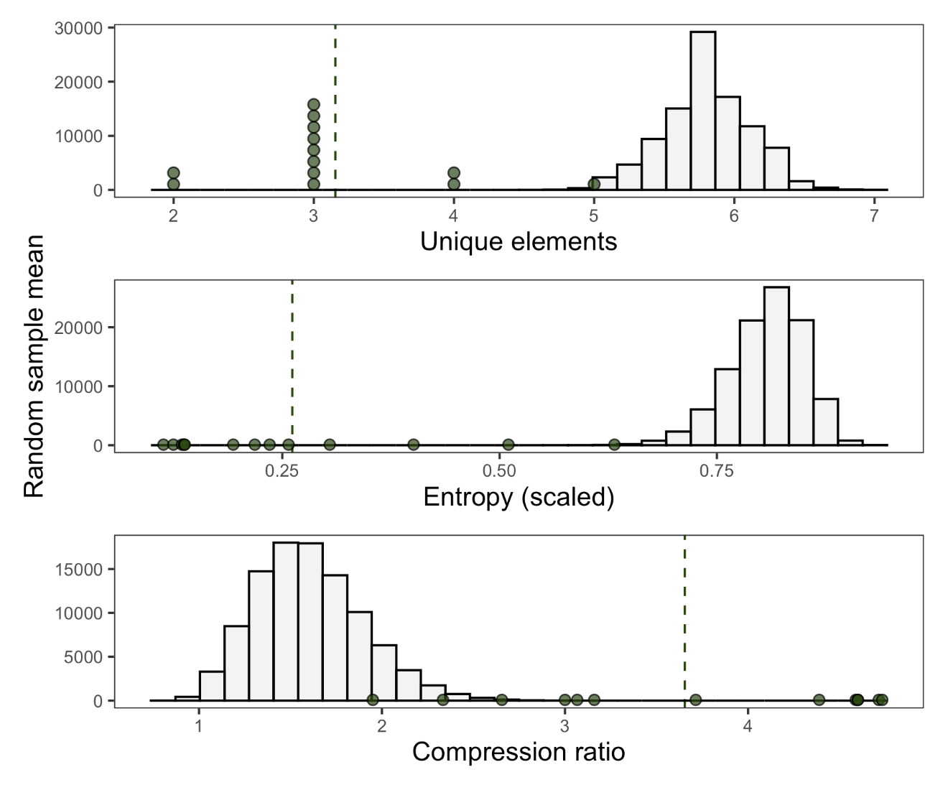

**Figure S2.** Empirical means from the small sample of COP displays (n = 13), compared to randomized mean values. Distributions show 100,000 mean values, with each mean value calculated from 13 displays drawn randomly, without replacement, from the full dataset. Green points are empirical values from COP displays with dashed green line at the empirical mean.

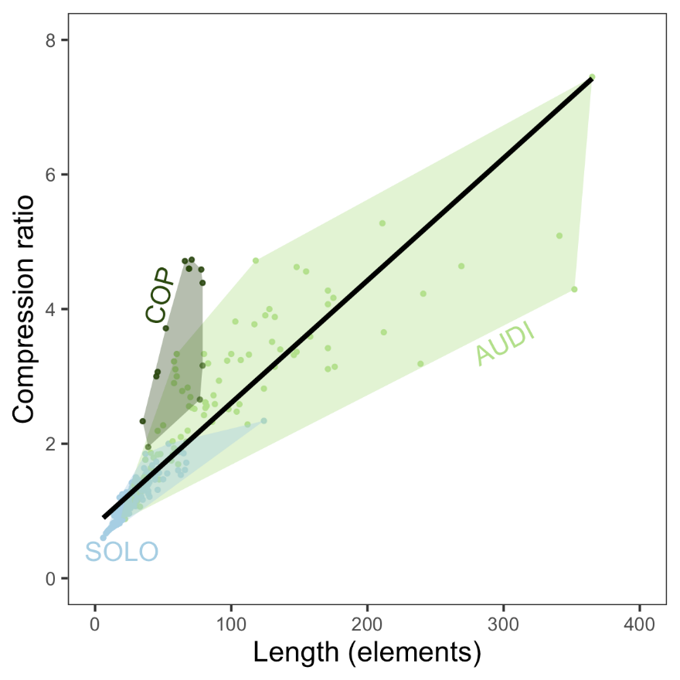

**Figure S3.** Correlation between display length (total number of elements) and compression ratio (the ratio of uncompressed display string length to compressed string length).

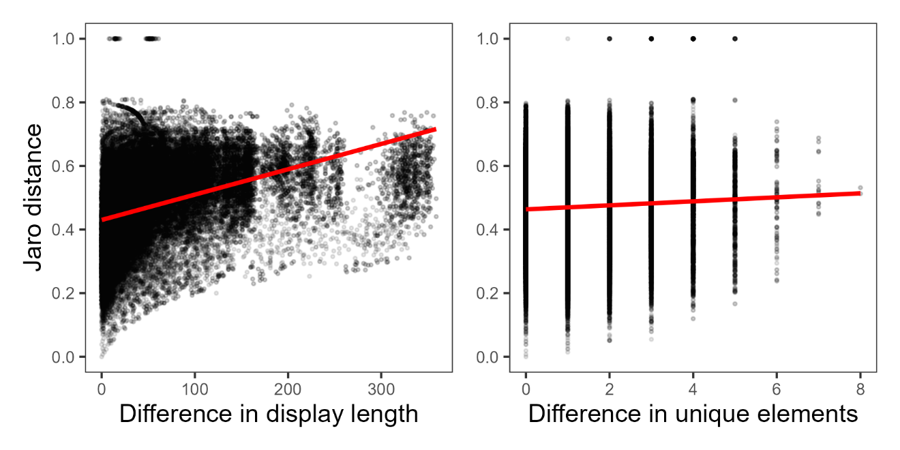

**Figure S4.** Correlations between Jaro distance and (*Left*) absolute difference in display lengths or *(Right)* absolute difference in number of unique elements. Each point represents the corresponding difference/distance between two displays. Red lines show significant but poorly-fitting linear regressions. Jaro distance ~ Difference in display length: adjusted *R2 =* 0.15, *P* < 0.001; Jaro distance ~ Difference in unique elements: *R2 <* 0.01, *P* < 0.001

**COMPARSION OF BEFORE- AND AFTER- COPULATION DISPLAYS**

In our main analyses, we end successful displays (COP) at the first copulation. However, the males in all 13 COP displays continued performing after this point. After-copulation displays ranged from 12 to 139 elements in length, featuring a both qualitatively and quantitatively different array of behaviors as before-copulation displays (Table S6). Side-to-side bows were less frequent, whereas long stretches of Neck twists were far more frequent (Table S6-7). Notably, three elements missing from before-copulation appeared in some after-copulation displays: pauses (“Zero”), Head-down bows, and the rare Metronome behavior. Although males performed Half bows, Position switches, and To-and-fro flights in some before-copulation displays, these elements were absent following copulation (Table S6).

Seven of 13 after-copulation displays featured additional copulations (1-3 copulations each; Table S7), while one featured an attempted copulation (ID#1987; Table S7). As in before-copulation displays, every copulation in after-copulation displays followed an Audible log-approach dive. All except one of these additional copulations—including the attempted copulation—followed a Side-to-side Bow into Audible log-approach dive combination. One after-copulation display (ID#992) featured three successful copulations, each one following a Side-to-side Bow into Audible log-approach Dive sequence (Table S7). The lone exception (ID#1920) featured a second copulation following a Neck twist into Audible log-approach dive.

Repertoire size, in terms of number of unique display elements, was similar between before- and after-copulation displays (mean ± SD unique elements before: 3.15 ± 0.80, after: 3.31 ± 0.95; paired two-sided T-test *t* = -0.46, *P* = 0.66; Fig. S6). However, after-copulation displays had a more complicated syntax. After-copulation displays had significantly higher entropy (scaled entropy before: 0.26 ± 0.16, after: 0.52 ± 0.19; *t* = -3.91, *P* < 0.01; Fig. S6), and were significantly less compressible than before-copulation displays (compression ratio before: 3.65 ± 1.01, after: 2.62 ± 1.48; *t* = 3.07, *P* < 0.01; Fig. S6).

Using Jaro distances, we found that nearly every before-copulation display (12/13) was on average more similar to other before-copulation displays than after-copulation displays, including the after-copulation section of the same display (Fig. S7). The lone exception was the before-copulation display that, like several after-copulation displays, featured sections of Neck twists (ID#1824, Table S7; Fig. S7).

**Table S6.** Behavioral element frequencies across before-copulation (COP) and after-copulation displays (n = 13). Elements *M* (Attempted copulation) and *N* (Copulation) are shown here but excluded from quantitative analyses.

|  |  |  |  |
| --- | --- | --- | --- |
|  | **Element *N*** | **Before** | **After** |
| A. | Zero | 0 | 4 |
| B. | Audible log-approach dive | 13 | 12 |
| C. | Silent log-approach dive | 0 | 0 |
| D. | Side-to-side bow | 706 | 166 |
| E. | Half bow | 3 | 0 |
| F. | Head-down bow | 0 | 9 |
| G. | Metronome | 0 | 8 |
| H. | Position switch | 6 | 0 |
| I. | Neck twist | 71 | 387 |
| J. | To-and-fro flight | 5 | 0 |
| K. | Mixed | 0 | 0 |
| L. | Other | 1 | 2 |
| M. | Attempted copulation | 0 | 4 |
| N. | Copulation | 13 | 12 |

**Table S7.** Coded display strings for before-copulation (COP) and corresponding after-copulation displays. See Table S6 for single-character behavior codes. Elements *M* (Attempted copulation) and *N* (Copulation) are shown here but excluded from quantitative analyses. Lines break every 40 characters.

|  |  |  |  |
| --- | --- | --- | --- |
| **Display** | **Male ID** | **Before first copulation (COP)** | **After copulation** |
| 1455 | 296 | IIDDDDDDDEDDDDDDDDDDDDDDDDDDDDDDDDDDDDDD DDDDDDDDDDDDDDDDDDDDDDDDDDDDDDDDDDDDDEBN | DIIIIIIIIIIIIIIIIIIIIIIIIIIIIIIIIIIIIII |
| 1533 | 296 | DDDDDDDDDDDDDDDDDDDDDDDDDDDDDDDDDDDDDDDD DDDDDDDDDDDDDDDDDDDDDDDDDBN | IDDDIIIIIIIIIIIIIIIIIIIIIIIIIIIIIIIIIIII IIIIIIIIIDDDDDDDDDDIIIIIIIIDIIDII |
| 1558 | 296 | EDDDDDDDDDDDDDDDDDDDDDDDDDDDDDDDDDDDDDDD DDDDDDDDDDDDDDDDDDDDDDDDDDDDDDDDDDDDDBN | IIIIIBFDIIIIIIIIIIIIIGGGGGGGGIIIIIIIIIII IIIIIIIIIIIIIIIIIIIIIII |
| 1817 | 296 | IIDDDDDDDDDDDDDDDDDDDDDDDDDDDDDDDDDDDDDD DDDDDBN | IDBNDDDIIIIIIIIIIIIIIAIAIIAIIIIIIIIIIIII IIIII |
| 1824 | 296 | IIIIIIIIIIIDDDIIIIIIIIDDDIIIIIIIIDDDDDDD DDDDDDIIIIIIIIIIIIIDDDDDIIIIIIIIIIIDBN | DBNDDIIIIIIIIIIIIIIIIIIIIIIIIIIIIIIIIIII IIIIIIIII |
| 1878 | 296 | JJHHHHHHIIIIDDDDDDDDDDDDDDDDDDDDDDDDDDDD DDDDDDDDDDDDDDDDDDDDDDDDDDDDDDDDDDDDDDBN | DBNDDDDDDDDDDDIII |
| 1920 | 296 | IDDDDDDDDDDDDDDDDDDDDDDDDDDDDDDDDDDDDDDD DDDDBN | IIIIIIIIBNIIIIIDDDDDDDDDIIIIIIIIIIIIIILL |
| 1987 | 296 | IIDDDDDDDDDDDDDDDDDDDDDDDDDDDDJJJIIDDDBN | DBMDDIIIIIIIA |
| 2020 | 296 | DDDDDDDDDDDDDDDDDDDDDDDDDDDDDDDDDDDDDDDD DDDDDDDDDDDDDDDDDDDDDDDDDLDDDDBN | DBFFFFFFFFIIIIIIIIIIIIIIIIIIIIIIIIIII |
| 5005 | 940 | IDDDDDDDDDDDDDDDDDDDDDDDDDDDDDDDDDBN | IIDDDDDDDDDDD |
| 989 | 980 | DDDDDDDDDDDDDDDDDDDDDDDDDDDDDDDDDDDDDDDD DDDDDDDDDDDBN | DDBNIIIIIIIIIIIIIIIIIIIIIIIIIIIIIIIIIIII  I |
| 991 | 980 | IIIIIDDDDDDDDDDDDDDDDDDDDDDDDDDDDDDDDDDD DDDDDDDDDDDDDDDDDDDDDDDDDDDDBN | DBNIIIIIDDDDDDDDDDDDDDDDDDII |
| 992 | 980 | IDDDDDDDDDDDDDDDDDDDDDDDDDDDDDDDDDDDDDDD DDDDDDDDDDDDDDDDDDDDDDDDDDDDBN | DDDBNIIIIIIIIIIIIIIIIIIDDDDDDDDDDDDDDDDD DDDDDDDDDDDDDDDDDDDDDDDDDDDDDDDDDDDDDDDD DDDDDDDDDDDDDDDDDDDDDDBNDDDBNIIIIIIIIIII IIIIIIIIIIIIIIIIIIII |

**Figure S6.** Repertoire and syntax metrics for before-copulation (COP) and after-copulation displays.Black lines connect before- and after-copulation displays from the same sequence, separated by the first copulation. Gray brackets indicate paired, two-sided T-tests (\*\**P <* 0.01; dashed line = not significant).

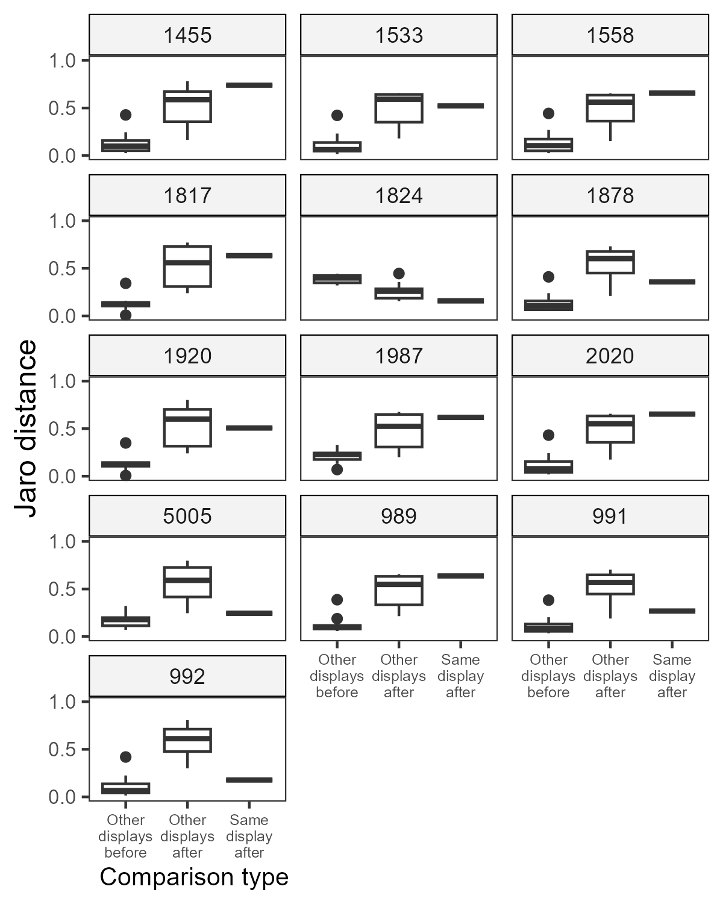

**Figure S7.** Jaro distances between each before-copulation (COP) display and three sets of comparison displays: (A) other before-copulation displays (n = 12), (B) other after-copulation displays (n = 12), and (C) the after-copulation section from the same display sequence (n = 1). Display ID is given above each set of comparisons.