**Table 1.** Core behavioral elements of male *Masius* courtship dances featured as featured across 308 SOLO, 102 AUDI, and 13 COP displays. Single-letter codes used in display strings are given on the left. Voucher videos of behaviors are archived at the Macaulay Library of Natural Sounds at Cornell University.

|  |  |  |  |  |  |
| --- | --- | --- | --- | --- | --- |
|  |  | **% displays present** | | |  |
|  | **Element** | **SOLO** | **AUDI** | **COP** | **Description** |
| A. | Zero | 100 | 27 | 0 | Paused (>5 s) while on the display log |
| B. | Audible log-approach dive | 100 | 100 | 100 | Swoop with vocalization from near the canopy to the log, with a dramatic snap and gymnastic vault upon landing |
| C. | Silent log-  approach dive | 69 | 1 | 0 | Same swoop as above, though lacking vocalization and often without vault |
| D. | Side-to-side bow | 100 | 100 | 100 | Movement from one edge of the display log to the other, then bowing head almost to the log surface |
| E. | Half bow | 43 | 18 | 15 |  |
| F. | Head-down bow | 99 | 99 | 0 | Stationary, chin-down posture with head held close to the surface of the log |
| G. | Metronome | 0 | 1 | 0 | Rhythmic swaying while perched near the log |
| H. | Position switch | 7 | 46 | 8 | Rapid body rotation (generally ~45°) |
| I. | Neck twist | 8 | 97 | 69 | With feet planted, lowering the side of the head towards the surface of the log |
| J. | To-and-fro flight | 25 | 87 | 15 | Flights of variable duration and distance from the log and back. |
| K. | Mixed | 14 | 4 | 0 | Mixture of two defined elements |
| L. | Other | 27 | 7 | 8 | Uncharacterized or miscellaneous behaviors (e.g., wing flashing) |

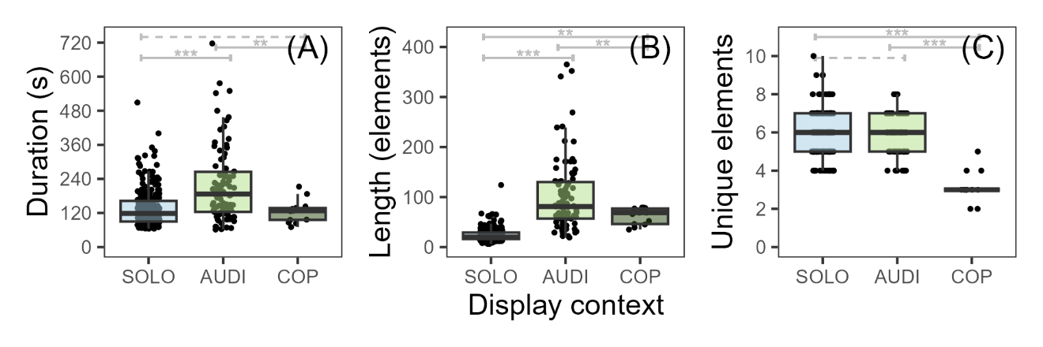

**Figure 1.** Repertoire complexity of *Masius* displays. Displays that ended in successful copulation (COP) had significantly smaller repertoires—measured in terms of number of unique elements—than solo male displays (SOLO) or unsuccessful displays for a female audience (AUDI), despite being significantly shorter than AUDI displays in both duration and number of elements. *(A)*: Display duration (seconds). *(B)*: Display length (total number of elements). *(C)*: Number of unique elements in displays. Gray brackets indicate pairwise Tukey’s HSD comparisons (\*\**P* ≤ 0.01; \*\*\**P* ≤ 0.001; dashed line = not significant).

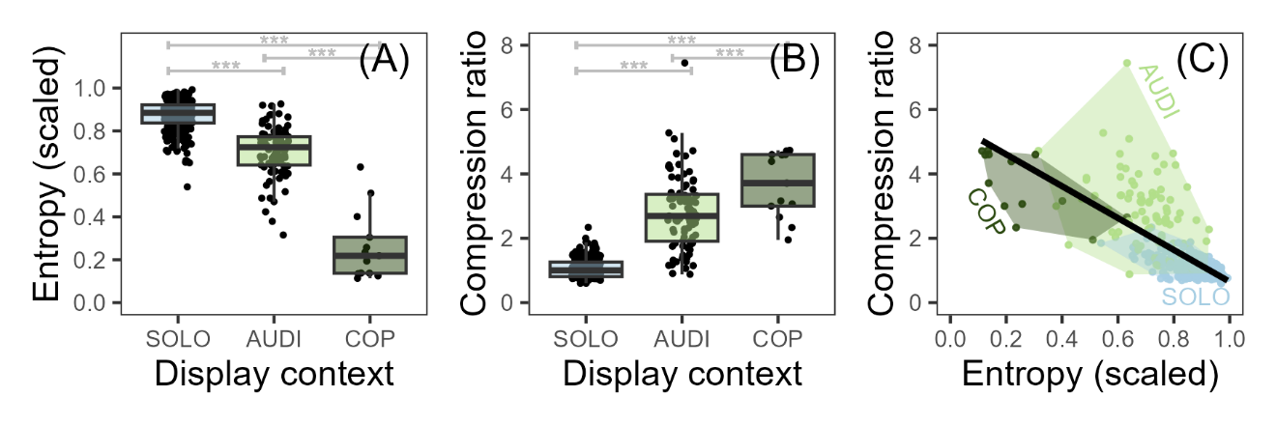

**Figure 2.** Syntax complexity of *Masius* displays. Displays that ended in successful copulation (COP) had both significantly lower entropy and significantly higher compressibility than solo male displays (SOLO) and unsuccessful displays for a female audience (AUDI). *(A)*: Entropy of displays scaled by maximum entropy given the number of unique elements in the display. *(B)*: Compressibility of displays, given as the length of the compressed display string divided by the length of original, single-character-coded display string. *(C)*: Linear regression (black line) between entropy and compressibility. Gray brackets indicate pairwise Tukey’s HSD comparisons (\*\*\**P* ≤ 0.001).

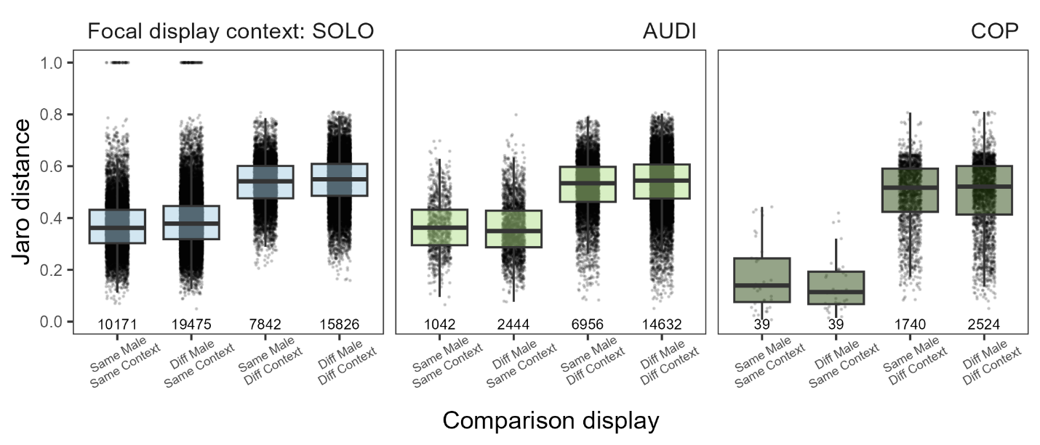

**Figure 3.** Context *vs.* individual variation in *Masius* displays. In terms of Jaro string distances, displays in all contexts (SOLO, AUDI, COP) were on average closer to displays in the same context than displays in other contexts, regardless of male performer. Each display from an individual identified male was compared to: displays from the same male in the same context (Same Male/Same Context), displays from a different male in the same context (Diff Male/Same Context), displays from the same male in a different context (Same Male/Diff Context), and displays from a different male in a different context (Diff Male/Diff Context). Each point shows a single Jaro distance value (0 = complete mismatch, 1 = complete match) between a focal display (SOLO, AUDI, or COP) and one comparison display. Bottom values give the total number of distances for each comparison type.