**Exercise 1: Multiple-Run Gradient Search**

Function fp

xbest =[ 0.3594 -0.2934]

fbest = -0.7902

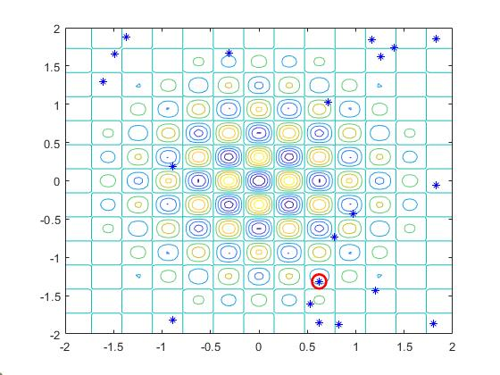

Function fp

xbest = -0.6224

fbest = -0.8225

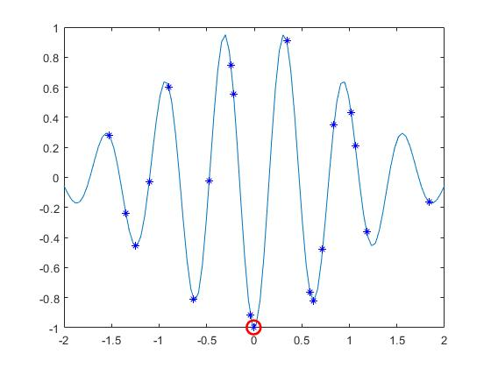

Function Rosenbrock

xbest =[ 1.0074 0.8328]

fbest = 3.3193

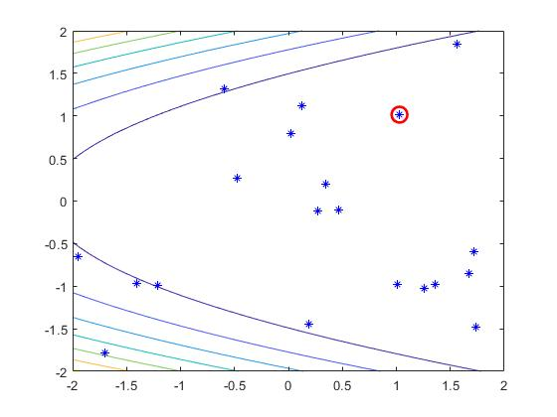

Function Auckley

xbest = 0.7180

fbest = 2.8564

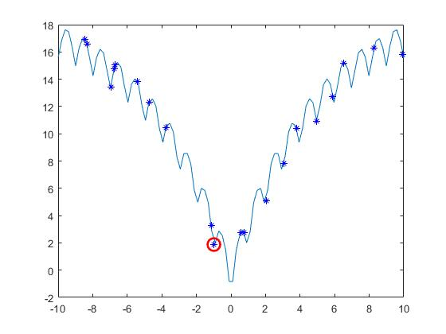

Function Auckley

xbest =[ 3.5201 3.6791]

fbest = 10.7750

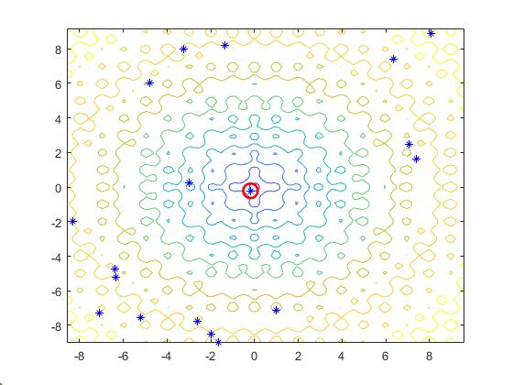

Function Auckley

xbest =[ 0.1890 -0.6001 1.0796]

fbest = 2.5283

**Exercise 2: Random Search**

Random Search Smart Random Search

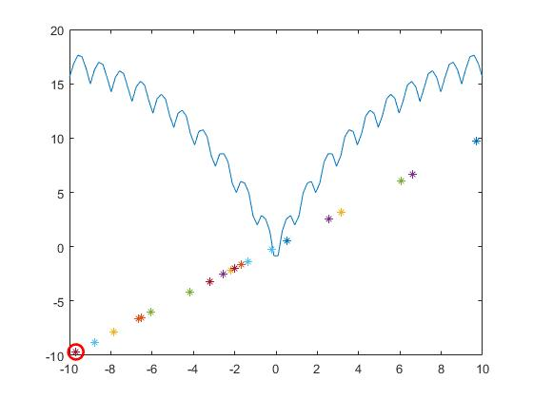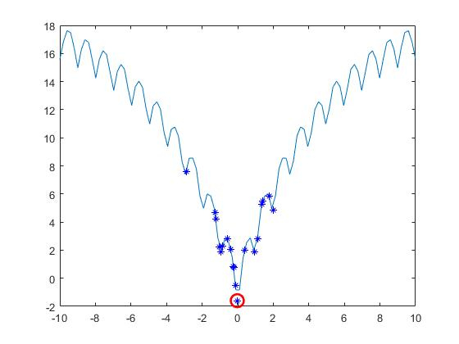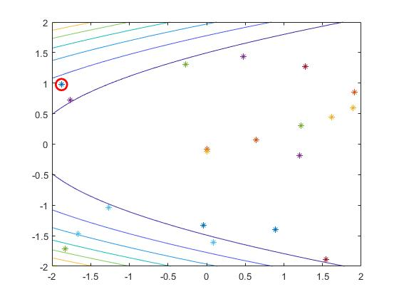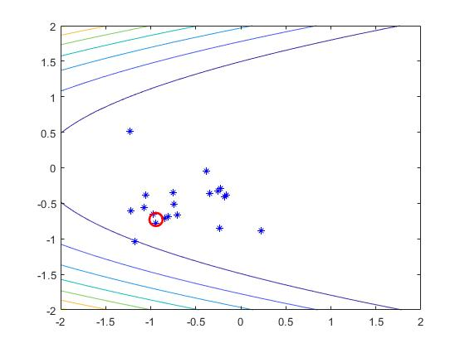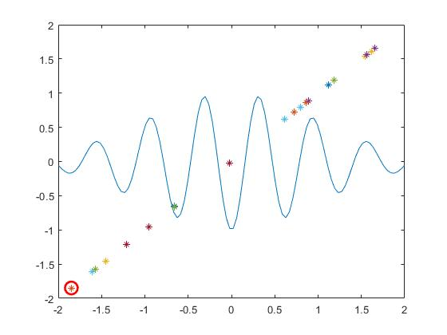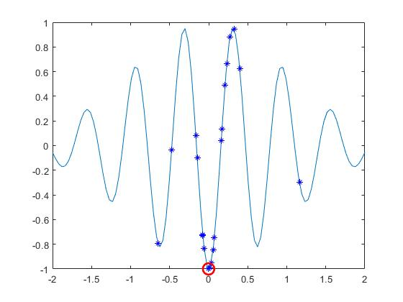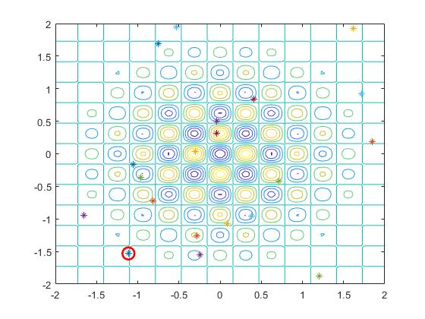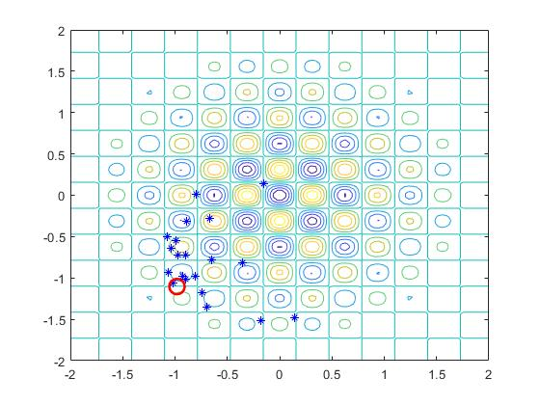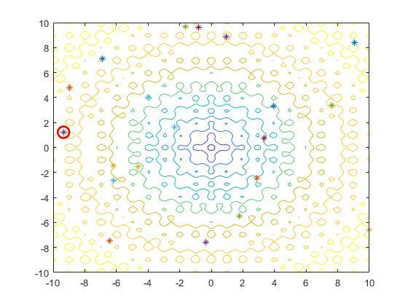 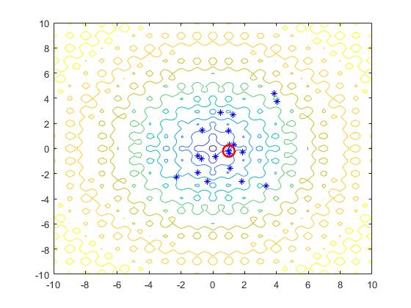

RS

xbest = [-2.0533 0.5681 -1.9926]

fbest = 5.3081

SRS

xbest1 =[ -0.3145 0.0415 -0.2470]

fbest1 = 0.6897

**Exercise 3: Differential Evolution Algorithm**

xbest =[ 0.0502 0]

fbest = -0.8756

iterations: 20 N=10 F=2 CR=0.5 function : fp

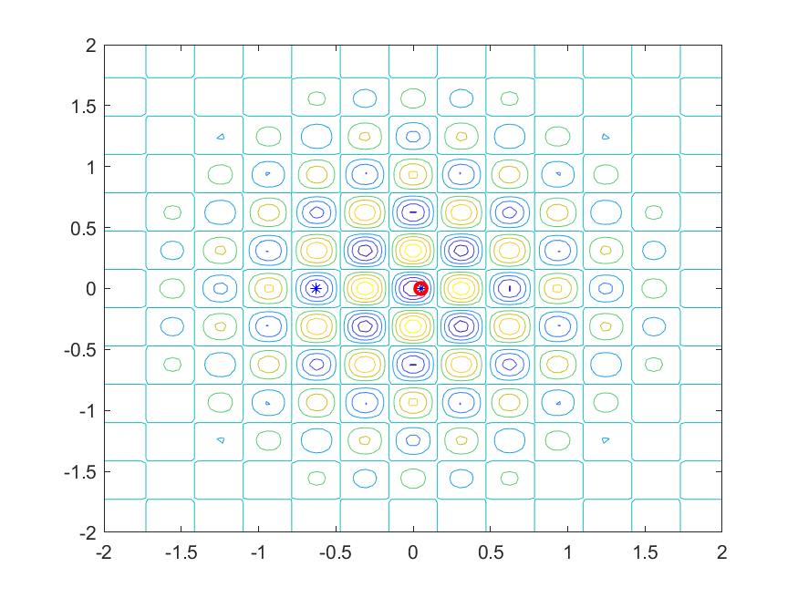

xbest = 1.0e-04 *[ 0.6923 0]

fbest = -1.0000

iterations: 20 N=10 F=1 CR=0.5 function : fp

xbest = -1.7909e-04

fbest = -1.0000

iterations: 20 N=10 F=1 CR=1 function : fp

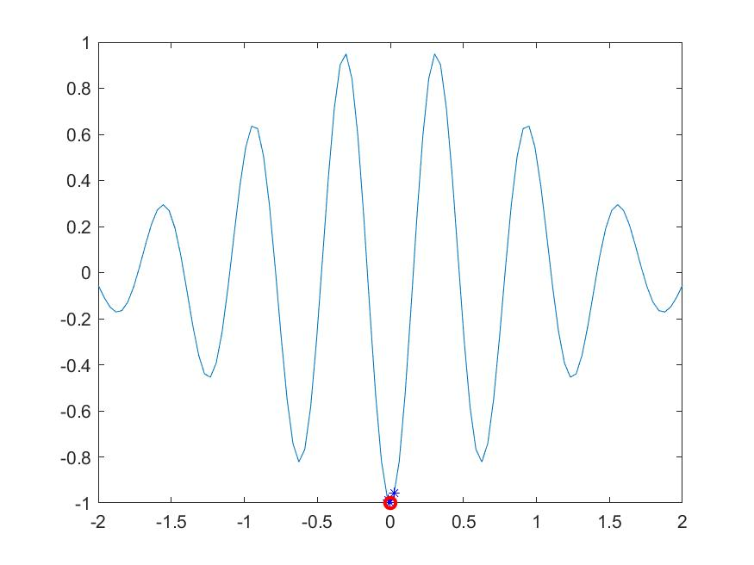

xbest = -0.0097

fbest = -0.9953

iterations: 20 N=10 F=1 CR=0.5 function : fp

xbest =[ 0.1581 0]

fbest = 0.7713

iterations: 20 N=10 F=1 CR=0.1 function : Rosenbrock

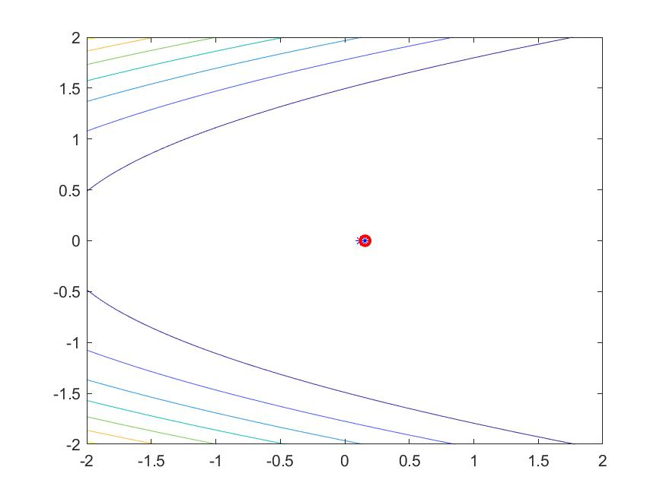

xbest =[ 1.1060 1.2297]

fbest = 0.0155

iterations: 20 N=10 F=1 CR=0.5 function : Rosenbrock

xbest =-1.5521e-05

fbest = -1.7182

iterations: 20 N=10 F=0.1 CR=0.5 function Auckley

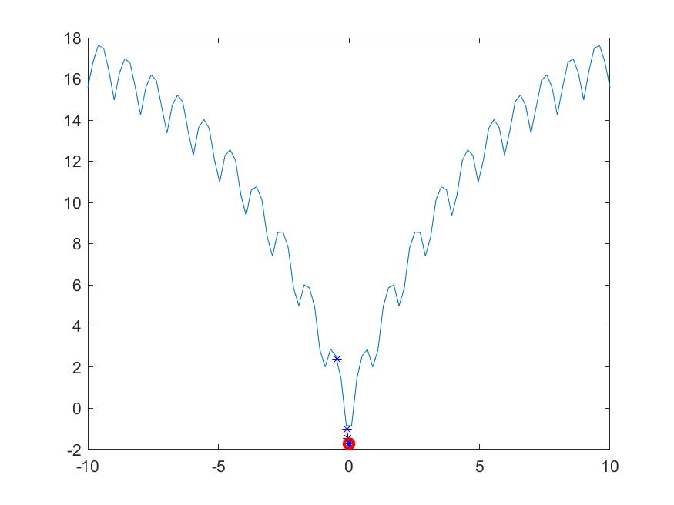

xbest = -0.0012

fbest = -1.7135

iterations: 20 N=10 F=1 CR=0.5 function Auckley

xbest =[ -0.0049 0]

fbest =-1.7039

iterations: 20 N=10 F=1 CR=0.5 function Auckley

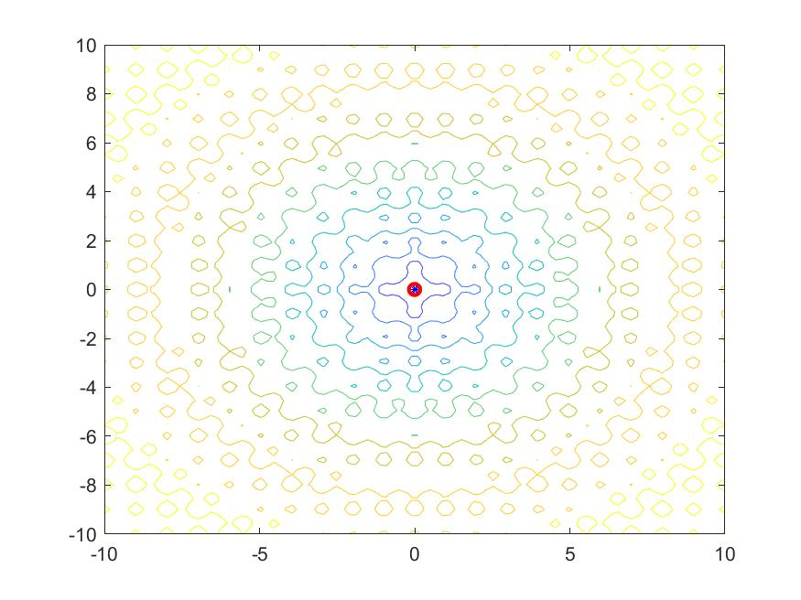

xbest =[ -0.0680 0]

fbest = -1.4072

iterations: 20 N=10 F=1 CR=0.5 function Auckley

xbest =[ 0 0 0]

fbest = -1.7183

iterations: 2000 N=100 F=1 CR=0.5 function Auckley

xbest =[ -0.9396 0 0]

fbest = 0.4018

iterations: 20 N=10 F=1 CR=0.5 function Auckley

**Exercise 4: Particle Swarm Optimization**

xbest =[ -0.3188 -0.3346]

fbest = -0.8790

iterations: 20 N=10 c=0.7298 c1=2 c2=2 function : fp

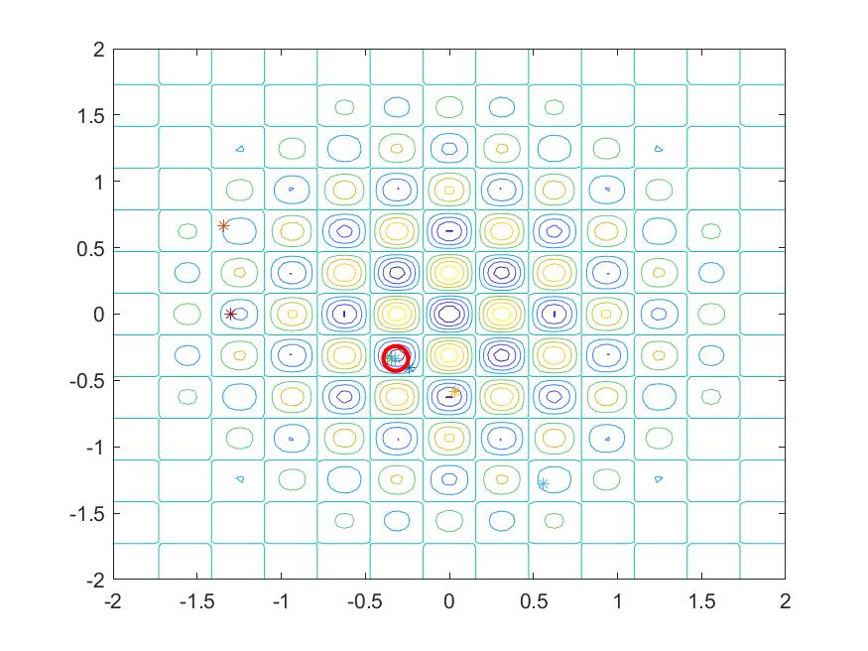

xbest =[ -0.0100 0.5650]

fbest = -0.6837

iterations: 20 N=10 c=0.5 c1=2 c2=2 function : fp

xbest = 1.6100e-04

fbest = -1.0000

iterations: 20 N=10 c=0.7298 c1=2 c2=2 function : fp

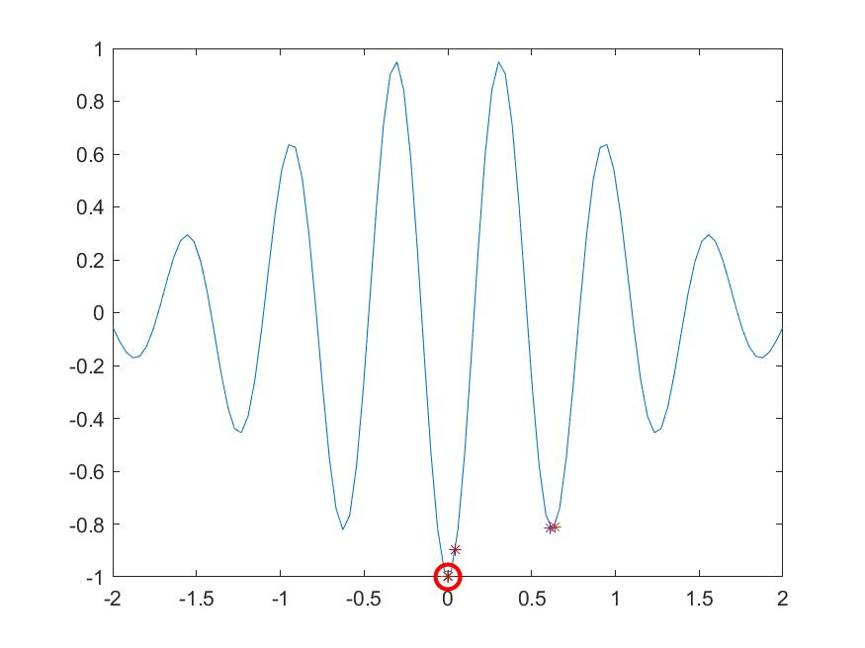

xbest = 0.0036

fbest = -0.9994

iterations: 20 N=10 c=0.9 c1=2 c2=2 function : fp

xbest =[ 0.9571 0.9172]

fbest = 0.0020

iterations: 20 N=10 c=0.7298 c1=2 c2=2 function :Rosenbrock

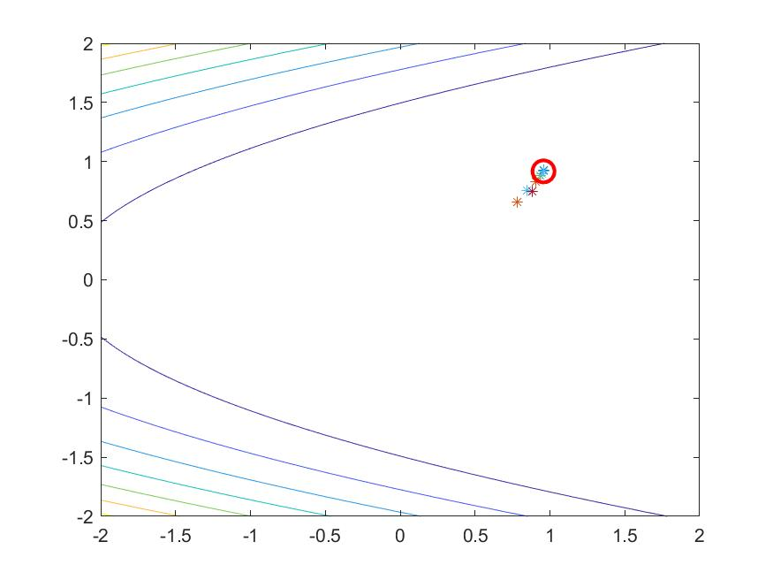

xbest =[ 0.8573 0.7226]

fbest = 0.0355

iterations: 20 N=10 c=0.7298 c1=1 c2=2 function :Rosenbrock

xbest = -0.0013

fbest = -1.7128

iterations: 20 N=10 c=0.7298 c1=2 c2=2 function : Auckley

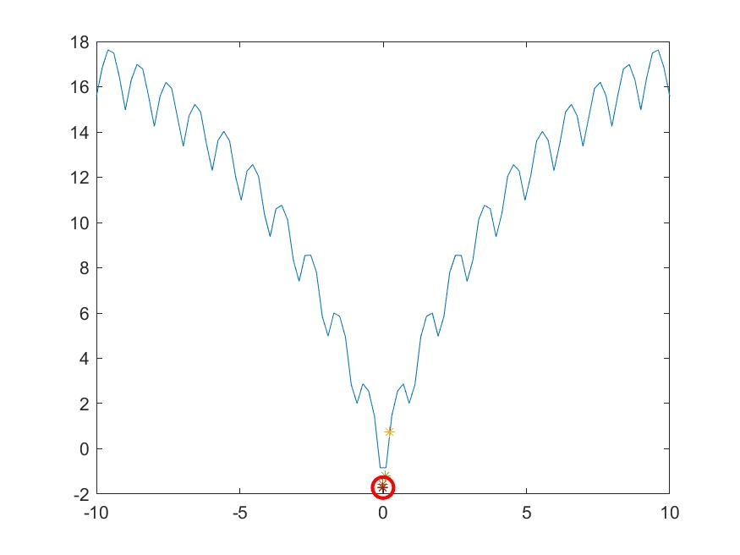

xbest = 9.4626e-04

fbest = -1.7144

iterations: 20 N=10 c=0.7298 c1=2 c2=1 function : Auckley

xbest =[ 0.0271 -0.0143]

fbest = -1.6068

iterations: 20 N=10 c=0.7298 c1=2 c2=2 function : Auckley

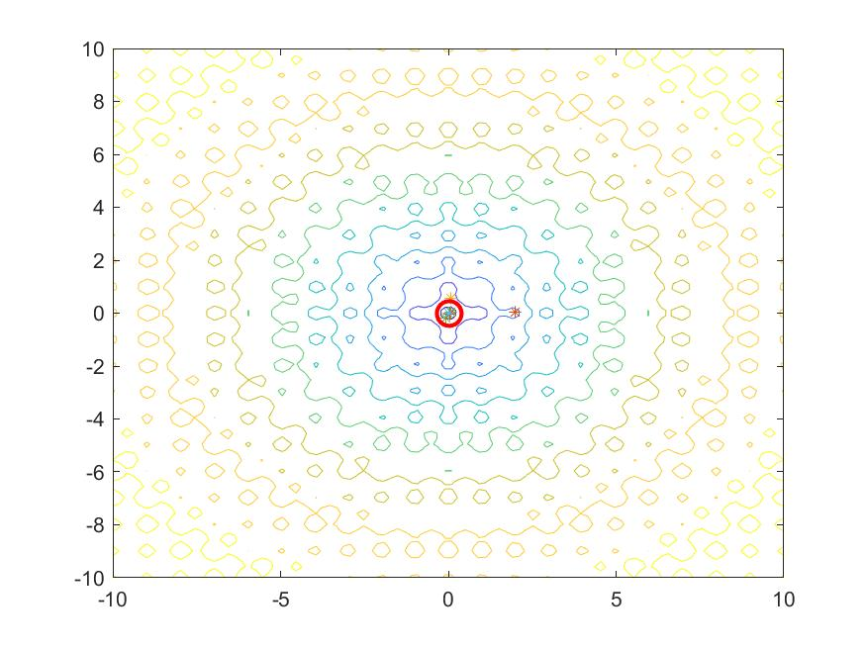

xbest =[ 0.0064 -0.0438]

fbest = -1.5418

iterations: 20 N=10 c=0.7298 c1=2 c2=3 function : Auckley

xbest = 1.0e-15 *[ 0.0252 0.1402 0.3398]

fbest = -1.7183

iterations: 2000 N=100 c=0.7298 c1=2 c2=2 function : Auckley

xbest = 1.0e-15 *[ 0.3367 -0.2302 0.1856]

fbest = -1.7183

iterations: 2000 N=100 c=0.7298 c1=3 c2=2 function : Auckley