System design RCU

The Rover Control Unit (RCU) is part of the rover and contains the microprocessor, required power supply and subcomponents (like RAM and flash storage) and a sensor package. It is the single rover controller, responsible for the experiment execution and performance evaluation.

According to the Roach2 proposal, the RCU shall

* Make pictures while the rover is in operation using an onboard camera
* Track the rovers movement inside the rocket module

Therefore, the software team proposes the following system design for the RCU.

# Overview

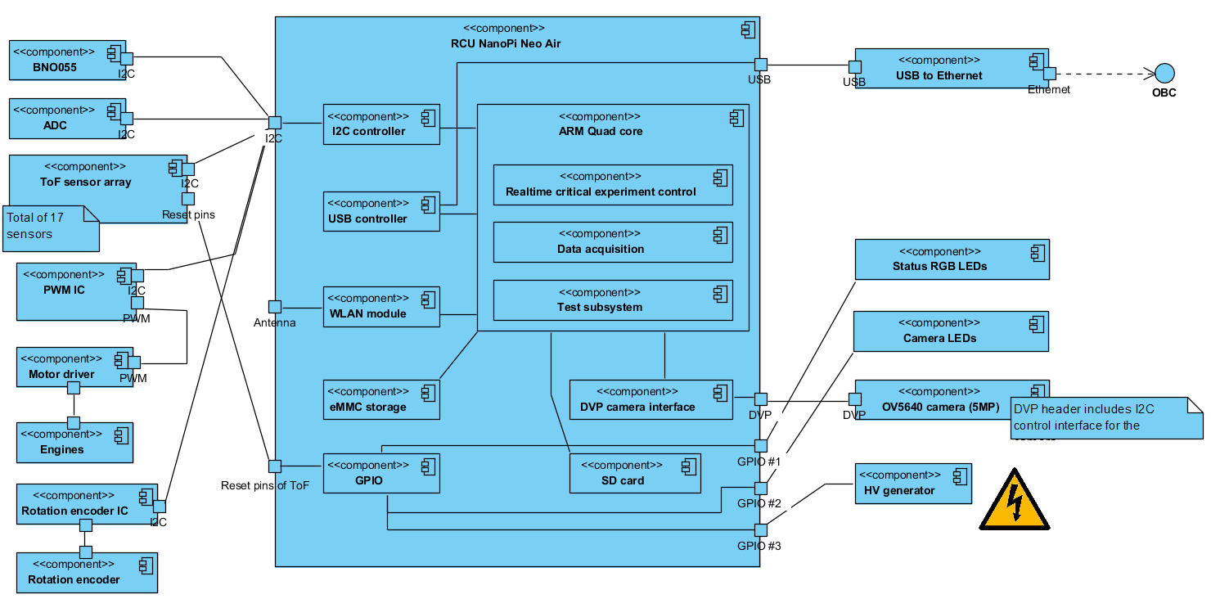

The central components is a FriendlyArm NanoPi Neo Air, which features a quadcore ARM processor with external DDR3 RAM and eMMC storage devices. The recorded data during the experiment will be stored on an external SD card, for which the device reader is already onboard. The OBC, which communicates with the REXUS service module, is connected to the RCU using an ethernet cable. The Neo Air does not feature a dedicated Ethernet PHY, therefore a USB to ethernet solution is added. All external sensors, excluding the camera, are connected via I2C. The 5MP OV5640 camera uses the parallel camera interface DVP, a CSI-2 interface is not available for these NanoPi boards (which are only 4x4cm in size). To support the image acquisition, external LEDs are placed on the rover front to illuminate the environment. These are switched on/off by the RCU. Additionally, RGB status LEDs are available for testing and status purposes. For ground tests, a WLAN/Bluetooth module is onboard to access the RCU wireless. Later when the experiment is in operational mode during rocket launch, the wireless communication is silenced.

# Sensor package

The RCU sensor package contains the following sensors:

* Bosch Sensortec BNO055 9-DoF IMU
* LM75AIM digital temperature sensor (-55°C to +125°C)
* ST VL53L0X ToF (Time of Flight) distance measurement sensors
* Rotation encoder for the engines
* ADC to measure supply voltage of all relevant power lanes (processor power supply, system power supply, each sensor’s power supply, HV generator(s) power supply, motor engine(s) power supply, camera power supply)

# Firmware

The vendor FriendlyArm supplies Linux operating systems, including a Ubuntu based version for this board. During implementation, this will serve as OS for the RCU. The whole firmware will be developed under Windows with Visual Studio 2017 (Community Edition) using cross platform compilation and executed on the ARM processor. The programming language will be C++.