Gradient Descent Optimization
Mathematics, Variants, and Implementation
A comprehensive guide to one of the most fundamental optimization algorithms in Machine Learning.
Autor: Maru
February 2026

Introduction to Gradient Descent
Gradient Descent is an iterative optimization algorithm used to find the minimum of a function. In the context of machine learning, it is used to minimize the Cost Function, which measures how well a model's predictions match the actual data.
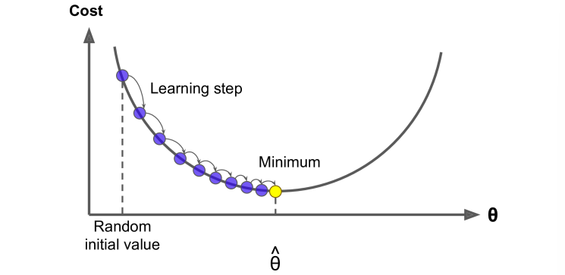
Figure 1: Visual representation of the learning steps towards the minimum.

The Mathematics of the Gradient
The core idea is to take steps proportional to the negative of the gradient of the function at the current point. The gradient represents the direction of steepest ascent; thus, moving in the opposite direction leads to the steepest descent.
$θ_{next}=θ_{current}−η⋅∇J(θ)$
The Update Rule
Where:\n- θ: Parameters of the model.\n- η (eta): The learning rate.\n- ∇J(θ): The gradient of the cost function.
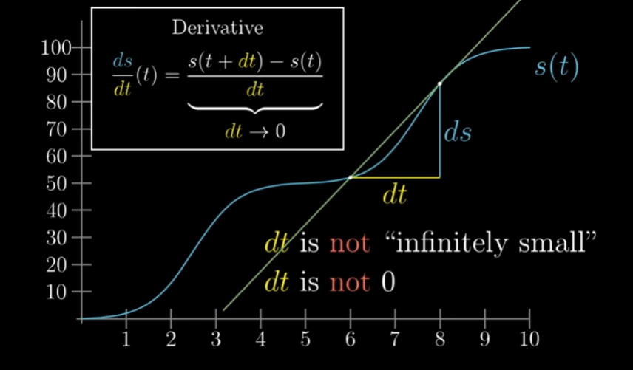
Figure 2: Mathematical foundations of derivatives and rates of change.

Learning Rate Challenges
Choosing the right learning rate is crucial. If it is too small, convergence will be slow. If it is too large, the algorithm might overshoot the minimum and diverge.
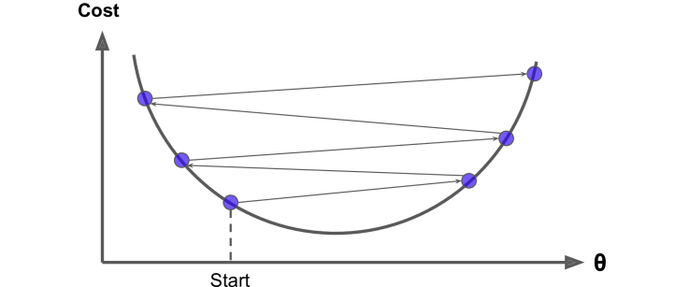
Figure 3: Overshooting the minimum due to a high learning rate.

Types of Gradient Descent
There are three main variants of the algorithm based on how much data is used to compute the gradient.
Comparison of Gradient Descent Variants
Variant | Data per Update | Convergence Speed
Batch GD | Entire Dataset | Slow
Stochastic GD | 1 Sample | Fast (noisy)
Mini-batch GD | Small Batch | Balanced
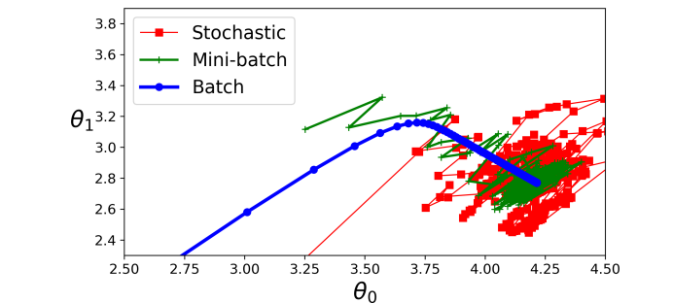
Figure 4: Comparison of paths taken by different GD variants.

Common Pitfalls
Gradient descent can get stuck in local minima or encounter plateaus where the gradient is nearly zero, making progress extremely slow.
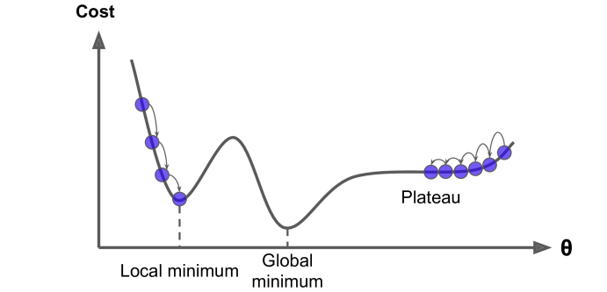
Figure 5: Local minima and plateaus in non-convex functions.

Conclusion
Gradient Descent remains the backbone of modern neural network training. Understanding its mathematical properties and limitations is essential for any machine learning practitioner.

