Gradient Descent: Algorithms and Mathematics
Optimization Techniques in Machine Learning
Comprehensive guide covering fundamentals, mathematics, types of gradient descent, challenges, and visualizations.
Autor: Maru
February 2026

Introduction to Gradient Descent
Gradient Descent (GD) is a first-order iterative optimization algorithm used to find a local minimum of a differentiable function. In machine learning, it minimizes the cost function J(θ) by iteratively adjusting parameters θ in the direction opposite to the gradient.
The basic update rule moves the parameters by a step proportional to the negative gradient: θ := θ - α ∇J(θ), where α is the learning rate.
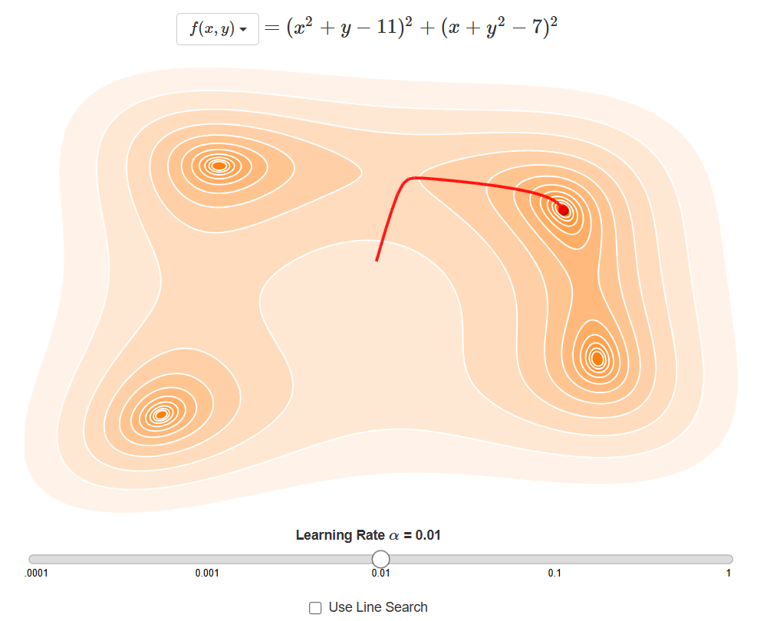
Illustration of gradient descent steps from a random initial value towards the minimum cost.
$θ:=θ−α∇J(θ)$
Gradient Descent Update Rule

Mathematical Foundations
Gradient descent relies on the concept of derivatives and gradients. The derivative measures the rate of change of a function, while the gradient generalizes this to multiple dimensions.
For a function f(x), the derivative df/dx ≈ Δf/Δx. In higher dimensions, the gradient ∇f points in the direction of steepest ascent.
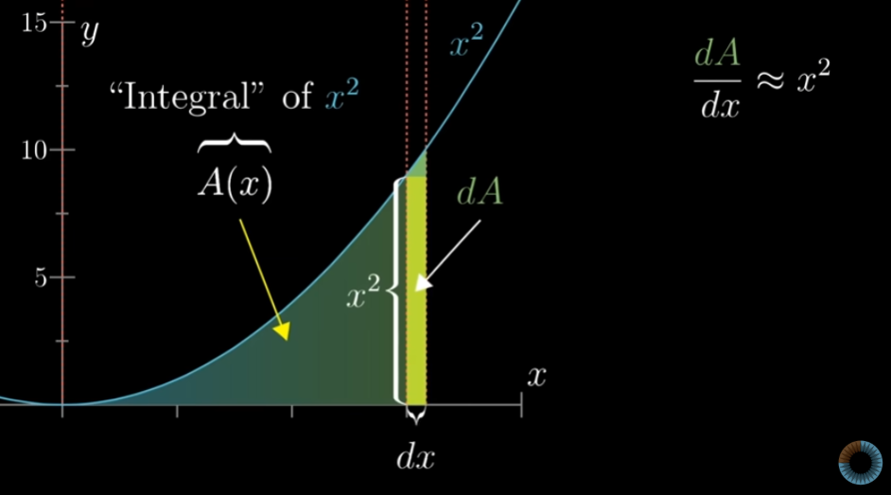
Visual representation of the derivative as the slope of the tangent line
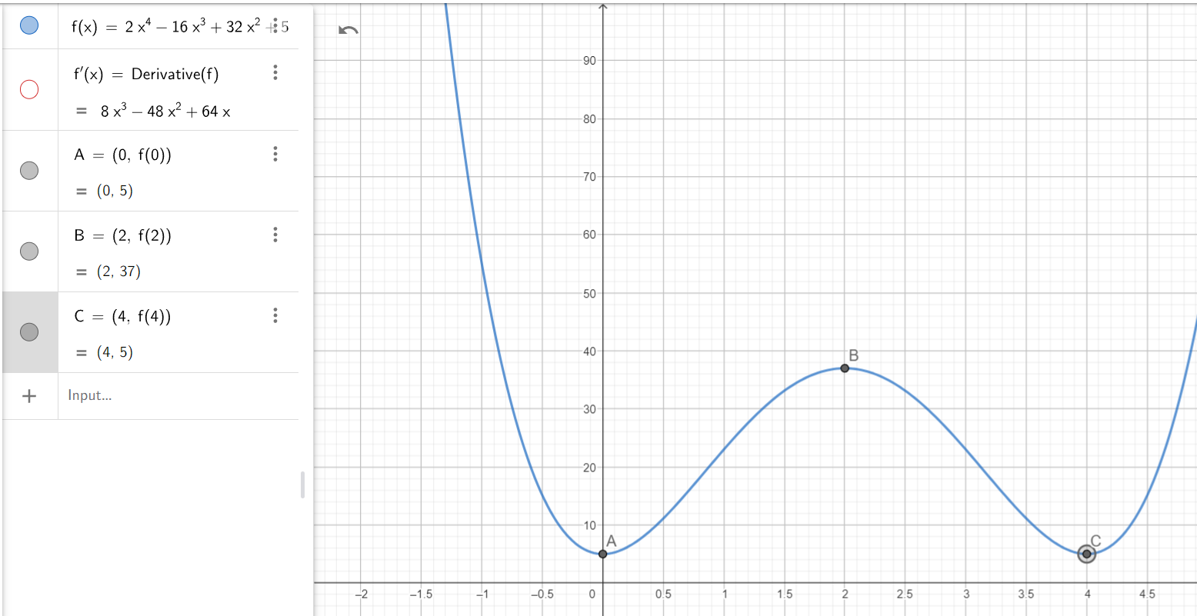
First derivative test for identifying minima
$∇J(θ)=\left[\frac{∂J}{∂θ_{1}},…,\frac{∂J}{∂θ_{n}}\right]$
Gradient Vector

Types of Gradient Descent
There are three main variants differing in how the gradient is computed:
Batch Gradient Descent*: Uses the entire dataset.
Stochastic Gradient Descent (SGD)*: Uses one sample per update.
Mini-batch Gradient Descent*: Uses a small batch of samples.
Comparison of Gradient Descent Variants
Type | Batch Size | Advantages | Disadvantages
Batch GD | Full dataset | Stable convergence, accurate | Computationally expensive, slow for large data
Stochastic GD (SGD) | 1 | Fast updates, escapes local minima | Noisy path, high variance
Mini-batch GD | 10-1000 | Balances speed and stability, GPU-friendly | Tuning batch size required
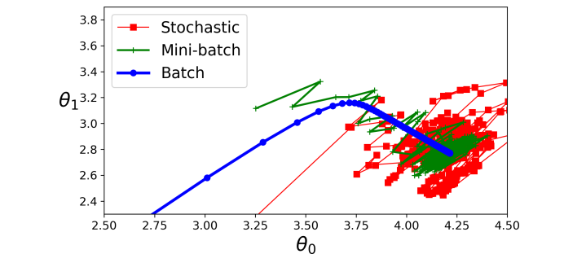
Convergence paths for Stochastic (red), Mini-batch (green), and Batch (blue) GD.

Learning Rate and Common Pitfalls
The learning rate α controls step size. Too small: slow convergence. Too large: overshooting.
Pitfalls include local minima, plateaus, and saddle points.
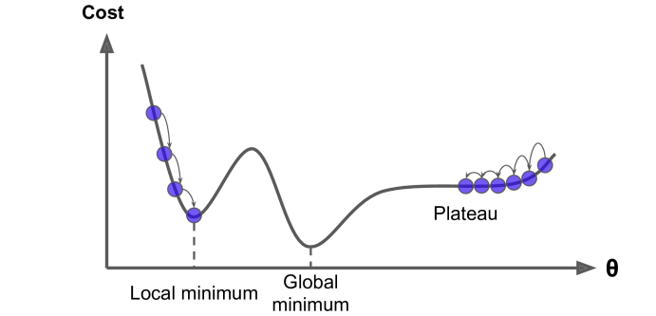
Cost function pitfalls: local minimum, global minimum, and plateau.
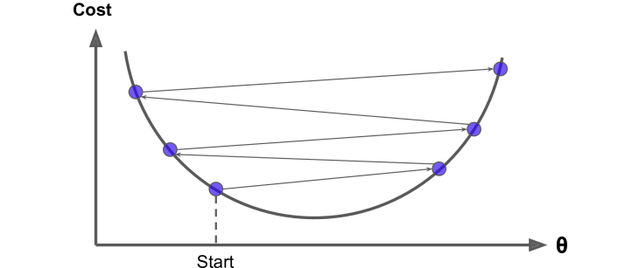
Effect of large learning rate causing divergence.

Gradient Descent in Multiple Dimensions
In higher dimensions, GD follows contour lines of the cost surface towards the minimum.
Visualized using contour plots and 3D surfaces.
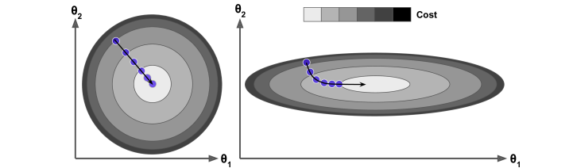
Contour plot showing gradient descent path in 2D parameter space.
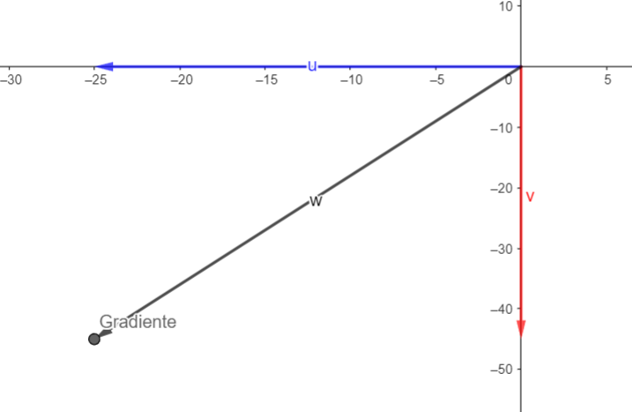
Gradient vectors in parameter space (θ0, θ1).
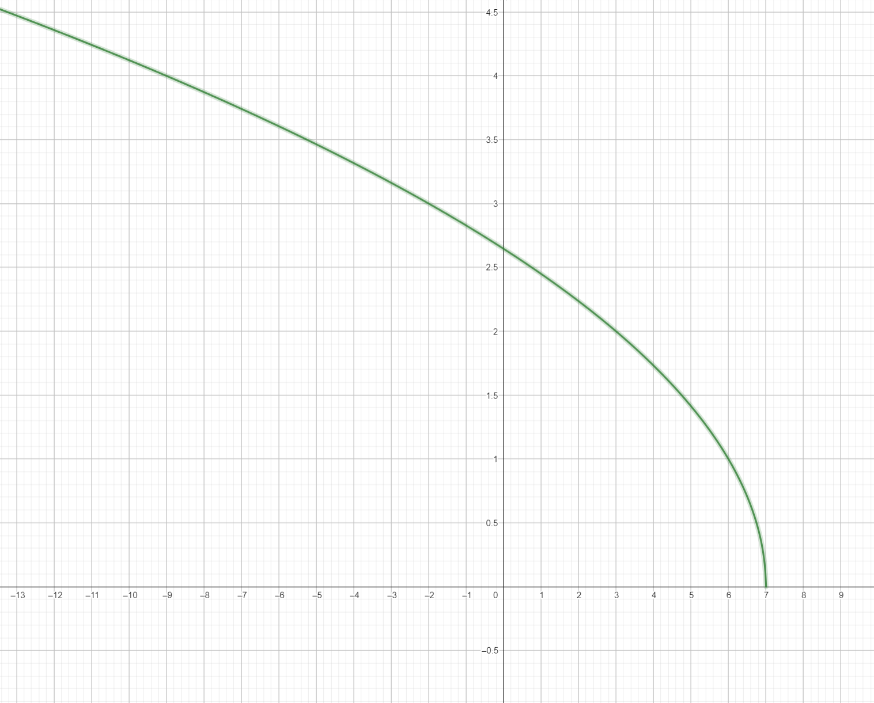
Domain and visualization of multivariable functions.

