Gradient Descent: Theory, Variants, and Practical Guidance
A two-column reference with formulas, tables, and visual intuition
Explains the mathematics of gradient descent, compares major variants, and provides practical guidance for using it effectively.
Autor: Maru
February 2026

1. What gradient descent is (in one paragraph)
Gradient descent is an iterative optimization method for minimizing a differentiable objective (or “loss”) function. Starting from an initial parameter vector θ₀, it repeatedly moves in the direction that most rapidly decreases the objective—namely the negative gradient. Despite its simple update rule, many practical variants exist (batch, stochastic, mini-batch, momentum, Adam, etc.), mainly to improve speed, stability, and robustness on large and noisy datasets.

2. Mathematical setup and notation
We seek to minimize a function J(θ) where θ ∈ ℝᵈ. In supervised learning with data {(xᵢ, yᵢ)}ᵢ₌₁ⁿ, a common form is an empirical risk:
J(θ) = (1/n)∑ᵢ ℓ(f(xᵢ;θ), yᵢ) + λR(θ),
where ℓ is a per-sample loss, R is a regularizer, and λ ≥ 0 controls regularization strength.
$θ^{⋆}∈\backslash arg\min_{θ∈ℝ^{d}}J(θ)$
Optimization objective (minimizer may not be unique).
The gradient of J at θ is the vector of partial derivatives:
∇J(θ) = [∂J/∂θ₁, …, ∂J/∂θ_d]ᵀ.
It points toward the direction of steepest increase of J; therefore −∇J(θ) is the steepest local decrease direction.
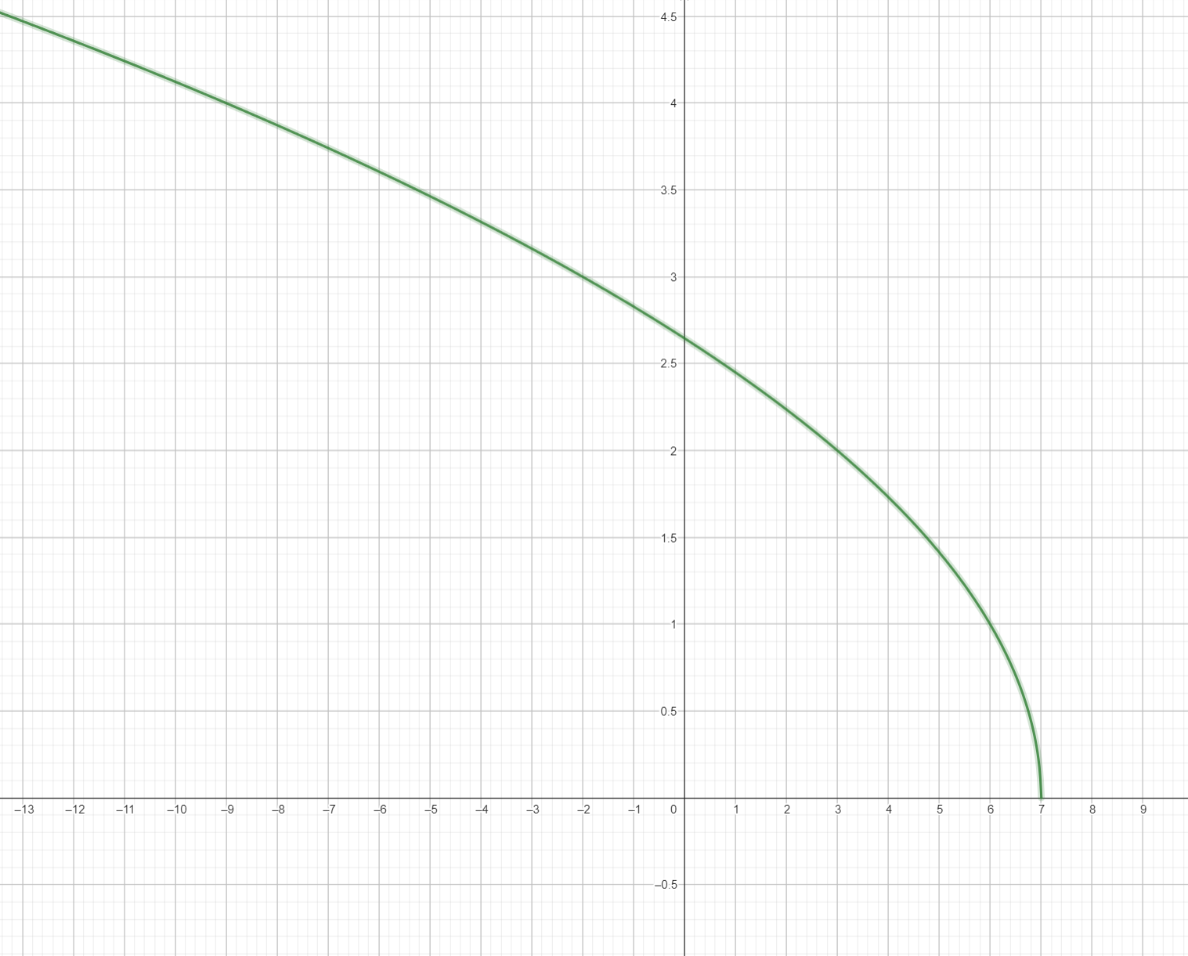
Function of two variables: the parameter space is often multi-dimensional (θ ∈ ℝᵈ).

3. Derivatives, gradients, and why the gradient matters
In 1D, the derivative f′(x) measures local slope. In multiple dimensions, the gradient generalizes this idea: it is the unique vector whose dot product with a direction u gives the directional derivative. This makes gradients the natural tool for designing local “move rules” that reduce an objective.
$D_{u}J(θ)=\lim_{ϵ→0}\frac{J(θ+ϵu)−J(θ)}{ϵ}=∇J(θ)^{⊤}u$
Directional derivative equals the gradient dotted with the direction.
A key justification comes from a first-order Taylor approximation:
J(θ + Δ) ≈ J(θ) + ∇J(θ)ᵀΔ.
If we choose Δ = −α∇J(θ), then the predicted change is approximately −α‖∇J(θ)‖², which is non-positive when α>0.
$J(θ+Δ)≈J(θ)+∇J(θ)^{⊤}Δ$
First-order (linear) approximation that motivates gradient descent.
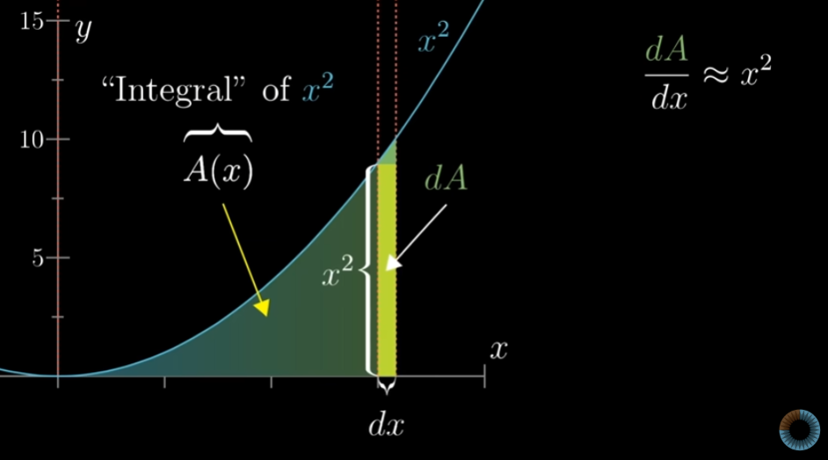
Derivative as a limiting slope: intuition behind “follow the slope downhill.”
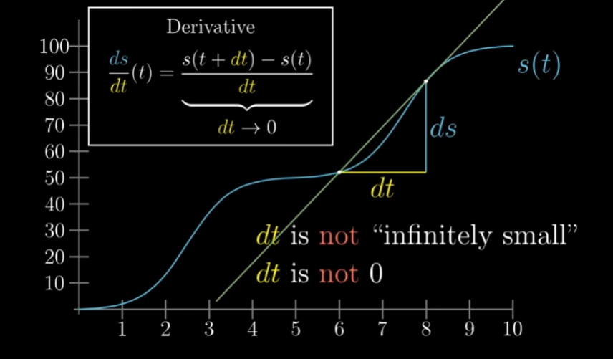
Derivative and finite differences: in computation, gradients are approximated or computed via backprop/automatic differentiation.
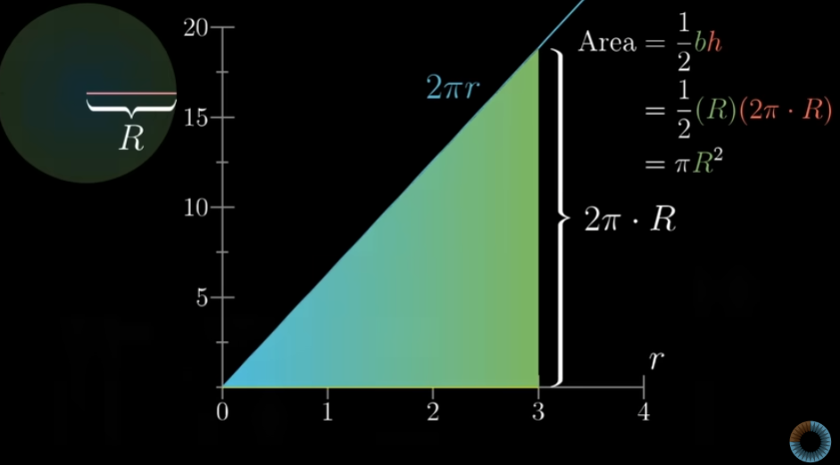
Area/accumulation picture: optimization often integrates many small improvements over iterations.

4. The core gradient descent algorithm
At iteration t, compute the gradient g_t = ∇J(θ_t) and update parameters by stepping against it. The scalar α>0 is the learning rate (step size). Choosing α well is essential: too large causes divergence/oscillation; too small makes progress slow.
$θ_{t+1}=θ_{t}−α∇J(θ_{t})$
Basic gradient descent update rule.
- Initialize θ₀ (randomly or from a heuristic).
- Repeat until a stopping condition is met: compute gradient g_t and update θ.
- Stop when ‖g_t‖ is small, validation loss stops improving, or after a fixed budget of steps.
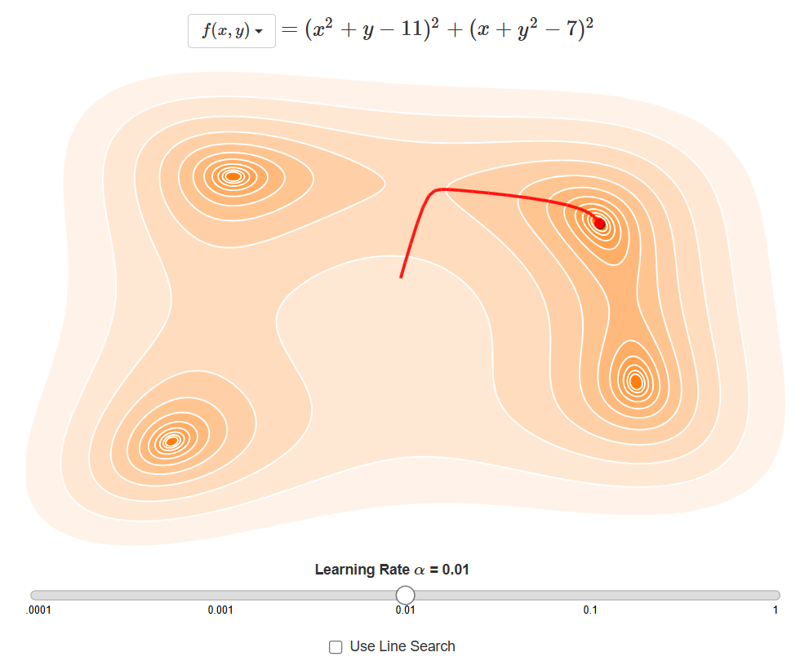
Typical 1D descent trajectory: repeated steps move toward a minimum of the cost curve.
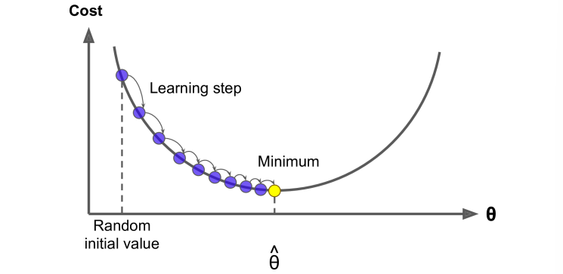
Gradient vector and its components: the update subtracts a scaled gradient from the current point.

5. Types of gradient descent: batch, stochastic, and mini-batch
The main distinction is how the gradient is estimated from data. Using all n samples gives a low-noise but expensive step. Using one sample is cheap but noisy. Mini-batches interpolate between these extremes and are the standard choice in modern deep learning.
$∇J(θ)=\frac{1}{n}\sum_{i=1}^{n}{∇_{θ}ℓ_{i}(θ)\text{(with }ℓ_{i}(θ)=ℓ(f(x_{i};θ),y_{i})}\text{)}$
Full (batch) gradient as the average of per-sample gradients.
$g_{t}=\frac{1}{|B_{t}|}\sum_{i∈B_{t}}{∇_{θ}ℓ_{i}(θ_{t})}$
Mini-batch gradient estimate using a batch B_t of samples.
Comparison of the three core gradient descent regimes.
Variant | Gradient estimate | Pros | Cons | Typical use
Batch GD | All samples | Stable descent; deterministic for fixed data | Slow per step; expensive on large n | Small/medium datasets; convex problems
Stochastic GD (SGD) | Single sample | Very fast updates; can escape shallow local structure | Noisy path; needs scheduling/averaging | Large-scale learning; online learning
Mini-batch GD | Small batch (e.g., 32–4096) | Efficient on GPUs; reduced noise; good generalization | Still stochastic; batch size tuning | Default for deep nets
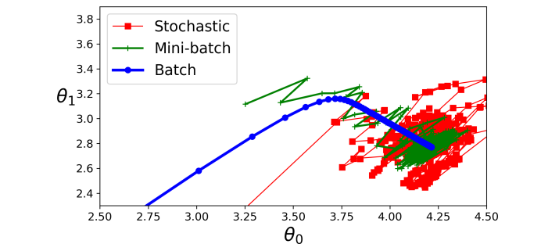
Batch vs mini-batch vs stochastic trajectories: noise level changes the path and convergence behavior.
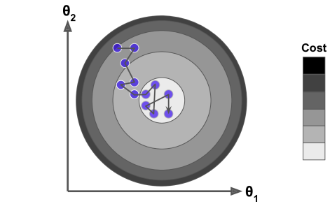
Contour plot intuition: SGD produces a jittery path while still trending toward lower cost regions.

6. Learning rate (step size): stability, speed, and schedules
The learning rate α controls how far each step moves. If α is too large, updates may overshoot minima or even diverge. If α is too small, training can stall. In practice, α is often scheduled over time (decayed) or adapted per-parameter (e.g., Adam).
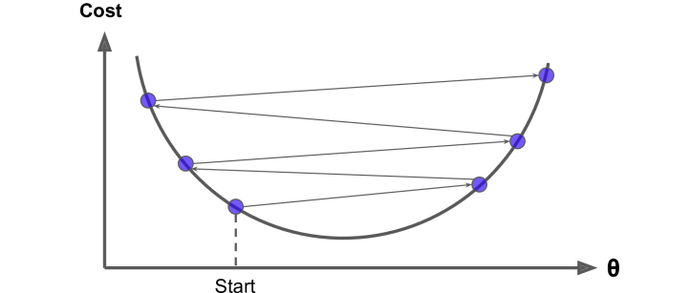
Overshooting due to a large learning rate: steps jump across the valley instead of settling into it.
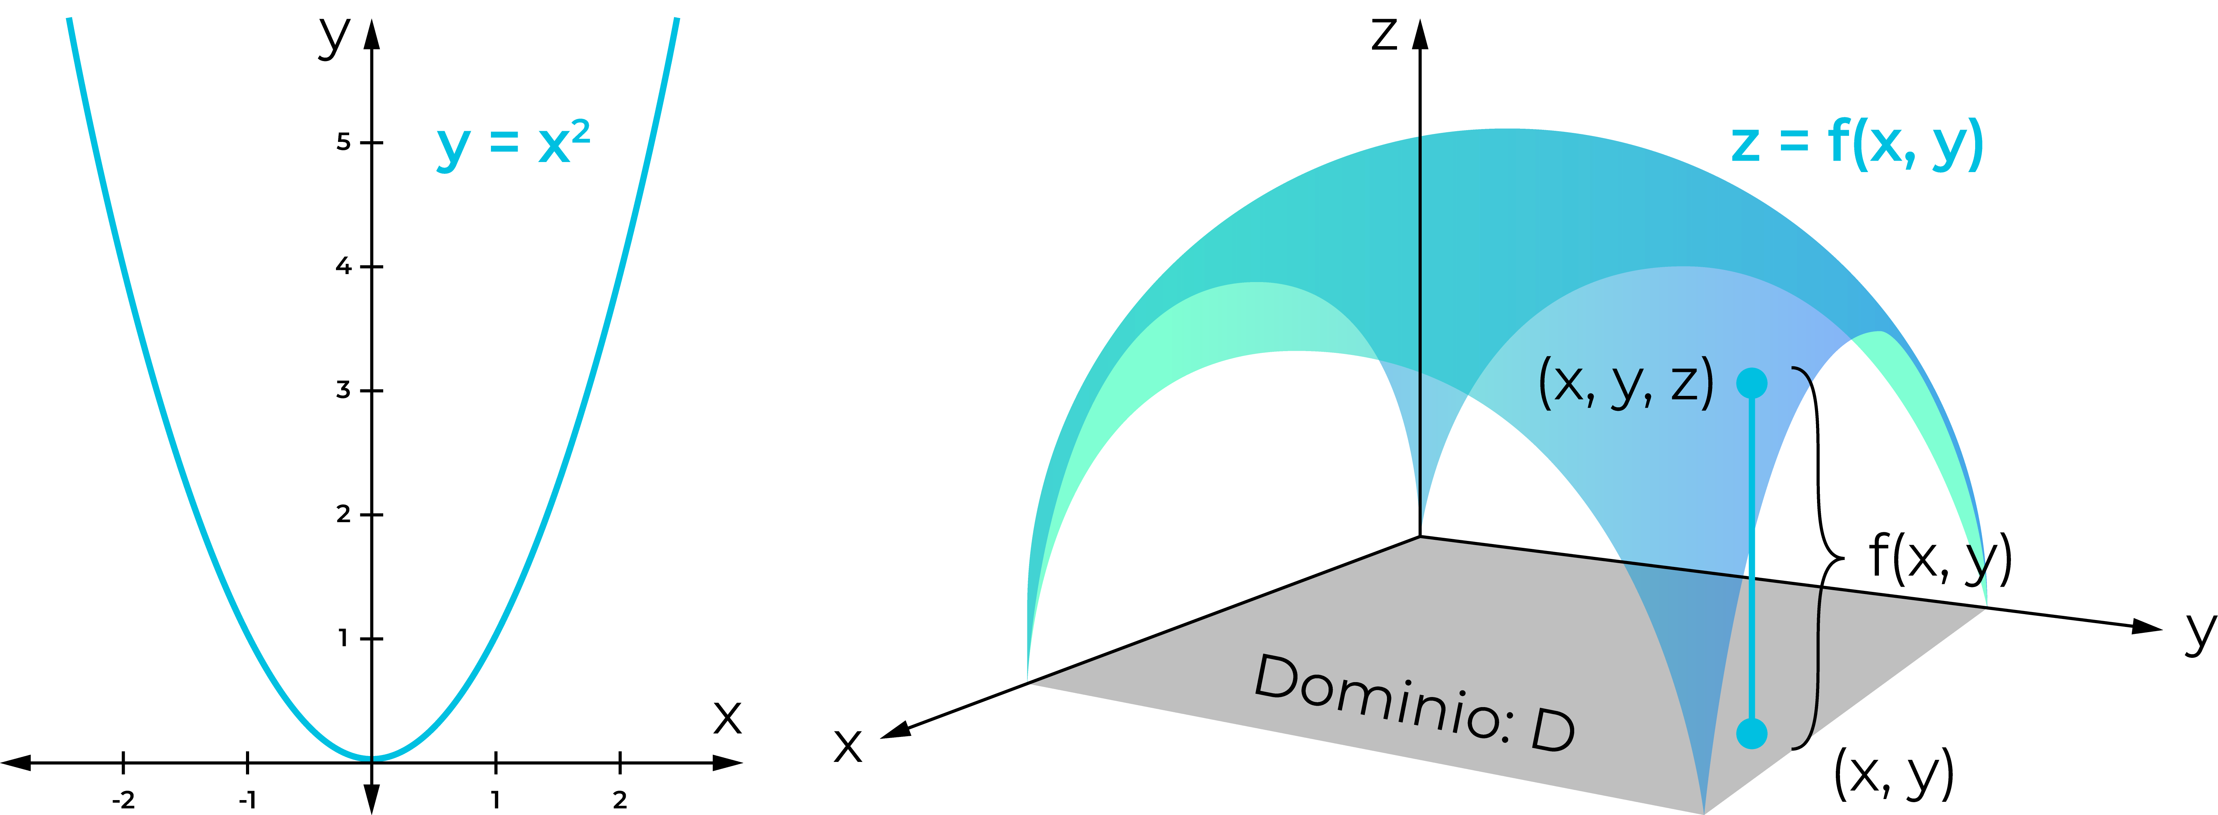
Learning-rate sensitivity: the step size strongly shapes the descent path and convergence speed.
Common learning-rate strategies and when they are useful.
Schedule | Example formula (α_t) | When it helps | Notes
Constant | α | Convex/smooth problems with tuned α | Simple but brittle if curvature varies
Step decay | α·γ^{⌊t/k⌋} | When progress plateaus | Common in deep learning training recipes
Exponential decay | α·exp(−kt) | Smooth long runs | May decay too fast if k is large
Cosine decay | α_min + (α_max−α_min)·(1+cos(πt/T))/2 | Modern deep learning; stable late training | Often combined with warmup
Warmup | α_t increases for first W steps | Large-batch training stability | Reduces early divergence
Line search (classic optimization) | Choose α_t to satisfy sufficient decrease | Well-behaved smooth objectives | More expensive per step; less used in deep nets

7. Convergence basics (what theory says)
Convergence guarantees depend on assumptions. For convex and L-smooth functions (gradient is Lipschitz), a step size α ≤ 1/L ensures the objective decreases monotonically. For μ-strongly convex functions, gradient descent converges linearly to the unique minimizer.
$‖∇J(θ)−∇J(ϕ)‖≤L‖θ−ϕ‖$
L-smoothness (Lipschitz gradient) assumption.
$J(θ_{t+1})≤J(θ_{t})−\frac{α}{2}‖∇J(θ_{t})‖^{2}\text{for }α≤\frac{1}{L}$
A common descent inequality for smooth objectives.
$‖θ_{t}−θ^{⋆}‖≤(1−αμ)^{t}‖θ_{0}−θ^{⋆}‖\text{for }0<α≤\frac{1}{L}$
Linear convergence under μ-strong convexity (one typical form).
In non-convex problems (typical for deep neural networks), the best general guarantee is often convergence to a point with small gradient norm, i.e., ‖∇J(θ_t)‖ → 0 in some sense. Practical success comes from good regularization, architectures, and robust optimizers.

8. Geometry and pitfalls: ravines, plateaus, and local structure
Real objectives may have very different curvature along different directions (ill-conditioning). This creates “ravines”: steep walls but a shallow floor. Standard gradient descent then zig-zags. Plateaus (small gradients) slow progress, and saddle points can trap methods that rely purely on first-order information.
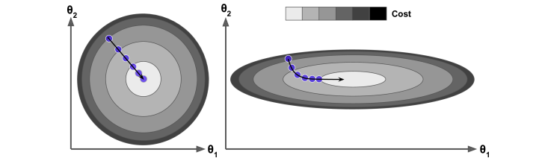
Contours with different axis scaling: anisotropic curvature produces curved or zig-zagging trajectories.
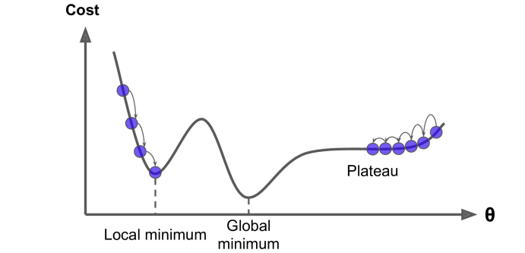
Local minima vs global minima and plateaus: non-convex landscapes can slow or mislead descent.
Feature scaling and normalization are crucial because they change the conditioning of the problem. In linear models, standardizing features often turns a narrow ravine into a more spherical bowl, allowing larger stable learning rates and faster convergence.

9. Momentum and accelerated first-order methods
Momentum accumulates a running “velocity” vector, smoothing noisy gradients and reducing zig-zagging in ravines. It can be interpreted as a low-pass filter on gradients and is often one of the most effective upgrades over vanilla SGD.
$v_{t+1}=βv_{t}+∇J(θ_{t}),θ_{t+1}=θ_{t}−αv_{t+1}$
Gradient descent with (classical) momentum, with β ∈ [0,1).
Nesterov accelerated gradient (NAG) evaluates the gradient at a look-ahead point, which can improve stability and theoretically improves rates for certain convex problems.
$v_{t+1}=βv_{t}+∇J(θ_{t}−αβv_{t}),θ_{t+1}=θ_{t}−αv_{t+1}$
One common form of Nesterov momentum (look-ahead gradient).

10. Adaptive learning-rate methods (AdaGrad, RMSProp, Adam)
Adaptive methods scale updates per parameter based on historical gradient magnitudes. They are especially helpful when different parameters have different natural scales or when gradients are sparse. However, their generalization behavior can differ from SGD+momentum, so selection is task-dependent.
$r_{t}=r_{t−1}+g_{t}⊙g_{t},θ_{t+1}=θ_{t}−α\frac{g_{t}}{\sqrt{r_{t}}+ϵ}$
AdaGrad (elementwise), with g_t a mini-batch gradient estimate.
$r_{t}=ρr_{t−1}+(1−ρ)(g_{t}⊙g_{t}),θ_{t+1}=θ_{t}−α\frac{g_{t}}{\sqrt{r_{t}}+ϵ}$
RMSProp: exponential moving average of squared gradients.
$m_{t}=β_{1}m_{t−1}+(1−β_{1})g_{t},v_{t}=β_{2}v_{t−1}+(1−β_{2})(g_{t}⊙g_{t})$
Adam maintains first and second moment estimates.
${\overset{^}{m}}_{t}=\frac{m_{t}}{1−β_{1}^{t}},{\overset{^}{v}}_{t}=\frac{v_{t}}{1−β_{2}^{t}},θ_{t+1}=θ_{t}−α\frac{{\overset{^}{m}}_{t}}{\sqrt{{\overset{^}{v}}_{t}}+ϵ}$
Adam bias correction and parameter update.
Common first-order optimizers related to gradient descent.
Optimizer | Key idea | Typical hyperparameters (common defaults) | Good for | Cautions
SGD | Noisy first-order steps | α tuned; optional schedule | Strong generalization; simple baselines | Needs careful α schedule
SGD + Momentum | Velocity smooths gradients | β≈0.9, α tuned | Ravines; faster convergence | Can overshoot if α too large
Nesterov | Look-ahead gradient | β≈0.9 | Stability + speed in some settings | More sensitive to implementation details
AdaGrad | Per-parameter scaling (accumulates) | α, ε≈1e−8 | Sparse gradients (e.g., NLP features) | Learning rate can decay too much
RMSProp | EMA of squared gradients | ρ≈0.9, α, ε | Non-stationary objectives | Hyperparameter coupling
Adam | EMA of first+second moments | β₁=0.9, β₂=0.999, ε=1e−8 | Fast training; robust defaults | May need weight decay variant (AdamW)

11. Stopping criteria and diagnostics
Practical stopping is usually based on validation performance (early stopping). In pure optimization, you may also stop when the gradient norm is small, the relative improvement in J is below a tolerance, or after a maximum iteration budget. Tracking learning curves helps detect divergence, overfitting, or stalled progress.
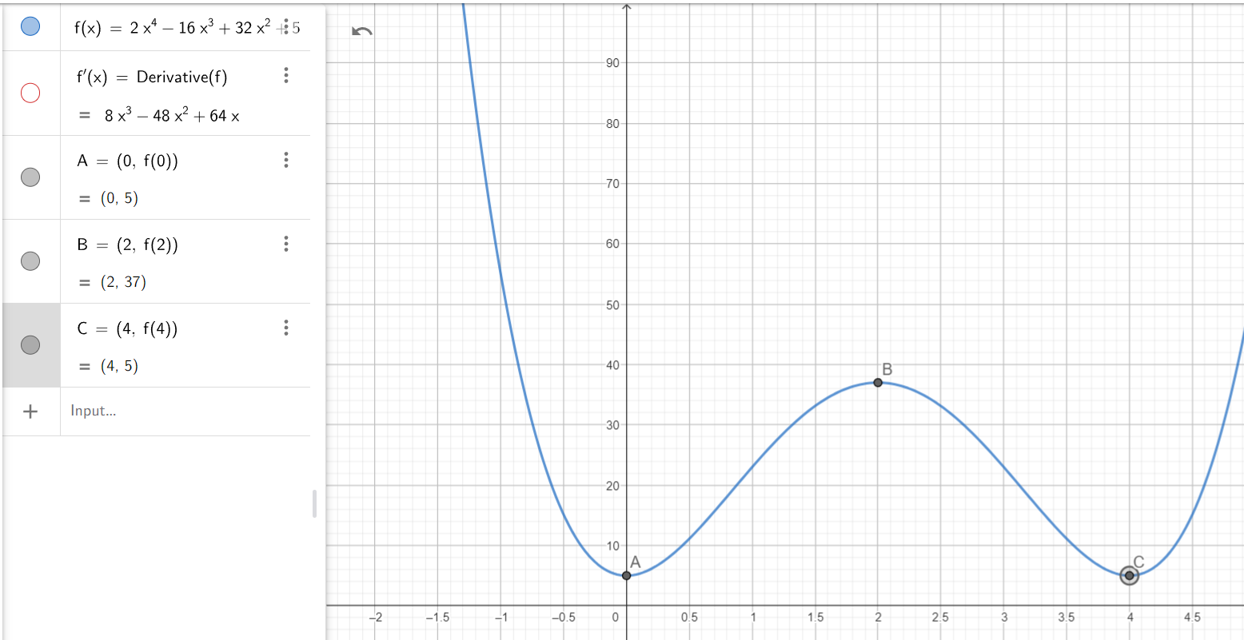
First-derivative criterion intuition: at an optimum, the derivative/gradient is (approximately) zero.
- **Divergence**: loss becomes NaN/inf or increases rapidly → reduce α, add gradient clipping, check data scaling.
- **Oscillation**: loss bounces without improving → reduce α or increase momentum carefully; consider scheduling.
- **Slow progress**: near-constant loss → increase α slightly, improve conditioning (normalization), or use momentum/Adam.
- **Overfitting**: training loss decreases while validation worsens → add regularization or stop earlier.

12. Worked examples (short)
Example A (1D quadratic). Let J(θ) = (1/2)aθ² with a>0. Then ∇J(θ)=aθ and θ_{t+1}=(1−αa)θ_t. This converges to 0 if |1−αa|<1, i.e., 0<α<2/a. The larger a (curvature), the smaller the stable step size.
$J(θ)=\frac{1}{2}aθ^{2} ⇒ θ_{t+1}=(1−αa)θ_{t}$
Closed-form recursion for a simple quadratic objective.
Example B (non-convex contour landscape). Even with a fixed α, gradient descent can be pulled toward different basins of attraction depending on initialization. In higher dimensions, saddle points and narrow valleys become more common, motivating momentum and adaptive methods.
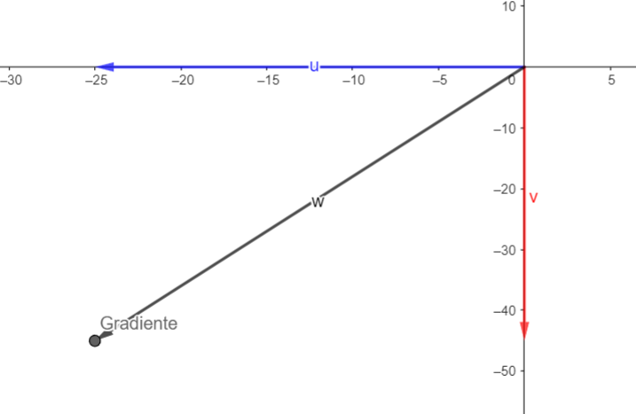
Gradient direction in 2D: the update decomposes into coordinate-wise components of the gradient.
[Image Placeholder: (If present) Learning dynamics can depend heavily on α and initialization; visualization aids understanding.]
(If present) Learning dynamics can depend heavily on α and initialization; visualization aids understanding.

Cost contours with iterative steps: descent tends to follow gradients perpendicular to level sets.

13. Practical checklist (applied gradient descent)
- **Scale inputs**: standardize features or use normalization layers; improves conditioning.
- **Pick a baseline**: start with SGD+momentum or Adam depending on domain norms.
- **Tune learning rate first**: it usually dominates performance; then tune batch size and regularization.
- **Use schedules**: decay α and consider warmup for large batches.
- **Monitor**: track training/validation loss and gradient norms; add gradient clipping if needed.
- **Reproducibility**: set seeds and log hyperparameters for fair comparison.

14. Summary
Gradient descent minimizes differentiable objectives by stepping in the direction of the negative gradient. Batch, stochastic, and mini-batch variants trade off compute cost against gradient noise. Learning rate strategy is critical, and geometry (conditioning) strongly influences behavior. Momentum and adaptive optimizers (RMSProp/Adam) often improve robustness, but good results still depend on careful monitoring and tuning.Suggested next topics: second-order methods (Newton, quasi-Newton), constrained optimization, proximal methods, and the theory of stochastic approximation for SGD.

