Gradient Descent

Bibliography
Title: Hands-on Machine Learning with Scikit-Learn, Keras, and TensorFlow: Concepts, Tools, and Techniques to Build Intelligent Systems
Author: Géron, A. (2019)
Chapter: 4 – Gradient Descent

Introduction
In simple terms, gradient descent consists of iteratively adjusting the parameters of a model in order to minimize a loss function, which measures the difference between the model’s predictions and the real values.
It can be conceptualized as an iterative process where, at each step:
- We vary the model parameters
- We evaluate whether the loss function has decreased
- We repeat the process until the loss function no longer decreases (convergence)
To experiment with gradient descent, you can use this interactive playground: https://www.benfrederickson.com/numerical-optimization/
Within this playground you will find an example with the function:
$$f(x,y) = (x^2 + y - 11)^2 + (x + y^2 - 7)^2$$
In this visualization you can see 4 local minima. The page allows you to adjust parameters such as the learning rate to experiment with the optimization process and observe how these changes affect the convergence of the algorithm.
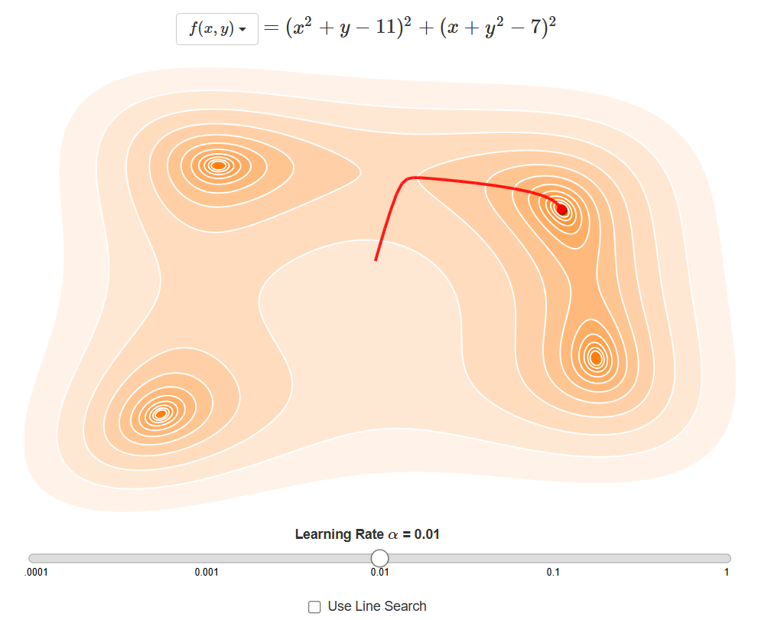
Figure 1. Example landscape with multiple local minima for numerical optimization.

Mountain Analogy
The book "Hands-on Machine Learning with Scikit-Learn, Keras, and TensorFlow" by Géron (2019) presents a very useful analogy to understand gradient descent:
Imagine you are on top of a mountain on a very dark night and you need to go down to the nearest valley. Although you cannot see the entire landscape around you, you can feel the slope of the ground under your feet. The most logical strategy would be to take steps in the direction of the steepest slope downward, because this will take you along the fastest descent path. This process is repeated at each step until you reach a point where you no longer detect any slope, indicating that you have found a local minimum (the valley).
The algorithm works similarly: the parameter θ (theta) is randomly initialized and then iteratively adjusted until the gradient (the slope) evaluated at that point is zero; that is, until the loss function can no longer decrease.
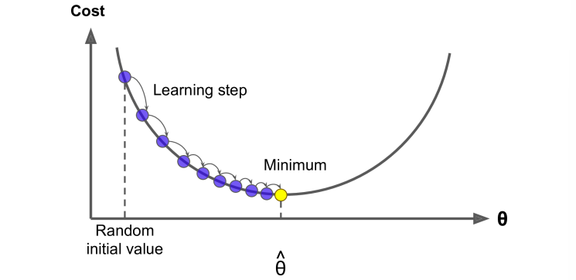
Figure 2. Gradient descent steps along the loss curve until reaching a minimum.

Algorithm Hyperparameters
In this algorithm, a concept called a hyperparameter is used. A hyperparameter is a value that must be set before starting the optimization process and is not learned automatically during training.

Number of iterations
This hyperparameter defines how many times the model parameters will be updated during the optimization process. An appropriate number of iterations is crucial to ensure the algorithm has enough time to converge to a minimum, without exceeding it and wasting computational resources.

Learning Rate
This hyperparameter controls the step size taken in the direction of the gradient during each iteration. Its selection is crucial:
- Learning rate too large: the algorithm can “jump” over the minimum, causing oscillations and preventing convergence.
- Learning rate too small: convergence will be very slow, requiring many more iterations.
The following image illustrates how a very large learning rate can make the algorithm oscillate without converging to the minimum, while a very small learning rate considerably slows down the optimization process.
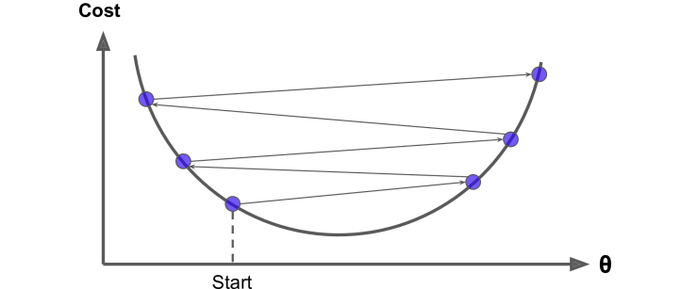
Figure 3. Effect of learning rate: too large (oscillation) vs. too small (slow convergence).

Limitations of Gradient Descent

Local minima vs. global minimum
Random initialization of the parameters can lead the algorithm to not find the global minimum of the function, but instead get trapped in a local minimum. This problem is especially relevant in functions that have multiple local minima.

Saddle points
In addition to local minima, there are problematic configurations called saddle points, where the gradient is zero but it does not correspond to a minimum. At these points, the function may be decreasing in some directions and increasing in others, which can confuse the algorithm.
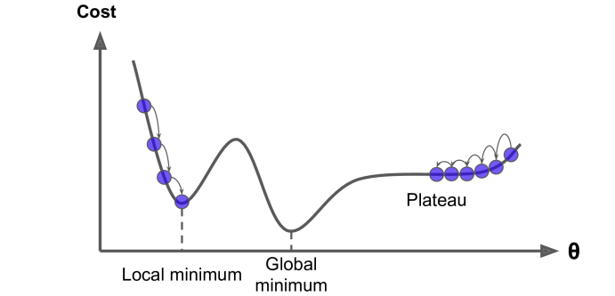
Figure 4. Common pitfalls: local minima, global minimum, and plateaus/saddle regions.

MSE Cost Function
To mitigate the problems above, gradient descent commonly uses MSE (Mean Squared Error) as the loss function. This function measures the average squared difference between the values predicted by the model and the real values.

Advantage of convexity
The MSE cost function has a very important mathematical property: it is a convex function. This means it has a unique global minimum, which guarantees that gradient descent will converge to the global minimum (optimal) as long as an appropriate learning rate is chosen.
$$MSE = (1/m) ∑_\{i=1\}^\{m\} (y_i - ŷ_i)^2$$
In the following visualization, the gradient descent optimization process is presented in a two-dimensional space. You can observe how the algorithm iteratively adjusts the parameters to minimize the loss function. The image on the left shows the case where the features have been scaled to have the same importance, while the image on the right shows the behavior without scaling.
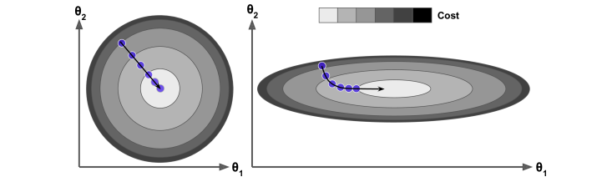
Figure 5. Optimization with feature scaling (left) vs. without scaling (right).
Note: When using gradient descent, it is important to scale the features so that they all have the same importance. This is because the algorithm can converge faster and more stably if the features are on the same scale.

Mathematical Implementation of Gradient Descent

Gradient computation
Starting from the data matrix called X, we delve into the computation of the gradient of the MSE loss function with respect to the model parameters θ (theta). This matrix of dimensions m×n contains m samples and n features, including a dummy feature for the bias.
Let ŷ be the vector of predictions and y the vector of real values, both of size m. The MSE loss function is defined as:
$$MSE(θ) = (1/m) ∑_\{i=1\}^\{m\} (ŷ_i - y_i)^2$$
Considering that ŷ = Xθ, where X is the feature matrix and θ is the parameter vector, the loss function can be rewritten as:
$$MSE(θ) = (1/m) ∑_\{i=1\}^\{m\} (θ^T X - y_i)^2$$

Handling the bias term
To simplify gradient computation, we consider that the parameter representing the bias of a linear model has an associated dummy feature that always equals 1. This way, the gradient can be computed in a unified manner.
$$θ_0 x_0 = θ_0 (where x_0 = 1 for all samples)$$
The full model prediction can be written as:
$$ŷ = θ_0 X_0 + θ_1 X_1 + θ_2 X_2 + ... + θ_n X_n$$

Partial derivative of the MSE
The computation of the partial derivative of the MSE with respect to a specific parameter θ_n is:
$$∂MSE(θ)/∂θ_n = (2/m) ∑_\{i=1\}^\{m\} ( θ^T x^(i) - y_i ) · x_n^(i)$$

Explanation of the term x_n^(i)
The final term x_n^(i) (which can also be written as X_{i,n}) appears as a result of applying the chain rule. Specifically, it is the result of differentiating the inner part of the cost function with respect to θ_n:
$$∂/∂θ_n ( θ^T x^(i) ) = ∂/∂θ_n ( θ_0 x_0^(i) + θ_1 x_1^(i) + ... + θ_n x_n^(i) + ... )$$
Since the partial derivative is computed with respect to θ_n, all other terms θ_j x_j^(i) (where j ≠ n) are constants and their derivative is zero. Only the n-th term remains:
$$∂/∂θ_n ( θ_n x_n^(i) ) = x_n^(i)$$
Where X_{i,n} represents the value of the n-th feature of the i-th sample. This is why each error term in the sum must be multiplied by the value of the corresponding feature.
In short, the inner derivative for feature n equals the values of each sample for that feature; i.e., x_n^(i).

Constructing the gradient vector
Initially, the gradient vector is structured as:
$$∇_θ MSE(θ) = [ ∂J/∂θ_0, ∂J/∂θ_1, ∂J/∂θ_2, ..., ∂J/∂θ_p ]^T$$
We already know how to compute each of these partial derivatives using summations:
- ∂J/∂θ_0 = (2/m) Σ_{i=1}^{m} (error_i) · x_0^(i) (where x_0^(i) = 1)
- ∂J/∂θ_1 = (2/m) Σ_{i=1}^{m} (error_i) · x_1^(i)
- ∂J/∂θ_2 = (2/m) Σ_{i=1}^{m} (error_i) · x_2^(i)
- ... and so on.

Matrix operation for computing the gradient
Basically, the sum of errors must be multiplied by each corresponding feature for each sample.
To do this efficiently, we need to transpose the matrix X. The original matrix X has dimensions m×n (where m are the samples and n are the features), while X^T will have dimensions n×m. Thus, when multiplying X^T by the error vector, each error is multiplied by each corresponding feature.
$$X^T e = [ (n+1)×m matrix ] · [ m×1 error vector ]$$

Matrix formula of the gradient
$$∇_θ MSE(θ) = (2/m) X^T (Xθ - y)$$

Tabular representation of the matrices
To better visualize the matrix operations, we can represent the matrices as if they were tables in a spreadsheet:

Matrix X
The matrix X has m rows (samples) and n columns (features, including the dummy feature for the bias):
x₀ | x₁ | x₂ | ... | x_m
1 | x₁₁ | x₁₂ | ... | x₁m
1 x₂₁ x₂₂ ... x₂m
...
1 x_n1 x_n2 ... x_nm

Parameter vector θ
The vector θ is a column of m dimensions, where m is the number of features (including the bias):
θ₀
θ₁
θ₂
⋮
θ_m

Target value vector y
The vector y is a column of n dimensions (number of samples) that contains the real values of the target variable:
y₁
y₂
y₃
...
y_n

Transposed matrix X^T
The matrix X^T is the transpose of X, with dimensions m×n (features by samples):
1 | 1 | ... | 1
x₁₁ | x₂₁ | ... | x_n1
x₁₂ | x₂₂ | ... | x_n2
...
x₁m x₂m ... x_nm

Important notes
Gradient dimensionality: the gradient vector dimension equals the total number of input features plus the bias term. That is, if there are n features, the gradient vector will have n+1 dimensions counting the dummy feature for the bias.
Dummy feature: remember that the feature X₀ is dummy and always equals 1 for all samples. Therefore, the first element of the gradient vector corresponds to the model bias θ₀.
Importance of scaling: when using gradient descent, it is essential to scale the features so that they have the same relative importance. This is because the algorithm can converge faster and more stably when the features are on similar scales.

Gradient vector
The gradient vector (∇f) at any point of a function always points in the direction of the maximum local ascent. This happens because its components (the partial derivatives) determine the direction and magnitude of ascent along each fundamental axis of the space. The vector sum of these individual ascent tendencies produces, by mathematical construction, the resulting vector that represents the most efficient path to increase the value of the function.

Practical example of the gradient vector
Consider a concrete example: if the gradient vector for f(x,y) at a point (x,y) is ∇f = (−25, −45), then:
- The rate of change of f with respect to x is −25, which indicates that if x increases by one unit, f decreases by 25 units.
- The rate of change of f with respect to y is −45, which indicates that if y increases by one unit, f decreases by 45 units.
- The composition of both partial derivatives ∇f = (−25, −45) indicates the direction of maximum local ascent, which in this case points downward on the y-axis and to the left on the x-axis of the Cartesian plane.
- If the objective is to minimize f, gradient descent moves in the opposite direction to the gradient vector; that is, upward and to the right in the Cartesian plane.
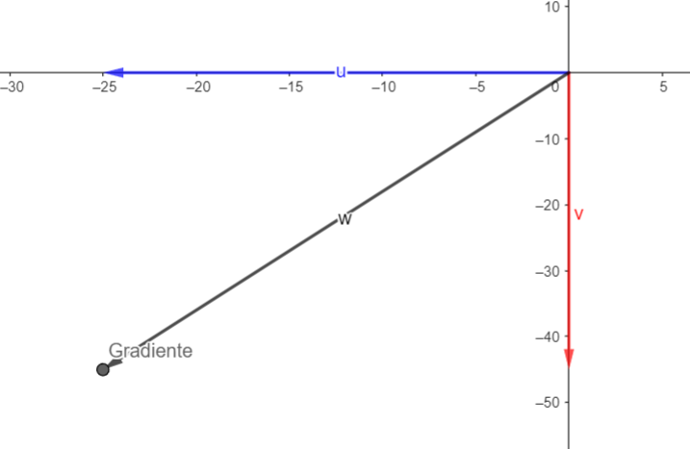
Figure 6. Visualization of a gradient vector and the opposite direction used for minimization.

Variants of Gradient Descent

Batch Gradient Descent
Batch Gradient Descent is the classic implementation of gradient descent that uses the entire dataset to compute the gradient at each iteration. This means that, instead of updating the model parameters after processing each individual sample (as in Stochastic Gradient Descent), the gradient is computed using all available samples and the parameters are updated once per iteration.

Computational limitations
This approach can be computationally expensive when working with large volumes of data, because it requires storing and processing the entire dataset in memory during each iteration of the algorithm.

Implementation of the update step
The fundamental step of gradient descent is performed by updating the model parameters in the opposite direction of the gradient of the loss function. The mathematical formula to update the parameters θ (theta) is:
$$θ := θ - α ∇_θ MSE(θ)$$
Where:
- θ represents the vector of model parameters
- α is the learning rate
- ∇_θ MSE(θ) is the gradient vector of the MSE loss function with respect to the parameters θ

Example implementation in Python
eta = 0.1 # learning rate
n_iterations = 1000
m = 100
theta = np.random.randn(2,1) # random initialization

for iteration in range(n_iterations):
gradients = 2/m * X_b.T.dot(X_b.dot(theta) - y)
theta = theta - eta * gradients

Stochastic Gradient Descent (SGD)
Stochastic Gradient Descent (SGD) is a more efficient variant of the traditional algorithm that updates the model parameters using a single sample (or a small batch of samples) in each iteration, instead of processing the entire dataset. This approach makes the updates more frequent and can significantly speed up convergence, especially when working with large datasets.

Computational advantages
This algorithm is considerably less demanding computationally, because it does not require storing or processing the entire dataset in memory during each iteration.

Characteristics of stochastic behavior
The random nature introduced by using individual samples presents both advantages and disadvantages:
- Advantage: it can help escape local minima due to fluctuations in the optimization path.
- Disadvantage: it can make convergence noisier and less stable compared to the batch method.

Learning Rate Decay
To mitigate the inherent instability of SGD, a technique called learning rate decay is used, which consists of progressively decreasing the learning rate as training advances. This helps to:
- Stabilize parameter updates
- Allow the algorithm to approach the global minimum more precisely
- Reduce oscillations near the optimal point
The function in charge of dynamically adjusting the learning rate is called a learning schedule.

Python implementation with a learning schedule
n_epochs = 50
t0, t1 = 5, 50 # learning schedule hyperparameters

def learning_schedule(t):
return t0 / (t + t1)

theta = np.random.randn(2,1) # random initialization

for epoch in range(n_epochs):
for i in range(m):
random_index = np.random.randint(m)
xi = X_b[random_index:random_index+1]
yi = y[random_index:random_index+1]
gradients = 2 * xi.T.dot(xi.dot(theta) - yi)
eta = learning_schedule(epoch * m + i)
theta = theta - eta * gradients

Important notes about the implementation
Epoch structure: each epoch iterates m times, where m is the total number of samples in the dataset. In each iteration, a random sample is selected and the parameters are updated using only that sample.
Key difference: unlike Batch Gradient Descent, which uses all samples to compute the gradient, SGD uses a single sample in each parameter update.
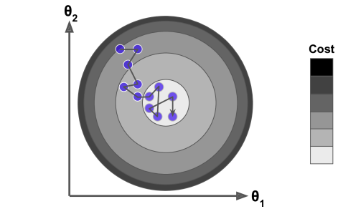
Figure 7. Noisy optimization path characteristic of SGD.

Mini-batch Gradient Descent
Mini-batch Gradient Descent represents a hybrid approach that combines the best characteristics of Batch Gradient Descent and Stochastic Gradient Descent. Instead of using the entire dataset (as in Batch GD) or a single sample (as in SGD), this method divides the dataset into small batches called mini-batches and updates the model parameters using a full batch in each iteration.

Advantages of the hybrid approach
This strategy provides an optimal balance between:
- Stability of updates: by using multiple samples per iteration, updates are more stable than in SGD.
- Computational efficiency: because it does not require the entire dataset in memory, it is more efficient than Batch GD.
- Parallelization: computations within each mini-batch can be effectively parallelized.
- Convergence: offers smoother convergence than SGD but faster than Batch GD.

Comparative visualization
The following image illustrates the differences in convergence behavior among the three variants of gradient descent:
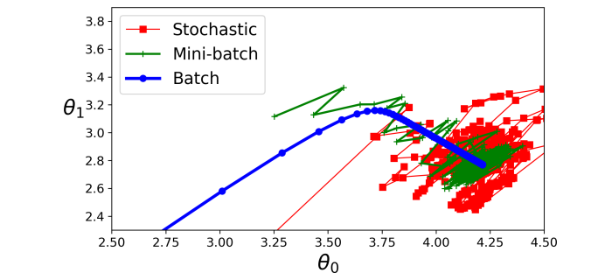
Figure 8. Comparison of convergence paths: Batch vs. Stochastic vs. Mini-batch.

Comparison of optimization algorithms
The following table presents a detailed comparison of different optimization algorithms used in machine learning, highlighting their performance characteristics and applicability:

Comparison table
Algorithm | Large dataset (m) | Out-of-core support | High dimensions (n) | Hyperparameters | Scaling required | Scikit-Learn
Normal Equation | Fast | No | Slow | 0 | No | N/A
SVD | Fast | No | Slow | 0 | No | LinearRegression
Batch GD | Slow | No | Fast | 2 | Yes | SGDRegressor
Stochastic GD | Fast | Yes | Fast | ≥2 | Yes | SGDRegressor
Mini-batch GD | Fast | Yes | Fast | ≥2 | Yes | SGDRegressor

Interpretation of the characteristics
- Large dataset (m): performance when the number of samples is very large
- Out-of-core support: ability to process data that does not fit in RAM
- High dimensions (n): efficiency when the number of features is very high
- Hyperparameters: number of parameters that must be tuned manually
- Scaling required: need to normalize features before training
- Scikit-Learn: implementation available in the Scikit-Learn library

Usage recommendations
- Normal Equation / SVD: ideal for small to medium datasets with few features
- Batch GD: appropriate when very stable convergence is required and the dataset fits in memory
- Stochastic GD: excellent for very large datasets or when online training is required
- Mini-batch GD: the most versatile option, combining efficiency and stability, and the most commonly used in practice

