**Abbreviations:**

COP = center of pressure

GRF = ground reaction force

V = vertical

AP = anterior-posterior

ML = medial-lateral

**Some definitions:**

Stance = time when foot is in contact with the ground (heel strike to toe-off of the same foot)

Ground reaction force = force applied by the ground on to the foot (by Newton’s 3rd law)

Center of pressure = estimated ‘point of application’ of the ground reaction force to the foot

Anterior, posterior, medial, lateral = see <https://teachmeanatomy.info/the-basics/anatomical-terminology/terms-of-location/>

**Manually extracted GRF and COP features (in xls data file called ‘discrete’):**

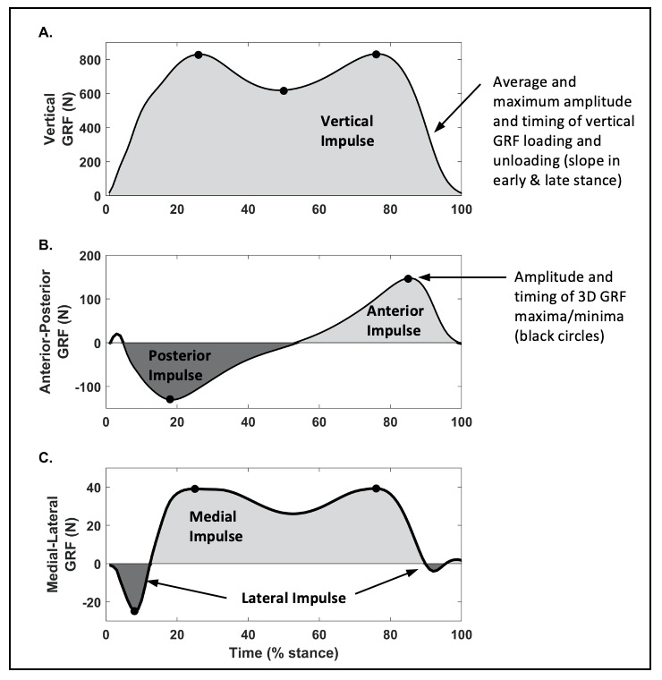

|  |  |  |  |
| --- | --- | --- | --- |
| **Variable** | **Variable Name in Dataset** | **Units** | **Calculation** |
| Stance time | stancetime | s | Time between initial and final contact (s) |
| Vertical GRF Impulse | vGRF_impulse | N*s | Positive area in stance (N*s) |
| Medial GRF Impulse | mGRF_impulse | N*s | Positive area in stance (N*s) |
| Lateral GRF Impulse | lGRF_impulse | N*s | Negative area in stance (N*s) |
| Anterior GRF Impulse | aGRF_impulse | N*s | Positive area in second half of stance (N*s) |
| Posterior GRF Impulse | pGRF_impulse | N*s | Negative area in first half of stance (N*s) |
| “Toe-out angle”: Angle formed by the COP path and the direction of travel (Chang et al. 2007) | TO_angle | deg | tan-1[(COPML_final – COPML_initial)/(COPAP_final - COPAP_initial)] |
| vGRF average loading rate (Milner 2008) | vGRF_avgLR | N/s | (vGRF80-vGRF20)/(t_vGRF80-t_vGRF20)  Where:  vGRF80 and vGRF 20 = vGRF @80% and 20%, respectively, of the time between initial contact and 1st peak V GRF  t_vGRF80 and t_vGRF20 are the time of occurrence of vGRF80 and vGRF20, respectively |
| vGRF maximum instantaneous loading rate | vGRF_iLR_max | N/s | Max rate between 20 and 80% of initial contact to vGRF peak 1 |
| Time of vGRF max instantaneous loading rate | t_vGRF_iLR_max | %stance |  |
| vGRF average unloading rate | vGRF_avgULR | N/s | (vGRF80-vGRF20)/(t_vGRF80-t_vGRF20)  Where:  vGRF80 and vGRF 20 = vGRF @80% and 20%, respectively, of the time between 2nd peak V GRF and final contact  t_vGRF80 and t_vGRF20 are the time of occurrence of vGRF80 and vGRF20, respectively |
| vGRF max instantaneous unloading rate | vGRF_iULR_max | N/s | Min* rate between 20 and 80% of vGRF peak 2 to final contact  *Calculated as minimum because slope of waveform during unloading is negative |
| Time of max instantaneous unloading rate | t_vGRF_iULR_max | %stance |  |
| 1st peak vertical GRF | vGRF_peak1 | N | Max vGRF in 1st half of stance (Milner 2008 method) |
| 2nd peak vertical GRF | vGRF_peak2 | N | Maximum vGRF in 2nd half of stance |
| Midstance vertical GRF valley | vGRF_valley | N | Min vGRF between vGRF peak 1 and peak 2 |
| Peak posterior GRF | apGRF_peak1 | N | Min in 1st half of stance |
| Peak anterior GRF | apGRF_peak2 | N | Max in 2nd half of stance |
| Peak lateral GRF in early stance | mlGRF_peak1 | N | Min in 1st half of stance |
| Peak medial GRF in early stance | mlGRF_peak2 | N | Max in 1st half of stance |
| Peak medial GRF in late stance | mlGRF_peak3 | N | Max in 2nd half of stance |
| Time of 1st peak vertical GRF | t_vGRF_peak1 | %stance | Time of occurrence of 1st peak vertical GRF |
| Time of 2nd peak vertical GRF | t_vGRF_peak2 | %stance | Time of occurrence of 2nd peak vertical GRF |
| Time of midstance vertical GRF valley | t_vGRF_valley | %stance | Time of occurrence of midstance vertical GRF valley |
| Time of peak posterior GRF | t_apGRF_peak1 | %stance | Time of occurrence of 1st peak AP GRF (posterior/negative peak) |
| Time of peak anterior GRF | t_apGRF_peak2 | %stance | Time of occurrence of 2nd peak AP GRF (anterior/positive peak) |
| Time of peak lateral GRF in early stance | t_mlGRF_peak1 | %stance | Time of occurrence of peak lateral GRF in 1st half of stance (negative peak) |
| Time of peak medial GRF in early stance | t_mlGRF_peak2 | %stance | Time of occurrence of peak medial GRF in 1st half of stance (positive peak) |
| Time of peak medial GRF in late stance | t_mlGRF_peak3 | %stance | Time of occurrence of peak medial GRF in 2nd half of stance (positive peak) |

N = Newtons

S = seconds