**DRAFT DRAFT DRAFT DRAFT DRAFT DRAFT DRAFT DRAFT DRAFT DRAFT**

Users Guide for LTER Personnel DB 1st draft July 2011

Macintosh HD:Users:gastil:Desktop:Screen shot 2011-07-25 at 10.10.16 AM.png

Table of Contents

Introduction

Interactive Web Forms: Public Interface

Search for people

Interactive Web Forms: Administrative Interface

Add a person

Edit a person

Web Services Interface

Why this is not part of the Users Guide (see the API)

TODO: make that a “real” TOC with document links.

For More Information

**Introduction**

The LTER PersonnelDB was designed and implemented by an IM Working Group. The main impetus for this new design is to allow synchronization of personnel data between LTER site systems and the LTER Network Office system. The new (new as of 2011) PersonnelDB has two kinds of interfaces: interactive web forms for manual lookup or entry, and an application program interface (API) interface of web services for systems to synchronize information. This database is designed to replace the LTER Directory, in part. The old directory contained two kinds of information: (1) contacts and roles and (2) research profiles. The latter will be stored in a new, separate database, tentatively named ProfileDB.

**Interactive Web Forms: Public Interface**

Start here: <http://sunshine.lternet.edu/personnelDB/>

Note as of July 2011 this is still a development version. Once this database is fully adopted and “in production”, it will have a more official-looking URL.

**Search for People**

The LTER PersonnelDB offers directory searches for any user, without login. In the Basic Search, a substring can be entered and any name where that substring occurs in the first or last name will be retrieved. Results can be filtered by site. (This is much like the old directory at <http://intranet2.lternet.edu/> (Peronnel Directory search is currently at mid-page right-side.) In the old directory, a substring would also return matches to the primary email address, which is not so for the new directory.

As of July 2011 there are only a small sample of personnel records loaded for testing.

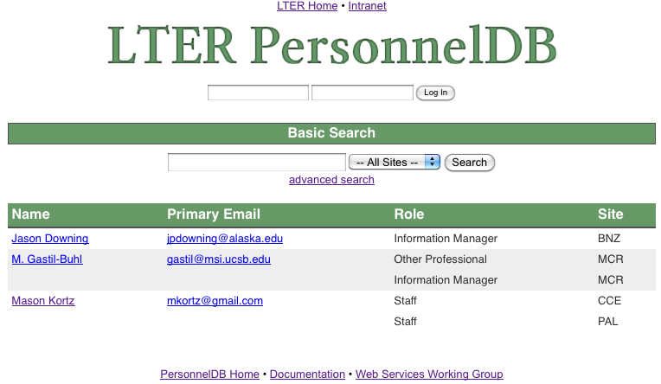

**Interactive Web Forms: Administrative Interface**

Begin at the same URL: <http://sunshine.lternet.edu/personnelDB/> and first log in.

Macintosh HD:Users:gastil:Desktop:Screen shot 2011-07-25 at 10.16.24 AM.png

Use your LTER Network username and password. If you have forgotten those, you can retrieve that information starting here: <http://intranet2.lternet.edu/user/password> . Once logged in, you will see a new button, ‘Add New Person’.

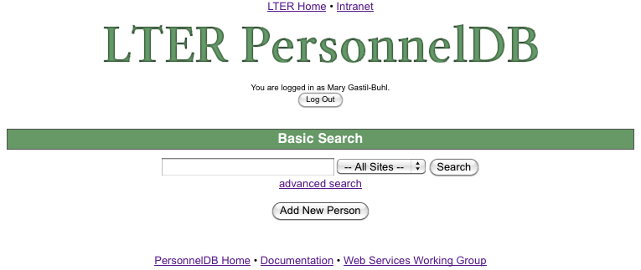

**Add a Person**

Only site IMs, the Network IM, and delegated persons accounts will have authority for this action. Click the button ‘Add New Person’. 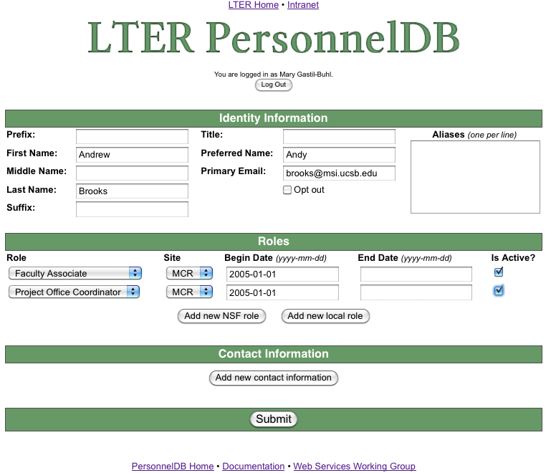

Not all fields are mandatory. TODO: mark these. In the above example, note the use of a Preferred Name. This is the name the person prefers to be addressed as, like a nickname. Opt out is for _____________??. Aliases are for ??born-as?.

The NSF role is required. Optionally, you may add a site-defined role by clicking ‘Add new local role’. (See section __ for adding roles specific to your site.) The Begin and End date are optional; enter a begin date if known. For on-going, leave End Date blank. Check ‘Is Active?’ if this person is currently active with your site.

The ‘**Add new contact information**’ button opens this part of the form.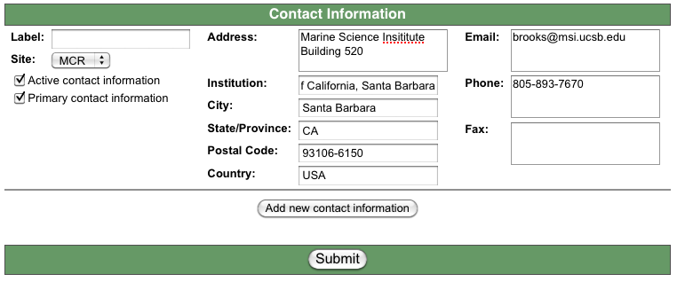

What is Label??. The address may have multiple lines. Why is there a redundant email here? Do we use this form all-blank-but-email to add additional emails?

Finally, click ‘Submit’. The new listing is displayed:

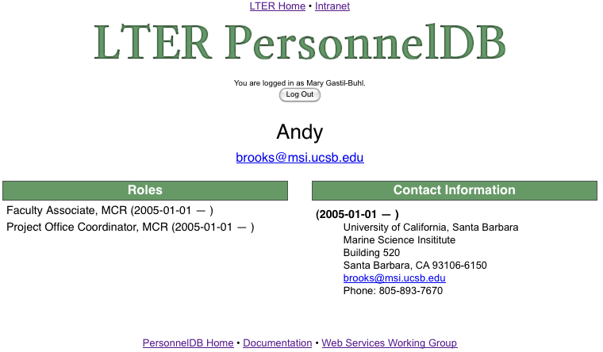

Whoopse. That Preferred Name was for the entire preferred name, not just an alternate first name. So, next: how to edit an entry…

**Edit a Person**

First use the directory page to list that person. If not already on the PersonnelDB home page, click the link at bottom [PersonnelDB Home](http://sunshine.lternet.edu/personnelDB/). In the Basic Search, enter part or all of the person’s name. (In this case I enter ‘andy’ or ‘andrew’ or ‘Brooks’; the search is case insensitive.) The person is found and, as long as you are logged in with an authorized username, an ‘**Edit**’ link appears to the right of that person’s entries. There may be multiple roles for a given person. One ‘Edit’ link will open the editing form for all these roles.

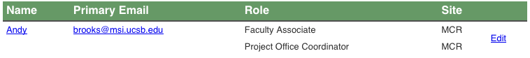

The Edit link opens the same form as was used to enter the person. Revise and ‘**Submit’**.

**Web Services Interface**

This Users Guide does not cover the use of the Web Services Interface. That is how programs interact with the LTER PersonnelDB. You may want the ability for your LTER site information system to synchronize with the network database. A programmer who sets this up will want to refer to the Application Program Interface (API) for that information. TODO: add link to API. These are the sorts of web services available:

The below is off-the-cuff and mostly wrong. Volunteer to re-write?

GET list of personnel matching a filter, returned in XML format

GET information for one person, returned in XML

POST a list of personnel to ADD to the database.

POST one or more UPDATES to personnel in the database.

DELETE one or more personnel entries in the database.

The XML used for this information exchange is an extension of the EML we use for dataset metadata.

**For More Information**

See the following links for further, possibly more up-to-date, information on the LTER PersonnelDB:

LTER PersonnelDB main page: <http://sunshine.lternet.edu/personnelDB/>

Documentation: <http://sunshine.lternet.edu/personnelDB/documentation/>

Web Services Working Group: <http://im.lternet.edu/projects/webservices>

**DRAFT DRAFT DRAFT DRAFT DRAFT DRAFT DRAFT DRAFT DRAFT DRAFT**