Testing the limits of estimating ecosystem fluxes with NEON flux towers: When and where does the gradient flux method work?

Target Journal: ESSD: https://www.earth-system-science-data.net/

Abstract
Early micrometeorological work employed the gradient-flux (GF) method to measure gas exchange between ecosystems and the atmosphere. Among GF methods, the modified Bowen ratio (MBR), aerodynamic (AE), and wind profile (WP) approaches are the most widely used for ecosystem-scale flux calculations and have been applied with varying success. Challenges in reliably applying the GF method limited its use, particularly in forests with tall canopies. Meanwhile, the eddy-covariance (EC) method has emerged as the primary method for measuring ecosystem–scale fluxes, although the GF method is still used to extend the suite of trace gas species measured with existing tower infrastructure. The National Ecological Observatory Network (NEON) provides standardized data across a wide range of ecosystem types, with consistent instrumentation and tower design (n = 47 towers), offering an opportunity to evaluate the GF method for ecosystem-scale fluxes of CO₂ and H₂O against EC. Here, we developed a protocol to assess the suitability of MBR, AE, and WP, and for these approaches, and to determine which pairs of sampling heights yielded the most reliable ecosystem fluxes. Across sites, the MBR was the most accurate, although MBR data filtering resulted in fewer observations than for the AE and WP. Reliable ecosystem fluxes were derived from sampling height pairs that were either both above (AA), or above and within (AW) the canopy. Variance in canopy height, GF approach, measurement level, and the distance between measurement levels and the mean canopy height impacted the probability that a sampling height pair would produce reliable fluxes. Although all GF approaches produced reliable fluxes under various conditions for most NEON towers, fluxes were subject to substantial filtering-induced data loss. To overcome limitations in the size of GF datasets, we ensembled fluxes across approaches and sampling height pairs, maintaining concordance between GF and EC. Ensemble GFs showed strong agreement with the EC method across ecosystems and seasons ( R²≈ 0.72 - 0.98) when sufficient data were available to fit diel curves. The ensemble GFs captured the magnitude of fluxes and the source/sink capacity of ecosystems. By comparison with state-of-the-art EC data, we systematically demonstrate that ensemble GFs can be used to understand ecosystem dynamics across terrestrial ecosystems, from simple to complex canopies, thereby expanding the species measured in EC networks.

Introduction
The history of ecosystem–atmosphere flux measurements span over a century and represents one of the most significant evolutions in environmental science (Baldocchi, 2014, 2003; Hicks and Baldocchi, 2020). Early micrometeorological work employed the gradient-flux (GF) method, in which fluxes are assumed proportional to a gradient and an eddy diffusivity ( i.e., the turbulent ability of the air to transport the scalar) (Meyers and Baldocchi, 2015). In the mid-to-late twentieth century, the GF method dominated ecosystem–atmosphere flux studies by measuring the difference in a scalar at two heights above the canopy and estimating eddy diffusivity (K) from profiles or similarity relations (Cellier and Brunet, 1992; Meyers and Baldocchi, 2015; Simpson et al., 1998). Numerous studies have illuminated the essential assumptions and limitations of the GF method in ecosystems with complex canopies (Raupach, 1979; Raupach and Legg, 1984; Stewart and Thom, 1973). Yet, the constraints imposed by the physical infrastructure required to apply this method (Wagner-Riddle et al., 2005),(Wagner-Riddle et al., 2005) limited its reliable use.
The eddy covariance (EC) method, which emerged from micrometeorology and turbulence research, provided the first direct measurements of flux density across the ecosystem–atmosphere interface (Baldocchi, 2014, 2003). Requiring high-frequency (10-20 Hz) measurements of vertical atmospheric turbulence and gas concentrations (Baldocchi, 2003), the advent of fast-response sensors (e.g., open-path infrared gas analyzers, sonic anemometers) in the 1980s enabled the development of continuous EC systems (Baldocchi, 2014). These advancements led to the emergence of whole-ecosystem carbon and water balance studies that transformed ecological research (Baldocchi, 2014). In the 1990s, the rise of coordinated networks provided standardized, long-term datasets critical for quantifying ecosystem carbon budgets, validating remote sensing and process-based models, and supporting the IPCC's carbon accounting frameworks. Modern micrometerology towers measure greenhouse gases (CO₂, CH₄, N₂O), volatile organic compounds (isoprene, monoterpenes), gaseous pollutants (O₃, NO₂, NO), and energy (sensible heat and latent energy) fluxes across diverse biomes—from Arctic tundra to tropical forests and wetlands. Limitations in funding, fast response instrumentation, and access have led to a global network with varying degrees of representativeness across different trace gases (Guenther et al., 2012; Karl et al., 2003; Malone et al., 2022; Reed et al., 2025; Spirig et al., 2005). Since there is no single, perfect way to measure ecosystem–atmosphere fluxes (Baldocchi 2014), we still need different approaches to flux calculation to expand the species measured with existing tower infrastructure, and for trace gases, where deploying the EC method is not feasible (i.e., N₂O, isoprene, monoterpenes, O₃, NO₂, NO).
Today, the widespread availability of EC provides a robust benchmark for assessing GF performance. It is now possible to define the operational limits of the GF method and strategically deploy it to extend our understanding of trace gas fluxes beyond the constraints imposed by EC alone. Hicks and Baldocchi (2020) called for a more comprehensive study of ecosystem fluxes using larger observational networks to investigate challenges like the detection limit of GFs across atmospheric stability and site-level canopy conditions (Hicks and Baldocchi, 2020). The National Ecological Observatory Network (NEON), funded by the National Science Foundation, has uniform micrometeorological instrumentation at 47 terrestrial sites across the United States. The NEON tower sites represent a wide diversity of ecoclimate regions and canopy structures (Kao et al., 2012; LaRue et al., 2022; Metzger et al., 2019). Each site has EC at the top of the tower for CO₂ and H₂O, and a concentration profile that extends down into the canopy, providing multiple sampling height pairs for GF calculation. Micrometerology, paired with canopy structure and measurements at multiple levels above and within the canopy, provides the infrastructure to evaluate the extent to which the GF method can be used to produce reliable ecosystem fluxes.
The GF approach can significantly enhance our understanding of the complexities of ecosystem exchange rates by utilizing co-located EC and GF instrumentation (Bolinius et al., 2016; Wu et al., 2015; Zhao et al., 2019), along with canopy lidar and spectral information. Specifically, we can compare different methodological approaches to GF fluxes, including the modified Bowen ratio (MBR), the aerodynamic (AE), and the wind profile (WP) approaches (Bolinius et al., 2016; Mayer et al., 2011; Meredith et al., 2014; Meyers et al., 1996). While all three GF approaches derive fluxes from mean concentration gradients, they differ in how they determine K. The MBR assumes that K is identical for a tracer and target gas and that vertical concentration gradients are consistent with the turbulent flux (Meyers et al., 1996). This assumption allows for the calculation of a target flux when only the tracer flux is measured using EC. Typically, the tracer gas is easier to measure (e.g., H₂O and CO₂) than the target gas (e.g., CH₄, N₂O, isoprene, monoterpenes, O₃, NO₂, NO). With the AE, K is derived from wind and turbulence statistics. This approach assumes steady-state, horizontally homogeneous conditions and is sensitive to atmospheric stability and surface roughness parameters (Dyer and Hicks, 1970; Monteith and Unsworth, 2013). The WP approach is a simplification of the AE that derives K directly from the measured wind speed profile and surface roughness, without assuming external turbulence parameters. The WP assumes steady-state, horizontally uniform conditions, and errors in estimating displacement height or roughness propagate into flux estimates. The WP is less accurate in complex terrain or under low turbulence (Stull, 1988).
Aside from the challenges associated with estimating K, additional issues arise from measuring concentrations at two different heights. Differences in footprint size between the upper and lower measurement heights pose a challenge, the magnitude of which can be influenced by the amount of heterogeneity in vegetation within the tower footprint and by differences in footprint size. Differences in spatial and temporal sampling footprints have been shown to yield significant differences in GF relative to EC (Zhao et al., 2019). These differences not only compromise interoperability among measurement techniques but, in the case of the GF method, also cause observations made at different heights on a tower to exhibit substantial footprint differences (Horst, 1999).
Here, we produce a standardized multi-site gradient-flux benchmark dataset for evaluating ecosystem-atmosphere exchange methods across NEON towers. The uncertainty and reliability of flux estimates from three GF methods (MBR, AE, and WP) were evaluated using CO₂ and H₂O EC fluxes from the top of NEON towers as a benchmark. We assess how canopy structure (e.g., height, gap fraction, top-of-canopy roughness, and heterogeneity) influences the likelihood that a given sampling height pair will produce reliable ecosystem fluxes. Ultimately, our goal is to determine where and when the GF method can be applied at NEON micromet towers, or at towers with similar characteristics in sampling time and measurement height. This study is structured around three guiding questions:
(Q1) How well does the GF method perform across different ecosystems?
(Q2) Which sampling height pairs, in relation to canopy properties, provide reliable ecosystem fluxes?
(Q3) Does the GF method provide a valid ecosystem assessment?
Although much of what we know about the limits of the GF method is rooted in the foundational history of the EC method (Raupach, 1979; Raupach and Legg, 1984; Stewart and Thom, 1973), it is now possible to record data from more instruments over extended periods and with greater precision than previously available. The NEON data provide an opportunity to review and refine our understanding of the GF method, enabling us to see how it can be used to understand ecosystem exchange rates.

Methods

2.1. Study Sites
NEON's standardized observations and data processing suite is explicitly designed for inter-site comparability and analysis of feedback across multiple spatial and temporal scales. Flux towers have multiple sampling levels, each outfitted with a suite of sensors mounted on perpendicular boom arms. The number of sampling levels on the tower varies from 4 to 8, depending on the site's mean canopy height. Towers were designed to be taller than the vegetation canopy at each site. Tower sampling heights were categorized based on the measurement height of the two levels used to calculate the GF (Table 1). Measurements were inclusive of both sampling levels above the canopy (AA) or one measurement height within the canopy (AW). Although AW is not considered ideal, when canopies are sparse, allowing sufficient connectivity, fluxes have been shown to provide reliable ecosystem assessments ((Meredith et al., 2014). We also included an additional modifier indicating whether a measurement height was above and most adjacent (+) or below and most adjacent (-) to the mean canopy height (Figure 1B). Across 47 towers, 208 measurement pairs were AA, and 237 pairs were AW. Tower sensors continuously collected data to capture patterns and cycles over periods ranging from seconds to years. The NEON implements a comprehensive quality management system, including frequent sensor calibration and data quality checks to minimize measurement errors and ensure high-quality data collection (Sturtevant et al., 2022).
Table 1. The gradient flux (GF) measurements were categorized into eight groups relative to the mean canopy height, with a modifier indicating whether a sampling height was directly above and most adjacent (+) or below and most adjacent (-) to the mean canopy height.
Canopy Level | Description | Sampling Height Pairs | Towers
AA+ | Both measurements above the canopy, with one of them directly above the canopy | 114 | 47
AA | Both measurements above the canopy | 94 | 43
AW+- | One measurement directly above and one directly below the canopy height | 32 | 32
AW+ | One measurement directly above and one within the canopy | 46 | 27
AW- | One measurement above and one directly below the canopy height | 69 | 32
AW | One measurement above and one within the canopy | 90 | 27

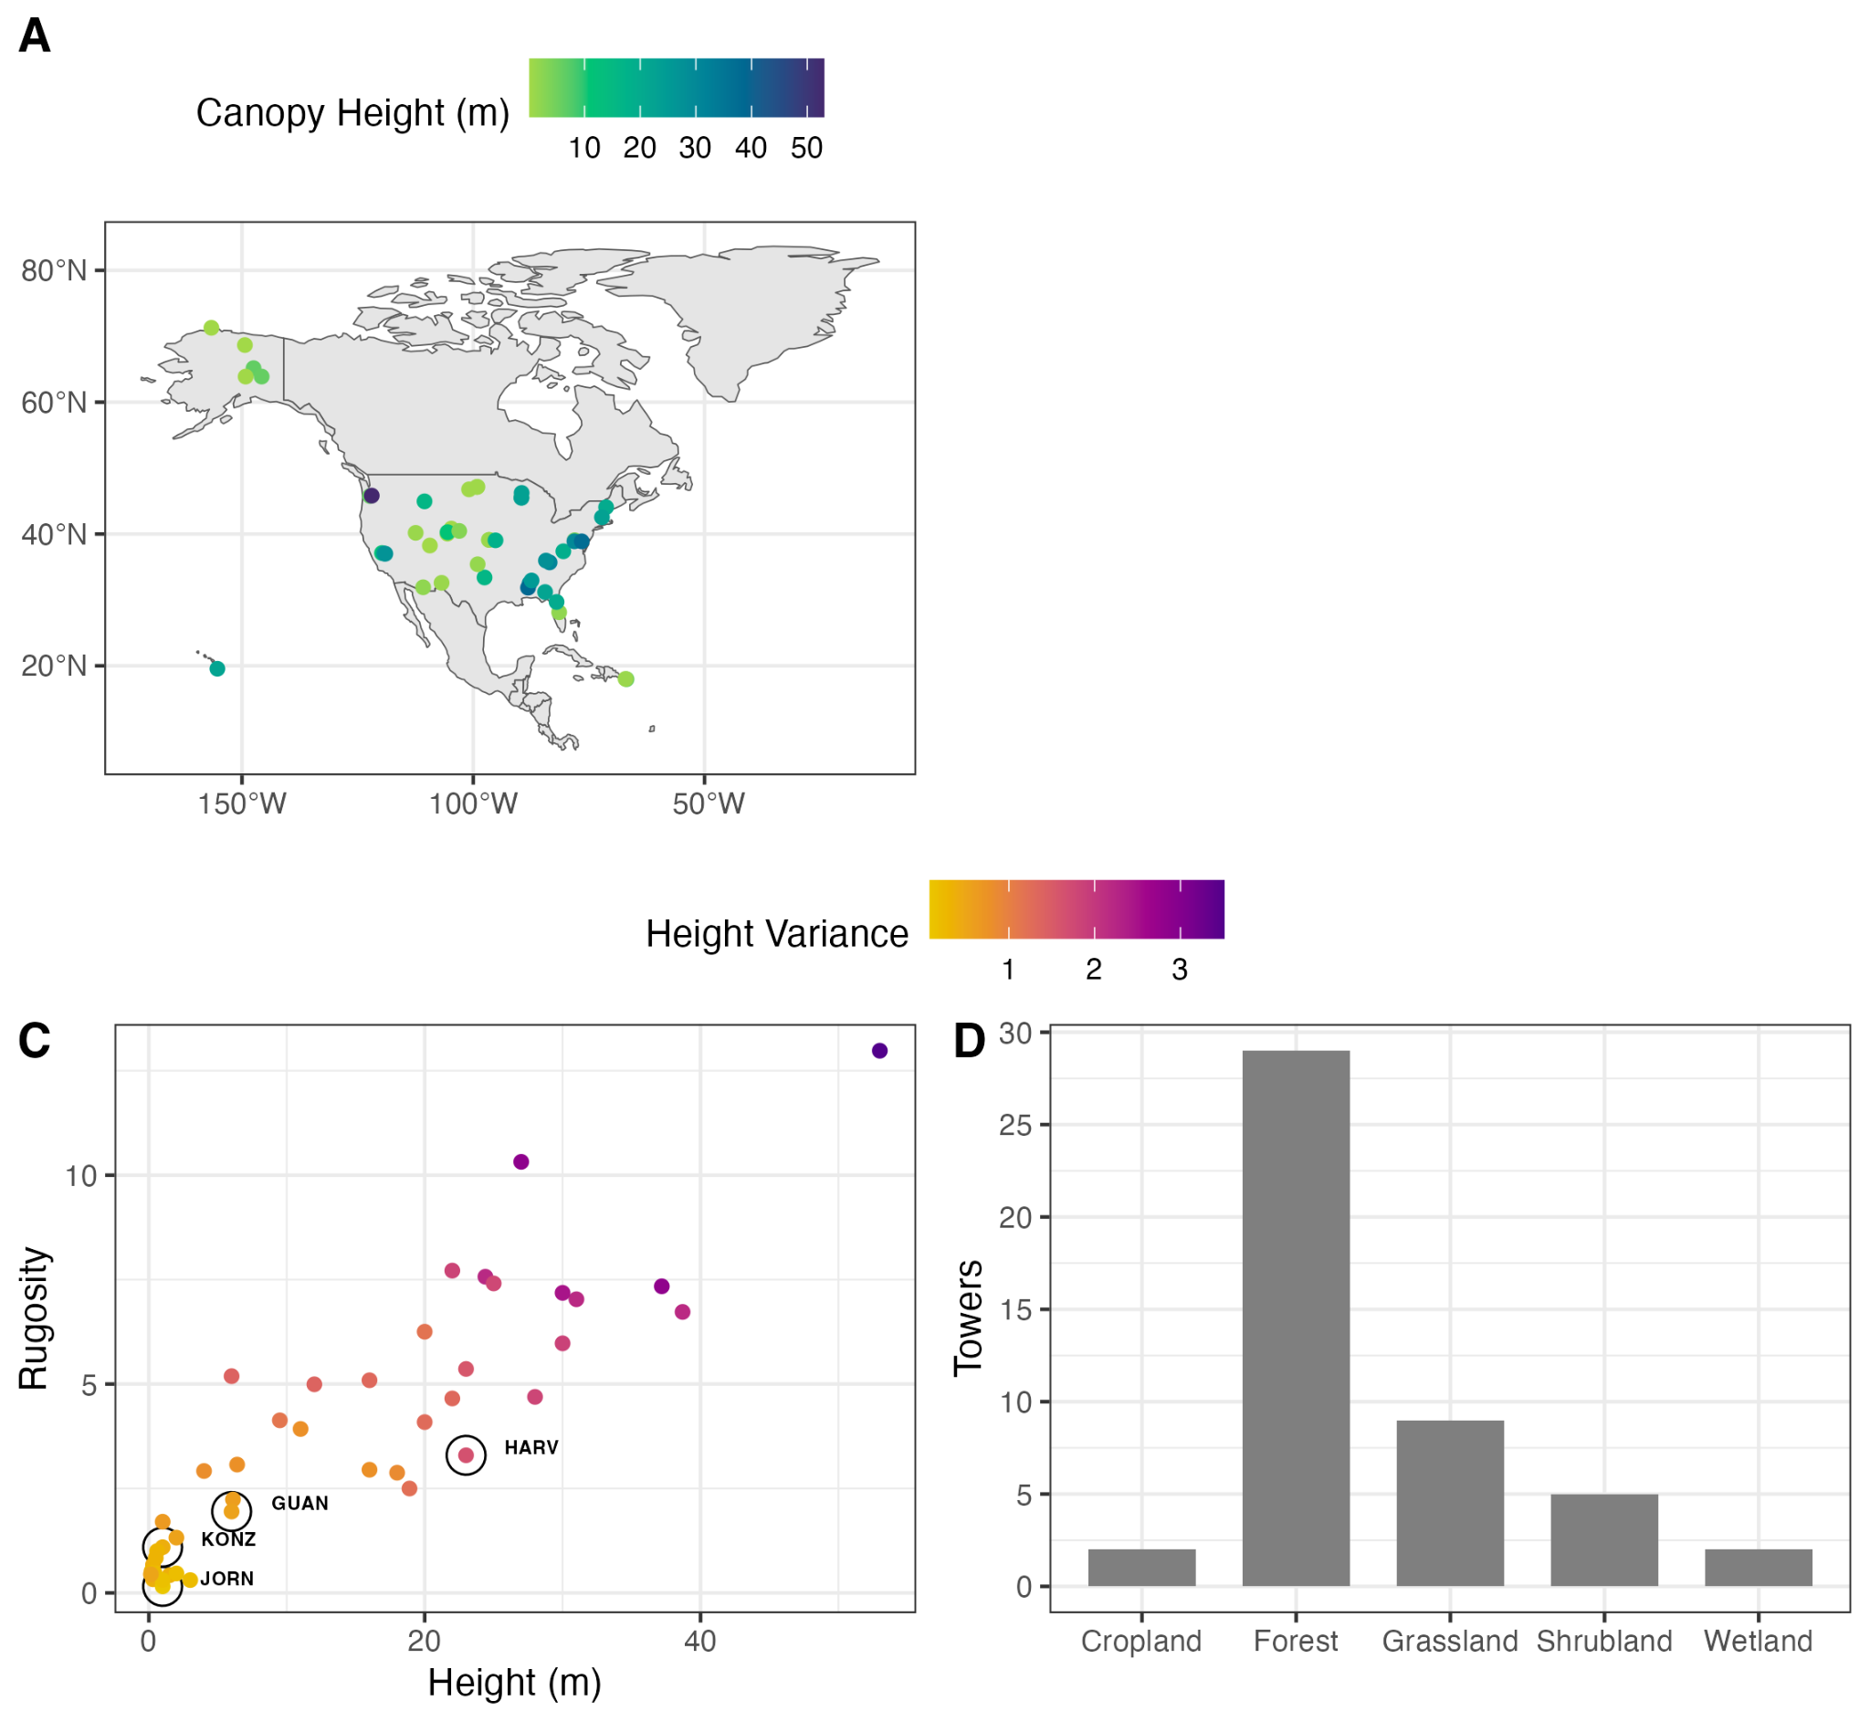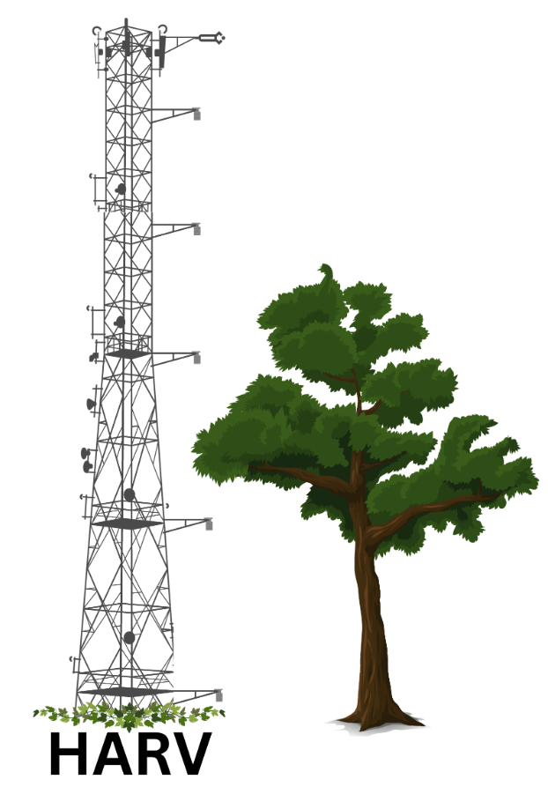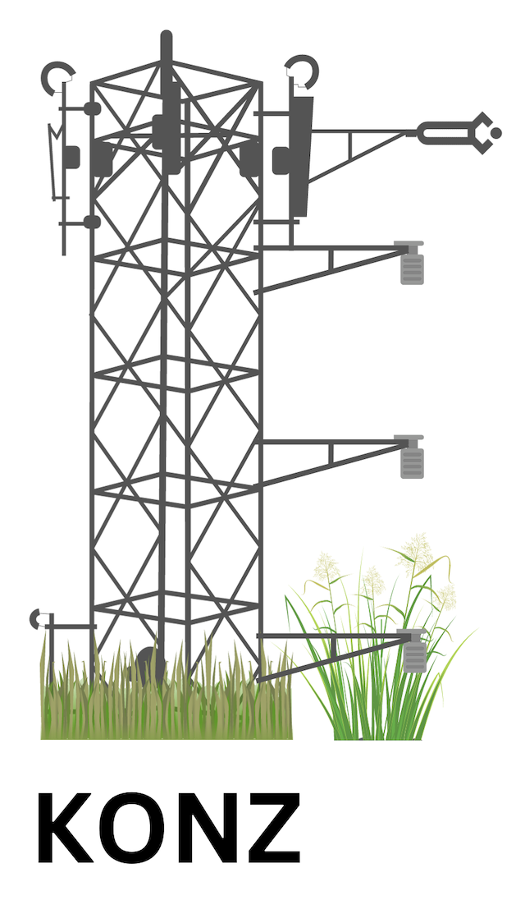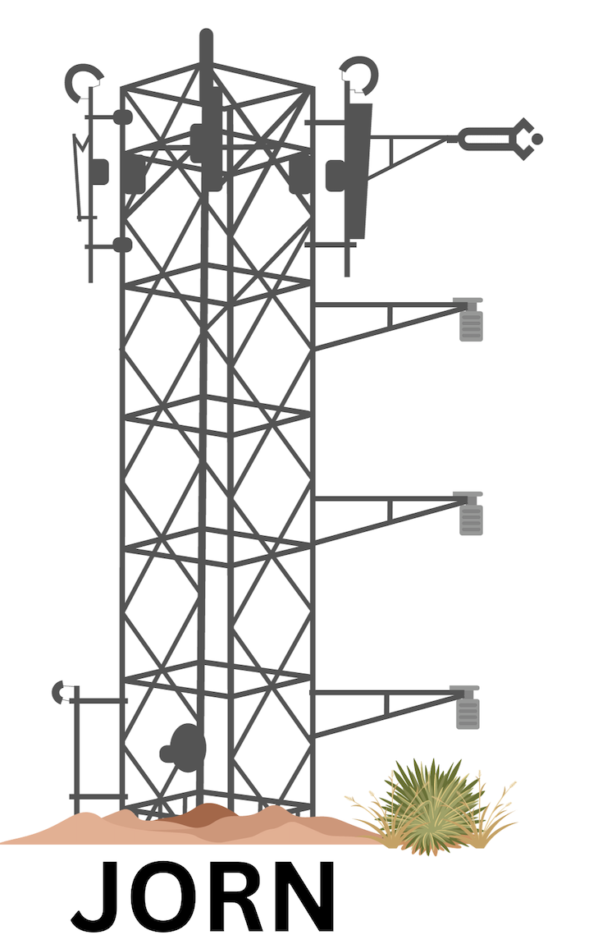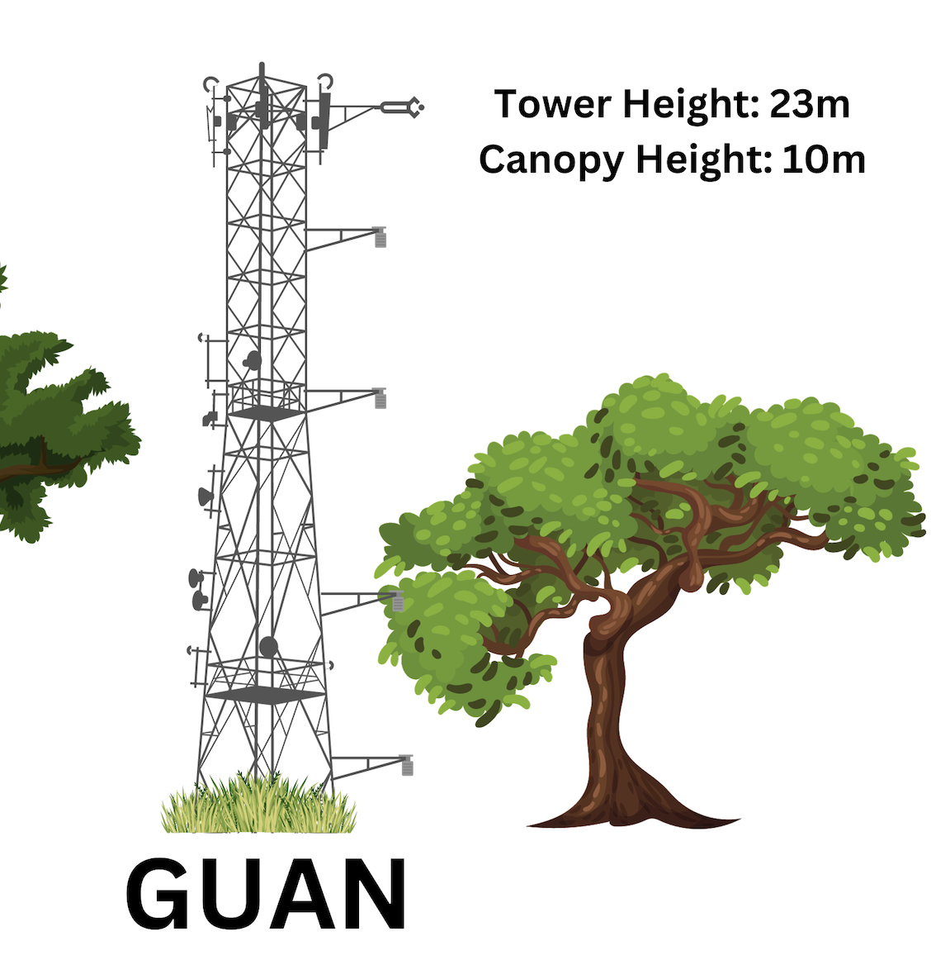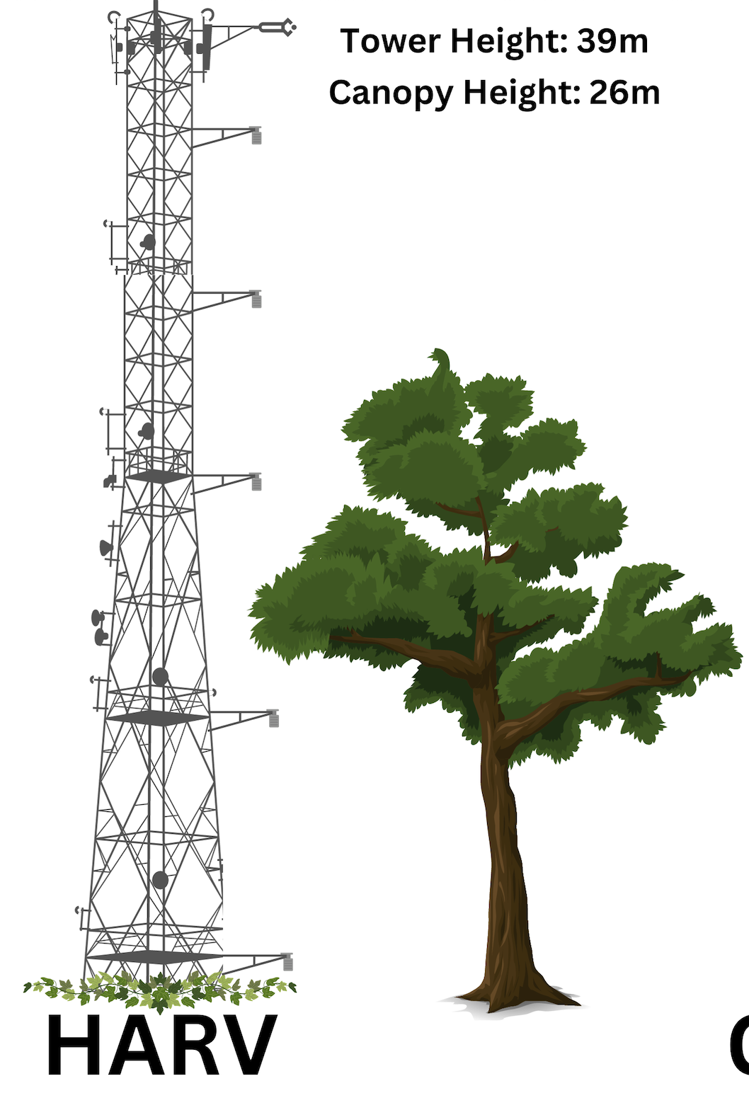

Above (A)
Canopy
B

HARV
GUAN
KONZ
JORN

Within (W)
Figure 1. NEON tower sites (A) are distributed across a range of canopy heights with measurement levels above and below the canopy (B). Across sites, canopy complexity increases with height (C). Sites are also distributed across five ecosystem types (D).
The NEON sites encompass 47 ecosystems, exhibiting wide variation in structural properties that influence the utility of the GF approach (Figure 1). Forests account for 62% (29 towers) of the towers and include tropical, temperate, and boreal forests, as well as savannas. Canopy complexity across forest types typically suggests that more diverse canopy structures indicate a more open canopy compared to heterogeneous tall canopies (Wang et al., 2024). Short-stature ecosystems include shrublands (5 towers) and grasslands (9 towers). While most towers represent upland ecosystems, temperate wetlands are also represented (2 towers). Within this wide variety of ecosystem types, canopy heights range from 0.15 to 53 meters. While GF methods were evaluated across all sites, we further selected a subset of the 47 tower sites, distributed across canopy variability, to examine site-level effects. The sites include the arid grassland in the Jornada Basin (JORN), the tallgrass prairie in Konza Prairie (KONZ), the tropical evergreen forest at Guanica Forest (GUAN), and the temperate mixed forest at Harvard Forest (HARV).

2.2. Instrumentation
Fast response fluxes of CO₂ (μmol m⁻² s⁻¹), latent heat flux (W m⁻²), sensible heat flux (W m⁻²), and friction velocity, u* (m s⁻¹) were measured using a gas analyzer (LI-COR - LI7200) and sonic anemometer (Campbell Scientific CSAT-3) at 20 Hz at the top of the towers. Eddy covariance processing at a 30-minute timescale was done following NEON protocols (Metzger et al., 2017) with de-spiking of data (Brock, 1986; Starkenburg et al., 2016), planar-fit coordinate rotation (Yuan et al., 2011), and corrections for the infrared gas analyzer (Welles and McDermitt, 2005), time lag (Rebmann et al., 2012), sonic temperature (Schotanus et al., 1983), and high-frequency spectral loss (Metzger et al., 2016).
Meteorological data included aspirated air temperature (Thermometrics Climate RTD 100 Ω Probe) and horizontal wind speed and direction (Gill Wind Observer II) at multiple profile heights at each site. Atmospheric pressure P (kPa; Vaisala PTB 330) and relative humidity (Vaisala HMP 155) were measured at the mid-tower and the tower top, respectively. Dry air mixing ratios of CO₂ (μmol mol⁻¹) and H₂O (mmol mol⁻¹) were measured at multiple profile heights at each site using a Picarro G2131-i NEON-specific analyzer with additional upgrades to the CH₄ channel. The gases, CO₂ and H₂O, were measured at a nominal rate of 1 Hz. The means and variances of calibrated mixing ratios were calculated at each sampling level (6-minute sampling periods). Air was sampled from inlets at each tower sampling level, starting at the top and proceeding to the next lower inlet until reaching the bottom, then returning to the top.
The NEON towers use high-accuracy sequential sampling over the tower profile. The mixing ratio pairs used for gradient differences spanned at least 20 minutes and had a 10-minute dwell time per sampling level (4-min flux, 6-min sampling), with some pairs spanning multiple canopy levels. Although sequential sampling is less than ideal, studies have shown that only minor errors are introduced into flux measurements when a single analyzer measures non-simultaneously at alternating heights (Griffith et al., 2002; Kamp et al., 2020; Nelson et al., 2019; Tanimoto et al., 2014). Meteorological data were available as 1- or 2-minute averages, depending on the variable, and the shortest available duration was used. Meteorological variables were aligned with the paired concentration measurement window by averaging them over the 20-minute sampling window. This approach, using linear regression for large time delays, has been used in other studies (Hall et al., 1999). Turbulent flux measurements reported as 30-minute averages were filtered using NEON’s final quality flag before linearly interpolating to the time midpoint of the combined sampling window's observed paired-level gradient mixing ratios. Additionally, due to interpolation, GFs could be calculated only when both the preceding and succeeding half-hourly eddy covariance fluxes were available. All data were downloaded using the neonUtilities package in R (Table 2).

Table 2. We used data from the National Ecological Observatory Network (NEON). This continental-scale research platform collects long-term, open-access data on animals, soil, water, and the atmosphere across the U.S. to understand how ecosystems are changing.
Data Product | NEON Product ID | Reference
Relative Humidity | DP1.00098.001 | (NEON, 2025g)
2D wind speed and direction | DP1.00001.001 | (NEON, 2025a)
Photosynthetically active radiation (PAR) | DP1.00024.001 | (NEON, 2025f)
Bundled Eddy Covariance | DP4.00200.001 | (NEON, 2025b)
Vegetation Indices | DP3.30026.001 | (NEON, 2025h)
Leaf area index (LAI) mosaics | DP3.30012.001 | (NEON, 2025e)
Ecosystem Structure | DP3.30015.001 | (NEON, 2025c)
Elevation-LiDAR | DP3.30024.001 | (NEON, 2025d)
Discrete Return LiDAR point cloud | DP1.30003.001 | (NEON, 2025d; Wang et al., 2024)

2.3. The Eddy Covariance Method
With the EC method, the net transport between the surface and the atmosphere is assumed to be one-dimensional, and the covariance between turbulent fluctuations of the vertical wind and the quantity of interest is used to calculate the vertical flux density. Measurements were typically made in the atmospheric surface layer, where normalized fluxes are constant with height, primarily represent fluxes from the underlying surface, and shear-driven turbulence is the dominant transport mechanism. The EC method involves fast time-resolution measurements of turbulence and trace gases, with measurement scales typically ranging from 1 to 3 km², depending on the measurement height, vegetation canopy height, and turbulence characteristics. Low-turbulence conditions were determined following Foken and Leclerc (2004), assigning quality flags and filtering when advective transport terms dominate and lead to underestimates of surface fluxes from turbulent measurements (Foken and Leclerc, 2004). Turbulent fluxes were expressed with time average components represented with overbars and deviations from the mean due to turbulence represented with prime notation. Net ecosystem exchange includes the turbulent flux, advection, and storage. In our study, advection was considered negligible, and storage was not included. Although we may be biasing the ecosystem flux by not including storage, both the flux gradient and the eddy covariance are representations of the turbulent flux; as such, they are both missing the storage component and thus are comparable.

2.4. Flux Gradient Method
The GF method utilized the difference in concentrations measured at two heights and the assumption that turbulent transfer of scalars is analogous to molecular diffusion. The standard approach is expressed as:
$F = {-⍴}_{d} K \frac{∂C}{∂z}$ Eq. 2
where F is the target turbulent flux (e.g., CO₂, H₂O, or CH₄; μmol m⁻² s⁻¹), $⍴$_{d} is the dry air density (mol m⁻³), C is the scalar dry air mixing ratio (μmol mol⁻¹) at height z (m), and K is eddy diffusivity (m² s⁻¹). Using dry air mixing ratios eliminates density effects. One challenge of the gradient-flux method is to parameterize the eddy diffusivity (K), which can be determined from the Monin-Obukhov similarity theory (Dyer and Hicks, 1970) or, as suggested by Miyata et al. (2000), from the friction velocity derived from a sonic anemometer (Miyata et al., 2000).

2.4.1. Modified Bowen Ratio
Fluxes were estimated following the MBR approach (Eq. 3) by expressing Eq. 2 for two fluxes, F₁ and F₂, taking the ratio, leading K to cancel out, and rearranging to:
$F_{2} = F_{1} \frac{( ΔC_{2} )}{( ΔC_{1})}$ Eq. 3
Where F₂ is the target flux, F₁ is a known flux, ΔC₂ is the target gas dry air mixing ratio gradient difference, and ΔC₁ is the known gas dry air mixing ratio gradient difference measured across the same height profile. The assumption underlying this approach is that the eddy diffusivity is identical for both the tracer (F₁) and the target gas (F₂). If F₁ is known from EC measurements, F₂ can be determined (Moncrieff et al., 1997). Using the MBR method removes the need to invoke Monin-Obukhov similarity for different stabilities, keeping the physics simple. Previous studies have used these methods to calculate ecosystem-scale fluxes for trace gases (e.g., methane (Werner et al., 2003; Zhao et al., 2019), hydrogen (Meredith et al., 2014), carbonyl sulfide (Commane et al., 2015), and mercury (Obrist et al., 2021).

2.4.2. The Aerodynamic Method
In the aerodynamic model, K is given as:
$K= \frac{k u*^{}(z-d)}{ϕ_{h}(ζ)}$ Eq. 4

where K is assumed to be the same for all variables (H₂O and CO₂), the von Karman constant (k) is 0.4 (Stull, 2012), u* is friction velocity and is measured by the fast response turbulent flux data, z is the mean of measurement height, d is the displacement height, ф_{h} (ζ ) is the stability correction function, and$ζ$ is the Obukhov stability parameter calculated as the ratio of effective height (z-d) and Obukhov length (L). z was calculated as the geometric mean between the two levels. Canopy height (h) was calculated aerodynamically from the turbulence statistics (Pennypacker and Baldocchi, 2026), and displacement height was estimated as 0.66h. The Obukhov length is given as:
$L = \frac{-u*^{3}T}{kg(\underline{w'{θ'}_{v}})}$ Eq. 5
where T is the surface air temperature measurement taken from the lowest tower height, g is gravitational acceleration (9.8 m s⁻²), and θ_{v} is the virtual potential temperature.
2.4.3. The Wind Profile Method
The eddy diffusivity for the wind profile method ($K_{wp})$ was calculated at each tower level as:
$K_{wp} =\frac{k^{2} (z-d) \underline{u}}{φ_{h} ln \frac{z-d}{z_{o}}}$ Eq. 6
where k is the von Karman constant, z-d is the effective height as calculated in the previous section, $\underline{u}$ is the average wind speed, and $z_{o}$ is the roughness length estimated as 0.1h. $φ_{h }$ is the stability correction function for heat, assumed to be equal to the stability correction function for CO₂ and H₂O, and calculated as (Lee et al., 2018):
for -5 < $ζ$ < 0:
$φ_{h } = {(1-16ζ)}^{-1/2}$ Eq. 7

for 0 <= $ζ$ < 1:
$φ_{h } = 1 + 5$$ζ$ Eq. 8

2.5. Filtering Gradient Fluxes
Gradient fluxes were filtered using a signal-to-noise ratio (SNR) based on the difference in concentration ($Δ$C) of the target gas (Eq.9):
$SNR =\frac{|ΔC|}{sd(ΔC)}$ Eq.9
We randomly sampled concentration measurements within the sampling period to estimate the standard deviation in △C. A conservative threshold of 3 was used at every site, based on the stabilization of the error between EC and GF for SNR values above this threshold. Depending on the technique, an SNR for both the target and tracer gases (TSNR) was required (MBR). In addition to filtering for SNR, we also filtered GFs using the friction velocity threshold (u*) defined for each site by AmeriFlux (Gu et al., 2005) at the top of the towers. The u* threshold indicated when shear-driven turbulent mixing was insufficient (Gu et al., 2005). Filtering GFs resulted in substantial data loss across approaches, ranging from 70% to 90%, for both CO₂ and H₂O. The SNR was the strongest filter, and u* was typically associated with less than 50% data loss. The TSNR, used for the MBR, filtered an additional ~20-30% of the remaining data on average. As a result of the TSNR, more data was filtered for the MBR than for the AE and WP. Filtered data also varied by sampling height pairs. Fewer data were filtered when at least one measurement was above the canopy (AA or AW).

2.6. Evaluation of Gradient Fluxes
We compared filtered GFs to the EC method as a standard. We determined which sampling height pairs yielded reliable data using Lin’s concordance correlation coefficient (CCC), a statistic that assesses the agreement between two continuous measurement sets (Lin, 1989). The CCC is often used to evaluate the reliability against a benchmark. A CCC value close to 1 indicates high positive agreement, meaning a strong linear relationship with slight bias. A CCC value close to -1 suggests strong negative agreement, meaning a strong linear relationship, but the two datasets are mirror images of each other. A CCC value close to 0 implies a very weak linear relationship. To test for significant differences in CCC values, we used the Kruskal-Wallis rank sum test in R (Okoye and Hosseini, 2024; Ostertagova et al., 2014). This nonparametric statistical test was used to determine if there were statistically significant differences between the medians of GF approaches or sampling height pairs. The Kruskal-Wallis test ranks all the data across all groups, then sums the ranks within each group and compares the sums to determine whether they differ significantly.
To assess an appropriate concordance threshold for identifying reliable sampling-height pairs (RSHP), we conducted a sensitivity analysis using three candidate cutoffs for the agreement between gradient fluxes and eddy covariance (EC), CCC ≥ 0.3, 0.5, and 0.7 (Table S1). For each cutoff, we determined the percent of sampling height pairs retained, the level of sign agreement, mean and absolute flux bias, the correlation, and the root mean square error (RMSE) between GFs and EC . The lower threshold (CCC >= 0.3) was a permissive screen emphasizing directional consistency, the upper threshold (CCC >= 0.7) as a conservative screen favoring low bias, and the intermediate threshold (CCC >= 0.5) as a candidate balance point. We then selected the threshold that provided the strongest tradeoff between retaining enough sampling-height pairs for analysis and achieving sufficiently strong flux concordance with EC. Based on this comparison, CCC >= 0.5 was retained as the primary operational threshold for moderate agreement (Landis and Koch, 1977) between EC and GF, balancing concordance with data loss. After calculating the CCC based on EC and filtering the CCC (EC) values below the threshold, we examined the remaining data to assess the amount of information retained.

2.7. Canopy Influence on Reliable Sampling Height Pairs

We explored how canopy characteristics (Table 3) affect GF reliability across different sampling height pairs. Based on the CCC (EC), we identified reliable/non-reliable sampling height pairs at each tower site. Next, we gathered canopy-structure information for each site from the NEON Airborne Observation Platform (AOP) data and the 30 m NEON structural diversity dataset, which were derived from the NEON AOP Discrete Return LiDAR point cloud product (Wang et al., 2024). A machine learning approach was employed to assess the impact of canopy structure and function on the reliability of sampling height pairs. First, data were divided into training (65%) and testing (35%) sets using stratified random sampling to maintain the distribution across all variables. A preliminary step included variable selection (Table 3). We fit random forest (RF) models using a series of candidate independent variable subsets, employing a modified backward elimination procedure with the VSURF package in R (Genuer et al., 2015). The fit of each model was evaluated using the out-of-bag mean square error (OOB MSE), and variable importance was computed as the increase in prediction error resulting from permuting a particular predictor. While random forest models are robust to multicollinearity (Genuer et al., 2015), we limited the inclusion of highly correlated variables to ensure that each variable in the final model improved model fit and did not affect other variables. Following variable selection, we fit a final model using the randomForest package (Liaw and Wiener, 2002; R Core Team, 2021). Each tree was built from a balanced bootstrap sample with 305 observations from sampling height pairs where CCC < 0.5 and 305 where sampling height pair CCC > 0.5, instead of sampling in proportion class imbalances in the data. Model fit was evaluated using the average of the 500 out-of-bag (OOB) mean squared errors (MSEs) from the final model, and variable importance was calculated as the average rank of each predictor variable across the 500 models. We explored the confusion matrix and the no-information rate, which represents the accuracy you would achieve by always predicting the most frequent class, without using a model. We compared model accuracy to the no information rate to evaluate model performance.

Table 3. Explored drivers of reliable sampling height pairs across NEON towers, including canopy attributes (Wang et al., 2024) that quantify measures of complexity and measurement height relative to the mean canopy height.
Category | Metrics | Description | Unit
Height | Mean Canopy Height (MCH) | Mean of maximum height in a 1 m² grid | m
Density | Vegetation Area Index (VAI) | Vegetation area per unit of ground area | m² m⁻²
Openness | Deep Gap Fraction (DGF)a | Fraction of 1m² canopy gaps in the plot | 1
Exterior Complexity | Top Rugosity (TopRugosity) | Standard deviation of outer canopy heights in 1 m² of plot | m
Exterior Complexity | Rumple Index (RumpleIndex) | Ratio between the canopy surface area and its projected area on the ground | m² m⁻²
Interior Complexity | Gini Coefficient Index (GiniCoeff) | The Gini coefficient of point height
Interior Complexity | Foliage Height Diversity (FHD) | The distribution of canopy cover among vertical canopy layers is quantified using a diversity index.
Interior Complexity | Standard Deviation of Height (SDH) | Standard deviation of point height | m
Interior Complexity | Mean of Standard Deviation of Height (MSDH) | Mean of the standard deviation of the point height in 3 × 3 m grid | m
Interior Complexity | Standard Deviation of Standard Deviation of Height (SDSDH) | Standard deviation of the standard deviation of height in 3 × 3 m grid | m
Ancillary | Area | Area of the bounding box of points in the NEON AOP Discrete Return LiDAR product | m²
Ancillary | Point Density | Number of points per unit of ground area in the NEON AOP Discrete Return LiDAR product | Pts m⁻²
Canopy Function | The normalized difference vegetation index (NDVI) | Normalized ratio of NIR and Red bands
Canopy Function | Leaf area index (LAI) | Ratio of upper leaf surface area to ground area
Canopy Function | Photochemical Reflectance Index (PRI) | Normalized ratio of bands sensitive to xanthophyll pigments
Canopy Function | Enhanced Vegetation Index (EVI) | Ratio of NIR and Red bands that also includes the Blue channel for better aerosol characterization
Canopy Function | Soil Adjusted Vegetation Index (SAVI) | normalized ratio of NIR and Red bands with correction factors to minimize soil contribution
Measurements  Distance | Upper distance to the canopy (Relative Dist A) | Relative Distance of the upper sampling height to the canopy | m
Measurements  Distance | Lower distance to the canopy (Relative Dist A) | Relative Distance of the lower sampling height to the canopy | m

2.9. Gradient Flux Ensemble
We explored different GF ensembles across sampling height pairs and approaches:
mean, median, weighted median uncertainty, inverse RMSE weighted, method specific weighted, and bayesian_fusion. The unweighted mean and median used all retained GF estimates equally. The uncertainty-weighted median used inverse RMSE as the observation weight. The inverse-RMSE weighted ensemble used a weighted mean with weights equal to 1 / RMSE. Method-specific weighting used approach-level mean RMSE, estimated separately by gas and approach across the RSHP-filtered dataset, to assign each method a fixed reliability weight. The Bayesian fusion variant used a precision-style weighting scheme proportional to the product of the approach-level inverse-variance proxy and the observation-level inverse-variance proxy. When weights were missing or non-positive, the algorithm reverted to the unweighted mean for that half-hour. We evaluated each ensemble against EC reference fluxes at the site-by-gas level. For each site, gas, and ensemble method, we retained only half-hourly comparisons with non-missing EC and ensemble fluxes and required more than 20 observations. We then calculated three performance metrics: R², CCC, and RMSE between EC and ensemble fluxes. Site-level metrics were summarized by gas and method using the mean, median, and standard deviation across sites. Although this is the first study to ensemble gradient fluxes across approaches and sampling height pairs, ensemble models have been shown to provide more robust and accurate estimates compared to approaches reliant on a single modeling framework (Willcock et al., 2020). Ensembles can also be useful for providing indications of uncertainty, particularly when validation data are not available.

2.10. Ecosystem Assessment

To evaluate whether the ensemble GF can provide ecologically meaningful information, we fit seasonal diel curves for both CO₂ and H₂O to assess fluxes over a 24-hour cycle. Daily changes in sunlight, temperature, and biological activity primarily drive diel curves for CO₂ and H₂O. Curves reveal an ecosystem's metabolic function by showing daily fluctuations in photosynthesis, respiration, and transpiration. Diel curves were fitted on ensemble GF data by season (winter, spring, summer, and autumn) at each site using the loess function in R (Jacoby, 2000). Using the diel curves, we measured the differences in total daily flux between the EC and the ensemble GF. The goal was to compare the pattern and magnitude, which should be similar between the EC and the ensemble GF, to ensure this information is a reliable data stream.

2.11. Methods Summary

This study was designed to explore when and where the GF method reliably estimates ecosystem fluxes of CO₂ and H₂O for the NEON flux towers (Figure 2). Confidence in the GF method was determined by its concordance with the EC method. While we don't expect identical flux measurements between the EC and GF methods due to footprint differences, we assess reliability by comparing the ecological implications of the measurements, which can be quantified effectively using the CCC. To determine the limits of the GF method, we begin by filtering based on u* and SNR. Next, we determined the CCC (EC) for each sampling height pair. We created an indicator to identify data from sampling heights with a CCC (EC) ≥ 0.5, balancing agreement with the EC while minimizing data loss. With the data that met the CCC (EC) threshold, we then explored the distribution of data across GF approaches (MBR, AE, WP), canopy measurement levels (AA and AW), seasons (winter, spring, summer, and autumn), and hours (0-23). We developed a model to explore the impact of canopy attributes on which sampling height pairs yielded reliable fluxes. Across ecosystems, where reliable GFs were available from different approaches and sampling height pairs, we ensembled all reliable GFs. We then compared the ensemble GF to the EC method, measuring the ensemble's concordance. Next, we performed ecosystem assessments by fitting seasonal diel curves for each site. To assess agreement, we compared diel curves from the EC method and the ensemble GF method.
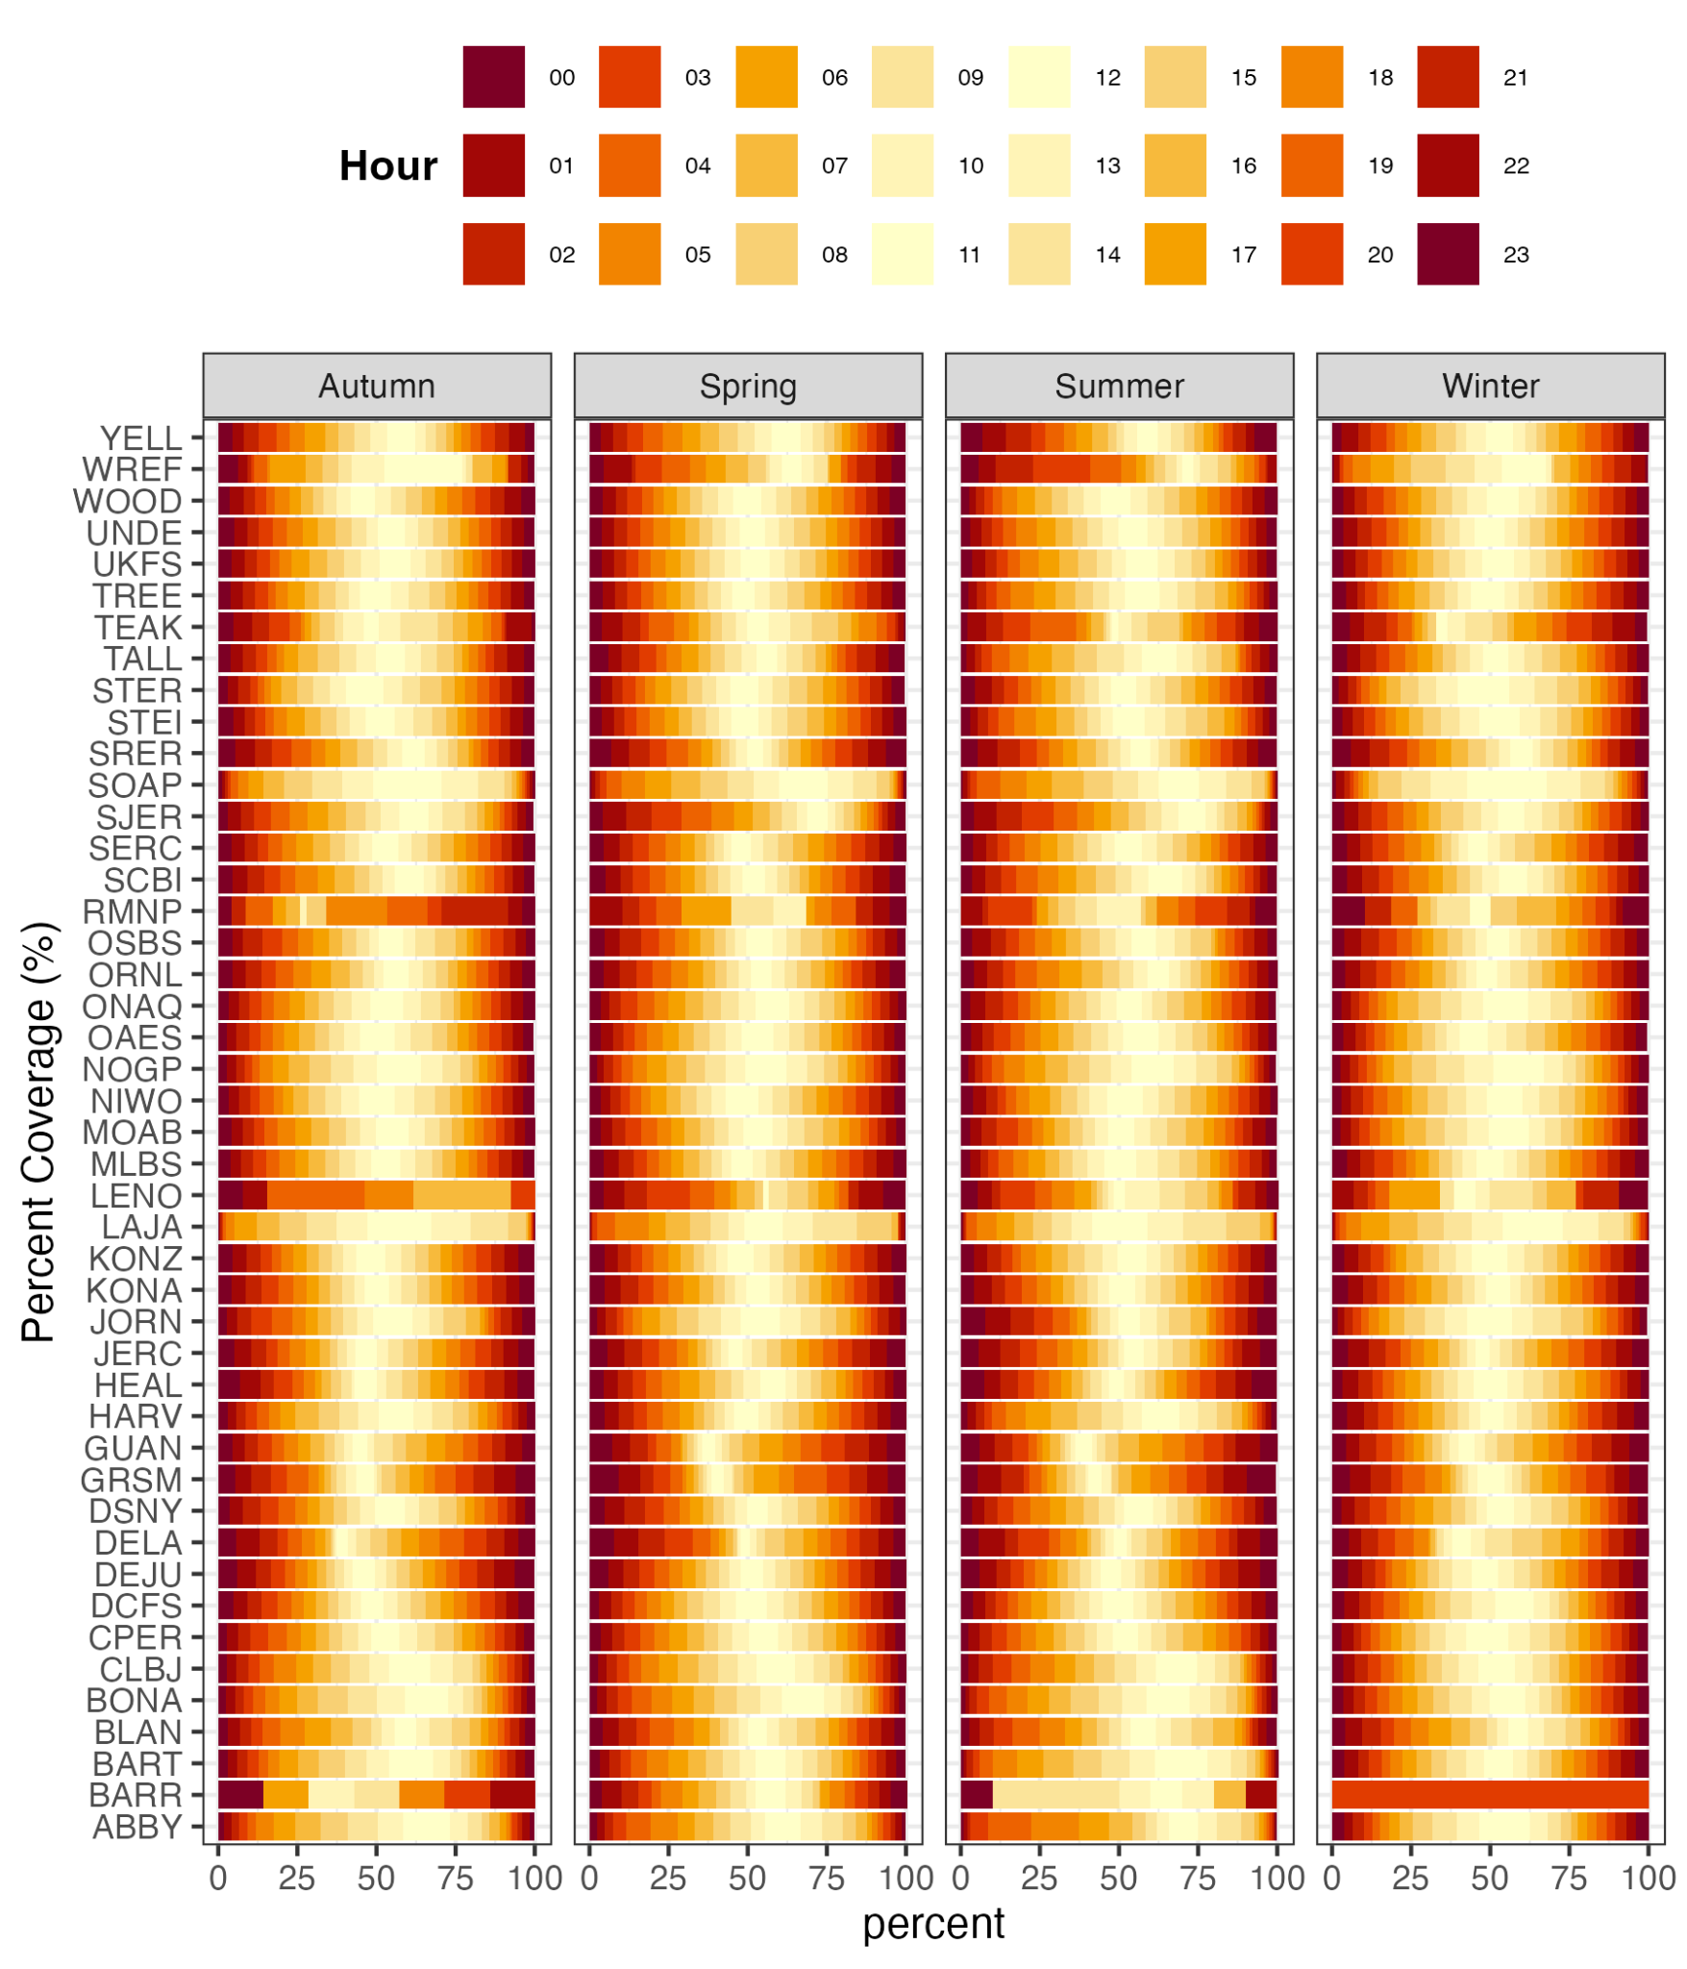
Reliable Sampling Height Pairs

GF
EC
CCC

Filtering
u*
SNR
TSNR
Canopy & Reliable Sampling Height Pairs
Methods
Approach: MBR, AE, WP
CCC (EC) ≥ 0.5
DIEL

Random Forest

Above (A)
Canopy
Structure
Ensemble

Ecosystem Assessment

Approach

Season

Sample Size
Hour

Q3
Q1
Q2

Canopy

Figure 2. This workflow was designed to explore when and where the gradient flux (GF) method produces reliable ecosystem fluxes of CO₂ and H₂O, using the eddy covariance (EC) method as a benchmark. Guiding questions include: How well does the GF method perform across different ecosystems (Q1)? Which sampling height pairs provide reliable ecosystem fluxes (Q2)? Does the GF method provide a valid ecosystem assessment (Q3)? We used a moderate concordance (CCC) threshold of 0.5 when comparing GFs to EC and to GFs at different sampling height pairs (Table S1).

Results
All of the 47 terrestrial NEON tower sites had GF data after filtering for u* and SNR. The GFs were distributed across approaches and canopy levels (AA and AW). While all GFs captured combinations of ecosystem components (soil and canopy) to varying degrees, the challenge was to determine which sampling height pairs were representative of the ecosystem scale flux by measuring their concordance with the EC method.
3.1. Gradient Flux Method Evaluation
The CCC (EC) for all sampling height pairs ranged from -0.66 to 0.97, with notable differences observed between approaches (MBR, AE, WP) and canopy levels (AA and AW; Figure 3). The range in CCC (EC) observed suggests that some sampling height pairs yielded GFs that aligned with the EC method. On average, the mean CCC (EC) for CO₂ was higher for the MBR ($\underline{CCC}$ = 0.27; p < 0.001) than the AE ($\underline{CCC}$ = 0.09; p < 0.001) and WP ( $\underline{CCC}$ = 0.13; p < 0.001; Figure A1). There was also a significant difference in concordance between canopy levels AA ($\underline{CCC}$ = 0.20), AW ($\underline{CCC}$ = 0.13; p < 0.001; Figure A1). Similar patterns were observed for H₂O, where there was a significant difference between the CCC of each GF approach and canopy level (p < 0.001; Figure A1). The MBR had a higher mean CCC ($\underline{CCC}$ = 0.29) compared to the AE ($\underline{CCC}$ =0.11) and WP ($\underline{CCC}$ = 0.24), and the canopy level AA had a higher mean CCC ($\underline{CCC}$ = 0.26; p < 0.001) compared to AW ($\underline{CCC}$ = 0.17; p < 0.001; Figure 3).
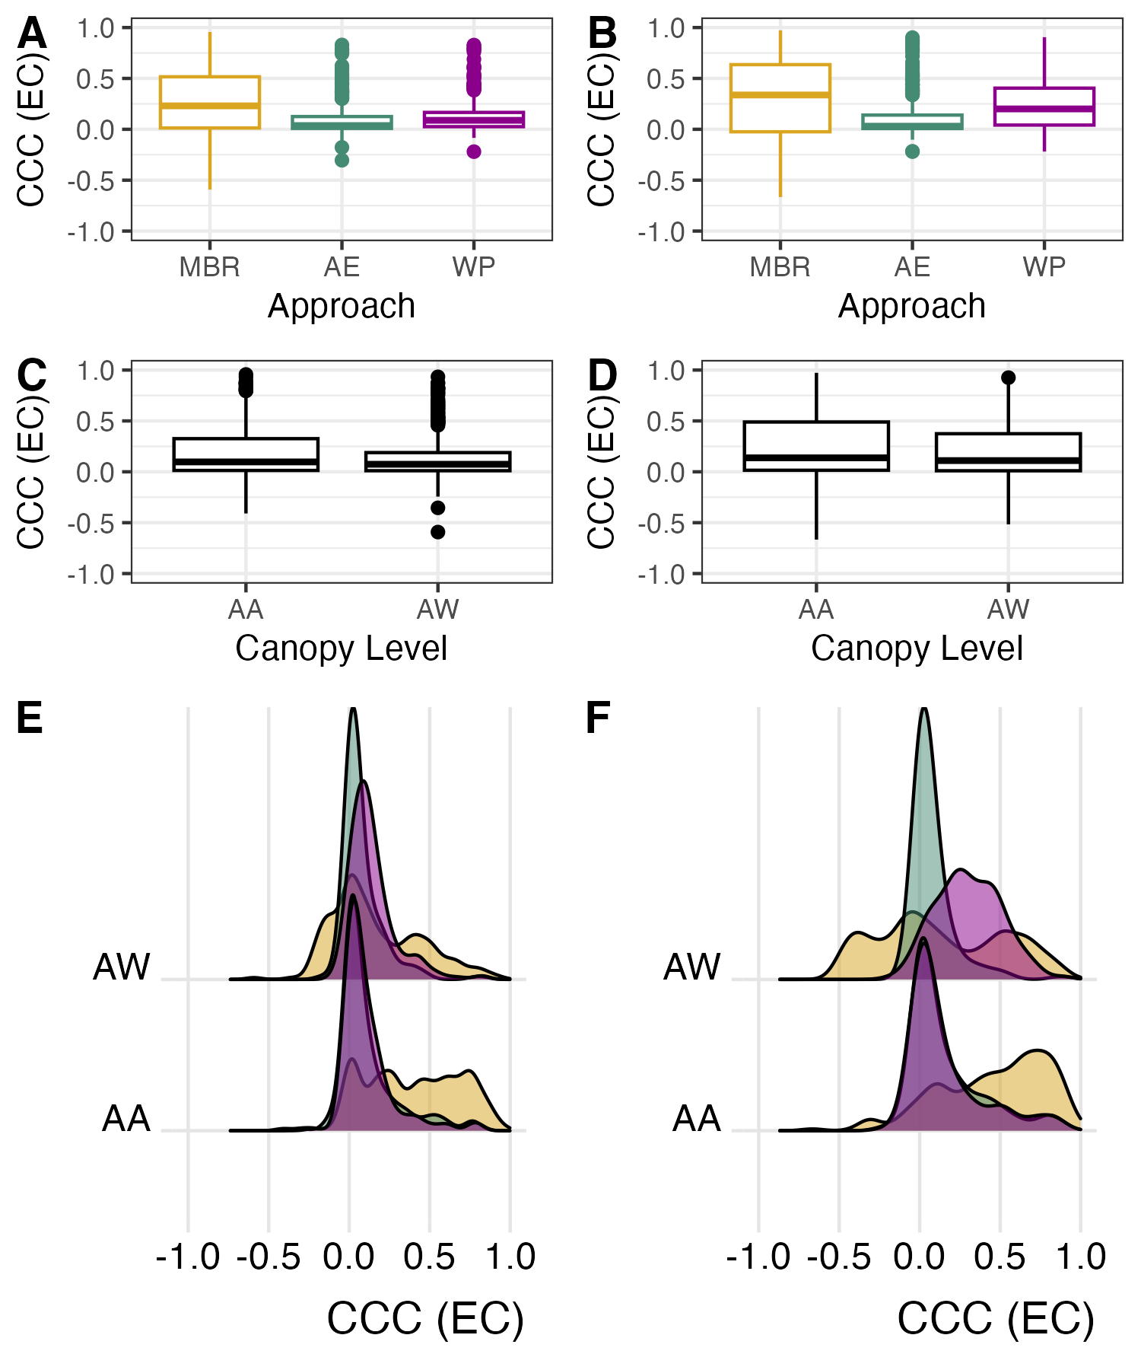

H₂O
CO₂
Figure 3. The concordance correlation coefficient of the GF compared to EC (CCC (EC) for sampling height pairs. Concordance varied by approach (MBR, AE, WP: tan, green, and purple, respectively) for CO₂ (A) and H₂O (B) and by canopy level (AA and AW) for CO₂ (C) and H₂O (D). The distribution of CCC (EC) values by approach and canopy level for CO₂ (E) and H₂O (F) showed wide variation in concordance across sampling height pairs.
Of the 47 terrestrial NEON tower sites, 38 sites had reliable sampling height pairs with a CCC (EC) ≥ 0.5 for CO₂. Across all sites, sampling height pairs, and approaches, 11% of sampling height pairs produced reliable GFs for CO₂ (Figure 4). The mean number of sampling height pairs at a site with a CCC (EC) ≥ 0.5 was 3.8 (2.6 S.D.) for CO₂ and 5.7 ( 3 S.D.) for H₂O. Most of the reliable sampling height pairs were from the MBR approach (78%), followed by the AE (11%) and WP (11%) for CO₂. The most reliable sampling height pairs were above the canopy (AA = 72%), with just 28% from the AW for CO₂. The $\underline{CCC}$ (EC) for a reliable sampling height pair (CCC (EC) ≥ 0.5) was similar for AA ($\underline{CCC}$ (EC) = 0.69; R²= 0.58) and AW ($\underline{CCC}$ (EC) = 0.67; R²= 0.53) for CO₂. Site-based results are shown in Supplement A (Figures A2).
More sites had reliable sampling height pairs for H₂O (44 sites), and 30 sites provided reliable GFs for both gases. Across all sites and sampling height pairs, 19% of sampling pairs were reliable for H₂O (Figure 4). Similar to patterns observed for CO₂, most reliable sampling height pairs were for the MBR (66%), followed by the AE (10%) and the WP (24%). The most reliable sampling height pairs were AA (60%), followed by AW (40%) for H₂O (Figures S3 and S4). The concordance was greatest for the AA ($\underline{CCC}$(EC) = 0.72; R²= 0.59) compared to the AW ($\underline{CCC}$(EC) = 0.65; R²= 0.50) across and within NEON tower sites for H₂O. Site-based results are shown in Supplement A (Figures A3).
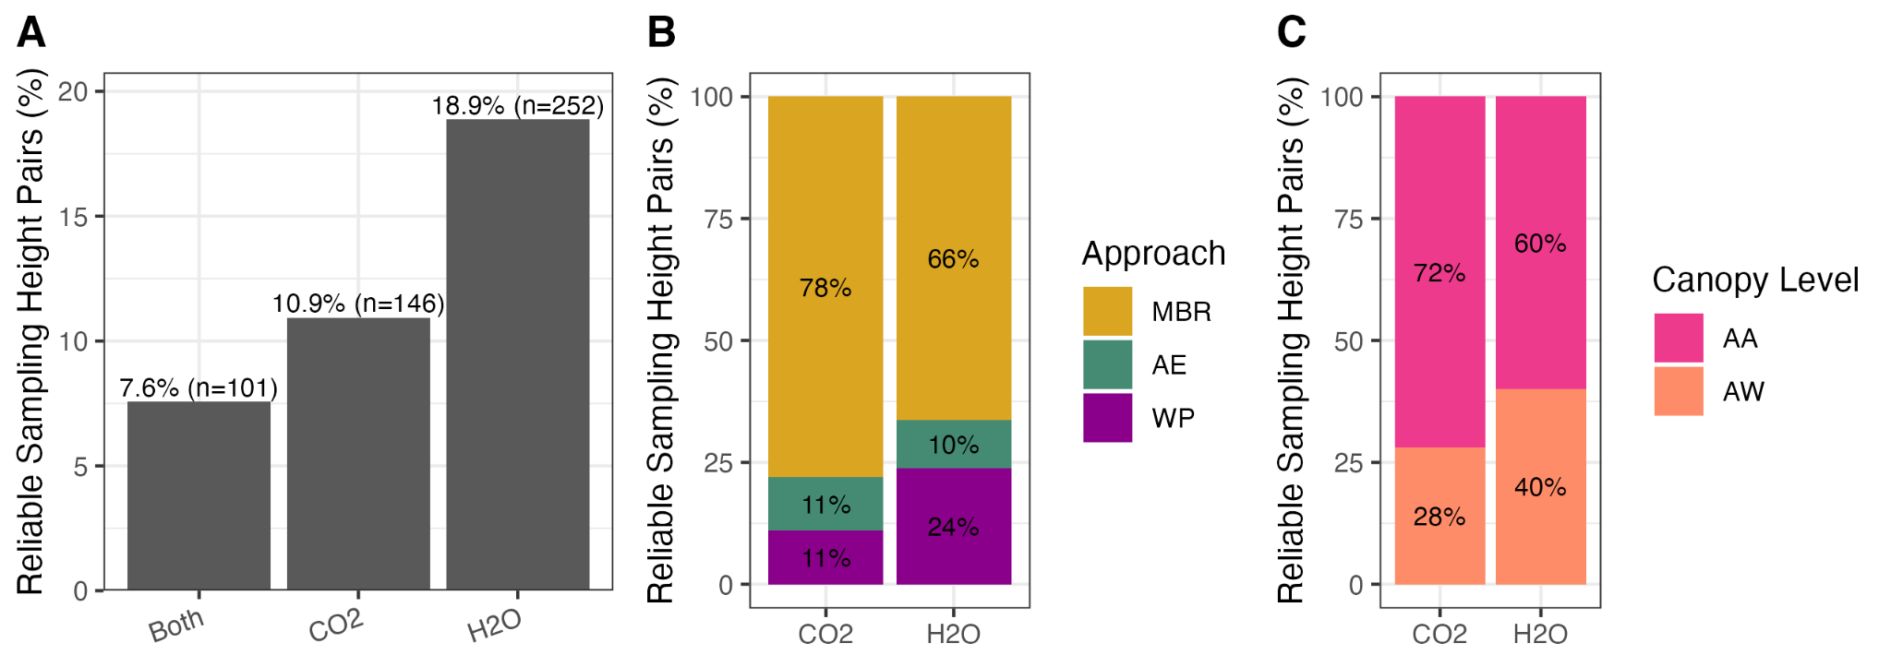
Figure 4. The percentage of reliable sampling height pairs (CCC (EC) > 0.5) for CO₂ and H₂O (A), by approach (B), and canopy level (C).
Across approaches, most sites had reliable CO₂ and H₂O data in all four seasons (winter, spring, summer, and autumn; Figure 5). For CO₂, most flux data were from the summer (34%; 11% S.D.) and autumn (25%; 7 S.D.), with the spring (24%; 9 S.D.) and winter (17%; 8 S.D.) undersampled. For H₂O, most flux data were from the spring (31%; 12 S.D.), and the summer (24%; 7 S.D.), autumn (21%; 6 S.D.), and winter (23%; 9 S.D.) were undersampled on average. The patterns in percent coverage by hour were consistent across seasons and suggest that early-morning and midday fluxes were undersampled for CO₂, and that early hours were undersampled for H₂O (Figures 5B and 5C). Site-based results are shown in Supplement A (Figures A4 and A5).
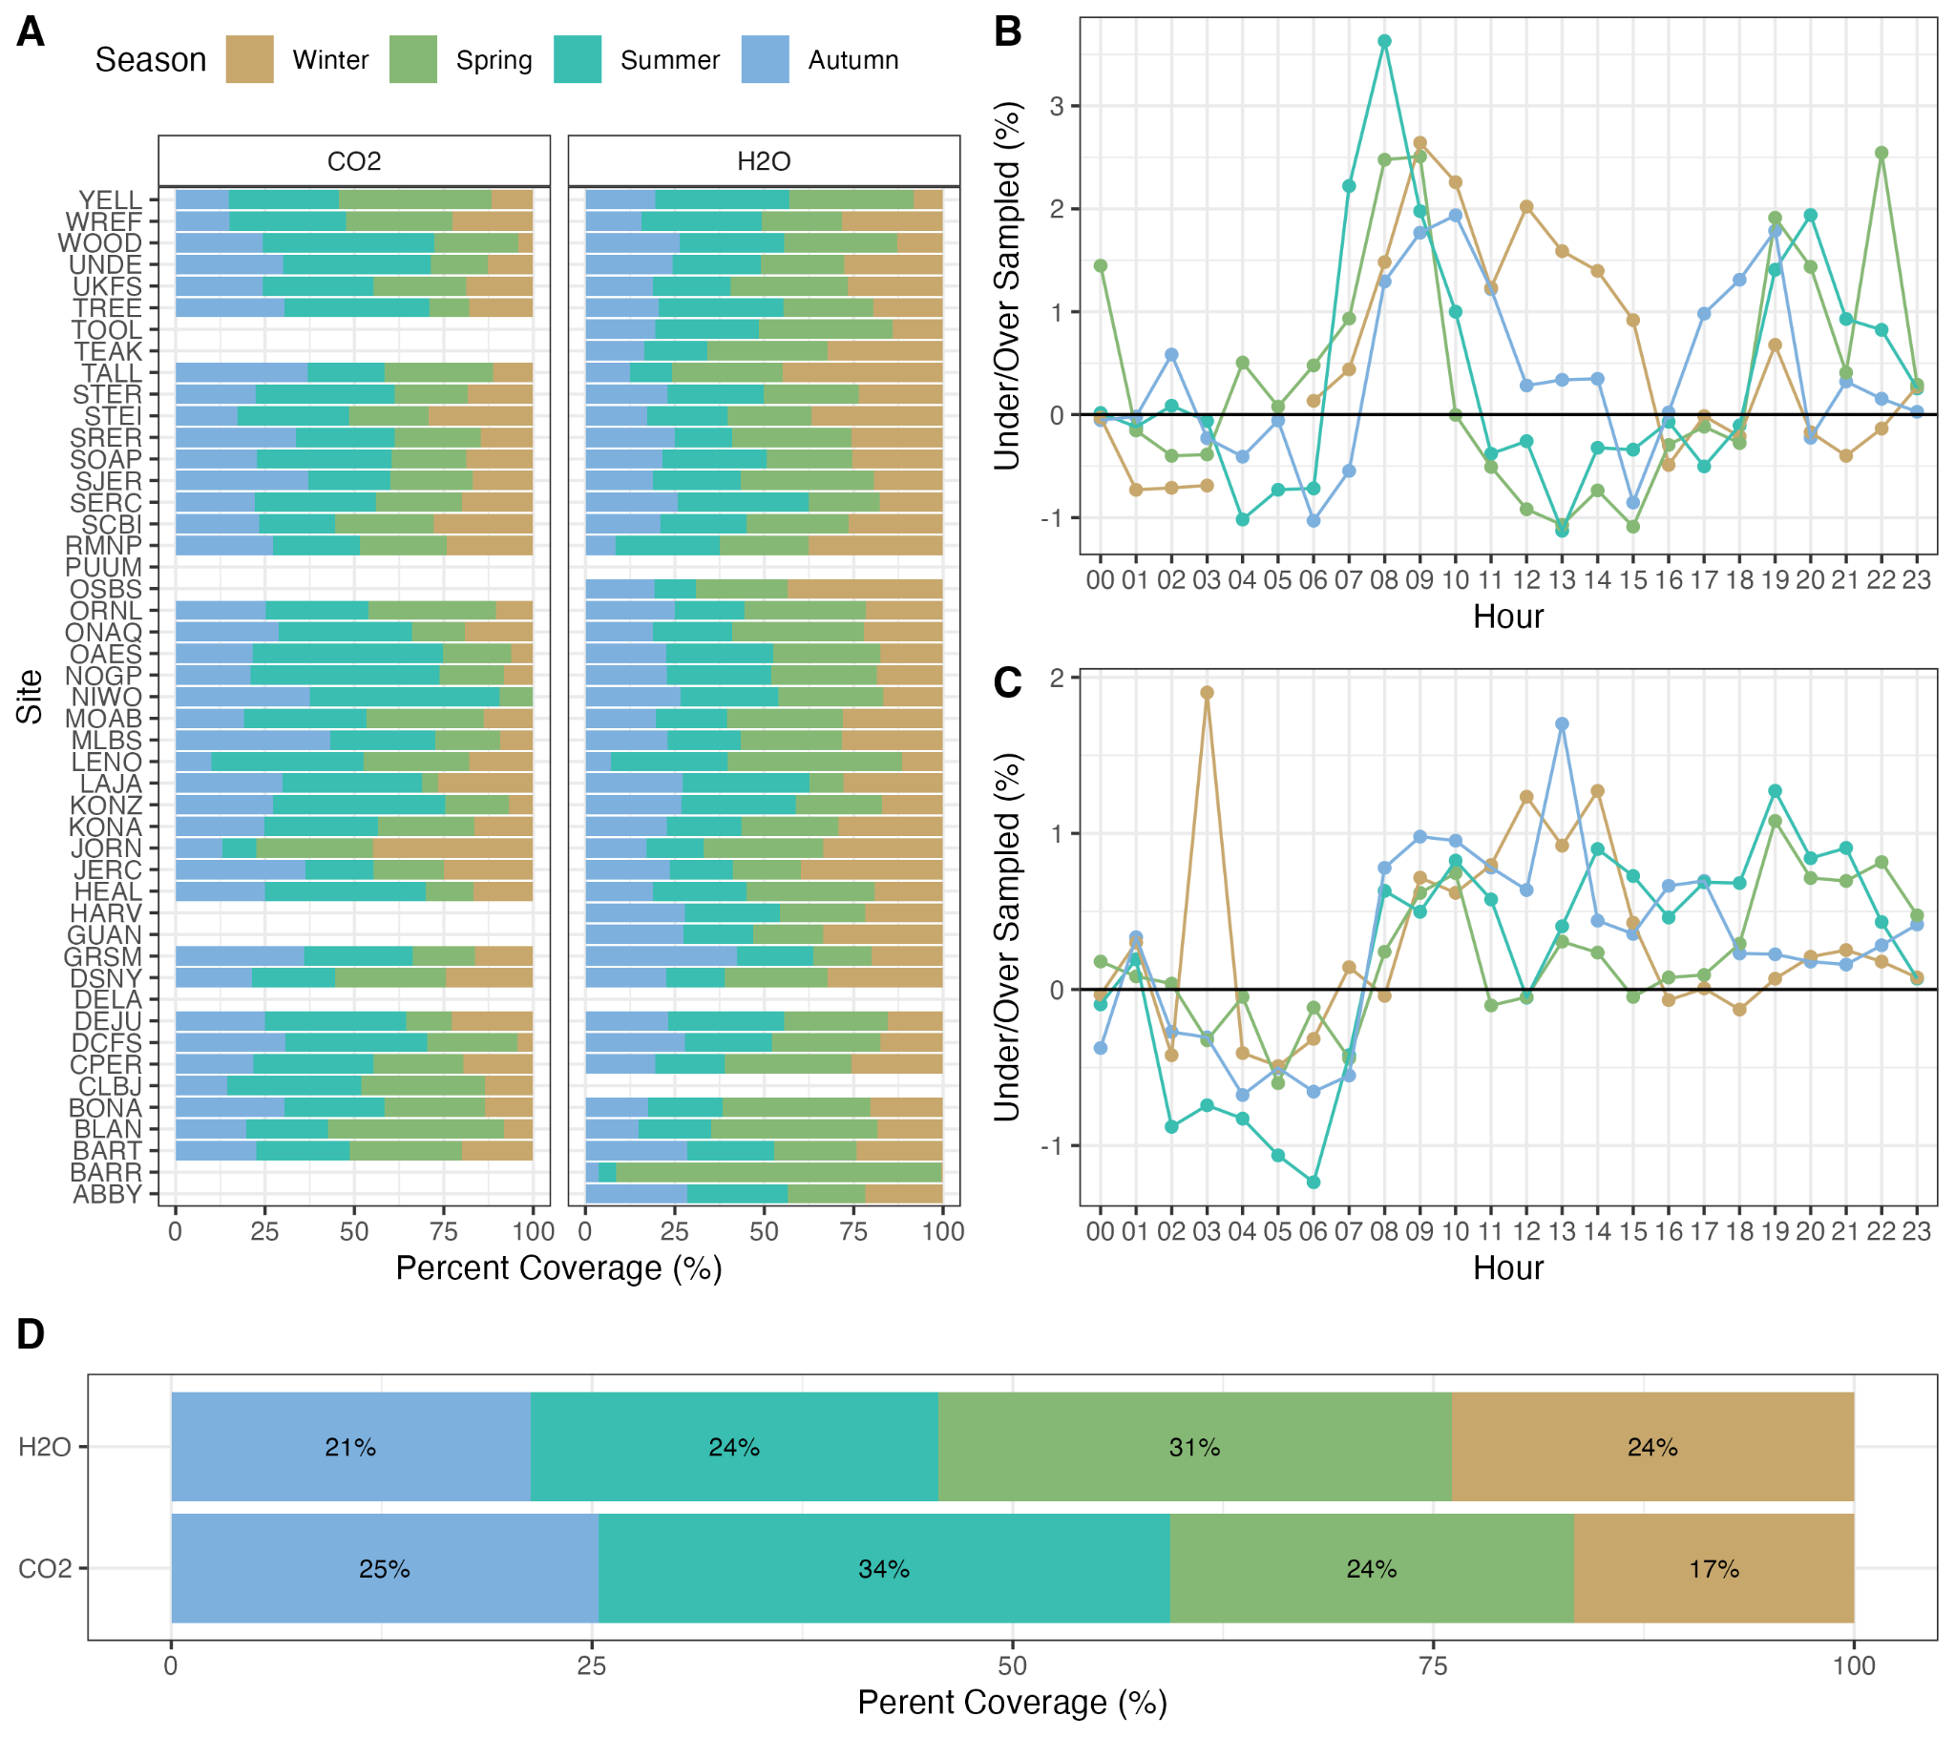
H₂O
CO₂
Figure 5. The percent coverage of gradient flux (GF) data from reliable sampling height pairs (CCC (EC) > 0.5) across sites by season (A) and hour for CO₂ (B) and H₂O (C). The summary across all sites (D) indicates that the data is skewed towards the summer for CO₂ and spring for H₂O.

Across all ecosystem types, the MBR provided reliable sampling height pairs with AE and WP important for tall canopies. The MBR produced reliable GFs when both measurement levels were above the canopy (AA), and the AE and WP were especially important for reliable cross-canopy fluxes (AW). As a result, the MBR was popular across all ecosystem types, and the AE and WP were essential when cross-canopy fluxes could be used to produce reliable GFs (Figure 6). Still, the size of GF datasets was larger in short stature ecosystems where there was a higher rate of reliable sampling height pairs above the canopy (AA). On average, the dataset size across the approaches indicates that AE and WP were larger (Figure A6 and Figure A7). The average sample size (in number of half hours per year) for CO₂ fluxes across sites was 1341 (1848 S.D.) for the MBR, 2872 (1762 S.D.) for the AE, and 1948 (1886 S.D.) for the WP for CO₂. The average sample size for H₂O across sites was 2030 (1837 S.D.) for the MBR, 9262 (8235 S.D.) for the AE, and 9132 (7145 S.D.) for the WP. Even though the AE and WP had larger datasets and were associated with forests, these ecosystems also had the smallest datasets on average (Figure A6 and Figure A7).
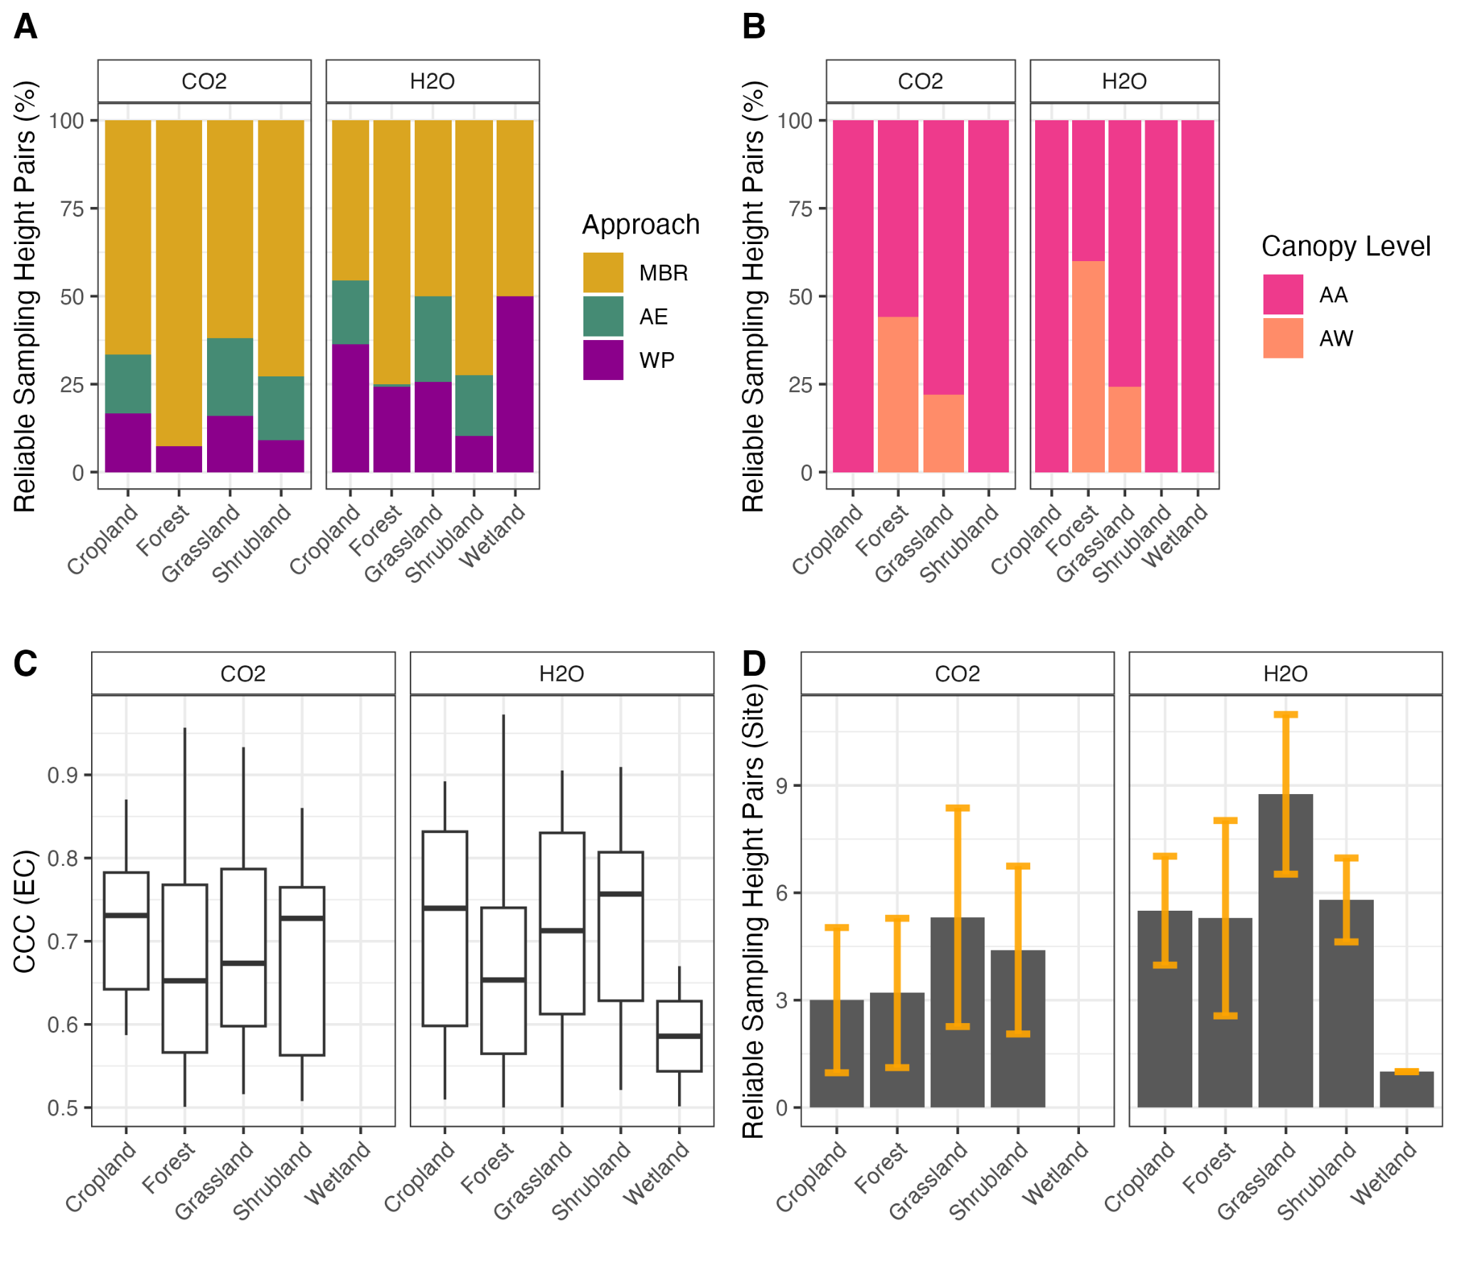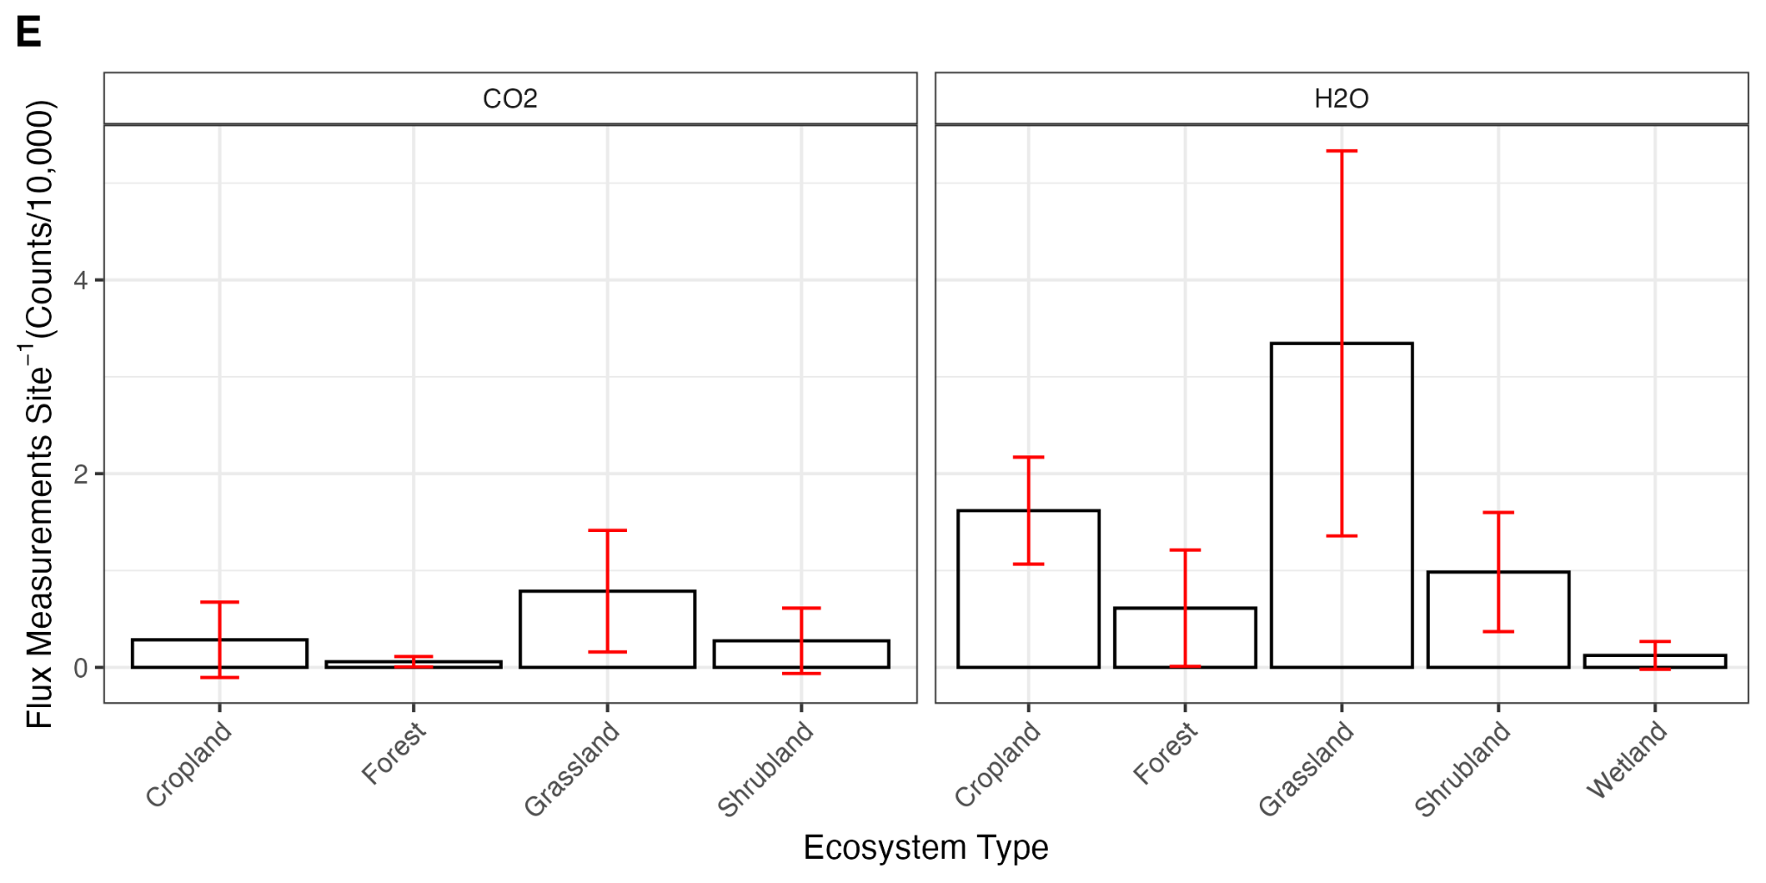
Figure 6. The percentage of reliable sampling height pairs (CCC (EC) > 0.5) for CO₂ and H₂O by approach (MBR, AE, and WP; A), canopy level (AA and AW; B), and ecosystem type. The concordance (CCC) varied across ecosystems (C) and resulted in variation in the average number of reliable sampling height pairs(D) and the average size of the GF dataset at tower sites (E).
3.4. Canopy Influence on Reliable Sampling Height Pairs
Structural attributes of ecosystems influenced which sampling height pairs had a CCC (EC) ≥ 0.5 (Figure 7). With the GF approach, the mean canopy height within the tower footprint, the standard deviation of canopy height (SDSDH), and the distance between the measurement height and the canopy at the upper (Relative Dist A) and lower (Relative Dist B) measurement levels influenced the reliability of sampling height pairs. The random forest model accuracy was 95%, which was significantly different from the no-information rate (0.85; p < 0.001). The sensitivity analysis revealed that the probability of a sampling height pair having a CCC (EC) ≥ 0.5 was highest for the MBR approach when measurements were above the canopy (i.e., AA; Figure 7). In contrast, AE and WP performed best when the top sampling height pair was above the canopy, and the bottom measurement was within the canopy (i.e., AW). Measurement levels farther from the mean canopy height had a higher probability of producing a reliable sampling height pair, except for the WP approach, where a measurement level within the canopy, closest to the top, also had a higher probability. Sampling height pairs for ecosystems with a lower canopy variance and shorter mean canopy height had a higher probability.
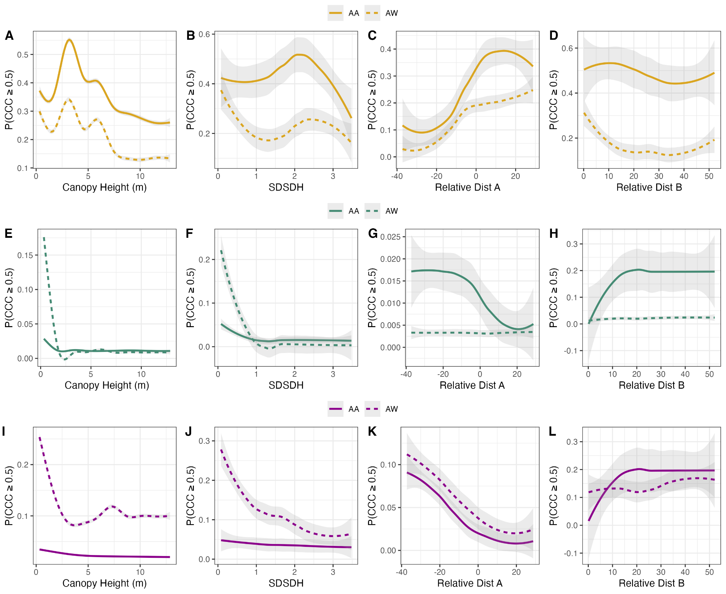
Figure 7. Sensitivity analysis for the model estimating the probability of a sampling height pair having a concordance correlation coefficient (CCC (EC) ≥ 0.5) for the MBR (A-D), the AE (E-H), and WP (I-L) by canopy level (AA, AW) for the mean canopy height (m), the standard deviation of canopy height (SDSDH), and the distance between the measurement height and the canopy at the upper (Relative Dist A) and lower (Relative Dist B) measurement levels influenced the reliability of sampling height pairs, respectively.
3.2. Gradient Flux Ensemble
Temporal overlap in GFs from different sampling height pairs and approaches was common across sites and ranged from 0 to 48% (Figure A9). The highest overlap was between the AE and WP, whereas data from all three approaches overlapped for fewer than 5% of available fluxes on average (Figure A8). There were small differences in ensemble method performance (Table 4). Therefore, we used the mean ensemble in all analyses. The concordance between ensembled GFs and EC was just as strong as the mean CCC (EC) across sites (Figure 8), suggesting that the GF ensemble did not reduce concordance with EC.
Table 4. Comparison of ensemble methods. ​​
Ensemble Method | Mean R2 | S.D. R2 | Mean CCC | S.D. CCC | Mean RMSE | S.D. RMSE
Bayesian fusion | 0.501 | 0.12 | 0.66 | 0.09 | 3.44 | 3.2
Inverse RMSE weighted | 0.501 | 0.119 | 0.66 | 0.09 | 3.46 | 3.2
Approach weighted | 0.499 | 0.118 | 0.66 | 0.08 | 3.47 | 3.2
Mean | 0.499 | 0.117 | 0.66 | 0.08 | 3.49 | 3.2
Median | 0.496 | 0.116 | 0.66 | 0.08 | 3.49 | 3.2
Median_weighted | 0.49 | 0.12 | 0.65 | 0.09 | 3.47 | 3.2

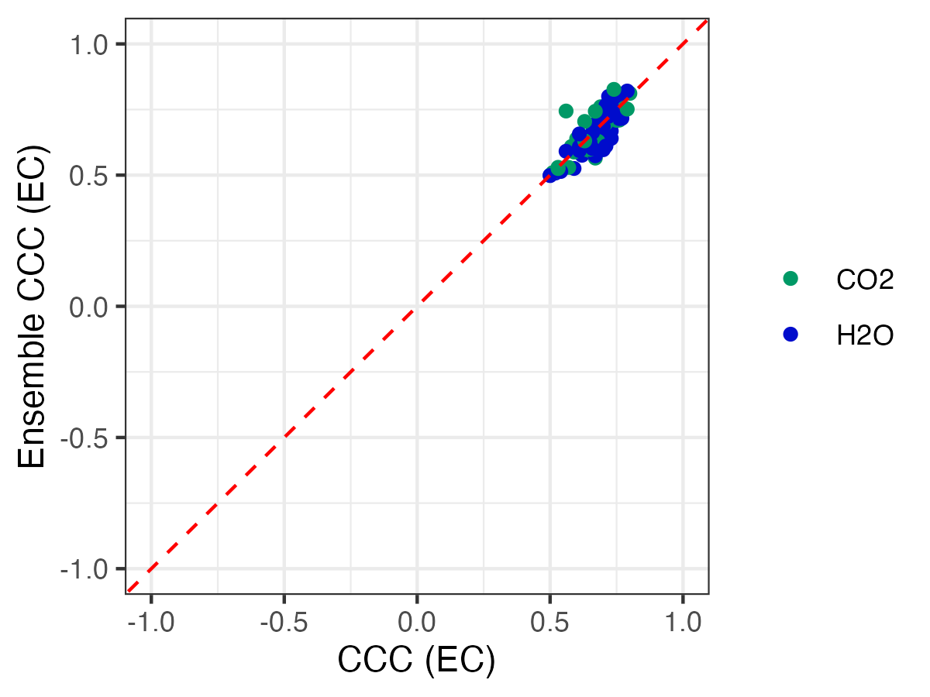
Figure 8. A comparison of the concordance between the mean CCC (EC) for reliable sampling height pairs at NEON towersites and the ensembled CCC (EC).
3.3. Ecological Assessment of Gradient Fluxes
All sites with reliable sampling height pairs produced seasonal diel curves that had strong correlations (R²≈ 0.72 - 0.98) with EC curves for both CO₂ (n = 28) and H₂O (n = 43; Figure 9). Most towers produced valid CO₂ curves for at least one season, and most sites (51% for CO₂ and 89% for H₂O) had data for the spring and summer curves. Although the GF tended to undersample mid-day measurements for CO₂ (Figure 5B) and early morning measurements for H₂O (Figure 5C), there were no consistent patterns across ecosystem types in over- or under-sampling of total daily diel curves. Seasonal daily flux rates differed by a mean absolute value of ~ 1.4 g CO₂ m⁻² day⁻¹ and were highly variable (1.4 S.D.) across sites and seasons. The H₂O datasets were larger, and correlations between GF and EC were stronger than those for CO₂. Seasonal daily flux rates differed by a mean absolute value of ~ 0.19 g H₂O m⁻² day⁻¹ (0.17 S.D.) across sites and seasons. Although differences in total daily fluxes across seasons yielded similar implications for the magnitude and sink/source strength of ecosystem fluxes, biases across ecosystem types ranged from 19 to 43% for CO₂ and 0 to 8% for H₂O. Correlations between GF and EC seasonal diel curves indicate that forested ecosystems were more likely to have lower R², and biases were larger for CO₂ than they were for H₂O. Altogether, ensemble GFs provided ecosystem assessments that aligned with the EC method, and performance limitations were influenced by the availability of sufficient data to capture diel patterns across seasons. Site-based diel curves are shown in Supplement A (Figures A9 and A10) and comparisons of GF and EC based diels are shown in Figure A11.

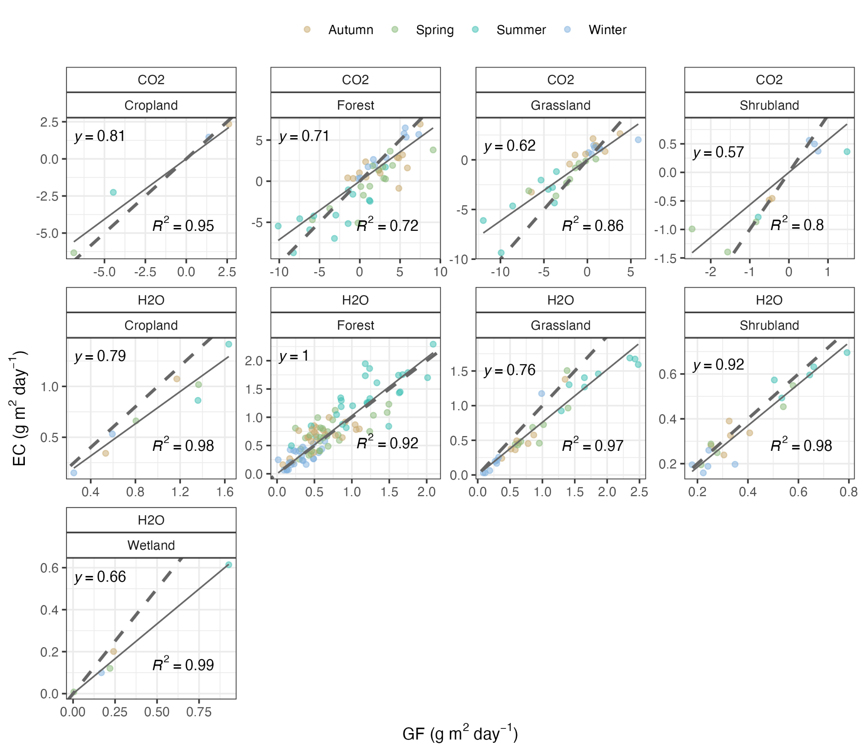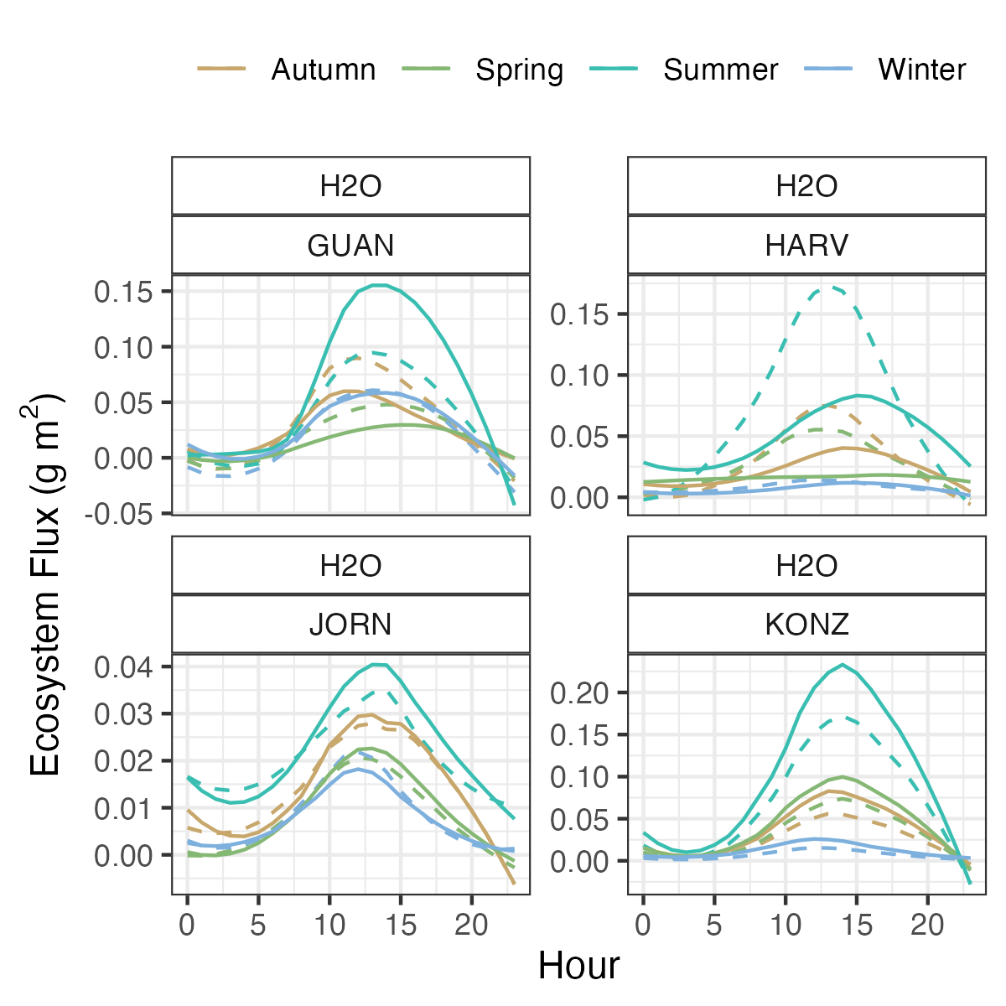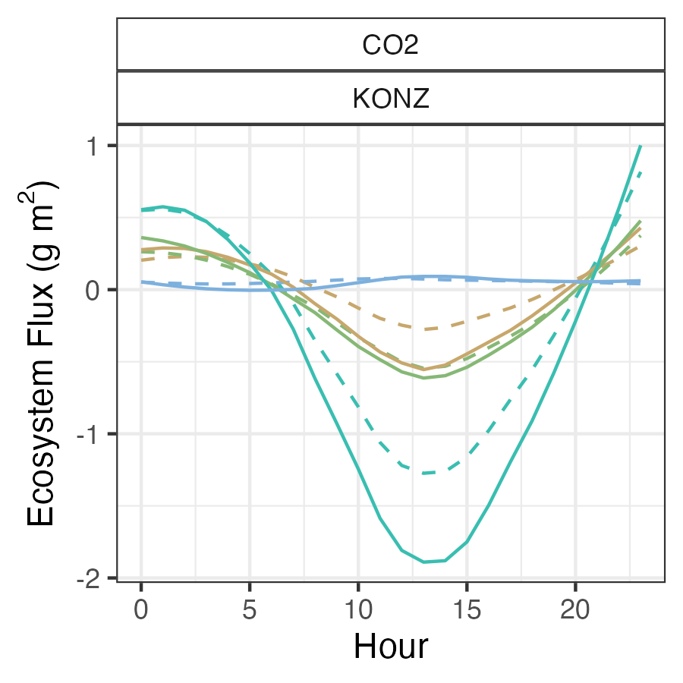

A
C
B
Ecosystem Assessment

GF (g m⁻² day⁻¹)
Figure 9. The correlation strength (R²) and slope (y) for total daily ensemble GF versus EC (A) based on diel curves for CO₂ (B) and H₂O (C) across seasons for ecosystem types. The dashed line in panel A is a one to one line. Panels B and C show diel curves for a subset of sites: the arid grassland in the Jornada Basin (JORN), the tallgrass prairie in Konza Prairie (KONZ), the tropical evergreen forest at Guanica Forest (GUAN), and the temperate mixed forest at Harvard Forest (HARV). The solid lines in panel B and C are GF diels and the dashed lines are EC diels.

Discussion
Across terrestrial ecosystems, the GF method can yield reliable estimates of ecosystem fluxes (Meredith et al., 2014; Mölder et al., 1999; Raupach and Legg, 1984; Zhao et al., 2019). Surprisingly, the GF approach worked better for H₂O than for CO₂, and reliable sampling height pairs were gas-dependent. Across gases, the MBR approach produced reliable fluxes when both measurement levels were above the canopy (Meredith et al., 2014), showed higher concordance when measurements were farther from the mean canopy height, and exhibited stronger agreement with much smaller datasets than other approaches. The AE and WP performed best for canopy-level AW (Meredith et al., 2014) when measurement levels were closer to the mean canopy height, yielding larger datasets than the MBR. Although concordance was weak to moderate for half-hourly fluxes, concordance between diel curves for ensemble GFs and EC was strong when sufficient data were present to capture seasonal patterns. The GF method performed well at short-stature sites under favorable conditions and also at forested sites when fluxes were cross-canopy (AW). The major limitation was the amount of available data and its representativeness of variation in conditions within and across ecosystems. Temporal overlap between GF approaches and sampling height pairs was low on average, suggesting that using multiple approaches and measurement levels could enhance temporal coverage of the flux data. Using an ensemble of all reliable GFs provided sufficient data to understand patterns in ecosystem function across seasons.

4.1. How well does the GF method perform across different ecosystems?
The GF method produced reliable fluxes across ecosystems when measurements were above or across the canopy (Meredith et al., 2014; Mölder et al., 1999; Raupach and Legg, 1984; Zhao et al., 2019). Ecosystems with short canopies often showed stronger agreement between GF and EC than those with tall canopies, a pattern observed across NEON sites. Lower performance in tall ecosystems was likely influenced by the proximity of tall canopies to the roughness sublayer, where the validity of similarity theory is in doubt (Simpson et al., 1997). With tall canopies, the distance between measurement pairs can also become limited by the tower height and gradient strength (Mölder et al., 1999; Simpson et al., 1998). Flux-gradient theories have been found to overestimate scalar fluxes within the roughness sublayer (ground to 2 or 3 times the canopy height) because turbulent structure is strongly influenced by the canopy (Baldocchi and Meyers, 1991; Högström et al., 1989; Kenion et al., 2024; Raupach and Thom, 1981; Simpson et al., 1998), especially for tall vegetation (Garratt, 1978). That said, the application of the GF method requires appropriate measurement systems and may require site-specific universal functions to improve GF performance within the roughness sublayer (Mölder et al., 1999), especially above forests, at just 1.2-1.4 times the canopy height (Meredith et al., 2014; Simpson et al., 1998).

4.2. Which sampling height pairs provide the most reliable GFs?

Across NEON sites, concordance varied with canopy structure. As canopy diversity was positively correlated with mean canopy height within the footprint, the canopy levels that produced reliable ecosystem fluxes were most often AA (Meredith et al., 2014). While we did not expect exact agreement between EC and GF due to the mismatch in measurement footprints and site turbulence characteristics, we did expect to see fluxes of comparable magnitude with similar diel patterns (Meredith et al., 2014). Footprint effects are more likely to become significant when observations are made at heights that are not yet well-mixed, such as within the roughness sublayer, and require particular caution when applying the GF method. The vertical distribution of sources and sinks also influences the determination of reliable sampling height pairs. In general, all GF approaches require that there are no sources or sinks of the trace gas or the reference species between the gradient inlets (Meredith et al., 2014). Yet, under these conditions, whole-canopy gradients should be used only when canopy gas fluxes are minimal (Meredith et al., 2014). Regardless of the GF approach, when using AW pairs, whole-canopy fluxes are limited during the daytime growing season due to canopy interference (Meredith et al., 2014). Studies have shown that GF schemes can fail within the canopy (Amiro, 1990; Baldocchi and Meyers, 1991, 1998; Meredith et al., 2014; Raupach and Thom, 1981; Shaw, 1977), where countergradient or zero-gradient fluxes are observed (Denmead and Bradley, 1985), due in part to the sporadic penetration of transporting eddies into the canopy. Specifically, for the MBR to work, the tracer gas should not exhibit a significantly different vertical distribution of sources and sinks (Meredith et al., 2014). The assumption made by the MBR approach, that eddy diffusivity is invariant among the target gas species and the scalar used as the tracer, is valid when the gases and the tracer have similar vertical distributions of their source or sink locations (Laubach et al., 2016; Meredith et al., 2014; Wolf et al., 2008).
Horizontal canopy heterogeneity is also a crucial factor for reliable flux calculations and comparability between the EC and GF (Kenion et al., 2024; Meredith et al., 2014; Zhao et al., 2019). The methods and approaches have different footprints (Zhao et al., 2019), underscoring the importance of canopy homogeneity. The heterogeneity of the surface affects EC differently than the GF approaches (Kenion et al., 2024). Changes in measurements with time resulting from spatial differences in fluxes may directly impact the variance, but possibly not the vertical gradient, because the changes with time may effect the mole fraction measurements at both vertical levels used to calculate the gradient, which depend on the difference between the two levels (Kenion et al., 2024). The impacts of heterogeneity could be more substantial during the day, given the greater source heterogeneity driven by primary productivity, which is absent at night (Kenion et al., 2024). Specifically, the MBR approach is not appropriate for ecosystems where the source and sink distributions of the target gas and the tracer are highly heterogeneous (Zhao et al., 2019). In an experiment on CH₄ flux in a rice paddy, Simpson et al. (1995) reported excellent agreement between the MBR and the AE method, with similar source distributions in both the vertical and horizontal directions for rice paddies (Simpson et al., 1995). Yet, over a small lake, Zhao et al. (2019) found a lack of agreement between the MBR and the EC trace gas fluxes due to differences in horizontal source distributions between the tracer scalar (H₂O) and the target gases (CH₄ and CO₂) (Zhao et al., 2019). In an MBR versus EC comparative study over a forest, Meredith et al. (2014) found that the eddy diffusivity for H₂O was 32% lower than the eddy diffusivity for CO₂, violating the basic assumption of the MBR method (Meredith et al., 2014). This discrepancy arose from differences in the vertical distributions of sources and sinks between CO₂ and H₂O. In addition to canopy sources and sinks, CO₂ had a stronger soil source than H₂O (Meredith et al., 2014). Our results show that under the right conditions, GF-measured AW can show strong concordance with the EC method at the top of the tower (Figures 3C-F, Figures 4C, and Figures 10D-F), and that identifying and filtering sampling height pairs that do not produce reliable ecosystem GFs is possible with (Figure 4) and without EC (Appendix B).

4.3. Does the GF method provide a reliable ecological assessment?

While the GF method yielded reliable ecosystem fluxes across different ecosystems and seasons, significant data loss due to filtering and the extraction of reliable sampling height pairs for these approaches can limit its utility. As the GF approaches produce reliable ecosystem fluxes under variable conditions, integrating data from all approaches and using reliable sampling height pairs enhances ecosystem assessments. This is the first study to show that ensemble GFs could be used to understand patterns in ecosystem fluxes across seasons. Strong alignment between the EC and ensemble GF diel curves suggests that this approach can be used to understand patterns in productivity, respiration, and transpiration. While the GF method is unlikely to provide the same temporal resolution of ecosystem dynamics as the EC method, the GF approach can yield sufficient data to understand diel patterns and the temperature- and moisture-sensitivity of ecosystem fluxes. The key to using the GF method is knowing when and where fluxes are representative of the scale of interest. The evaluation of canopy attributes and the comparison of GF concordance between sampling height pairs can be done to identify appropriate ecosystem-scale fluxes.

4.4. Recommendations for Improving GF Fluxes
The GF approach can provide ecosystem-scale fluxes, though their utility is limited by the precision of analyzers and underlying assumptions (Maier and Schack-Kirchner, 2014) that are biased toward large gradients. In ecosystems with small fluxes or during periods when fluxes are expected to be small, the GF method is not optimal (Laubach et al., 2016; Wu et al., 2015; Zhao et al., 2019). Without approaches to determine near-zero fluxes, the GF method is biased towards periods and ecosystems with non-zero fluxes. Even with the limitations of this approach, the GF method is still beneficial when instrumentation is limited, when footprints are small (Zhao et al., 2019), and when there is interest in decomposing ecosystem fluxes by source contribution (i.e., soil and canopy fluxes). To increase the data obtained from the GF method, sampling strategies at NEON towers and beyond can be optimized. Ideally, measurements between the two heights would alternate quickly between sampling points to guarantee the gradient is calculated within similar timeframes, to remove low-frequency noise, and to remove errors due to low-frequency drifts in the analyzer (Wagner-Riddle et al., 2005). Switching times for the gradient method can be as fast as 4 seconds (Wagner-Riddle et al., 1996), 10 seconds (Edwards et al., 2003), or 30 seconds when using lower power pumps (Brown et al., 2024). However, this shorter sampling time decreases the precision of the sensor, leading to a tradeoff between the long time needed to achieve the desired precision and the short time needed to prevent major temporal changes in the concentration of the trace gas. The Picarro G2131-i achieves an acceptable precision after 30 seconds of 0.2 ppm for CO₂, 0.1 ppt for H₂O, and 50 ppb for CH₄. Rather than sampling continuously at the same level for 6 minutes, alternating the measurements between two levels approximately every minute may produce more ecologically relevant information, particularly in the upper levels of the canopy, where the GF method can be applied.
Poor performance at different sampling heights was occasionally due to opposite signs between GF and EC, a pattern we call "countergradient.” Countergradient fluxes occur when the transport of a quantity is in the opposite direction to its mean gradient, contradicting the standard gradient-diffusion theory. Counter-gradient fluxes are primarily important within the canopy. Across NEON sites, counter-gradients were more frequent at taller-canopy sites and influenced which sampling height pairs were reliable. When counter-gradient fluxes were observed within the surface layer, this might indicate an issue with the measurement approach rather than a physical phenomenon itself. For example, when switching flow lines, the use of buffer volumes can improve temporal representativeness, and insufficient buffering could potentially lead to such artifacts. Long delays between sampling levels also increase sensitivity to non-stationarity that can lead to countergradients. While filtering out counter-gradients lead to significant data loss, with the remaining data it is still possible to use canopy measurements to produce reliable ecosystem GFs, as found in other studies (Meredith et al., 2014; Wu et al., 2015). In addition to countergradient flows, gradient strength was also an important contributor to our ability to use the GF method. Within ecosystems, gradient strength can be optimized by increasing the distance between sampling height pairs (Cellier and Brunet, 1992; Meredith et al., 2014). Though balancing the distance between pairs with canopy interference is a challenge in ecosystems with a tall canopy (Cellier and Brunet, 1992; Meredith et al., 2014).

Conclusions
Ecosystem GFs were consistent with those obtained using the EC method across seasons, though at a much lower temporal resolution than can be provided with the EC method. While the GF method has been shown to produce reliable fluxes across ecosystems (Meredith et al., 2014; Mölder et al., 1999; Raupach and Legg, 1984; Zhao et al., 2019), the key was to identify which sampling height pairs that were representative of the ecosystem flux and to use multiple GF approaches to increase the temporal resolution of reliable data. With the GF method, it is valuable to have a system that can leverage multiple GF approaches, especially given the possibility that each technique may suffer significant data loss under specific conditions. Creating an ensemble of reliable ecosystem GFs effectively increased the temporal resolution of reliable data. The NEON tower network design enabled us to use independent flux measurements to determine when and where we can apply the GF method to measure ecosystem fluxes. The GF method was much more limited by where reliable fluxes could be measured than by when they could be measured. In ecosystems with low SNR in fluxes, the GF method with sequential sampling could not be used. At nearly all sites, we could use the GF method, though depending on the ecosystem, GFs were not always available in all seasons. Ecosystems with tall canopies showed lower concordance, though ecological implications for those sites were sufficient and may benefit from canopy corrections, which would be a valuable focus of future research. While the GF method may not produce sufficiently high temporal resolution data compared to the EC method, the GF would still yield enough data to understand seasonal and interannual patterns in ecosystem-level fluxes, supporting wider deployment of surface flux measurements across more locations and for a broader range of trace gases that are not easily measured at turbulent resolving frequencies. Future work should focus on canopy corrections for tall/complex forests and the development of standardized data products.
Data Availability:
We need to publish the data used to produce the plots on EDI.
Design a netcdf with all sites and ensembleGF data + storage flux + DIELS, inclusive of the canopy information from AOP. Setup the file using FLUXNET formatting.
Code Availability:
Acknowledgements
This work was conducted as a part of The Flux Gradient Project Synthesis Group funded by the National Science Foundation under grant DEB#1929393, through the Long Term Ecological Research Network Office (LNO), National Center for Ecological Analysis and Synthesis (NCEAS), University of California, Santa Barbara. The National Ecological Observatory Network is a program sponsored by the U.S. National Science Foundation and operated under cooperative agreement by Battelle. Data used in this research were obtained through NEON Research Support Services. We also acknowledge the use of AmeriFlux data resources provided by the U.S. Department of Energy’s Office of Science. Support for this work was also provided by the Yale Center for Natural Carbon Capture and the Yale School of the Environment. MU was supported by the Arctic Challenge for Sustainability III (ArCS III; JPMXD1720251001).

References
Amiro, B. D.: Comparison of turbulence statistics within three boreal forest canopies, Boundary Layer Meteorol., 51, 99–121, https://doi.org/10.1007/bf00120463, 1990.
Baldocchi, D.: Measuring fluxes of trace gases and energy between ecosystems and the atmosphere - the state and future of the eddy covariance method, Glob. Chang. Biol., 20, 3600–3609, https://doi.org/10.1111/gcb.12649, 2014.
Baldocchi, D. and Meyers, T.: On using eco-physiological, micrometeorological and biogeochemical theory to evaluate carbon dioxide, water vapor and trace gas fluxes over vegetation: a perspective, Agric. For. Meteorol., 90, 1–25, https://doi.org/10.1016/S0168-1923(97)00072-5, 1998.
Baldocchi, D. D.: Assessing the eddy covariance technique for evaluating carbon dioxide exchange rates of ecosystems: past, present and future, Glob. Chang. Biol., 9, 479–492, 2003.
Baldocchi, D. D. and Meyers, T. P.: Trace gas exchange above the floor of a deciduous forest: 1. Evaporation and CO₂ efflux, J. Geophys. Res., 96, 7271–7285, https://doi.org/10.1029/91jd00269, 1991.
Bolinius, D. J., Jahnke, A., and MacLeod, M.: Comparison of eddy covariance and modified Bowen ratio methods for measuring gas fluxes and implications for measuring fluxes of persistent organic pollutants, Atmos. Chem. Phys., 16, 5315–5322, https://doi.org/10.5194/acp-16-5315-2016, 2016.
Brock, F. V.: A Nonlinear Filter to Remove Impulse Noise from Meteorological Data, J. Atmos. Ocean. Technol., 3, 51–58, https://doi.org/10.1175/1520-0426(1986)003<0051:ANFTRI>2.0.CO;2, 1986.
Brown, S. E., Wagner-Riddle, C., and Conrad, B.: Low-power flux gradient measurements for quantifying the impact of agricultural management on nitrous oxide emissions, Agric. For. Meteorol., 353, 110027, https://doi.org/10.1016/j.agrformet.2024.110027, 2024.
Cellier, P. and Brunet, Y.: Flux-gradient relationships above tall plant canopies, Agric. For. Meteorol., 58, 93–117, https://doi.org/10.1016/0168-1923(92)90113-I, 1992.
Commane, R., Meredith, L. K., Baker, I. T., Berry, J. A., Munger, J. W., Montzka, S. A., Templer, P. H., Juice, S. M., Zahniser, M. S., and Wofsy, S. C.: Seasonal fluxes of carbonyl sulfide in a midlatitude forest, Proc. Natl. Acad. Sci. U. S. A., 112, 14162–14167, https://doi.org/10.1073/pnas.1504131112, 2015.
Denmead, O. T. and Bradley, E. F.: Flux-gradient relationships in a forest canopy, in: The Forest-Atmosphere Interaction, Springer Netherlands, Dordrecht, 421–442, https://doi.org/10.1007/978-94-009-5305-5_27, 1985.
Dyer, A. J. and Hicks, B. B.: Flux-gradient relationships in the constant flux layer, Quart. J. Roy. Meteor. Soc., 96, 715–721, https://doi.org/10.1002/qj.49709641012, 1970.
Edwards, G. C., Thurtell, G. W., Kidd, G. E., Dias, G. M., and Wagner-Riddle, C.: A diode laser based gas monitor suitable for measurement of trace gas exchange using micrometeorological techniques, Agric. For. Meteorol., 115, 71–89, https://doi.org/10.1016/s0168-1923(02)00166-1, 2003.
Foken, T. and Leclerc, M. Y.: Methods and limitations in validation of footprint models, Agric. For. Meteorol., 127, 223–234, https://doi.org/10.1016/j.agrformet.2004.07.015, 2004.
Garratt, J. R.: Flux profile relations above tall vegetation, Q. J. R. Meteorol. Soc., 104, 199–211, https://doi.org/10.1002/qj.49710443915, 1978.
Genuer, R., Poggi, J.-M., and Tuleau-Malot, C.: VSURF: an R package for variable selection using random forests, 2015.
Griffith, D. W. T., Leuning, R., Denmead, O. T., and Jamie, I. M.: Air–land exchanges of CO2, CH4 and N2O measured by FTIR spectrometry and micrometeorological techniques, Atmos. Environ. (1994), 36, 1833–1842, https://doi.org/10.1016/s1352-2310(02)00139-5, 2002.
Guenther, A. B., Jiang, X., Heald, C. L., Sakulyanontvittaya, T., Duhl, T., Emmons, L. K., and Wang, X.: The Model of Emissions of Gases and Aerosols from Nature version 2.1 (MEGAN2.1): an extended and updated framework for modeling biogenic emissions, Geosci. Model Dev., 5, 1471–1492, https://doi.org/10.5194/gmd-5-1471-2012, 2012.
Gu, L., Falge, E. M., Boden, T., Baldocchi, D. D., Black, T. A., Saleska, S. R., Suni, T., Verma, S. B., Vesala, T., Wofsy, S. C., and Xu, L.: Objective threshold determination for nighttime eddy flux filtering, Agric. For. Meteorol., 128, 179–197, https://doi.org/10.1016/j.agrformet.2004.11.006, 2005.
Hall, B., Claiborn, C., and Baldocchi, D.: Measurement and modeling of the dry deposition of peroxides, Atmos. Environ. (1994), 33, 577–589, https://doi.org/10.1016/s1352-2310(98)00271-4, 1999.
Hicks, B. B. and Baldocchi, D. D.: Measurement of fluxes over land: Capabilities, origins, and remaining challenges, Boundary Layer Meteorol., 177, 365–394, https://doi.org/10.1007/s10546-020-00531-y, 2020.
Högström, U., Bergström, H., Smedman, A.-S., Halldin, S., and Lindroth, A.: Turbulent exchange above a pine forest, I: Fluxes and gradients, Boundary Layer Meteorol., 49, 197–217, https://doi.org/10.1007/bf00116411, 1989.
Horst, T. W.: The Footprint for Estimation of Atmosphere-Surface Exchange Fluxes by Profile Techniques, https://doi.org/10.1023/a:1001774726067, 1999.
Kamp, J. N., Häni, C., Nyord, T., Feilberg, A., and Sørensen, L. L.: The aerodynamic gradient method: Implications of non-simultaneous measurements at alternating heights, Atmosphere (Basel), 11, 1067, https://doi.org/10.3390/atmos11101067, 2020.
Kao, R. H., Gibson, C. M., Rachel E. Gallery, Meier, C. L., Barnett, D. T., Docherty, K. M., Blevins, K. K., Travers, P. D., Azuaje, E., Springer, Y. P., Thibault, K. M., McKenzie, V. J., Keller, M., Alves, L. F., Hinckley, E.-L. S., Parnell, J., and Schimel, D.: NEON terrestrial field observations: designing continental-scale, standardized sampling, Ecosphere, 3, art115, https://doi.org/10.1890/es12-00196.1, 2012.
Karl, T., Guenther, A., Spirig, C., Hansel, A., and Fall, R.: Seasonal variation of biogenic VOC emissions above a mixed hardwood forest in northern Michigan: BIOGENIC VOC EMISSIONS ABOVE MIXED HARDWOOD FOREST, Geophys. Res. Lett., 30, https://doi.org/10.1029/2003gl018432, 2003.
Kenion, H. C., Davis, K. J., Miles, N. L., Monteiro, V. C., Richardson, S. J., and Horne, J. P.: Estimation of urban greenhouse gas fluxes from mole fraction measurements using Monin–Obukhov similarity theory, J. Atmos. Ocean. Technol., 41, 833–846, https://doi.org/10.1175/jtech-d-23-0164.1, 2024.
Landis, J. R. and Koch, G. G.: The measurement of observer agreement for categorical data, Biometrics, 33, 159–174, https://doi.org/10.2307/2529310, 1977.
LaRue, E. A., Fahey, R., Fuson, T. L., Foster, J. R., Matthes, J. H., Krause, K., and Hardiman, B. S.: Evaluating the sensitivity of forest structural diversity characterization to LiDAR point density, Ecosphere, 13, e4209, https://doi.org/10.1002/ecs2.4209, 2022.
Laubach, J., Barthel, M., Fraser, A., Hunt, J. E., and Griffith, D. W. T.: Combining two complementary micrometeorological methods to measure CH₄ and N₂O fluxes over pasture, Biogeosciences, 13, 1309–1327, https://doi.org/10.5194/bg-13-1309-2016, 2016.
Lee, E.-H., Lee, E., Park, R., Kwon, Y. C., and Hong, S.-Y.: Impact of turbulent mixing in the stratocumulus-topped boundary layer on numerical weather prediction, Asia Pac. J. Atmos. Sci., 54, 371–384, https://doi.org/10.1007/s13143-018-0024-0, 2018.
Liaw, A. and Wiener, M.: Classification and regression by randomForest, R news, 2, 18–22, 2002.
Lin, L. I.: A concordance correlation coefficient to evaluate reproducibility, Biometrics, 45, 255–268, https://doi.org/10.2307/2532051, 1989.
Maier, M. and Schack-Kirchner, H.: Using the gradient method to determine soil gas flux: A review, Agric. For. Meteorol., 192-193, 78–95, https://doi.org/10.1016/j.agrformet.2014.03.006, 2014.
Malone, S. L., Oh, Y., Arndt, K. A., Burba, G., Commane, R., Contosta, A. R., Goodrich, J. P., Loescher, H. W., Starr, G., and Varner, R. K.: Gaps in network infrastructure limit our understanding of biogenic methane emissions for the United States, Biogeosciences, 19, 2507–2522, 2022.
Mayer, J.-C., Bargsten, A., Rummel, U., Meixner, F. X., and Foken, T.: Distributed Modified Bowen Ratio method for surface layer fluxes of reactive and non-reactive trace gases, Agric. For. Meteorol., 151, 655–668, https://doi.org/10.1016/j.agrformet.2010.10.001, 2011.
Meredith, L. K., Commane, R., Munger, J. W., Dunn, A., Tang, J., Wofsy, S. C., and Prinn, R. G.: Ecosystem fluxes of hydrogen: a comparison of flux-gradient methods, Atmospheric Measurement Techniques, 7, 2787–2805, 2014.
Metzger, S., Burba, G., Burns, S. P., Blanken, P. D., Li, J., Luo, H., and Zulueta, R. C.: Optimization of an enclosed gas analyzer sampling system for measuring eddy covariance fluxes of H 2 O and CO 2, Atmospheric Measurement Techniques, 9, 1341–1359, 2016.
Metzger, S., Durden, D., Sturtevant, C., Luo, H., Pingintha-Durden, N., Sachs, T., Serafimovich, A., Hartmann, J., Li, J., Xu, K., and Desai, A. R.: eddy4R 0.2.0: a DevOps model for community-extensible processing and analysis of eddy-covariance data based on R, Git, Docker, and HDF5, Geosci. Model Dev., 10, 3189–3206, https://doi.org/10.5194/gmd-10-3189-2017, 2017.
Metzger, S., Ayres, E., Durden, D., Florian, C., Lee, R., Lunch, C., and Zulueta R: From NEON field sites to data portal: A community resource for surface–atmosphere research comes online, Bulletin of the American Meteorological Society, 100, 2305–2325, 2019.
Meyers, T. P. and Baldocchi, D. D.: Current micrometeorological flux methodologies with applications in agriculture, in: Agronomy Monographs, American Society of Agronomy, Crop Science Society of America, and Soil Science Society of America, Madison, WI, USA, 381–396, https://doi.org/10.2134/agronmonogr47.c16, 2015.
Meyers, T. P., Hall, M. E., Lindberg, S. E., and Kim, K.: Use of the modified bowen-ratio technique to measure fluxes of trace gases, Atmos. Environ., 30, 3321–3329, https://doi.org/10.1016/1352-2310(96)00082-9, 1996.
Miyata, A., Leuning, R., Denmead, O. T., Kim, J., and Harazono, Y.: Carbon dioxide and methane fluxes from an intermittently flooded paddy field, Agric. For. Meteorol., 102, 287–303, https://doi.org/10.1016/s0168-1923(00)00092-7, 2000.
Mölder, M., Grelle, A., Lindroth, A., and Halldin, S.: Flux-profile relationships over a boreal forest — roughness sublayer corrections, Agric. For. Meteorol., 98-99, 645–658, https://doi.org/10.1016/s0168-1923(99)00131-8, 1999.
Moncrieff, J. B., Massheder, J. M., de Bruin, H., Elbers, J., Friborg, T., Heusinkveld, B., Kabat, P., Scott, S., Soegaard, H., and Verhoef, A.: A system to measure surface fluxes of momentum, sensible heat, water vapour and carbon dioxide, J. Hydrol., 188-189, 589–611, https://doi.org/10.1016/S0022-1694(96)03194-0, 1997.
Monteith, J. and Unsworth, M.: Principles of environmental physics: plants, animals, and the atmosphere, 2013.
Nelson, A. J., Lichiheb, N., Koloutsou-Vakakis, S., Rood, M. J., Heuer, M., Myles, L., Joo, E., Miller, J., and Bernacchi, C.: Ammonia flux measurements above a corn canopy using relaxed eddy accumulation and a flux gradient system, Agric. For. Meteorol., 264, 104–113, https://doi.org/10.1016/j.agrformet.2018.10.003, 2019.
NEON: 2D wind speed and direction (DP1.00001.001), 2025a.
NEON: Bundled data products - eddy covariance (DP4.00200.001), 2025b.
NEON: Ecosystem structure (DP3.30015.001), 2025c.
NEON: Elevation - LiDAR (DP3.30024.001), 2025d.
NEON: LAI - spectrometer - mosaic (DP3.30012.001), 2025e.
NEON: Photosynthetically active radiation (PAR) (DP1.00024.001), 2025f.
NEON: Relative humidity (DP1.00098.001), 2025g.
NEON: Vegetation indices - spectrometer - mosaic (DP3.30026.001), 2025h.
Obrist, D., Roy, E. M., Harrison, J. L., Kwong, C. F., Munger, J. W., Moosmüller, H., Romero, C. D., Sun, S., Zhou, J., and Commane, R.: Previously unaccounted atmospheric mercury deposition in a midlatitude deciduous forest, Proc. Natl. Acad. Sci. U. S. A., 118, e2105477118, https://doi.org/10.1073/pnas.2105477118, 2021.
Okoye, K. and Hosseini, S.: Mann–Whitney U test and kruskal–Wallis H test statistics in R, in: R Programming, Springer Nature Singapore, Singapore, 225–246, https://doi.org/10.1007/978-981-97-3385-9_11, 2024.
Ostertagova, E., Ostertag, O., and Kováč, J.: Methodology and application of the Kruskal-Wallis test, Applied mechanics and materials, 611, 115–120, 2014.
Raupach, M. R.: Anomalies in flux-gradient relationships over forest, Boundary Layer Meteorol., 16, 467–486, https://doi.org/10.1007/bf03163564, 1979.
Raupach, M. R. and Legg, B. J.: The uses and limitations of flux-gradient relationships in micrometeorology, Agric. Water Manag., 8, 119–131, https://doi.org/10.1016/0378-3774(84)90049-0, 1984.
Raupach, M. R. and Thom, A. S.: Turbulence in and above Plant Canopies, Annu. Rev. Fluid Mech., 13, 97–129, https://doi.org/10.1146/annurev.fl.13.010181.000525, 1981.
R Core Team: R: A Language and Environment for Statistical Computing, 2021.
Rebmann, C., Kolle, O., Heinesch, B., Queck, R., Ibrom, A., and Aubinet, M.: Data Acquisition and Flux Calculations, in: Eddy Covariance, Springer Netherlands, Dordrecht, 59–83, https://doi.org/10.1007/978-94-007-2351-1_3, 2012.
Reed, D. E., Chu, H., Peter, B. G., Chen, J., Abraha, M., Amiro, B., Anderson, R. G., Arain, M. A., Arruda, P., Barron-Gafford, G. A., Bernacchi, C., Beverly, D. P., Biraud, S. C., Black, T. A., Blanken, P. D., Bohrer, G., Bowler, R., Bowling, D. R., Bret-Harte, M. S., Bretfeld, M., Brunsell, N. A., Bullock, S. H., Celis, G., Chen, X., Classen, A. T., Cook, D. R., Cueva, A., Dalmagro, H. J., Davis, K., Desai, A., Duff, A. J., Dunn, A. L., Durden, D., Edgar, C. W., Euskirchen, E., Bracho, R., Ewers, B., Flanagan, L. B., Florian, C., Foord, V., Forbrich, I., Forsythe, B. R., Frank, J., Garatuza-Payan, J., Goslee, S., Gough, C., Green, M., Griffis, T., Helbig, M., Hill, A. C., Hinkle, R., Horne, J., Humphreys, E., Ikawa, H., Iwahana, G., Jassal, R., Johnson, B., Johnson, M., Kannenberg, S. A., Kelsey, E., King, J., Knowles, J. F., Knox, S., Kobayashi, H., Kolb, T., Kolka, R., Krauss, K. W., Kutzbach, L., Lamb, B., Law, B., Lee, S.-C., Lee, X., Liu, H., Loescher, H. W., Malone, S. L., Matamala, R., Mauritz, M., Metzger, S., Meyer, G., Mitra, B., Munger, J. W., Nesic, Z., Noormets, A., O’Halloran, T. L., O’Keeffe, P. T., Oberbauer, S. F., Oechel, W., Oikawa, P., Olivas, P. C., Ouimette, A., Pastorello, G., Perez-Quezada, J. F., Phillips, C., Posse, G., Qu, B., Quinton, W. L., Reba, M. L., Richardson, A. D., Picasso, V., et al.: Network of networks: Time series clustering of AmeriFlux sites, Agric. For. Meteorol., 372, 110686, https://doi.org/10.1016/j.agrformet.2025.110686, 2025.
Schotanus, P., Nieuwstadt, F. T. M., and De Bruin, H. A. R.: Temperature measurement with a sonic anemometer and its application to heat and moisture fluxes, Boundary Layer Meteorol., 26, 81–93, https://doi.org/10.1007/bf00164332, 1983.
Shaw, R.: Secondary wind speed Maxima inside plant canopies, Journal of Applied Meteorology, 16, 514–521, https://doi.org/10.1175/1520-0450(1977)016<0514:SWSMIP>2.0.CO;2, 1977.
Simpson, I. J., Thurtell, G. W., Kidd, G. E., Lin, M., Demetriades-Shah, T. H., Flitcroft, I. D., Kanemasu, E. T., Nie, D., Bronson, K. F., and Neue, H. U.: Tunable diode laser measurements of methane fluxes from an irrigated rice paddy field in the Philippines, J. Geophys. Res., 100, 7283–7290, https://doi.org/10.1029/94jd03326, 1995.
Simpson, I. J., Edwards, G. C., Thurtell, G. W., den Hartog, G., Neumann, H. H., and Staebler, R. M.: Micrometeorological measurements of methane and nitrous oxide exchange above a boreal aspen forest, J. Geophys. Res., 102, 29331–29341, https://doi.org/10.1029/97jd03181, 1997.
Simpson, I. J., Thurtell, G. W., Neumann, H. H., Den Hartog, G., and Edwards, G. C.: The Validity of Similarity Theory in the Roughness Sublayer Above Forests, Bound.-Layer Meteorol., 87, 69–99, https://doi.org/10.1023/A:1000809902980, 1998.
Spirig, C., Neftel, A., Ammann, C., Dommen, J., Grabmer, W., Thielmann, A., Schaub, A., Beauchamp, J., Wisthaler, A., and Hansel, A.: Eddy covariance flux measurements of biogenic VOCs during ECHO 2003 using proton transfer reaction mass spectrometry, Atmos. Chem. Phys., 5, 465–481, https://doi.org/10.5194/acp-5-465-2005, 2005.
Starkenburg, D., Metzger, S., Fochesatto, G. J., Alfieri, J. G., Gens, R., Prakash, A., and Cristóbal, J.: Assessment of Despiking Methods for Turbulence Data in Micrometeorology, https://doi.org/10.1175/jtech-d-15-0154.1, 2016.
Stewart, J. B. and Thom, A. S.: Energy budgets in pine forest, Q. J. R. Meteorol. Soc., 99, 154–170, https://doi.org/10.1002/qj.49709941913, 1973.
Stull, R. B.: An Introduction to Boundary Layer Meteorology Springer, 1988.
Stull, R. B.: An introduction to boundary layer meteorology, 13, 2012.
Sturtevant, C., DeRego, E., Metzger, S., Ayres, E., Allen, D., Burlingame, T., Catolico, N., Cawley, K., Csavina, J., Durden, D., Florian, C., Frost, S., Gaddie, R., Knapp, E., Laney, C., Lee, R., Lenz, D., Litt, G., Luo, H., Roberti, J., Slemmons, C., Styers, K., Tran, C., Vance, T., and SanClements, M.: A process approach to quality management doublesNEONsensor data quality, Methods Ecol. Evol., 13, 1849–1865, https://doi.org/10.1111/2041-210x.13943, 2022.
Tanimoto, H., Kameyama, S., Iwata, T., Inomata, S., and Omori, Y.: Measurement of air-sea exchange of dimethyl sulfide and acetone by PTR-MS coupled with gradient flux technique, Environ. Sci. Technol., 48, 526–533, https://doi.org/10.1021/es4032562, 2014.
Wagner-Riddle, C., Thurtell, G. W., King, K. M., Kidd, G. E., and Beauchamp, E. G.: Nitrous oxide and carbon dioxide fluxes from a bare soil using a micrometeorological approach, J. Environ. Qual., 25, 898–907, https://doi.org/10.2134/jeq1996.00472425002500040035x, 1996.
Wagner-Riddle, C., Thurtell, G. W., and Edwards, G. C.: Trace Gas Concentration Measurements for Micrometeorological Flux Quantification, in: Agronomy Monographs, American Society of Agronomy, Crop Science Society of America, and Soil Science Society of America, Madison, WI, USA, 321–343, https://doi.org/10.2134/agronmonogr47.c14, 2005.
Wang, J., Choi, D. H., LaRue, E., Atkins, J. W., Foster, J. R., Matthes, J. H., Fahey, R. T., Fei, S., and Hardiman, B. S.: NEON-SD: A 30-m structural diversity product derived from the NEON Discrete-Return LiDAR Point Cloud, Sci. Data, 11, 1174, https://doi.org/10.1038/s41597-024-04018-0, 2024.
Welles, J. M. and McDermitt, D. K.: Measuring carbon dioxide in the atmosphere, in: Agronomy Monographs, American Society of Agronomy, Crop Science Society of America, and Soil Science Society of America, Madison, WI, USA, 287–320, https://doi.org/10.2134/agronmonogr47.c13, 2005.
Werner, C., Davis, K., Bakwin, P., Yi, C., Hurst, D., and Lock, L.: Regional‐scale measurements of CH₄ exchange from a tall tower over a mixed temperate/boreal lowland and wetland forest, Glob. Chang. Biol., 9, 1251–1261, https://doi.org/10.1046/j.1365-2486.2003.00670.x, 2003.
Willcock, S., Hooftman, D. A. P., Blanchard, R., Dawson, T. P., Hickler, T., Lindeskog, M., Martinez-Lopez, J., Reyers, B., Watts, S. M., Eigenbrod, F., and Bullock, J. M.: Ensembles of ecosystem service models can improve accuracy and indicate uncertainty, Sci. Total Environ., 747, 141006, https://doi.org/10.1016/j.scitotenv.2020.141006, 2020.
Wolf, A., Saliendra, N., Akshalov, K., Johnson, D. A., and Laca, E.: Effects of different eddy covariance correction schemes on energy balance closure and comparisons with the modified Bowen ratio system, Agric. For. Meteorol., 148, 942–952, https://doi.org/10.1016/j.agrformet.2008.01.005, 2008.
Wu, Z. Y., Zhang, L., Wang, X. M., and Munger, J. W.: A modified micrometeorological gradient method for estimating O₃ dry depositions over a forest canopy, Atmos. Chem. Phys., 15, 7487–7496, https://doi.org/10.5194/acp-15-7487-2015, 2015.
Yuan, R., Kang, M., Park, S.-B., Hong, J., Lee, D., and Kim, J.: Expansion of the planar-fit method to estimate flux over complex terrain, Meteorol. Atmos. Phys., 110, 123–133, https://doi.org/10.1007/s00703-010-0113-9, 2011.
Zhao, J., Zhang, M., Xiao, W., Wang, W., Zhang, Z., Yu, Z., Xiao, Q., Cao, Z., Xu, J., Zhang, X., Liu, S., and Lee, X.: An evaluation of the flux-gradient and the eddy covariance method to measure CH4, CO2, and H2O fluxes from small ponds, Agric. For. Meteorol., 275, 255–264, https://doi.org/10.1016/j.agrformet.2019.05.032, 2019.

