Supplementary Information
Figure S1 and Tables S1–S3. The tables are provided in the accompanying workbook (Supplementary_Tables_S1-S3.xlsx), one sheet per table; their captions are given below.
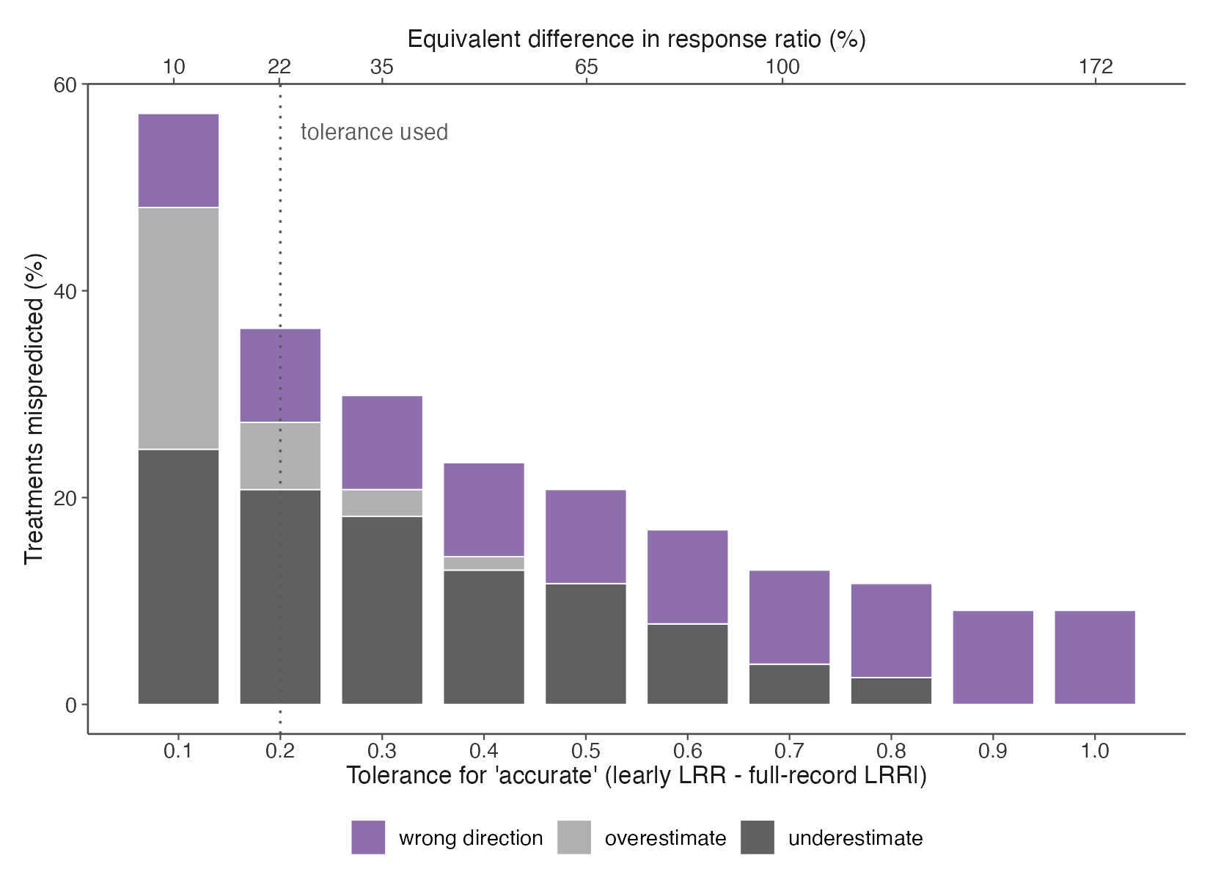
Figure S1. Sensitivity of the early-versus-full-duration classification to the tolerance used to define agreement. Bars show the percentage of the 78 treatment-experiment combinations whose three-year LRR estimate was classified as an underestimate, overestimate, or wrong-direction prediction of the full-record LRR, for tolerances from 0.1 to 1.0 (top axis: the equivalent percentage difference in the response ratio). The dotted line marks the tolerance used in the main text (0.2, ~22%). The eight wrong-direction cases (opposite signs, both |LRR| > 0.1) do not depend on the tolerance. Mispredicted treatments (of 78) at tolerances 0.1, 0.2, 0.3, 0.5, and 1.0: 43, 24, 18, 15, and 8.
Table S1. Details of the 18 case-study datasets: setting, experiment, manipulation, response variable and type, years analyzed, number of years sampled, number of analyzable treatments (in parentheses, the number screened), EDI data-package identifier, and data citation. (Workbook.)
Table S2. Per-treatment statistics for the 78 classified treatment-experiment combinations: trend class, slope, P-value and R-squared of the linear fit of the response ratio over time, coefficient of variation (CV), mean response ratio, number of timepoints, record length, early (first three calendar years) and full-duration log response ratios (LRR) with their difference and classification (accurate, underestimate, overestimate, wrong direction; tolerance 0.2), years to first detection of a significant trend (directional treatments only), the number, percentage (of consecutive measurement transitions), and years of sign flips, and the P-value and directional call when the trend analysis is repeated on the log response ratio. (Workbook.)
Table S3. SiZer results for the 74 treatment-experiment combinations with at least five timepoints: number of significant slope changes at a 5-year bandwidth, the years at which they occurred, and segment slopes with P-values. (Workbook.)

