Search use cases

**Goal: search that will always return a dataset**

The terms used in the search interface may be a subset of the entire controlled vocabulary

**Use case 1:**

Auto complete search field(s)

Autocomplete to search within all terms, not only the start of the terms

Include synonyms (non-preferred terms) in search (possibly offer user to turn it off)

Multiple search terms with ‘and’ and ‘or’

**Use case 2:**

Broaden the search

Broader (parent) term,

Related terms

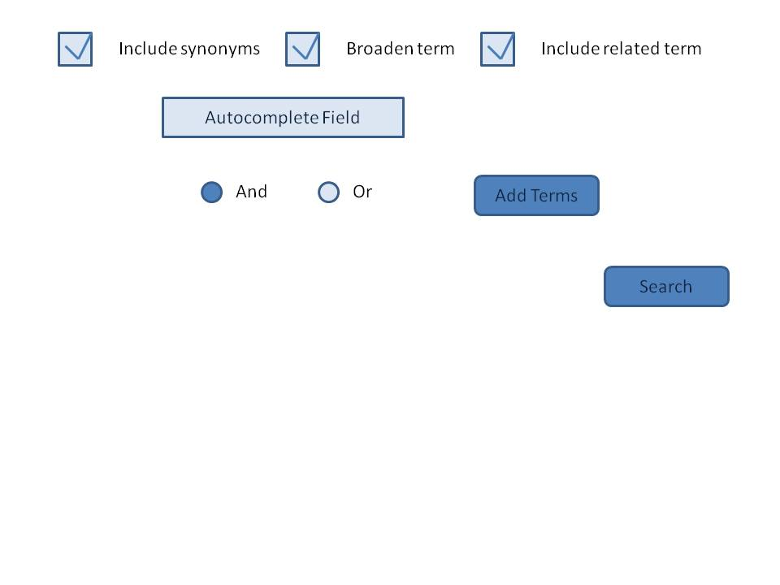

**Use case 3:**

Narrow the search

Search within the found datasets with a new term

Offered search terms should be restricted to those occurring in the datasets chosen by previous search

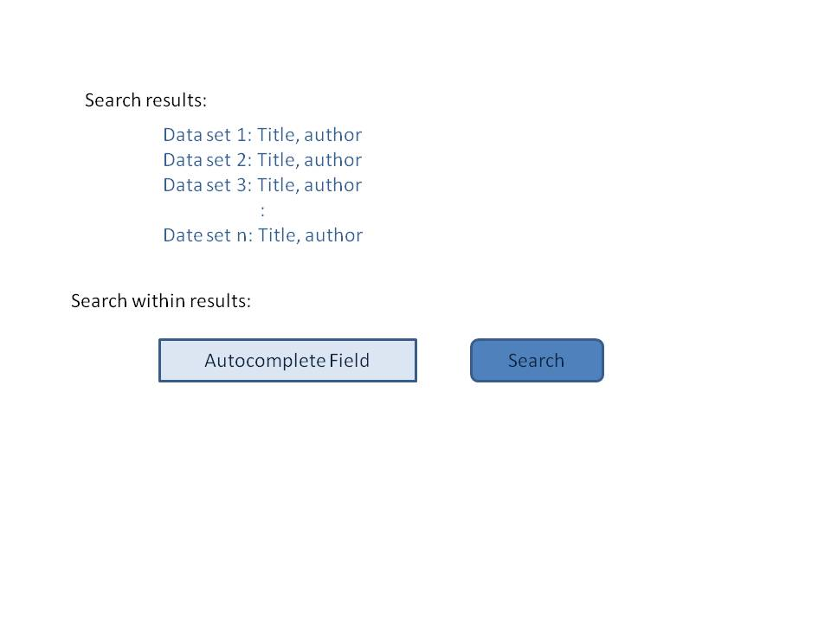

**Use case 4:**

Search on LTER core areas, signature datasets

**Use case 5:**

Browse the hierarchy tree

Open and close branches in the same window or open to different window

Show number of datasets for each search term

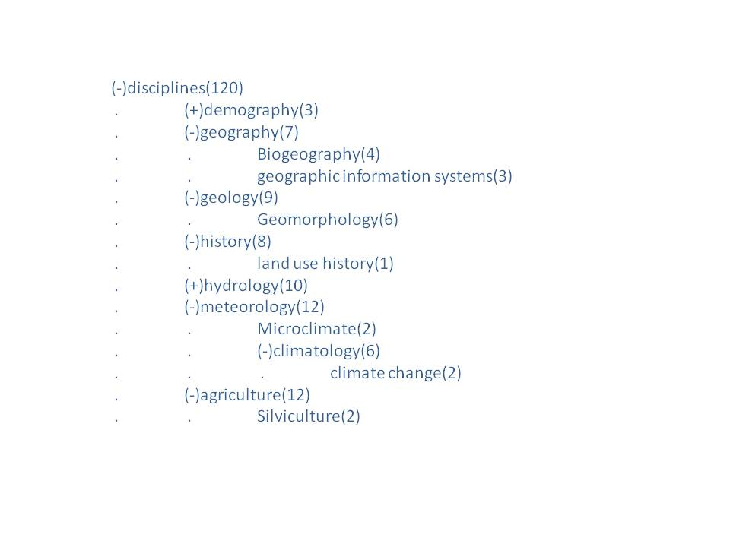

**Use case 6:**

Switch vocabulary to search to a particular site’s vocabulary