**RoomQuake 2017**

**Portals**

RoomQuake 2017 offers a set of four portals:

1. A portal for **teachers** to configure their classrooms, configure simulated earthquakes, and deliver those earthquakes according to user-defined schedules. This portal also allows the teacher to designate the current *activity* (see below). Typically, teachers access this portal using their personal computers.
2. A portal for simulated **seismographs**. Typically, 3-5 computers are distributed around the classroom.
3. A portal for **students** to submit their interpretations (readings) of seismograms associated with simulated earthquakes. Typically, students access this portal using their personal or tablet computers, or mobile phones.
4. A portal for a **public display**, which aggregates student readings and presents their (filtered) distributions and means in real time as students submit those readings. Typically, an additional computer connected to a projector or large display is used.

Access to portals for participants (teachers and students) are provided by specialized URLs:

*Teacher portal:* [*https://tinyurl.com/yalznluk*](https://tinyurl.com/yalznluk)

*Student portal:* [*https://tinyurl.com/ycspkvvs*](https://tinyurl.com/ycspkvvs)

Access to shared portals (seismograph, public display) are provided by a common URL:

*Shared portals:* [*https://tinyurl.com/ya7ouaeg*](https://tinyurl.com/ya7ouaeg)

**Activities**

RoomQuake 2017 is organized around three activities:

1. During the **planning** activity, teachers can configure the classroom and develop a *schedule* for simulated earthquakes.
2. During the **instant quake** activity, teachers can specify and deliver individual simulated earthquakes to seismographs independent of scheduled quakes. Scheduled quakes are ignored during this activity.
3. During the **scheduled quakes** activity, simulated quakes are delivered to seismographs according to the *schedule* defined during planning. Teachers can also modify the schedule during this activity; modifications take effect immediately.

**Design**

Each portal offers a number of *resources* (represented as tabs on the interface). The specific set of resources available through a portal depends on the current activity. When the teacher changes the *activity*, all portals are automatically updated to reflect the appropriate set of resources. The current activity and portal always appear at the top of the page.

Table: Resources available to each portal during different activities

|  |  |  |  |
| --- | --- | --- | --- |
|  | **planning** | **instant quakes** | **scheduled quakes** |
| **teacher** | change activity  configure room  build schedule  overview (this document) | change activity  configure room  initiate individual quakes  overview | change activity  configure room  edit schedule  overview |
| **student** | none | report readings | report readings |
| **seismograph** | none | seismograph simulator | seismograph simulator |
| **public display** | none | aggregate view | aggregate view |

**Resources**

**activity**

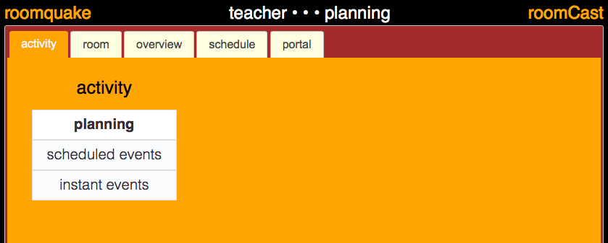

Use: Click on the activity tab to see the list of available activities (the current activity is highlighted). Clicking on an activity switches RoomQuake to that activity type and updates all portals according to the design (above).

**room (configure classroom)**

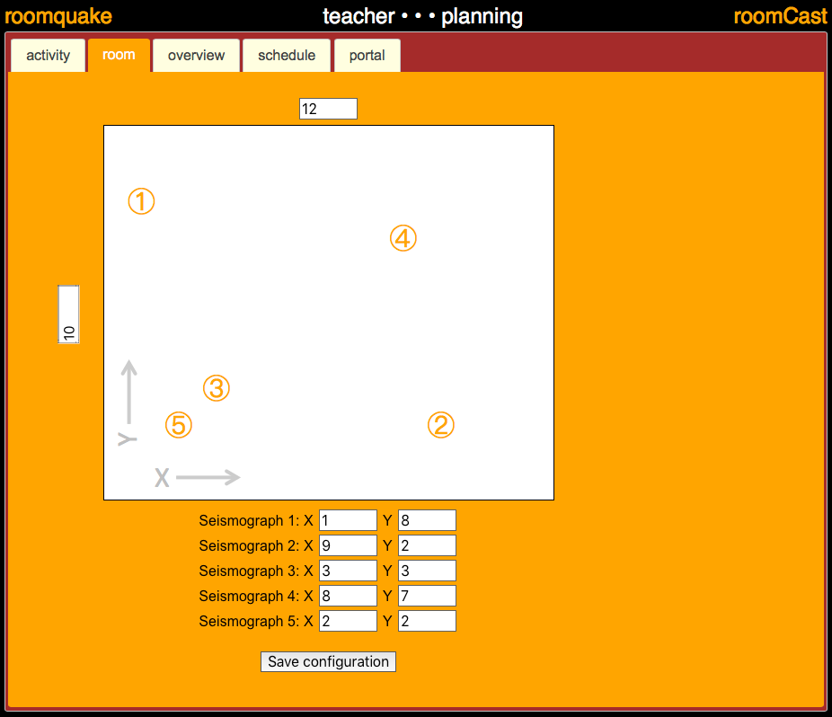

Use: All units are in *meters*. Choose a corner in your classroom to serve as the origin of your coordinate system. Click on the dimension fields (left and top) to specify the length of the room along each dimension. Position the computers that you want to serve as seismographs around the room, and measure their position within the coordinate system. Enter the coordinates of your seismograph computers by typing in the text fields below the map of the room. (You do not need to use five seismographs; simply leave the X and Y fields blank for seismographs you do not wish to use.) Click on "Save configuration" to save the room layout configuration.

**overview**

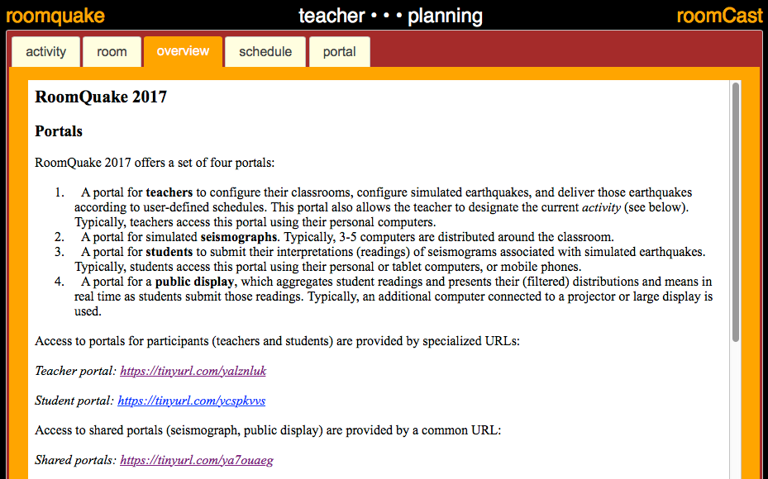

Use: A copy of this document.

**schedule**

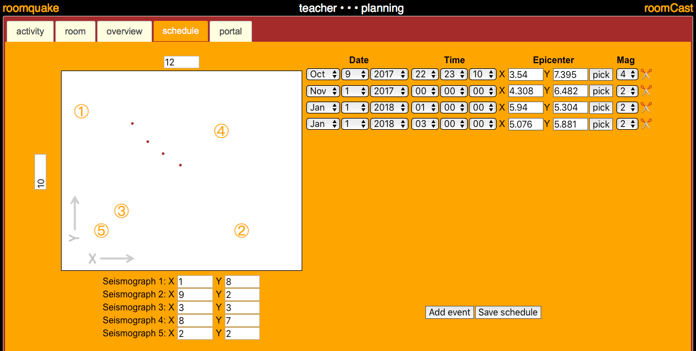

Use: This resource is used to build or edit a schedule of simulated earthquakes which will be delivered during the "scheduled quakes" activity. The "room" display (left) shows the locations of the scheduled events (brown dots). Add an event using the "Add event" button. Edit the date, time, epicenter, and magnitude of the events using pull-down menus and text fields in the block of controls in the upper right portion of the screen. Use the "scissors" icon to delete an event. (Past events are made available on the seismographs via a "scrollback" feature, and should not generally be deleted.) Click on "pick" to select an event; you may then click on the room map to choose an epicenter. Click on "Save schedule" to save or update the schedule; saved changes take place immediately.

**portal (select a new portal)**

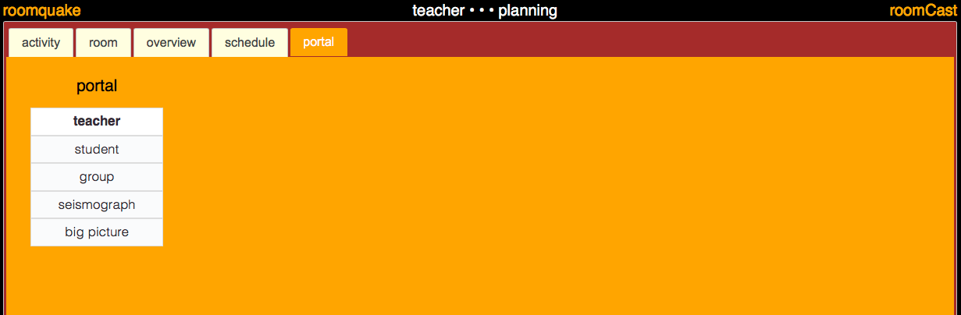

Use: The portal tab allows you to select a different portal for use. When you are using the teacher portal, you have access to all other portals (this is to allow teachers to preview what the other portals will look like directly on their computers). When you use other portals, the list of available portals that you can choose are limited.

**instant (individual simulated earthquakes)**

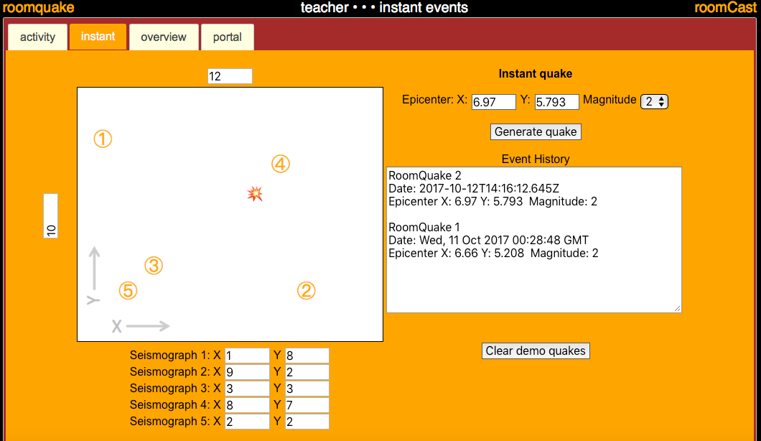

Use: Generate an individual simulated earthquake. Choose an epicenter by typing in the Epicenter X and Y fields (upper right) or by clicking on the room map (an ‘explosion’ symbol will designate the location of the selected epicenter). Select the desired magnitude from the pulldown menu. Click the "Generate quake" button to initiate the simulated event and send it to the classroom seismographs. The "Event History" list shows the list of "instant quakes" that have been generated and are available through the "scrollback" feature on the seismographs. Click the "Clear demo quakes" to erase that list and make those prior quakes unavailable through the scrollback feature.

**readings (submit estimates of event parameters)**

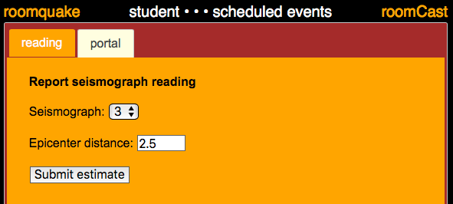

Use: Used by students to submit estimates of event parameters based on their interpretations of simulated seismograms. Select seismograph for which you are reporting, and fill in the fields to construct your estimate. Click "Submit estimate" to send add estimate to aggregate resource (usually shown on the "big picture" display).

**aggregate**

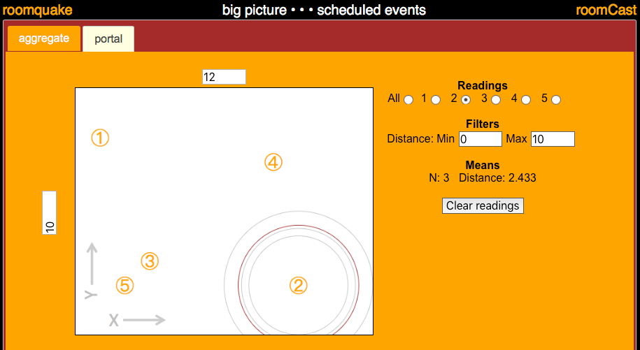

Use: Real-time display reflecting student estimated readings of event parameters. Map displays concentric circles around selected seismographs reflecting student estimates of event distance (gray), and a red circle representing the mean of all student estimates. Use distance filters (one for each seismograph) to remove outliers (this is this is particularly helpful for addressing student input errors). Clear all reading (and start over) by clicking the "Clear readings" button.

Last update: October 12, 2017