**Watershed**

|  |  |  |  |  |  |  |
| --- | --- | --- | --- | --- | --- | --- |
| USGS | Fixed Station | Fraction (-) | | | | Area (ha) |
| FLC | ULC | GLC | ALC |
| 03275600 | GMW070-0006 | 0.1637 | 0.166 | 0.1129 | 0.5517 | 52002.0 |
| 03330241 | WTI010-0001 | 0.1590 | 0.0806 | 0.0255 | 0.6134 | 12905.8 |
| 03327500 | WUW160-0006 | 0.0845 | 0.0962 | 0.0416 | 0.7568 | 707649.0 |
| 04183000 | LEM010-0014 | 0.0869 | 0.1200 | 0.1176 | 0.6224 | 493268.3 |
| 03357500 | WWE040-0001 | 0.2248 | 0.0617 | 0.1015 | 0.6061 | 84825.5 |
| 03302800 | OBS140-0004 | 0.3626 | 0.0602 | 0.3492 | 0.2254 | 73934.9 |
| 03358000 | WWE060-0002 | 0.1445 | 0.0571 | 0.0891 | 0.7068 | 63410.6 |
| 03325500 | WMI020-0002 | 0.0503 | 0.0669 | 0.0349 | 0.8446 | 33549.8 |
| 03369500 | WEM070-0001 | 0.4441 | 0.0490 | 0.0838 | 0.4178 | 51403.5 |
| 03342500 | WBU160-0002 | 0.3329 | 0.0720 | 0.0769 | 0.4848 | 59427.4 |
| 03328500 | WAE070-0011 | 0.1003 | 0.0700 | 0.0489 | 0.7648 | 203474.9 |
| 03348000 | WWU030-0003 | 0.0761 | 0.1555 | 0.0619 | 0.6941 | 105339.2 |
| 03353500 | WWU120-0002 | 0.0789 | 0.2009 | 0.0997 | 0.5984 | 44669.7 |
| 03351500 | WWU100-0001 | 0.0669 | 0.1176 | 0.0677 | 0.7412 | 43142.5 |
| 03329700 | WDE050-0002 | 0.0369 | 0.0671 | 0.0268 | 0.8648 | 71715.7 |

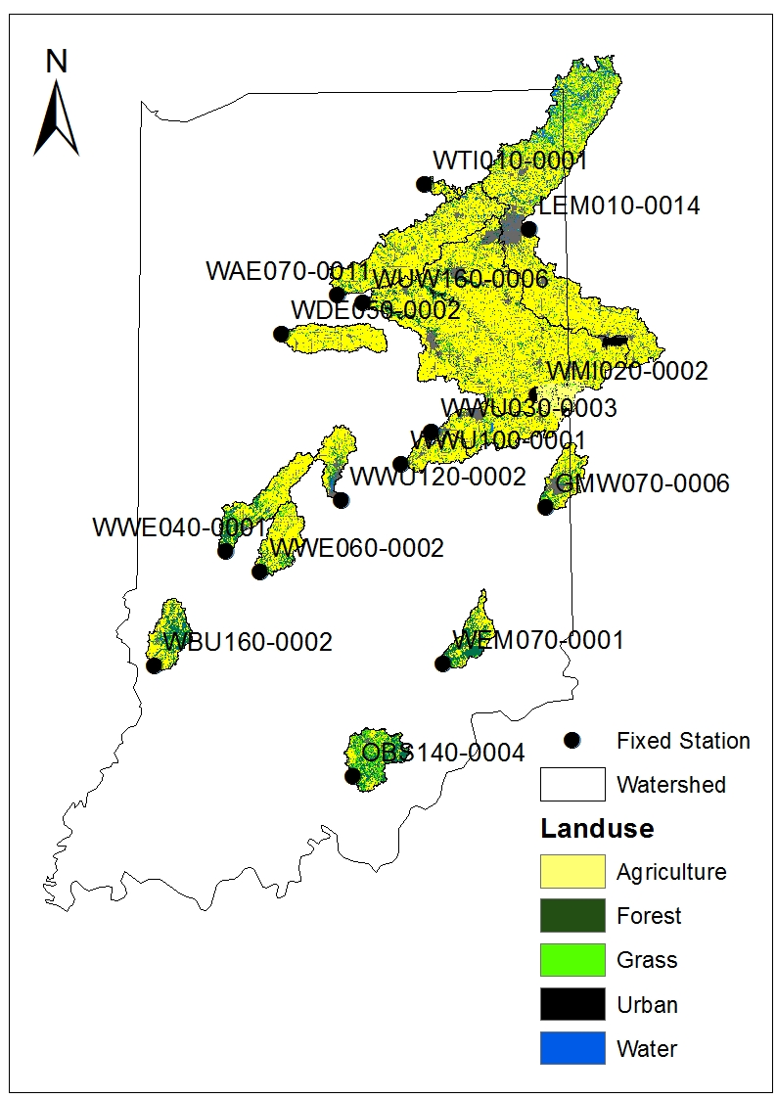

Calibration Period: 1991. 01. 01. – 2000. 12. 31.

Validation Period: 2001. 01. 01. – 2010. 12. 31.

|  |  |  |  |  |  |  |  |  |  |  |  |  |  |  |
| --- | --- | --- | --- | --- | --- | --- | --- | --- | --- | --- | --- | --- | --- | --- |
| USGS | Fixed Station | FLC | ULC | GLC | ALC | Area (ha) | Flow (cms) | | Sediment (ton/yr) | | Phosphorus (ton/yr) | | Nitrogen (ton/yr) | |
| Cal. | Val. | Cal. | Val. | Cal. | Val. | Cal. | Val. |
| 03275600 | GMW070-0006 | 0.1637 | 0.1660 | 0.1129 | 0.5517 | 52002 | 6.2 | 8.1 | 6197 | 8713 | 29251 | 40333 | 676052 | 863800 |
| 03330241 | WTI010-0001 | 0.1590 | 0.0806 | 0.0255 | 0.6134 | 12906 | 1.3 | 1.4 | 225 | 247 | 1631 | 1829 | 38057 | 41284 |
| 03327500 | WUW160-0006 | 0.0845 | 0.0962 | 0.0416 | 0.7568 | 707649 | 74.8 | 88.3 | 175587 | 229142 | 860572 | 1023048 | 10254895 | 12391004 |
| 04183000 | LEM010-0014 | 0.0869 | 0.1200 | 0.1176 | 0.6224 | 493268 | 55.1 | 62.8 | 148571 | 179825 | 652051 | 748633 | 7245372 | 8206456 |
| 03357500 | WWE040-0001 | 0.2248 | 0.0617 | 0.1015 | 0.6061 | 84826 | 9.4 | 13.8 | 18322 | 28805 | 52532 | 74053 | 1229360 | 1771259 |
| 03302800 | OBS140-0004 | 0.3626 | 0.0602 | 0.3492 | 0.2254 | 73935 | 8.9 | 11.2 | 7725 | 10038 | 81373 | 92382 | 683329 | 879441 |
| 03358000 | WWE060-0002 | 0.1445 | 0.0571 | 0.0891 | 0.7068 | 63411 | 7.9 | 9.7 | 13395 | 16900 | 62859 | 75795 | 1123027 | 1358407 |
| 03325500 | WMI020-0002 | 0.0503 | 0.0669 | 0.0349 | 0.8446 | 33550 | 3.7 | 4.8 | 9414 | 13147 | 78251 | 111483 | 506880 | 672028 |
| 03369500 | WEM070-0001 | 0.4441 | 0.0490 | 0.0838 | 0.4178 | 51404 | 6.9 | 7.6 | 10429 | 11562 | 68948 | 74910 | 329296 | 361356 |
| 03342500 | WBU160-0002 | 0.3329 | 0.0720 | 0.0769 | 0.4848 | 59427 | 6.8 | 7.7 | 20300 | 23697 | 64140 | 87049 | 207520 | 222116 |
| 03328500 | WAE070-0011 | 0.1003 | 0.0700 | 0.0489 | 0.7648 | 2034745 | 23.7 | 25.0 | 59678 | 69446 | 368900 | 386216 | 2974436 | 3192826 |
| 03348000 | WWU030-0003 | 0.0761 | 0.1555 | 0.0619 | 0.6941 | 105339 | 15.7 | 16.1 | 37312 | 38054 | 214650 | 185039 | 1433003 | 1438376 |
| 03353500 | WWU120-0002 | 0.0789 | 0.2009 | 0.0997 | 0.5984 | 44670 | 4.1 | 5.9 | 2757 | 3986 | 16648 | 23809 | 272065 | 382306 |
| 03351500 | WWU100-0001 | 0.0669 | 0.1176 | 0.0677 | 0.7412 | 43142 | 5.0 | 7.0 | 5133 | 8261 | 25208 | 34398 | 516588 | 719789 |
| 03329700 | WDE050-0002 | 0.0369 | 0.0671 | 0.0268 | 0.8648 | 71716 | 7.3 | 8.4 | 13358 | 17427 | 124298 | 146759 | 1310403 | 1545222 |

**Process Description**

**Current Work Finished:**

1. Fifteen streamflow data from USGS were separated by Eckhardt filter equation (WHAT).
2. Both annual runoff depth (mm/ha/year) and baseflow (mm/ha/year) were computed.
3. Optimization program (SCE) was executed for annual runoff and baseflow. In other words, the parameters in following pages (R1~R4 and B1~B4) were optimized separately for annual runoff and baseflow.

**Potential Next Step:**

* Water quality data from the Fixed Station are for streamflow, neither for runoff nor for baseflow.
* The pollutant coefficients (sediment, nitrogen, and phosphorus) need to be computed based on streamflow.
* Annual streamflow depth is sum of annual runoff and baseflow, annual streamflow from each landuse can be calculated by sum of the parameters. For instance, annual streamflow from forest (FLC) is sum of *R1* for annual runoff and *B1* for annual baseflow.
* If this is reasonable, I will proceed like this:  
  L = [ X1 ∙ FLC ∙ (*R1*+*B1*) +  
   X2 ∙ ULC ∙ (*R2*+*B2*)+  
   X3 ∙ GLC ∙ (*R3*+*B3*)+   
   X4 ∙ ALC ∙ (*R4*+*B4*) ] ∙ AREA ∙ C  
  Where, L is annual load (sediment, nitrogen, or phosphorus), X is parameter to calibrate, FLC is fraction of forest, ULC is fraction of urban, GLC is fraction of grass, ALC is fraction of agriculture, AREA is watershed area, C is unit conversion factor to ton per year, and R is annual runoff depth, and B is annual baseflow depth.

**Annual Runoff**

$$R=\left(R_{1}∙FLC+ R_{2}∙ULC+ R_{3}∙GLC+ R_{4}∙ALC\right)∙AREA∙C$$

R: average annual runoff (cubic meter per second, cms)

FLC: fraction of forest (-)

ULC: fraction of urban (-)

GLC: fraction of glass (-)

ALC: fraction of agriculture (-)

AREA: watershed area (ha)

R1: annual runoff depth from forest (60.6 mm)

R2: annual runoff depth from urban (120.5 mm)

R3: annual runoff depth from grass (71.0 mm)

R4: annual runoff depth from agriculture (61.8 mm)

C: unit conversion factor, (=0.001 * 10000 / 365 / 86400)

Calibration

* Period: 1991-2000
* NSE: 0.9971
* R2: 0.9973

Validation

* Period: 2001-2010
* NSE: 0.9541
* R2: 0.9986

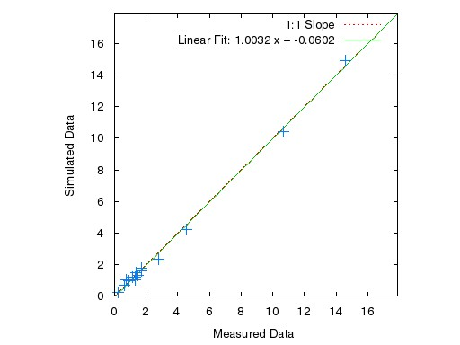

Calibration

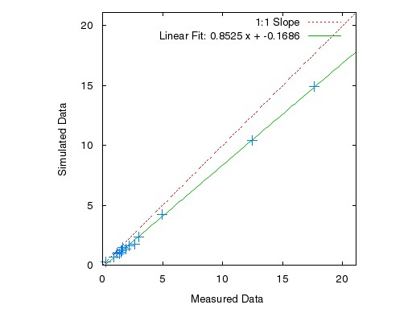

Validation

**Annual Baseflow**

$$B=\left(B_{1}∙FLC+ B_{2}∙ULC+ B_{3}∙GLC+ B_{4}∙ALC\right)∙AREA∙C$$

B: average annual baseflow (cubic meter per second, cms)

FLC: fraction of forest (-)

ULC: fraction of urban (-)

GLC: fraction of glass (-)

ALC: fraction of agriculture (-)

AREA: watershed area (ha)

B1: annual baseflow depth from forest (265.4 mm)

B2: annual baseflow depth from urban (92.2 mm)

B3: annual baseflow depth from grass (286.7 mm)

B4: annual baseflow depth from agriculture (318.6 mm)

C: unit conversion factor, (=0.001 * 10000 / 365 / 86400)

Calibration

* Period: 1991-2000
* NSE: 0.9903
* R2: 0.9918

Validation

* Period: 2001-2010
* NSE: 0.9672
* R2: 0.9951

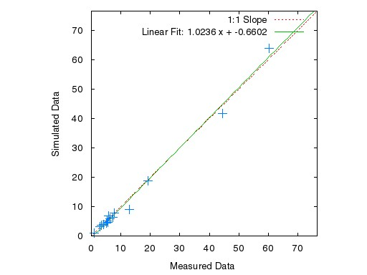

Calibration

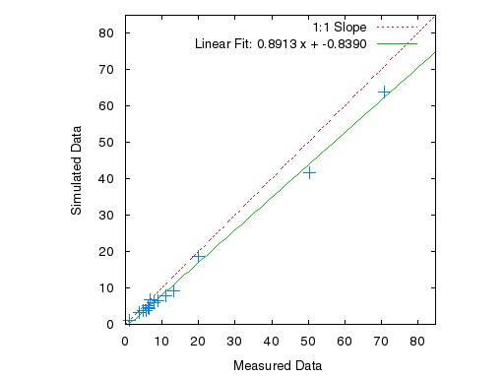

Validation

**Annual Streamflow**

$$Q=\left((R_{1}+B_{1})∙FLC+ (R_{2}+B_{2})∙ULC+ (R_{3}+B_{3})∙GLC+ (R_{4}+B_{4})∙ALC\right)∙AREA∙C$$

Q: average annual streamflow (cubic meter per second, cms)

FLC: fraction of forest (-)

ULC: fraction of urban (-)

GLC: fraction of glass (-)

ALC: fraction of agriculture (-)

AREA: watershed area (ha)

C: unit conversion factor, (=0.001 * 10000 / 365 / 86400)

**Note**: There was no optimization process here. Average annual streamflow were computed using the calibrated average annual runoff and baseflow (the equation above).

Calibration

* Period: 1991-2000
* NSE: 0.9923
* R2: 0.9934

Validation

* Period: 2001-2010
* NSE: 0.9647
* R2: 0.9967

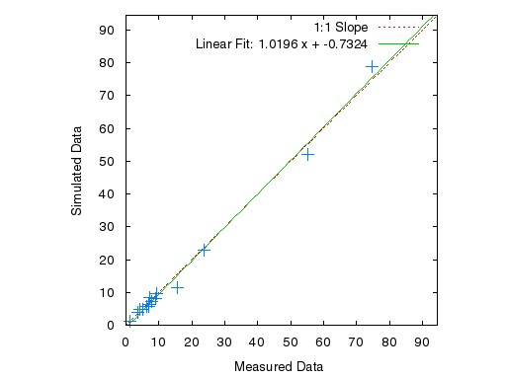

Calibration

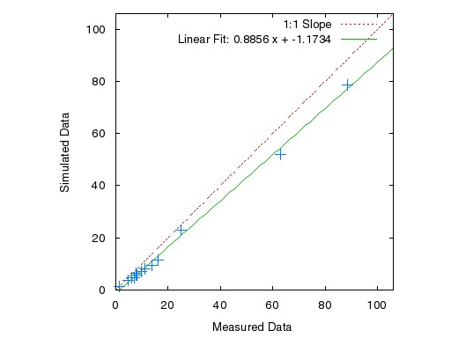

Validation

Followings need to be updated

After flow optimization processes are done

**Sediment**

$$L=\left(X_{1}∙FLC∙Q_{FLC}+ X_{2}∙ULC∙Q_{ULC}+ X_{3}∙GLC∙Q_{GLC}+ X_{4}∙ALC∙Q_{ARC}\right)∙AREA∙C$$

L: sediment load (kg)

FLC: fraction of forest (-)

ULC: fraction of urban (-)

GLC: fraction of glass (-)

ALC: fraction of agricultural area (-)

QFLC: flow depth from forest (391.09 mm)

QULC: flow depth from urban (303.71 mm)

QGLC: flow depth from grass (480.32 mm)

QALC: flow depth from agriculture (335.82 mm)

AREA: watershed area (ha)

X1: sediment concentration from forest (56.29 mg/l)

X2: sediment concentration from urban (90.48 mg/l)

X3: sediment concentration from grass (91.13 mg/l)

X4: sediment concentration from agriculture (76.70 mg/l)

C: unit conversion factor, (=0.001 * 10000 * 1000 / 1000000)

Calibration

* Period: 1991-2000
* NSE: 0.9740 (0.7937 for small 13 values)
* R2: 0.9771 (0.8541 for small 13 values)

Validation

* Period: 2001-2010
* NSE: 0.9164 (0.8027 for small 13 values)
* R2: 0.9886 (0.8759 for small 13 values)

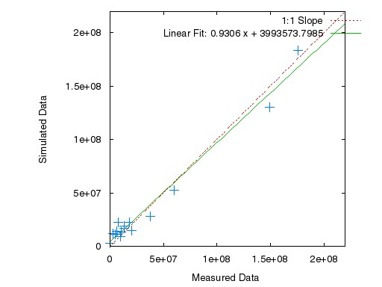

Calibration

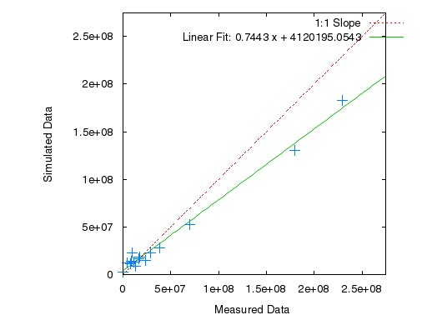

Validation

**Phosphorus**

$$L=\left(X_{1}∙FLC∙Q_{FLC}+ X_{2}∙ULC∙Q_{ULC}+ X_{3}∙GLC∙Q_{GLC}+ X_{4}∙ALC∙Q_{ARC}\right)∙AREA∙C$$

L: sediment load (kg)

FLC: fraction of forest (-)

ULC: fraction of urban (-)

GLC: fraction of glass (-)

ALC: fraction of agricultural area (-)

QFLC: flow depth from forest (391.09 mm)

QULC: flow depth from urban (303.71 mm)

QGLC: flow depth from grass (480.32 mm)

QALC: flow depth from agriculture (335.82 mm)

AREA: watershed area (ha)

X1: sediment concentration from forest (0.06 mg/l)

X2: sediment concentration from urban (0.26 mg/l)

X3: sediment concentration from grass (0.45 mg/l)

X4: sediment concentration from agriculture (0.42 mg/l)

C: unit conversion factor, (=0.001 * 10000 * 1000 / 1000000)

Calibration

* Period: 1991-2000
* NSE: 0.9676 (0.7748 for small 13 values)
* R2: 0.9679 (0.8848 for small 13 values)

Validation

* Period: 2001-2010
* NSE: 0.9518 (0.7496 for small 13 values)
* R2: 0.9834 (0.8851 for small 13 values)

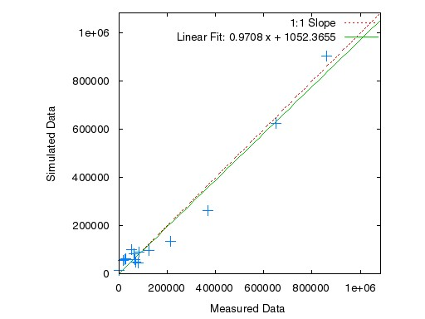

Calibration

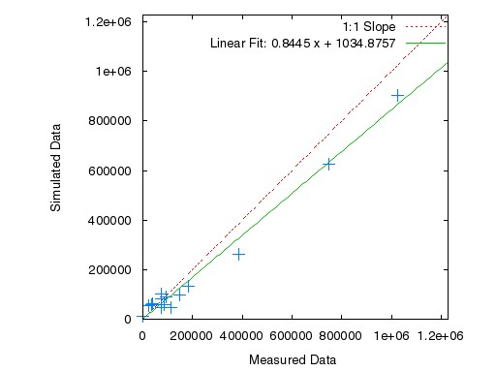

Validation

**Nitrogen**

$$L=\left(X_{1}∙FLC∙Q_{FLC}+ X_{2}∙ULC∙Q_{ULC}+ X_{3}∙GLC∙Q_{GLC}+ X_{4}∙ALC∙Q_{ARC}\right)∙AREA∙C$$

L: sediment load (kg)

FLC: fraction of forest (-)

ULC: fraction of urban (-)

GLC: fraction of glass (-)

ALC: fraction of agricultural area (-)

QFLC: flow depth from forest (391.09 mm)

QULC: flow depth from urban (303.71 mm)

QGLC: flow depth from grass (480.32 mm)

QALC: flow depth from agriculture (335.82 mm)

AREA: watershed area (ha)

X1: sediment concentration from forest (0.42 mg/l)

X2: sediment concentration from urban (4.12 mg/l)

X3: sediment concentration from grass (3.73 mg/l)

X4: sediment concentration from agriculture (5.05 mg/l)

C: unit conversion factor, (=0.001 * 10000 * 1000 / 1000000)

Calibration

* Period: 1991-2000
* NSE: 0.9944 (0.9648 for small 13 values)
* R2: 0.9954 (0.9937 for small 13 values)

Validation

* Period: 2001-2010
* NSE: 0.9252 (0.8646 for small 13 values)
* R2: 0.9440 (0.8810 for small 13 values)

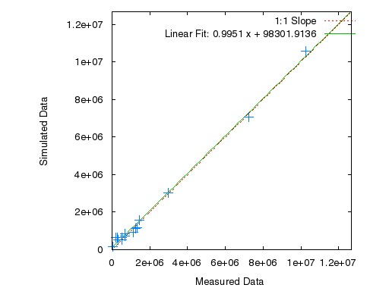

Calibration

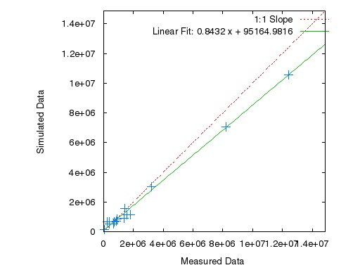

Validation