Author | Jian,Xu (NSB - CN/Hangzhou)
Owner | Jian,Xu (NSB - CN/Hangzhou)
Organization | MN BB HW3
Approver | TypeNameHere
Document ID | TypeIDHere
Document location | TypeDocLocationHere
Change History
Version | Status | Date | Author | Owner | Reviewed by | Reviewed date | Approver | Approval date | Description of changes
0.1 | Draft | DD-MM-YYYY | YourNameHere | YourNameHere | YourNameHere | DD-MM-YYYY | YourNameHere | DD-MM-YYYY | TypeYourCommentsHere
0.2 | Draft | DD-MM-YYYY | YourNameHere | YourNameHere | YourNameHere | DD-MM-YYYY | YourNameHere | DD-MM-YYYY | TypeYourCommentsHere
1.0 | Approved | DD-MM-YYYY | YourNameHere | YourNameHere | YourNameHere | DD-MM-YYYY | YourNameHere | DD-MM-YYYY | TypeYourCommentsHere

ASOE Hardware Architecture and Implementation Specification
ASOE Top level HW Architecture & HW Implementation Specification

Contents
1 How to use this template 3
1.1 Scope 3
1.2 Subtitle 3
1.2.1 Further subtitle 3
2 Second title 3
2.1 Second subtitle 3
3 Third title 3
3.1 Third subtitle 3

Scope
The purpose of this document is to specify the Hardware Architecture and the HW Implementation of the ASOE product.
Further Implementation details of the sub blocks and sub functions are available in HW Implementation and HW-SW interface specifications of these sub blocks and sub functions.
This document is done according to AirScale SM-r6 product concept, AirScale SM-r6 product definition and AirScale SM-r6 product architecture documents.

The main reasons for the development of ASOE are:
- HW technology for LTE/5G including concurrent mode
- Functional enhancements compared to current AirScale SM platform including massive MIMO
- Retain compatibility with existing AirScale system module platform.
- Fronthaul support for OBSAI, CPRI and eCPRI (Ethernet based) with up to 25Gbps.
- Development based on
  - One Nokia Reef Shark SoC Technology with Intel
  - Two Loki L1 SoCs Technology from Marvell
- Reduced BB footprint & power/capacity ratio Scope

Introduction
ASOE is fully integrated core unit which is common HW for indoor and outdoor deployments. .
Supported RATs: 4G, 5G. HW ready for 2G
Main functions: ASOE Core unit is active cooled indoor/outdoor unit. It is able handle all the system module functions: TRS, M-,C- and U-plane processing.

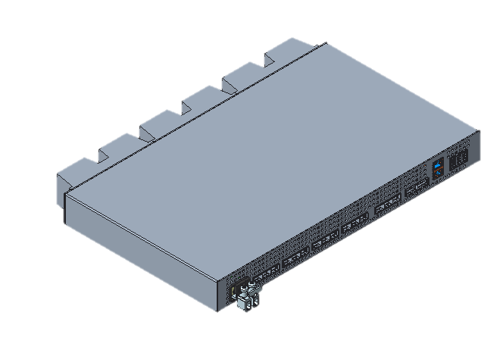
Figure 1 ASOE Indoor Unit (Update)

Figure 2 ASOE Outdoor Unit (Update)
The folllowing ASOE Block Diagram is a copy from the Error! Reference source not found. AirScale_SM_Product_Concept which gives a high level overview:
Figure 3 ASOE high level Block Diagram（update 9 SFPs->12 SFPs，TBD with SM_product concept）

HW Architecture Overview
The ASOE extension unit is based on the ASPD board with additional eMech parts (see chapter Error! Reference source not found.).

ASOE Architectural Diagrams
The Visio sources for the ASOE architectural diagrams can be found here: Error! Reference source not found.
The diagrams of the ASOE. are shown below Figure 4 ASOE Architectural Diagram (TBD)
Detailed comparison of the different versions of the ASOE can be found in (TBD)

ASOE Major Components
- Construction and key components
  - Core unit, includes functions for common and capacity units
  - Two power groups, Loki-B block can be powered down. In this case associated RF interfaces (RF7…12) are not usable.
  - 1 x Snowfish 24cx (with switch) processing environment for TRS/OAM/L3/L2 processing with HW accelerators
- Atom 2.2GHz cores (24pcs)
- 24GB DDR4-2933 SDRAM, dual-rank with 2 channels

  - 2x Marvell CNF95xxN “Loki” SoC with 8GB+ECC DDR4/Loki
- 16x XC4500 Ceva DSP cores 1.1GHz per Loki
- 8GB DDR4-2933, single-rank with 2 channels

  - Pseudo eUSB Flash 14GB SW usable size, 2x Boot Flash (512+128Mbit)
(Such content TBD)
- BMUXO external Flash for Golden, Update image, SPD content, device tree
- OIP internal Flash for Update Image
- SNF KGI / CI / KB Flashes
- LokiA 2 Flashes for (FW+U-Boot)
Inventory Flash
- LokiB 2 Flashes for (FW+U-Boot)
Inventory Flash
- NIC Configuration Flash
- MPLL EEPROM
- PEX Configuration Flash
- PCO Configuration Flash

ASOE Interfaces
ASOE has four main interfaces:
- Frontpanel Interfaces
  - 12 x RF SFP28 interfaces, max 25G. Support OBSAI/CPRI/Ethernet modes.
  - 2 x TRS SFP28 interfaces, 1/10/25G Ethernet with MACSec
  - 1 x 1000BASE-T TRS interface, 1G Ethernet
  - Support 802.3at PoE up to 15W (TBD)
  - 1 x System Extension Interface (SEI) SFP28, 10/25GE with MACSec
  - External Alarms, Sync OUT, Sync IN, 1GE Local Management Port
  - -48V DC input

- FAN interface
  - Single pluggable interface for easy FAN assembly change
  - 12V FAN

- Board internal interfaces
  - PCIe control to Sync FPGA. SFP low-speed controls + I2C from FPGA or separate PLD
  - 4 x 25GE for Loki-SNF, 3 for L2 data+control and 1 for L1
  - 3 x 25GE inter-Loki links
  - All internal data can be routed via SNF switch to SEI port

- Test interfaces on PROTO ASPD boards for SNF and LOKI debugging based on (TBD)
  - HE-10 (RS232/UART),
  - ERF6 CONN with 40 pins (PCIe),
  - USB-C (USB2.0/USB3.0),
  - USB-C (UART/SGMII)
  - HE-10 (JTAG)
  - MIPI10 (JTAG for LOKI Lauterbach probe)
NOTE: Test Connectors will not be available on customer boards.

Basic functional block architecture

Ethernet topology

Figure 5 ASOE Ethernet topology
SNF is connected to each Loki via 4 high speed lanes:
SNF lane | Signal name on Top Level | Loki | Signal name within Loki block | Lane of Loki
PHY1.4 NAC LP12 | 1025GE_1 | Loki A | LANE_0 | GSERC0.3
PHY1.5 NAC LP13 | 1025GE_2 |  | LANE_1 | GSERR0.2
PHY1.6 NAC LP14 | 1025GE_3 |  | LANE_2 | GSERR0.1
PHY1.7 NAC LP15 | 1025GE_4 |  | GSERC4_LANE_1 | GSERC4.1
PHY2.0 NAC LP16 | 1025GE_1 | Loki B | LANE_0 | GSERC0.3
PHY2.1 NAC LP17 | 1025GE_2 |  | LANE_1 | GSERR0.2
PHY2.2 NAC LP18 | 1025GE_3 |  | LANE_2 | GSERR0.1
PHY2.3 NAC LP19 | 1025GE_4 |  | GSERC4_LANE_1 | GSERC4.1
Table 1 SNF lanes between SNF and LokiA and between SNF and LokiB

Synchronization topology(TBD)
Figure 6 ASOE synchronization topology

With this SM-RM point-to-point connection use case, ASOE is sync master to RU. ASOE supports sync via Ethernet fronthaul(IEEE1588 plus SynceE) but no SyncE ITU-T compliance, The frequency sync source is not from SyncE domain but from BTS domain. T-BC domain is also not required, BTS domain provides IEEE1588 time sync for Ethernet fronthaul.
Conventional CPRI fronthaul sync is also supported from BTS domain.

ASOE synchronization topology is illustrated in figure 12.
The Sync sources can be:
- ToD/PPS from external GNSS receiver
- ToP / IEEE1588 from backhaul
- SyncE from backhaul
- Time/Frequency reference from SYNC IN port
The BTS frequency synchronization function is composed of the main functional blocks: phase/frequency measurement, the OCXO and the FLL/PLL algorithm running in SW which tunes the OCXO.
The clock reference inputs are fed to the central BTS frequency synchronization function. One of the reference signals is selected as active reference source for frequency synchronization.
In case of time/phase synchronization, the selected time/phase reference input is used for BTS time/phase synchronization and can be used also for BTS frequency synchronization.
RP1 clock & RP1 burst to Loki for internal frequency/phase/time sync(BCN forwarding).
With AirScale a central SyncE EEC function is implemented.
- SyncE recovered clock from FH to SyncE cleaner and distribution block
- SyncE transmit clock from SyncE cleaner and distribution block to each FH port located in Lodin L1 FPGA.
BTS domain time/phase distribution path
Control and Timing block BTS domain RP1 burst Loki BTS domain SW BCN forwarding Loki PTP domain Ethernet FH
BTS domain frequency distribution path
Control and Timing block BTS domain RP1 clock Loki BTS domain/ PTP domain/Serdes Ethernet FH
ASOE (FH port) timing accuracy target:
100ns(OTDOA)/700ns(5G LB)/1.34us(5G HB) minus RU and fiber path accuracy margins

I2C topology
Figure 7 ASOE I2C topology

ASOE I2C block is referenced partly from ASIL and ABIO designs:
1, Snowfish part is mainly coming from ASIL with one I2C mux removed as less I2C slaves on ASOE against ASIL;
2,Loki part is almost the same as ABIO I2C desgin.

Power management
ASOE is integrated core system module designed to operate with the Telecom DC voltage range (36VDC-60VDC) input without any adjustion.
ASOE maximum power consumption is estimated to be XXXW (TBD) this value includes FANs, optical modules power and PSU power loss.

Temperature management
Temperature management is a feature that takes care of system level temperature management that consists:
• Temperature readings
• Speed adjustment of cooling FANs
• Overheating protection
• QSFP+ temperature control and protection

External Interface and connectivity
All external interfaces locate on frontpanel:
- 12 x RF SFP28 interfaces, max 25G. Support OBSAI/CPRI/Ethernet modes.
- 2 x TRS SFP28 interfaces, 1/10/25G Ethernet with MACSec
- 1 x 1000BASE-T TRS interface, 1G Ethernet
  - Support 802.3at PoE up to 15W (TBD)
- 1 x System Extension Interface (SEI) SFP28, 10/25GE with MACSec
- External Alarms, Sync OUT, Sync IN, 1GE Local Management Port
- -48V DC input

3 HDMI based ports are classified as type 3a per GR-1089, All other ports are classified as type 2 or 4 per GR-1089, this implies weak surge protection and ports shall work inside same LPZ zone. As outdoor installation position is same as radio on pole/mast and the interface connection crosses LPZ zone, optical connection and external surge protection device must be adapted.

SFP/QSFP & cable/fiber

Fronthual conectivity purpose
A complete list of fronthaul module device is as below.
Table 1 ASOE fronthaul device list (TBD)
Application | Type & Spec | SI code | Product code | Description
SFP28 Fronthaul | SFP28 25Gbase-SR | 474900A | P462265 | AOMC SFP28 70m MM I-temp RS
SFP28 Fronthaul | SFP28 25Gbase-LR | 474902A | P462270 | AOSD SFP28 10Km SM I-temp RS

Optical module (TBD)
SFP28 25Gbase-SR module is used on both ASOE and radio, This is an I-temperature grade SFP28 optical module with rate selection(25G/10G). It supports 70m OM3 MM fiber or 100m OM4 MM fiber.
SFP28 25Gbase-LR module is also used on both ASOE and radio, This is an I-temperature grade SFP28 optical module with rate selection(25G/10G). It supports 10km SM fiber.

Fiber
To mate SFP28 module, there’re OD LC-LC OM3 MM fibers with various length options. Nokia code is TBD. Connector type is LC for both ends. IP protection is provided by OCTIS at ASOE end and R2CT at radio end.

Backhaul connectivity purpose(TBD)
ASOE has various backhual interface type by support from various modules.
A complete list of backhaul module device is as below.
Table 2 ASOE backhaul device list (TBD)
Application | Type & Spec | SI code | Product code | Description
SFP+ backhaul | SFP+ 10Gbase-SR | 473471A | P206937 | FOTA Optical SFP+ 10GBase-SR 850nm MM
SFP+ backhaul | SFP+ 10Gbase-LR | 473472A | P206994 | FOTB Optical SFP+ 10GBase-LR 1310nm SM
SFP+ backhaul | SFP+ 10G 30km BiDi 15dB | 475344A |  | AOXG 10G SFP+ 1330/1270nm 30km SM I
SFP+ backhaul | SFP+ 10G 30km BiDi 15dB | 475345A |  | AOXH 10G SFP+ 1270/1330nm 30km SM I

Optical module
ASOE backhaul supports optical connection only. 4 types of SFP+/SFP28 module can be used.
10Gbase-SR
10Gbase-SR SFP+ module supports backhaul connection over OM3 MM fiber up to 300m length. An I-temperature grade module FOTA is used.

10Gbase-LR
10Gbase-LR SFP+ module supports backhaul connection over dual core SM(G.652) fiber up to 10km length. An I-temperature grade module FOTB is used.

10G BiDi 30km SFP+
This 10G SFP+ module supports backhual connection over single core SM(G.652) fiber up to 30km, also to save fiber resource, Two I-temperature grade BiDi SFP+ modules will be used and they are counterpart to each other.
AOXG works at 1330 TX wavelength and 1270 RX wavelength.
AOXH works at 1270 TX wavelength and 1330 RX wavelength.
The total link power loss budget of AOXG/AOXH is 15dB.

Fiber
There’s no fiber defined for backhaul connection to CU. Two exsisting short length fibers will be used for TRS chaining and SEI chaining.
FUFAS MM OD fiber LC OD-LC OD dual 2m OM2, Nokia code is 473288A
FUFAR MM OD fiber LC OD-LC OD dual 5m OM2, Nokia code is 473287A
IP protection is provided by OCTIS at both ends.

SEI connectivity purpose
ASOE SEI port only uses 10Gbase-SR optical module. The 10Gbase-SR Module and short length MM fiber are same as backhaul port.

1GE Electrical transport interface (1000BASE-T) and LMP
Interface definition according to BCAI Link layer architecture specification, interface 1GE Electrical interface (1000BASE-T), see reference.
There is 1 pcs 1000BASE-T interfaces in ASOC, one LMP

GNSS receiver connectivity purpose(TBD)
ASOE can support up to 100m length GPS cable to FYGM GNSS receiver. Since ASOE is an OD product, the cable connection to GNSSreceiver does not requires very long cable. An exsiting 30m length GPS cable will be used for ASOE GNSS receiver connectivity. The cable assembly name is FTSE, Nokia code is 472510A.
A new GPS cable shorter than 30m is considered, detail is TBD.
ASOE SYNC in port only supports 500V surge protection level. For long GPS cable connection crossing LPZ zones, GPS OVP box must be used. The box is FYEA GPS Surge Protector Kit (A103 later version), Nokia code is 471812A.

SYNC in/SYNC out connectivity purpose (TBD)
ASOE uses SYNC cable for SYNC chaining of several ASOEs. A set of existing SYNC cable with different length can be used. All these cables are listed in table 5, the connector types are all HDMI with rubber boot for IP protection.
Table 3 ASOE SYNC cables
SI code | Description
472509A | FTSF Sync Cable F (2m, FSMF to FSMF)
473899A | FTSP synch cable FSMF 5m
473900A | FTSQ synch cable FSMF 10m
473901A | FTSR synch cable FSMF 15m

EAC connectivity purpose(TBD)
ASOE can use FSEB or FSEE alarm boxes with relevant cables which are listed in table 6.
Table 4 ASOE alarm boxes and cables
SI code | Description | Application
474117A | FSAO HDMI to HDMI EAC cable 2.5m | FSEE - AirScale System Module or FSMF
474118A | FSAP HDMI to HDMI EAC cable 15m | FSEE - AirScale System Module or FSMF
472578A | FTSI EAC cable HDMI-37 2.5m | FSEB - AirScale System Module or FSMF
472839A | FSAH EAC cable HDMI-D37 15m | FSEB - AirScale System Module or FSMF
472695A | FSAF EAC cable HDMI-D37 50m | FSEB - AirScale System Module or FSMF
471424A | FSEB Flexi System External Alarm Box
473751A | FSEE AirScale System External Alarm Box
Note: FSEB is phasing out. It is not used for new deployment.

ASOE test interfaces(TBD)

Test Interfaces
On ASCB, there are several test and debug interfaces. The interface connectors would be under following location.
- Connectors under Service lid. These connectors would be available on both prototype and mass product.
- Connectors on other location of PWB. Some of connectors are not mounted even on prototype.
The difference between Service lid and Bottom of PWB are:
Service Lid:
- The connector under Service lid would be used much frequently, and user can open the service lid window to access the connector.
- The service lid size should be limited, as it would impact mechanical design.
Other location of PWB
- The connector on other location of PWB would be used rarely, and user need to de-assemble the module(Mechanics) and to solder the connector if needed.

ASOE DBG UART and USBC HW implementation and HW-SW IF specification.docx(TBD):
Two groups of test connectors are used on ASOE. The first group is placed on TOP and BOTTOM side. The Second group is placed on BOTTOM side, but can be accessed via the FrontPanel even in the AMIA system based on USB-C connector type.
- For SNF, more information is available in reference (debug sheet).
  - 2 USB-C connectors are present on the frontplane (bottom side):
    - One for the Intel debug box or for an SSD card, link to USB 3&2
    - The other in use with a SMART [22] test adapter card for the UART0 and an 1000Base-X via the I210 NIC device connected to the PCIe interface of SNF.
  - HE10 (on PWB): UART0 / RS232 connection for VT links.
(connector shared also for Loki A/B and BMUXO)
Note: RX path is multiplexed by OIP.
- For LOKI A/B, more information is available in reference [10] (debug sheet).
  - USB-C connector is present on frontplane, bottom side, for Ethernet access
(VT and possible net access) NOTE: boot only via QSPI and JTAG
  - A MIPI10 connector is implemented for JTAG access (DAP/BPHY) of Lauterbach probe
  - A 40 pins connector is implemented for Layer1 (L1) trace on ABIO X version only.
This connector allows attaching the Lauterbach probe:
“On such probe both connectors are needed, one for the PCIe the other for JTAG access to some registers”.
NOTE: The L1 team require the connectors MIPI10 and PCIe to be accessible: Needed also in mass production. Mechanic is prepared for that.
NOTE: A custom-made cable is used for connecting the Lauterbach PCIe connector to the probe and a Lauterbach adapter is needed to connect the MIPI10 JTAG to the Lauterbach probe.
  - HE10 UART connector for VT links. (connector shared with SNF and BMUXO)
Note: RX path is multiplexed by OIP.
Note: UART0 and UART1 of each Loki is connected to OIP for multiplexing and mapping onto e.g. both paralle on the HE10 connector in a one use case.
- For BMUXO, more information is available in reference (TBD).
  - HE10 UART connector for DDT TX link. (Connector shared with SNF and Loki A/B UARTs)
  - The DDT TX signal is also available on 3 USB-C connectors used together with SMART.
Not mapped to USB2.0/3.0 USB-C connector.
  - 6 pin connector is used for SPI IF in order to flash SPI the memories via BMUXO. (Available on ABINO X version only)

- For CLOCK, more information is available in reference [13]
The following table gives an overview of the test connectors used on ASOE(TBD):
Block | Connector | TOP/  BOTTOM | Board | Protocol | Usage
SNF / LOKIA / LOKIB / BMUXO | HE-10  X84000  5449016 | TOP | X-version  Y-version  A TBD | RS232/  UART | SNF/Loki Console  BMUXO DDT
LOKIA / LOKIB | MIPI10  X29001 A  X39001 B  P516122 | BOTTOM | X-version  Y-version  M-version | JTAG | Lauterbach
LOKIA / LOKIB | 40pin  X29000 A  X39000 B  P515640 | BOTTOM | X-version  Y-version  M-version | PCIe | Lauterbach
BSCAN | 2x7 JTAG  X82000  5469522 | TOP | X-version  Y-version | JTAG | e.g. XILINX Programmer  for FPGA Flash programming
BMUXO | 1x6 MOLEX  X40800  P517023 | TOP | X-version  Y-version | SPI | e.g. dediprog programming Flashes through BMUXO
CLOCKS | 1x4 Header  X50000  5449002 | BOTTOM | Y-version | I2C | Programming external EEPROM of the MPLL
CLOCKS | 8xMM8430  S50000-3  S50400-3  5429062 | BOTTOM | Y-version | Coax | PhaseNoise/Frq measurement
POL | 1x4 Header  5449002 | BOTTOM | Y-version | I2C | TI fusion GUI + TI probe for TPS53659
Table 9 ASOE test connectors

SnowFish
ASOE SNF HW Implementation HW-SW IF Specification.docx: (Update)
Links to further documents can be found at reference Error! Reference source not found..
The SnowFish SoC (SNF) embeds 24 active Tremont ATOM cores running @ 2.2GHz and an Integrated Ethernet switch (NAC). The following DDR4 configurations are used:
2x DDR4 memory IFs in DUAL Rank mode
using 2x (8+1) x8bit 4Gb devices for each IF 2x 8GB
The goal is to run the DDR4 buses at 2933MHz.
Figure 8 Top level Block Diagram of the SNF and its neighborhood on ASOE
More information is available in the documents of Error! Reference source not found.

SNF EEPROM memories
There are 3 SPI flashes for the SNF, accessible in QSPI format:
- CI (for ‘Current Image’), this memory contains the different version of SNF initializations; size is 512Mb
- KGI (for ‘Known Good Image’), this memory contains a minimal boot allowing the SNF to update CI, its size is 128Mb (X11 version and ff). The KGI memory contains the minimum code to allow SNF to boot and update the CI memory (from network). See Error! Reference source not found.
- KB (for Kernel Boot), this memory would contain a ‘Kernel boot’ for the NAC (Ethernet switch) within the SoC. Kernel boot contains a specific Kernel (simplified Linux) and tools (IES), usable by the NAC, allowing the SoC to boot from the network.
This SPI memory is a backup in case ‘INTEL APIs’ for NAC boot would not be available, and we would have to develop it internally.
As soon as the INTEL tools will be available (and included in the CI), the KB flash will be removed from design.
The image of this memory is upgraded, when needed, by the applicative SW.
The size of this memory is 512Mb.
The ‘Chip Select 0’ (SPI_CS_N[0]) pin of SNF is always used to access the Flash device that have the valid descriptor to boot. This is set by “HW boot strap pins”. For information on “update by JTAG or FSP” see chapter Error! Reference source not found..
Below is an HLV of the QSPI architecture used on SNF:
Figure 9 HLV of SNF QSPI environment

SNF and Loki high Speed links interconnections
SNF is connected to each Loki via 4 high speed lanes:
SNF lane | Signal name on Top Level | Loki | Signal name within Loki block | Lane of Loki
PHY1.4 NAC LP12 | 1025GE_1 | Loki A | LANE_0 | GSERC0.3
PHY1.5 NAC LP13 | 1025GE_2 |  | LANE_1 | GSERR0.2
PHY1.6 NAC LP14 | 1025GE_3 |  | LANE_2 | GSERR0.1
PHY1.7 NAC LP15 | 1025GE_4 |  | GSERC4_LANE_1 | GSERC4.1
PHY2.0 NAC LP16 | 1025GE_1 | Loki B | LANE_0 | GSERC0.3
PHY2.1 NAC LP17 | 1025GE_2 |  | LANE_1 | GSERR0.2
PHY2.2 NAC LP18 | 1025GE_3 |  | LANE_2 | GSERR0.1
PHY2.3 NAC LP19 | 1025GE_4 |  | GSERC4_LANE_1 | GSERC4.1
Table 5 SNF lanes between SNF and LokiA and between SNF and LokiB

LOKI
ASOE LOKI HW implementation HW-SW IF Specification.docx: (Update)
Links to further documents can be found at reference Error! Reference source not found..
NOTE: Loki will not be populated on the ASOE.ASPD X01 an X02 versions.
LOKI SoC reference is CNF95xxN from Marvell. It is based on Marvell CNF9535 design with Nokia fronthaul IP. This SoC is based on 6x 64bit-ARM cores, 16x CEVA XC4500 DSP cores and HW acceleration blocks for the L1 processing. Each Loki is using 2x 4GB+ECC DDR4 memory channels. The chip format is 4Gb (x8bit). The goal is to run the DDR interfaces with 2933MTps.
Loki has
- 4 HS lanes for PCIe used for tracing in ASOE.ASPD use case.
- It has a QLM with 4 lanes as standard [4x 1/10/25GE] :
  - 3 lanes are connected to SNF and
  - 1 lane is used as a 1GE debug interface (via USB-C).
  - IEEE1588v2 and SyncE recovered clock support
- It has 5 DLM with 2 lanes each. Both lanes of a DLM have to be in same mode and 3 modes are supported:
  - CPRI 2.4576/4.9152/9.8304G with IQ compression,
  - OBSAI RP3-01: line rates 3.072/6.144G
  - eCPRI 10/25G Ethernet
  - Support for fronthaul forwarding
  - Synchronization and timing
- Peripheral interfaces
  - UART used for console
  - SPI
  - GPIO
  - I2C
    - one for the SFPs inventory,
    - the other for the SFPs I/O pins.
    - These links are relayed (‘de-muxed’ and registered) see chapter Error! Reference source not found.
- Power Supply Interfaces
  - PMBus
  - AVS
Loki boots from QSPI flashes after getting released by the onboard SNF.
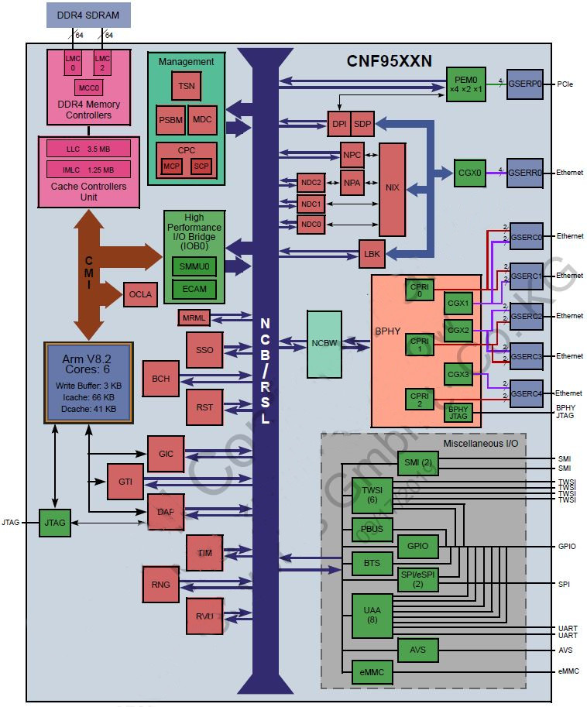channels
Figure 10 Rough block diagram of the Loki blocks
Figure 11 Top level Block Diagram of the Loki and its neighborhood

Loki serial Flash memories
Each Loki is linked up to two types of SPI flashes, one for BOOT and one for the Inventory:
- BOOT: A 128Mb QSPI Flash is used by the SoC to boot.
A second Flash (spare) is present on the PWB to allow a different architecture approach and/or update, if needed.
- Inventory: A 64Mb SPI Flash is used to store the board inventory.
This memory is HW write protected (status is visible by OIP).
These memories are flashed/TBD either by JTAG (in factory) or by SNF via BMUXO (through FSP bus) see chapter Error! Reference source not found.: BMUXO configures the SPI access muliplexers
Below is an HLV of the ASOE X01 variant and a HLV of the ASOE X11 variant:
Figure 12 Loki A/B QSPI HLV used on ASOE
Figure 13 Loki A/B QSPI HLV used on ASOE

Second title

Second subtitle
Lorem ipsum dolor sit amet, consectetuer adipiscing elit. Maecenas porttitor congue massa. Fusce posuere, magna sed pulvinar ultricies, purus lectus malesuada libero, sit amet commodo magna eros quis urna.
Nunc viverra imperdiet enim. Fusce est. Vivamus a tellus.
Pellentesque habitant morbi tristique senectus et netus et malesuada fames ac turpis egestas. Proin pharetra nonummy pede. Mauris et orci.
Aenean nec lorem. In porttitor. Donec laoreet nonummy augue.
Suspendisse dui purus, scelerisque at, vulputate vitae, pretium mattis, nunc. Mauris eget neque at sem venenatis eleifend. Ut nonummy.

Third title

Third subtitle

