FBO INSTALLATION GUIDE

Fast Business Online
Document for: IT Department / IT Administrator
----------------------------------------

1. Document Control
Item | Details
Document title | FBO Installation Guide
Product | FBO - Fast Business Online
Target audience | IT Department / IT Administrator
----------------------------------------

2. Purpose
This guide provides the IT installation steps for FBO (Fast Business Online). It explains the required software components, SQL Server configuration, IIS requirements, installer execution, database setup, and follow-up activities required before the application can operate.
----------------------------------------

3. Audience
This document is intended for IT personnel who are responsible for preparing the server environment and installing the FBO application.
- Windows Server administration.
- SQL Server installation and configuration.
- IIS configuration.
----------------------------------------

4. Requirements
The source installation guide identifies the following minimum components.
Component | Requirement
SQL Server | SQL Server 2014 or later
SQL Server collation | SQL_Latin1_General_CP1_CI_AS
SQL Server Browser | Startup Type must be Automatic
SQL Server service account | Built-in account: Local System
.NET Framework | .NET Framework 3.5 and .NET Framework 4.8
IIS | IIS must be enabled with the required features selected
Crystal Reports Runtime | Installed during the FBO installation process to support report/template viewing

Hardware Configuration Requirements:
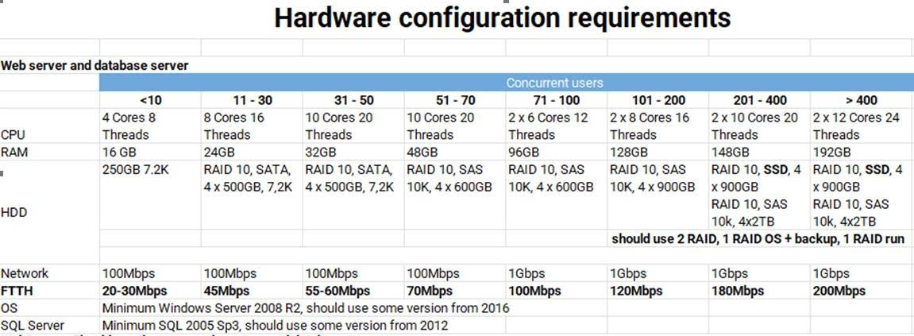
For your requirement about 2 data for Local and USA data, FAST suggest the hardware for 11-30 user
----------------------------------------

5. Prerequisites

5.1 Configure SQL Server Services
Description: Before installing FBO, ensure that SQL Server services are configured correctly.
Steps:
- Open SQL Server configuration or the SQL Server setup/service configuration screen.
- Confirm that SQL Server Database Engine is installed.
- Set SQL Server Browser Startup Type to Automatic.
- Confirm that the Database Engine collation is SQL_Latin1_General_CP1_CI_AS.
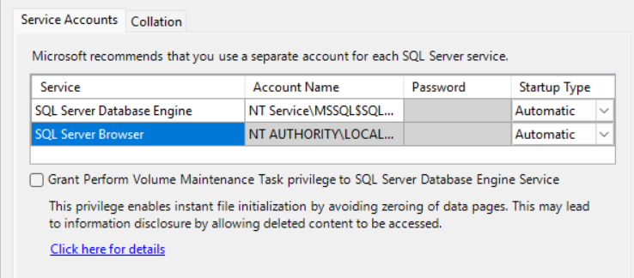
SQL Server service accounts and SQL Server Browser startup type

6.2 Configure SQL Server Service Account
Description: The source guide indicates that the SQL Server service should use the built-in Local System account.
Steps:
- Open the SQL Server service properties.
- Go to the Log On tab.
- Select Built-in account.
- Select Local System.
- Apply the configuration.
- Restart the SQL Server service if required by the environment.
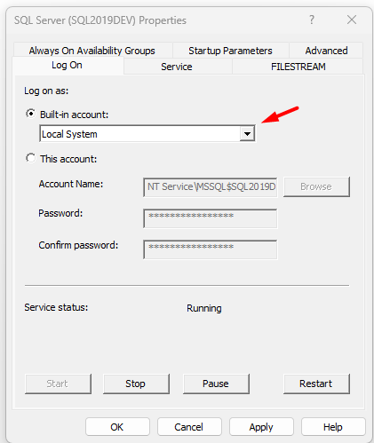
SQL Server service logon configured as Local System

5.3 Enable .NET Framework and IIS Features
Description: FBO requires .NET Framework and IIS components to be enabled before installation.
Steps:
- Open Windows Features or Server Manager.
- Enable .NET Framework 3.5.
- Enable .NET Framework 4.8
- Enable Internet Information Services.
- Ensure IIS Web Management Tools are selected.
- Ensure IIS World Wide Web Services are selected.
- Complete the Windows feature installation.
Expected result: The server has the required .NET Framework and IIS components enabled for FBO installation and website deployment.
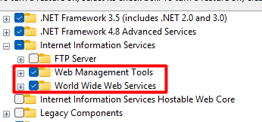
Windows features required for .NET Framework and IIS
----------------------------------------

6. Installation Package

6.1 Obtain the Installation Package
Description: The FBO installation package must be provided by FAST.
Steps:
- Download or obtain the FBO installation package from FAST.
- Extract or open the installation folder on the target server.
- Locate the Install application file.
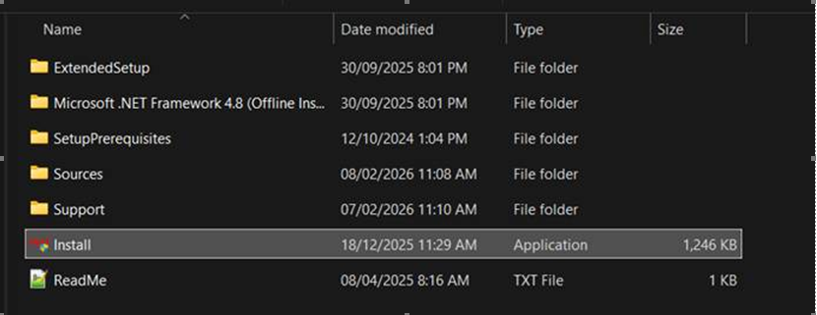
FBO installation package and Install application
----------------------------------------

6.2 Start the Installer
Description: Run the installer from the package provided by FAST.
Steps:
- Right-click the Install application.
- Run the installer with the required administrator permission.
- Review the setup wizard information.
- Click “Tiếp”.
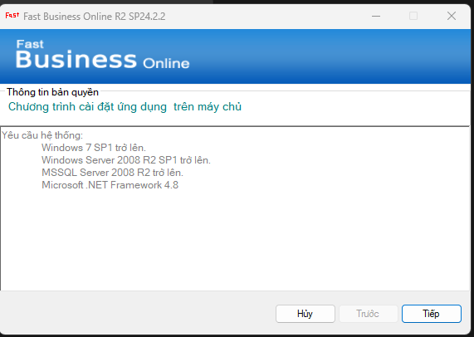
FBO setup wizard start screen

6.3 Select Installation Components and Program Path
Description: Select the FBO program installation option and define where the program files will be stored.
Steps:
- Select the option “Cài đặt chương trình” to install the program.
- Enter or browse to the program storage path.
- Select the option to check required supporting components if available in the installer.
- Confirm that the selected path has enough storage and appropriate access permission.
- Select the option to use an installed SQL Server.
- Enter the SQL Server name.
- Enter the SQL Server login name and password if SQL authentication is used.
- Click “Tiếp”.
Expected result: The installer can connect to the SQL Server that will host the FBO databases.
Note: The source screenshot shows SQL login sa as an example. Use the authentication method and account approved for the target environment.
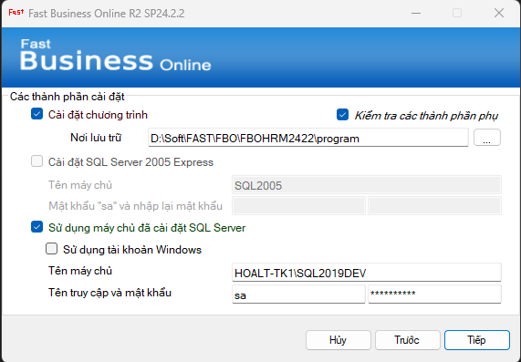
Program path and SQL Server connection configuration

6.4 Configure Database Information
Description: Declare the database names and database storage paths required by FBO.
Steps:
- Enter the system database name.
- Enter the storage path for the system database.
- Select the option to install a blank application database.
- Enter the blank application database name.
- Enter the storage path for the blank application database.
- Click “Tiếp”.
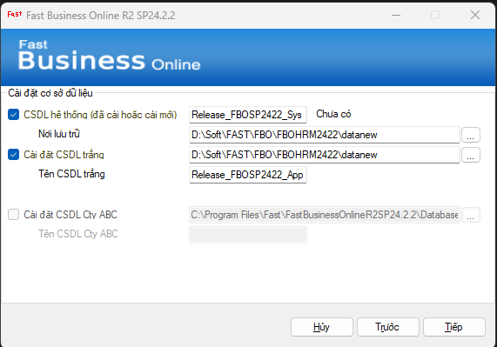
FBO database configuration screen

8.5 Confirm Installation
Description: Review and confirm the components that will be installed.
Steps:
- Review the installation confirmation screen.
- Confirm the components to be installed, including Microsoft Access Database Engine install/configuration, web service deployment/configuration, system database creation, and blank application database creation.
- Click “Cài đặt”.
- Wait for the installation process to complete.
Expected result: The installer installs the FBO program and creates the blank database environment.
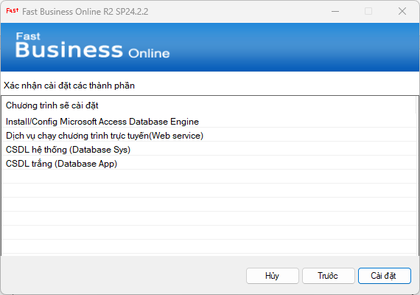
FBO installation confirmation screen
----------------------------------------

9. Post-Installation Configuration

9.1 Crystal Reports Runtime
During installation, the program installs Crystal Reports Runtime to support viewing report and print templates.

9.2 IIS Website Deployment
After the installation process, FBO is installed as a website on IIS.
IT must provide or confirm the protocol required to run the application online. The source document does not specify whether the target protocol is HTTP or HTTPS.
Items to confirm:
- Website binding protocol.
- Host name or URL.
- Port.
- SSL/TLS certificate requirement.
- Firewall and network access rules.

9.3 Serial Key and License Activation
FBO requires a serial key and license before the application can operate.
FAST is responsible for performing the serial key and license steps.

