**This is to certify that**

**Mr./ Ms:** Huong Hoang Luong

**Has successfully Designed & Developed:**

Lam Nguyen Hong Truc

Tuong Dinh Manh

Hoang Le Thien

Doan Le Thi Thuy

**Submitted by:**

Lam Nguyen Hong Truc

**Date of Issue:** 09-Mar-2018

**Authorized Signature:**

**ACKNOWLEDGEMENT**

I would like to acknowledgement all those who have given moral support and helped in making the project a success.

I wish to express my gratitude to the eProject Team at the Head Office, who guide and helped me. I would also like to express my gratitude to all the staff members of my center for not only providing me with the opportunity to work with them on this project, but also for their support and encouragement throughout the process.

I also express my sincere gratitude to the eProject Team at the Aptech Head Office and my project guide at the organization, for his valuable guidance and support for the completion of this project.

And finally, I would like to offer many thanks to all my colleagues for their valuable suggestions and constructive feedback.

**Synopsis**

ASKME is a Web application that provides an online marketplace for advertisers.

ASKME manages the online marketplace by displaying a veriety of e-commerce sites and other portals where the advertisers can place their ads on.

ASKME is beneficial in the following ways:

* Allows customers to advertise and promote itself
* Allows customers to quickly view the details of their desired destination site
* Automatically detects and display customer’s current location through geolocation
* Will be visually appealing

**Hint:** The Web application can be similar to [www.buysellads.com](http://www.buysellads.com), though it can be much simpler in functionality. The marketplace page on this site can give an idea of how and what to design.

**Problem Definition**

ASKME operates in the mobile phone business and supports the Customer to answer questions related to the mobile phone.

 Nowadays, due to the need to expand the market, the company needs to promote many products and services to the users so that the new company builds the web site Askme.Com.Vn .web site was built for the purpose of providing Information about the types of phones that are being used in the market, answers to common problems of users on the mobile web site provides the main functions are as follows:

Allows the user to view information about the companies currently active in the market, referring to detailed information about mobile phones, product comparison between phones and many more. Other topics that Askme company wants to meet customers. The support and contribution of customers is the foundation to help Askme company increasingly perfect and more development.

Form No.1/eProjects/PS/Ver1.0

**Customer Requirement Specification (CRS)**

**Client:** ASKME

**Business/Project Objective:**

Website building provides users with the most useful information about mobile phone products and can compare between the phone products together.

Allows customers to choose the appropriate phone product for themselves.

**Input provided by the client:**

* List of deliverables

**Hardware Requirements:**

* A minimum computer system that will help you access all the tools in the courses is a Pentium 166 or better
* 64 Megabytes of RAM or better

**Software Requirements:**

* Notepad/HTML editor
* Dreamweaver
* IE 5.0/ Netscape 6.0

Form No.2/eProject/CRS/Ver1.0/1 of 2

**Scope of the Work (in brief):**

Depending on the decision taken by the management regarding the ASKME application, following are the requirements base on which the Single Page Application (SPA) needs to be developed:

1. A home page for ASKME that will further display menu options for Trademark, Compare Phone, About Us and Contact Us.
2. Trademark will display the mobile phone products that consumers want to see the famous brands such as: Samsung, Oppo, iPhone, ..
3. Compare Phone displays the phones the customer wants to compare.
4. About Us and Contact Us should contain some relevant information.
5. The user can view and visit the links of their favorite brands or SmartPhone.

Form No.2/eProject/CRS/Ver1.0/2 of 2

**Architecture and Design of the System**

The application will have a client-sever architecture.

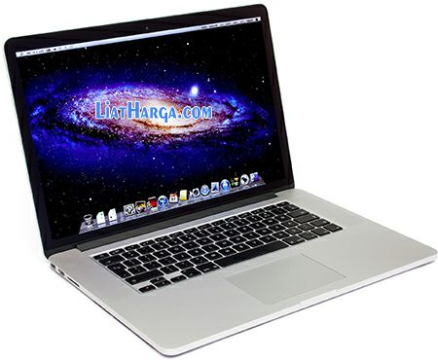

**Front End Technologies**

**(HMTL5,**

**CSS3,**

**JQuery,**

**Bootstrap,**

**AngularJS)**

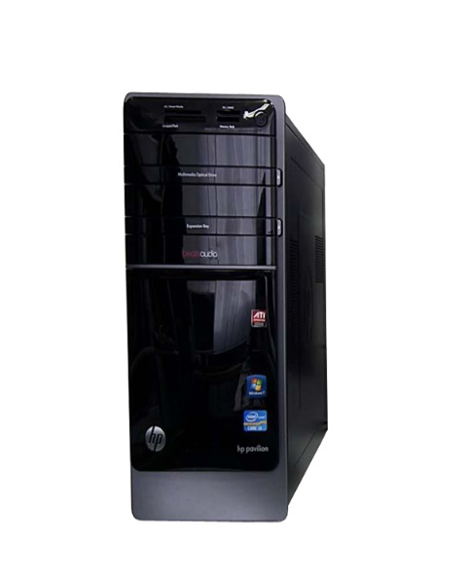

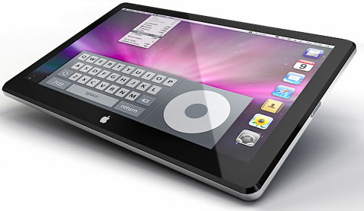

**CLIENTS**



Form No.3/eProject/Design/Ver1.0/1 of 1

**Site Map**

The sample site map illustrates the navigation flow of the objects on the Web portal.

**Home**

Home Home Page

SmartPhone SmartPhone Page

Iphone 8 Plus and SS Galaxy   
 Note 8

Compare Phone Compare Phone Page SS Galaxy S8 and SS Galaxy S9

Iphone 7 and Iphone 8

About Us About Us Page

Contact Us Contact Us Page

Form No.4/eProject/Site Map/Ver1.0/1 of 1

**Task Sheet**

|  |  |  |  |  |  |  |  |
| --- | --- | --- | --- | --- | --- | --- | --- |
| **Project Ref. No:**  **eP/Advertisement**  **Portal Management System/01** | | **Project Tit**  **le:** | **Activity Plan Prepared By:** | **Date of Preparation of Activity Plan:** | | | |
| **Sr.No.** | **Task** | **Actual Start Date** | **Actual Days** | **Team Mate Names** | **Status** |
| 1.  2.  3.  4.  5. | Home Page  SmartPhone Page  Compare Phone Page  Contact Us Page  About Us Page | ASKME  ASKME  ASKME  ASKME  ASKME | Hoang  Lam  Doan  Tuong  Doan | 01-Mar-2018  03-Mar-2018  01-Mar-2018  04-Mar-2018  04-Mar-2018 | 2  2  3  2  2 | Tuong  Hoang  Lam  Hoang  Hoang | Completed  Incompleted  Incompleted  Incompleted  Completed |

Form No.5/eProject/TS/Ver1.0/1 of 1

**Checklist of Validationsx**

|  |  |
| --- | --- |
| **Option** | **Validated** |
| Do all text links lead to the approriate Web site? | Yes |
| Do all the image links lead to the approriate Web site? | Yes |
| Are all the images and links clearly visible on the page? | Yes |
| Is the Web page opening properly in all the tested Web browsers? | Yes |
| Is the Web page taking too long to load? | Yes |
| Is the navigation sequence correct through all the Web pages on the site? | Yes |
| Is the JavaScrip code working as expected in all click events? | Yes |

Form No.6/eProject/VAL/Ver1.0/1 of 1

**Submission Checklist**

|  |  |  |  |  |  |
| --- | --- | --- | --- | --- | --- |
| **Sr.No** | **Particulars** | **Yes** | **No** | **NA** | **Comments** |
| 1. | Are all the users able to view the images and links? | Yes |  |  |  |
| 2. | Have all the views, modules, and controllers been property intergrated and is the site functional as a Single Page Application? | Yes |  |  |  |
| 3. | Are the GUI contents devoid of spelling mistakes? | Yes |  |  |  |
| 4. | Is the application user-friendly? | Yes |  |  |  |
| 5. | Is the Web site launching correctly in the browser? | Yes |  |  |  |

Form No.7/eProject/CKL/Ver1.0/1 of 1