**Iteration 1**

**Group 7**

**Group Members:**

Callum MacNeil

Luke Veer

Emma Doan (Ngoc Doan)

Minh Nguyen

Shaoqin Wan

Lam Tieu

William Huynh

**Date: Oct 16, 2022**

**Mention your GitLab repo: 3130 Group Project**

**https://git.cs.dal.ca/callumm/3130-group-project.git**

**Iteration Plan**

1. **User Stories & Acceptance Criteria**

**-Log In**

**-Register**

**-Stay Logged In/Show Password**

**Provide your git project dashboard link.:** https://git.cs.dal.ca/callumm/3130-group-project/-/boards

**2. Tasks Assignment: Acceptance test and Engineering task**

**[Necessary Field --> labels,task description, member assigned, start date, end date(expected), status [pending,completed,in progress] ]**

* **Could be downloaded from gitlab [refer tutorial]**

|  |  |  |  |  |  |  |
| --- | --- | --- | --- | --- | --- | --- |
| **Corresponding UserStory and Acceptance Criteria** | **Task(s)** | **Estimate** | **Member Assigned** | **Start** | **Expected** | **Status** |
| AT:1:1 | Debug Android Studio | 6 hours | Callum | 2022-10-13 | 2022-10-13 | Completed |
| AT:1:1 | Implement Espresso Test | 30 Minutes | Callum | 2022-10-13 | 2022-10-13 | Completed |
| AT:1:1 | Pass Espresso Test | 2 hours | Luke | 2022-10-14 | 2022-10-14 | Completed |
| AT:2:2 | Implement Junit Test | 30 minutes | Luke | 2022-10-14 | 2022-10-14 | Completed |
| AT:2:3 | Implement log in functionality | 3 hours | Callum | 2022-10-14 | 2022-10-14 | Completed |
| AT:3:1 | Implement Espresso Test for register page nav | 30 minutes | Callum | 2022-10-14 | 2022-10-14 | Completed |
| AT:3:2 | Implement register page nav | 4 hours | Luke | 2022-10-14 | 2022-10-14 | Completed |
| AT:3:2 | Implement firebase Junit test | 30 minutes | Luke | 2022-10-14 | 2022-10-14 | Completed |
| AT:2:1 + AT:2:2 + AT 2:3 | Write Espresso Tests for register feature | 1 hour | Emma | 2022-10-14 | 2022-10-14 | Completed |
| AT:2:1 + AT:2:2 + AT 2:3 | Write Junit Test for register feature | 1 hour | Emma | 2022-10-14 | 2022-10-14 | Completed |
| AT:2:1 + AT:2:2 + AT 2:3 | Build UI For register feature | 1.5 hours | Shaoqin | 2022-10-14 | 2022-10-14 | Completed |
| AT:2:2 | Implement type-tracking to notice user’s input validity of confirmed password and email | 1.5 hour | Shaoqin | 2022-10-14 | 2022-10-14 | Completed |
| AT:2:1 + AT:2:2 | Set up Firebase and connect the app to the Database | 30 minutes | Minh | 2022-10-14 | 2022-10-14 | Completed |
| AT:2:1 + AT:2:2 | Build logic to validate username, email, and password | 1.5 hours | Minh | 2022-10-14 | 2022-10-14 | Completed |
| AT:2:1 + AT:2:2 | Implement save user input to Database logic | 30 minutes | Minh | 2022-10-14 | 2022-10-14 | Completed |
| AT:2:1 + AT:2:2 + AT 2:3 | Add dependencies and config for Espresso Test to pass | 30 minutes | Emma | 2022-10-14 | 2022-10-14 | Completed |
| AT:2:1 + AT:2:2 | Implement UI for User Type drop-down selection | 30 minutes | Shaoqin | 2022-10-14 | 2022-10-14 | Completed |
| AT:2:1 + AT:2:2 + AT 2:3 | Refactor Espresso Tests for register feature | 30 minutes | Emma | 2022-10-14 | 2022-10-14 | Completed |
| AT:2:1 + AT:2:2 | Build logic and validation for User Type drop-down selection | 30 minutes | Shaoqin | 2022-10-14 | 2022-10-14 | Completed |
| AT:2:1 + AT:2:2 + AT 2:3 | Build on-click methods to display messages (validation output) and switch to the login windows | 1.5 hours | Minh | 2022-10-14 | 2022-10-14 | Completed |
| AT:2:1 + AT:2:2 + AT 2:3 | Update the logic and make changes to failed tests | 1 hour | Emma | 2022-10-14 | 2022-10-14 | Completed |
| AT:2:1 + AT:2:2 + AT 2:3 | Document code and ensure meaningful comments, variable, and method names | 1 hour | Minh, Emma, Shaoqin | 2022-10-14 | 2022-10-14 | Completed |
| AT:2:1 + AT:2:2 + AT 2:3 | Refactor and format code | 1 hour | Minh, Emma, Shaoqin | 2022-10-14 | 2022-10-14 | Completed |
| AT:2:1 + AT:2:2 + AT 2:3 | Update the code to pass the Espresso test | 1 hour | Minh, Emma, Shaoqin | 2022-10-14 | 2022-10-14 | Completed |
| AT:3:1 | Write Espresso Tests | 30 minutes | Lam Tieu | 15th October | 15th October | Completed |
| AT:3:2 | Write Espresso Tests | 30 minutes | Lam Tieu | 15th October | 15th October | Completed |
| AT:3:3 | Write Espresso Tests | 30 minutes | Lam Tieu | 15th October | 15th October | Completed |
| AT:3:1 | Set up files/Create Landing page from Login | 1 hour | Lam Tieu | 14th October | 14th October | Completed |
| AT:3:1 + AT:3:2 + AT:3:3 | Implement showHidePassword() method to show/hide password when clicking button | 1 hour | William Huynh | 15th October | 15th October | Completed |
| AT:3:1 + AT:3:2 + AT:3:3 | Run the code and run tests; tests not run | 20 minutes | Lam Tieu | 15th October | 15th October | Completed |
| AT:3:1 + AT:3:2 + AT:3:3 | Fix gradle files and run tests; all tests passed | 20 minutes | William Huynh | 15th October | 15th October | Completed |
| AT:3:1 + AT:3:2 + AT:3:3 | Integrate feature with other pair’s LogIn code/Update feature with new LogIn code | 2 hours | William Huynh | 15th October | 15th October | Completed |
| AT:3:4 | Implement stay logged in feature to stay inside the app once the user already logged in before | 2 hours | William Huynh | 16th October | 16th October | Completed |
| AT:3:4 | Refractor stay logged in code and pushed to gitlab/Merge with ‘master’ branch | 1 hour | Lam Tieu | 16th October | 16th October | Completed |

**3. Work Schedule (May 27th 2019 ~ June 18th 2019) [This is not mandatory, but it keeps track of the contribution of each group member]**

|  |  |  |  |  |  |  |
| --- | --- | --- | --- | --- | --- | --- |
| **Monday** | **Tuesday** | **Wednesday** | **Thursday** | **Friday** | **Saturday** | **Sunday** |
| **27** | **28** | **29** | **30** | **31** | **1** | **2** |
| Group Meeting: Brainstorming user stories |  | Lab 3: Agile game |  |  |  | Generated a list of user stories |
| Set up a board in Trello for user stories |  |  |  |  |  | Group review |
| **3** | **4** | **5** | **6** | **7** | **8** | **9** |
| Group Meeting:  Iteration 1 Planning, programming pairs assigned, User stories assigned to programming pairs | Callum set up git lab repo and added members | Client Meeting: discussed the user story with client if clarification is needed | Shaoqin added the starting code to the main branch | Callum set up CI/CD pipeline |  |  |
|  |  |  |  |  |  |  |
| **10** | **11** | **12** | **13** | **14** | **15** | **16** |
| Group Meeting |  | Client Meeting: | Callum and Luke began ping pong style pair programming | Callum and Luke finished programming log in feature | Group meeting:  Finishing touches before merging | Took demo video and filled out the iteration report |
|  |  |  |  |  | Merging branches and debugging tests |  |
|  |  |  |  |  | Resolving merge conflict and small refactor | Submit iteration report 1 |
| **17** | **18** |  |  |  |  |  |
|  |  |  |  |  |  |  |
|  |  |  |  |  |  |  |
|  |  |  |  |  |  |  |
|  |  |  |  |  |  |  |

**4. Iteration Plan Change Log [Depends on Situation if you have made any changes in the iteration plan ]**

**Progress Charts**

1. **Testing Report**

**Following are situations to consider.**

* + If you have your CI running with Junit tests, provide screenshots of Espresso tests as shown above and discussed in the tutorial.

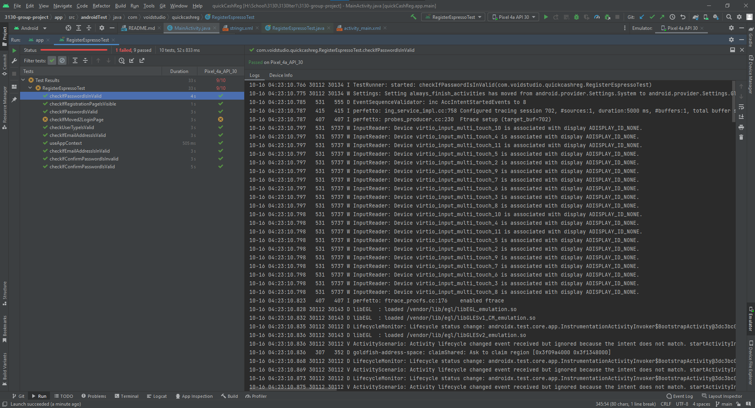

* + If you have not yet configured CI, show the proof of testing for both Junit and Espresso test as discussed in the tutorial.

**Note**: Take snapshots of the espresso and Junit tests if not configured by the CI when every 3-4 issues are completed.

**2. Burndown Chart**

**3. Velocity Chart**

**Regular Standup Meetings [Can have your own format]**

1. **General + Lab Meeting Minutes: 2022-09-29**

Time and location: Teams

Attendance: Emma, Minh, Shaoqin, Callum, Luke, Lam, William

Summary:

* Client Meeting (30 minutes):
* Met up with client TA through Microsoft Teams
* Discussed and choose the critical user stories that need to work on
* Evaluated user stories and decide the priority of each task during the implementation phase
* Iteration Planning (1 hour)
* We set up Gitlab before the meeting and listed user stories and upload it to Gitlab on the day of meeting.
* Set up Gitlab
* Finished User Stories
* We evaluated user stories by story points:
* Use Planning Poker to help with the estimation
* Effort estimation: 1-7 (least to most)
* Points: 1pt = 2 hours
* Overestimate is better than underestimate
* Update every time we hit save, commit and push to remote repo to minimize conflicts
* Constantly update with teammates on progress
* Create shared database and update database accordingly
* We brainstormed and discussed on the logic of each feature and how each feature could be implemented
* We assigned programming pairs and tasks that each programming pair will be responsible with.
* Upload user stories to Gitlab
* Evaluate and upload stories point to Gitlab
* Assign and upload programming pairs to Gitlab

**3. General Meeting Minutes: 2022-10-06**

Time and location: Teams

Attendance: Emma, Minh, Shaoqin, Callum, Luke, Lam, William

Summary:

Working on progress:

* Discuss with clients further on requirements and type of users
* Each pair started working on the allocated user stories.
* We finalized the common way to document code, file naming, and version control methods.
* Decide the day of code review
* Finalize the day of finishing Espresso test and Junit test for each feature
* Ensure the engineering tests that we used are for each acceptance test

**4. General Meeting Minutes: 2022-10-13**

Time and location: In person – SUB

Attendance: Emma, Minh, Shaoqin, Callum, Luke

Summary:

Work in progress:

* Meet with client TA in person to update on first iteration process
* Work on the allocated user stories.
* Work on Espresso Test and Junit Tests, run test when finish
* Ensure the engineering tests that we used are for each acceptance test

**5. Merge Meeting : 2022-10-15**

Time and location: In person – 4th floor Goldberg

Attendance: Emma, Minh, Shaoqin, Callum, Luke, William, Lam

Summary: Merged branches

Work in progress:

* Iteration Report
* Demo Video

**Iteration Post-mortem Review [4/100]**

*Issues With Development*

Some main issues could be listed such as:

* Connection with Firebase Database
* Espresso Test and JUnit Test failed (ex: RunTimeException, PerfomanceException with ‘single click’)
* Merge conflicts

*Solutions*

* Connect firebase and ensure to download the google-services.json file
* Ensure the build gradle file is correct
* Start early to get used to the software
* Pull any changes first before merge again

*Goals for Upcoming Iteration*

* Work on the next iteration early
* Minimize issues
* Refactoring

**Links:**