

**Steps to set up the application and run the code challenge**

Document Version / Details: Ver. 2.0/ 14-Nov-2022

Step 1. Download XAMPP with PHP 7.4 Version and Install it.

Link to downlaod xampp <https://www.apachefriends.org/download.html>

Step 2. Start XAMPP Server and MYSQL.

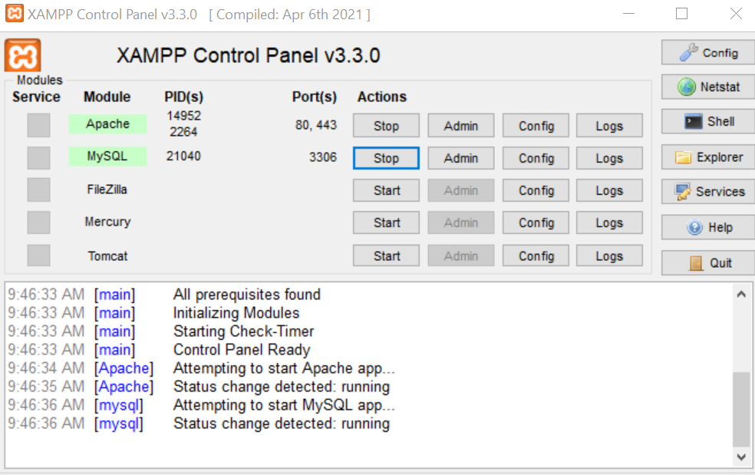

Step 3. Download [kar-test.zip](https://github.com/ltimaneesh/kar-test/blob/main/kar-test.zip) from github and extract it and and paste it into your htdocs folder(C:\xampp\htdocs) where xampp installed.

Link to download the application - <https://github.com/ltimaneesh/kar-test>

Step 4. Go to phpmyadmin (<http://localhost/phpmyadmin/>)

Step 5. Create new database with name **kar-test**.

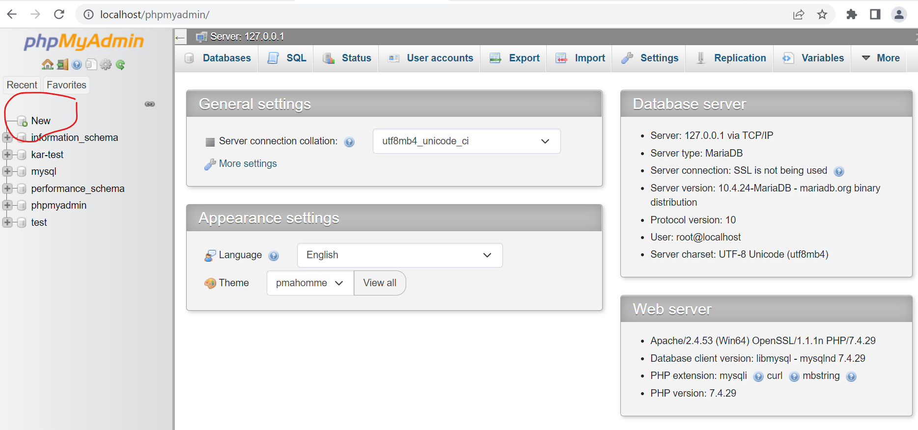

Step 6. Import kar-test.sql into phpmyadmin

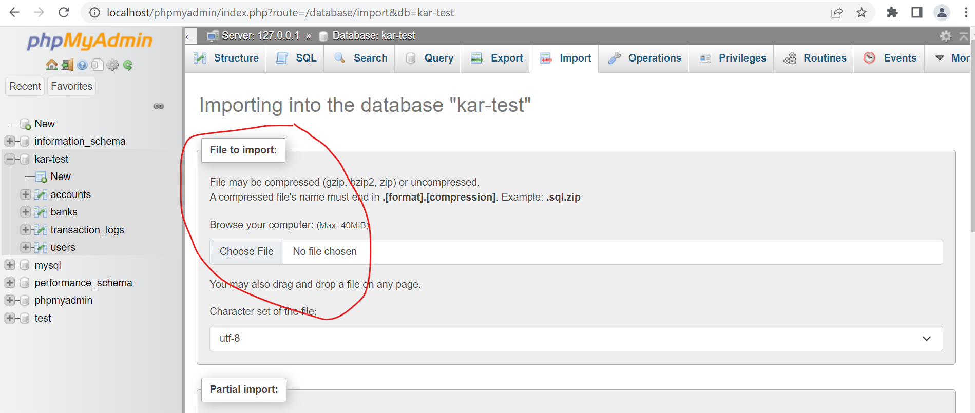

Step 7. Install Postman

Step 8. Run the all below APIs and validate the results.

**API END POINTS URL & Details**

1. Show bank name

URL: http://localhost/kar-test/index.php

METHOD - GET

INPUT REQUEST- Nothing

OUTPUT- {"status":"success","bank_name":"LTIMindtree"}

1. Show all accounts

URL: http://localhost/kar-test/index.php/account

METHOD - GET

INPUT REQUEST- Nothing

OUTPUT- {"status":"success","data":[{"account_number":"1"},{"account_number":"2"},{"account_number":"3"}]}

1. Show specific account details

URL: http://localhost/kar-test/index.php/account/1

METHOD - GET

INPUT REQUEST- Passed account number in url like 1/2/3 etc

OUTPUT- {"status":"success","data":{"user_name":"maneesh","account_balance":"3340.00"}}

1. Show account type with details

URL: http://localhost/kar-test/index.php/account/checking/1

METHOD - GET

INPUT REQUEST- Passed account number in url like 1/2/3 etc

OUTPUT- {"status":"success","data":{"user_name":"maneesh","account_type":"Corporate","account_balance":"1000.00"}}

1. Create new account

URL: http://localhost/kar-test/index.php/account/create

METHOD - POST

INPUT REQUEST-

user_name=maneesh

account_type=Individual

OUTPUT- {"status":"success","msg":"New account created successfully."}

1. Modify existing account

URL: http://localhost/kar-test/index.php/account/modify

METHOD - POST

INPUT REQUEST-

user_name=maneesh

account_type=Individual

account_number= 2

OUTPUT- {"status":"success","msg":"Account updated successfully."}

1. Remove an account

URL: http://localhost/kar-test/index.php/account/remove

METHOD - POST

INPUT REQUEST- account_number=6

OUTPUT- {"status":"success","msg":" Removed successfully."}

1. Deposit money into an account

URL: http://localhost/kar-test/index.php/account/deposit

METHOD - POST

INPUT REQUEST- to_account=6 , amount = 500

OUTPUT- {"status":"success","msg":" Amount 500 deposited successfully."}

1. Withdraw money from an account

URL: http://localhost/kar-test/index.php/account/withdrawal

METHOD - POST

INPUT REQUEST- from_account=6 , amount = 500

OUTPUT- {"status":"success","msg":" 500 withdrawn successfully."}

1. Transfer money one account to onother acccount

URL: http://localhost/kar-test/index.php/account/transfer

METHOD - POST

INPUT REQUEST- from_account=6 , to_account=5 ,amount = 500

OUTPUT- {"status":"success","msg":"Transferred successfully."}

**Postman samples screenshots**

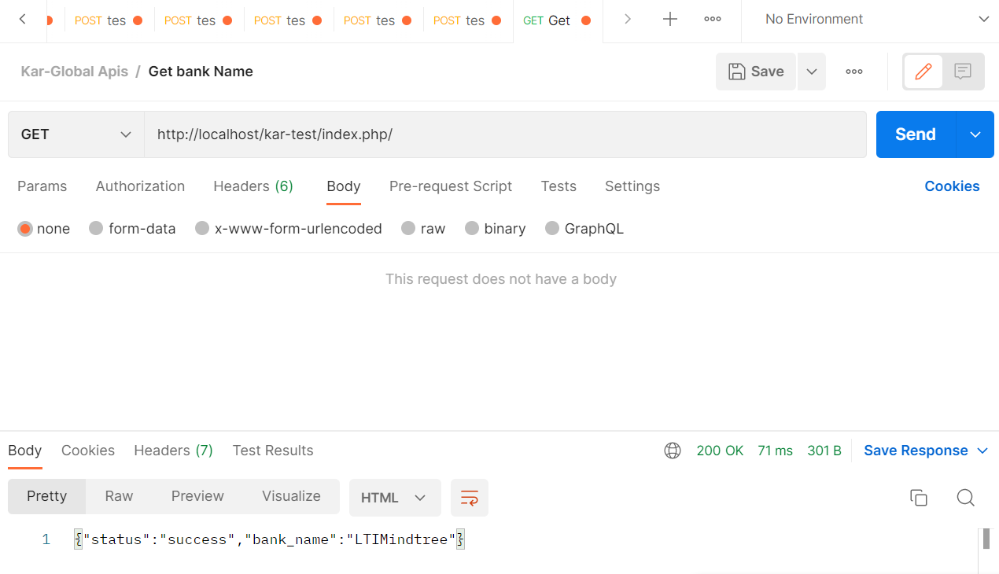

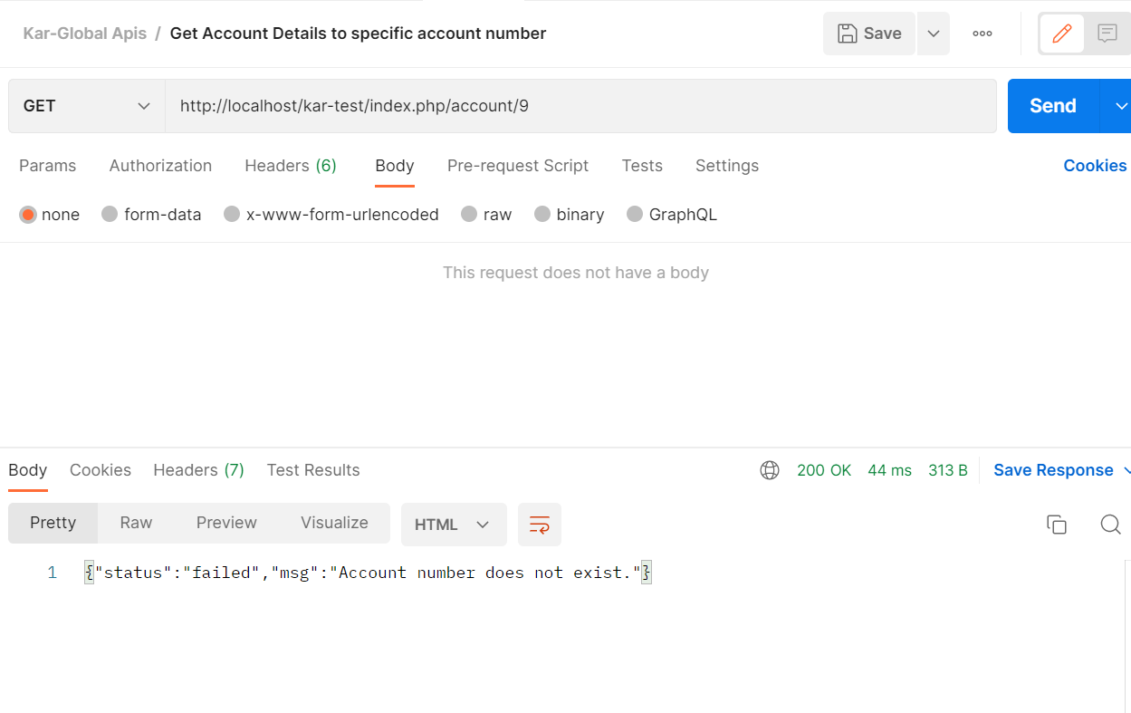

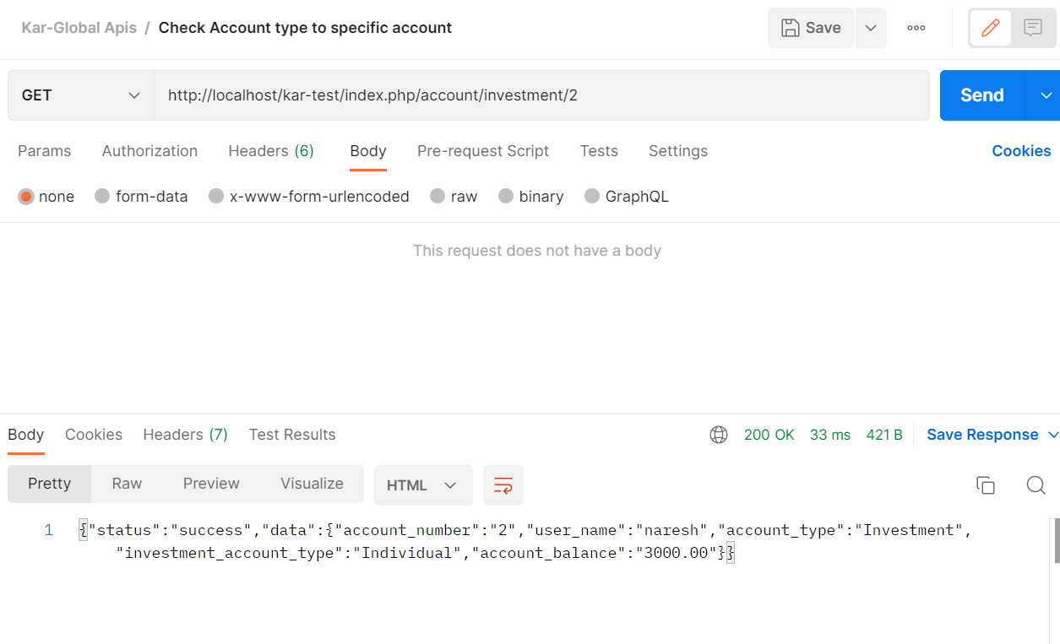

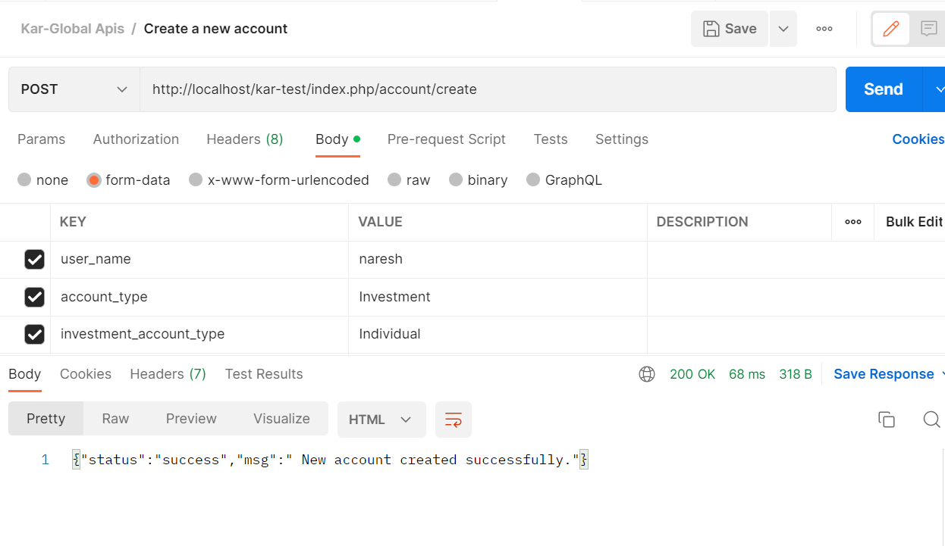

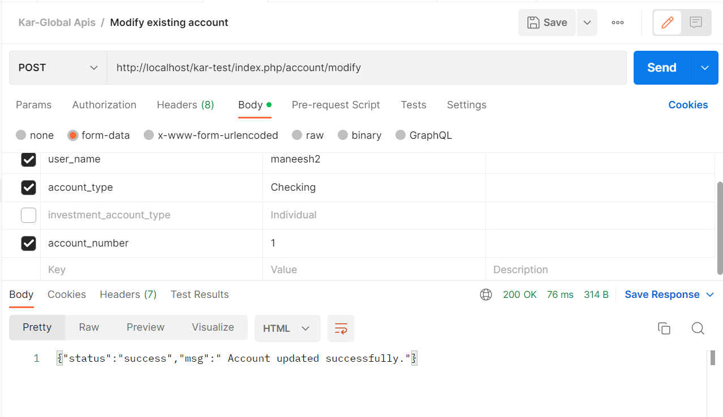

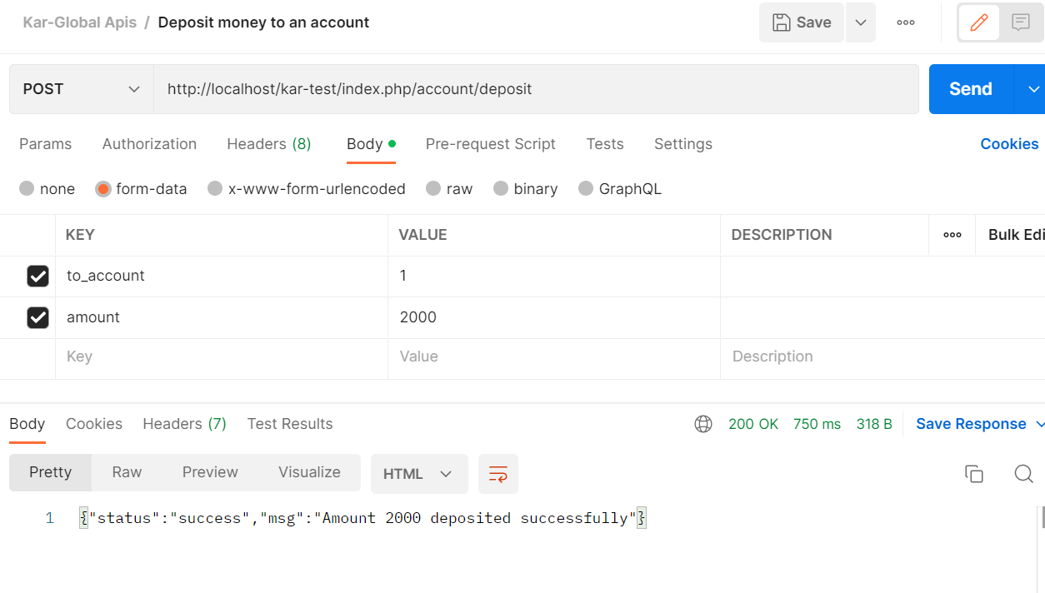

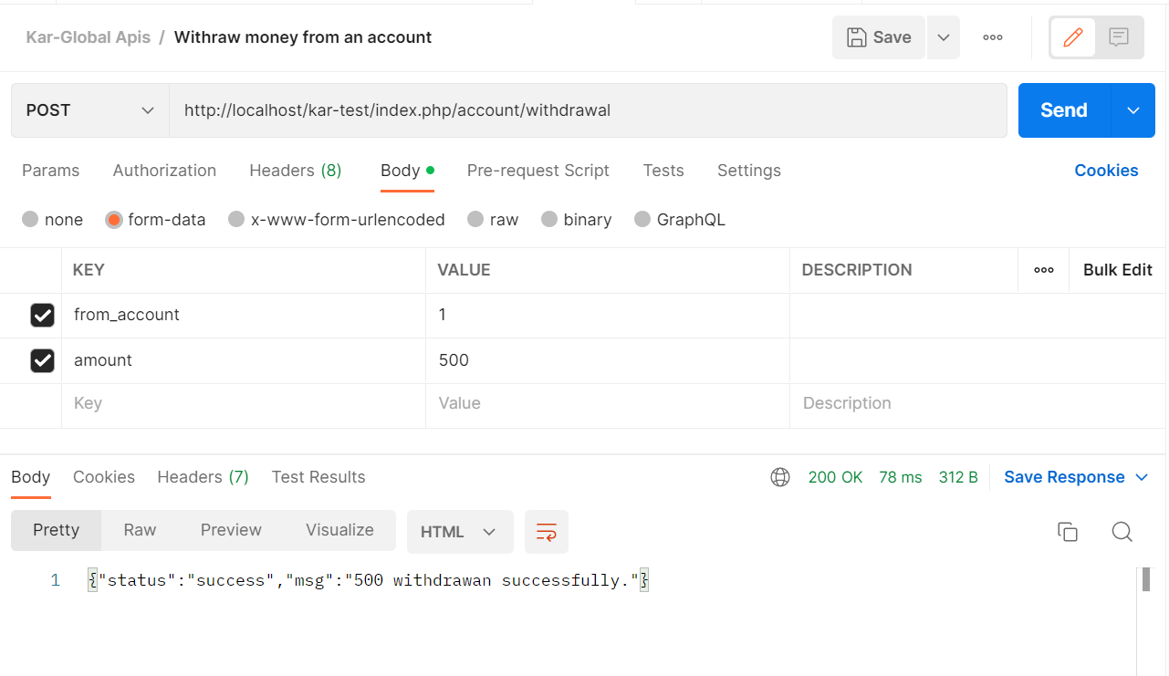

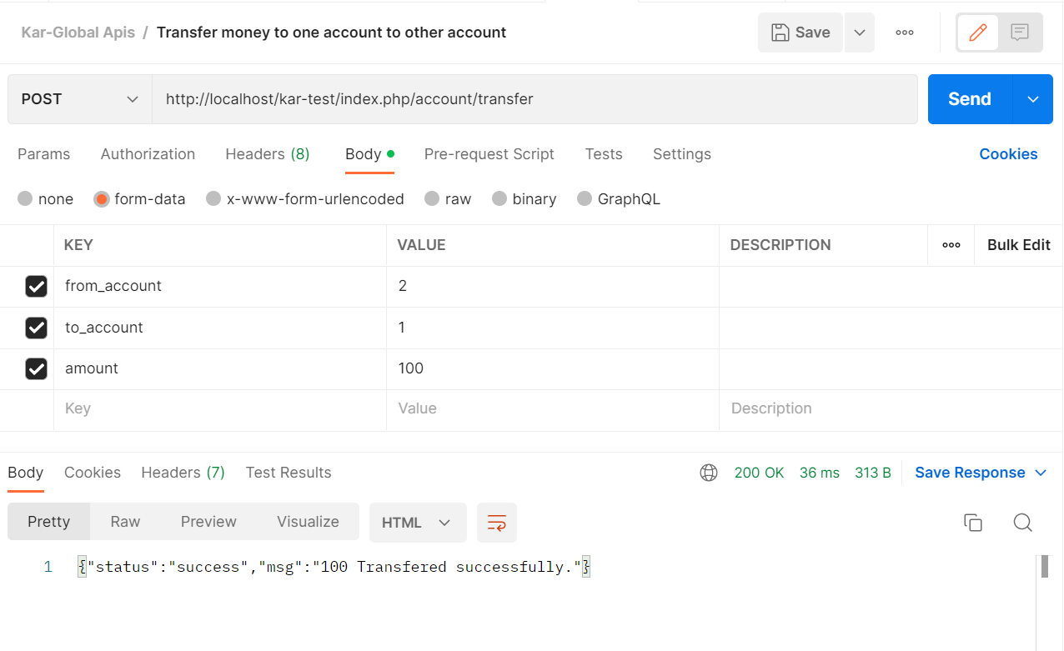

**Unit test samples screenshots**

