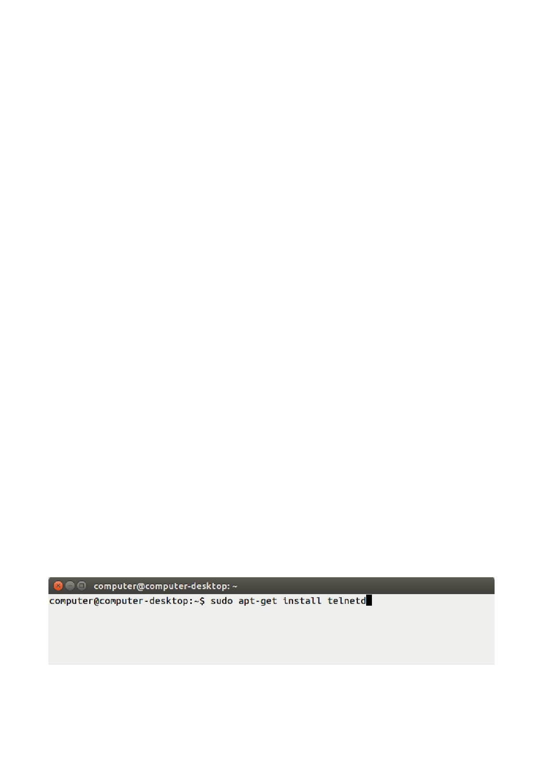
Practical 11

Aim: Perform Remote login using Telnet server. Command Prompt

Theory:

TELNET (Teletype Network) is the service that allows you to access another computer by logging
in to the remote system, such that, you can pass commands to another system by sitting back at your
place. It allows you to send the instructions to a remote client, but in a plain-text format. Telnet listens to all the requests by the user usually on TCP port 23, but you can change it accordingly.

Telnet is one of the oldest communication protocol to perform this activity, later on with the
advancement of technology "SSH" came into existence, which is a secure method as it sends all the
data in an encrypted format. SSH is used by the professionals in the public network where they
can't take a chance to expose their credentials to everyone. But with this, it doesn't mean that Telnet
is vanished. There are many situations where people use Telnet specifically for testing and debugging, in a local or private network.

If telnet is invoked with a host argument, it performs an open command implicitly; see the description below.
Options:
-4 - Force IPv4 address resolution. -6 - Force IPv6 address resolution.
-8 - Request 8-bit operation. This causes an attempt to negotiate the TELNET BINARY option for both input and output. By default telnet is not 8-bit clean.
-E - Disables the escape character functionality; that is, sets the escape character to ``no character''.
-K - Specifies no automatic login to the remote system.
-L- Specifies an 8-bit data path on output.This causes the TELNET BINARY option to negotiated on just output.

Steps to Install and Use Telnet in Ubuntu

Step 1: Firstly, open the "Terminal" window by pressing "Ctrl + Alt + T". In the figure, you may see "$" that signifies that you are not logged in as a root user.
So, I"ll write "sudo apt-get install telnetd" and press enter. If you are a root user, then you don't need to write sudo in Ubuntu. "telnetd" is a daemon that gets invoked by "inetd" or its extension "xinetd", both are the internet servers.

Step 2: Then you are asked to enter the user password and then press enter. Processing will start as
soon as you press enter. After this, I have noticed a line "274 KB additional disk space will be used" on the terminal screen.
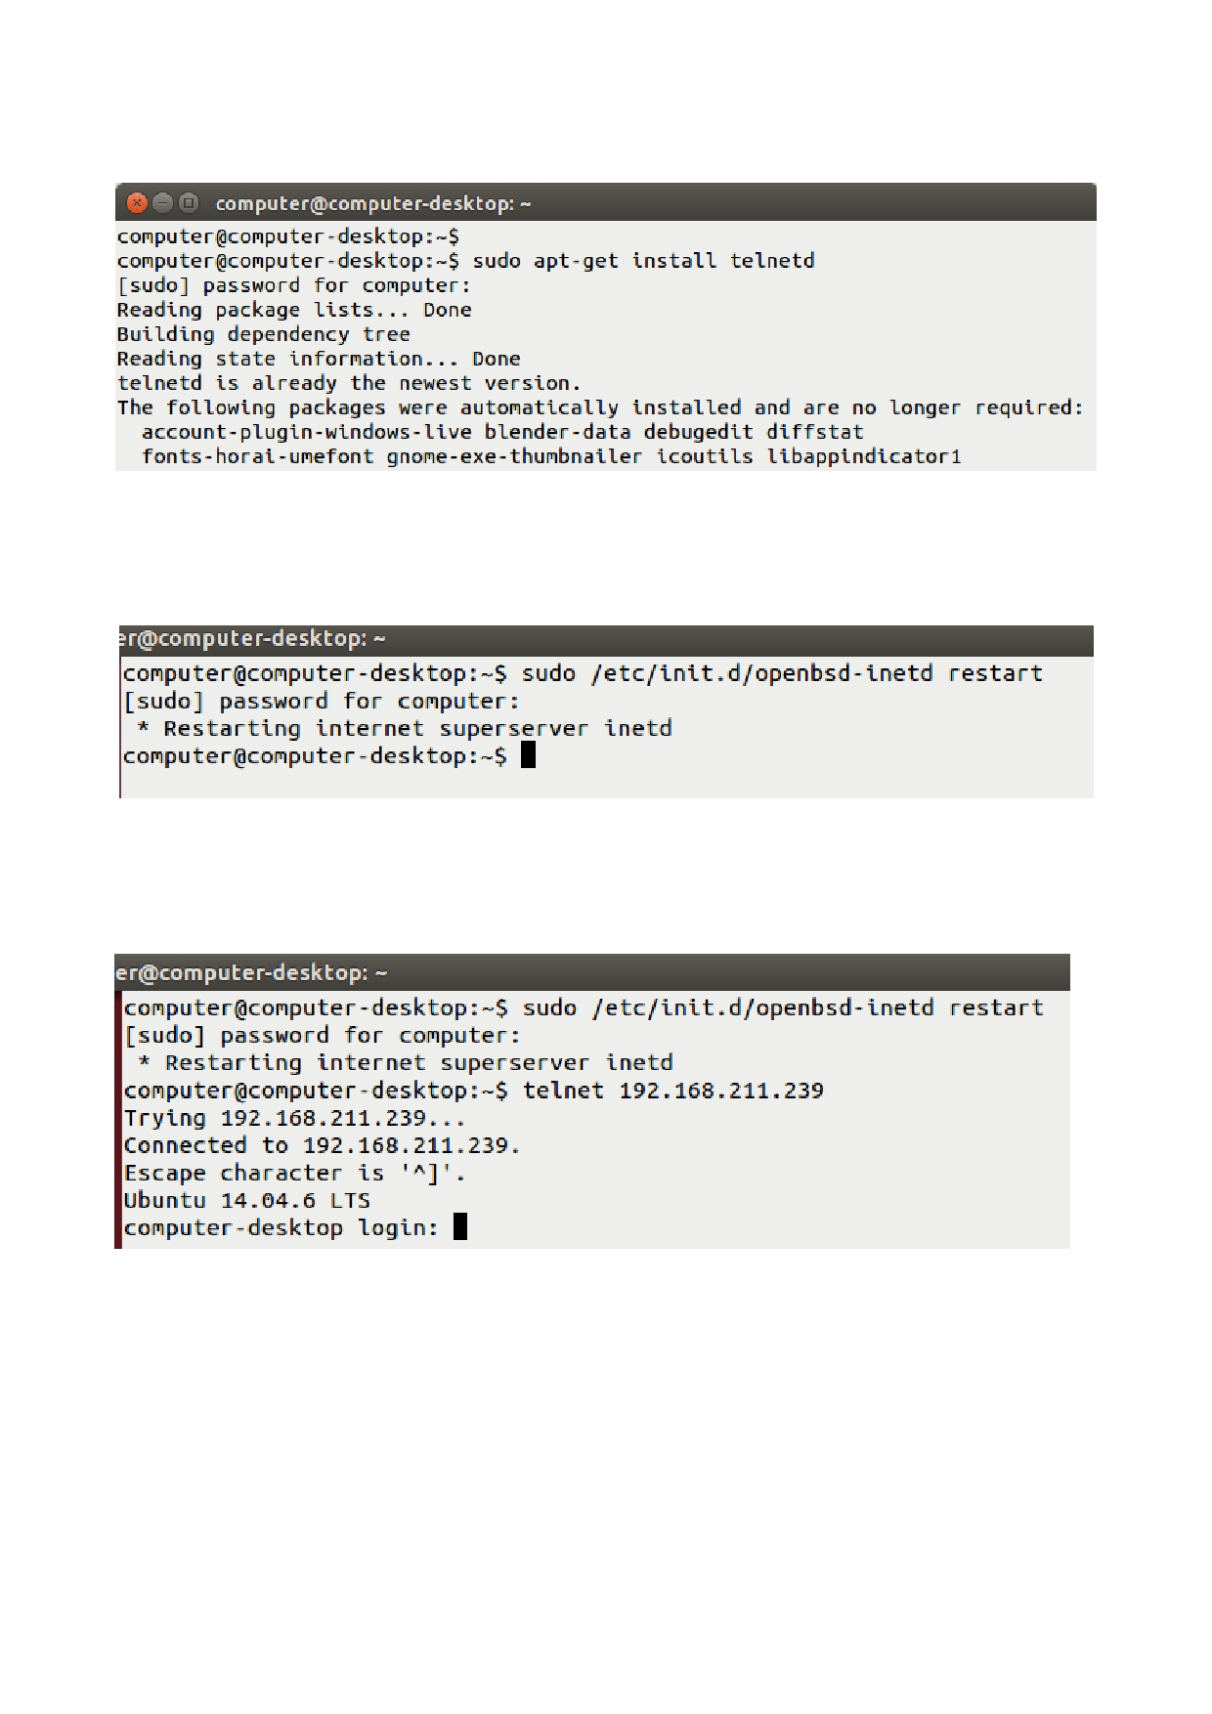
You may also observe some sort of a message like this and then you"ll be asked to continue or not.
Just write "y" and then press enter to continue.

Step 3: Now when you are done with it, restart "inetd". Type "sudo /etc/init.d/openbsd-inetd
restart". "inetd" is daemon used for dealing with incoming network and it is responsible for deciding which program to run when a request comes.

To connect with any remote client:
Step 4: Just type:"telnet hostipaddress". For an example: "telnet 192.168.211.239" and press enter.

OR
try this

1. sudo apt-get install telenetd
2. sudo etc/init.d/openbsd-inetd restart
3. telnet telehack.com

Conclusion: Hence,Remote login to other computer is using telnet server is successfully executed.

