EXPERIMENT.NO : 1

AIM: A. Use basic networking commands in Linux (ping, tracert, nslookup,netstat, ARP, RARP, ip, iconfig, dig, route ) command prompt.
B. Set up multiple IP addresses on a single LAN.

1. PING (Packet InterNet Groper)
Description : The most commonly used network tool is the ping utility. This utility is used to provide a basic connectivity test between the requesting host and a destination host. This is done by using the Internet Control Message Protocol (ICMP) which has the ability to send an echo packet to a destination host and a mechanism to listen for a response from this host. Simply stated, if the requesting host receives a response from the destination host, this host is reachable. This utility is commonly used to provide a basic picture of where a specific networking problem may exist. For example, if an Internet connection is down at an office, the ping utility can be used to figure out whether the problem exists within the office or within the network of the Internet provider.

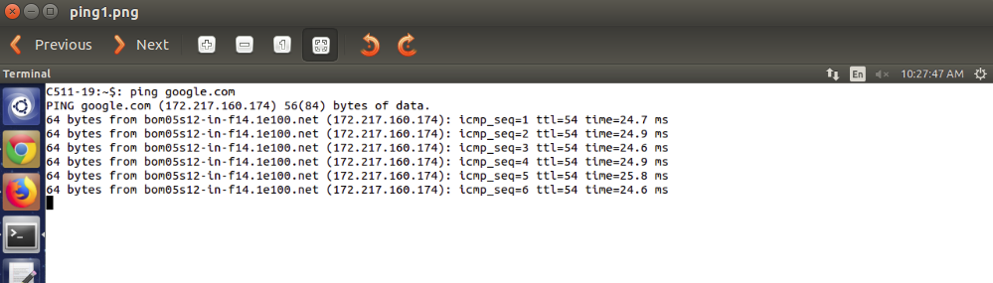

2. TRACEROUTE
Discription : Typically, once the ping utility has been used to determine basic connectivity, the traceroute utility can used to determine more specific information about the path to the destination host including the route the packet takes and the response time of these intermediate hosts.

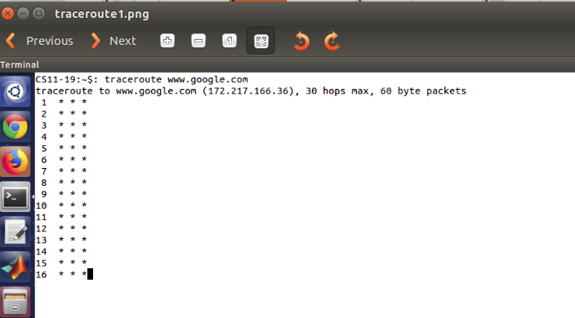
3.NSLOOKUP (NAME SERVER LOOKUP)
Description : Some of the most common networking issues revolve around issues with Dynamic Name System (DNS) address resolution issues. DNS is used by everyone using the Internet to resolve commonly known domain names (i.e. google.com) to commonly unknown IP addresses. When this system does not work, most of the functionality that people are used to goes away, as there is no way to resolve this information. The nslookup utility can be used to lookup the specific IP address(es) associated with a domain name. If this utility is unable to resolve this information, there is a DNS issue. Along with simple lookup, the nslookup utility is able to query specific DNS servers to determine an issue with the default DNS servers configured on a host.

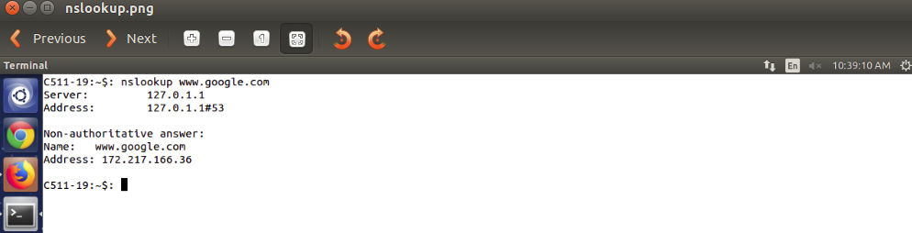
4.NETSTAT (NETWORK STATISTICS)
Description : Often, one of the things that are required to be figured out is the current state of the active network connections on a host. This is very important information to find for a variety of reasons. For example, when verifying the status of a listening port on a host or to check and see what remote hosts are connected to a local host on a specific port. It is also possible to use the netstat utility to determine which services on a host that is associated with specific active ports.

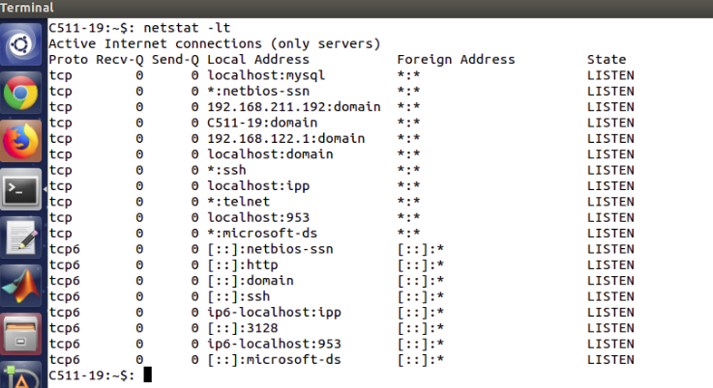

5. IFCONFIG (INTERFACE CONFIGURATION)
Description : One of the most important things that must be completed when troubleshooting a networking issue is to find out the specific IP configuration of the variously affected hosts. Sometimes this information is already known when addressing is configured statically, but when a dynamic addressing method is used, the IP address of each host can potentially change often. The utilities that can be used to find out this IP configuration information include the ipconfig utility on Windows machines and the ifconfig utility on Linux based machines.

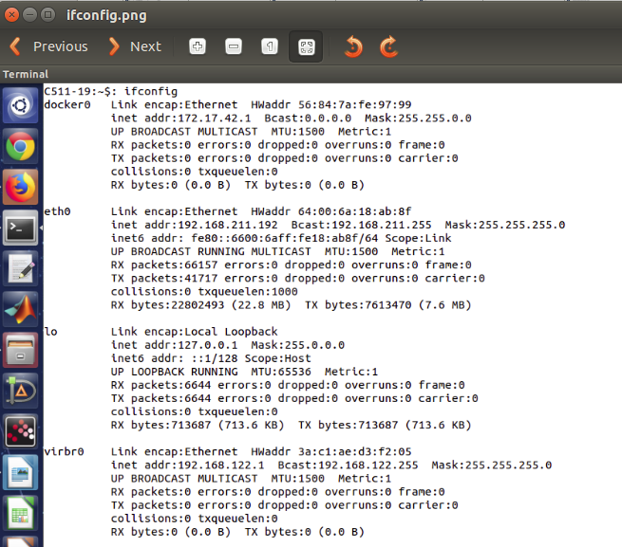

6.IP (INTERNET PROTOCOL)
Description : IP command in Linux is present in the net-tools which is used for performing several network administration tasks. IP stands for Internet Protocol. This command is used to show or manipulate routing, devices, and tunnels. It is similar to ifconfig command but it is much more powerful with more functions and facilities attached to it.
It can perform several other tasks like configuring and modifying the default and static routing, setting up tunnel over IP, listing IP addresses and property information, modifying the status of the interface, assigning, deleting and setting up IP addresses and routes.
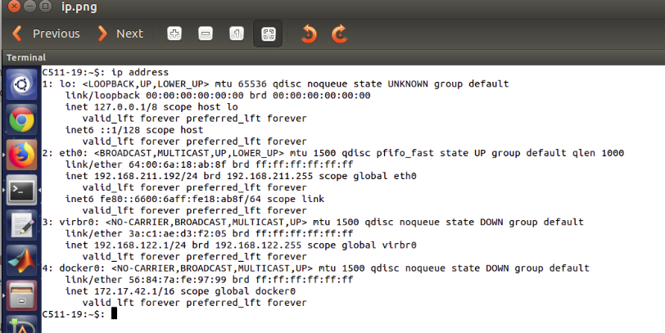
7. DIG
Description : Dig stands for (Domain Information Groper) is a network administration command-line tool for querying Domain Name System (DNS) name servers. It is useful for verifying and troubleshooting DNS problems and also to perform DNS lookups and displays the answers that are returned from the name server that were queried. dig is part of the BIND domain name server software suite. dig command replaces older tool such as nslookup and the host. dig tool is available in major Linux distributions.
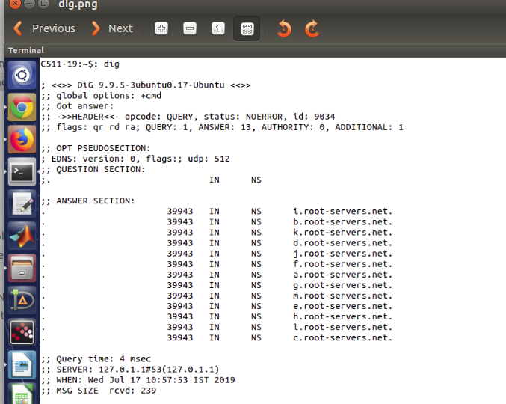

8. ROUTE
Description : The last of the tools covered in this article is the route utility. This utility is used to display the current status of the routing table on a host. While the use of the route utility is limited in common situations where the host only has a single IP address with a single gateway, it is vital in other situations where multiple IP address and multiple gateways are available.
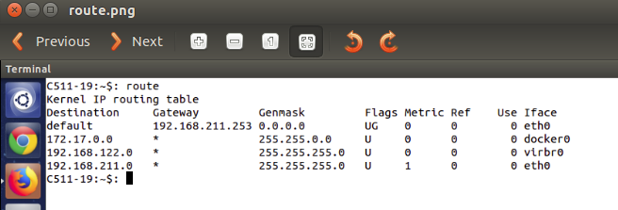
9.ARP (ADDRESS RESOLUTION PROTOCOL)
The address resolution protocol (arp) is a protocol used by the Internet Protocol specifically IPv4, to map IP network address to the hardware addresses used by a data link protocol. The protocol operates below the network layer as a part of the interface between the OSI network and OSI link layer.
The term address resolution refers to the process of finding an address of a computer in a network. The address is "resolved" using a protocol in which a piece of information is sent by a client process executing on the local computer to a server process executing on a remote computer. The information received by the server allows the server to uniquely identify the network system for which the address was required and therefore to provide the required address. The address resolution procedure is completed when the client receives a response from the server containing the required address.
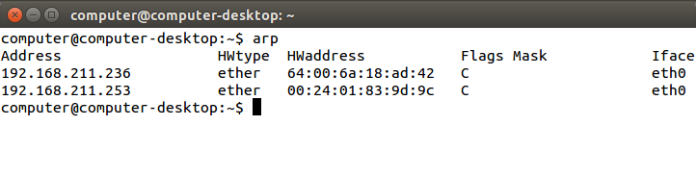

10.RARP (REVERSE ADDRESS RESOLUTION PROTOCOL)
The Reverse Address Resolution Protocol (RARP) is an obsolete computer networking protocol used by a client computer to request its Internet Protocol address from a computer network, when all it has available is its link layer or hardware address, such as a MAC Address. The client broadcasts the request and does not need prior knowledge of the network topology or the identities of servers capable of fulfilling its request.

