EXPERIMENT NO :- 1-b

AIM : Setup Multiple IP address.

THEORY :The concept of creating or configuring multiple IP addresses on a single network interface is called IP aliasing. IP aliasing is very useful for setting up multiple virtual sites on Apache using one single network interface with different IP addresses on a single subnet network.
The main advantage of using this IP aliasing is, you don’t need to have a physical adapter attached to each IP, but instead you can create multiple or many virtual interfaces (aliases) to a single physical card.

The instructions given here are applies to all major Linux distributions like Red Hat,Fedora, and CentOS. Creating multiple interfaces and assign IP address to it manually is a daunting task. Here we’ll see how we can assign IP address to it defining a set of IP range. Also understand how we are going to create a virtual interface and assign different range of IP Address to an interface in one go. In this article we used LAN IP‘s, so replace those with ones you will be using.

Creating Virtual Interface and Assign Multiple IP Addresses:
Here I have an interface called “ifcfg-eth0“, the default interface for the Ethernet device. If you’ve attached second Ethernet device, then there would be an “ifcfg-eth1” device and so on for each device you’ve attached. These device network files are located in “/etc/sysconfig/network-scripts/” directory. Navigate to the directory and do “ls -l” to list all devices.

Let’s assume that we want to create three additional virtual interfaces to bind three IP addresses (172.16.16.126,172.16.16.127, and 172.16.16.128) to the NIC. So, we need to create three additional alias files, while “ifcfg-eth0” keeps the same primary IP address. This is how we moving forward to setup three aliases to bind the following IP addresses.

Open a file “ifcfg-eth0” and view the contents.

Here we only need two parameters (DEVICE and IPADDR). So, open each file with VI editor and rename the DEVICE name to its corresponding alias and change the IPADDR address. For example, open files “ifcfg-eth0:0“, “ifcfg-eth0:1” and “ifcfg-eth0:2” using VI editor and change both the parameters.

Once, you’ve made all changes, save all your changes and restart/start the network service for the changes to reflect.

To verify all the aliases (virtual interface) are up and running, you can use “ifconfig” or “ip” command.

Ping each of them from different machine. If everything setup correctly, you will get a ping response from each of them.

Assign Multiple IP Address Range :
If you would like to create a range of Multiple IP Addresses to a particular interface called “ifcfg-eth0“, we use “ifcfg-eth0-range0” and copy the contains of ifcfg-eth0 on it as shown below.

Now open “ifcfg-eth0-range0” file and add “IPADDR_START” and “IPADDR_END” IP address range.

Save it and restart/start network services.

Verify that virtual interfaces are created with IP Address.

CONCLUSION : Hence we have implemented multiple IP address on a single LAN using command prompt.

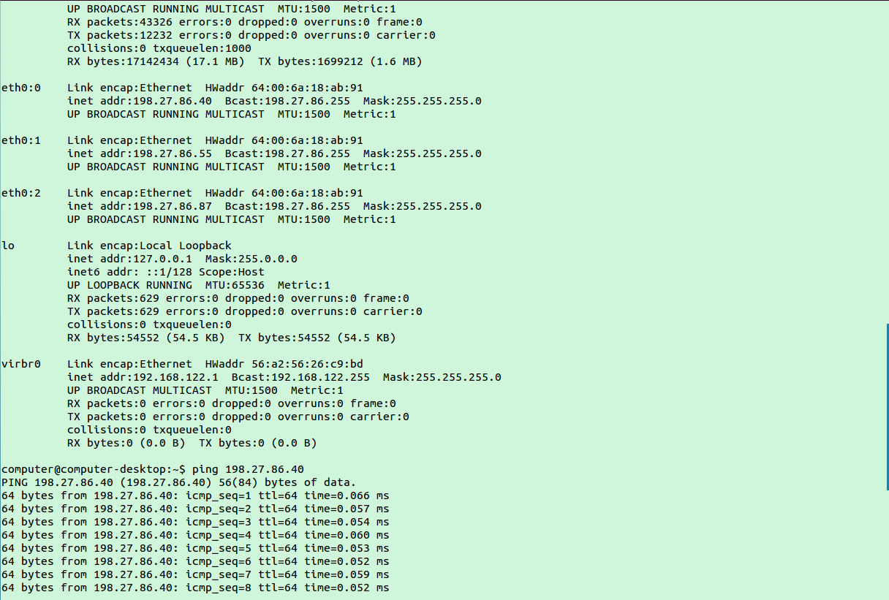

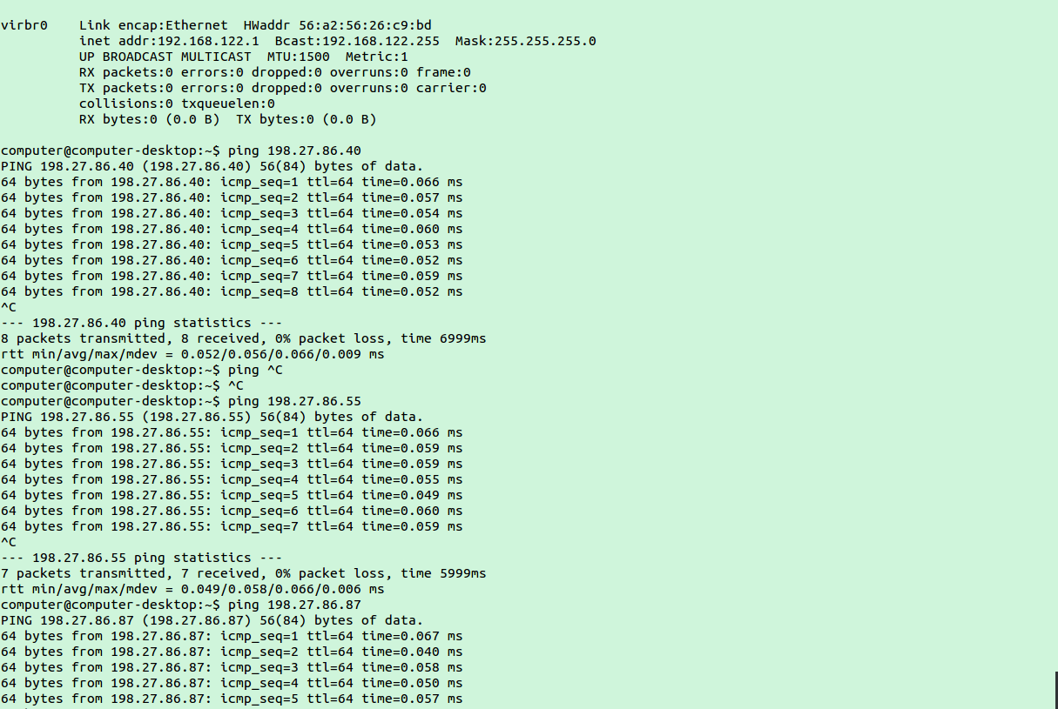
Conclusion:-.Hence we have implemented multiple IP address on a single LAN.

