
Experiment No: 3

Aim:Perform network discovery using discovery tools.(Mrtg)

Theory:

The Multi Router Traffic Grapher (MRTG) is a tool to monitor the traffic load
on network links. MRTG generates HTML pages containing PNG images which provide a LIVE visual representation of this traffic.

MRTG Features

Portable

MRTG works on most UNIX platforms and Windows NT.

Perl

MRTG is written in Perl and comes with full source.

Portable SNMP

MRTG Uses a highly portable SNMP implementation written entirely in Perl (thanks to Simon Leinen). There is no need to install any external SNMP package.

SNMPv2c support

MRTG can read the new SNMPv2c 64bit counters. No more counter wrapping.

Reliable Interface Identification

Router interfaces can be identified by IP address, description and ethernet address in addition to the normal interface number.

Constant size Logfiles

MRTG's logfiles do NOT grow thanks to the use of a unique data
consolidation algorithm.

Automatic Configuration

MRTG comes with a set of configuration tools which make configuration and

setup very simple.
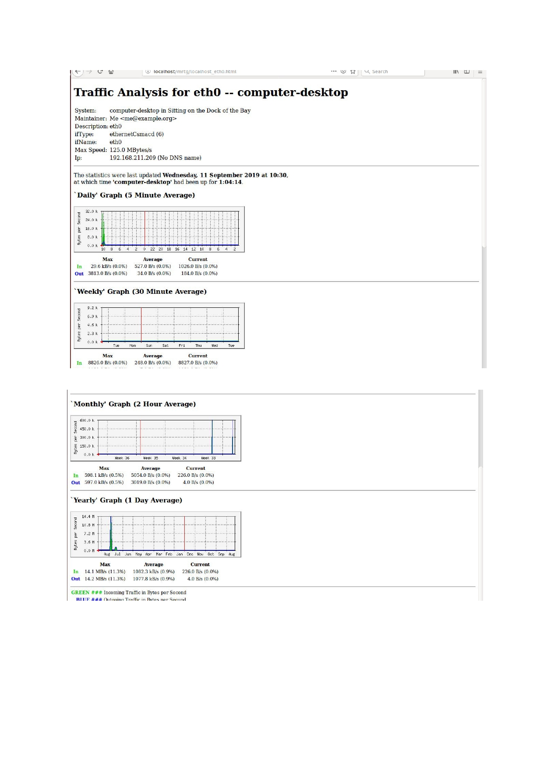
Output:

Conclusion: Hence we successfully executed the program of MRTG.

