Large Scale Computing

Lab 3

1. **Job script**

#!/bin/bash

#SBATCH --job-name=blender_flower

#SBATCH --output=blender.out

#SBATCH --error=blender.err

#SBATCH --array=1-100

#SBATCH --time=00:30:0

#SBATCH -N 1

#SBATCH --ntasks-per-node=1

#SBATCH --cpus-per-task=4

#SBATCH --mem-per-cpu=1GB

#SBATCH -p plgrid

#SBATCH -A plglscclass24-cpu

module load blender

BLEND_FILE="repeat_zone_flower_by_MiRA.blend"

OUTPUT_DIR="$SCRATCH/rendered_frames"

mkdir -p $OUTPUT_DIR

blender -b "$BLEND_FILE" -o "$OUTPUT_DIR/frame_" -F PNG -f $SLURM_ARRAY_TASK_ID

# Notify completion

echo "Rendering completed for frame $SLURM_ARRAY_TASK_ID. Results are in $OUTPUT_DIR"

1. **History**

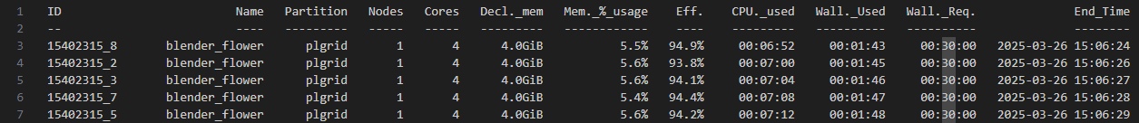

To perform calculations I used a python script:

import re

def parse_time_to_hours(time_str):

    h, m, s = map(int, time_str.split(':'))

    return h + m / 60 + s / 3600

file_path = "hpc-jobs-history.txt"

total_cpu_hours = 0

total_efficiency = 0

job_count = 0

with open(file_path, "r") as file:

    for line in file:

       # ID   Name   Partition   Nodes   Cores   Decl._mem   Mem._%_usage   Eff. CPU._used   Wall._Used   Wall._Req.   End_Time

        match = re.search(r"(\d+)\s+\S+\s+\S+\s+\d+\s+(\d+)\s+\S+\s+\S+\s+(\S+)%\s+(\d+:\d+:\d+)\s+(\d+:\d+:\d+)", line)

        if match:

            cores = int(match.group(2))

            efficiency = float(match.group(3))

            cpu_time = parse_time_to_hours(match.group(4))

            print(match.group(1), match.group(2), match.group(3), match.group(4))

            total_cpu_hours += cpu_time

            total_efficiency += efficiency

            job_count += 1

average_efficiency = (total_efficiency / job_count) if job_count else 0

print(f"Total CPU-Hours Used: {total_cpu_hours:.2f} hours")

print(f"Average Efficiency: {average_efficiency:.2f}%")

1. **Efficiency**

Average efficiency ≈ 97.53%

Highest efficiency = 99.4%

1. **CPU-hours**

Estimated time for the whole animation ≈ 61.92 h