FIT5147 Project: Predictors of Australian Election Results

Name: Lachlan Moody

Student Number: 27809951

Tutor Name: Bruno Luis Mendivez Vasquez & Ying Yang

Introduction ~ .5 page

Data Wrangling ~ 1 page

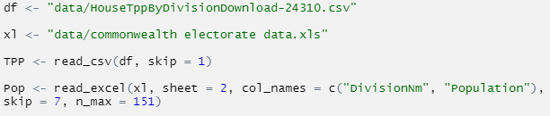

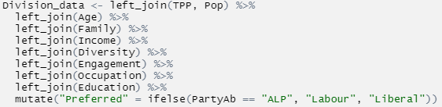

Figure 1: Tabular data wrangling





Data Checking ~ 1 page

Once the appropriate data wrangling and checking was completed in R Studio, the shapefile and combined csv file (saved as Division_data in Figure 1, were imported to Tableau public and were joined using the variables ‘Elect_div’ and ‘DivisionNm’.

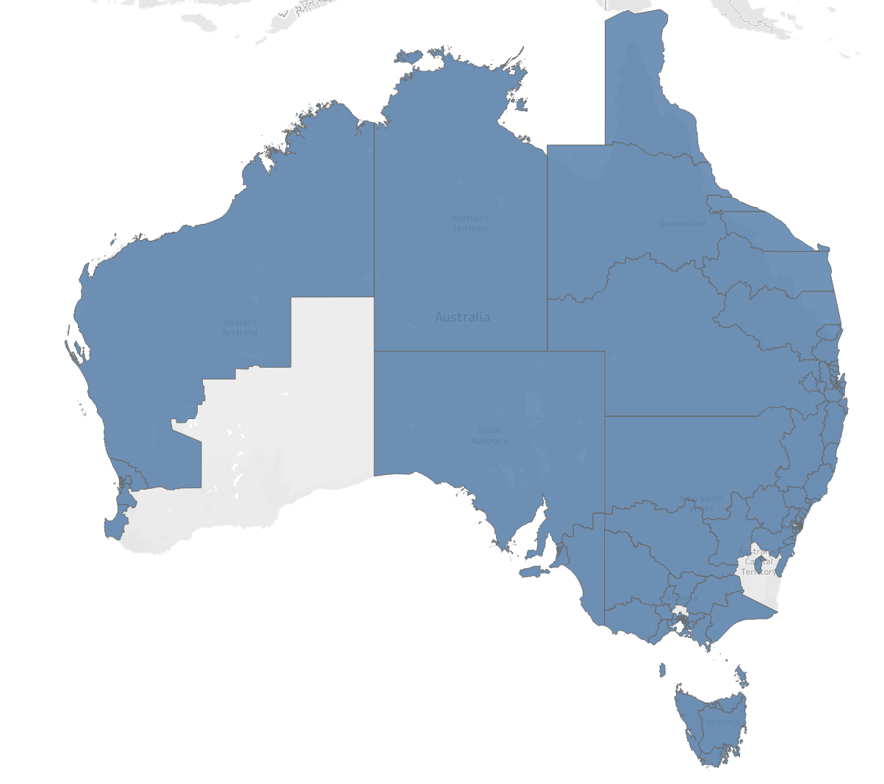

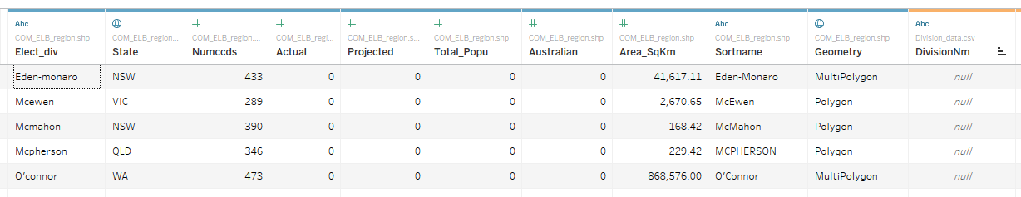

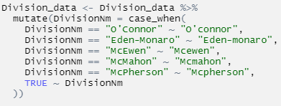

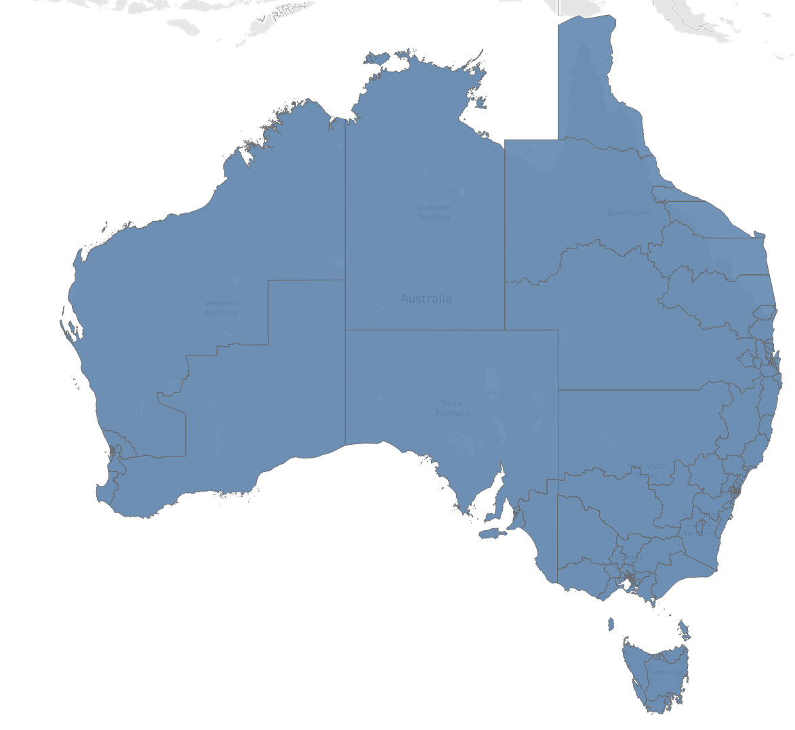

Data Exploration

Q1: How were Australia’s national election results distributed in 2019 on a two-party preferred basis?

To first examine the 2019 election results, a broad overview of the data distribution was required. The shapefile data was first plotted over a map of Australia in Tableau, with each electoral division coloured according to the party that won the preferred vote. Alongside this a pie chart was created comparing the total number of results received from each party. In both instances Labour was coloured red and Liberal blue to align with the party’s respective colours. The output is shown below in Figure 2.

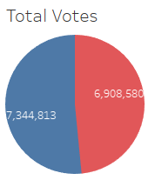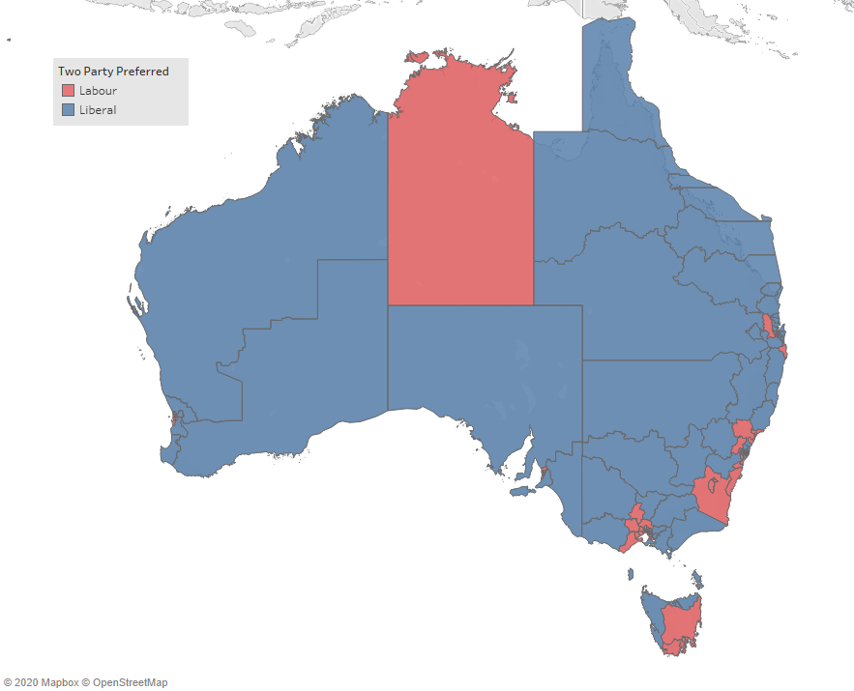

Figure 2: Distribution of TPP votes in Australia for 2019

Looking at these two outputs paints two very different pictures. Examing the chloropleth map, it would first appear that the Liberal party took almost all of the available seats in the country except for some small pockets in New South Wales around Sydney and Victoria in the Melbourne metro area. The majority of the Northern Territory and Tasmania also swung towards Labour. However, when looking at the number of votes received by each party, the gap appears much smaller at approximately 400,000 votes (or around a 3% swing). So what is the explanation for this apparent visual discrepency? To explore this area further, information relating to each seat was analysed, the outputs of which can be seen below in Figure 3, Figure 4 & Figure 5.

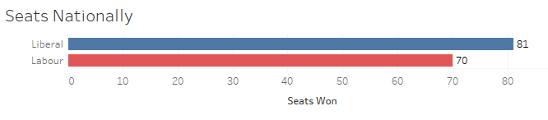

Figure 3: Number of seats won Nationally

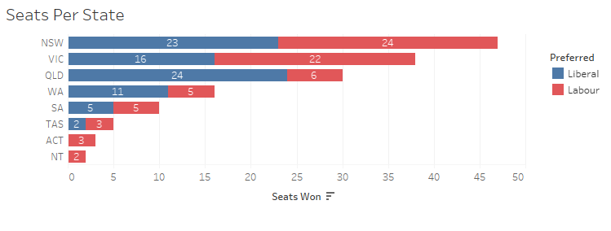

Figure 4: Number of seats won by state

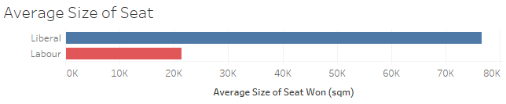

Figure 5: Size of seat won by party

The first plot was created by counting the number of seats won by each party across the entire country. While the overall outcome may be the same, again, the results paint a much tighter picture than one initially may get from examining the map only, as at first glance it would appear that there is a much greater discrepancy than only 11 seats.

Furthermore, examining the second plot which groups the seats won by state, it appears that Labour actually won in New South Wales (barely), Victoria and tied in South Australia. This led to a theory that there were many smaller seats in the metropolitan regions that Labour were winning, while the Liberal party was performing better in larger regional seats. This was confirmed in Figure 5 which plotted the average size of the seats won by each party. As can be seen above, on average, the Liberal party were winning seats almost 4 times larger than that of Labour. This explained the visual discrepancy seen earlier in Figure 2.

The final variable of interest from this data set related to swing – that is the percentage change in votes for each electorate compared to the previous election in 2016. This required more robust visual analysis than available in Tableau, so returning to R Studio, two violin plots were created using ggplot2 (Wickham, 2016) comparing the swing percentage for each party overall and within each individual state, the output is displayed below.

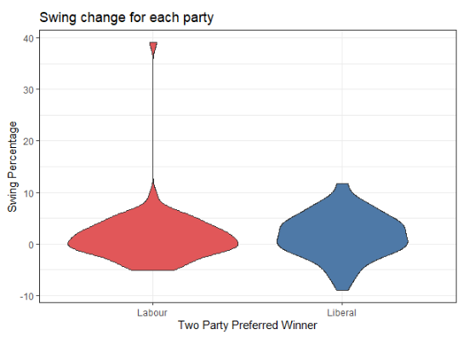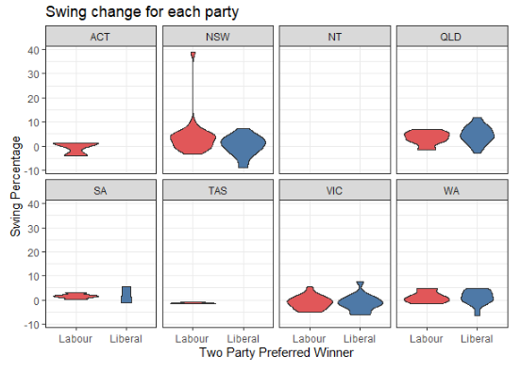

Figure 6: Distribution of swing percentage for each party

Figure 6 provides several key insights. Firstly, both distributions are centred closely above zero, with the Liberals polling slightly higher, supporting the reported swing on election night (Beaumont, 2019). Furthermore, the Labour distribution is thicker around zero which would indicate the level of support they received didn’t change much from the previous election. Noticeably, there is one value which appears to be a positive outlier in the Labour distribution. On further investigation it was found to be the seat of Whitlam in New South Wales and it experienced a 39.09% swing in favour of Labour. Initially this was thought to be a data entry error, however further searching online provided the reason for this drastic change from 2016 to 2019. This occurred because the Liberal Party did not even contest the seat in the latest election, with the opposition candidate coming from The Nationals (Green 2019). Thus, the entire difference in result, which was reported as 39.1% was credited as a swing to the Labour Party. Finally, examining on a state-by-state basis, most notably in Queensland, the Labour party recorded barely any positive swing, with most seats remaining the same or losing votes to the Liberals. This is supported by the findings in Figure 4 which has the state as the Liberal’s biggest win at 24 seats to 6.

Q2: How were Australia’s national demographic statistics distributed in 2019 for each electorate?

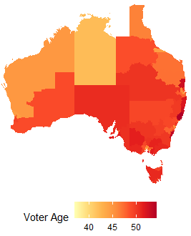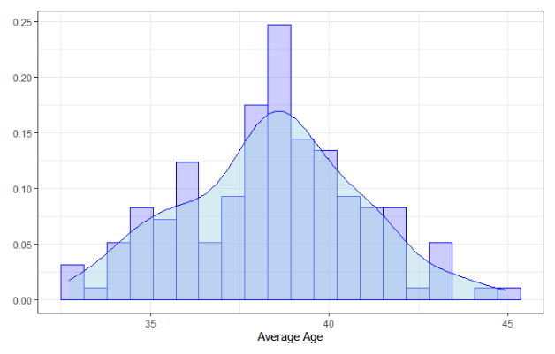

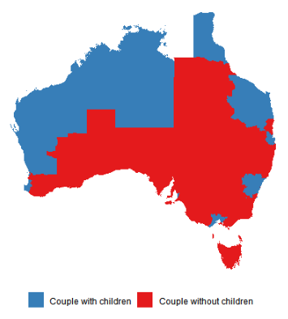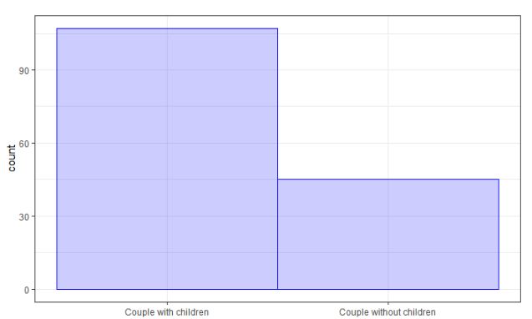

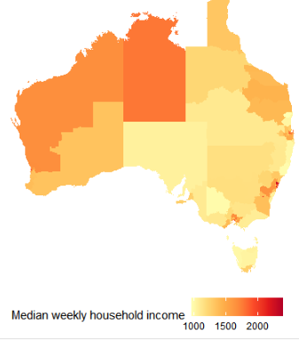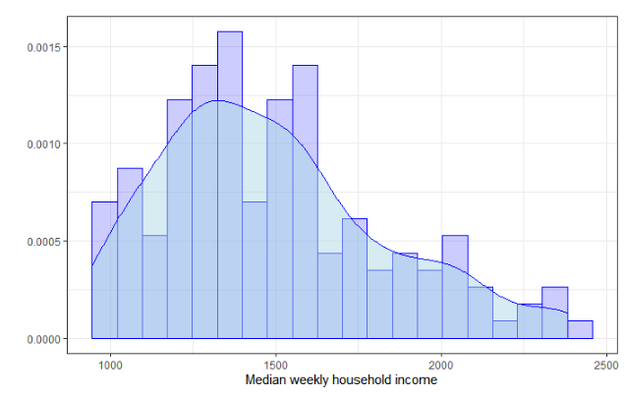

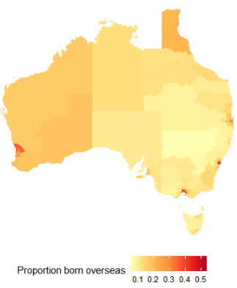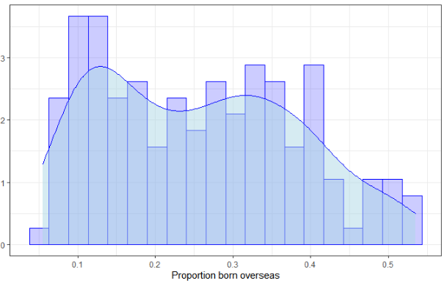

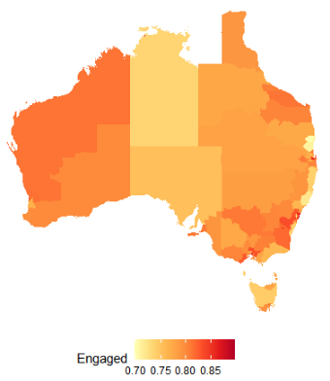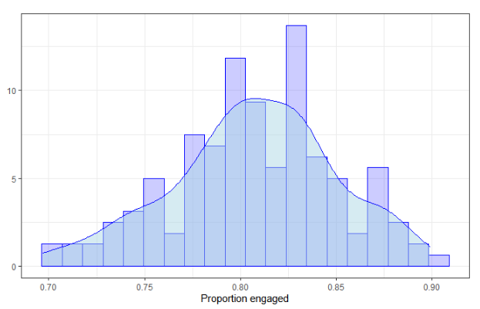

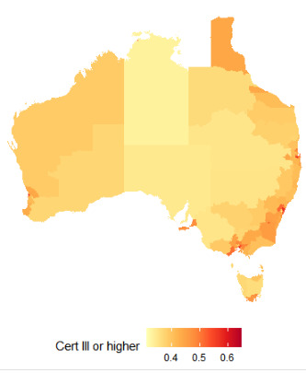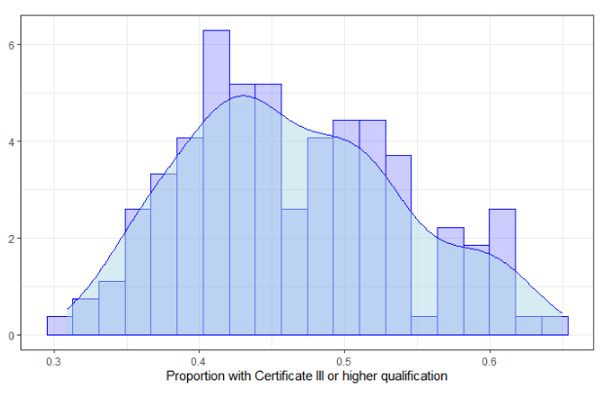

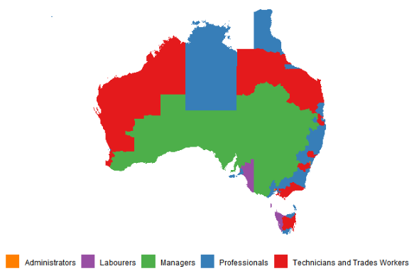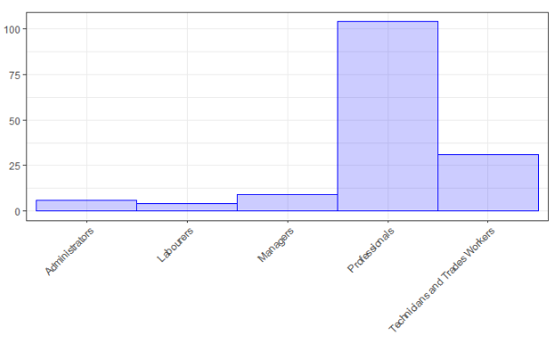

Q3: Is there any interaction or explanatory power between demographic statistics and election results in Australia?

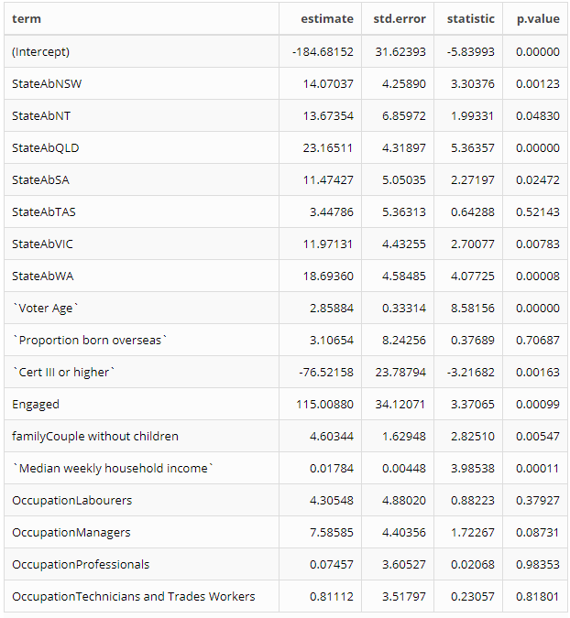

Table 1: Overall model statistics

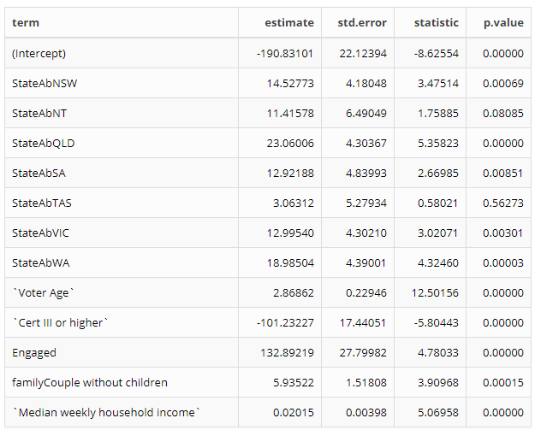

Table 2: Stepwise model results

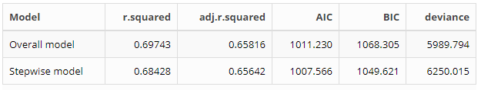

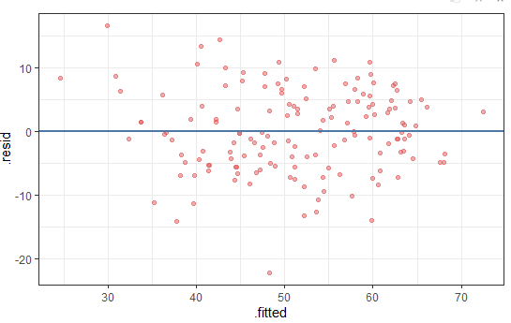

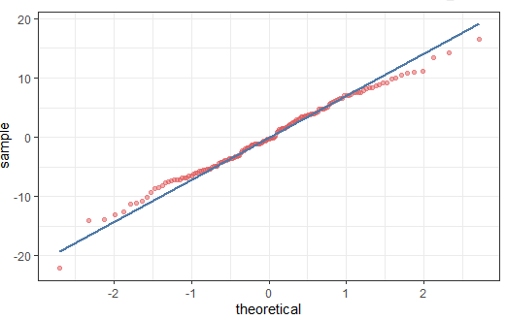

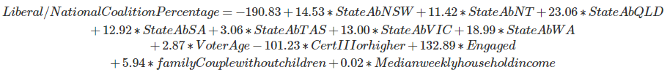

Conclusion ~ .5 page

Reflection ~ .5 page

Bibliography ~.5 page

<https://theconversation.com/final-2019-election-results-education-divide-explains-the-coalitions-upset-victory-118601>

https://www.abc.net.au/news/elections/federal/2019/guide/whit

<https://www.aihw.gov.au/reports/life-expectancy-death/deaths-in-australia/contents/life-expectancy>

<https://results.aec.gov.au/24310/Website/HouseDefault-24310.htm>

<https://www.aec.gov.au/Electorates/gis/gis_datadownload.htm>

<https://www.abs.gov.au/AUSSTATS/abs@.nsf/DetailsPage/2082.02019?OpenDocume>

H. Wickham. ggplot2: Elegant Graphics for Data Analysis. Springer-Verlag New York, 2016.

Appendix

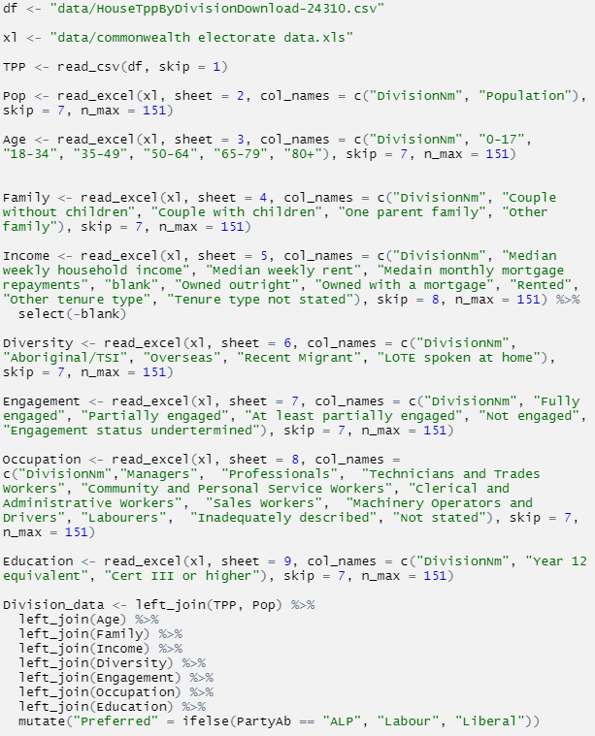

|  |  |
| --- | --- |
| Variable Name | Description |
|  |  |
|  |  |
|  |  |
|  |  |
|  |  |
|  |  |
|  |  |

