IEEE STANDARD 1016: Software Design Specification

The Software Design Specification Outline
1. Introduction

1.1 Purpose of this document
Show pictures and pseudo code trace for test plan for input and output function table

1.2 Scope of the development project
See SRS 1.2 scope

1.3 Definitions, acronyms, and abbreviations
Not applicable

1.4 References
Not applicable
1.5 Overview of document
Section 2 overview of structure and relationships
Section 3 picture examples of test plan function table with pseudo code trace
2. System architecture description
2.1 Overview of modules / components
Same color means the files depend on each other
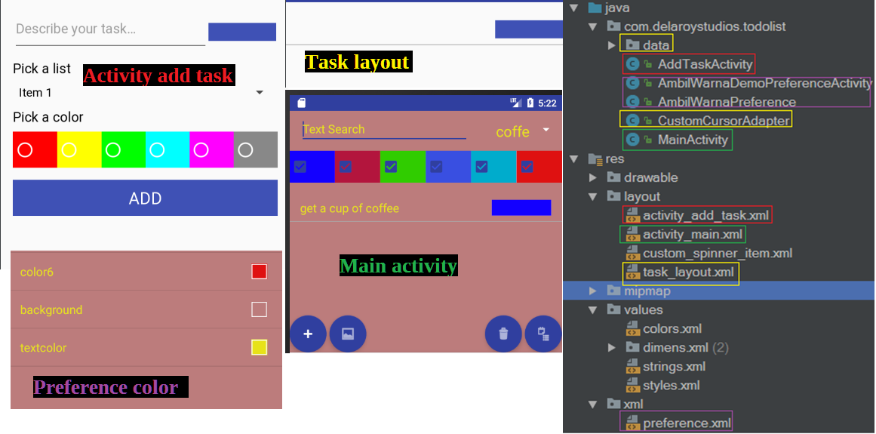

2.2 Structure and relationships
See 6.0 pseudocode for components

2.3 User interface issues
Not applicable.

3. Detailed description of components

3.1 Component template description
Will give examples pictures for test plan function table

3.2a
Open Add Task Activity | Click fab add symbol, or  Click on a task | Open Add Task Activity  Fab short for floating action button
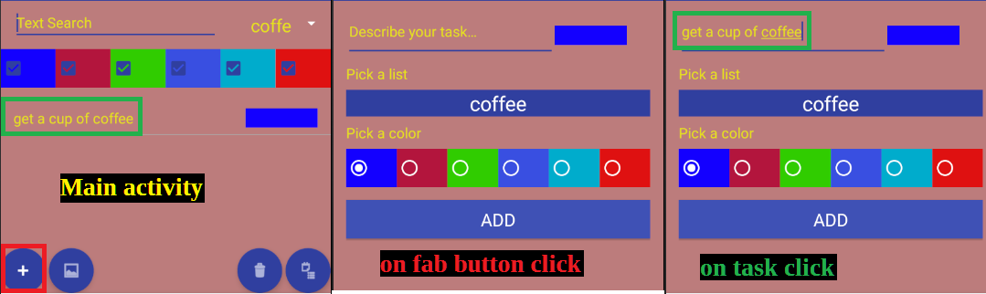
3.2b
Open Color Settings | Click fab picture symbol | Open Color Settings  Temporarily changes drop down to editColorLoader  On resume loads first list on the drop down
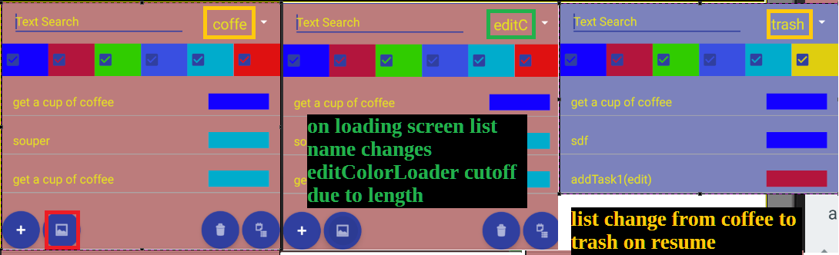
3.2c
Delete list | Click fab trash symbol | Open delete list dialog: “Do you want to delete list name” (no, yes)
Delete dialog no | Select no | Nothing changes
Delete dialog yes | Select yes | Move all task in list to trash  Delete list from trash permanently delete all trash task
Delete task | Swipe left or right | Task is moved to trash  Trash delete permanently removes list
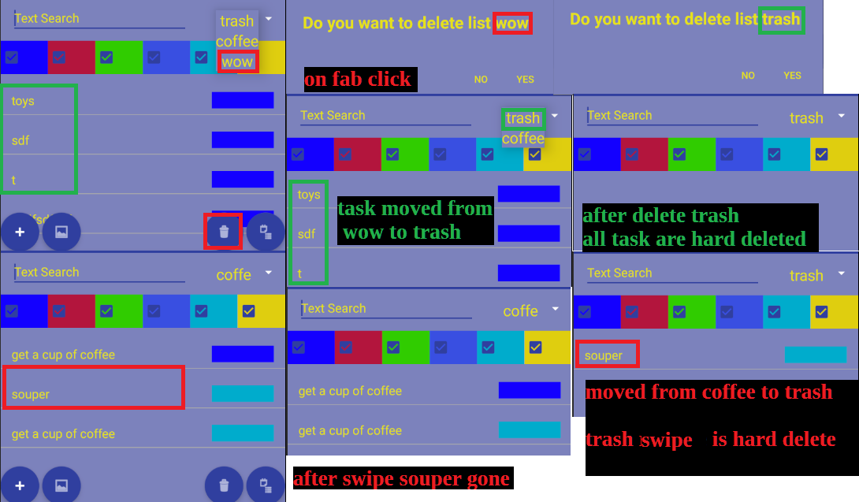

3.2d
Add list | Click fab menu symbol | Add dialog: “Add a list” (no, yes, text field for name),  cut off display if text field is too long
Add dialog no | Select no | Nothing changes
Add dialog yes | Select yes | Change list task and drop down to text field name  Empty list or duplicate names does not create a new list
Drop down list | Click + select a list | View task from selected list
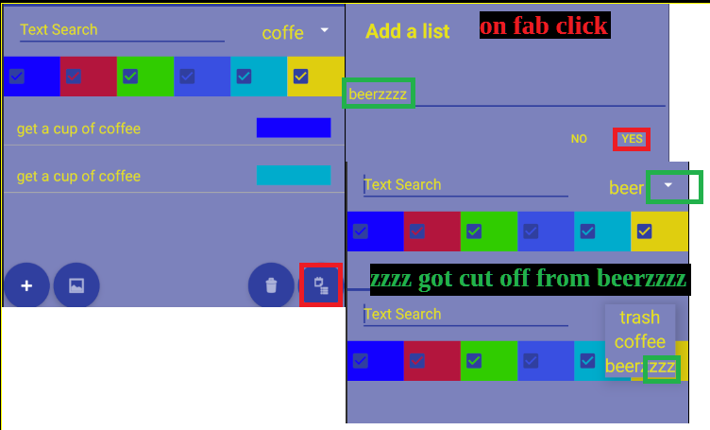
3.2e
Filter colors | Click checkbox | If checked, show task with color
String search | Enter Text Search Field | Show task that contains substring of Text Search Field
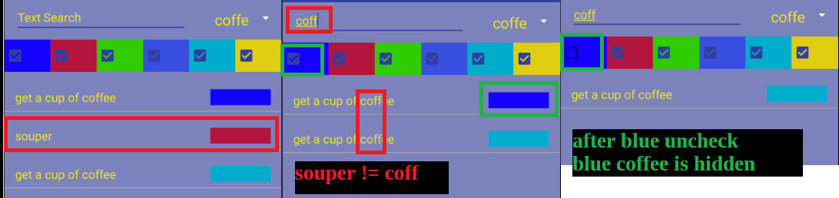

3.2f
Test function | Input | Expected Output
Change color # | Click color # box | Open custom color selector
Change text color | Click text color box | Open custom color selector
Change background | Click background box | Open custom color selector
Custom color selector | (Cancel, ok, color selector) | (Cancel -> old color, ok -> change color to color selector)
On resume | Click back | Update changed color settings
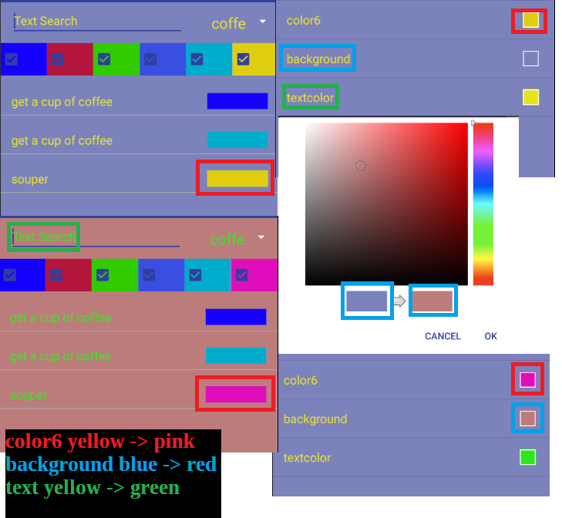

3.2g
Test function | Input | Expected Output
Task name | Task textfield | On Add click names task to textfield,  does not show if empty textfield, cutoff display if textfield is too long
Pick a list | Click drop down + select | On Add click names list to drop down selection
Pick a color | Select a color | On Add click assigns selected color to task
Add button | On Add click | Writes task to table with parameters (name, color, list)

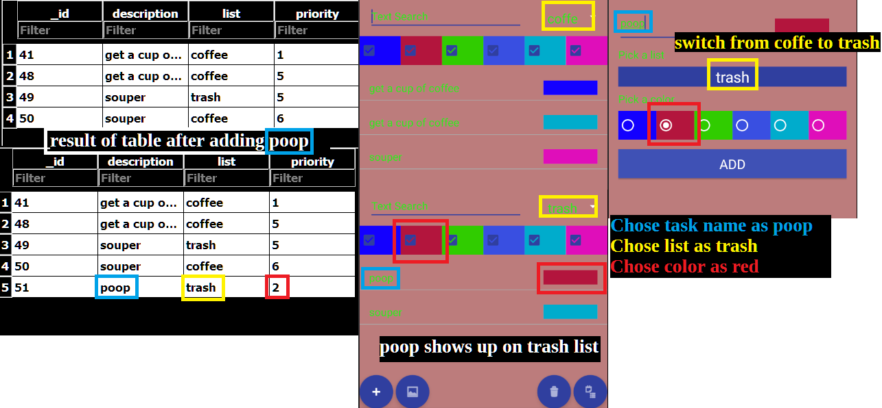

4.0 Reuse and relationships to other products
Not applicable.

5.0 Design decisions and tradeoffs
Not applicable.

6.0 Pseudocode for components reference 3.2a-3.2g with pink comments
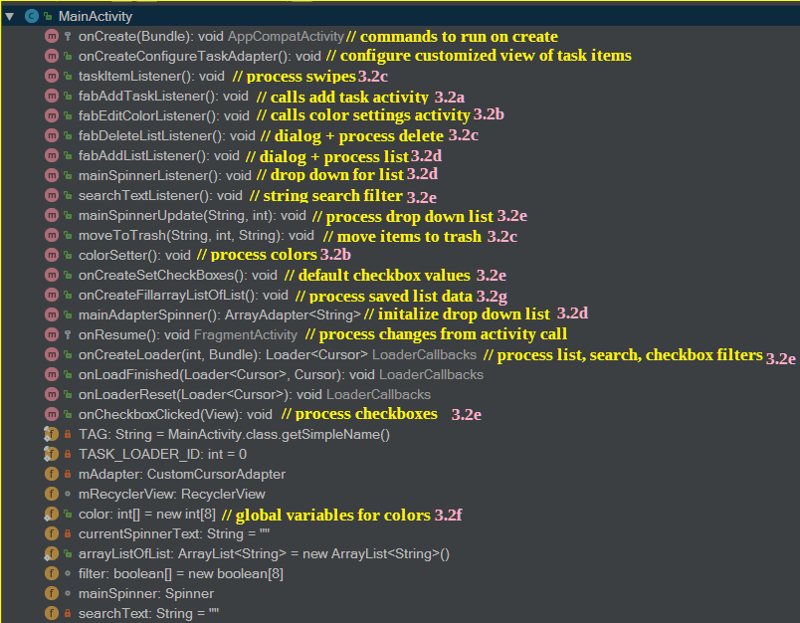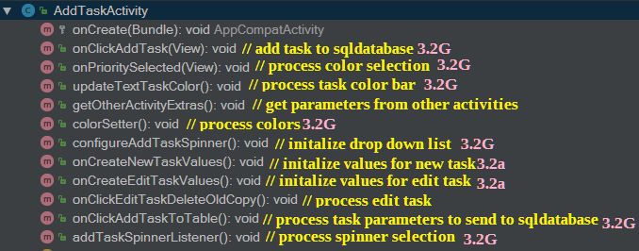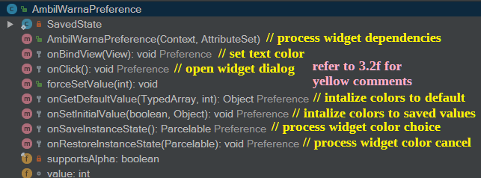

7.0 Appendices (if any) Not applicable.

