<Project Name>
Test Plan
Version <1.0>
<12/15/2017>

VERSION HISTORY
This project was done alone and due to time constraints, the test plan was made after the project has been fully completed.
TABLE OF CONTENTS
1 INTRODUCTION 3
1.1 Purpose of The Test Plan Document 3
2 FUNCTION TESTING 3
2.1 Test Approach(s) 3
2.2 Test Table 3-4
2.3 Test Hardware 4
TEST PLAN APPROVAL 4

Introduction

Purpose of The Test Plan Document
Test plan has a list of all the function test made with test driven development.

Function Testing

TEST APPROACH(S) TEST DRIVEN DEVELOPMENT

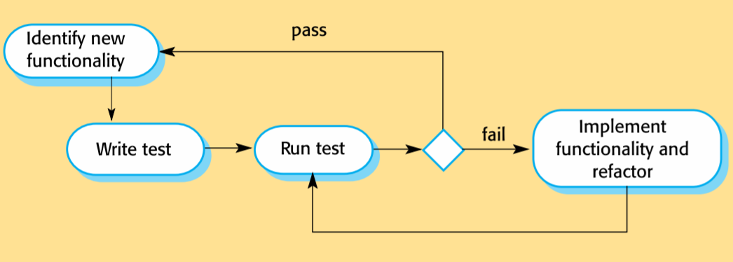

ACTIVITY TABLES
Pass for input and expected output.
Fail for input and not expected output.

COLOR SETTINGS TaBLE
Test function | Input | Expected Output
Change color # | Click color # box | Open custom color selector
Change text color | Click text color box | Open custom color selector
Change background | Click background box | Open custom color selector
Custom color selector | (Cancel, ok, color selector) | (Cancel -> old color, ok -> change color to color selector)
On resume | Click back | Update changed color settings

ADD TASK ACTIVITY TaBLE
Test function | Input | Expected Output
Task name | Task textfield | On Add click names task to textfield,  does not show if empty textfield, cutoff display if textfield is too long
Pick a list | Click drop down + select | On Add click names list to drop down selection
Pick a color | Select a color | On Add click assigns selected color to task
Add button | On Add click | Writes task to table with parameters (name, color, list)

MAIN ACTIVITY TABLE
Test function | Input | Expected Output
Open Add Task Activity | Click fab add symbol, or  Click on a task | Open Add Task Activity  Fab short for floating action button
Open Color Settings | Click fab picture symbol | Open Color Settings  Temporarily changes drop down to editColorLoader  On resume loads first list on the drop down
Delete list | Click fab trash symbol | Open delete list dialog: “Do you want to delete list name” (no, yes)
Delete dialog no | Select no | Nothing changes
Delete dialog yes | Select yes | Move all task in list to trash  Delete list from trash permanently delete all trash task
Delete task | Swipe left or right | Task is moved to trash  Trash delete permanently removes list
Add list | Click fab menu symbol | Add dialog: “Add a list” (no, yes, text field for name),  cut off display if text field is too long
Add dialog no | Select no | Nothing changes
Add dialog yes | Select yes | Change list task and drop down to text field name  Empty list or duplicate names does not create a new list
Drop down list | Click + select a list | Show that task in that list
Filter colors | Click checkbox | If checked, show task with color
String search | Enter Text Search Field | Show task that contains substring of Text Search Field

Test Hardware
- Nexus 5X API 25 (Android 7.1.1., API 25) Emulator
-Samsung SM-J710MN (Android 6.0.1, API 23) Phone

Test Plan Approval
The project was done alone, so no approval was required.

