**Supplementary Material**

**Table S1.** Training session information. The table presents the date of all executed training sessions for both pilots and the number and type of runs performed in each session and reported here. Asterisks indicate one or more runs have been lost due to technical failure or bad maintenance.

|  |  |  |  |  |  |  |  |  |  |
| --- | --- | --- | --- | --- | --- | --- | --- | --- | --- |
| **P1** | | | | | **P2** | | | | |
| **Session**  **#** | **Session**  **Date** | **Offline** | **Online** | **Race** | **Session**  **#** | **Session**  **Date** | **Offline** | **Online** | **Race** |
| 1 | 04/04 | 5 | 1 | 0 | 1 | 14/07 | 4 | 1* | 0 |
| 2 | 08/04 | 3 | 0 | 0 | 2 | 21/07 | 2 | 0 | 0 |
| 3 | 18/04 | 2 | 0 | 0* | 3 | 04/08 | 4 | 0 | 0 |
| 4 | 29/04 | 0 | 0 | 2* | 4 | 11/08 | 3 | 1* | 0 |
| 5 | 02/05 | 0 | 0 | 5 | 5 | 18/08 | 0 | 2* | 2 |
| 6 | 09/05 | 0 | 0 | 8 | 6 | 23/08 | 0 | 1 | 8 |
| 7 | 20/05 | 1 | 0 | 3 | 7 | 25/08 | 0 | 0 | 7* |
| 8 | 27/05 | 1 | 0 | 9 | 8 | 01/09 | 0 | 6 | 0 |
| 9 | 03/06 | 0 | 0 | 9 | 9 | 08/09 | 0 | 6 | 0 |
| 10 | 17/06 | 2 | 2 | 3 | 10 | 22/09 | 2 | 0 | 5* |
| 11 | 24/06 | 5 | 0 | 0 | 11 | 26/09 | 0 | 1* | 7 |
| 12 | 30/06 | 6 | 1 | 0 | 12 | 29/09 | 0 | 1 | 7 |
| 13 | 04/07 | 2 | 5 | 0 | 13 | 03/10 | 0 | 0 | 2 |
| 14 | 07/07 | 1* | 1 | 0* | 14 | 05/10 | 0 | 0 | 8 |
| 15 | 13/07 | 1 | 0 | 0* | 15 | 06/10 | 0 | 0* | 9 |
| 16 | 20/07 | 1 | 0 | 0* | 16 | 08/10 | 0 | 0 | 2 |
| 17 | 25/07 | 0* | 0* | 0 |  | **Total** | 15 | 19 | 57 |
| 18 | 26/07 | 0* | 0* | 0 |  |  |  |  |  |
| 19 | 27/07 | 1 | 0 | 0* |  |  |  |  |  |
| 20 | 03/08 | 1 | 0 | 0* |  |  |  |  |  |
| 21 | 10/08 | 1 | 0 | 11 |  |  |  |  |  |
| 22 | 15/08 | 0 | 0 | 10 |  |  |  |  |  |
| 23 | 17/08 | 3 | 0 | 7 |  |  |  |  |  |
| 24 | 24/08 | 0 | 0 | 11 |  |  |  |  |  |
| 25 | 25/08 | 0 | 0 | 16* |  |  |  |  |  |
| 26 | 31/08 | 0 | 0 | 16 |  |  |  |  |  |
| 27 | 07/09 | 0 | 0 | 10 |  |  |  |  |  |
| 28 | 09/09 | 4 | 0 | 7 |  |  |  |  |  |
| 29 | 14/09 | 0 | 0 | 0 |  |  |  |  |  |
| 30 | 21/09 | 0 | 0 | 10 |  |  |  |  |  |
| 31 | 22/09 | 0 | 0 | 16 |  |  |  |  |  |
| 32 | 28/09 | 0 | 1 | 9 |  |  |  |  |  |
| 33 | 30/09 | 0 | 1 | 14 |  |  |  |  |  |
| 34 | 06/10 | 0 | 0 | 9* |  |  |  |  |  |
| 35 | 08/10 | 0 | 0 | 2 |  |  |  |  |  |
| **Total** | 35 | 40 | 12 | 182 |  |  |  |  |  |

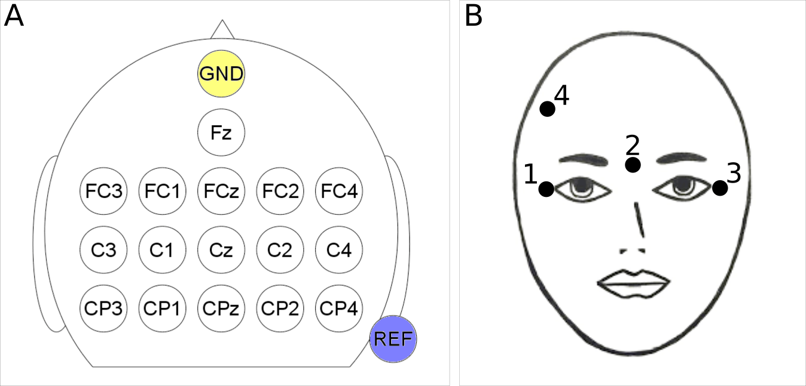

**Fig. S1.** Electrode configurations. **(A)** EEG channel configuration over 16 locations of the sensorimotor cortex according to the international 10-20 system. **(B)** EOG electrode configuration on the pilot’s right and left canthi, nasion and forehead for the detection of ocular and facial muscle artifacts.

Movie S1. Typical race training session of pilot P1. The pilot performs race training at his home a few days before the Cybathlon BCI competition. The video demonstrates the usage setup and the Brain Runners BCI control paradigm.