**Supplementary Materials**

S1 Fig. BCI feature discriminancy maps per training month.

S2 Fig. BCI feature discriminancy per training modality.

S3 Fig. Electrode configurations.

S1 Table. User-training methodology of the Cybathlon BCI race competitors.

S2 Table. Training session information.

S1 Movie. Typical race training session of pilot P1.

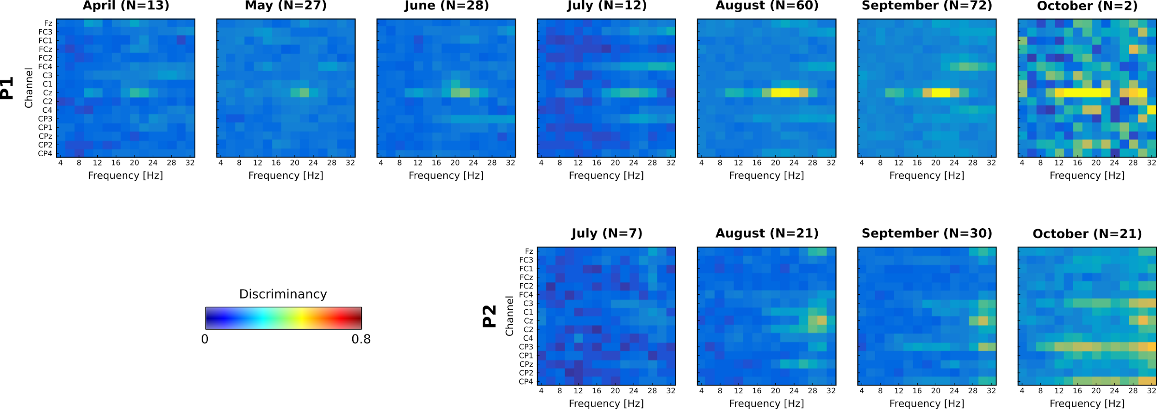

**S1 Fig.** BCI feature discriminancy maps per run (N) averaged for each training month. Bright color indicates high discriminancy between Both Hands and Both Feet motor imagery tasks employed by both pilots (P1 top, P2 bottom). The discriminancy of each feature (channel-frequency pair) is quantified as the Fisher score of the EEG signal's power spectral density distributions for these two mental classes.

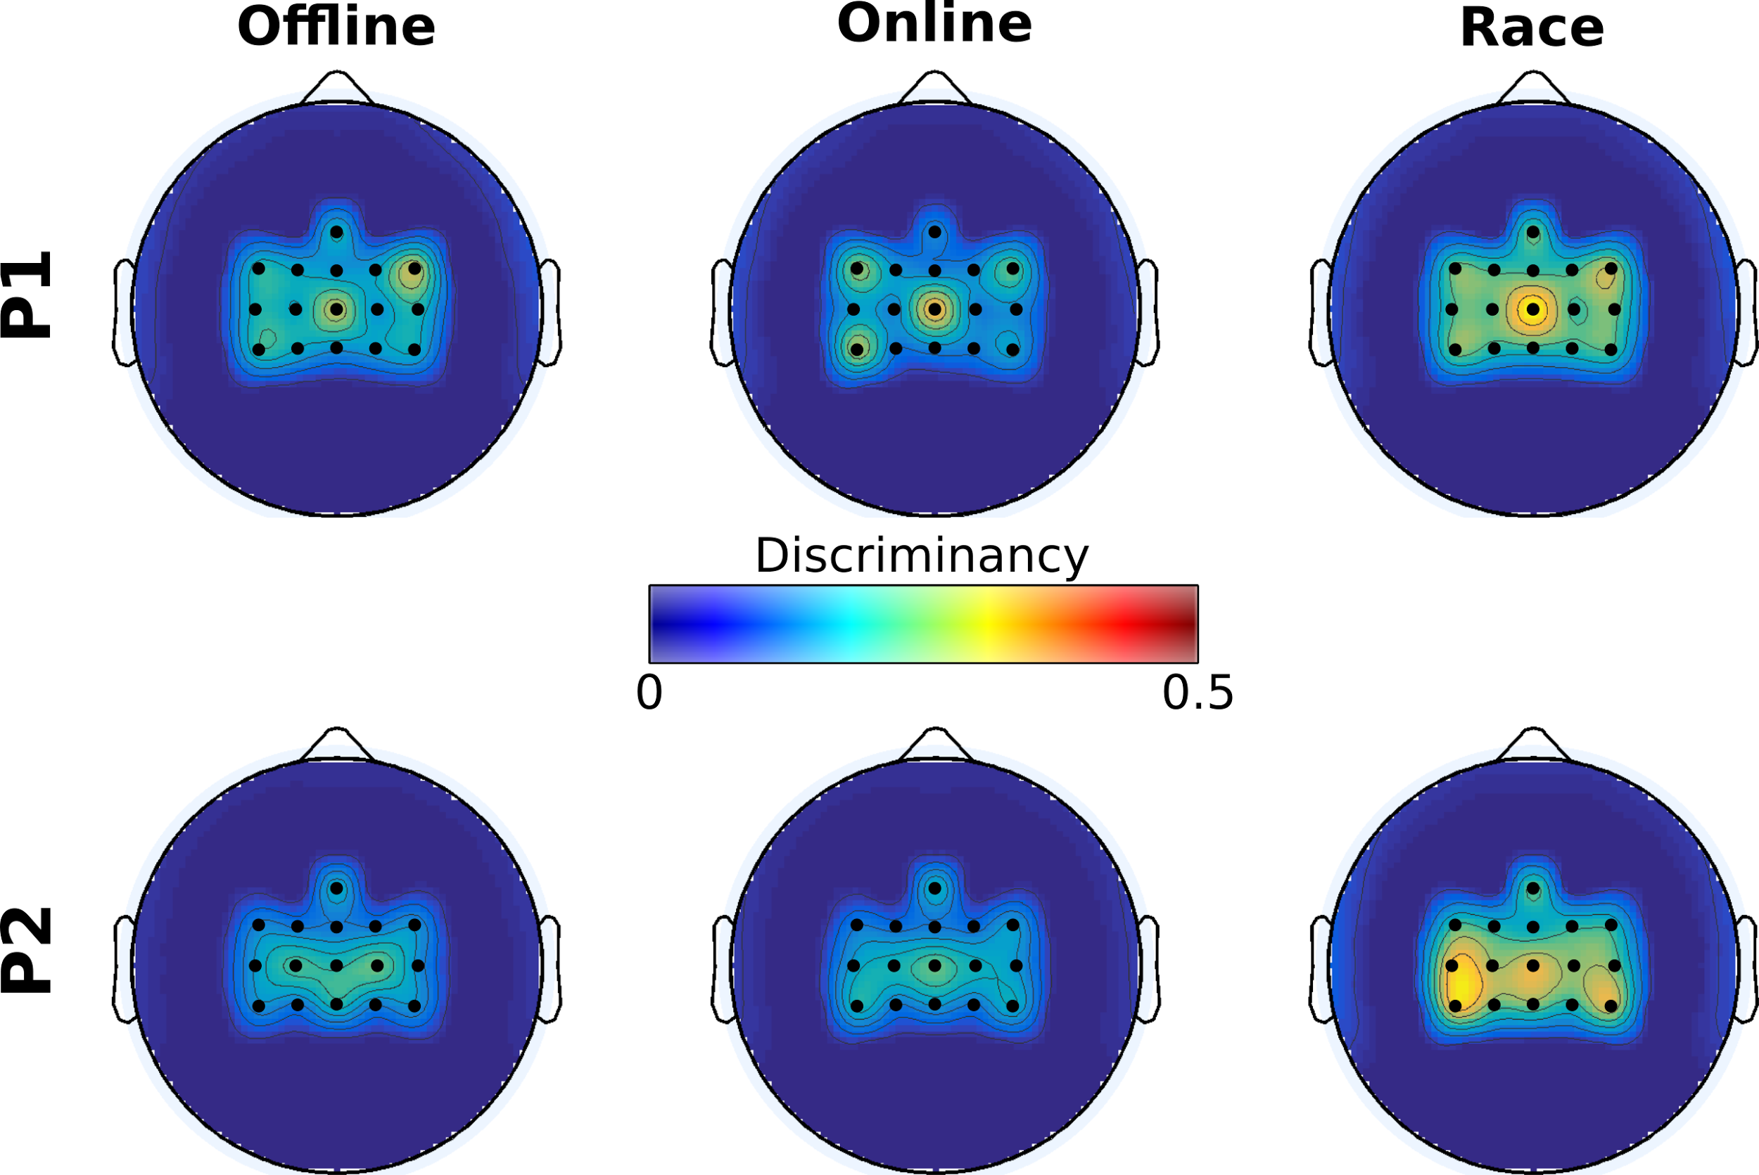 **S2 Fig.** BCI feature discriminancy per training modality. Topographic maps of discriminancy per training modality on the 16 EEG channel locations over the sensorimotor cortex monitored. Bright color indicates high discriminancy between Both Hands and Both Feet motor imagery tasks employed by both pilots (P1 top, P2 bottom). The discriminancy of each channel is quantified as the Fisher score of the EEG signal's power spectral density distributions for these two mental classes in the high β band (22-32 Hz), on this channel. Each map illustrates local Fisher scores (with inter-channel interpolation) averaged over all runs of the supertitled modality.

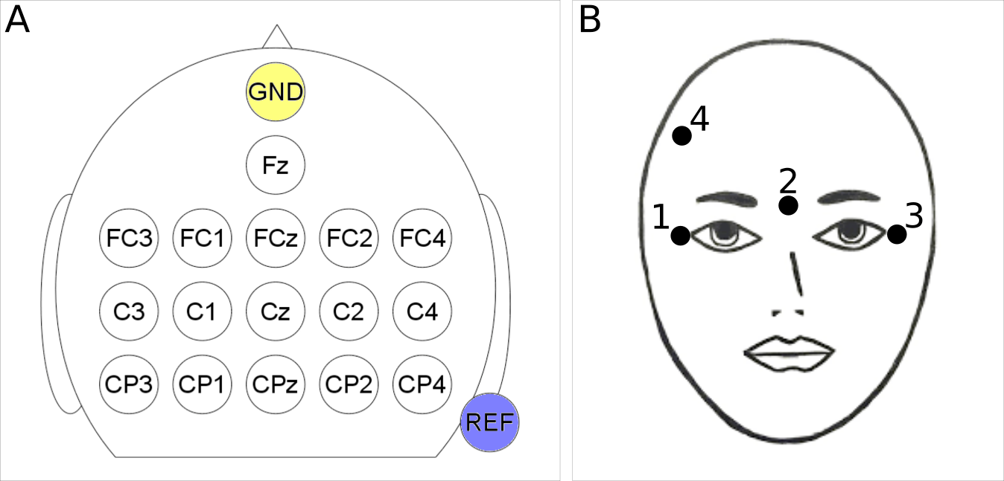

**S3 Fig.** Electrode configurations. **(A)** EEG channel configuration over 16 locations of the sensorimotor cortex according to the international 10-20 system. **(B)** EOG electrode configuration on the pilot’s right and left canthi, nasion and forehead for the detection of ocular and facial muscle artifacts.

**S1 Table.** User-training methodology details of the Cybathlon BCI race competitors.

|  |  |  |  |  |  |
| --- | --- | --- | --- | --- | --- |
| **Team** | **Duration** | **# Sessions** | **Intensity** | **Recalibration** | **Feature re-selection** |
| BrainGain [[72]](https://paperpile.com/c/dIT9gv/9qYn) | 1.5 months | 14 | 2 / week | Every session  and right before official races | No |
| Athena-Minerva [[73,74]](https://paperpile.com/c/dIT9gv/9mOO+IoIt) | 18 months | N/A | 1 / 2 weeks | Every session | Yes |
| OpenBMI | 3 months | 14 | 1-2 / week | Every session | Only first 6 weeks |
| NeuroCONCISE [[75,76]](https://paperpile.com/c/dIT9gv/6Nwr+3GKf) | 1 month | 9 (+10 in 2011) | 2-3 / week | Every session | Yes |
| Mahidol BCI | 3 months | 26 | 2 / week  4 in last week | At least once per week | Yes |
| MIRAGE91 [[37]](https://paperpile.com/c/dIT9gv/qwi2) | ~12 months | ~35 | 1 / month  2 / day in last week | Every session | No |
| Brain Tweakers | ~7 months (P1) ~4 months (P2) | 35 (P1)  16 (P2) | ~2 / week | Once | Once |

**S2 Table.** Training session information. The table presents the date of all executed training sessions for both pilots and the number and type of runs performed in each session and reported here. Asterisks indicate one or more runs have been lost due to technical failure or bad maintenance.

|  |  |  |  |  |  |  |  |  |  |
| --- | --- | --- | --- | --- | --- | --- | --- | --- | --- |
| **P1** | | | | | **P2** | | | | |
| **Session**  **#** | **Session**  **Date** | **Offline** | **Online** | **Race** | **Session**  **#** | **Session**  **Date** | **Offline** | **Online** | **Race** |
| 1 | 04/04 | 5 | 1 | 0 | 1 | 14/07 | 4 | 1* | 0 |
| 2 | 08/04 | 3 | 0 | 0 | 2 | 21/07 | 2 | 0 | 0 |
| 3 | 18/04 | 2 | 0 | 0* | 3 | 04/08 | 4 | 0 | 0 |
| 4 | 29/04 | 0 | 0 | 2* | 4 | 11/08 | 3 | 1* | 0 |
| 5 | 02/05 | 0 | 0 | 5 | 5 | 18/08 | 0 | 2* | 2 |
| 6 | 09/05 | 0 | 0 | 8 | 6 | 23/08 | 0 | 1 | 8 |
| 7 | 20/05 | 1 | 0 | 3 | 7 | 25/08 | 0 | 0 | 7* |
| 8 | 27/05 | 1 | 0 | 9 | 8 | 01/09 | 0 | 6 | 0 |
| 9 | 03/06 | 0 | 0 | 9 | 9 | 08/09 | 0 | 6 | 0 |
| 10 | 17/06 | 2 | 2 | 3 | 10 | 22/09 | 2 | 0 | 5* |
| 11 | 24/06 | 5 | 0 | 0 | 11 | 26/09 | 0 | 1* | 7 |
| 12 | 30/06 | 6 | 1 | 0 | 12 | 29/09 | 0 | 1 | 7 |
| 13 | 04/07 | 2 | 5 | 0 | 13 | 03/10 | 0 | 0 | 2 |
| 14 | 07/07 | 1* | 1 | 0* | 14 | 05/10 | 0 | 0 | 8 |
| 15 | 13/07 | 1 | 0 | 0* | 15 | 06/10 | 0 | 0* | 9 |
| 16 | 20/07 | 1 | 0 | 0* | 16 | 08/10 | 0 | 0 | 2 |
| 17 | 25/07 | 0* | 0* | 0 | **Total** | 16 | 15 | 19 | 57 |
| 18 | 26/07 | 0* | 0* | 0 |  |  |  |  |  |
| 19 | 27/07 | 1 | 0 | 0* |  |  |  |  |  |
| 20 | 03/08 | 1 | 0 | 0* |  |  |  |  |  |
| 21 | 10/08 | 1 | 0 | 11 |  |  |  |  |  |
| 22 | 15/08 | 0 | 0 | 10 |  |  |  |  |  |
| 23 | 17/08 | 3 | 0 | 7 |  |  |  |  |  |
| 24 | 24/08 | 0 | 0 | 11 |  |  |  |  |  |
| 25 | 25/08 | 0 | 0 | 16* |  |  |  |  |  |
| 26 | 31/08 | 0 | 0 | 16 |  |  |  |  |  |
| 27 | 07/09 | 0 | 0 | 10 |  |  |  |  |  |
| 28 | 09/09 | 4 | 0 | 7 |  |  |  |  |  |
| 29 | 14/09 | 0 | 0 | 0 |  |  |  |  |  |
| 30 | 21/09 | 0 | 0 | 10 |  |  |  |  |  |
| 31 | 22/09 | 0 | 0 | 16 |  |  |  |  |  |
| 32 | 28/09 | 0 | 1 | 9 |  |  |  |  |  |
| 33 | 30/09 | 0 | 1 | 14 |  |  |  |  |  |
| 34 | 06/10 | 0 | 0 | 9* |  |  |  |  |  |
| 35 | 08/10 | 0 | 0 | 2 |  |  |  |  |  |
| **Total** | 35 | 40 | 12 | 182 |  |  |  |  |  |

**S1 Movie.** Typical race training session of pilot P1.