# Assignment2—Report

# Code Part:

State class：

Use a for loop to lookup in the finger table if the finger[i].id is between the current node.id and id that need to find then return the finger[i] or return the current node.

The code in DHT.java ,webClient.java,NodeResource.java and NodeService.java





# Test part:

Join operation, for node 44 and node23 to join the node 55:



User routes operation to see the successor and predecessor of current node and finger table:

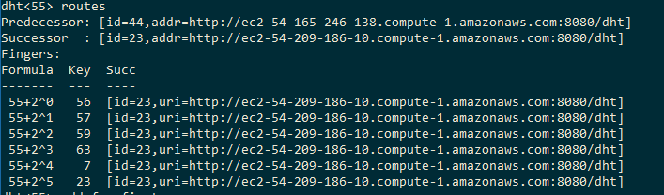

We could found that the predecessor has changed to node 44 and successor has changed to node 23 and all the finger table has point to node 23 which is correct.

The routes in node 44 and node 23:

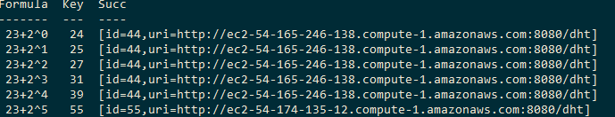

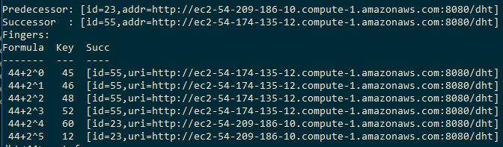

Which means the node has insert into the DHT network.

Add test (local node):

1. Added foo3 fourth in the node 55 which should be add in the local node



2.User bindings to see if the node has the entry of the foo3.



Add test (remote node):

1. Added key:foo and value:first in the node 55 as remote node



2. Found that the foo and first has been send to the node 23, nothing store in node 55.





Get test (local)

1. Testing the get method in node44 and get the response with the value of {first}.



Get test (remote)

1.Testing the get method in node44 for the foo which .



Delete test:

Bindings before delete:

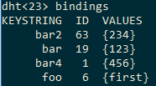

Delete test in node 23 with delete (foo ,first)



Result:

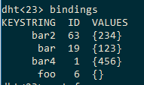

The node that store key foo. We could found that the value has been deleted.

Some other operations is in the video.