# Homework2

Problem1:

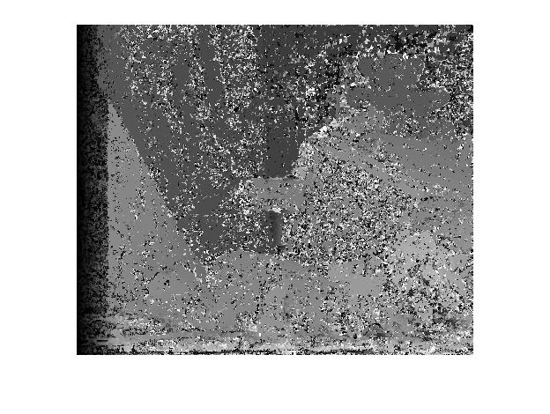

3X3 SAD Window and the error rate is 48.09%