Overview
SQLBolt is the first lab I’ll be working through after completing this week’s deliverables. The following site has tutorials and practice exercises that help me get more practice navigating around SQL and exploring the functionality of different functions. This helps me understand and break down query logic as the add-on SQL interactive notifies me the results and errors of my query immediately.

SQL Lesson 1: SELECT queries 101
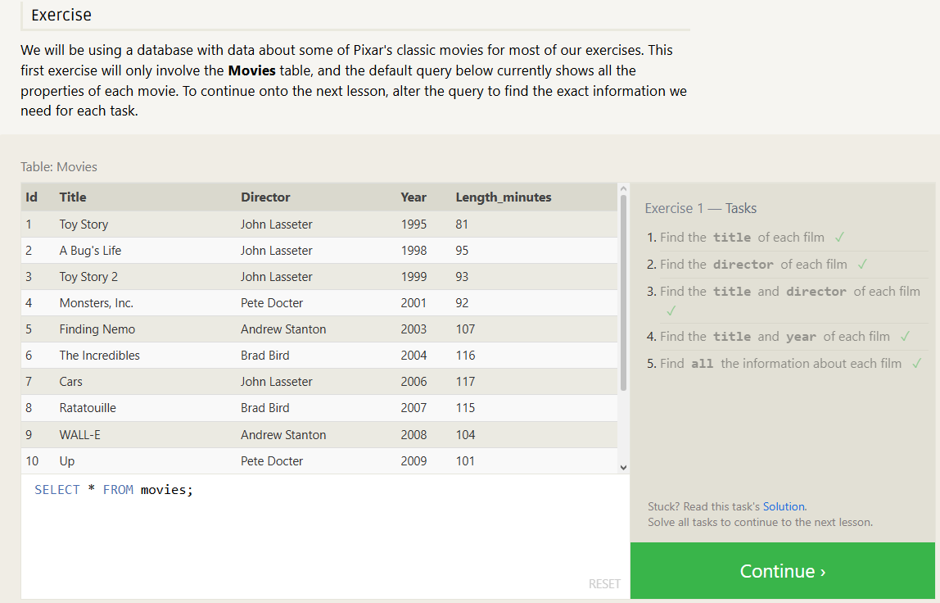
Review
- Learned how to use the SELECT function and search specifically for attributes in tables
- Used * for all, and attribute(s) for specification in tables

SQL Lesson 2: Queries with constraints (Pt. 1)
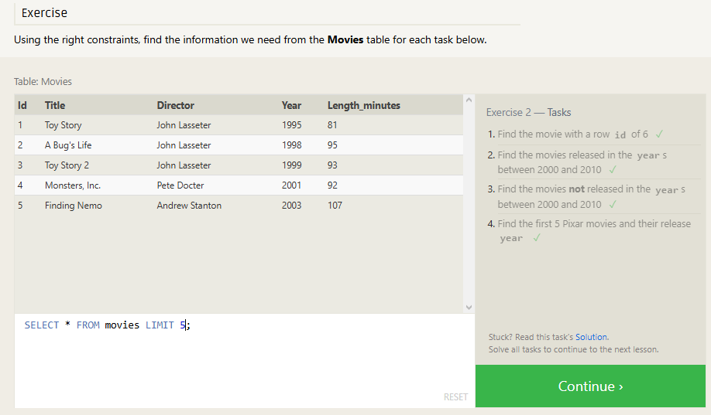
Review
- Reviewed over the LIMIT function to reduce number of results/records
- Introduced the NOT function to “reverse” output results
- Used the WHERE function in conjunction with BETWEEN to filter ranges of records

SQL Lesson 3: Queries with constraints (Pt. 2)
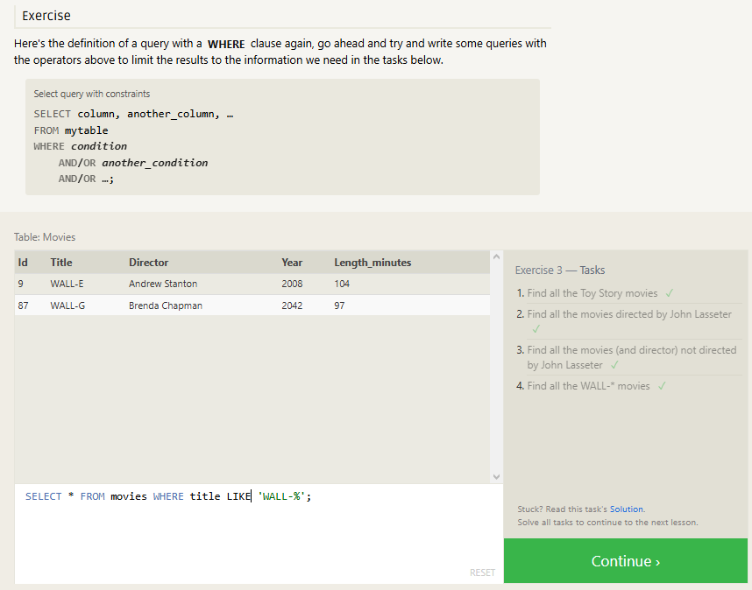
Review
- Used the LIKE function and wildcards to filter for similar results compared to exact searches
- Applied logical operators to widen or narrow results to specifications

SQL Lesson 4: Filtering and sorting Query results
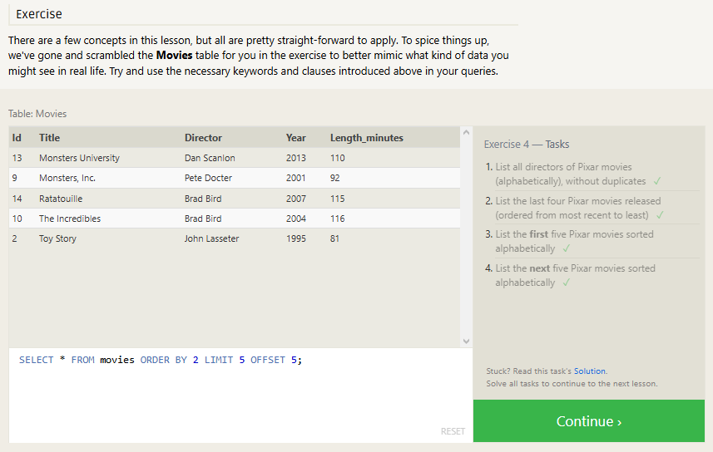
Review
- Reviewed sorting algorithms and filtering for results displayed
- Used OFFSET to look for the “next” results

SQL Review: Simple SELECT Queries
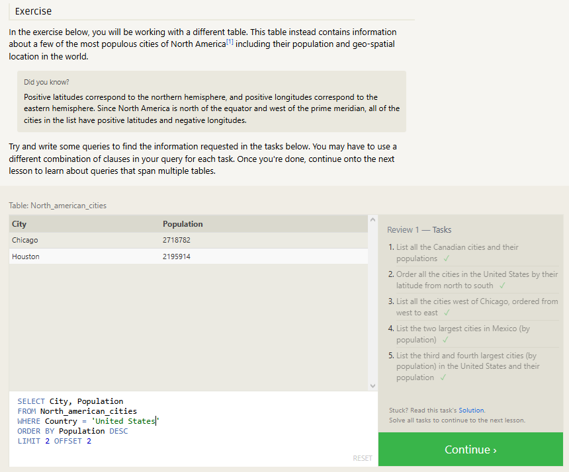
Review
- Lesson 1-5 Review

SQL Lesson 6: Multi-table queries with JOINS
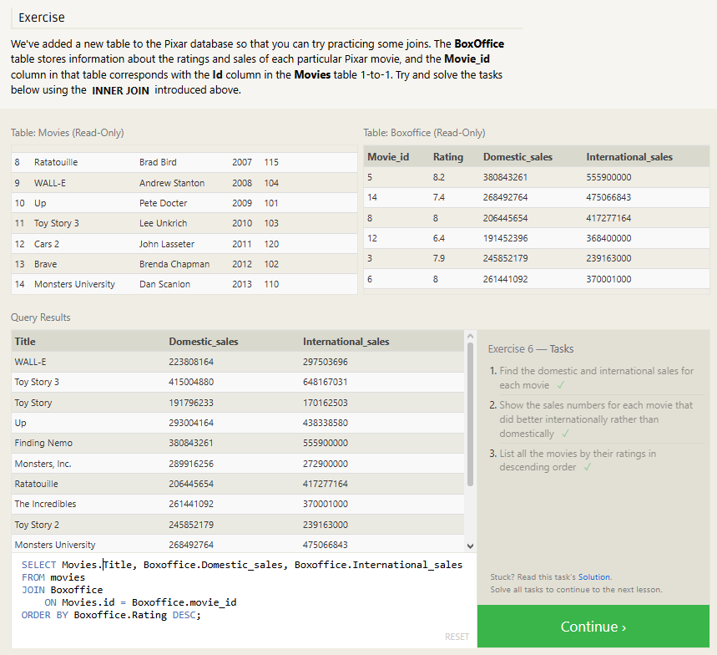
Review
- Learned to reference multiple tables through JOINS
- Learned differences in JOINS (INNER, LEFT, RIGHT, FULL)
- Learned how to reference other table attributes after using JOINS

SQL Lesson 7: OUTER JOINs
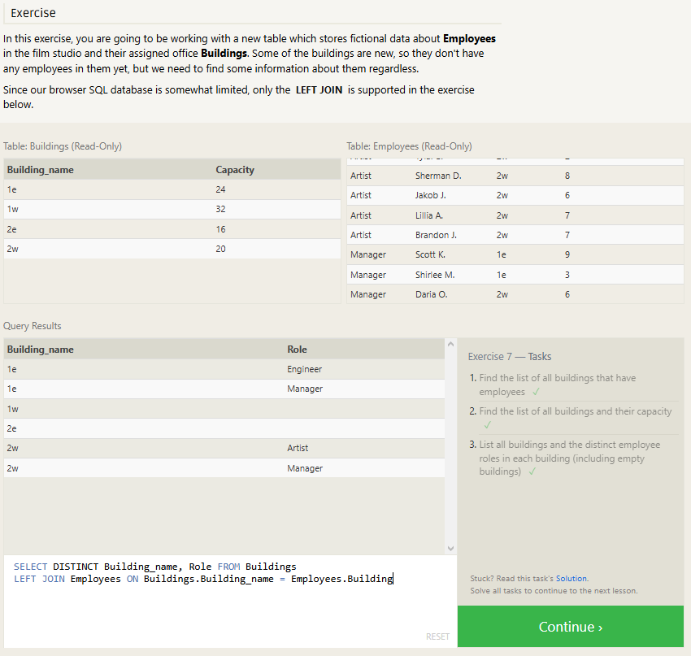
Review
- Worked with LEFT JOINS for the first time, holding all column values in the initial table when joining with tables (to the right).

SQL Lesson 8: A short note on NULLs
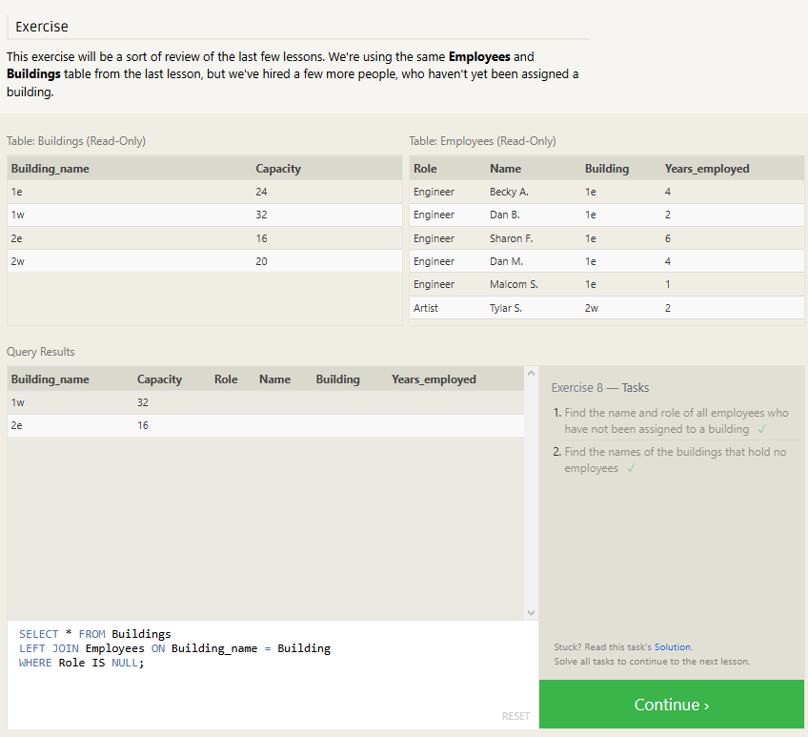
Review
- Learned what NULL is
- Learned how to use NULL to find data that does not exist
- Used LEFT JOIN to find NULL values in one table to another

SQL Lesson 9:

