Longley Pham
Caldon
Data Analytics Pre-Work
2 April 2026
Exercise 2.A Improving Weak Prompts
- Explain regression
  - You are a statistician explaining regression to me as if I’m a high school student preparing for college statistics. List 5 key concepts in 1-2 sentences per concept and add real-world context to each point to help understand the fundamentals of regression. Include at least one common mistake students make working with statistics.
  - 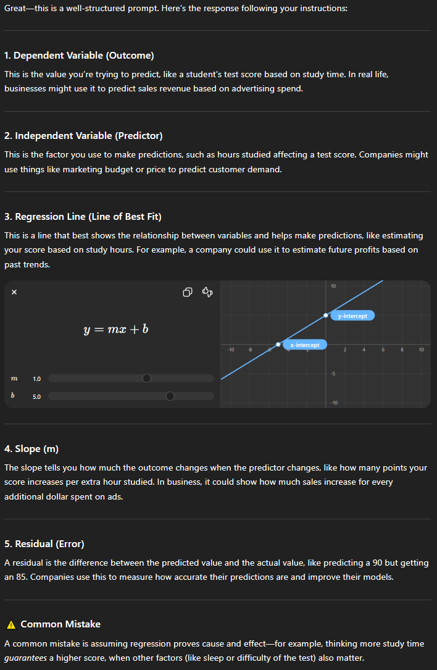
  - My revised prompt is stronger because it gives ChatGPT more context to work with. I identified the context into the task, followed by constraints that I wanted the AI to follow. Instead of going for general knowledge, I asked the bot to explain it in a certain way, tailoring to different tasks rather than just to “explain regression.”
- Help me understand SQL
  - As an analyst, help me, a mathematician, understand how SQL is applied in corporate businesses within 3 key ideas. Include at least three fields that it is applied in and why it is important to have it.
  - 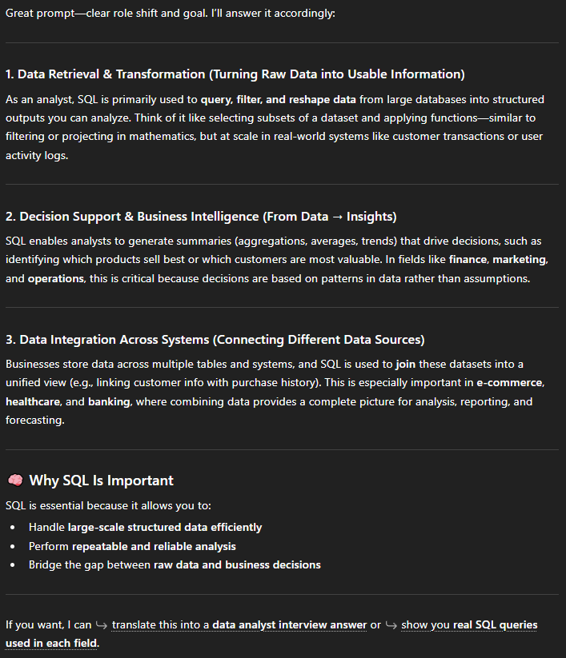
  - The revised prompt effectively explains SQL from an expert to a similar field, linking knowledge from mathematics directly to database structure and information handling. ChatGPT generates key concepts, related fields, and importance within seconds of the revised prompting, tailored directly to another field that may be able to collaborate with SQL experts.
- Create a dataset
  - Create a dataset with 10 rows showing top games as Game Name, Parent Company, Genre, Concurrent players, Annual revenue generated in 2025, Annual revenue generated in 2024, and percentage difference. Revenue should be formatted as $XX.XX B. Percentage difference should be formatted up to 1 decimal place. Format as a table, and sort by revenue generated in 2025.
  - 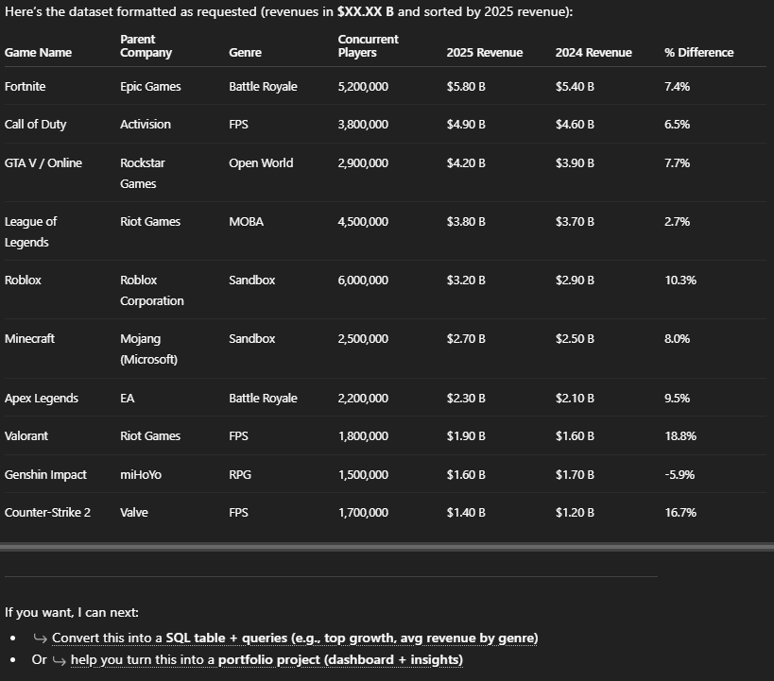
  - The revised prompt specified game titles rather than a random sample set, giving data where we can draw revenue information from. The formatting of numbers and percentage were specified, otherwise given as millions or up to 2-3 decimal places. I would shorten the constraints down to 5-7 companies in the future; overall, the readability can be improved but is still consistently formatted.

Works Cited
OpenAI. (2026). ChatGPT (Aug 2025 version) [Large language model]. https://chat.openai.com/chat

