15CTT-Group3

Version <1.1>

Table of Contents

1. Use-case Model 4

2. Use-case Specifications 4

# Use-case Model

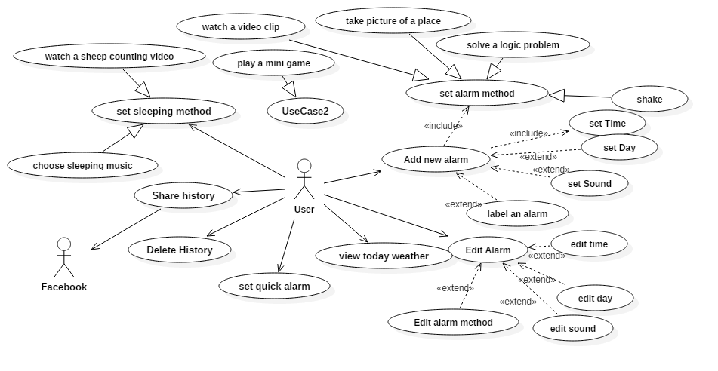

# Use-case Specifications

## Use-case: Add a new quick alarm

|  |  |
| --- | --- |
| Use case Name | Add a new quick alarm |
| Brief description | This use case describes how the user add a new alarm |
| Actors | User |
| Basic Flow | 1. At the homepage, the user clicks on plus icon. 2. The user can choose two type quick alarm or alarm type. 3. User choose quick alarm, then different type of minute boxes appeared 4. For each boxes clicked the minute will be stacked up. 5. If user choose OK, the alarm is set up. 6. If user choose Cancel, then nothing will happen |
| Alternative Flows |  |
| Pre-conditions | User have not added new alarm. |
| Post-conditions | The user create new alarm successfully. |

## Use-case: Add a new alarm

|  |  |
| --- | --- |
| Use case Name | Add a new alarm |
| Brief description | This use case describes how the user add a new alarm |
| Actors | User |
| Basic Flow | 1. User choose hour, minute and day sesssion(AM/PM) 2. Set up the volume of alarm clock 3. User choose snooze function. 4. System displays time option 5. User selects the period of snoozing time. 6. User presses “OK” 7. User choose ringtone function 8. System display a list of music 9. User select ringtone and presses”OK” 10. User Choose Label 11. System display a box for user to input name 12. User input name and presses “OK” 13. User choose Alarm off method |
| Alternative Flows |  |
| Pre-conditions | User have not added new alarm. |
| Post-conditions | The user create new alarm successfully. |

## Use-case: Edit an alarm

|  |  |
| --- | --- |
| Use case Name | Add a new alarm |
| Brief description | This use case describes how the user edit an existing alarm |
| Actors | User |
| Basic Flow | 1. User long-click on an alarm box 2. Alarm box appears on the screen 3. User modifies alarm 4. User presses “OK” 5. Alarm box disappears 6. System update the alarm accordingly |
| Alternative Flows | 1. **User wants to edit time** 2. **User wants to edit day** 3. **User wants to edit ringtone** 4. **User wants to edit alarm method** |
| Pre-conditions | Alarm already exists |
| Post-conditions | The user edits the alarm successfully |

## Use-case: View today weather

|  |  |
| --- | --- |
| Use case Name | View weather |
| Brief description | This use case describes how user view today weather |
| Actors | User |
| Basic Flow | 1. User taps on the weather icon in the bottom navigation bar 2. App switches view to weather activity 3. App display current weather at user’s defined location |
| Alternative Flows | 1. **App cannot get weather info from Web API service.**    1. App display error message |
| Pre-conditions | User is on alarm activity |
| Post-conditions | User successfully views weather on current day |

## Use-case: Set sleeping method

|  |  |
| --- | --- |
| Use case Name | Set sleeping method |
| Brief description | This use case describes how the user set sleeping method |
| Actors | User |
| Basic Flow | 1. User taps on the sleeping icon on the bottom navigation bar 2. User tap on one of the sleeping method box 3. User presses start button |
| Alternative Flows | 1. User chooses sleeping music method    1. Music list appears on screen    2. User selects a song    3. User presses OK |
| Pre-conditions | User is on any activity |
| Post-conditions | The user successfully activate an sleeping method |

## Use-case: Share history

|  |  |
| --- | --- |
| Use case Name | Share history |
| Brief description | This use case describes how the user can view and share their sleeping statistics |
| Actors | User |
| Basic Flow | 1. User taps on Statistics tab on bottom navigation bar 2. Statistics activity shows up 3. User taps on share button in the menu bar 4. User choose a mean of sharing 5. App sends a link to selected service 6. User continues on sharing service 7. User returns from sharing service 8. Application displays statistics activity |
| Alternative Flows |  |
| Pre-conditions | User has been using the app for at least a week |
| Post-conditions | User successfully shares their statistics |